# \\obmh.nhs.uk\home\MHOx-Home2\carmel.parker\My Documents\2017\new leaflet templates\A4 logo size.png

**PUBLIC**

**Report to the Meeting of the Oxford Health NHS Foundation Trust**

**Board of Directors**

**For information and assurance**

**BOD 79/2017**  
(agenda item: 9)

**28th June 2017**

**Incident, Mortality and Patient Safety Quality Report**

**Executive Summary**

The following report provides a summary of incidents and deaths reported up to March 2017, alongside a review of trends in incident data over the previous 2 years. It also includes a review of mortality data and serious incidents which have occurred in the Trust.

The report is split into the following sections:

* Overview of incidents reported
* Analysis of restrictive practice
* Data quality
* CAS Alerts and Risk Notes
* Identifying, reporting, reviewing and learning from deaths
* Serious incident investigations and learning

**Governance Route/Approval Process**

Earlier versions of this report were considered by the Safety quality sub-committee on 20th April 2017 and the Quality committee on the 10th May 2017.

**Recommendation:**

This report is submitted for information and assurance.

**Author and title:** Charlotte Forder, Pam Treadwell, Paul Butler and Jane Kershaw (Quality and Risk Team)

**Lead Executive Director:** Ros Alstead Director of Nursing and Clinical Governance

**1.0 Overview of Reported Incidents**

Looking back at levels of incident reporting from the point at which the Ulysses incident reporting system was introduced across all services from 2011 (which followed the merger with Community Health Oxfordshire in 2011), reporting levels have increased from a mean average of 720 a month to an average of 1112 a month from March 2015 to March 2017 (Figure 1). Given overall reporting levels in Ulysses have been consistent for over the past 2 years, it follows that April 2015 is a suitable starting point to look at variation in the detail of the data. [1]

No seasonality has been observed in numbers of incidents reported. Similar numbers of incidents are reported as occurring from Monday – Friday, while reduced numbers are reported on weekends. A review of the times at which incidents were reported as occurring showed that 27% of all incidents occurred between 10am and 1pm.

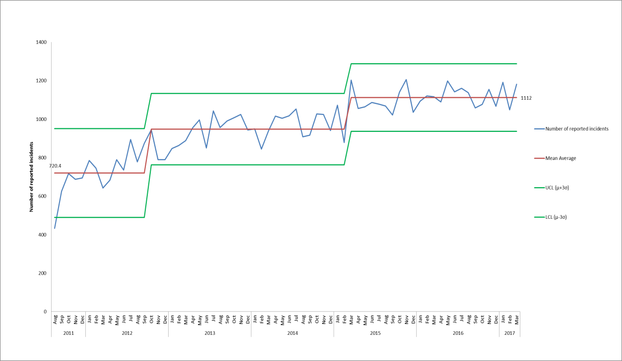

*Figure 1. Control chart displaying monthly number of incidents reported on Ulysses system from August 2011- March 2017*

1.1 Actual Impact of Incidents

Overall in Q4 2016/17, 3432 incidents were reported, 61% with no harm which is in line with the national picture according to the NRLS. In Q4, however, a higher proportion of incidents were reported by Oxford Health in the category of major injury/severe property damage. Of the 39 incidents with major injury/severe property damage reported in Q4, 18 were in district nursing teams, 9 were in AMHTs (5 of these were self-harm), 3 were in adult acute mental health wards and 2 were in community hospitals. The 18 incidents recorded with major harm in district nursing, 14 were pressure ulcers, and 8 of these were acquired in the care of Oxford Health while 6 were inherited. None of the 8 acquired pressure ulcers in District Nursing were identified as SIs as there were no lapses in the care provided. A review is currently taking place to establish how these incidents should be graded if the harm is not as a result of a lapse in the care provided by the Trust. If the 14 pressure ulcer incidents are excluded from the data then the percentage of incidents with major injury reduces from 1.14% to 0.7%.

1.2 Incidents reported across Directorates and Service Lines

The proportion of incidents reported by each directorate has been consistent over the 2 year period from April 2014.

Further to this no significant trends were seen in incidents reported across different service lines from April 15 – March 17; however there does seem to be a small increase in incidents reported by AMHTs as shown in figure 2. Of the 60 incidents reported by AMHTs in March 2017, 70% were by the two AMHTs with the highest activity; AMHT Oxon City + NE (n=24) and AMHT Bucks Aylesbury (n=18). Overall the 60 incidents include 16 incidents of self-harm, 12 of violence and aggression and 4 unexpected deaths. Two of the 60 incidents for AMHTs have been identified as SIs and one as a possible SI (5%). There was no significant change to the number of attended appointments or distinct patients seen in 2016/17, although a further review of open referrals and queries around data quality are being followed up.

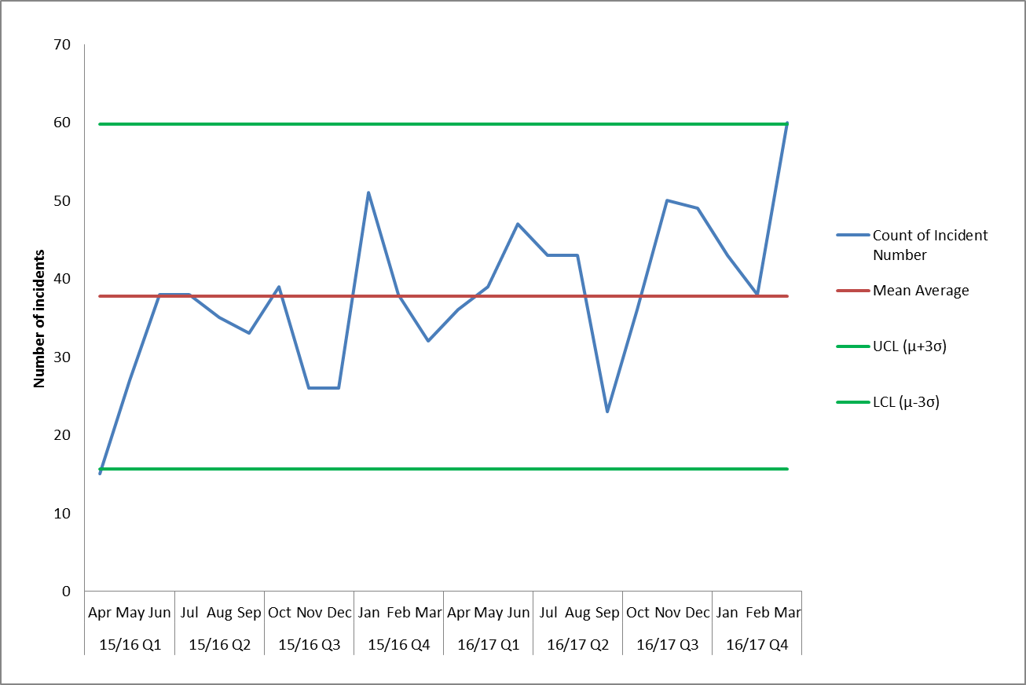

*Figure 2. Incidents reported on Ulysses by Adult Mental Health Teams (AMHTs) from April 2015 to March 2017*

1.3 Incidents reported across Departments

Figure 3 shows the incidents reported over 2 years for the departments which are reporting the most incidents. No trends are seen but there was a spike in incidents reported by CAMHS Highfield in Q3 15/16 and numbers increased again in February and March of 2017 which relates to the complex care of two patients at different times. One patient on Highfield has had a very high number of incidents (n=87) reported over the last two months (April and May 2017) relating to supporting the young person to eat and to prevent self-harm, the clinical team are looking for a more suitable placement to care for the person.

Overall reporting was reviewed for all departments with a mean average of ten or more incidents per month across the 2 year period. A decline in reported incidents was seen for Kingfisher and Watling wards while an increase was seen in reporting by Vaughan Thomas and CAMHS Marlborough House. No corresponding patterns were seen in the number of inpatient bed days on these wards, so we believe this is due to patient acuity and reporting culture.

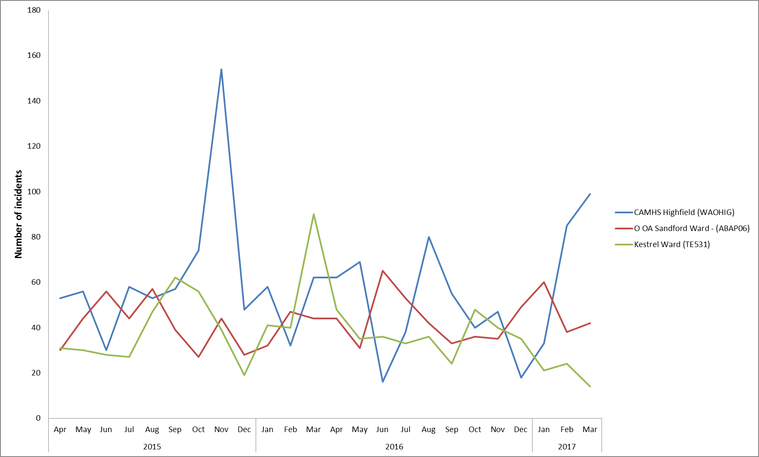

*Figure 3. Total incidents reported on Ulysses by 3 departments with most reported incidents from April 2015 – March 2017*

1.4 Cause Groups

Over the last two years violence/aggression and skin integrity (pressure damage) have consistently been the causes linked to most reported incidents. Violence/aggression was the cause associated with 18% of all 2016/17 incidents while 16% were skin integrity incidents. The third highest cause of incidents in Q4 2016/17 was self-harm. The 3 main cause groups in Q4, violence + aggression, skin integrity and self-harm are looked at in more detail in the next sections.

A review of data in the remaining cause groups highlighted the following:

* **Sexual:** There was a peak in sexual incidents in December 2016 (19 incidents) and January 2017 (26 incidents). Of the incidents in January 2017 most were on Vaughan Thomas ward and 11 of these were linked to 1 patient.
* **Sharps/needlestick**: There was a peak in February 2017, 20 incidents were recorded, 13 were due to sharps disposal and 11 of which were in podiatry. In May 2017 there was a rise in sharps injuries in the older people’s directorate. It is believes the higher number of incidents in podiatry relate to accidents by a number of new starters/ mistakes in the way scalpels are being held. Further analysis is underway to identify any unsafe practices and improvements which can be made.
* **Health** – increase in Q4 2016/17 due to one patient resisting treatment and requiring support with eating.
* **Conveyance** - a peak in conveyance incidents was seen in Q2 2016/17. Monthly reports are now being sent out to the transport contract manager and adult directorate Heads of Service to ensure all conveyance incidents are being reviewed.

1.4.1 Violence + Aggression

Violence/ aggression continues to be the highest cause of reported incidents, but there has been no overall change to monthly numbers over the previous 2 years, and no trends were found when looking at the breakdown by directorate or service line.

Within the violence/ aggression cause group incidents are classified into sub-categories. The category ‘Violence No Injury - Patient on Staff’ has consistently been attributed to the majority of the incidents and this was the cause recorded for 41% of incidents of violence/ aggression over 2 years. Over the same time 20% of the incidents were recorded in the category ‘Verbal Abuse Patient on Staff’ and 15% were in the category ‘Violence with Injury - Patient on Staff’.

The peaks in incidents reported by particular departments seem to be linked to the patient mix as patterns remained the same when looked at in the context of bed days. Of the 576 incidents reported in Q4, 222 incidents (38.5%) were linked to 24 patients.

Looking at the actual impact of incidents of violence/ aggression on all wards from April 2015 – March 2017, 84% resulted in no injury/property damage, 13.8% resulted in minor injury/property damage and 0.99% resulted in moderate or major injury.

Sandford ward (older people mental health) continues to be the department with most reported incidents of violence and aggression (figure 5). In Q4 2016/17 one patient was involved in 48% of all incidents reported on this ward. Using bed days as a denominator Sandford still has the highest number of reported incidents with 6.5 incidents per 100 bed days in 2016/17. This is compared to 5.3 on Ashurst, 3.4 on Kennet, 4.3 on Kestrel and 2.2 on CAMHS Highfield. A review of expected staffing levels and the mix of patients on Sandford ward is being completed.

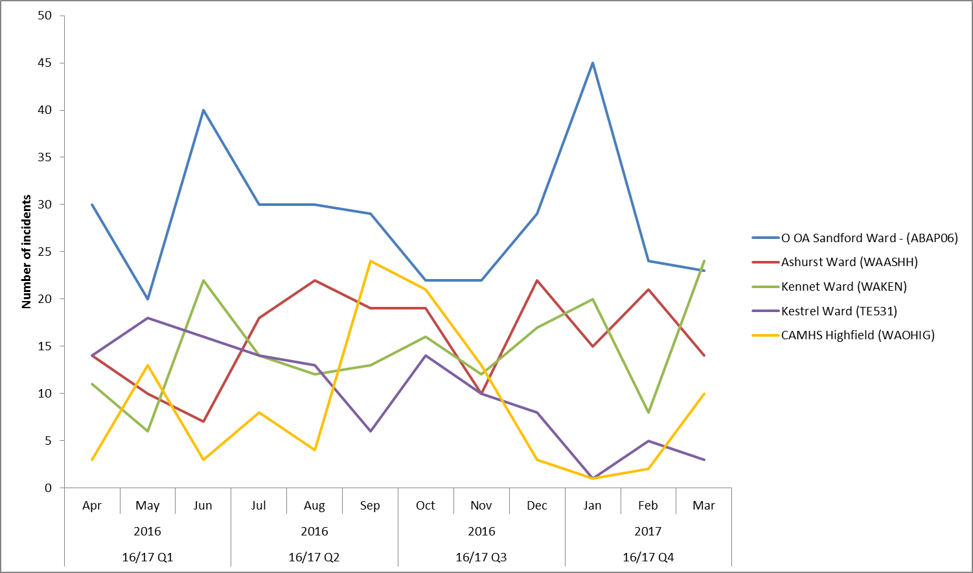

*Figure 5. Incidents of Violence & Aggression reported on Ulysses by the 5 departments with most reported incidents from April 2015 – March 2017*

1.4.2 Skin Integrity (pressure damage)

In July 2016 changes were made to the Ulysses system to enable information to be collected, analysed and reported on whether pressure ulcers were ‘acquired’ in the service of Oxford Health or ‘inherited’ before the patient came into our care. Although skin integrity is the cause group with the second highest reported number of incidents, from July 2016 onwards 46% of the reported pressure ulcers were inherited (figure 6).

From July 2016 to March 2017, 733 pressure ulcers were reported as acquired, the majority developing when people were being treated by the district nursing service in the community (92%). The majority of acquired pressure ulcers are category 2, 68% (15% category 3 and 14% category 4). In 2016/17 there have been 21 pressure ulcers in categories 3 and 4 which were investigated as serious incidents. This is a decrease from 2015/16 when there were 28. Further work is being done to allow improved reporting to learn from category 2 pressure ulcers.

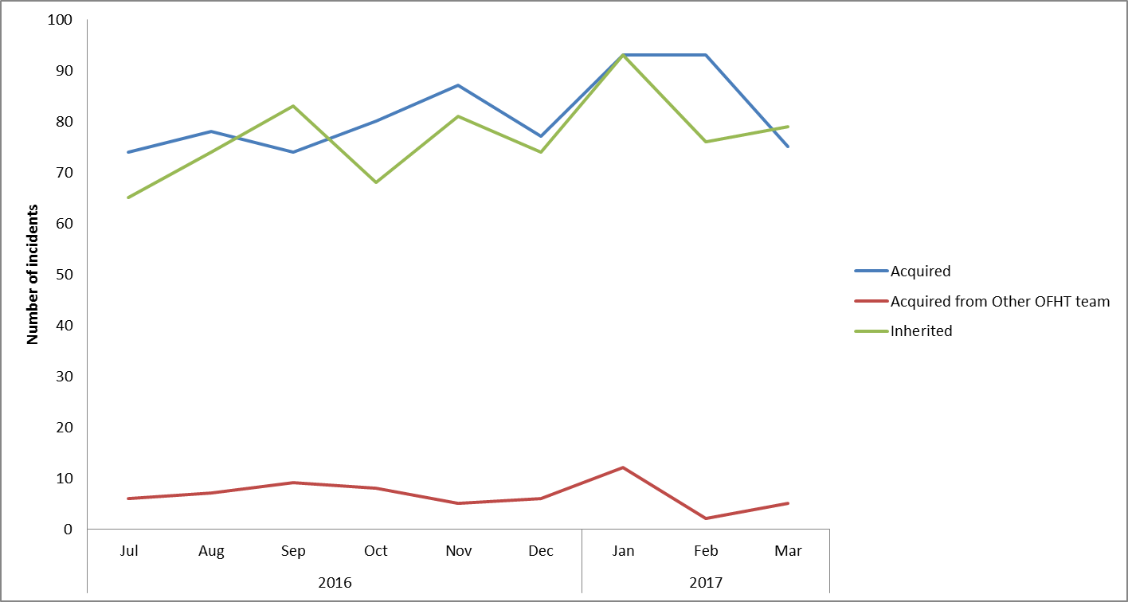

*Figure 6. Acquired and Inherited Pressure Ulcers reported on Ulysses from July 2016 to March 2017*

In 2016/17 the following improvements have been achieved;

* There are 6 district nursing teams testing the quick time learning (QTL) process. The QTL process is managed by the clinical development lead (CDL) for the named team. The CDL will meet with the team as soon as possible after the reporting of a category 2 or above pressure damage. If the pressure damage occurs within the service (acquired) then the team analyse the case and see if the damage could have been prevented or if all actions were taken to reduce risk. The process is completed electronically on the trusts incident reporting system and the team hold a local action plan for themselves. Any county wide learning is shared widely as appropriate.
* A react to red (skin) and use of a SSKIN bundle project was tested by the reablement service in 2016/17. The project used two approaches; to give staff the ability to complete basic skin risk assessments and to use a daily SSKIN bundle tool to monitor patient risk of skin breakdown, contacting the district nurse service at an earlier stage of skin deterioration should this be a concern. The initial results of the project were positive and planning has started to test the approach further across the district nursing service.
* Pilot sites across the trust and Oxford University Hospitals NHS Foundation Trust are working on improving the information patients are given about pressure damage.
* Training on pressure ulcer prevention and management and equipment awareness is available to complete electronically or in a classroom.
* A competency framework which has been launched across community nursing teams for all staff to complete.
* Partnership working with local authority and the voluntary sector to help raise awareness of pressure ulcers.
* All category 3 and 4 pressure ulcers have an initial review report completed reviewed by the senior clinical team.
* From October 2016 a general risk assessment template has been introduced which provides a tool for staff to use for a range of situations; from patients who express challenging behaviours, non-concordance, environmental risk, to a change on process.
* Documentation introduced for district nursing and carers handovers to structure communication and to clarify actions and responsibilities.
* The care plan templates are being reviewed, amended and piloted.

1.4.3 Self Harm

The data on self-harm from April 2015 to March 2017 shows a decline in incidents reported in the adult directorate, the mean average decreased from 92 per month prior to June 2016, to 59 per month from June 2016 onwards. Having reviewed the data across the service lines the decline was seen in Forensic wards, mostly related to a decline in self-harm incidents for three patients who are still in our care.

In Q4 2016/17, 313 incidents of self-harm were reported in total, 58 in January, increasing to 134 in February and 121 in March. Overall 152 incidents (49% of those reported in Q4) were linked to 11 patients.

Figure 8 shows the variation in the number incidents of self-harm reported by the 3 departments with most incidents in this category. The spikes seen tend to be repeated episodes of self-harm attributed to small numbers of patients. In Q4, 37 of the 113 incidents related to CAMHS Highfield (33%) and were carried out by one patient, a further 26 incidents were linked to a second patient on Highfield.

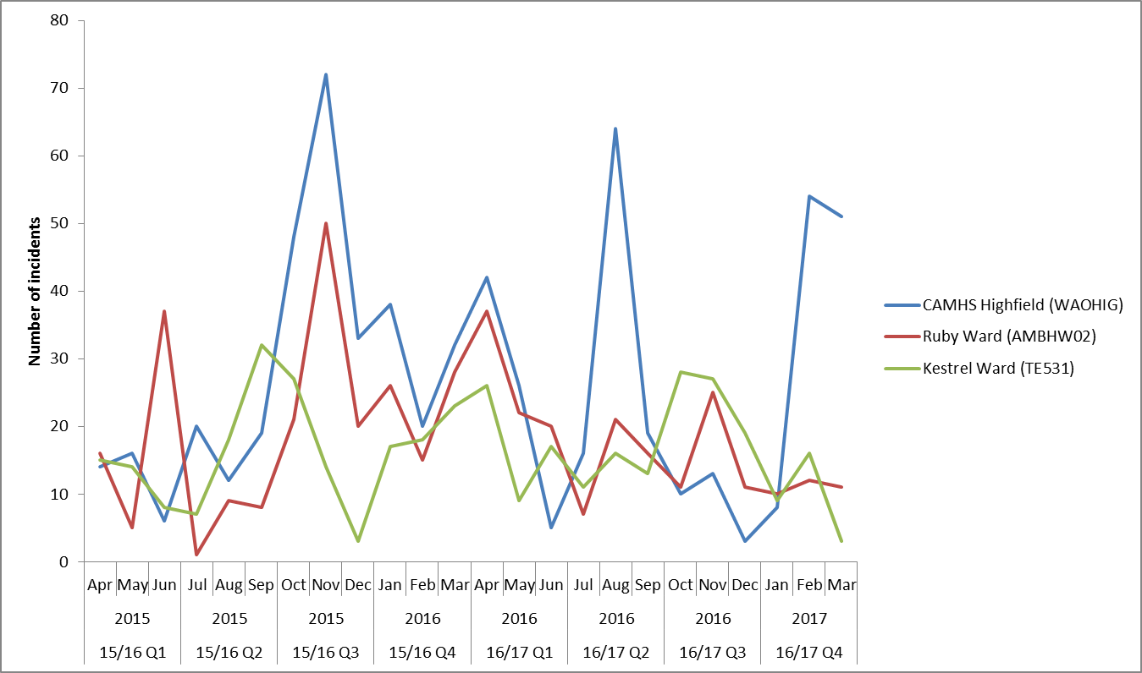

*Figure 8. Incidents of Self Harm reported on Ulysses by the 3 departments with most reported incidents from April 2015 – March 2017*

1.5 Restrictive Practice

The use of restrictive practice is reported to the Executive Team weekly.

The number and duration of time in a physical restraint has reduced in 2016/17, figure 9 shows the number of restraints for the last 2 years. The mean monthly average number of restraints has reduced from 162 in 2015/16 to 137 in 2016/17. The small increase in February and March 2017 relates to one patient who was very unwell at this time and the restraints were used to ensure that this patient was safe. The decline in the use of restraint is as a result of an improvement across our adult mental health and forensic wards from June 2016. The most common reasons for using restraint are violence and aggression on staff or self-harm. The number and duration of time in prone restraints (where the patient is placed face down) has decreased, seen in figure 10, the mean monthly average decreased from 30 prior to June 16 to 20 from June 2016 onwards. 17% of restraints in Q4 involved the use of a prone position (72 incidents). The number of forms recording the use of the highest level of hold, thumb-wrist hold has remained low at 2% (8 restraints in Q4) maintaining the fall in high level holds.

The number of patients restrained five times or more is 15 in Q4. Restraint was used on 112 patients in total in Q4, with 15 patients accounting for 66% (289 out of 436) of all incidents involving restraint. Highfield continues to have patients who feature with multiple restraints, with four patients this quarter. Sandford also has multiple patients requiring restraint (three patients). Kestrel has consistently featured, although this quarter features less prominently.

Below is further information about the two patients who have been restrained the most in Q4;

* The Highfield patient who has been restrained 98 times has presented with complex challenging behaviour and has made multiple attempts to go AWOL from the ward and been aggressive towards staff. The patient is currently Nasogastric fed on a regular basis requiring frequent episodes of restraint in order to administer this treatment. They have been referred to adolescent secure care and are awaiting an appropriate bed. They have been nursed in long term segregation since 23rd February 2017.
* The patient restrained 42 times on Sandford has featured in the last two quarters as well. He presents with particular challenges when delivering personal care. He often requires physical intervention in order to administer medication via a peg feed and washing. During this time he is hostile and aggressive. The duration of the restraints are limited to the duration of the intervention and once they have been completed his aggression subsides quickly. Therefore he has been requiring frequent but short episodes of restraint. He has a robust care plan around this. It is thought that there may be a higher frequency of restraint for this patient due to the frequency of the interventions that require restraint and the practicalities of completing an incident form for each occasion (multiple times per day).

The use of seclusion declined from October 2015 and stayed the same in 2016/17, see figure 11. The majority of seclusions are carried out in the Trust’s intensive psychiatric care unit. In 2016/17 we started collecting central information on use of rapid tranquilisation and long term segregation (mainly used on forensic wards) to enable regular monitoring.

There have been 61 incidents where rapid tranquilisation was administered, restraint has been used on every occasion. Lorazepam was used in 39 (64%) of incidents. Although the data we are now able to gather for the use of rapid tranquilisation has improved there are still data issues due to the format of the incident form. Depending on the course group the option to record rapid tranquilisation does not appear. A new form has been released in May 2017 to better capture this information and to ensure the requirement to confirm if rapid tranqiuilisation has been used or not is present despite the course group for the incident. At present rapid tranquilisation is very underreported and the data is not representative therefore it is not possible to identify trends.

The Trust has four areas where patients may be placed in long term segregation (LTS); these are on Highfield, Watling, Kestrel and Kennet. In January 2017 Ashurst reviewed its use of long term segregation and no longer has high dependency areas. They have however in exceptional circumstances had to use LTS on a short term basis and do feature for LTS in quarter 4, having used it on 2 occasions. The use of long term segregation has reduced in Q4 of 2016/17 (361 days, half as much as in Q3). There was a peak between March to August 2015 due to a patient in CAMHS who required a high number of seclusions. There was a decline in the number of seclusion in 2015 that has been maintained but no trend identified since then.

The reduction in restrictive practices seems to be a result of the actions from the PEACE (positive engagement and calm environments) project which included a revision and roll out of new staff training (which is continually being reviewed with matrons), identifying and supporting a PEACE champion on each ward, and a reporting mechanism so that all restrictive practice is reviewed by senior clinicians including executive directors on a weekly basis. Any concerns about care are highlighted weekly and followed up by the Head of Nursing to review if practice was and is appropriate. With the planned integration of Oxfordshire learning disabilities services a review of the restrictive practice used will take place, in particular the restraint training required.

The forensic service has a local procedure which allows them to use handcuffs if approved in writing by the Head of Service and Clinical Lead. These are used when escorting patients out of the units who are at high risk of attempting to abscond, usually to court or medical appointments. The escorting staff must be trained in their use. The units using handcuffs are Marlborough House, the Oxford Clinic and Thames House. Handcuffs were used a total of 22 times over the last quarter with 15 different patients to escort patients (usually detained under home office restrictions) at high risk of absconding to court, prison, medical appointments or for transfer between wards

In Q4 there has been one serious incident graded as orange that involved restrictive practice in the form of restraint. The nature of the incident and reason for the grading was not related to the restraint and was in relation to self harm and an estates issue with doors. Since April 2015 there have been eight complaints relating to the restraint of patients, none in Q4. All eight complaints are spread across seven wards and relate to eight individuals. All the complaint investigations have concluded that restraint techniques used were appropriate and the complaints have not been upheld.

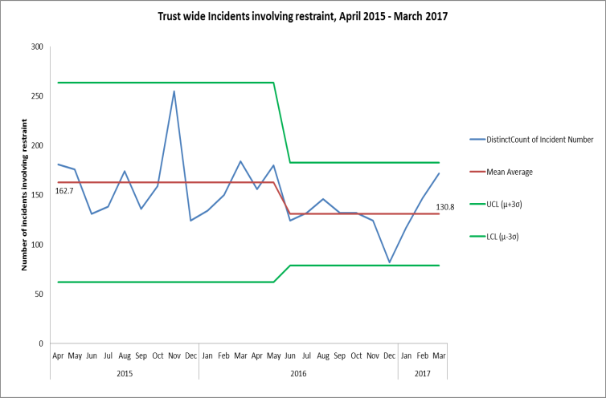

*Figure 9. Number of restraints*



*Figure 10. Number of prone restraints.*

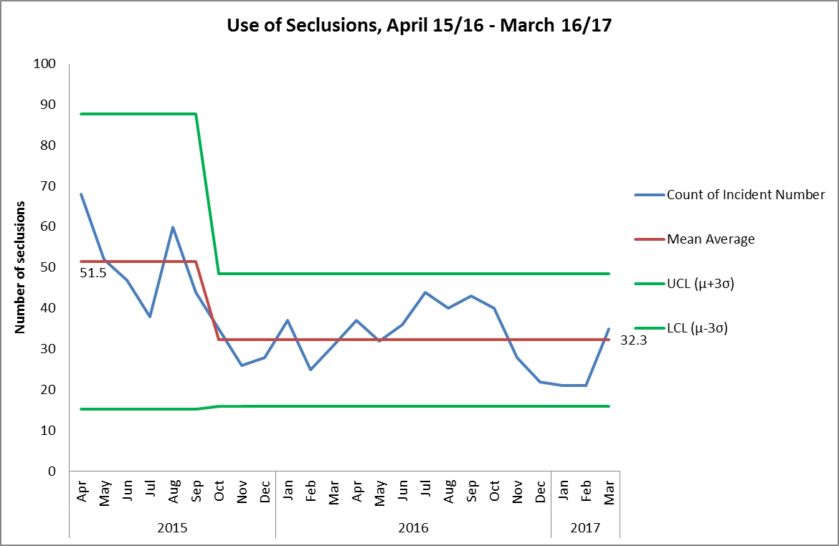

*Figure 11. Use of seclusion*

1.7 Never Events

There have been no incidents meeting the never event criteria over the last three years.

**2.0 Data Quality**

2.1 Incidents waiting to be graded by managers (also known as being held in web holding)

Incidents waiting to have the risk rating graded are still included in all Trust reports as the actual impact and detail of the incident are reported, but there is an ongoing work to reduce the number in order to improve data quality and timeliness of incident reviews by managers. The details of incident will not be shared externally or uploaded to NRLS until it has been reviewed and closed by the manager. All incidents are emailed to the manager of the reporting person, plus all ungraded incidents are reviewed by the central quality and risk team to ensure serious incidents are not missed and a regular report of all ungraded incidents is sent to the directorate governance teams.

The Trusts current policy states incidents should be closed by the manager within 5 working days, the policy is under review. The NRLS requires NHS trusts to upload all patient safety incidents at least monthly and recommends any deaths or incidents with major impact should be uploaded within 2 working days. In 2016/17 the median number of days to close an incident was 9 days (the mean was 26 days).

The number of incidents awaiting review by managers is currently 915 (snapshot in June 2017) which is quite static, figure 12 shows a snapshot from each month in the last six months. No incidents are in web holding over 12 months old.



Figure 12. Incidents in web holding

The table below lists the teams with the highest number of incidents awaiting review. The CAMHS Highfield team have the most incidents in web holding (n=239 as of 2nd June 2017); however they are also the department which has reported the highest number of incidents in 2016/17 (n=642). There are some teams who report a high number of incidents e.g. Sandford ward, Ruby ward and Kestrel ward, but are to manage these effectively and close the incidents timely resulting in few incidents being in web holding.

|  |  |  |  |
| --- | --- | --- | --- |
| **Department Name (includes departments with >20 incidents in Web-holding)** | **Total incidents in Web-holding, 02.06.17** | **Total number of incidents reported in FY 16.17** | **Incidents in web-holding as % of incidents reported in 6 months** |
| CAMHS Highfield | 239 | 642 | 37% |
| Ashurst Ward | 61 | 355 | 17% |
| CAMHS Marlborough House | 53 | 438 | 12% |
| AMHT Oxon City And NE | 44 | 190 | 23% |
| Sapphire Ward | 32 | 198 | 16% |
| Allen Ward | 22 | 196 | 11% |
| AMHT Bucks Aylesbury Team | 22 | 85 | 26% |

The internal auditors, Tiaa, completed an audit of the incident management system in February 2017 the key findings were to; the number of incidents un-graded and held in web holding (although no safety risk posed), improving the timely completion of initial review reports and improving the review/ update of the patient safety incident flag on incidents. An action plan has been submitted to address the findings.

2.2 Improvements to the Ulysses Incident Reporting System

* Further changes within the sub-categories of skin integrity were put in place from 1st April 2017.
* Improvements to reporting of restraints and rapid tranquilization within Ulysses were introduced from 1st May 2017.
* The Quality + Risk team are also working with Ulysses to shorten the form that managers are required to complete and to create patient detail look ups from the Carenotes system to make it easier to report and close an incident.

**3.0 CAS alerts and Risk Notes**

In Q4, 17 CAS alerts and one field safety notice were issued. Of these 15 were not applicable to the trust and 1 has been closed. There is one field safety notice and one remaining CAS alert from Q4 that remain open and in time.

The Senior Health and Safety Advisor monitors all CAS alerts in conjunction with designated specialists as appropriate (if from estates, pharmacy or clinical lead) in order that suitable action to improve patient safety is taken and alerts are closed within timescales. There is an escalation process for CAS alerts which are due to expire or where there is no evidence that the work has been completed. There is currently no expectation of any breaches of deadline.

The following risk notes were written and circulated during Q4:

* 11/01/2017-Writing a report or witness statement for court proceedings relating to children and young people
* 18/01/2017 -Recording communication with family members
* 24/03/2017 -Ligature and ensuite bathroom door (re-issued)
* 24/03/2017 –Re-attaching oxygen in an emergency
* 24/03/2017- Recognising the acutely ill and deteriorating patient (resources for staff)

**4.0 Learning from deaths**

4.1 Developments

Over the past 18 months the Trust has been reviewing and developing how we identify, review, report and learn from deaths. In 2016/17 the following achievements were made;

* The process for identifying, recording and reviewing deaths has been revised and the new process is starting to be implemented. This includes a decision making tool to categorise deaths into expected and unexpected and natural and unnatural, which will help the trust to focus learning.
* A trust wide mortality review group was established which meets quarterly, chaired by the Medical Director and attended by clinical clinicians and members from our Council of Governors. This group reports into the safety quality sub-committee.
* A programme of thematic reviews has been established.
* Cross referencing between the patient electronic systems and the incident system is now happening regularly to be able to better understood, analyse and identify areas for further review.
* Two board of director seminar have been held to focus on the trusts learning from deaths.
* A large amount of work has been carried out to reduce and prevent suicides. This includes work with; Cruse Bereavement Care, piloting a family liaison role, two internal events held with senior clinicians to review the national and local themes for suicides and start the development of a new trust wide suicide prevention strategy, system wide work with the Thames Valley Suicide Prevention and Intervention Network, provision of suicide awareness and prevention training for staff within and outside the trust, local MDT reviews have been introduced following every suicide, and a staff psychological debriefing service has continued to be embedded.

4.2 Palliative care and care provided at the end of someone’s life

The trust delivers specialist palliative care and care at the end of someone’s life for children, adults and older people. The trust has a steering group to ensure a continued focus on improving care for these patients, work this year has included;

* A review of existing trust policies and the development of new guidelines following new national standards and internal feedback
* Staff training video on use of syringe drivers**[2]** produced in collaboration with the Oxfordshire Palliative Care Education Group
* End of life link nurses network in the trust has been established
* Workshops for staff have been held using an interactive forum theatre approach to support staff with having difficult conversations
* Resources and information on end of life and palliative care have been amalgamated into a single section on the trust internal website for staff
* A local survey of beavered families has been conducted
* Review of the current end of life care plan, which is individualised to each person, and used by a series of organisations in Oxfordshire, has started to ensure it reflects the new NICE guidance; this is due to complete in 2017/18.
* Joint work across the system continues, particularly with the Oxfordshire clinical commissioning end of life clinical reference group, Oxfordshire Palliative Care Education Group and the Oxford Universities Hospital end of life care working party.

4.3 Trends

Below is some high level information about the number of deaths across all our services, both inpatients and outpatients, which have been reported and reviewed by the trust. The Trust also published information about the number and review of deaths in our annual Quality Account for 2016/17. The trust is encouraging more work across the health and social care system so that a system wide approach can be taken to reviewing and learning from deaths. Here are some examples of multi-agency mortality review groups the Trust is involved with; Oxfordshire Vulnerable Adult Mortality Panel, Oxfordshire Morbidity and Mortality meeting held with Oxford University HospitalsNHS Foundation Trust, and thechild death overview panes held in each County. The trust has also been sharing processes, policies and learning with Southern Health NHS Foundation to support the imminent transition of Oxfordshire learning disability services.

The Trust reviews unexpected deaths on a weekly basis with oversight and monitoring by the bi-monthly Trust-wide Mortality Review Group. The Mortality Review Group is chaired by the Medical Director and reports to the Safety Quality sub-committee on a quarterly basis. The Mortality Review Group has been meeting for just over a year and has just reviewed their terms of reference. Thematic reviews on; learning from suicides and deaths across the adult mental health services, and an analysis of inpatient deaths have been presented and discussed by the Mortality Review Group. The following thematic reviews are underway; deaths of people with a diagnosis of personality disorder, joint working between children and adult services and learning from serious self-harm near misses. In addition to the work of the Mortality Review Group two seminars were held in 2016/17 with the board of directors to spend time going through the detail around deaths, and the Trust co-hosted a south region event for mental health and community NHS Trusts in December 2016 to share good practice and themes coming from mortality reviews.

Over the last 3 years (April 2014 to March 2017) the trust has reported 14,936 deaths including expected and unexpected, natural and unnatural, against 408,433 different people seen, this equates to 3.7% of people seen. Figure 13 shows the number of deaths by month for the 3 year period. We include the deaths of people currently being seen (and those referred and not seen yet) and also those discharged from the trust. Looking at the breakdown of the 14,936 deaths over 3 years, 11,988 deaths were of current patients with an open referral (80%) and 2,943 were patients who had been discharged.

The overall number and rate of deaths has not changed over the 3 year period, see figure 13, apart from in January 2015, in line with the national trend. In January 2015 there was an increase in deaths for us as a trust and nationally due to a peak in flu activity predominantly affecting older people. Nationally there is a recognised period from December to March each year called the ‘excess winter deaths’ period.

The majority of deaths (77%) reported by the trust are of people aged 75 and over who were being seen by one of our physical health services for example by a district nurse or the reablement service (provided by the trust up until 30th September 2016). Less than 1% (0.7%) of current deaths are identified as a suspected or confirmed suicide, all have been reviewed by the trust. 479 deaths were inpatients (3%) with over 85% aged over 75 (and over 30% aged over 90 years old) and the majority occurring on community hospital wards. The number of inpatient deaths in 2016/17 equates to about 6% of inpatient admissions.

The trust reviews all unexpected deaths or those where there were concerns about the care beforehand. In addition 126 of the deaths have had a formal RCA investigation through the serious incident process, of which 14 have subsequently been downgraded. 13 formal complaints were investigated either raised by the patient or family before their death or family after their death over the 3 year period, with 3 complaints received in 2016/17.

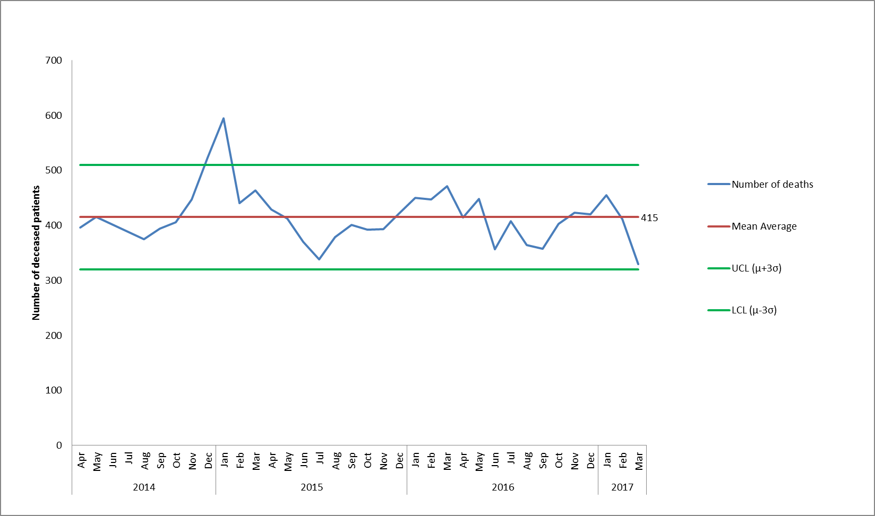

*Figure 13. Control chart to show number of deceased patients with open referrals and patients who have been discharged but who were seen in the 6 months prior to death. Data sources: Carenotes and Adastra patient administration systems, national trace, Ulysses incident reporting system. Potential additional deaths recorded on PCMIS and Dental PAS systems yet to be added, these represent very small numbers.*

A coroner will issue a Regulation 28 to prevent any future deaths if they feel any actions or learning is not being acted on sufficiently. The Trust has received two Regulation 28 rules in 2016/17 relating to;

* + The suicide of a man being treated in the community by an older people CMHT who died in August 2016. The two concerns raised mirror the recommendations in the trusts SI investigation around improving how teams liaise with family members to understand a patients heightened risk and the development of a new procedure for cover arrangements for when staff are on leave. The coroner asked for more detail on the timescales for these actions as detailed in the SI investigation report.
  + A drug overdose (probably not a suicide) of a man who was a Buckinghamshire inpatient on section 17 leave who died in December 2015. The concerns raised were about improving the practical implementation of section 17 leave, failings in the first SI investigation completed by the trust (which led to a second investigation being carried out prior to the inquest hearing), and the transfer of risk history from other providers. An update on the actions is being presented to the Trust’s Quality Committee in July 2017.

4.4 Emerging Themes

From the Trusts review of deaths the following themes have been identified;

* Improving physical healthcare for patients with a mental health illness
* Developing how we listen and involve carers and families during patients care
* Improve transitions in care across pathways

In 2017/18 we have incorporated these themes and the learning from our mortality reviews and investigations completed for individual deaths into our annual quality objectives for 2017/18, which are published in the Trusts Quality Account on NHS Choices.

4.5 National guidance

In March 2017 the National Quality Board published the first edition of the national guidance on learning from deaths supported by NHS England, the CQC and NHS Improvement; this was launched at an event attended by the Trust’s Medical Director and Chairman. Following this new guidance the Trust is reviewing our Incident Reporting and Management Policy to pull out and develop a separate policy for the identifying, reporting, investigating and learning from deaths which will be published by September 2017. The other requirements in the new guidance are already being met and the Trust’s proposed internal future developments being led through the SI improvements and the Mortality Review Group seem to be in line with future guidance requirements being suggested.

In addition the CQC have requested in June 2017 they are routinely sent information about all unexpected mental health deaths for current inpatients and community patients, backdating this to 1st April 2015. The Trust has previous to this only been sending information to the CQC about deaths of detained patients or mental health inpatient deaths. This change is as a result of the responsibilities the CQC inherited around patient safety from the HSE (Health and Safety Executive).

**5.0 Serious Incident Review**

5.1 Summary of number of serious incidents and themes

In Q4 of 2016/17, 22 serious incidents were identified and reported to commissioners and of these 1 has been downgraded to date. Ten of the serious incidents are suspected suicides. A summary of case incidents was reviewed by the Trust’s Quality Committee in May 2017.

Also in Q4, 23 finished serious incident investigation reports were reviewed at panel, identifies of any contributory factors and learning from each serious incident were reported and reviewed by the Trust’s Quality Committee in May 2017.

Figure 14 shows the number of serious incidents and downgrades from April 2014 to March 2017. In 2016/17 the Trust submitted 27 SI investigations to our commissioners before the 60 day timescale (18 to Oxfordshire CCG and 9 to Buckinghamshire CCG). The Trust has had no breaches to the SI timescales from 1st November 2016; however there may be a possible breach in June 2017 as the Trust is waiting for agreement from the Buckinghamshire CCG around an extension request.

The overall themes and learning from the serious incidents reviewed at panel in Q4 are;

* Challenges with staffing levels and use of temporary staff
* Variable completeness of documentation e.g. assessments, MEWS, care plans
* Essential checks are not always being completed e.g. environmental risk assessments
* Physical health care needs to be more routinely reviewed and monitored in mental health
* Vulnerability at points of transition between teams, with private providers e.g. paid for carers
* Staff need practical and regular resuscitation practice

The central SI team continue to work on the next phase of their improvement plan focused on; improving how beavered families are engaged and involved in investigations, improving how learning is shared and actions identified/ sustained. The team has revised the foundation RCA training and added ‘plug-in’ modules which were rolled out in June 2017 for investigators to improve skills around involving families, analysis using human factors approaches and skills in cognitive interviewing styles. There is now an expectation any member of staff band 7 or above investigating an SI will have completed a refresher in RCA training within the last three years.

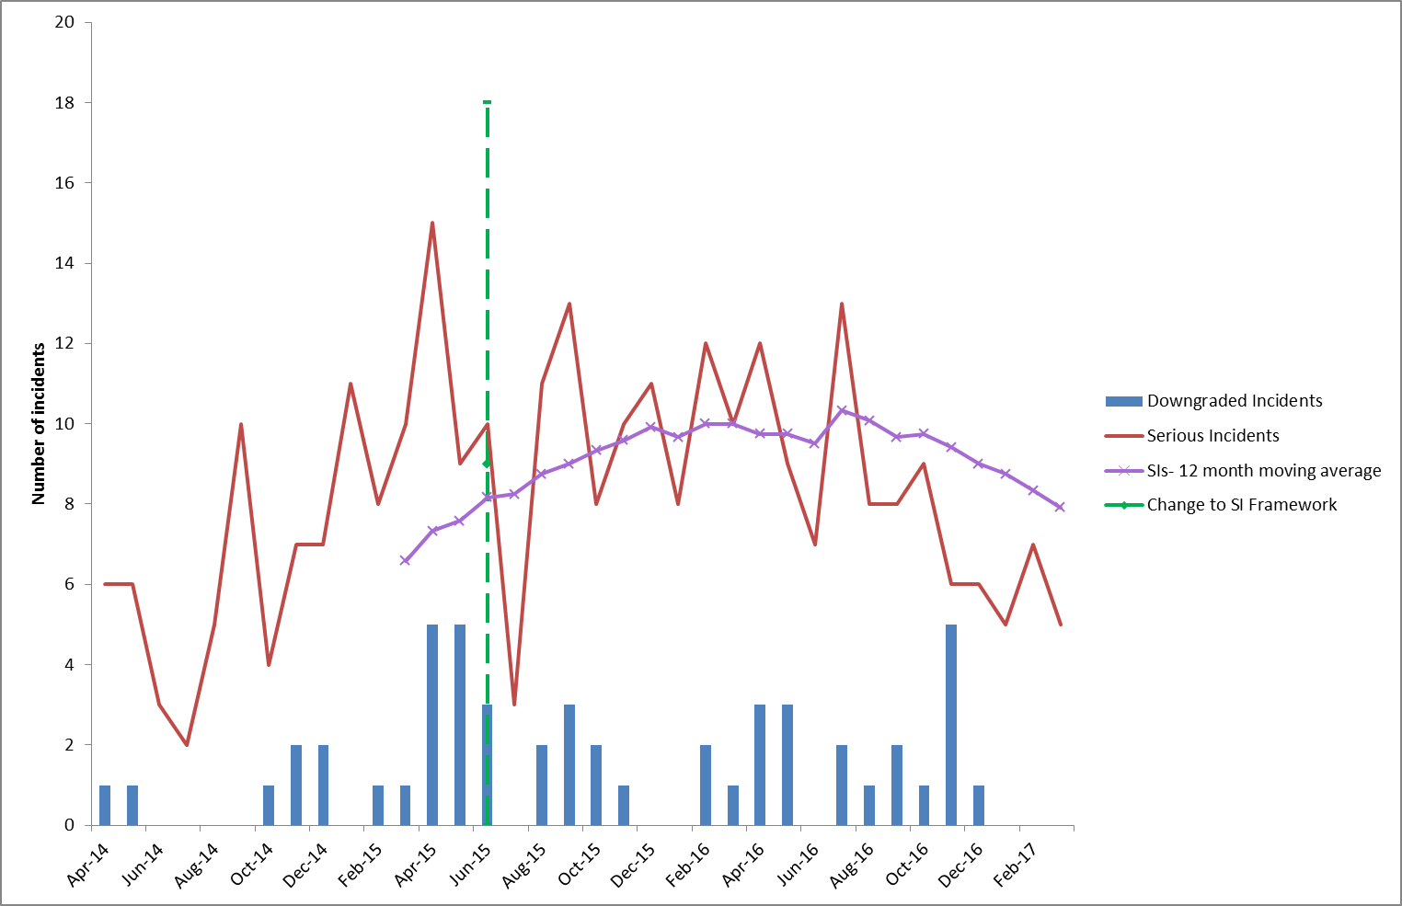

*Figure 14. Serious Incidents and Downgraded Incidents investigated from April 2014-March 2017 (based on date incident occurred)*

5.2 Serious incidents by team

The following teams have had more than three serious incidents in 2016/17[3];

* Oxfordshire City and NE AMHT (9)
* Ruby ward (7)
* Buckinghamshire Aylesbury AMHT (5)
* Amber ward (4)
* Buckinghamshire Chiltern AMHT (3)
* Oxfordshire North and West AMHT (3)

So far in 2017/18 only one team has had more than one serious incident which is the Buckinghamshire Chiltern AMHT, which has had three incidents which all happened in April 2017. The incidents relate to; a current patient being arrested in the possession of knives in a public area, an ex-patient discharged back to their GP in December 2016 and continued to receive support from another agency SMART for substance misuse was found dead in April 2017 in a public place and appears to have drowned. The third incident was an ex-patient discharged back to their GP in March 2017 who suffered major injuries (but survived) following jumping from a cliff whilst on holiday visiting relatives. All three incidents are currently under investigation.

Details of the incidents for the top three teams are detailed below;

| Team | Types of serious incidents | Themes from investigation |
| --- | --- | --- |
| Oxfordshire City and NE AMHT | 5 suspected/ confirmed suicides, 1 domestic homicide by an ex-patient, 1 unexpected death it seems as a result of an accident, and 2 attempted overdoses. | 5 out of 9 serious incidents have had an investigation completed and 4 are still underway.  There were no directly contributable factors found in the 5 completed investigations. However secondary learning points or areas for learning with hindsight were identified to continue to improve care. |
| Ruby ward | 2 suspected/ confirmed suicides (1 person on the ward and 1 person in the grounds), 2 serious self-harms, 1 fall with harm, 1 pressure damage (category 4) and 1 allegation of a relationship between a patient and staff member. | 5 out of 7 serious incidents have had an investigation completed and 2 are still underway.  The investigations have identified;   * failures in monitoring and acting around physical health care e.g. falls assessments, pressure damage and use of catheters * high use of agency staff * compliance with mandatory training levels e.g. resuscitation * concerns with leadership and inter-professional working * maintaining staff/ patient boundaries * compliance with the observation policy.   An action plan for each investigation has been agreed and is monitored centrally. |
| Buckinghamshire Aylesbury AMHT | 3 suspected/ confirmed suicides, 1 unexpected death of an ex-patient, and 1 sexual allegation against a patient. | 2 out of 5 serious incidents have had an investigation completed and 3 are still underway.  There were no directly contributable factors found in the 2 completed investigations. However secondary learning points or areas for learning with hindsight were identified to continue to improve care. |

5.3 Overdue Actions from Serious Incidents

There are a total of 58 actions overdue from 32 separate SI investigations as of 16th June 2017. A status report is presented weekly to the Trust-wide clinical review meeting chaired by an Executive Director and the governance leads in each directorate receive a weekly detailed report of all actions still outstanding. In the last two weeks 6 actions have been closed.

**6. Homicide investigations**

A separate detailed paper on all mental health homicides and domestic homicides with the learning and actions taken from April 2011 to December 2016 was presented to the Trust’s Quality Committee in early February 2017 and an update will be presented in July 2017. Unfortunately in February and March 2017 there have been three new homicides; one which occurred in Oxfordshire whereby the perpetrator was a current patient, a second in Oxfordshire in which the perpetrator was not a current service user but had one brief contact in the last six months with trust services and the third in Wiltshire where the perpetrator was not a current service user but had received treatment in the last 12 months. In all cases the victims have died and a Police investigation is underway. The Trust is working with the Police, safeguarding services and other agencies and internal investigations have been started.

1. The control charts used in the report are Individuals control charts originally generated using the Baseline Enterprise Software. Control limits not displayed in all charts but control limits have been used to identify all patterns in the data that are referred to.
2. A syringe driver helps reduce symptoms and control pain by delivering a steady flow of injected medication continuously under the skin.
3. Based on incident date at a point in time, as the information is refreshed or as SIs are possibly downgraded this figure may change over time.