Report to the Meeting of the

Oxford Health NHS Foundation Trust
BOD 80/2017
(agenda item: 10)

Board of Directors

Staffing 24th April to 21st May 2017

Inpatient Safer Staffing Report
For Information
Introduction
The purpose of this paper is to provide a report of the actual staffing levels to the Board of Directors. The data within the report will outline the staffing levels (for both registered and unregistered nursing staff) on each ward. These figures will be measured against the required figures on a shift by shift basis for a 4 week period from 24th April to 21st May2017. The paper will also provide details of agency usage against the 5% cap, together with sickness and vacancy rates for all in-patient areas.

There is a national requirement on providers to be transparent on our monitoring and reporting of in-patient staffing levels. Ensuring sufficient staffing levels are in place is crucial to deliver safe, effective and high quality care.

Management of Staffing Levels
In-patient staffing levels continue to be reported every week within the Weekly Review Meeting (WRM). Table 1 in the body of the report summarises the staffing position for the month for each ward.
In order to ensure that staffing levels are under continual review, each ward undertakes a range of immediate actions on a daily basis in order to ensure that safe staffing levels are maintained which are appropriate to the needs of patients. These actions include moving staff between wards, booking staff via staffing solutions via bank or agency, revising rotas, and utilising additional staff that are not include in the ward numbers as required.

During the month 24th April to 21st May 2017, six wards did not meet the required 85% staffing levels. This is a reduction of one ward from the previous month when the number of wards who did not reach 85% staffing or over was 7. The six wards identified as not meeting above 85% staffing cover were Cotswold House (Oxford), Chaffron, Glyme, Phoenix, Sandford, Vaughan Thomas wards. More detail of the staffing issues for on each of these ward areas is provided in the main body of the report.

There are a number of reasons why wards have been unable to fully staff every shift, a number of which are detailed in the report. Reasons include staff sickness rates, patient acuity levels and additional tasks (e.g patient escorts), however recruitment difficulties continue to be a major risk for the Trust.

Recommendations
The Board is asked to note:
- The processes in place to ensure safe staffing levels on all the wards in the organisation, those wards where there are concerns and the actions being taken to ensure safe staffing

Author and Title: Susan Haynes, Deputy Director of Nursing and Clinical Standards
Lead Executive Director: Ros Alstead, Director of Nursing and Clinical Standards

A risk assessment has been undertaken around the legal issues that this paper presents and there are no issues that need to be referred to the Trust Solicitors. This paper links to all of the five CQC Domains.

Inpatient Safer Staffing
Period: 24th April to 21st May 2017
Introduction
This is the monthly report to the Board of Directors outlining the staffing levels (registered and unregistered) on each ward against their required need on a shift by shift basis for a 4 week period from 24th April to 21st May 2017.

This report will be published on our website with a link from NHS Choices website.

Management of Staffing Levels

As outlined in previous reports, an escalation processes for the management of staff shortages is in place within each clinical area, in order to manage staffing safely on a shift by shift basis, with senior clinical staff giving appropriate support to ward teams as and when required. Senior ward staff and immediate managers review ward staffing levels on an on-going basis; shift by shift and where there are changes in patient acuity. Ward Matrons review staffing daily as a minimum and more frequently where required.

In-patient staffing levels continue to be reported every week and discussed within the Weekly Review Meeting (WRM), which takes place each Monday morning. Table 1 in the body of the report summarises the staffing position for the month for each ward.

In order to ensure that staffing levels are under continual review, every ward undertakes a range of immediate actions on a daily basis to ensure safe staffing levels are maintained appropriate to the needs of patients. These actions include booking staff via staffing solutions via bank or agency, revising rotas, moving staff between wards and utilising additional staff that are not include in the ward numbers as required.

During the month 24th April to 21st May 2017, six wards did not meet the required 85% staffing levels. This is a reduction of one ward from the previous month when the number of wards who did not reach 85% staffing or over was 7.

The six wards identified as not meeting above 85% staffing cover were Cotswold House (Oxford), Chaffron, Glyme, Phoenix, Sandford, Vaughan Thomas wards. More detail of the staffing issues for on each of these ward areas is provided in this report.

Throughout the month 2017 all wards were staffed to achieve safe staffing levels; however this continued to be achieved in some wards by our staff working additional hours and shifts, the high use of temporary staff both from the trusts internal bank ‘staffing solutions’ and external agencies. Where there is high use of agency this is generally long term use of agency cover (especially in forensic services) which provides continuity of care.

SafeCare
In order to assist nursing staff to improve the day to day management of staffing levels, the Trust has recently approved the adoption of the SafeCare IT solution in order to provide live staffing data in the hands of ward managers, matrons, senior nurses and ops. This will clearly show how safe each ward is on a shift-by-shift basis.

The initial launch of Safe Care took place on Friday 12th May 2017, and roll out is now progressing via a formalised project group. This group will be responsible for identifying an acuity model and for overseeing the implementation of Safecare to all in-patient areas initially.

Summary Position
Table 1 below shows the staffing levels by ward for the time period 24th April to 21st May 2017, together with figures for the previous 4 and 8 week period. The data presented includes details of staffing by shifts and also details of skill mix, agency, sickness and vacancy figures. The thresholds presented in the table are measured against trust/ national targets and used to highlight particular wards for further review.

During the reporting period six wards were highlighted as having fallen below 85% of shifts filled to the required numbers during this period (one less than last month); this is a decrease of one ward from the previous report. The seven wards which fell below the threshold are Cotswold House (Oxford), Chaffron, Glyme, Phoenix, Sandford, and Vaughan Thomas wards.

Children and Younger Peoples Directorate
Cotswold House (Oxon):
Cotswold House Oxon fell below the agreed threshold of 85% shifts filled again last month. The overall number of shifts which were fully staffed was 84.8% (just below the 85% threshold) and is an improvement of 3.6% from the previous month when the figure was 81.2%.

The ward used more unregistered staff with only 42.8% of shifts meeting the aspirational level of 50% registered to unregistered ratio, and employed people from agencies (5.1% average agency use) to meet vacancies. The overall vacancies are currently are 4.1 WTE.

The percentage of agency use during the month was 7.8% against a target of 5%., however there does appear to be a downward trajectory looking at figures for the past four months Sickness rates for the month was 5% against a target of 3.5%.

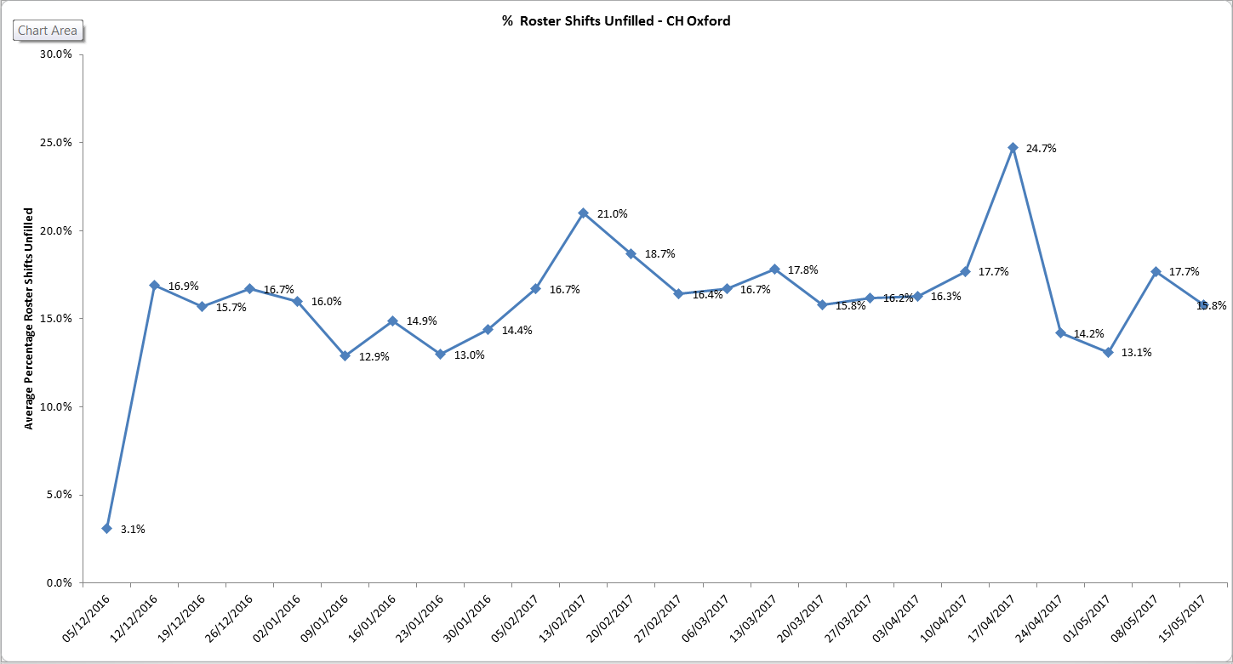

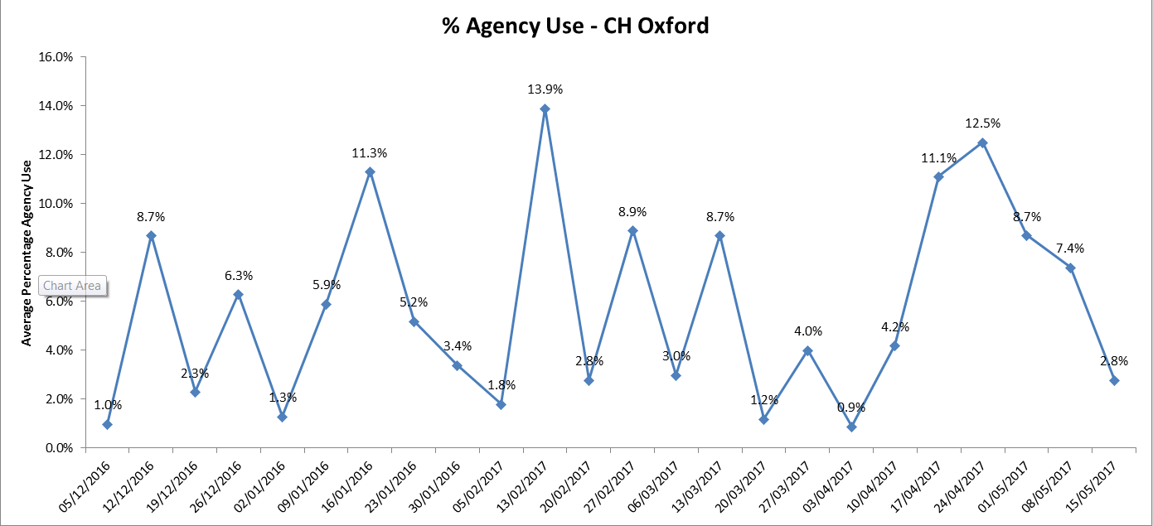

Adult Directorate
Forensic Services
Chaffron Ward: overall 80.5% of shifts on Chaffron ward were fully staffed, which is a decrease of 0.5% from the previous month, and sickness has decreased from 13.4% to 9.6%. During the reported period there was no use of agency cover.

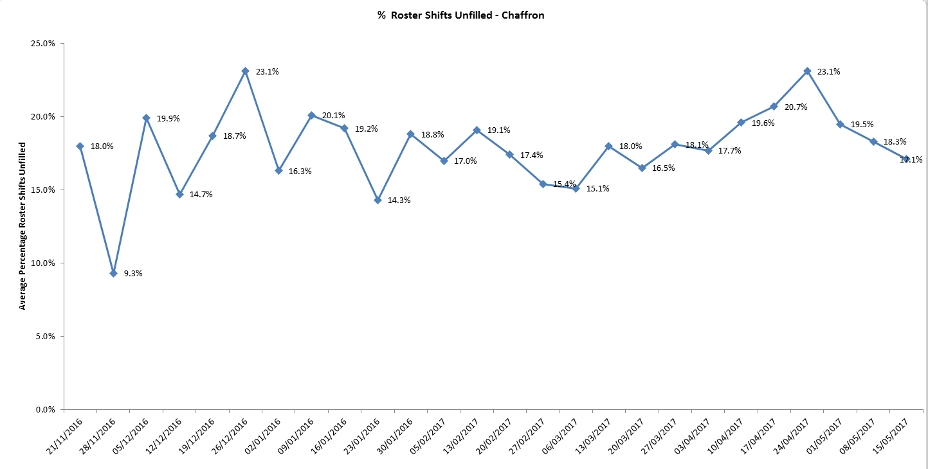

Glyme Ward - overall 81.2% of shifts were fully staffed, which was a 0.5% increase from last month. The ward has used more unregistered staff (with 45.2% of shifts covered by registered nurses which is an increase of 2.5% in registered cover from last month). The ward currently has 4.4 WTE vacancies, and sickness is at 4.9%

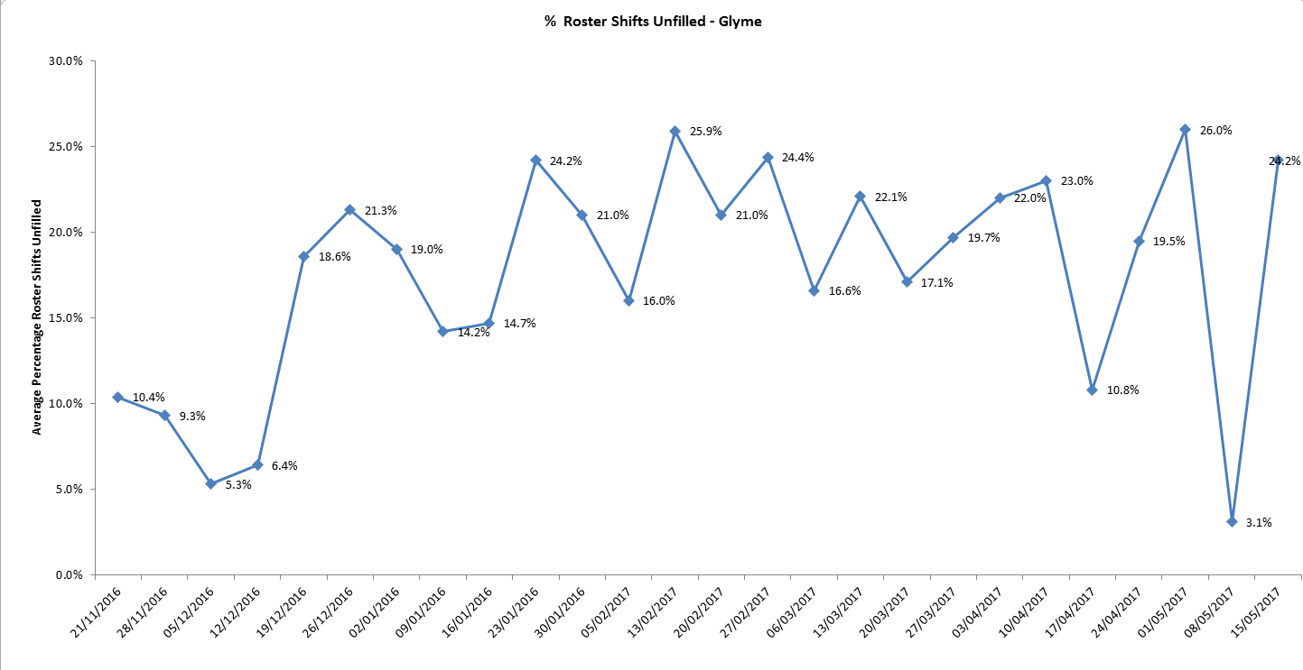

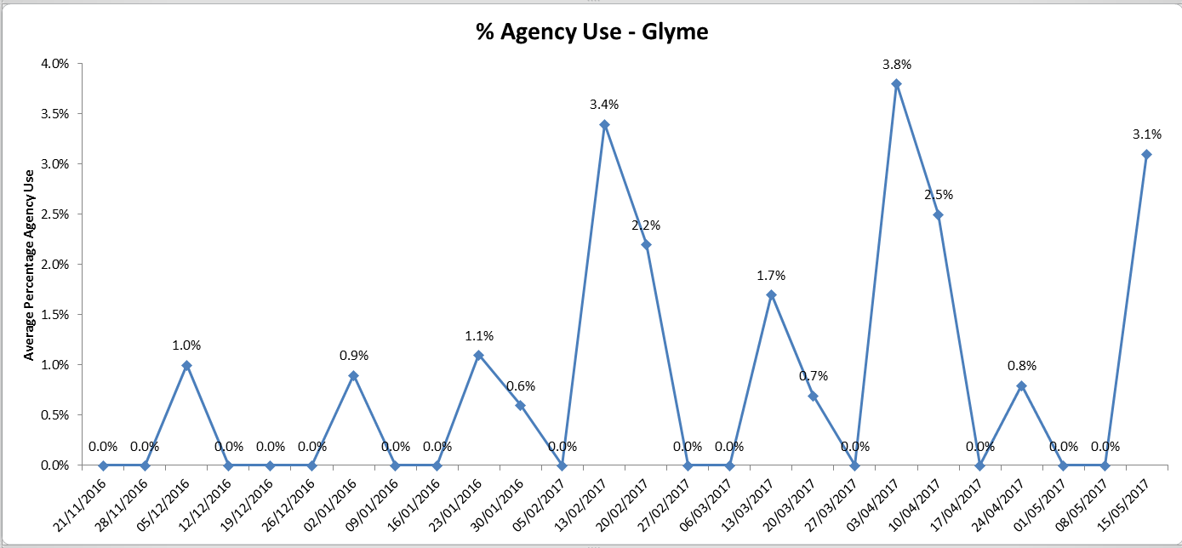

Phoenix Ward: overall 79% of shifts were fully staffed, a decrease of 0.4% % from last month. The ward used more registered to unregistered staff (with 53% of shifts having registered cover), and has employed some 15.5% average agency use, an increase of 6.6%. The sickness rate on Phoenix is currently 5.4% (which is an increase of 0.7% from last month), and the overall vacancies are currently 11.1 WTE (an increase of 2.3WTE from last month).

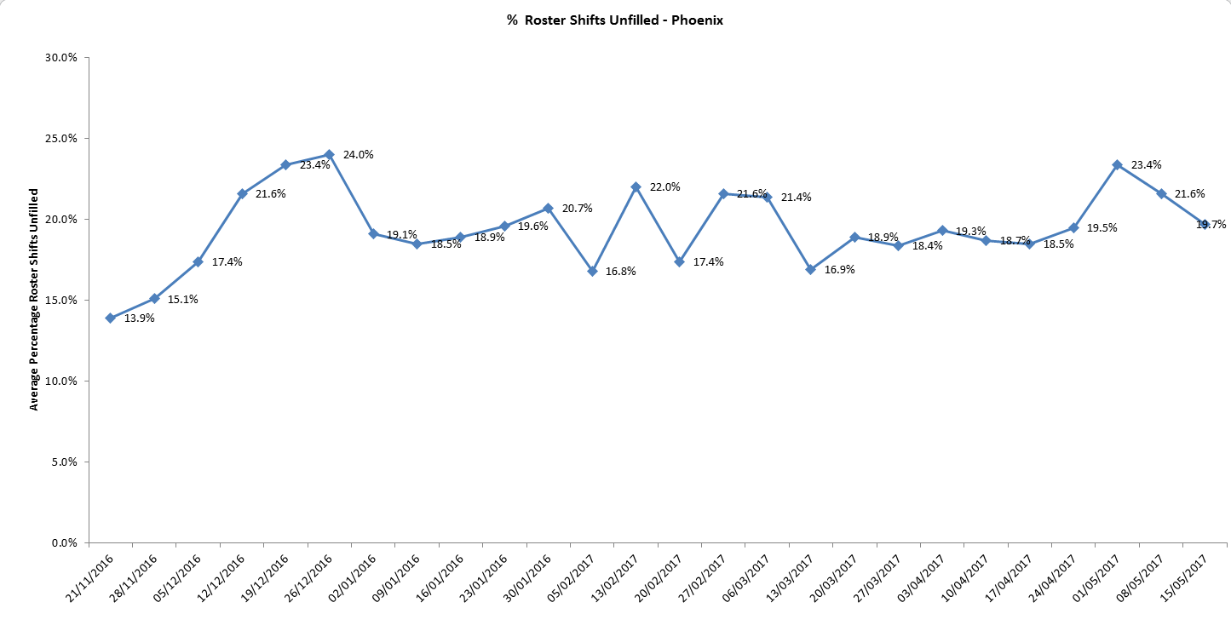

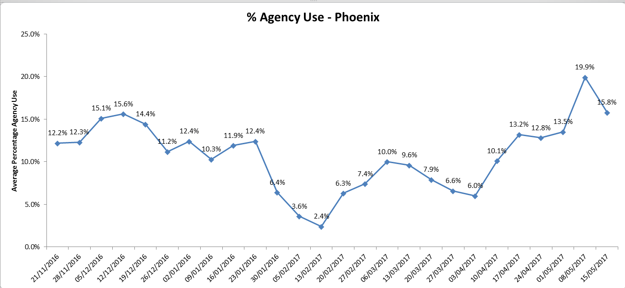
Vaughan Thomas Ward: overall 83.1% % of shifts were fully staffed – an increase of 8.6% from last month. The ward has used more unregistered to unregistered staff (with only 40.8% of shifts meeting the aspired 50% registered to unregistered ratio – a reduction of 2.1%). The ward has employed nurse agency cover (25.2% average agency use – an increase of 4.5%) and currently has 14 WTE vacancies.

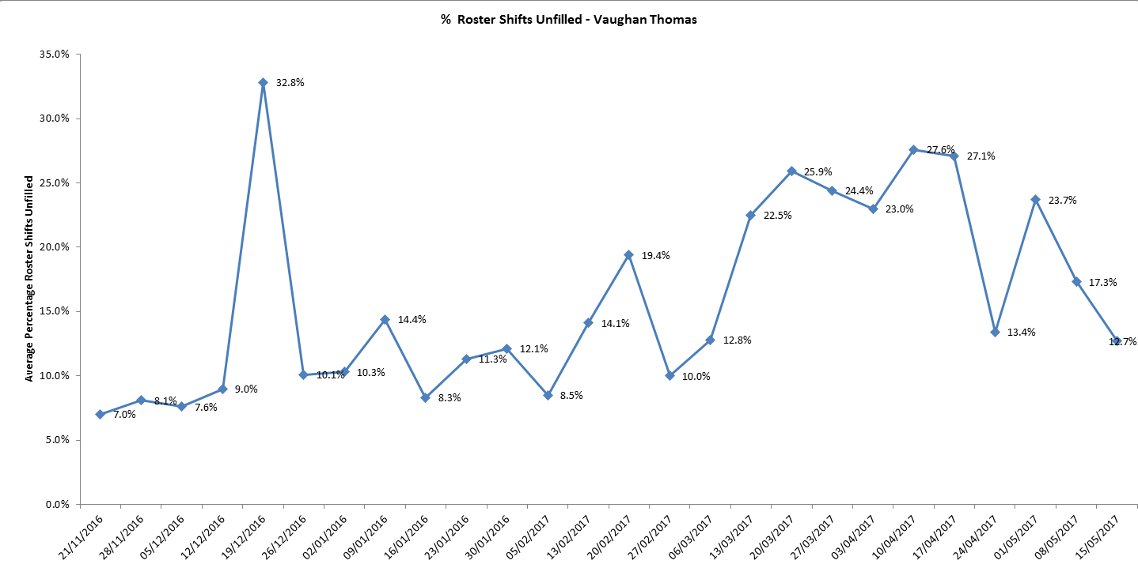

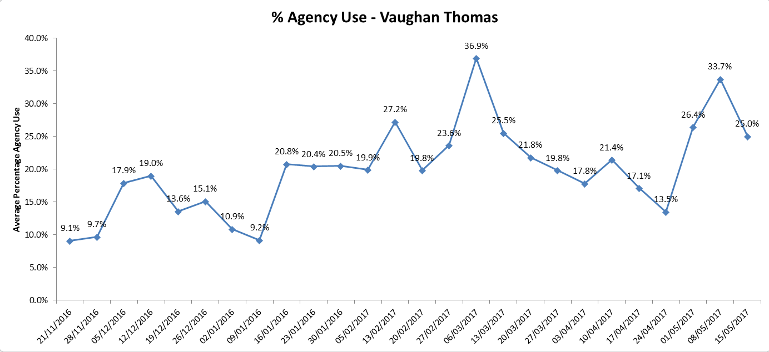

Older Adult Directorate

Sandford Ward: The overall number of shifts which were fully staffed was 78% which is a reduction of 4.8% from last month. The ward used more unregistered staff (with only 44.9% of shifts meeting the aspired 50% registered to unregistered ratio), and employed people on long working lines from agencies (19.2%).

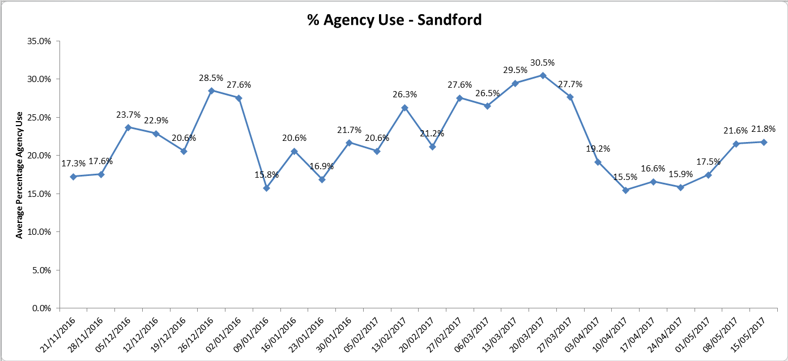

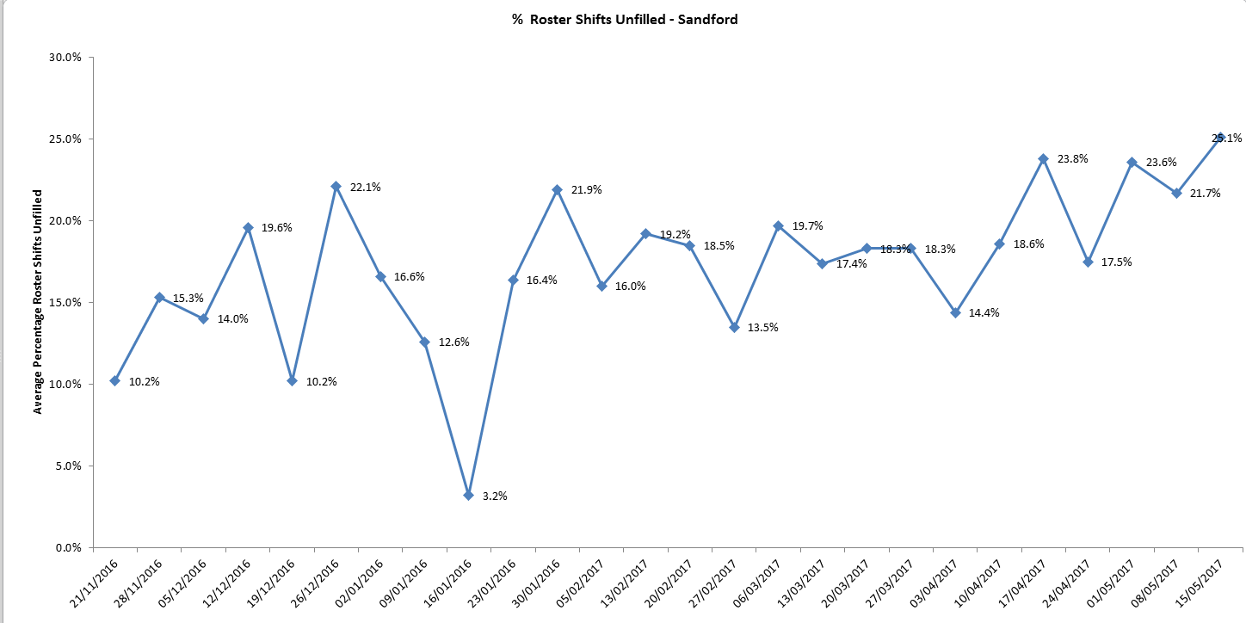

Threshold targets
There are agreed threshold targets for ward staffing levels. For agency usage the target is 5%, sickness 3.5% and vacancies 9%. Wards not mentioned above which are performing adversely against these targets are can be viewed in table 1.

The areas of highest concern are as follows:

- Allen ward - Agency use – 32.3% and 13.6 WTE vacancies
- Amber ward - sickness 12.6% (the highest percentage this month) and 10.8WTE vacancies
- Ashurst ward - Agency use – 26.8%, and 15.2 WTE vacancies
- Bicester Community Hospital –sickness 11.9%
- City Community Hospital - Agency use – 15.9%, sickness 6.1% and 7.7WTE vacancies
- Cherwell - sickness 8.1% and 3.6 WTE vacancies
- Highfield CAMHS –Agency use –27.3%, and 20.9 WTE vacancies (the highest number this month).
- Kennet ward - –Agency use –11.2%, sickness 6.1) % and 8.3 WTE vacancies.
- Kestral ward - Agency use –37.7% and 17.6 WTE vacancies
- Kingfisher - Agency use – 30.2%, sickness 8.5% and 13.4 WTE vacancies.
- Linfoot ward Witney - Agency use – 6.8%, and 10.2 WTE vacancies
- Marlborough House Swindon (CAMHS) - Agency use –16.6% and 7.4 WTE vacancies
- Opal Ward – 8.9 vacancies
- Ruby Ward - - Agency use –32.8% (highest percentage again this month), sickness 5.3% and 9.5 WTE vacancies
- Sapphire – Agency use – 24.7% and 10.9 WTE vacancies
- St Leonards Wallingford - Agency use –20.2%,
- Watling - Agency use –12.2%, sickness 6.1% and 13.1 WTE vacancies
- Wenric - Agency use –18.5% and 11.9 WTE vacancies
- Wenrisc Witney – vacancies 6.3 WTE.
- Wintle - Agency use –15.3% vacancies, 6.9% sickness and 8.8 WTE.
- Woodlands – Agency use –7.8%, sickness 6.9% and 4.4 WTE vacancies.

Recruitment

Last month there were a total of 285.2WTE vacancies across the 32 in-patient ward areas. This is a mean average of 8.9 vacancies per ward. Operational managers and working in partnership with HR in order to ensure a coordinated approach top recruitment and retention across the organisation. In addition an initial meeting has been held with the OUH in order to look at joint initiatives and approaches across the county.

.

Table 1. Staffing 27th March to 23rd April 2017

 | % of shifts filled against required numbers (highlighted amber if less than 85%)
 | Latest 4 week period - 24th April to 21st May 2017 | 4 week period - 27th March to 23rd April 2017 | 4 week period - 27th Feb to 26th Mar 17 |  | Latest 4 week period - April 24th to May 21st 2017
Ward |  |  |  |  | % Registered day shifts filled by nurses (submitted to NHS England) | % Unregistered day shifts filled by nurses (submitted to NHS England) | % Registered night shift filled by nurses (submitted to NHS England) | % Unregistered night shifts filled by nurses (submitted to NHS England) |  | % Registered Skill Mix (target 50% or more) |  |  |  | % Agency Use  (thresholds based on Trust targets, 5%) |  |  | % Sickness  (thresholds based on Trust targets, 3.5%) |  | Vacancies Vs Budget (WTE)  (thresholds based on Trust targets, 9%)
Abingdon Ward 1 | 97.7% | 99.4% | 93.7% |  | 72% | 89% | 91% | 93% |  | 52.7% |  |  |  | 10.7% |  |  | 8.5% |  | 6
Abingdon Ward 2 | 99.4% | 98.2% | 99.6% |  | 78% | 95% | 95% | 97% |  | 56.8% |  |  |  | 11.6% |  |  | 6.6% |  | 9.6
Allen | 91.3% | 91.6% | 94.2% |  | 100% | 91% | 100% | 96% |  | 38.7% |  |  |  | 32.3% |  |  | 5.5% |  | 13.6
Amber | 87.7% | 93.6% | 100.0% |  | 100% | 94% | 100% | 100% |  | 43.9% |  |  |  | 11.6% |  |  | 12.6% |  | 10.8
Ashurst (PICU) | 95.6% | 94.8% | 90.6% |  | 102% | 96% | 115% | 87% |  | 34.6% |  |  |  | 26.8% |  |  | 4.6% |  | 15.2
Bicester | 99.5% | 98.5% | 98.0% |  | 95% | 99% | 99% | 99% |  | 53.3% |  |  |  | 8.4% |  |  | 11.9% |  | 2.9
Cotswold House Marlborough | 93.9% | 94.5% | 97.0% |  | 100% | 95% | 100% | 100% |  | 50.5% |  |  |  | 6.4% |  |  | 0.4% |  | 7.2
Cotswold House Oxford | 84.8% | 81.2% | 83.3% |  | 103% | 93% | 100% | 98% |  | 41.9% |  |  |  | 7.8% |  |  | 5.0% |  | 5.2
Chaffron | 80.5% | 81.0% | 83.8% |  | 116% | 99% | 100% | 100% |  | 53.3% |  |  |  | 0.0% |  |  | 9.6% |  | 5.2
Cherwell | 85.9% | 91.1% | 89.7% |  | 99% | 96% | 98% | 99% |  | 45.5% |  |  |  | 8.1% |  |  | 4.5% |  | 5.6
City | 97.6% | 99.2% | 97.8% |  | 92% | 92% | 100% | 99% |  | 55.5% |  |  |  | 15.9% |  |  | 6.1% |  | 7.7
Didcot | 99.3% | 99.7% | 96.7% |  | 81% | 98% | 91% | 96% |  | 52.1% |  |  |  | 6.7% |  |  | 4.7% |  | 1.2
Glyme | 81.2% | 80.7% | 79.9% |  | 95% | 89% | 96% | 93% |  | 45.2% |  |  |  | 1.0% |  |  | 4.9% |  | 4.4
Highfield (CAMHS) | 86.9% | 85.1% | 85.6% |  | 89% | 89% | 91% | 98% |  | 35.6% |  |  |  | 27.3% |  |  | 2.4% |  | 20.9
Kennet | 95.1% | 97.2% | 99.4% |  | 64% | 116% | 100% | 100% |  | 34.6% |  |  |  | 11.2% |  |  | 6.1% |  | 8.3
Kestrel | 90.9% | 96.1% | 94.0% |  | 76% | 118% | 84% | 111% |  | 36.8% |  |  |  | 37.7% |  |  | 1.6% |  | 17.6
Kingfisher | 89.1% | 91.4% | 84.8% |  | 87% | 97% | 77% | 117% |  | 36.0% |  |  |  | 30.2% |  |  | 8.5% |  | 13.4
Lambourne House | 97.1% | 85.2% | 93.7% |  | 83% | 121% | 94% | 108% |  | 46.6% |  |  |  | 0.6% |  |  | 2.5% |  | 0.8
Linfoot Witney | 98.8% | 98.3% | 98.3% |  | 79% | 96% | 91% | 104% |  | 54.4% |  |  |  | 6.8% |  |  | 7.3% |  | 10.2
Marlborough House Swindon (CAMHS) | 95.2% | 97.4% | 97.7% |  | 111% | 84% | 122% | 91% |  | 50.6% |  |  |  | 16.6% |  |  | 3.0% |  | 7.4
Opal (Rehabilitation) | 95.8% | 95.3% | 93.1% |  | 99% | 85% | 109% | 91% |  | 48.7% |  |  |  | 3.2% |  |  | 3.3% |  | 8.9
Phoenix | 79.0% | 81.3% | 80.3% |  | 100% | 96% | 100% | 100% |  | 53.0% |  |  |  | 15.5% |  |  | 5.4% |  | 11.1
Ruby | 86.9% | 86.1% | 94.1% |  | 107% | 92% | 105% | 97% |  | 36.1% |  |  |  | 32.8% |  |  | 5.3% |  | 9.5
Sandford | 78.0% | 81.3% | 82.8% |  | 106% | 94% | 100% | 99% |  | 44.9% |  |  |  | 19.2% |  |  | 14.2% |  | 8.6
Sapphire | 99.5% | 80.1% | 74.7% |  | 64% | 101% | 81% | 99% |  | 41.0% |  |  |  | 24.7% |  |  | 2.7% |  | 10.9
Vaughan Thomas | 83.1% | 74.5% | 82.0% |  | 163% | 54% | 104% | 96% |  | 40.8% |  |  |  | 25.2% |  |  | 6.5% |  | 14
St Leonards Wallingford | 96.0% | 97.7% | 98.5% |  | 97% | 82% | 65% | 166% |  | 53.1% |  |  |  | 20.2% |  |  | 5.0% |  | 1.1
Watling | 87.4% | 85.9% | 86.1% |  | 103% | 97% | 102% | 99% |  | 32.4% |  |  |  | 12.2% |  |  | 3.8% |  | 11.9
Wenric | 86.8% | 89.4% | 93.8% |  | 102% | 91% | 129% | 86% |  | 38.3% |  |  |  | 20.0% |  |  | 8.9% |  | 10.2
Wenrisc Witney | 93.5% | 93.2% | 93.9% |  | 99% | 89% | 100% | 99% |  | 57.4% |  |  |  | 5.6% |  |  | 3.7% |  | 6.3
Wintle | 92.7% | 92.8% | 93.4% |  | 88% | 105% | 112% | 95% |  | 35.7% |  |  |  | 15.3% |  |  | 6.9% |  | 8.8
Woodlands | 98.0% | 98.1% | 98.9% |  | 98% | 99% | 100% | 100% |  | 43.9% |  |  |  | 7.8% |  |  | 6.9% |  | 4.4

Data source: electronic rostering system

