

**PUBLIC**

**Report to the Meeting of the Oxford Health NHS Foundation Trust**

**Board of Directors**

**BOD 07/2018**  
(Agenda item: 8)

**31st January 2018**

**Learning from Deaths**

**Executive Summary**

This is an interim report which follows the internal seminar held with board members in December 2017 and presentation to CQC inspectors in our routine relationship meeting in January 2018. A detailed quarterly report will be presented to board in February 2018. The interim report summaries; the governance in the trust around reviewing and learning from deaths, shares the trends from April 2014 to December 2017 including the % of deaths which have been reviewed through the SI process and by the coroner, and describes the themes coming from the reviews of deaths including the actions taken and planned.

There are no changes to the trends from previous quarters or an increase in the overall number of deaths. The majority of deaths are people aged 75 and above, who have been previously under the care of the district nursing service. The number of inpatient deaths has decreased from July 2015. The key themes for learning from the review of deaths are; i) physical health for patients with a mental health illness, ii) family engagement and communication, and iii) communication at points of transitions and changes in care between teams, services and organisations. The report shares the actions being taken around these themes.

Further developments will continue to be introduced to improve the effectiveness of how we learn from deaths.

**Governance Route/Approval Process**

The information has been reviewed by the Safety quality sub-committee.

**Recommendation:**

This report is submitted for information and assurance.

**Author and title:** Jane Kershaw, Head of Quality Governance

**Lead Executive Director:** Ros Alstead, Director of Nursing and Clinical Governance

1. Introduction

The diagram below summaries the governance structure and oversight in the trust around learning from deaths. The lead on mortality for the Non-Executive Directors is the chair of the trust’s quality committee and the lead Executive Director is the Director of Nursing and Clinical Standards. As part of the governance the board of directors receive a quarterly report on themes, trends and actions, the last report titled incident, mortality and patient safety report was published in October 2017.

The following is an interim report which follows the internal seminar held with board members in December 2017 and presentation to CQC inspectors in our routine relationship meeting in January 2018. A detailed quarterly report will be presented to board in February 2018.

Deaths in scope as defined up the trust’s policy[1] are reviewed weekly by the directorate mortality forums and the trust-wide clinical review meeting and these feed themes and learning into the bi-monthly trust-wide mortality review group which reports to the safety quality sub-committee. The trust-wide mortality review group is chaired by the Medical Director and includes governors as members, the group last met on 18th January 2018.



Figure 1.

A number of multi-agency forums have been developed to improve how providers can learn from deaths within a system or county. The trust participates in the following forums;

* Oxfordshire vulnerable adult mortality review group, focused on learning from the deaths of people with a learning disability
* Child safeguarding boards in each county, which review every child death as part of the national CDOP process
* Oxford University Hospitals NHS FT mortality and morbidity group
* New South regional mortality review group has been established facilitated by Oxford AHSN, the first meeting was held in December 2017.
* Multi-agency mental health homicide and domestic homicide reviews as appropriate.

Where the Trust identifies the need for a multi-agency review of a death and there is no established group to facilitate this, the details of the death are sent to the commissioner to facilitate a review.

1. Trends from April 2014 to December 2017

This report on trends is based on data taken from the patient information systems and the incident/ deaths reporting system.

The information includes;

* Deaths of current patients and those discharged from the trust but seen within the last 6 months prior to death
* Inpatient and community patient deaths
* Expected and unexpected death
* Natural and unnatural deaths

2.1 Trust-wide number of total deaths (current patients and discharged patients)

The overall number and rate of deaths has not changed over the period, apart from in January 2015, in line with the national trend. In January 2015 there was an increase in deaths for us as a trust and nationally due to a peak in flu activity predominantly affecting older people (figure 3). Nationally there is a recognised period from December to March each year called the ‘excess winter deaths’ period. Out of all deaths 0.6% relate to completed suicides (both suspected or following a verdict from the coroner).

On average 1.13% of patients who have received treatment have died (includes former discharged patients and also expected deaths).

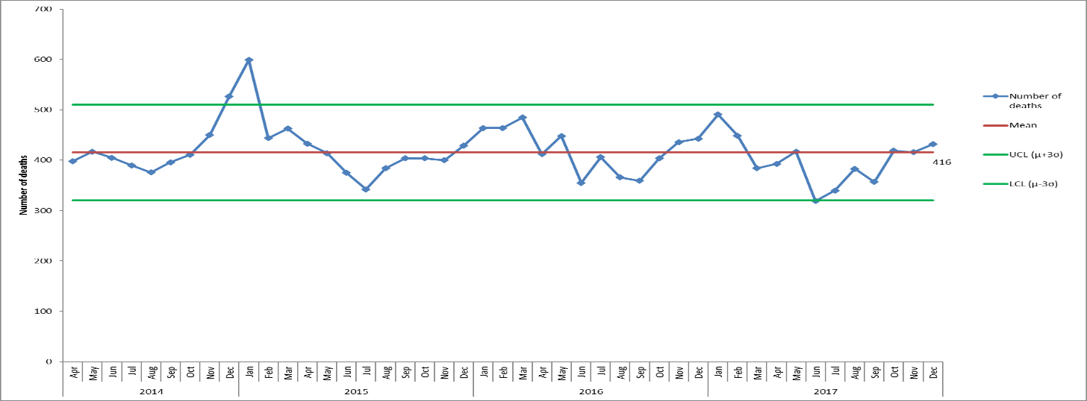

*Figure 2. Trust-wide deaths of patients with open referals and patients discharged but seen in the 6 months prior to death, April 2014 – December 2017. Data from carenotes, adastra and Ulysses systems.*

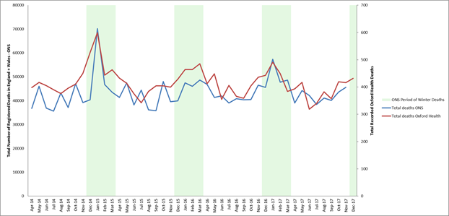

*Figure 3. Show seasonal trends in Oxford Health mortality data alongside seasonal trends in data on all deaths reported by the ONS (data ‘for England, Wales and Elsewhere’). Chart also shows the ONS periods of winter deaths.*

2.2 Trust-wide the number of total deaths by age (current and discharged patients)

No significant change across any age ranges. Majority of deaths continue to be for people aged 75 and above.

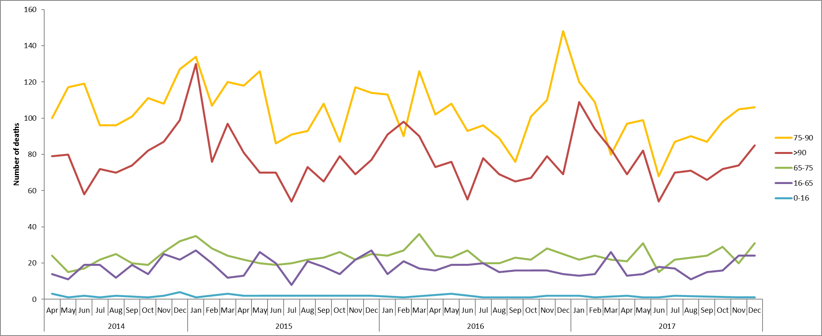

*Figure 4. Trust-wide the number of total deaths by age (current and discharged patients)*

2.3 Trust-wide the number of total deaths by service providing treatment (current and discharged patients)

No significant change across service types. The majority of people who die have received treatment by a physical health service e.g. district nurses.

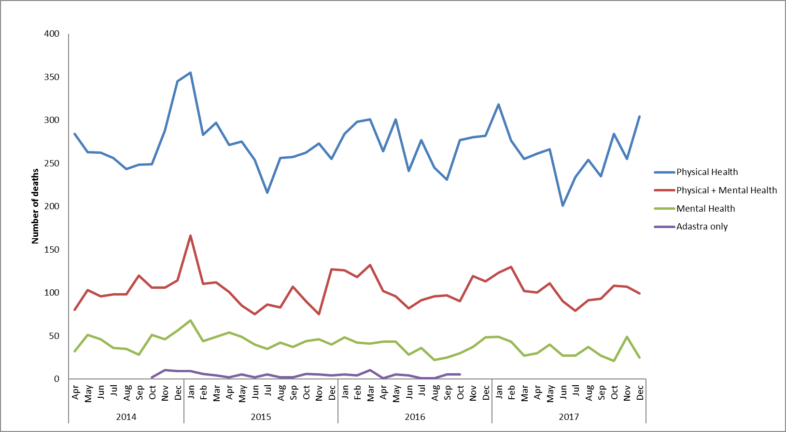

*Figure 5. Trust-wide deaths by service. Adastra = urgent care services.*

2.4 Trust-wide the total number of deaths split by current and discharged patients

Quarter 3 continues to show a possible trend in current patient deaths declining and discharged patient deaths increasing.

Looking at the discharged patient deaths, 38% were in the District Nursing service (n=261), and 13.8% (n=95) were in the Older People Mental Health service. Some of the increase relates to the Reablement Service being re-tendered and provided by another provider from 1st October 2016, therefore a number of patients were discharged. The Older People’s Mortality Review Group have carried out further analysis of the data for former patients who died within 6 months of being discharged from the trust and a snapshot qualitative audit of cases. No themes or concerns were identified in the care provided, with the majority of patients receiving end of life care.

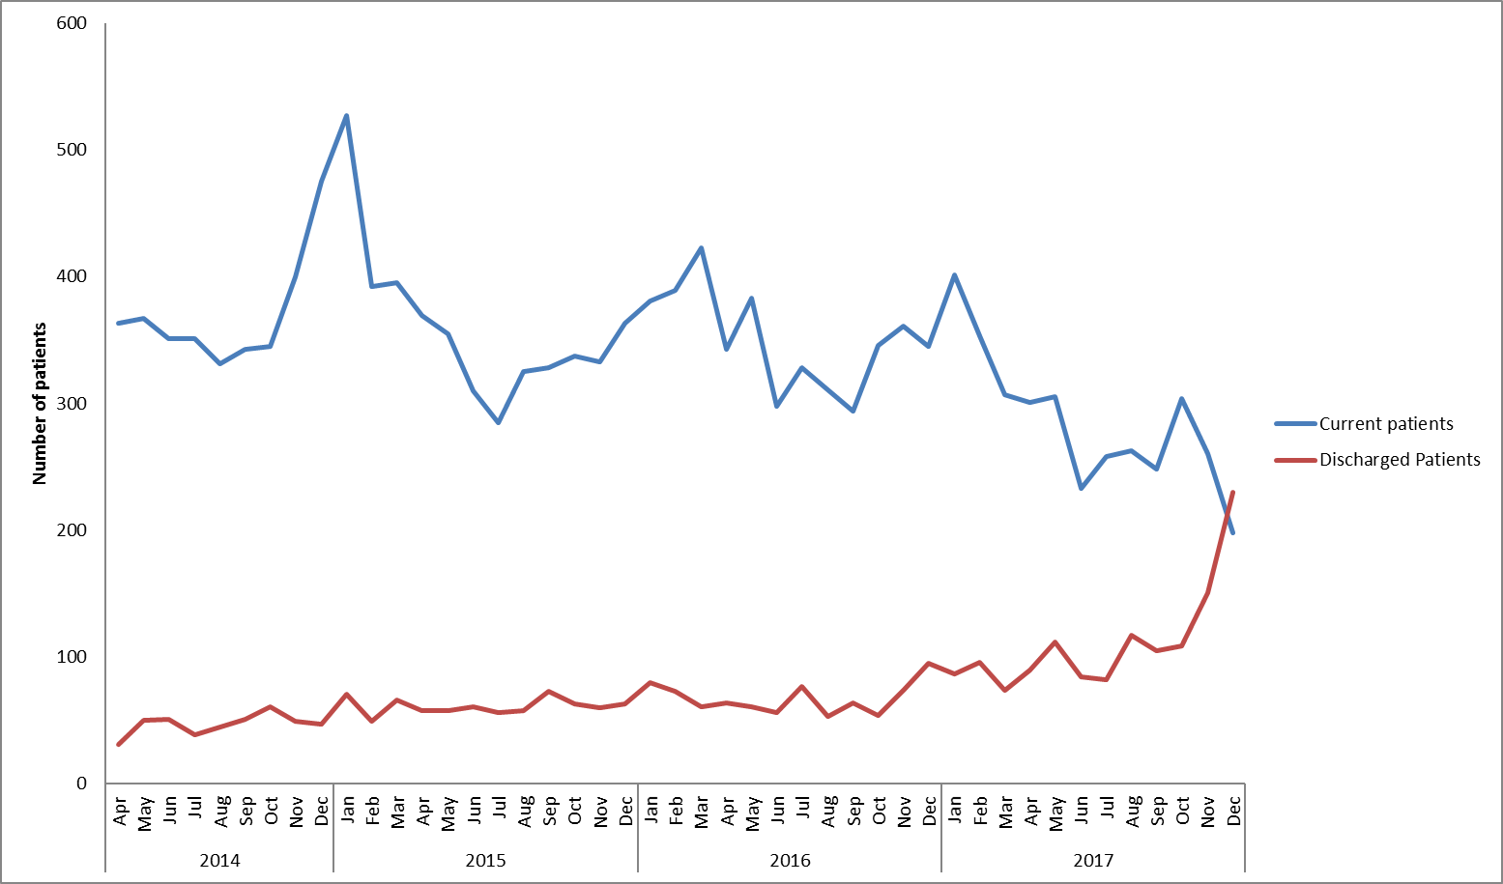

*Figure 6. Trust-wide deaths of patients with open referrals at time of death (current) vs discharged patients (seen within the 6 months prior to death).*

2.5 Trust-wide the number of inpatient deaths across all services (mental health and physical health)

The mean average for the number of inpatient deaths has deceased from July 2015. All unexpected inpatient deaths are reviewed.

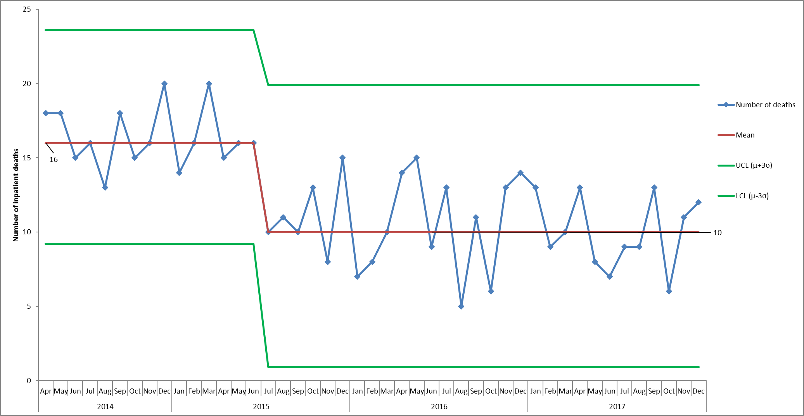

*Figure 7. Trust-wide numbers of inpatient deaths*

1. Reviews of deaths

The identification of deaths for current and former patients, as reported above, is reviewed regularly based on a check against a national register of deaths. This review includes inpatients and patients being supported in the community.

We implemented changes to how clinicians screen, report and investigate deaths from July 2017, these changes are all captured in the published policy. The scope of which deaths should be reported onto the incident/ deaths reporting system has been re-defined, therefore we have seen an increase in the number of deaths reported, reviewed and investigated. In 2017/18, 4% of deaths (current and discharged patients) have been reported onto the system for further review (this increases to 18% of deaths for mental health services).

Between April 2014 to December 2017 1.3% of deaths have met the SI criteria and a root cause analysis investigation has been completed. The coroner has held an inquest to review 0.9% of the deaths of patients known to the trust. On a weekly basis the trust-wide clinical review meeting triangulates and discusses complaints, serious incidents (SI), deaths and outcomes from coroner inquest meetings.

1. Thematic reviews

The following outcomes from thematic reviews have been presented to the trust-wide mortality review group;

* Themes from suspected and confirmed suicides (presented in Dec 2016)
* Themes identified from a review of SIs across adult mental health services (presented March 2017)
* Themes from mortality reviews for community hospitals (presented in May 2017)
* Inpatient deaths (presented June 2017)
* Review of deaths of people with a learning disability people within Oxfordshire who died between April 2011 - March 2015 (presented August 2017)

In addition, the following thematic reviews have been completed and presented to senior clinicians in workshops;

* Suspected and confirmed suicides (January 2017)
* Serious harm and deaths for people who were diagnosed with a personality disorder (August 2017)

Currently a thematic review is in progress looking at how children and adult services work together and share information. The draft findings have been reviewed and the final report is due in March 2018.

1. Emerging Themes

The themes emerging from the reviews of deaths are as follows with the actions being taken identified below.

| Theme | Actions being taken |
| --- | --- |
| Physical healthcare for patients with a mental health illness | Physical healthcare group  The trust-wide physical healthcare group reports to the effectiveness quality sub-committee which is leading on this work. There are also CQUINs around this theme for 2017/18.  A gap analysis has been completed against the CQCs standards on physical healthcare in mental health services. This identified a number of actions which have been taken in 2016/17, for example;   * Purchasing new equipment to carry out annual physical health checks for all patients on caseload * Developing a new patient handbook * Introducing a ‘my physical health assessment and plan’ * Implementing physical health clinics in each AMHT * The Clinical Practice Educators have developed and deliver mandatory training for all AMHT staff, with enhanced competency based training for nurses and OTs. * Physical health leads have been identified in each AMHT and adult/ forensic ward. Leads have completed a 4-day physical health skills training course. The leads meet 6 weekly. * The recording of physical healthcare information on the trusts electronic health record has been reviewed and amended; there are now only 5 forms available, all found in one area in the patient’s record. * Expanding the availability of Immediate Life Support training   Work plan for 2017/18  The analysis also identified further actions for 2017/18 including;   * RGN physical health leadership posts are being recruited to support the AMHTs and adult wards * Standardising the model of physical health clinics offered by AMHTs * Improving how inpatient discharge information is shared electronically and automatically with GPs * Improving how staff monitor identified cardio-metabolic risk factors * Continue the work led by the IAPT services as early implementer sites for better integrated pathways for people with a long term physical health * Develop and introduce an electronic MEWs form for the wards on CareNotes.   A modern matron with a lead for physical health in mental health started in January 2018.  New Strategy  A new physical health strategy linked to the work of the Five Year Forward View for Mental Health and the CQCs quality standards has been developed and is planned to be launched at a conference on 26th January 2018. The physical health strategy will be broader than for mental health services to include pressure damage, sepsis, falls, diabetes care, and public health elements related to MECC/ smoking cessation. |
| Family/ carer engagement and communication | Strategy  The ‘I Care, You Care’ (carers) strategy is focused on improving this issue. A new role, carers lead has been recruited and the person is due to start at the end of February 2018 to lead on the implementation of the above strategy.  Triangle of Care accreditation  The Trust continues to work towards achieving a third star in the Carers Trust triangle of care accreditation (we currently have two stars awarded). The teams continue to complete self-assessments against the national carer standards and be peer reviewed by the Carers Trust. The last peer review was in Dec 2016.  Commitment to carers  The Trust has also worked with other organisations and carers in Oxfordshire to co-produce a ‘commitment to carers’ similar to a charter to be clear with carers and staff the standards expected. The commitment is planned to be launched by March 2018. |
| Communication at points of transitions and changes in care between teams, services or organisations | Transition development group  The terms of reference for the Trust’s transition development group have been widened to include clinical and managerial representatives from adult mental health services, adult social care and third party organisations. The group has developed an improvement plan based on the results of two audits one in 2016/17 and one in 2017/18. The quarterly audit has been continued to monitor the impact of the improvement plan.  The transition development group oversees the improvement plan but also reviews disputed cases escalated by clinicians, for review, analysis and learning to determine if appropriate decisions were made with regards to on-going needs of a young person.  Improvement plan  The improvement plan includes;   * Review of the Trust’s transition protocol * Review of incident and complaint data to identify learning * Introducing a new quarterly audit of all young people transitioned * Developing a link in with the county council to review the transition pathway for social care * Improving information on web forums, new CAMHS website for example, regarding transition, third sector organisations and provision. * Developing relationships with new partners in new Oxfordshire CAMHS model and in particular transition planning for those young people not transitioning to adult mental health teams * Linking with the college nurses to get a joined up approach to engage them with young people who may be in their colleges and transitioning   The above work is also supported by a national CQUIN in 2017/18 focused on improvements to the experience and outcomes for young people as they transition out of Children and Young People’s Mental Health Services (CYPMHS) into Adult Mental Health Services (AMHS).  HSIB  In addition, the Trust has been working voluntarily with the Healthcare Safety Investigation Branch (HSIB), around transitions following a death, to ask for their expertise to identify improvements and learning from elsewhere in the country and internationally. A preliminary scoping investigation has been completed with findings reported back in November 2017. HSIB considered there was a potential for national learning so a full investigation has been started. An interim bulletin about the decision to move to a full investigation is due to be published at the end of January 2018.  Thematic review  As mentioned above, the trust has almost completed a thematic review around joint working and information sharing between adult mental health teams and children’s services. |

Table 1.

1. Serious Incident (SI) Reviews

In quarter 3 of 2017/18, 14 SIs[2] have were identified and reported, of these 1 was subsequently downgraded. Of the 14 reported SIs in quarter 3, 9 involve a death of which 4 are suspected or confirmed suicides. In total in FY 17/18, 52 SIs have been identified and investigated and 13 of these have been downgraded as no omissions have been identified in the care provided. The trust is developing a suicide prevention strategy and is also involved in the system-wide Oxfordshire and Buckinghamshire public health suicide prevention plans.

There has been a reduction in the number of confirmed SIs over the last 3 years (figure 8) as a result of improvement work particularly around pressure damage and self-harm.

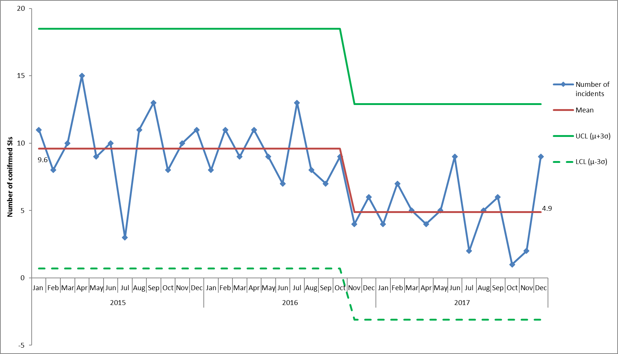

*Figure 8. Monthly numbers of confirmed serious incidents, January 2015 – December 2017*

The overall themes and learning from the SIs reviewed are;

* Challenges with staffing levels and use of temporary staff which has a negative effect on the continuity of care for patients and the morale of remaining staff.
* Variable completeness of documentation e.g. assessments, MEWS, care plans
* Essential checks are not always being completed e.g. environmental checklists
* Physical health care needs to be more routinely reviewed and monitored in mental health (see table 1 above for actions)
* Vulnerability at points of transition between teams, with private providers (see table 1 above for actions)
* Information around changes in risk is not routinely communicated between members of the same team or with other teams (see table 1 above for actions)
* Permission to share appropriate information with family and carers is not sought frequently and is often not documented (see table 1 above for actions)

1. Never Event

The trust has reported a never event in relation to the circumstances surrounding the death of a disabled child at their home in November 2017 who was receiving support from the children’s integrated therapies service. An internal investigation has started and an independent investigation is being commissioned to consider whether the death was associated with a known risk around the use of a particular bed. The trust took immediate actions following the incident to ensure the safety of other children. We have informed the CCG, NHS England and the CQC of the never event and the actions we have taken so far.

1. Conclusion

The interim report summaries; the governance in the trust around reviewing and learning from deaths, shares the trends from April 2014 to December 2017 including the % of deaths which have been reviewed through the SI process and by the coroner, and describes the themes coming from the reviews of deaths including the actions taken and planned.

Further developments will continue to be introduced to improve the effectiveness of how we learn from deaths.

1. The policy is published at - <https://www.oxfordhealth.nhs.uk/wp-content/uploads/2017/09/FINAL-Policy-for-reporting-and-learning-from-incidents-and-deaths-including-serious-incidents-V3.pdf>
2. Serious Incidents are nationally defined as incidents where there were acts or omissions identified in care that resulted in death, lead to abuse or serious harm requiring further treatment