

# Report to the Meeting of the

**BOD 149/2017**

(Agenda item 10)

# Oxford Health NHS Foundation Trust

# Board of Directors

# 29th November 2017

# INPATIENT SAFER STAFFING Staffing 11th September to 5th November 2017

**For: Information**

**Executive Summary**

**Introduction**

The purpose of this paper is to provide a report of the actual staffing levels to the Board of Directors. There is a national requirement on providers to be transparent on our monitoring and reporting of in-patient staffing levels. Ensuring sufficient staffing levels are in place is crucial to deliver safe, effective and high quality care.

The data within the report will outline the staffing levels (for both registered and unregistered nursing staff) on each ward. These figures will be measured against the required figures on a shift by shift basis for the 8 week period 11th September to 5th November 2017.

The paper will also provide information in relation to:

* Evenlode staffing levels
* Staffing establishment review
* Rollout of the Safe Care acuity and demand data collection module on Health Roster.
* OHFT’s involvement in NHSI Carter 90 day rapid improvement programme with the aim of improving efficiency and productivity of e-rostering by ensuring the right staff are in the right place at the right time to align with patient needs.

**Recommendations**

The Board is asked to note:

* The processes in place to ensure safe staffing levels on all the wards in the organisation, those wards where there are concerns and the actions being taken to ensure safe staffing including project work and wider recruitment and retention work.

**Author and Title:** Kate Riddle, Interim Deputy Director of Nursing and Clinical Standards

**Lead Executive Director:** Ros Alstead, Director of Nursing and Clinical Standards

*A risk assessment has been undertaken around the legal issues that this paper presents and there are no issues that need to be referred to the Trust Solicitors. This paper links to all of the five CQC Domains.*

**Inpatient Safer Staffing**

Period: 11th September to 5th November 2017

**Introduction**

This is the report to the Board of Directors outlining the staffing levels (registered and unregistered) on each ward against their required need on a shift by shift basis. This report covers the 8 week period: 11th September to 5th November 2017.

In addition, there is information about other work that is in progress in relation to staffing:

* Evenlode staffing levels
* Staffing Establishment review
* Roll of Safe Care acuity and demand data collection module on Health Roster.
* Trust involvement in NHSI Carter 90 day rapid improvement programme with the aim of improving efficiency and productivity of e-rostering by ensuring the right staff are in the right place at the right time to align with patient needs.

This report will be published on our website with a link from NHS Choices website.

**Management of Staffing Levels**

Anescalation process for the management of staff shortages is in place within each clinical area, in order to manage staffing safely on a shift by shift basis. As part of this process, senior clinical staff are providing appropriate support to ward teams as and when required. In addition, senior ward staff and immediate team managers’ review ward staffing levels on an on-going basis; shift by shift basis, and where there are changes in patient acuity. Ward Matron’s review staffing daily as a minimum and more frequently where required.

In-patient staffing levels continue to be reported every week and discussed within the Weekly Review Meeting (WRM), which takes place each Monday morning. Appendix 1 in the body of the report summarises the staffing position for the reporting period.

In order to ensure that staffing levels are under continual review, every ward undertakes a range of immediate actions on a daily basis to ensure safe staffing levels are maintained appropriate to the needs of patients. These actions include booking staff via staffing solutions via bank or agency, revising rotas, moving staff between wards and utilising additional staff that are not include in the ward numbers as required.

**Summary position of inpatients wards staffing levels.**

Appendix 1 shows the staffing levels for all wards by ward for the time period 11th September – 5th November 2017, together with figures for the previous 4 week period. The data presented includes details of staffing by shifts and also details of skill mix, agency, sickness and vacancy figures. The thresholds presented in the table are measured against trust/ national targets and used to highlight particular wards for further review.

During this period:

9th October – 6th November - Thirty wards had 85% or above of shifts filled against required numbers.

11th September – 8th October - Twenty nine wards had 85% or above of shifts filled against required numbers.

Two wards Sandford and Vaughan Thomas were below 85% throughout the reporting period but fill rates have improved to 81.7% and 84.5 respectively.

Unfilled shifts rates are slowly improving from a peak of 10.9% to 7% week of 6.11.17

Average sickness remains above Trust target of 3.5%.

The average % agency use has decreased in the second period of reporting to 15.8% but remains above Trust target of 5%.

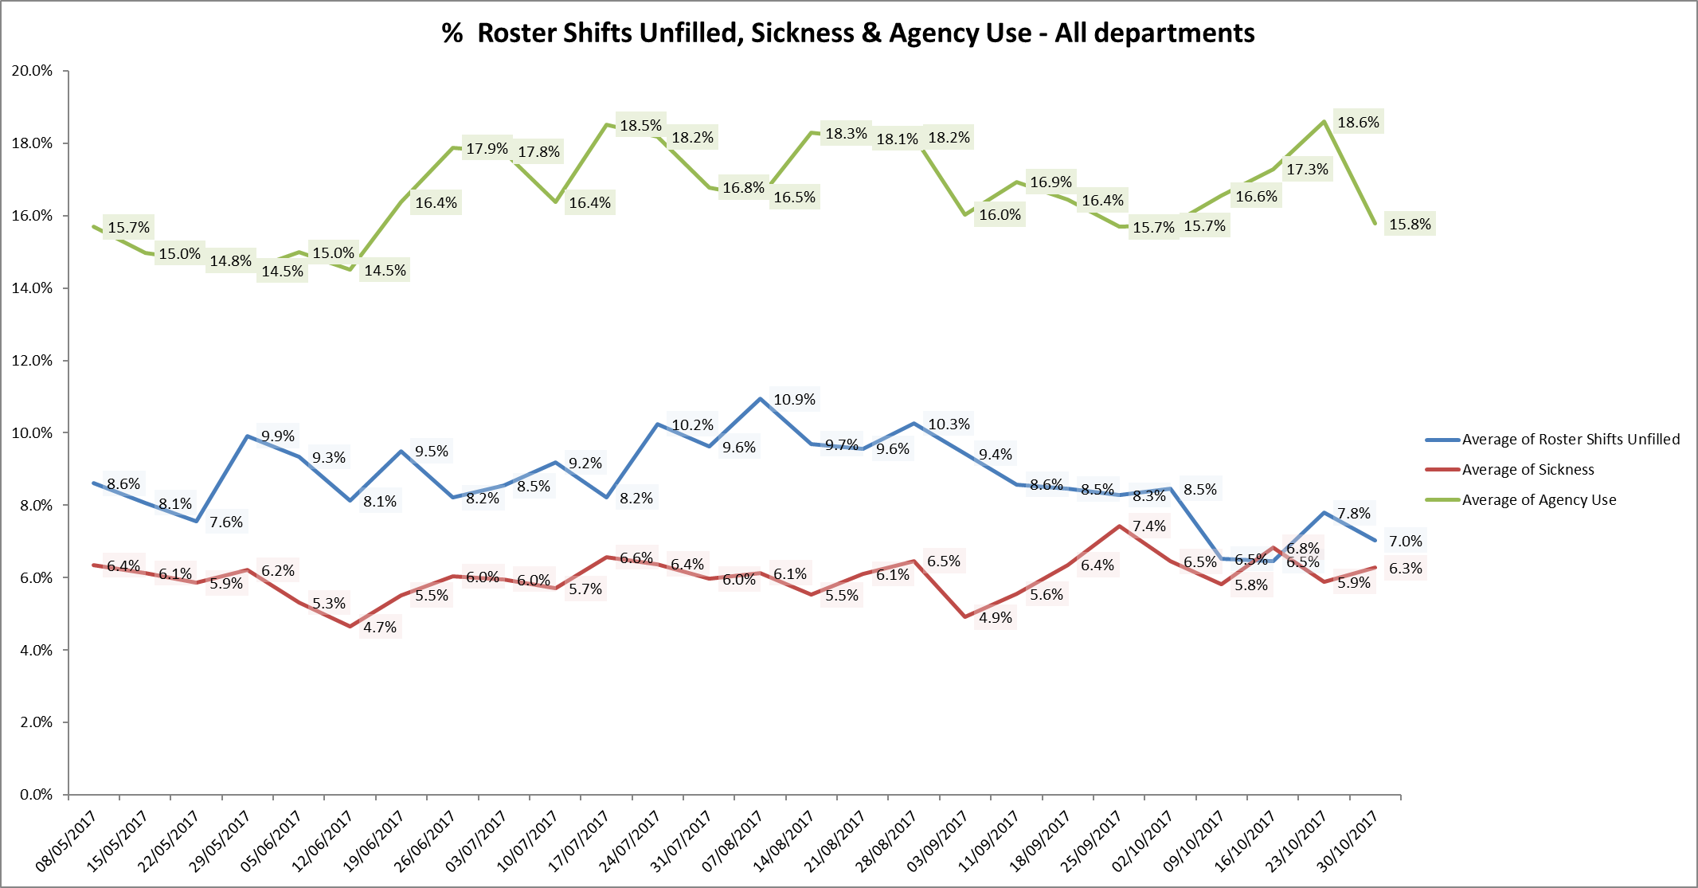

**Registered skill mix**



For this reporting period nine wards had in place 50% registered staff skill mix, compared to four wards for the previous period 14th August -10th September.

The remaining twenty three wards are all below 50% with six wardsbelow 35% for registered nurse as follows:

* Ashurst 23.3% down from 28.8%
* Allen 29.9% down from 46.8%
* Ruby 31.3% down from 35.2%
* Highfield 34% up from 33.2%
* Kennet 33.7% up from 32.5%
* Cotswold House Oxford 34.1% down from 34.4%

This relates to continued registered nurse vacancies. The Trust recruitment and retention work continues with the ‘Work with us’ and ‘Bank with us’ programmes plus more focussed work with student nurses to have job offers in place prior to qualification. This includes offering flexible workers contracts to students.

Further work has commenced to review the skill mix staffing on mental health wards to include development of new roles to support inpatient staffing.

More detail on key wards with high % above threshold targets is included in the charts below.

**Adult Directorate wards**

**Allen ward**

Agency use increased over the eight-week period peaking at 45.3% this relates to continued staff vacancies with 15.7% WTE vacancies.

Fill rates have improved overall but fill rates for registered nurses on day shifts is at 78% for the period 9th October – November 6th. and sickness levels are low at 1.5%.

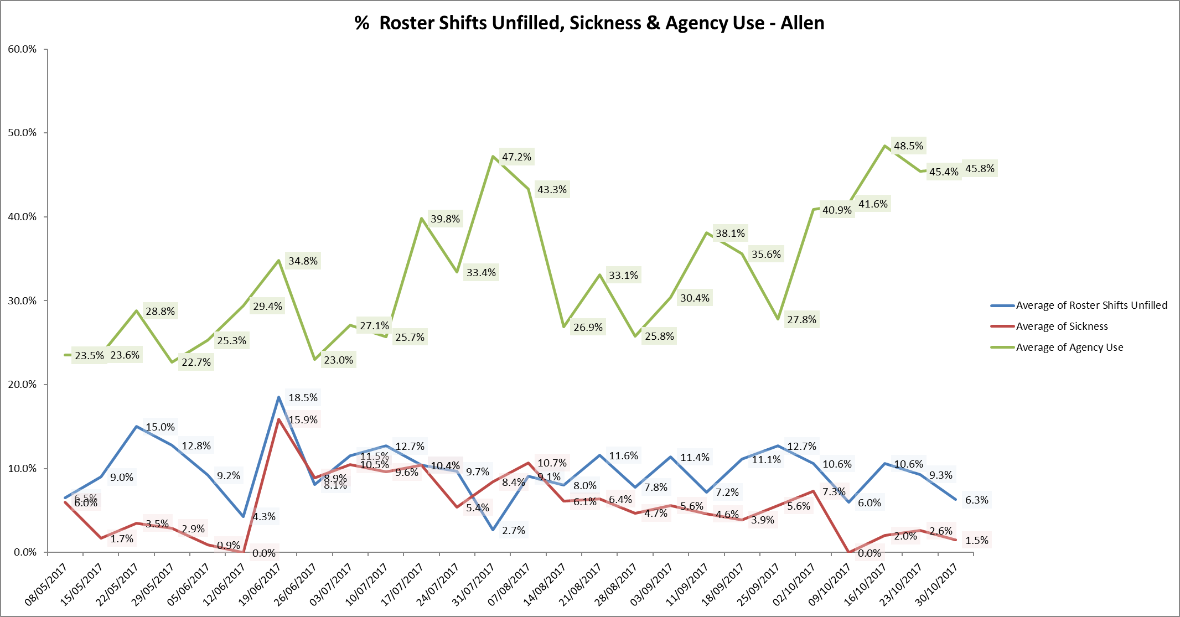

**Ashurst ward**

There has been a significant increase in agency use over this reporting period from 11/09/17, however Registered nurse fill rates for the period 9th October to 5th November were 60% of required numbers. The need for agency use relates to a combination of staff sickness now at 7.9% and a vacancy figure of 15.7 wte. Registered nursing skill mix is at 23.3%. this is the lowest % across the inpatient wards.

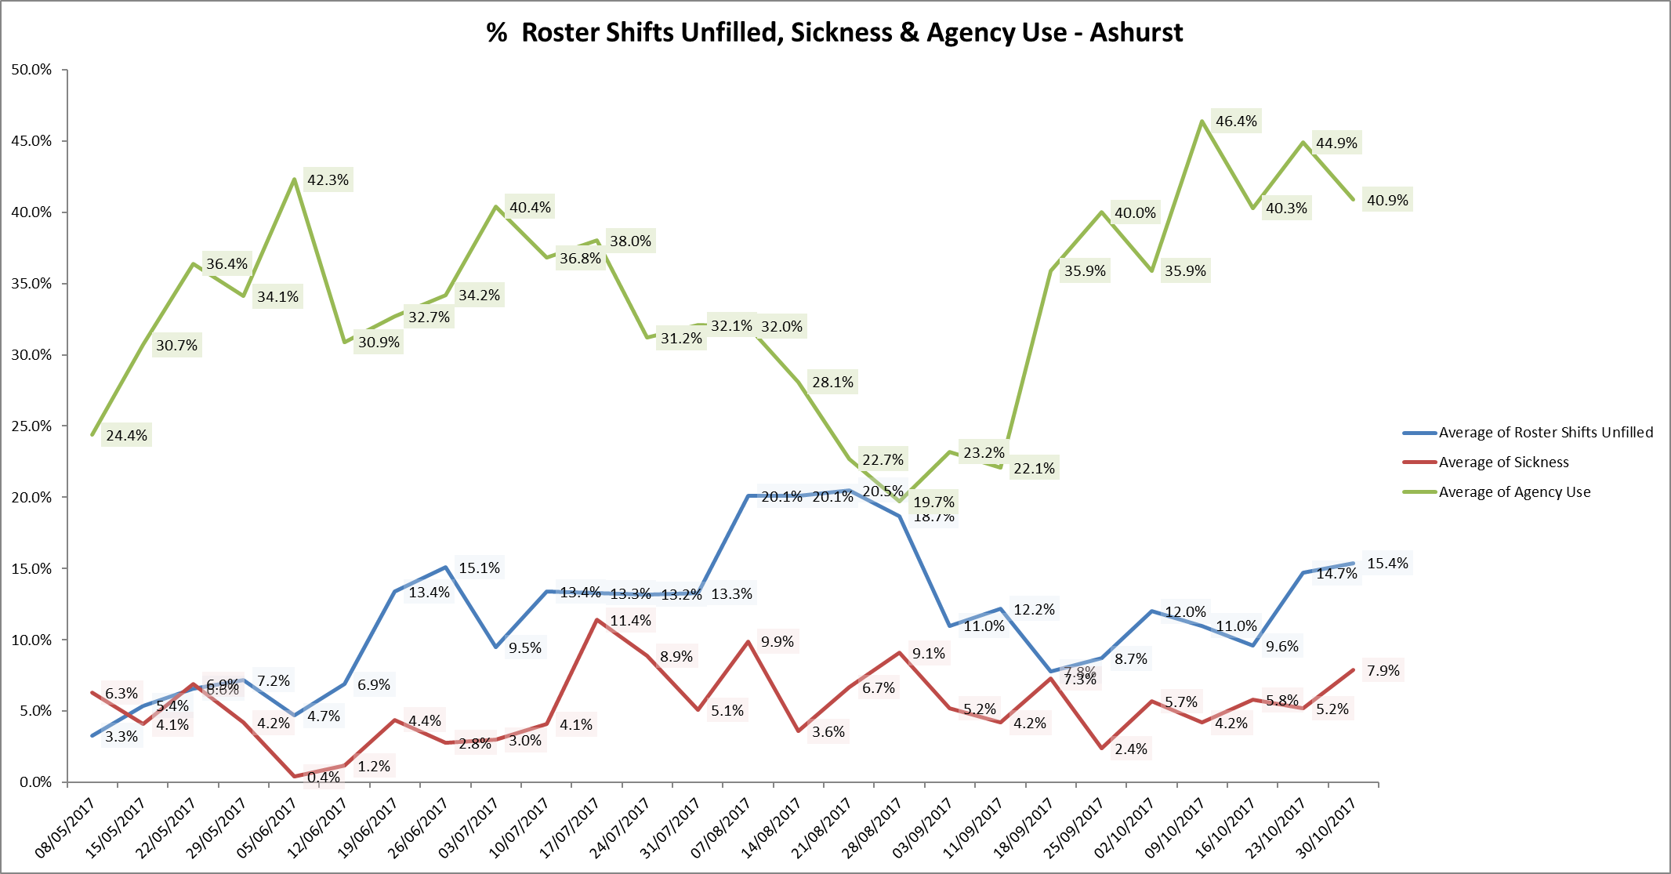

**Ruby ward**

The agency use has risen throughout this period peaking at 55.6% with a same reduction to 53.2% at the end of the period. Registered nursing skill mix is at 31.1%, sickness is 6.1% and vacancies are 12.7 WTE.

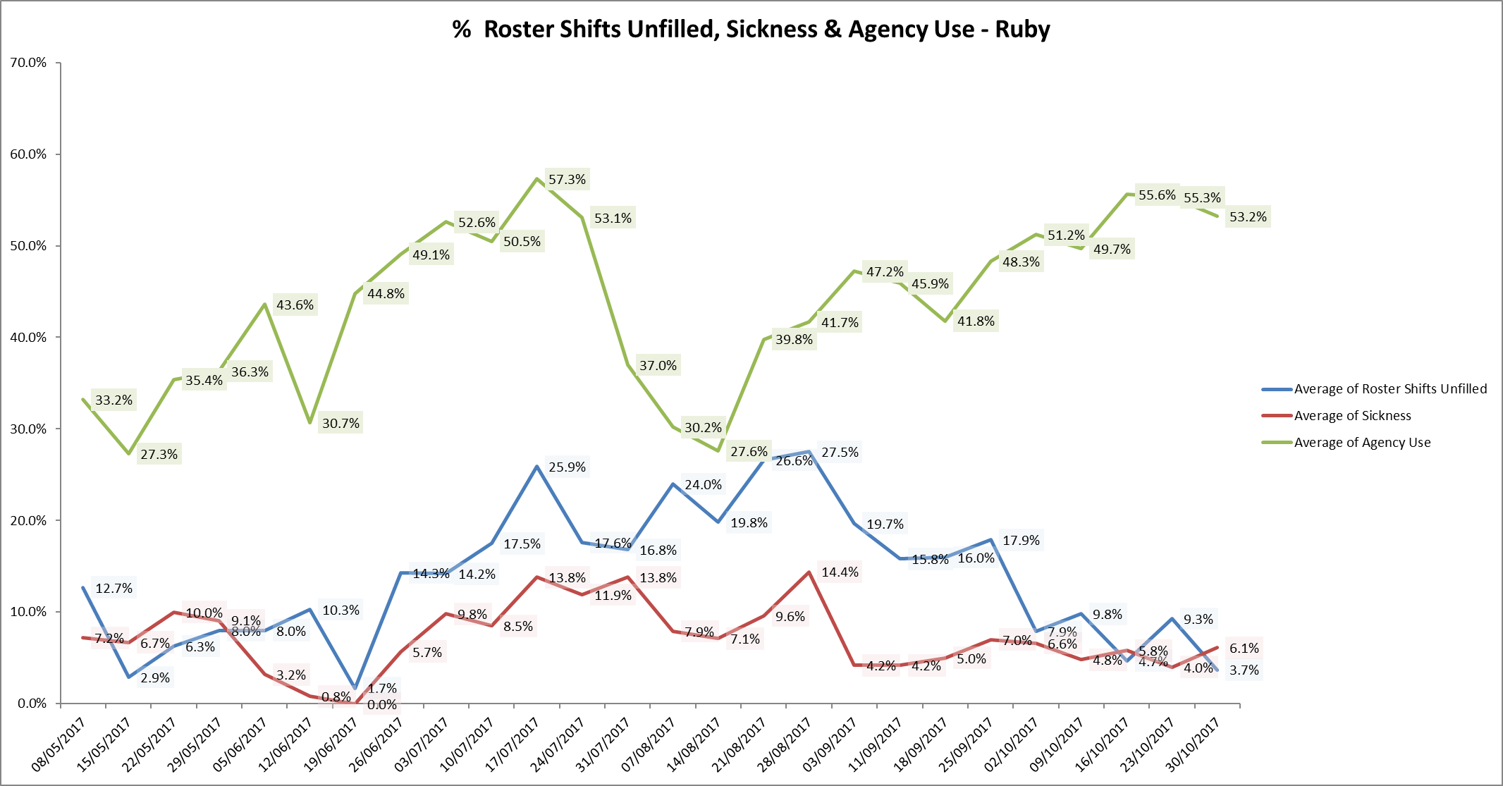

**Forensics**

**Kestral Ward**

Agency use peaked at 43% and has decreased to 30.2% at the end of the period, sickness has increased to 12.9% but overall fill rates are being maintained above 85%



**Children and Young Peoples Services**

**Highfield Unit**

There is a national shortage of CAMHS beds particularly PICU beds which has resulted in patients being cared for Tier 4 beds for prolonged periods whilst awaiting PICU beds. This is on the Trust risk register and has been escalated to NHSE.

High agency use within Highfield is linked to level of patient acuity, HDU staffing requirements and high level of staff vacancies (35.6% WTE), sickness has increased to 4.6% at the end of the period.

In order to manage safe staffing levels and maximise staff retention, the ward has been closed to admissions since 2.11.17.



**Evenlode**

There have been no escalations about concerns with staffing levels in the reporting period. Evenlode are going onto the Work Force Management system this month so going forward reporting will have the same level of information as for other units and there will be acuity data to inform future staffing.

**Staffing establishment**

Staffing levels on inpatient wards have been reviewed against patient acuity and bed numbers. Details by ward are provided in the chart below. This has led to some minor changes in staffing levels and skill mix which have been reviewed and agreed by the heads of nursing and service directors. A bi-annual process for reviewing and agreeing planned staffing levels and budgets across all areas of the Trust including inpatient areas has been agreed. The next review will take place in December 2017 and January 2018 taking effect from 1 April 2018.

**Safe Care project roll out update**

**Current status**

There is a rolling programme to train staff on inpatient units and 29 wards are now live collecting patient acuity census data, inputting this into Safe Care and updating their staffing information through Safe Care. There are three adult wards to go live.

The data is starting to be reviewed by the Heads of Nursing to monitor census completion, acuity levels and will inform safer staffing reports once robustly embedded in practice.

**NHSI Carter 90-day Rapid Improvement Programme update**

Oxford Health is one of 23 Trusts participating in a 90 day rapid improvement programme with the aim of improving efficiency and productivity of e-rostering by ensuring the right staff are in the right place at the right time to align with patient needs.

Our improvement aim is to improve roster approval and publication times supporting our staff to plan their work and home life.

Through the improvement of rostering practice, it is anticipated over time that the following benefits will be gained:

* Increased staff satisfaction and well-being by:
  + Ensuring the right staff are in the right time reducing work related stress.
  + Staff knowing sufficiently in advance their working arrangements enabling them to plan their home life.
  + Reducing levels of agency staffing and increasing levels of substantive employees and bank workers who are familiar with the units and ways of working making easier for all on the shift.
  + Where possible meeting the flexible needs of our staff.
  + Consistent management of working hours across all staffing groups.
* Increased patient and carer’s satisfaction by ensuring staffing levels meet patient demand.
* Improved efficiency and savings through:
  + Better management of unavailability and hours worked.
  + Better management of demand versus staffing levels.
  + Reduced agency use.

Work to date includes

* All inpatient units have been sent the Roster Building Guide and Roster Approval checklist.
* Roster review meetings have taken place with CYP wards and Older Adults. Dates are schedules with Adult and Forensic wards. Staffing Solutions team are supporting these initial meetings.
* The Staffing Solutions team will be working in a detailed way with 3 units to identify if further improvements in roster building can be achieved with increased support including improved auto rostering or self rostering if required. This work has started with Didcot ward.

In terms of impact there has been an increase in the lead time for publication with Roster publication at 6weeks

25/107 rosters of week 9/10/17

30/107 rosters of week of 6/11/17

56/107 rosters of week of 4/12/17

Lead time shifts sent to bank before worked has increased slightly which enables bank staff to be sourced earlier.

Overall potential cost savings to be calculated and reported in January 2018.

Appendix 1Inpatient Safer StaffingPeriod: 11th September to 5th November 2017

**See separate worksheet BOD 149ii/2017**