BOD 24/2018
(Agenda item:6)

Report to the Meeting of the

Oxford Health NHS Foundation Trust

Board of Directors

28th February 2018

Monthly Performance Report – M10 January 2018

For: Information

Executive Summary

The monthly performance report provides an overall view of the Trusts performance against both national and locally contracted indicators. In January, the Trust met 827 of 927 (89%) of the performance indicators. Although the number of indicators reported each month varies due to a number of factors, Oxford Health continues to achieve 90% compliance overall.

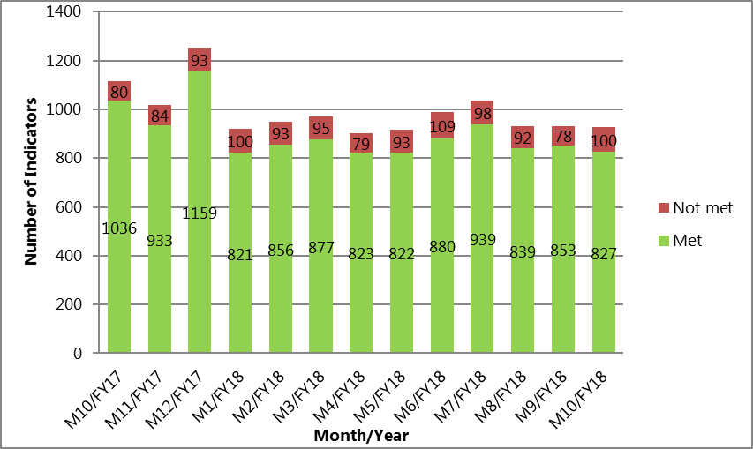

Performance Trends:

Although the Trust consistently achieves 90% compliance against contracted indicators, there are a small number of areas where performance is below the required levels. These areas of non-compliance are extracted from the Trust’s performance dashboard and presented in this report using an ‘exceptions’ based format. Further analysis continues on those indicators that are consistently being reported as ‘red’ so that the root causes can be identified and resolved. Progress updates will be included in this report as information becomes available.

National Position:

Following a review of the performance data, the following indicators continue to be highlighted as underperforming at a national level. This is primarily because the data published by NHS digital is not the latest information:

- Workforce – The difficulties in recruiting and retaining suitably qualified staff continues to have a direct impact on the Trust’s ability to deliver services. Work to address these issues continues to be led by HR under their Workforce Strategy.

- Priority Metrics – These are indicators that have to be reported nationally such as patient ethnicity, Employment for Adults & Accommodation. The work to collect the required data and upload it into the national data sets has now been included in the Data Quality Improvement Programme.

- Settled Accommodation - At a national level, performance is measured against a definition of settled accommodation. However, within the Outcomes Based Contract (OBC) the definition used by our Commissioners is stable accommodation. Although we are not compliant using the national definition, the Trust has achieved the locally contracted targets.

Older Peoples

The Older Peoples Directorate achieved 77% compliance in January against the contracted targets. This is a decrease from the performance achieved in November and December with pressures in particular in the Out of Hours and Continuing Health Care (CHC) services.

In looking at the performance trends and identifying areas where further action is required, the following issues have been highlighted and escalated to the Operations Management Team:

- The Out of Hours (OOH) Services. Services remain under pressure over the winter period and 2 of the 9 indicators continue to breach (unfilled shifts & face to face base visits). The service continues to ensure that every patient is safe whilst under OOH care and the team are continuing their improvement work. At the present time, the service is forecasting compliance with all indicators by May 2018.

- Oxfordshire Continuing Health Care (CHC) Adults – A significant increase in the number of 7 day referrals has resulted in breaches in 4 of the 10 CHC performance indicators. During January, there were 14 urgent referrals which was 40% more than previous month.

- Estimated Discharge Date (EDD) – Following a clinical review of the EDD indicator, we have submitted a proposal to Oxfordshire CCG to change from the existing 24hour to a 72hour target. This is to give sufficient time for a clinical review by the Multi-Disciplinary Team (MDT). Commissioners have responded by extending the indicator to 48hours for all admissions excluding EMU which is currently being reviewed again.

- Stroke Therapy – Lack of workforce continues to have a high impact on the Trust’s ability to achieve the contracted stroke therapy targets. There is insufficient capacity within the service to cover staff sickness, annual leave or vacancies. At the present time, the service has a 26% vacancy rate against their budgeted establishment. Action is being taken to recruit into the vacant posts as quickly as possible.

- Falls – The demand for falls assessments continues to exceed the Trust’s available capacity. A business case for further investment will be drafted for submission to commissioners by the end of Q4 2018.

- Physical Disabilities Physiotherapy Service. There has been a consistent increase in referrals to the Physical Disabilities Physiotherapy Service (due mainly to Parkinson’s). The Service has reviewed the current delivery model and has taken all steps possible to improve efficiency which has been overseen by the commissioners. A business case to justify an increase in investment has been submitted to Oxfordshire CCG.

- Delayed Transfers of care (DTOC) and Length of Stay (LOS) continue to be an issue across the system. Although there has been a significant impact due to the delays as a result of the HART service capacity issues, work continues to address the issues that are solely within the remit and control of Trust. The excellent performance reported last month has continued and the position as of the 15th February was 4 patients attributable to the Trust.

Children & Young People

In January, CYP achieved 94% compliance against the combined performance assessment framework indicators and locally agreed contracted targets.

In looking at the performance trends and identifying areas where further action is required, the following issues have been highlighted and are now being overseen by the Operations Management Team:

- CAMHS ‘Getting More Help’, 4 Week Waits – Buckinghamshire – An increase in the number of referrals in the north of the County has had an impact on the overall compliance of this particular target. The service is currently planning on how best to deploy resource to ensure that all areas of the County are compliant by April 2018.

- Buckinghamshire CAMHS 4 Week waiting times – The service is now offering additional assessments as part of a targeted effort to improve the 4 week wait times by April 2018.

- Autism Spectrum Disorder (ASD) – A new pathway for ASD is currently being introduced to overcome the considerable delays that have previously been seen within this service. The new pathway will have increased staffing and there is early confidence that patients will be seen within the 12 week targets that have been agreed with commissioners. The new pathway will be operational from April 2018.

- CAMHS 12 Week waiting times – During January the service completed 336 assessments; the largest number ever completed (Previous high was 290). Despite this, overall performance has declined from December, however, this is representative of the fact that there was a significant backlog of waiters who had already breached the 12 week wait time when they were assessed. A comprehensive plan is in place to achieve the agreed contractual targets and to address the backlog of referrals that are currently queued. This is being overseen by a joint CCG & Oxford Health mobilisation Team.

- CAMHS 4 Week waiting times – There continues to be issues with the 4 week waiting time targets, in particular in Swindon, Wiltshire and Bath & North East Somerset (BaNES) (T2). Work is underway to address these issues as part of the transition to the new service delivery models with more appropriate targets being set. These are due to go-live in April 2018. We expect to see an improvement in performance in Q2 2018.

Adults:

The Adults Directorate achieved 73% compliance against the contracted targets in January.

In looking at the performance trends and identifying areas where further action is required in the Adults Directorate, the following issues have been highlighted and escalated to the Operations Management Team:

- Improving Access to Psychological Therapies (IAPT) – In January, there has been a substantial reduction in the number of ‘hidden waits’ at step 3 with waiting times for treatment now reduced to 10 weeks. This is a substantial improvement from the position seen last year (previously as high as 21 weeks) and an exceptional improvement in such a short period of time. All credit to Jo Ryder and the team for their efforts in achieving such a great improvement.

- Cluster Reviews – The cluster reviews indicator in Oxfordshire continues to be below target. Operational staff continue to be reminded of the importance of clustering within the agreed timescales. The services are currently forecasting to achieve the contracted target by April 2018.

- Care Reviews - Analysis of the performance data has shown that timescales for care reviews specifically in Aylesbury continue to be below target. Service leads are working with operational services to improve this position.

- Learning Disabilities – Work is currently underway to validate the data used as evidence for the new indicators. The position will be checked and confirmed in preparation for the March 2018 Board Report.

Recommendation

The Board of Directors is asked to review and note the monthly Board performance report.

Author and Title: Martyn Ward – Director of Performance & Strategy

