

**PUBLIC**

**Report to the Meeting of the Oxford Health NHS Foundation Trust**

**Board of Directors**

**For information and assurance**

BOD

**28th February 2018**

**Incident, Mortality and Patient Safety Quality Report**

**Executive Summary**

* Incident reporting levels continue to increase indicating a learning culture. There is additional analysis on timing of incidents by cause group/ type which is interesting and may support how staffing on the wards is managed.
* 67% of reported incidents identify no harm caused, this is generally in line with the national picture[1] according to the NRLS data. Since Jan 2017 the trust has had an increase in major injuries related to changes in how skin integrity incidents are being reported and a reduction in the number of serious incidents (defined as patient incidents with serious harm where there were omissions found in the care provided), and an increase in patient self-harm across the AMHTs (adult mental health team).
* Trust-wide the majority of incidents relate to skin integrity (17%), violence and aggression (16%), self-harm (12%) and communication/ confidentiality (8%). A breakdown by cause group split by mental health services and physical health services is in the report.
* The older people directorate continue to report the highest number of incidents relating to skin integrity (36%) and falls (12%). Half (52%) of skin integrity incidents are inherited prior to receiving care from services in the trust and this is increasing whilst acquired pressure damage is reducing. The majority of acquired pressure ulcers were identified as grade 2 (70%), in Q3 42 pressure ulcers were identified as grade 3 or 4 however none were identified as an SI.
* Patient falls remain one of the highest cause of incidents for physical health services (second to skin integrity incidents), however, it appears there may have been a reduction in the number of patient falls in 2017 and focused work is being led by the new falls prevention steering group.
* Following the last report two patients inappropriately placed one on a CAMHS ward and one on a forensic ward have been moved to specialist placements in December 2017 not provided by the trust which has meant we have seen a decrease in the number of self-harm and violent/ aggression incidents.
* The wards/ teams highlighted with spikes in the number of reported incidents were: Kennet, Wenric, Ruby, Faringdon and Shrivenham district nursing service and the out of hours’ service in Banbury. Further detail is provided in the report.
* There is a separate analysis of incidents reported by the learning disability services for the last 3 years following transfer in July 2017. There has been an increase in self harm incidents related to multiple incidents for a small number of patients.
* Overall the report demonstrates a significant reduction in the use of restrictive practice since June 2016, this includes the use of prone and supine position restraint and high level holds. Violence and aggression (Q3 44%) and self-harm (Q3 33%) are the most common reasons for using restraint. The number of incidents of violence and aggression where restraint was used has decreased from Dec 2016. The use of seclusion has fluctuated over the past 2 years remaining broadly at the same number, improved reporting has been introduced so we hope to better understand if there are changes within the duration of seclusions. There has been a dramatic reduction in long term segregation in Q3 related to the inappropriate placement of a few patients in the trust whilst they waited for specialist care.
* The trust has had one never event in 2017/18 which happened in November 2017. An internal investigation is underway and an independent investigation is being commissioned but has not started yet.
* There is continued work to improve the timeliness of managers grading incidents, the teams with the highest number waiting for grading has changed from Q2. The median time taken by a manager to review and grade an incident is 9 days. Individual support is provided by the risk team to clinical teams with the highest number of incidents in web-holding. All incidents in web-holding are included in reports and reviewed centrally to ensure no serious incidents are missed. There are no incidents in web holding over 12 months old.
* The trust received 15 new patient safety alerts in Q3 which were relevant for action and closed 11 in Q3. No alerts are overdue.
* The report details the regulation 28 rulings received from coroners in 2016/17 and 2017/18 so far. No change from the last quarterly report.
* 14 SIs were identified and reported in Q3 2017/18, of which 9 of these involve a death (4 a suspected or confirmed suicide). In 2017/18 so far 52 SIs have been identified. The key themes identified are around physical healthcare, vulnerability at points of transitions and handoffs and identification/ involvement of families. The trust-wide actions being taken around the key themes are detailed in the report.
* Of those SI investigations reported in 2017/18 (April to December 2017); 25 were submitted on time, eight early and five have breached the 60-day target with no agreed extension from the commissioner.
* A summary of developments made to the SI process in 2017 to improve the quality of investigations and therefore learning, and to further involve patients/ families.
* An analysis of SIs over the last 3 years is presented, showing a decline overall due to the reduction of pressure ulcer SIs following the focused action within the community nursing teams. There has been no grade 3 or 4 acquired pressure ulcers in the last 4 months. Self-harm and pressure ulcers are the two main causes of SIs. Five teams are identified as having 10 or more SIs over the last 3 years, of these four teams have reduced the number of SIs.
* Continued focus is needed on implementing actions timely and providing evidence of closure.
* We are seeing an increase in being asked to be involved in domestic homicide reviews following the revision of the national guidance which increased the scope for reviews to include all suspected or confirmed suicides where there was coercive controlling behavior. A summary of the number and themes from mental health homicides and domestic health homicides over the last 6 ½ years is presented.

**Governance Route/Approval Process**

A more detailed report based on the information presented was discussed and reviewed by the Safety quality sub-committee in January 2018.

**Recommendation:**

This report is submitted for information and assurance.

**Author and title:** Charlotte Forder and Jane Kershaw (Quality and Risk Team)

**Lead Executive Director:** Ros Alstead Director of Nursing and Clinical Governance

**1.0 Overview of Reported Incidents**

1.1 Number of incidents

Figure 1 shows reporting levels have continued to increase from the point the Ulysses incident reporting system was introduced from 2011. The increase in reporting in Q2 and Q3 relates to CAMHS, the adult mental health wards and community mental health teams, and the transfer of the learning disabilities service from July 2017, however, there was then a drop in the number of incidents reported in December 2017.

No seasonality has been observed in numbers of incidents reported. Similar numbers of incidents are reported as occurring from Monday – Friday, while reduced numbers are reported on weekends. A review of the times at which incidents were reported as occurring showed that 28% of all incidents in 2017 occurred between 10am and 1pm. Looking at the timing of incidents within particular cause groups shows the following differences;

* Violence + Aggression – high numbers of incidents occur throughout the day, tailing off from around 8pm. Highest numbers seem to occur between 10am and 12pm (15% in the previous year).
* Self-Harm – Most incidents occur in the evening with 48% of incidents in the previous year occurring between 5pm and midnight, and 17% between 8pm and 10pm.
* Security e.g. AWOL/ found with banned items– Incidents tend to occur later in the afternoon with 34% of incidents in the previous year occurring between 2pm and 6pm
* Staffing – The highest proportion of incidents in the previous year were reported as occurring between 9pm and 10pm (14%), and also between 7 and 8am (11%).

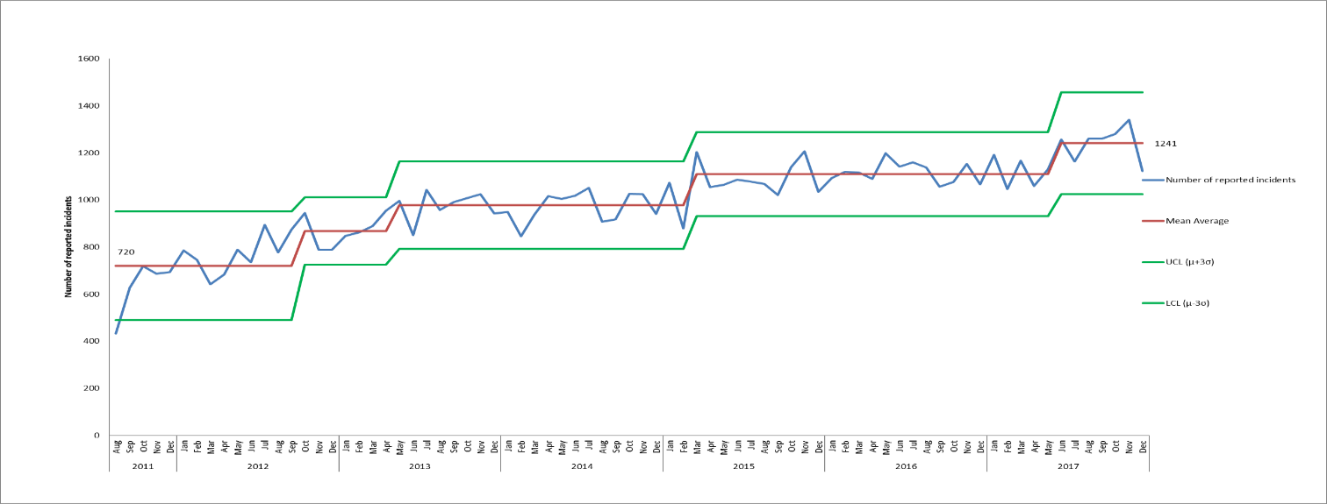

*Figure 1. Control chart displaying monthly number of incidents reported on Ulysses system from August 2011- December 2017*

* 1. Actual Impact of Incidents

Overall in Q3 2017/18, 3742 incidents were reported, as in Q2, 67% of these were reported as causing no harm, this is generally in line with the national picture[2] according to the NRLS data. Since Jan 2017 the trust has had an increase in major injuries (see figure 2) but a reduction in serious incidents defined as patient incidents with serious harm where there were omissions found in the care provided.

The increase in incidents reported as resulting in major injury has been seen in the Older People directorate in relation to skin integrity incidents. This is a result of a change in practise in reporting of harm due to pressure ulcers in 17/18. Prior to this there were data quality issues and inconsistencies in relation to the reporting and grading of harms linked to skin integrity concerns. For example, 80% of grade 4 pressure ulcers were being reported as ‘moderate harm’ rather than ‘major harm’. The grading was subsequently standardised and since Q1 17/18 acquired grade 4 pressure ulcers have been graded as major. At the same time the distinction between acquired and inherited harms was introduced.

The Trust has also seen a notable reduction in the number of significant pressure ulcers compared to previous financial years, as demonstrated in the review of serious incidents relating to pressure damage later in this report. This decrease is a result of the improvement actions detailed in the pressure ulcer reduction plan taken including improved learning from lower grade acquired harms (category 2 pressure ulcers) and the introduction of the Quick Time Learning initiative.

Of the 35 incidents with major injury/severe property damage reported in Q3, 17 were in district nursing teams (down from 25 in Q2). Of the District Nursing incidents, 15 were in the category of Skin Integrity and 10 of these were grade 4 pressure ulcers that had been acquired in service, the other 5 were a result of SCALE. The Initial Reviews completed did not identify any lapses in care for these incidents and none are being investigated as SIs. The other 2 district nursing incidents graded as major were in the category of health, one respiratory arrest and one in the category of diagnosis failure/delayed diagnosis as staff in a care home had failed to contact the district nurse team to advise of a decline relating to pressure damage. There were 3 further incidents of acquired grade 4 pressure damage in other departments (CHos-Didcot, CT-Central and PODS SW Witney), again no lapses of care were reported.

In the Adult Directorate an average of 2 incidents per month have been reported as resulting in major harm since April 2015, however, in Q3 above average numbers were reported with 11 incidents on total, 6 in October, 4 in November and 1 in December. Of these, 7 were reported within the AMHTs, 4 of these were in Oxon City + NE AMHT and 3 in AMHS Bucks Aylesbury. In Oxon City and NE AMHT 3 of the incidents were of self-harm, one overdose and 2 incidents of major harm caused by cutting (both by the same patient). There was also an incident of major injury caused to a member of the public by a patient, this is being investigated as a serious incident. In Bucks Aylesbury there was a reported suicide attempt by jumping that resulted in a fracture, and there were 2 incidents of major injury cause by a physical illness.

The remaining incidents of major injury were across 11 different departments. Four of these related to self-harm, two patients took overdoses in Psychological services (one in Talking Space, one in Healthy Minds), there was an incident of cutting that caused major injury on Wintle ward, and there was an incident of self-harm by hanging in CAMHS Buckinghamshire (targeted), this is being investigated as a serious incident.

There were 2 further incidents of diagnosis failure/delayed diagnosis that resulted in major injury, one on CHos City ward (an undiagnosed fracture of the hip) and one in the LDS community team where a patient was diagnosed with pneumonia and sepsis. There was an incident of major injury on CAMHS Marlborough house where an ambulance had to be called for a patient with low blood sugar. The final incident that was graded as major was reported on MIU due to suspected assault on a 10-week old patient, it was reported as a safeguarding concern and the police were informed.

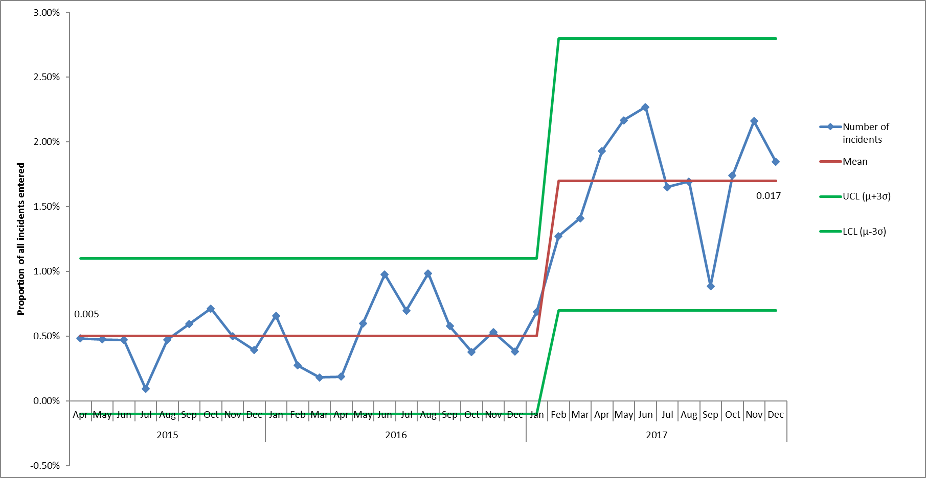

*Figure 2. Control chart displaying proportion of all incidents that are reported as resulting in major injury or property damage, April 2015 - December 2017. Inherited pressure ulcers are excluded.*

* 1. Incidents reported across Directorates, Service Lines and Departments

Older People Directorate

The Older People Directorate continue to report the highest number of incidents (with the exception of September 2017 when more incidents were reported in the adult directorate) and numbers of incidents have been generally consistent since April 2015. Within this directorate 88% of incidents in Q3 related to physical health services, and the majority of incidents continue to be recorded in the categories of Skin Integrity (36%, n = 622) and Falls (12%, n=201). Of the Skin Integrity incidents in Q3 52% (n=322) were inherited from home/another provider rather than being acquired in the care of the trust. There were also 44 incidents of SCALE, 55 moisture legions and 6 incidents of medical device related damage. Overall 31% of the skin integrity incidents related to pressure damage were acquired during the care provided by the trust.

Children and Young People Directorate

In this directorate 80% of incidents relate to mental health departments, and 20% relate to physical health. Above average numbers of incidents were reported in the Children & Young People (CYP) Directorate between Feb and October 2017 (with the exception of August). The mean monthly number of incidents prior to February was 137, and the monthly mean number of incidents increased to 181 from February onwards, however only 109 incidents were reported in December 2017. Of all the incidents reported by CYP from February onwards, 25% involved one particular patient on CAMHS Highfield, this patient moved to an appropriate specialist placement outside Oxford Health in December 2017 and incidents have dropped considerably as a result (figure 3).

The high number of incidents reported by CAMHS is a symptom of the current challenges around a lack of available CAMHS PICU beds across the region. The Board has previously discussed its concerns about pressures for specialist CAMHS beds and there have been incidences when an under 18 have had to be admitted to an adult mental health ward. For each case an incident has been reported and a full review completed. There is collaborative work being undertaken with the commissioner NHS England (NHSE) to try to improve capacity.

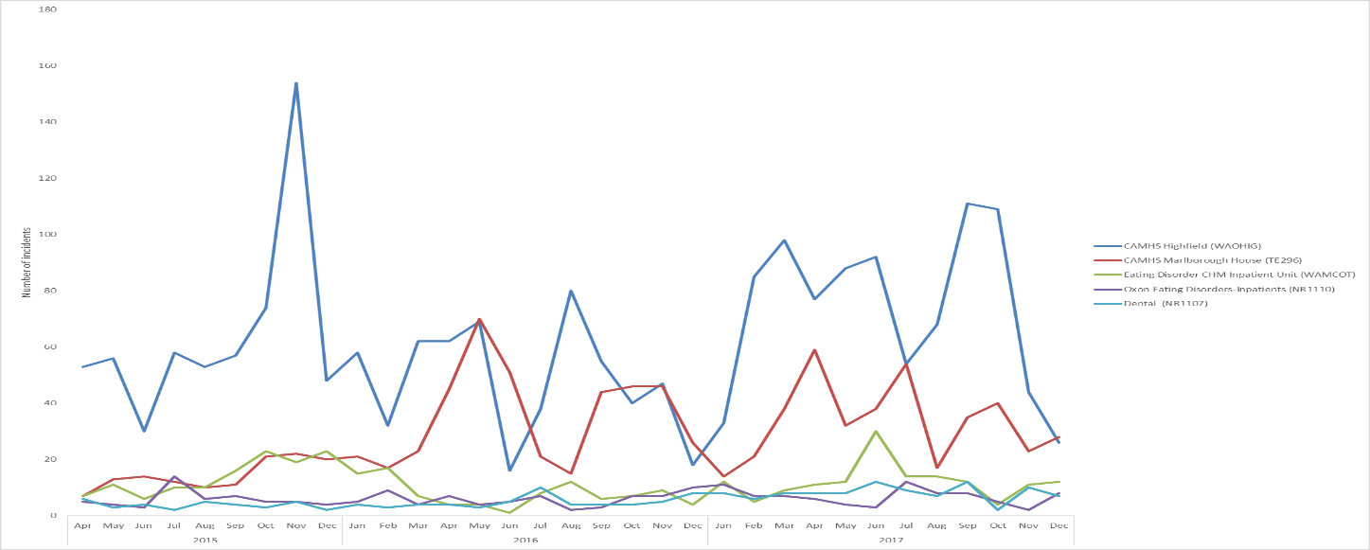

*Figure 3. Incidents reported in Children & Young People Directorate in departments with most reported incidents, April 2015 – December 2017. Above average numbers reported in CYP from February to October 2017, with the exception of August.*

Adult Directorate

In Q3 98% of incidents in the adult directorate were reported in mental health services (Luther street homeless GP and learning disability services account for the other incidents), and the increase in incidents seen previously in this directorate was sustained (figures 4). Figure 5 shows numbers of incidents across the different service lines. Above average numbers of incidents were reported on adult mental health wards from June-November 2017, and a high numbers of incidents were recorded on Forensic wards in December 2017 (n=209, mean monthly average =150). Following the spike in incidents in the AMHTs in September numbers declined but remained above average. The other reason for the increase in incidents is the transfer of the Learning Disability services from Southern Health NHS FT in July 2017.

Within the Adult Mental Health wards the main increase was on Ruby ward where 73 incidents were reported in October and 84 in November, numbers returned to normal in December when 39 incidents were reported (monthly average = 38). Within the forensic wards increases in incidents were seen on both Kennet and Wenric House. AMHT Oxon City and NE continues to be the highest reporter amongst the AMHTs, 68 incidents were reported in Q3 compared with 97 in Q2.

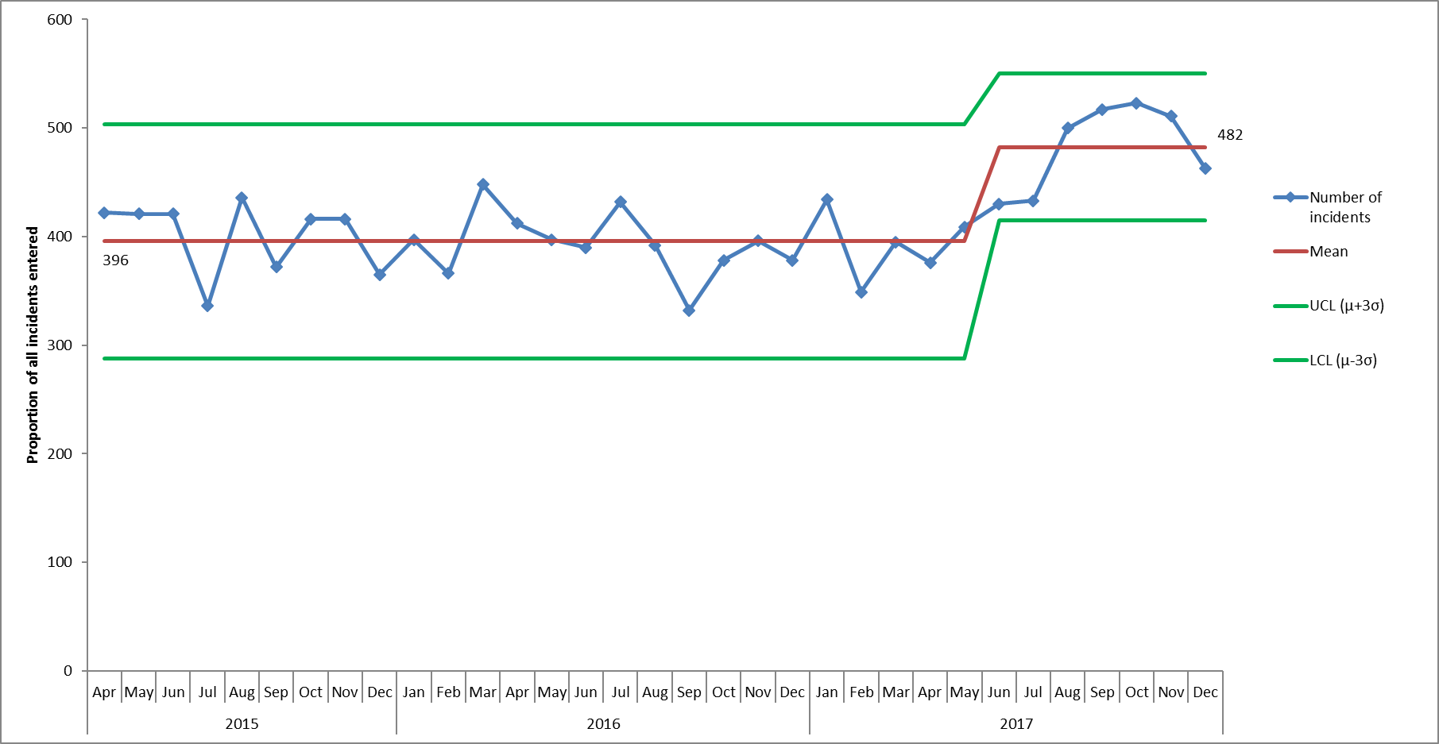

*Figure 4. Control chart displaying monthly number of incidents reported in the Adult directorate from April 2015-December 2017*

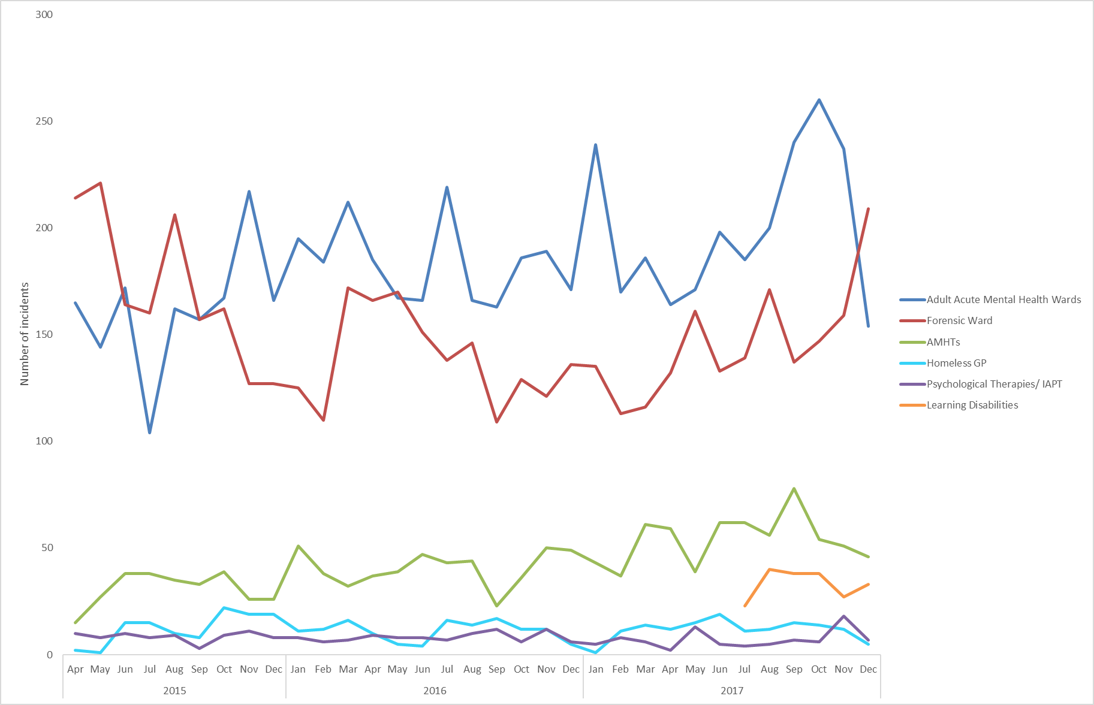

*Figure 5. Incidents reported on Ulysses by services with most reported incidents, April 2015 to December 2017*

1.4 Team/ ward level of analysis

Overall reporting has been reviewed for all departments with a mean average of 5 or more incidents per month since April 2015 (looking back over the last 3 years).

For inpatient wards incident numbers have also been reviewed in the context of occupied bed days, trends remain the same as when looked at in terms of incident numbers alone. Prior to Q2 17/18 the mean average number of incidents/100 bed days has been 2.8 per month. In Q2 and Q3 of 17/18 this increased to 3.5 incidents per 100 bed days per month. This reflected the increases/peaks in numbers of incidents seen on certain wards.

In Q3 17/18 a particular increase in incidents was seen on Kennet and Wenric wards. On Kennet an average of 28 incidents per month have been reported since June 2016, in December 43 incidents were reported on this ward (85 incidents in total in Q3). Of the December incidents 16 related to Violence/Aggression and 10 were security incidents. On Wenric house 97 incidents were reported in Q3, again the increases related to Violence/Aggression (34% of Q3 incidents, n=33) and security (23% of incidents, n=22).

The increase in incidents seen previously on Ruby ward continued in October and November 2017. Overall in Q3 196 incidents were reported, compared with 124 in Q2 and 54 in Q1. Figure 6 shows the incidents on Ruby ward broken down by cause. The peak in incidents was in November when 84 incidents were reported, and 59 of these were in the cause group self-harm. Of the Q3 self-harm incidents one patient was involved in 14 incidents in October, 19 incidents in November and then 9 incidents in December. A second patient was involved in 18 patients in October, 19 in November and 7 in December, and a 3rd patient had 9 incidents reported in November and 8 in December (none in October). As a result of the patient acuity on the ward a number of beds have been temporarily closed to enable the staff to provide more intensive care to a smaller number of patients.

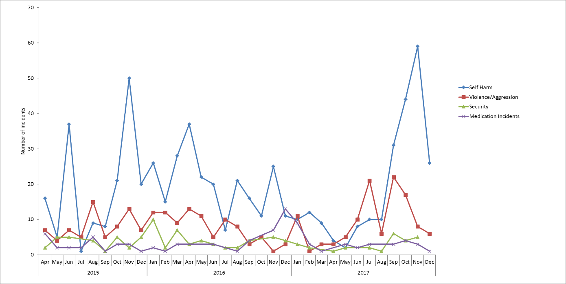

*Figure 6. Incidents reported on Ruby ward by cause, April 2015 – December 2017.*

Above average numbers of incidents were reported in DNSW Faringdon & Shrivenham in October and November 2017, with 20 incidents reported in each month. In Q3 53 incidents were reported in total and 41 of these were in the category of skin integrity. Of these multiple incidents were reported for 9 patients and 5 incidents were reported for one particular patient. Two further patients had 4 skin integrity incidents each reported over the quarter.

A spike in incidents was reported in OOH Banbury in November 2017 (n=10, mean monthly average = 1.8). Of these 4 related to an ongoing issue of youths being reported on site which is being managed by the police and security team at the Horton Hospital. There were also 3 further incidents that related to communication issues caused by problems with phones and printers.

1.5 Incidents reported in Learning Disability Services

In July 2017 learning disability services were transferred to Oxford Health from Southern Health. The services transferred were 3 community teams, an intensive support team, vison outreach adult social care team, step down care home and a forensic inpatient ward. As part of the transfer the trust was provided with incident data from the Southern Health incident reporting system (also Ulysses) in the 3 years prior to transfer. Figure 7 shows that the average number of reported incidents in the applicable services increased to 33 per month in April 2016 (as a result of an increase in incidents reported by community teams) and has been at a consistent level since this point, including following the transfer of the service to Oxford Health.

In the 3 years prior to transfer most reported incidents were in causes linked to violence/aggression (26%, 225 incidents). In the quarter prior to transfer (Q1 17.18) 40 incidents (35%) related to violence/aggression. In Q2 and Q3, following transfer, 79 incidents of violence/aggression were reported and this represented 39% of all incidents.

Following transfer of services there has been an increase in reported incidents of self-harm. In the 12 months prior to transfer 11 incidents of self-harm were reported in total, 3 in Q1 17/18, whereas in Q2, following transfer, 15 incidents were reported and 9 incidents were reported in Q3. Of the 9 incidents reported in Q3, 6 were reported by 3 community teams, 3 overdoses, 2 incidents of cutting and 1 incident of a patient striking themselves/object. All resulted in minor or no injury. Three incidents were also reported on Evenlode, one of cutting and 2 of the same patient re-opening wounds, all resulted in minor injury. At the end of Q2, when the increase in incidents of self-harm was first identified, a review of all incidents in the quarter was carried out by a senior community nurse. The summary from this report is provided below.

*Summary of review of Q2 incidents of self-harm reported by the learning disability services:*

There was evidence of continued support from staff to meet the needs of the service user, with further work identified around supporting staff to work with patients with complex mental health needs. There was evidence of good multi-disciplinary working and liaison with agencies involved in the service users care. It is likely the increase in reports of self-harm are related to the service users’ situation and at the time, rather than being related to any changes in staff’s knowledge and awareness of reporting such incidents. This would be reasonable to suggest as most of the incidents above were recorded as multiple incidents for a small number of service users representing ongoing risk and concern for the service user.

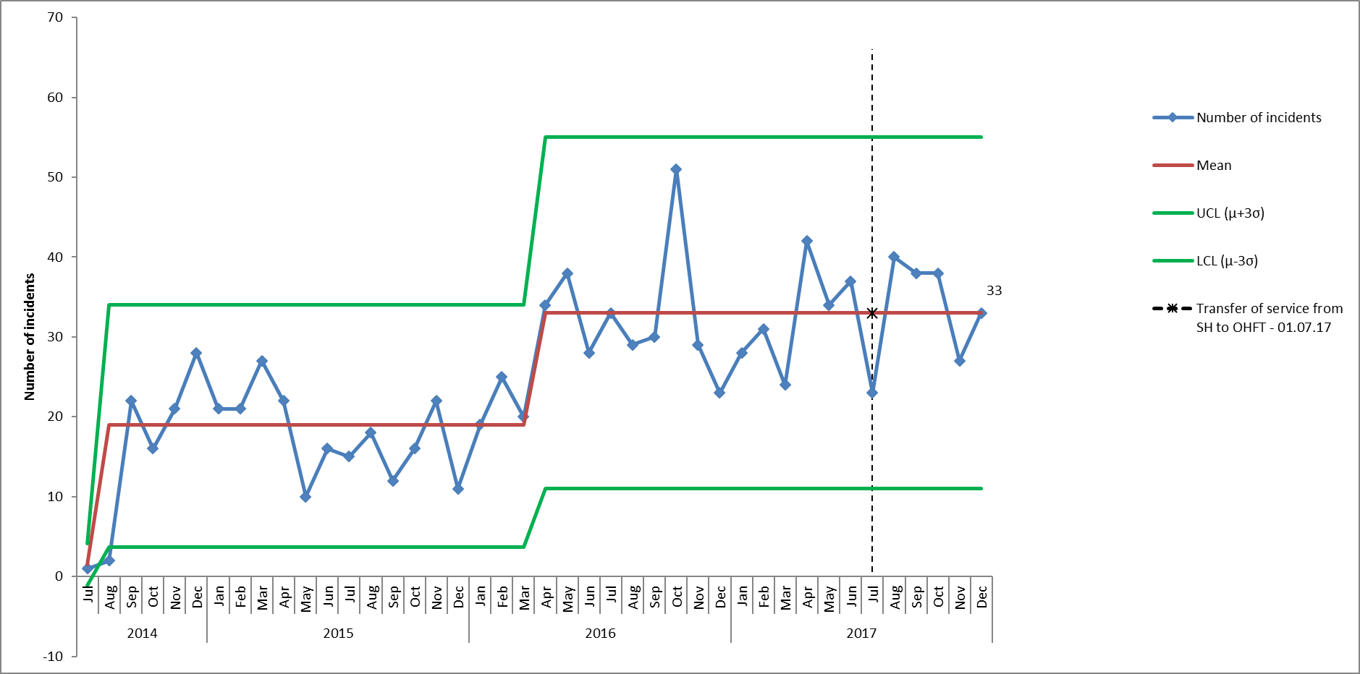

*Figure 7. Control chart displaying monthly number of incidents reported by learning disability services before and after transfer from Southern Health to Oxford Health (on 01.07.17). Incident data prior to July 2017 was transferred from Southern Health within the Ulysses incident reporting system (used by both trusts).*

1.6 Cause Groups

The trends across all cause groups are reviewed quarterly and in this report just the most reported incident types or those areas where there has been a change are reported. Table 2 shows the 3 cause groups with most reported incidents in different services in Q3.

*Table 2. Cause groups with most reported incidents*

|  |  |  |
| --- | --- | --- |
| Trust-wide services | Mental health services | Physical health services |
| Skin Integrity (n=627) | Violence and Aggression (n=542) | Skin Integrity (n=623) |
| Violence/Aggression (n=593) | Self-Harm (n=440) | Communication/ Confidentiality (n=187) |
| Self-Harm (n=447) | Security (n=234) | Falls (n=149) |
| Communication/Confidentiality (n=295) | Medication Incidents (n=138) | Medication Incidents (n=148) |

Skin Integrity was the cause associated with 17% of all Q3 incidents (n=627) while 16% were incidents of Violence/Aggression (n=593). The third highest cause of incidents in Q3 2017/18 was again self-harm (12%, n=447) where above average numbers were recorded between August and November 2017. The 3 main cause groups in Q3 skin integrity, violence and aggression and self-harm are looked at in more detail later in the report.

A review across all other cause groups highlighted the following:

* **Communication/Confidentiality:** This is the 2nd highest cause group associated with incidents reported in physical health services. Within this category most incidents are recorded in the sub-category of ‘poor communication, patient affected’. This accounted for 28% of incidents in Q3 (n=84) and there was a particular spike in November when 41 incidents were reported. Of the Q3 incidents 24 were reported by podiatry and 23 were reported by health visiting. The podiatry incidents were reported across 6 different departments, City St Barnabas reported 10 incidents and North Orchard reported 8. All incidents related to delays in urgent referrals that had been sent to healthshare (external provider) being forwarded on to podiatry. The health visiting incidents were reported by 7 different teams and were largely related to patient information that they had not been made aware of. The 2nd highest sub-category relates to breaches of patient confidentiality and 42 incidents were reported in Q3 by 33 different departments. The 211 remaining incidents in the cause group were split across 100 different departments. Four communication/confidentiality incidents were graded as moderate in Q3, one relating to a breach of patient confidentiality and 3 relating to poor communication-patients affected, these were in 4 different departments. All other incidents were graded as no or minor injury/damage.
* **Security**: Above average numbers of incidents have been reported in this category since April and a peak was seen in June 2017. In total 271 incidents were reported in Q3 compared with 318 in Q2, however, Q3 saw spikes in incidents in the categories of ‘AWOL detained unescorted’ and patients found with banned items (figure 8). In October 2017, 22 incidents were reported in the category AWOL-detained unescorted, the mean average in this category is 10 incidents/month. Of the 22 incidents 11 were on Phoenix ward, one patient was involved in 4 of these and a 2nd was involved in 3. The remaining incidents in this category were split over 6 wards (CAMHS Marlborough house, Woodlands forensic ward, and the adult MH wards Ruby, Wintle, Vaughan Thomas and Opal). There were also 17 incidents of patients going AWOL while on escorted leave, of these 7 related to 4 different Sapphire patients and 6 incidents related to 2 different patients on Ashurst.

In December 24 incidents were reported of patients being found with banned items (mean average since April 2015 = 9/month). Of these 19 were on forensic wards with 11 on Wenric House, and 5 were on adult mental health wards. Of the 11 Wenric incidents 7 were reported on the same day due to an environmental check of patient bedrooms.

There were also 32 incidents relating to staff safety which have been scrutinised by the health and safety committee and also the safety quality sub-committee in Jan 2018, and 32 attempted AWOLS. Of the attempted AWOLS 13 incidents were reported by CAMHS Highfield and these related to 4 patients. Five of the incidents related to the same patient. Numbers of incidents in the category ‘unsafe access/egress’ decreased following the increase seen in September. Ten incidents of misuse of drugs were reported in Q3, these were on 7 different wards.

As in Q2 the highest reporters of security related incidents were Phoenix ward (n=31) and Wenric House (n=22). Overall 5 incidents were graded as moderate (none as major), of the moderate incidents 2 involved the police (one due to a patient in seclusion on Kennet who was found to have had a mobile phone that they smashed up and was threatening to use it as a weapon, and the other due to criminal damage caused by a patient to the Ridgeway reception).

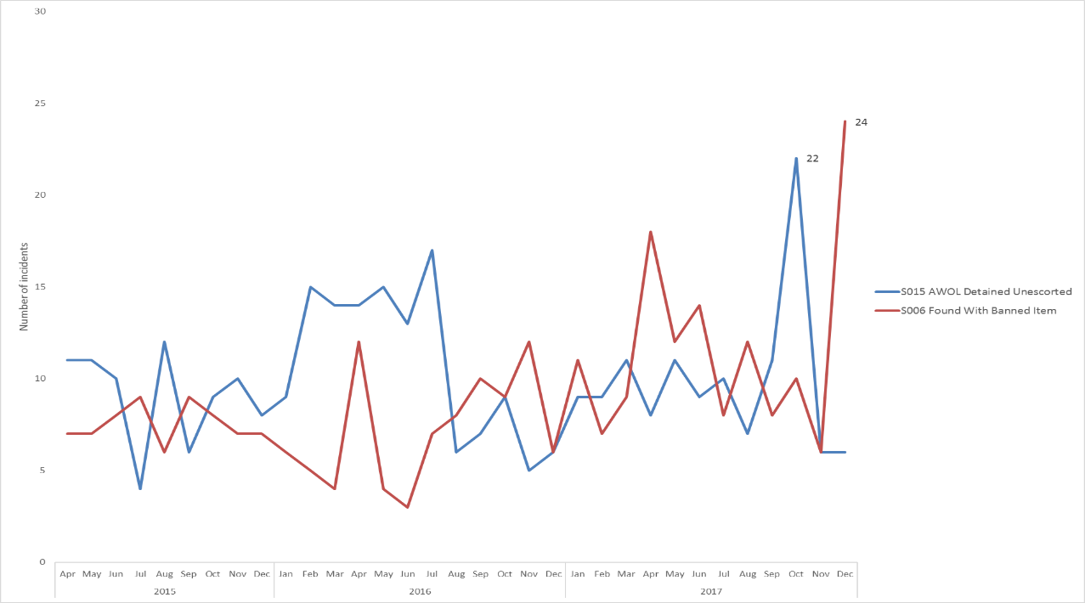

*Figure 8. Number of incidents reported in security categories of ‘AWOL detained unescorted’ and ‘Patients found with banned items’ showing spikes in Q3.*

* 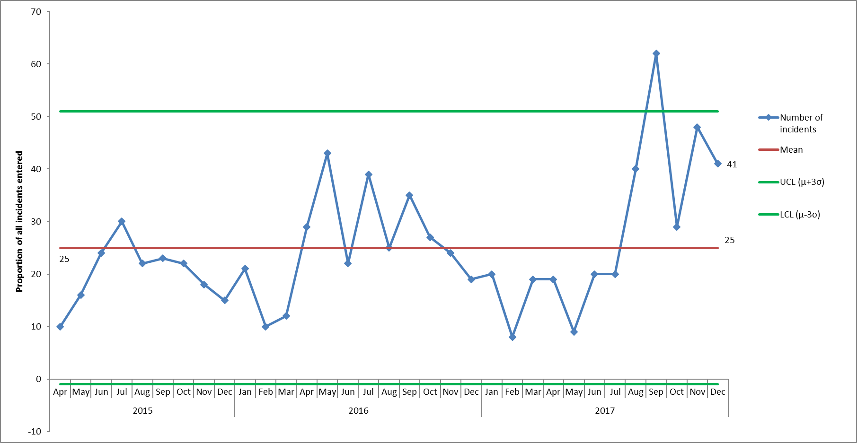**Conveyance/ transport:** Above average numbers of conveyance incidents continued to be reported in Q3 with 118 in total, compared with 122 in Q2 and 48 in Q1 (figure 9)**.**  Of the 118 incidents reported in Q3, 51% (n=60) were reported by Podiatry teams, 16% by AMHTs (n=19) and 15% by community hospitals (n=18). Of all incidents 59 (50%) related to patients being picked up late, in 38 incidents transport did not arrive, and in 13 incidents the transport refused a pre-agreed arrangement. Again the increase may be a result of staff being reminded of the importance of reporting all transport incidents so that these can be discussed by the Heads of Service in the contract meeting with SCAS. In response to problems with non-urgent transport SCAS have put in place dedicated vehicles as part of the contract, the impact of this is being monitored.

*Figure 9. Control chart to show number of conveyance incidents reported on Ulysses from April 2015 – December 2017, increase in incidents reported in August and peak in September 2017.*

* **Equipment/Property/Medical Devices**: Following a spike in incidents related to Equipment/Property/Medical Devices in June 2017, when 71 incidents were reported, numbers returned to expected levels in Q3. The category with most incidents was Faulty Equipment - Non Medical Device, with 19.4% of incidents (n=26). These were reported by 23 different departments and incidents do not appear to be linked. Two of the incidents were graded as moderate, one was a faulty syringe driver and 2 related to oxygen cylinder incidents, however, no adverse impact to a patient was mentioned in any of these incidents. In the previous 2 quarters higher than usual numbers of incidents were reported in the category ‘Unsafe condition In Building’. This continued in October, when 12 incidents were recorded in the category, however this decreased to 8 in November and 3 in December. Of the 23 incidents in this category 4 were reported by Luther street, 3 of which were related to drug paraphernalia being found outside the building, as reported in previous quarters (actions have and are being taken to improve the safety and security around the external building). The category with the 3rd highest number of incidents related to Lack of/Delayed equipment, 5 of these related to missing deliveries from Millbrook, 4 of which were reported by the Tissue Viability service. The medical device group reviews all incidents quarterly.
* **Sexual:** Following the peaks seen in 2 months in 2017, numbers declined in Q3. In Q3 34 incidents were reported compared with 52 in Q2. Of the 34 incidents 11 related to inappropriate comments, 5 related to ‘sexual allegations staff on patient’ and 5 to ‘inappropriate touching staff affected’.

In terms of impact 30 incidents were reported as causing no injury, 3 as minor and 1 as moderate (relating to an alleged assault on a patient by a member of the public). A further incident in CAMHS is being investigated as a serious incident, this related to sexual allegations on one patient by another patient. The highest reporter of incidents in this category was Wenric House with 7 incidents in total, Kestrel reported 3 incidents and the remaining 24 incidents were reported across 20 different departments.

* **Sharps/needlestick**: In Q3 43 incidents were reported, compared with 32 in Q2. Numbers have been above average for most of 2017 and were particularly high in November 2017 when 22 incidents were reported, 12 of which were reported by Podiatry. Of the Q3 incidents 32 resulted in no injury and 11 resulted in minor injury. A review tool has been introduced to identify process and system improvements following each sharp incident.
* **Falls**: Falls remain one of the highest cause of incidents within the Older People Directorate (second to skin integrity incidents), however, it appears that there may have been a reduction in the number of patient falls in 2017 (figure 10). The mean average number of falls prior to Feb 2017 was 78/month, from February onwards 66 patient falls per month have been reported.

In Q3 190 patient falls were reported, 130 in physical health departments and 60 in mental health departments. The 2 departments with most reported falls, however, were both older adult mental health wards; Sandford ward reported 28 falls and Amber ward reported 22. On Sandford 10 patients fell, 8 patients had multiple falls and one patient fell 8 times. On Amber 8 patients fell and 1 patient fell on 7 occasions. In physical health services 115 patient falls were reported across 24 different community hospital departments, with the most being reported on Didcot and Wallingford wards with 17 and 15 falls respectively. A patient on Abingdon ward 1 fell 6 times and 2 patients on Wallingford and Linfoot fell 5 times over the quarter. One fall, in the O OA Central CMHT was reported as causing major injury after the patient fell at home, and 5 falls were reported as resulting in moderate injury. No falls in Q3 are being investigated as serious incidents.

A new Falls Prevention Steering Group has been established within the Directorate and data us being looked at in more detail to identify learning and to monitor the impact of actions. The fall categories on the Ulysses system are also being reviewed to help make the data more meaningful.

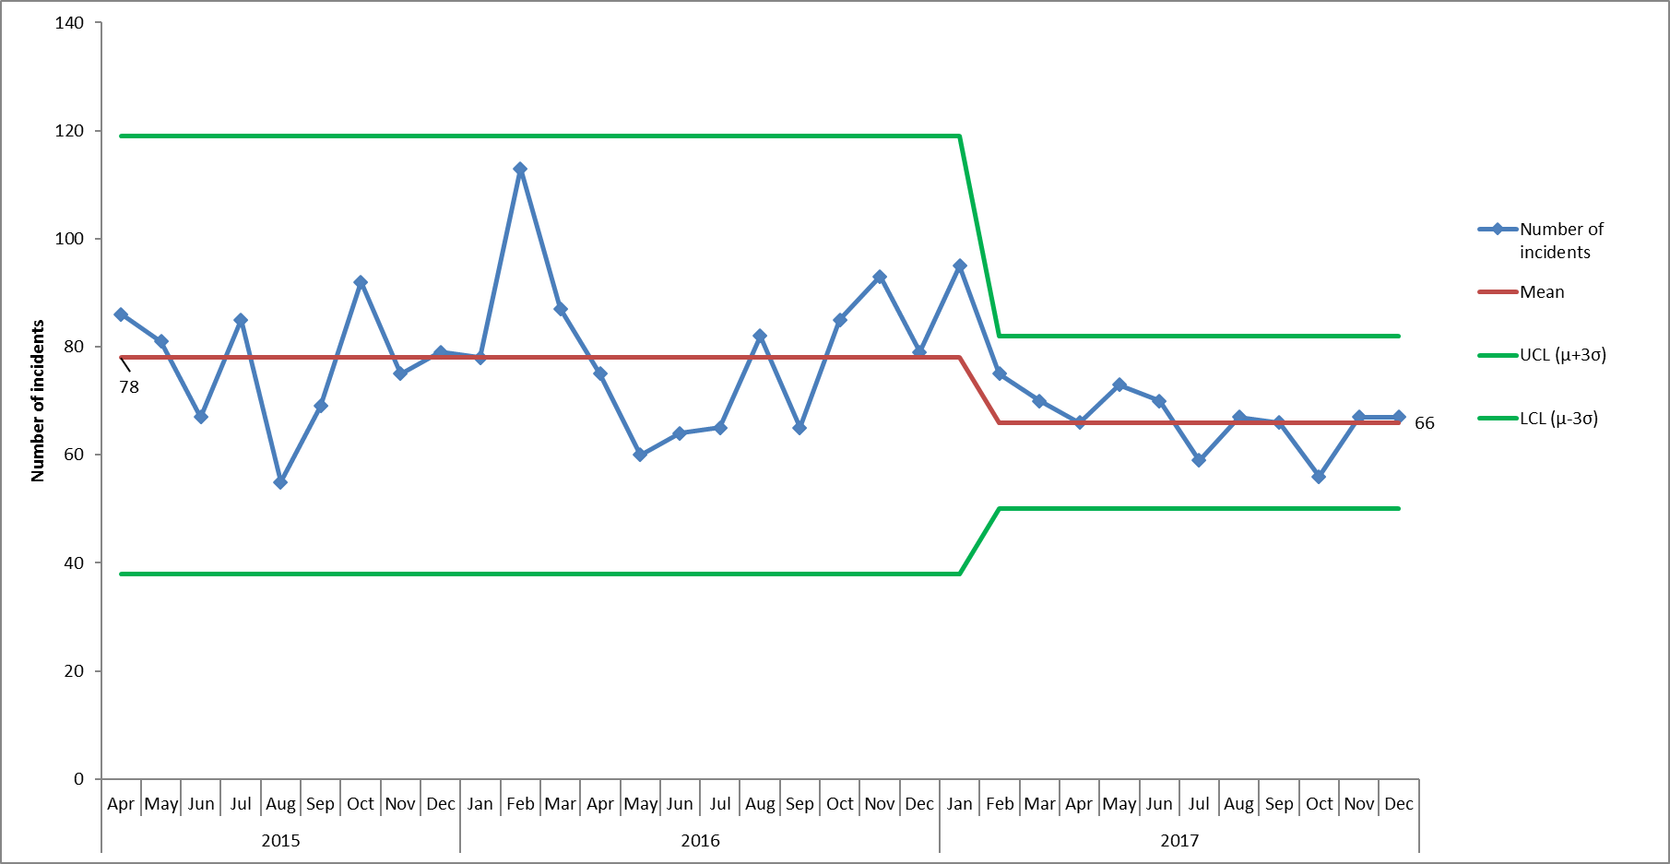

*Figure 10. Control chart to show number of patient falls reported in the Adult Directorate 2015 – December 2017.*

* **Medication Incidents:** Overall in Q3 286 incidents were reported in this category. In Q3 62% of incidents (n-**=**177) were reported in the category of ‘medicines administration/supply to patient. In July 2016 new error types were added to help categorise medication incidents. Since then error type with most reported incidents has consistently been delayed/mmitted medication. The 43 incidents reported in this category in Q3 were reported across 32 different departments. In 29 incidents the wrong dose was reported as being given, incidents were reported across 22 departments and the most were reported on kingfisher with 3 in the quarter, all resulted in no injury/minor injury.

The District Nursing service consistently report most medication incidents, however, these are generally reported over a number of different teams (53 incidents in Q3 across 22 teams). A peak was seen in incidents reported by community hospitals in November of Q3 with 26 incidents reported. These were reported across 8 different departments, with the most on Abingdon ward 1 (n=6). Linfoot ward and Abingdon ward 2 reported 5 incidents each.

Three incidents in Q3 resulted in moderate injury, one patient was sent medication by pharmacy despite not having had the required blood test, and 2 patients were prescribed doses outside recommended guidelines (one on Amber ward and one at MIU Abingdon).

**Further detail into the 3 cause groups with most reported incidents trust-wide:**

1.6.1 Violence + Aggression

Violence and aggression continues to be the highest cause of reported incidents, and in total 595 incidents were reported in Q3 compared with 621 in 21 2017/18.

Above average numbers of incidents were reported in this category from August to November, with 221 incidents reported in November 2017 (mean average over the previous 2 years has been 201 incidents/month), however this dropped to 167 incidents reported in December 2017.

In Q3, the highest reporter of incidents was Kestrel ward, with 52 reported incidents, followed by Kennet, with 45 (both of these are Forensic wards in the Adult Directorate).

Following the peak in incidents of Violence and Aggression in the Adult directorate in September 2017 (n=172), numbers have declined and in December 135 incidents were reported. In the previous quarter a spike in incidents occurred on Ruby ward in July and September, however numbers reduced in Q3 (31 incidents in total compared to 49 in Q2). In Q2 a single patient was involved in 14 of the incidents of Violence/Aggression, no incidents were reported for this patient in Q3.

Incidents reported on Wenric House increased, however, with 12 being reported in November and 15 December, compared with a mean average of 4.5/month over the past 2 years. This made them the 4th highest reporter in Q3. Of the 33 incidents reported on Wenric house in this quarter, 17 of related to a single patient. On Kingfisher ward 16 of the 23 incidents reported involved a single patient.

Although the 3rd highest reporter of incidents of Violence and Aggression in Q3 was Sandford (Older adult directorate), the decline in incidents reported on this ward has been maintained following actions taken in Q2, with an average of 12 incidents per month now being reported, compared with 27/month prior to May 2017.

Within the violence and aggression cause group incidents are classified into sub-categories. Of all incidents of Violence and Aggression, 62% were related to Violence/Aggression directed towards staff. The categories with most reported incidents were once again ‘VA009 Violence No Injury - Patient On Staff’, with 24% of incidents, and ‘VA002 Verbal Abuse Patient On Staff’ with 21%.

Looking at the actual impact of incidents of Violence and Aggression in Q3, in 80% of incidents there was no injury or damage to property, 15% of incidents caused minor injury or property damage, 3.7% of incidents caused moderate injury or property damage and 0.3% of incidents resulted in major injury. Following the increase in the number of incidents reported as resulting in moderate injury in the previous quarter, numbers have now declined, although monthly numbers were still above average. In Q3 22 incidents resulted in moderate injury, compared with 33 in Q2. Of the 22 incidents resulting in moderate injury/property damage, 12 incidents were in categories relating to violence by a patient towards staff, 5 incidents were in the category of violence by a patient towards property, and 3 were by patients towards the public. The 33 incidents were split over 15 departments, with most incidents taking place Ashurst where 4 were reported, and 4 different patients were involved. Two incidents were reported as resulting in major injury in Q3, one of these was an assault by an AMHT Oxon City+NW patient on a member of the public and is being investigated as a serious incident. The other was reported by the minor injury unit as an assault on a 10-week old patient, the incident was reported to the police and as a safeguarding concern.

Two further incidents of violence/aggression resulted in RIDDORS, a housekeeper was assaulted by a patient on Sandford, and a staff member was injured during a restraint on Evenlode ward. Each staff member involved in a RIDDOR incident is followed up by the senior health and safety advisor to offer additional support.

In August 2017 a Ulysses User Group meeting took place in which it was discussed that the actual impact given should incorporate psychological harm as well as physical injury. Prior to this the Risk Team were amending the actual impacts of incidents reported and basing it on physical injury recorded only. The increase in incidents reported as moderate may be a result of this change in procedure.

1.6.2 Skin Integrity (pressure damage)

Since July 2016 52% of the reported pressure ulcers have been categorised as being inherited from home or another provider, rather than being acquired/developed in the service of Oxford Health, in Q3 17/18 this increased to 62% (Figure 11)**[3]**. The amount of inherited pressure damage is increasing whilst acquired pressure damage is reducing.

In Q3 2017/18 627 skin integrity incidents were reported, of these 522 were pressure ulcers, 55 were moisture legions, 44 were categorised as SCALE and 6 were due to damage caused by medical devices. Two of the pressure ulcers occurred in the Children & Young People Directorate (1 acquired and 1 inherited), 3 pressure ulcers were reported in the adult directorate (2 acquired and 1 inherited, all in forensic wards) and the remainder were in the Older People Directorate.

Of the acquired pressure ulcers in Q3 2017/18 the majority developed when people were being treated by the district nursing service in the community (83%, n=163), while 7% were acquired in community hospitals and 6% in community therapy. The majority of the acquired pressure ulcers in Q3 were identified as grade 2 (n=138, 70%). In Q3 42 pressure ulcers were identified as grade 3 or 4, but none are being investigated as serious incidents.

Of all skin integrity incidents in Q3 52 were graded as major, of these 34 were inherited pressure ulcers, 13 were pressure ulcers that had developed in service, and 5 were incidents of scale. The pressure damage steering group continues to lead on the improvement work to reduce acquired pressure damage.

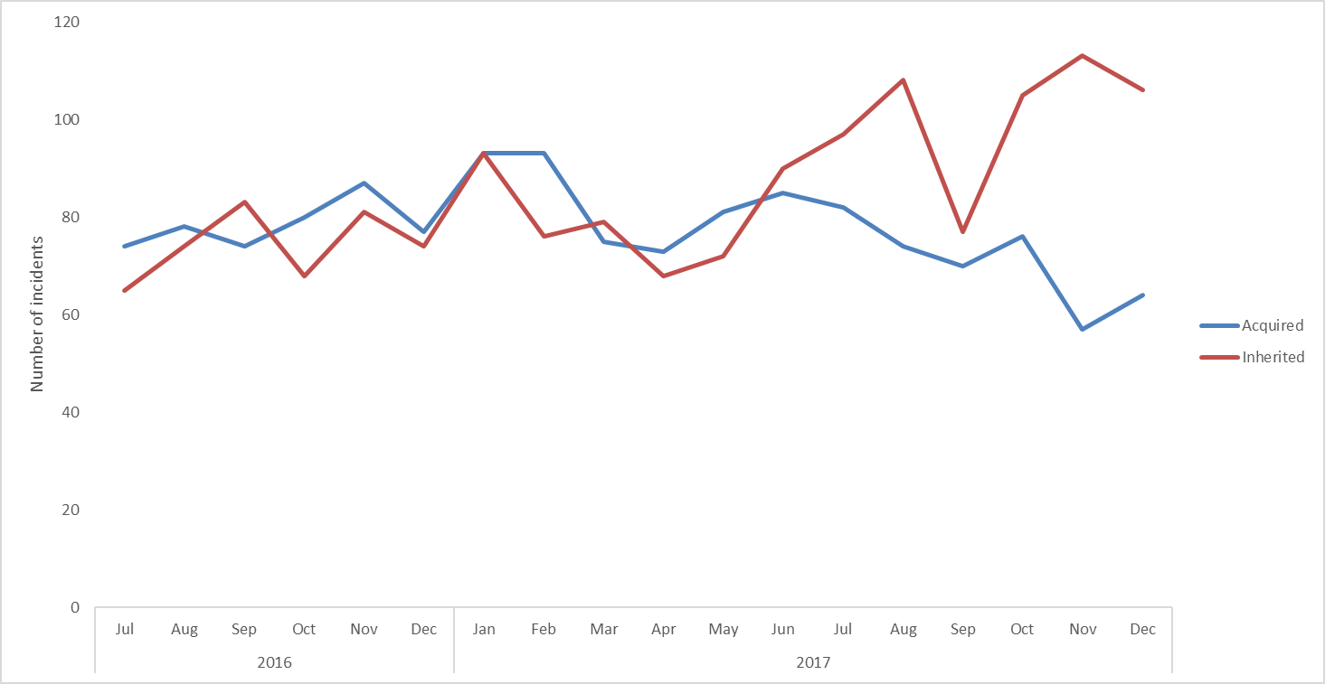

*Figure 11. Acquired and Inherited Pressure Ulcers reported on Ulysses from July 2016 to December 2017*

1.6.3 Self Harm

In the Children and Young People directorate 141 incidents of self-harm were reported in Q3, of these 91% were in CAMHS with 69% on CAMHS Highfield (n-97) and 19% on CAMHS Marlborough House (n=27). There were also 13 incidents in 3 different eating disorder units with 9 being reported on the Eating Disorder CHM Inpatient Unit. Above average levels of Self Harm were reported in CAMHS from Feb-Oct 2017, with a particular spike in September. Figure 12 shows that there was a large drop in numbers of incidents in this service in November and December 2017. The decline is due to a particular patient on CAMHS Highfield who has now moved on from the service. This patient accounted for 63 of the Highfield incidents in Q3 before leaving. A further 8 patients were involved in incidents of self-harm on Highfield, with one patient being involved in 10 incidents, a 2nd in 9 and a 3rd in 8.

A number of self-harm incidents are as a result of a patient using a ligature. It is important to understand the complexity of different types of ligature and we have to respond differently depending on what is used. For example, a ligature can be used from the physical environment (a curtain rail, a door handle) or can be a moveable object (a piece of clothing). The Trust regularly reviews our environments and responds to national alerts to either remove or minimise a ligature within the physical environment.

On Highfield there was a particular spike in ligature incidents in October with 22 incidents reported in this category (25 in total in the quarter). The ligature incidents involved 7 different patients, and either no harm or minor harm was recorded for all. Twelve incidents on Highfield involved cutting, 9 involved patients striking themselves/surroundings and 1 overdose was reported. The overdose occurred when the patient was on leave, they were taken to A&E but no harm was reported.

On CAMHS Marlborough house self-harm incidents were reported for 9 patients, with one of these being involved in 9 incidents. On this ward the most common type of self-harm incident was ‘Striking Self or Object/Surroundings’ with 13 incidents. There were also 6 incidents of cutting, 4 ligature incidents, 2 overdoses and 2 incidents in the category of ‘ingestion of a harmful substance/item’. Two incidents on this ward resulted in moderate injury; one was an incident of cutting where stitches were required, and the 2nd was the result of an overdose while the patient was on leave, they began to feel ill when they returned to the ward and were transferred to the Great Western Hospital.

A spike in incidents reported on adult mental health wards was seen in Q3, with 73 incidents in October and 82 in November (mean average since April 2015 = 32 incidents per month). This was due to an increase in incidents on Ruby ward (figure 13) where 129 incidents were reported in Q3, accounting for 68% of all incidents in the service. Overall 9 patients were involved in the incidents on Ruby, 7 of whom were involved in multiple incidents, and as discussed previously 3 patients were involved in 82% of the incidents (n=103). Of the ruby ward incidents 86% (n=111) were recorded as ligature incidents, all but 1 of these resulted in no or minor injury. One ligature incident resulted in moderate injury but this was to a member of staff due to a wound caused by the ligature cutters. Three further incidents resulted in moderate injury to patients, one due to a patient punching themselves, one due to a wound being re-opened and the 3rd due to a patient ingesting buttons.

On other adult wards one patient was involved in 13 incidents on Ashurst and another was involved in 12 incidents (one on Wintle, one on Ashurst). One incident on Wintle resulted in major injury due to severe cutting (of the toes). The patient was taken to A&E.

Numbers of self-harm incidents also increased on forensic wards in December with 33 incidents reported (average in previous year = 15/month). There were 55 forensic incidents reported in total in the quarter and of these 60% (n=33) occurred on Kestrel ward. On Kestrel one patient was involved in 17 incidents and a 2nd patient in 14 incidents. A further 10 incidents occurred on Kingfisher, all involving the same patient, and 6 on Watling (3 patients). Of the 55 forensic incidents, 19 were recorded as ligature incidents and 15 as cutting. Moderate injury was reported in 3 incidents, 1 of cutting and 2 of a patient striking themselves/surroundings (one on Kestrel, one on Kingfisher and one on Watling).

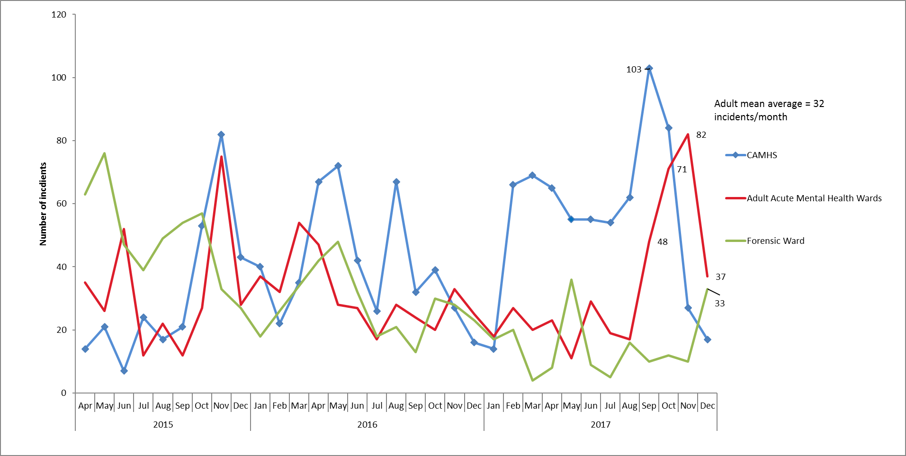

*Figure 12. Incidents of Self Harm reported on Ulysses in 3 main service lines in which Self Harm reported, April 2015 – December 2017*

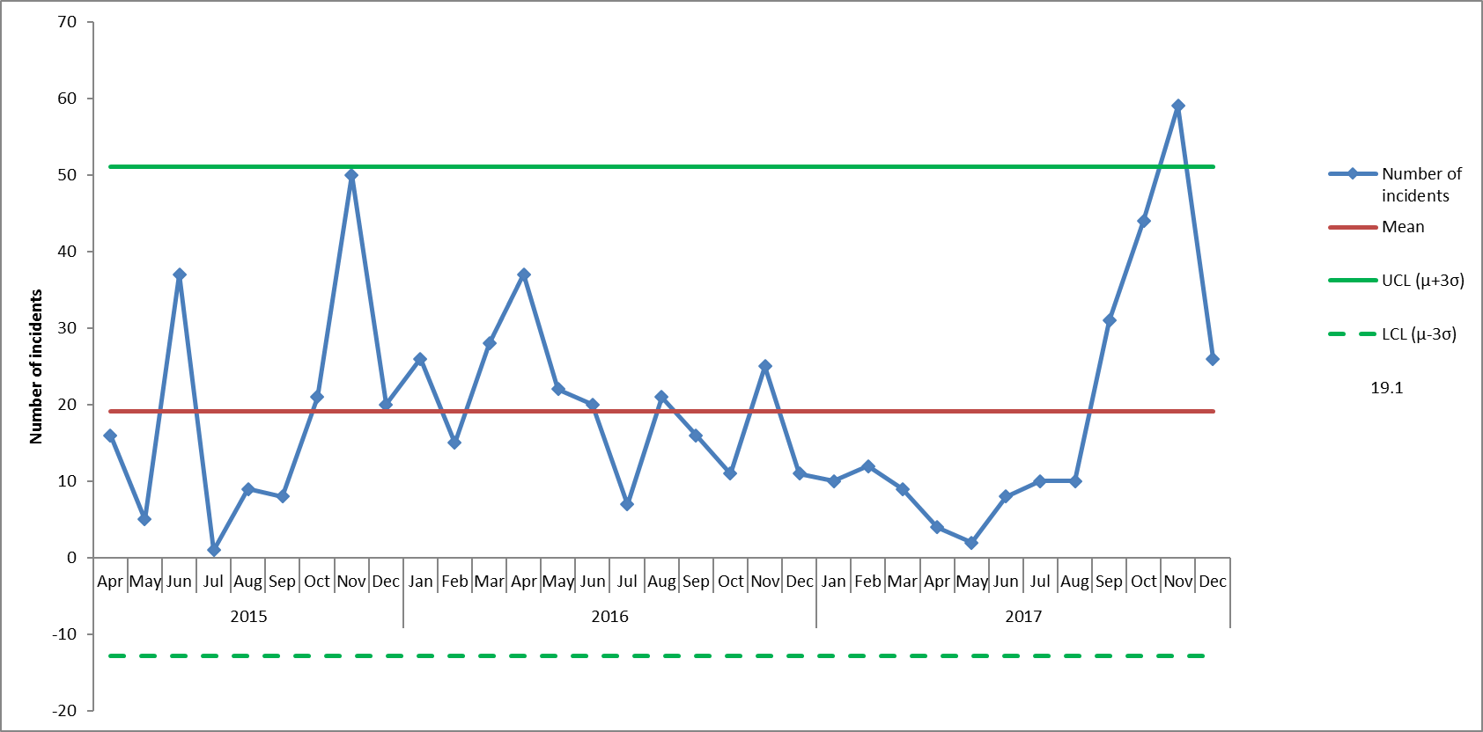

*Figure 13. Incidents of Self Harm reported on Ulysses on Ruby ward, April 2015 – December 2017*

In the Older People Directorate 10 incidents of self-harm were reported in total in Q3, across 10 different departments. Of these 4 were overdoses, one of which resulted in moderate injury. This incident occurred in the North CMHT.

In total 29 incidents were reported by AMHTs in Q3, and 16 of these were overdoses. Four AMHT incidents resulted in major injury, 2 of these (reported by AMHT Oxon City & NE) related to the same patient who had a major injury on Wintle ward. This patient has been involved in 25 incidents in the past year. An overdose AMHT Oxon City & NE resulted in major injury and a suicide attempt by jumping was reported by AMHT Bucks Aylesbury Team.

One incident of self-harm is being investigated as a serious incident, this was in CAMHS Bucks, the patient tried to hang themselves.

In Q2 the category ‘other’ made up 31% of all incidents of Self Harm reported. On October 1st 2017 3 additional sub-categories were added to the Self Harm cause group to help to better identify self-harm incidents going forward. There does seem to have been a decrease in use of the ‘other’ category in November and December and 72 incidents have been entered in the new categories (striking self or object/surroundings, ingestion of harmful items/substances, and re-opening wounds.

**2.0 Restrictive Practice**

The use of restrictive practice is reported to the weekly clinical review meeting and then on exception to the Executive Team. The most common reasons for using restraint continues to be violence and aggression on staff or self-harm.

2.1 Trends

Overall the use of physical restraints has reduced since April 2015, there have been decreases in use of restraint on forensic wards however an increase in the use of restraint on CAMHS wards relating mostly to the care of one patient who has now moved on to an appropriate placement This patient, on CAMHS Highfield, was restrained 95 times in Q3, which accounted for 79% of the incidents in which restraint was used on the ward (total= 121).

The number and duration of time in prone restraints (where the patient is placed face down) has decreased since April 2015, the mean monthly average decreased from 30 prior to June 2016, to 18 from June 2017 onwards (figure 14). In Q3 2017/18 11% of incidents (n=42) involved prone restraint, compared with 12% in Q2. A similar reduction was seen in use of the supine position, prior to July 2016 an average of 35 incidents per month in which this position was used were recorded, this decreased to 20 incidents per month from July 2017 onwards. The number of forms recording the use of the highest level of hold, thumb-wrist hold has remained low at below 3% (11 restraints in Q3 compared with 7 in Q2) maintaining the fall in high level holds.

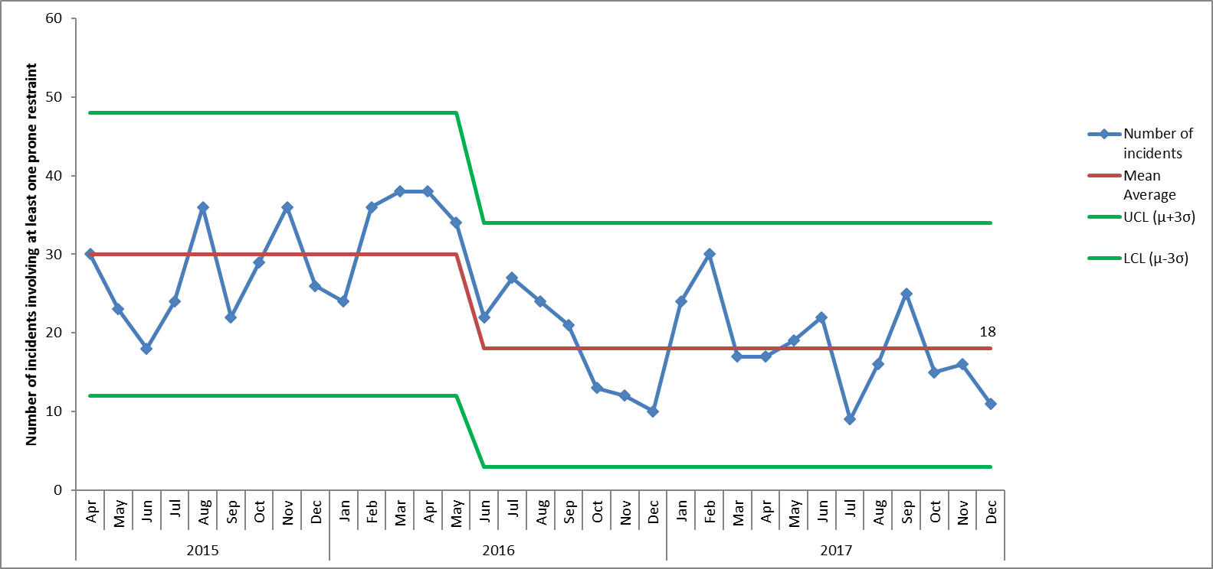

*Figure 14. Number of incidents in which prone restraint used, April 2015-December 2017*

The number of patients restrained five times or more was 18 in Q3 (previously 23 in Q2). Restraint was used on 104 patients in total in Q3, with the 18 patients who were restrained most accounting for 63% (240 out of 381) of the incidents.

Violence and Aggression has consistently been the highest course group for incidents involving restraint (with the exceptions of February and September 2017 in which self-harm was reported to be the main cause of use of restraint). In Q3 17/18 Violence and Aggression was attributed as the cause for 44% of restraints, and self-harm was attributed to 33%. Often incidents contain aspects of both self harm and violence and aggression, however, only one cause group can be selected.

Looking at all reported incidents of Violence and Aggression, the proportion of these incidents in which restraint was used has decreased from 39% to 32% from December 2016 onwards (figure 15).

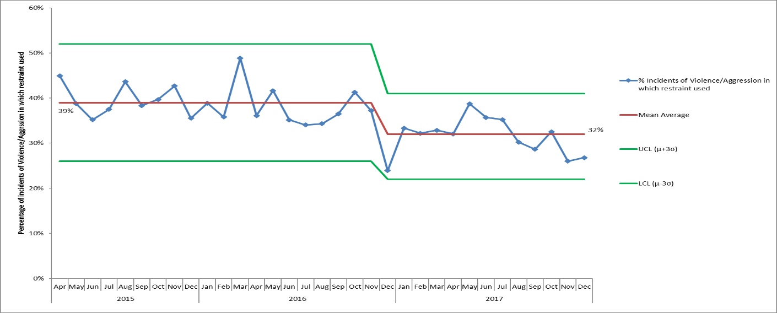

*Figure 15. Proportion of incidents of Violence/Aggression in which restraint used, April 2015-December 2017*

Use of seclusion dropped towards the end of 2015 and has been variable over the past 2 years. With the exception of October above average numbers of incidents have been reported since May 2017. The Adult directorate consistently has the highest use of seclusion within the trust accounting for 91% (96) of all seclusions. Seclusion decreased in forensic wards earlier in 2017, however below shows that this has increased in the later part of 2017. In the past, the highest reporting ward has consistently been Ashurst which is continued this quarter with 21 seclusions, involving 11 patients, one of which was secluded on 6 occasions. Ruby has reduced its seclusions this quarter to 9 in Q3 from 20 in Q2 2017/18. Kennet has the second highest number of seclusions with 17, one patient being secluded on 6 occasions. Evenlode had a patient that was secluded on 5 occasions.

Within CYP directorate 8 seclusions were reported and Highfield had a patient who was secluded on 7 occasions. The older people directorate reported one seclusion in Q3. The cause group attributed to the majority of seclusions is violence and aggression, which was the cause group in 80% of incidents in which seclusion was used in Q3 (84 of 105 incidents).

In Q2 17/18 long term segregation (LTS) was used for 619 days in total, a reduction from 822 days in Q2. At the end of quarter 3 there were 3 patients in LTS. A patient has been in LTS since the February 2017 on Highfield. The clinical case has been outlined in the restraint section of this report, and this patient has now been transferred to another service. The patient who has been in for 102 days is now back in LTS following only managing a short period on the main ward on Kennet. The patient who has was in LTS on Ashurst for 100 days has been transferred to a specialist placement to meet his complex health needs.

The chart below enables us to crudely compare use of restrictive practice. At present the overall picture from the data outlined in this report is that our restrictive practice is reducing albeit at a very steady rate.

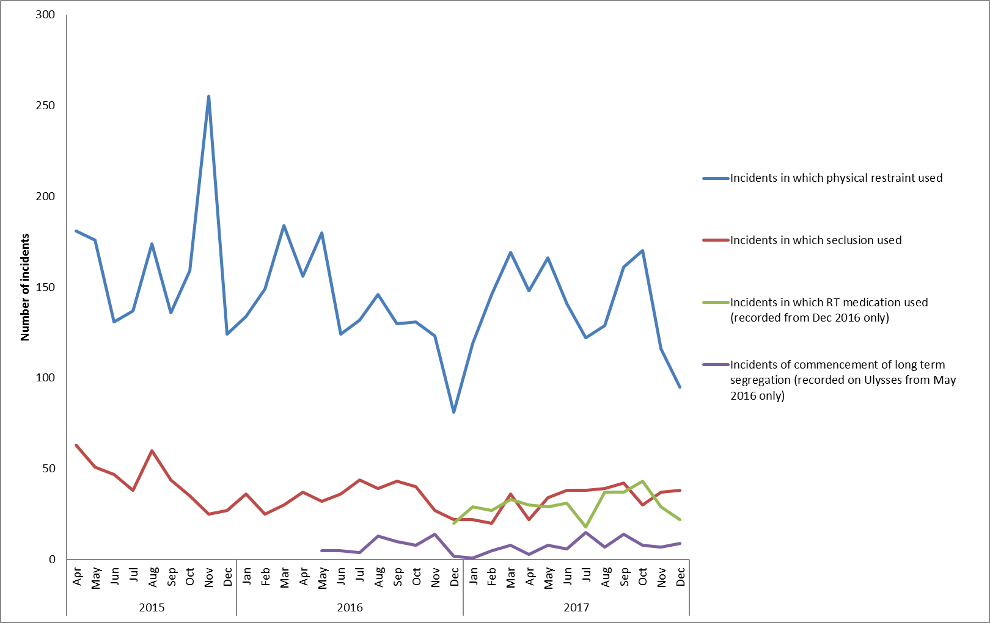

*Figure 16. Comparison of types of interventions used, April 2015-December 2017*

**3.0 Never Events**

The trust has reported a never event in relation to the circumstances surrounding the death of a disabled child at their home in November 2017 who was receiving support from the children’s integrated therapies service. An internal investigation has started and an independent investigation is being commissioned to consider whether the death was associated with a known risk around the use of a particular bed. We have informed the CCG, NHS England and the CQC of the never event.

**4.0 Data Quality**

4.1 Contract with Ulysses Limited

We have renewed the software licence contract with Ulysses Limited for a year from 20th August 2017 to continue the supply of the incident management system, which we also use to manage concerns/ complaints, legal claims, policy register and patient safety alerts. Currently there is only one other competitive supplier in the market place, Datix. The product offered by Datix was reviewed in 2016/17 with the decision that currently Ulysses provides the better system with more functionality, flexibility and at a more competitive cost. The learning disability services which transferred used Ulysses previously, so by remaining with Ulysses there was continuity for staff and the incident/ complaint data for the last 2 years was able to be transferred. Ulysses provides the trust with training as required, webinars on upgrade changes and a customer helpline. The last upgrade to the system was implemented by Ulysses in November 2017.

4.2 System developments

The information analyst in the quality and risk team leads on system developments and on extracting and analysing data from Ulysses. The member of staff is currently seconded to work three days a week in the Business Intelligence team which enables a good transfer of knowledge and skills. The focus is on developing an interactive automated dashboard using BI software to bring together a range of data sources including patient systems, complaints/ concerns, incidents and Sis, staffing information, training and appraisal information.

The incident management system is continually being developed and a change document is kept to catalogue changes made. A group of senior staff meet regularly to discuss and approve requests from users (staff), improve data quality, develop the design of the system, and discuss future development requirements.

4.3 Incidents waiting to be graded by managers (also known as being held in web holding)

On 12.01.18 the number of incidents awaiting to be graded by the reporters’ manager was 1293, compared with 1382 at the end of Q2. Again, the teams with the highest number of incidents waiting for grading has changed. At the end of Q2 AMHT City and NE had the most incidents awaiting grading with 133, whereas they now only have 21 outstanding. Ruby ward now has the most incidents awaiting grading with 247 as of 12.01.18 (table 5). High numbers of incidents were reported on Ruby in Q3 (n=193). Sapphire have a high number in relation to the number of incidents reported in the previous year (72% of incidents reported in 12 months are still awaiting grading). There are no incidents in web holding over 12 months old.

Incidents waiting to have the risk rating graded are still included in all reports as the actual impact and detail of the incident are reported, but there is an on-going work with individual teams to try and reduce the number in order to improve data quality and timeliness of incident reviews by managers. The details of major incidents/ deaths are uploaded to NRLS within 2 working days based on impact to the patient. All incidents are emailed to the manager of the reporting person, plus all ungraded incidents are reviewed by the central quality and risk team to ensure serious incidents are not missed and a regular report of all ungraded incidents is sent to the directorate governance teams. The Quality and Risk team also offer support to teams with high numbers of incidents awaiting grading within a particular quarter, an admin member contacts teams and offers to spend time with them in order to help reduce the numbers and provide guidance if there are any queries.

The Trusts revised policy as of September 2017 states incidents should be closed by the manager within 7 working days. The NRLS requires NHS trusts to upload all patient safety incidents at least monthly and recommends any deaths or incidents with major impact should be uploaded within 2 working days. In 2016/17 the median number of days to close an incident was 9 days (the mean was 26 days), all major incidents/ deaths were updated within 2 working days of being detected.

*Table 5. Incidents in web-holing in relation to incidents reported in previous 12 months*

|  |  |  |  |
| --- | --- | --- | --- |
| **Departments with 30 or more incidents that have been open for > 7d** | **Total incidents in Web-holding, 12.01.18** | **Total number of incidents reported in previous year, Jan - December 2017** | **Incidents in web-holding as % of incidents reported in 12 months** |
| Ruby Ward (AMBHW02) | 247 | 449 | 55% |
| Sapphire Ward (AMBHW01) | 142 | 196 | 72% |
| Ashurst Ward (WAASHH) | 68 | 330 | 21% |
| CAMHS Marlborough House (TE296) | 43 | 399 | 11% |
| Wenric House (WAWEN) | 31 | 300 | 10% |
| Luther Street Medical Centre | 30 | 141 | 21% |

**5.0 Patient safety alerts and Risk Notes**

In Q3 19 patient safety alerts were issued (excluding 9 high voltage alerts), of these 15 were applicable to the Trust and were cascaded.  11 alerts where closed in Q3 and there are no alerts that are overdue. Confirmed in reporting by NHS Improvement.

One risk note was issued in Q3 - Risk note 17, details below:

*Title: Use of trust medicines*

Date of Issue: October 2017

A recently reported medicine incident highlighted that some clinical staff may be using medicines, supplied by the trust, to treat their own symptoms.

This practice is unacceptable and breaches trust policy. Medicines procured and supplied by the trust are solely for the use of patients receiving OHFT care.

Staff must ensure that they bring their own supplies of medicines to treat either illness or minor ailments.

**6.0 Learning from Deaths**

A separate report was presented to trust board in January 2018 with information and themes from the reviews of deaths up to 31st December 2017.

Since January 2017 there have been three formal complaints and one concern received relating to the care of a patient who has now died, one of which has been subsequently withdrawn. Each of the concerns has been investigated and responded to.

6.1 Coroner reviews

In May 2017 a review was completed to check if all detained patient deaths had been reported to the coroner as required following a change in requirement from July 2013. All but one death which occurred in an acute hospital premise (not on our Trust’s premises) has been referred to the coroner appropriately. The one death not referred to the coroner was subject to an internal SI investigation and referred later to the coroner who decided to take no further action. Learning was identified following the mistake not referring one death to the coroner; to improve the liaison between the legal team and the MHA office, and to improve medic knowledge about the requirements and responsibilities to report a death to the coroner.

A coroner will issue a Regulation 28 to Prevent any Future Deaths (PFDs) if they feel any actions or learning is not being acted on sufficiently. The Trust has received two Regulation 28 rules in 2016/17 (SI 66 and SI 110) and one in 2017/18 (SI 62), we have responded to the coroner with the actions taken and the detail has been previously reported to the safety quality sub-committee, quality committee and trust board.

The trust has also received two informal letters from coroners in 2017/18 (these are not PFDs):

1. SI 122 (downgraded) In June 2017 an Oxfordshire coroner wrote to the Trust following an inquest into an ex-patient who committed suicide, to ask for more assurance around issues raised at the inquest regarding this lady’s discharge from an adult AMHT and relying on her to self-refer to the complex needs service with no follow up from the AMHT. Response sent to coroner.
2. SI 111 - In December 2017 an Oxfordshire coroner wrote to the trust asking for more assurance around two concerns in relation to medicine management and liaison with family. Response being compiled.

**7.0 Serious Incident Review**

7.1 Summary of number of serious incidents and themes

In Q3 of 2017/18, 14 SIs[4] have were identified and reported, of these 1 was subsequently downgraded. Of the 14 reported SIs in Q3, 9 involve a death of which 4 are suspected or confirmed suicides. One SI related to a patient in ICU following self-harm. In total in FY 17/18 so far 52 SIs have been identified and reported and 13 of these have subsequently been downgraded.

In Q3 of 2017/18, 10 SI investigations were completed, reviewed at panel and submitted to the commissioner.

The key themes and learning from the serious incidents and deaths reviewed are;

* Physical health care needs to be more routinely reviewed and monitored in mental health
* Vulnerability at points of transition between teams, with private providers
* Information around changes in risk is not routinely communicated between members of the same team or with other teams
* Identification and involvement of family/ carers

The themes and actions being taken are detailed below.

| Theme | Actions being taken |
| --- | --- |
| Physical healthcare for patients with a mental health illness | Physical healthcare group  The trust-wide physical healthcare group reports to the effectiveness quality sub-committee which is leading on this work. There are also CQUINs around this theme for 2017/18.  A gap analysis has been completed against the CQCs standards on physical healthcare in mental health services. This identified a number of actions which have been taken in 2016/17, for example;   * Purchasing new equipment to carry out annual physical health checks for all patients on caseload * Developing a new patient handbook * Introducing a ‘my physical health assessment and plan’ * Implementing physical health clinics in each AMHT * The Clinical Practice Educators have developed and deliver mandatory training for all AMHT staff, with enhanced competency based training for nurses and OTs. * Physical health leads have been identified in each AMHT and adult/ forensic ward. Leads have completed a 4-day physical health skills training course. The leads meet 6 weekly. * The recording of physical healthcare information on the trusts electronic health record has been reviewed and amended; there are now only 5 forms available, all found in one area in the patient’s record. * Expanding the availability of Immediate Life Support training   Work plan for 2017/18  The analysis also identified further actions for 2017/18 including;   * RGN physical health leadership posts are being recruited to support the AMHTs and adult wards * Standardising the model of physical health clinics offered by AMHTs * Improving how inpatient discharge information is shared electronically and automatically with GPs * Improving how staff monitor identified cardio-metabolic risk factors * Continue the work led by the IAPT services as early implementer sites for better integrated pathways for people with a long term physical health * Develop and introduce an electronic MEWs form for the wards on CareNotes.   A modern matron with a lead for physical health in mental health started in January 2018.  A successful physical health conference was held in Jan 2018.  New Strategy  A new physical health strategy linked to the work of the Five Year Forward View for Mental Health and the CQCs quality standards is in development. The physical health strategy will be broader than for mental health services to include pressure damage, sepsis, falls, diabetes care, and public health elements related to MECC/ smoking cessation. |
| Family/ carer engagement and communication | Strategy  The ‘I Care, You Care’ (carers) strategy is focused on improving this issue. A new role, carers lead has been recruited and the person is due to start at the end of February 2018 to lead on the implementation of the above strategy.  Triangle of Care accreditation  The Trust continues to work towards achieving a third star in the Carers Trust triangle of care accreditation (we currently have two stars awarded). The teams continue to complete self-assessments against the national carer standards and be peer reviewed by the Carers Trust. The last peer review was in Dec 2016.  Commitment to carers  The Trust has also worked with other organisations and carers in Oxfordshire to co-produce a ‘commitment to carers’ similar to a charter to be clear with carers and staff the standards expected. The commitment is planned to be launched by March 2018. |
| Communication at points of transitions and changes in care between teams, services or organisations | Transition development group  The terms of reference for the Trust’s transition development group have been widened to include clinical and managerial representatives from adult mental health services, adult social care and third party organisations. The group has developed an improvement plan based on the results of two audits one in 2016/17 and one in 2017/18. The quarterly audit has been continued to monitor the impact of the improvement plan.  The transition development group oversees the improvement plan but also reviews disputed cases escalated by clinicians, for review, analysis and learning to determine if appropriate decisions were made with regards to on-going needs of a young person.  Improvement plan  The improvement plan includes;   * Review of the Trust’s transition protocol * Review of incident and complaint data to identify learning * Introducing a new quarterly audit of all young people transitioned * Developing a link in with the county council to review the transition pathway for social care * Improving information on web forums, new CAMHS website for example, regarding transition, third sector organisations and provision. * Developing relationships with new partners in new Oxfordshire CAMHS model and in particular transition planning for those young people not transitioning to adult mental health teams * Linking with the college nurses to get a joined up approach to engage them with young people who may be in their colleges and transitioning   The above work is also supported by a national CQUIN in 2017/18 focused on improvements to the experience and outcomes for young people as they transition out of Children and Young People’s Mental Health Services (CYPMHS) into Adult Mental Health Services (AMHS).  HSIB  In addition, the Trust has been working voluntarily with the Healthcare Safety Investigation Branch (HSIB), around transitions following a death, to ask for their expertise to identify improvements and learning from elsewhere in the country and internationally. A preliminary scoping investigation has been completed with findings reported back in November 2017. HSIB considered there was a potential for national learning so a full investigation has been started. An interim bulletin about the decision to move to a full investigation is due to be published at the end of January 2018.  Thematic review  The trust has almost completed a thematic review around joint working and information sharing between adult mental health teams and children’s services. A senior group of clinicians reviewed the draft analysis, findings and recommendations in January 2018. |

Table 7.

7.2 Timeliness of process

Since April 2017 38 SI investigations have been completed including those downgraded after completion. Of these five investigations have breached the 60-day national timescale without an agreed extension from the CCG (4 OCCG and 1 BCCG). Eight investigations have been submitted before the deadline. Currently there are 18 SI investigations in progress of which 6 have extensions agreed with the CCG due to the complexity of the investigation or further time needed to work with the patient/ family. The progress with investigations is monitored and reported to the senior clinical weekly review meeting.

7.3 Developments to the SI process

Following three audits of the SI process and quality of investigations in July 2016 (Oxford AHSN), Oct 2016 (Mazars group) and May 2017 (Tiaa) and feedback from past investigating officers (Aug 2016) the below actions have been completed.

In 2017 the SI database was moved to be held on the Ulysses system alongside incidents to remove duplication by the central team, improve data quality and to enable better analysis. Additional checks and improvements to demonstrating patient/ family engagement in the process were introduced as part of the SI panels, which is part of a perspective audit. Reporting on process measures and the status with actions from completed investigations has been improved and is now reported weekly to the senior clinical review meeting.

The central SI team revised, consulted on and rolled out new reporting templates for initial review reports and SI investigation in mid-2017 and revised the policy on the reporting and management of incidents and deaths which was published in September 2017. Trust-wide reoccurring themes were added to the SI investigation report template so that authors consider these themes/ factors in their investigations.

A new information leaflet for families to encourage engagement in the SI investigation was developed and introduced in 2017.

Changes to the SI root cause analysis training were introduced in early 2017 which included enhancing the one-day foundation course to include three further modular half days, the modules were focused on family engagement including language/ tone of reports, cognitive interviewing and human factors in healthcare. The reason for these changes was to improve the quality of investigations (including analysis of root causes) and family engagement in the process. The changes have been evaluated with participants and in 2018 the training content will remain largely the same however the training will be delivered across two consecutive days.

The team continue in 2018 to work on improving how; i) families are engaged and involved in investigations, ii) learning is shared across the trust and iii) actions are sustained and their impact reviewed.

7.4 Review of SIs in previous 3 years

There has been a reduction in the number of confirmed serious incidents in the previous 3 years (figures 24 and 25). Prior to November 2016 the mean monthly average was 9.6, from November 2016 onwards an average of 4.9/month have been confirmed.

The decline has been seen in the Older People Directorate, particularly in relation to pressure ulcers. Within this time there has been no change to the overall numbers of pressure ulcer incidents reported (mean average = 164 incidents/month) so the reduction in serious incidents is not a result of a reduction in identification or reporting. The decrease in the incidence of serious incidents of pressure damage in Older Peoples Directorate comes as a result of a dedicated focus within community nursing teams to assess and advise their patients and carers on the signs of pressure damage and to put in place preventive measures. This has led to a zero occurrence of grade 3 and grade 4 acquired pressure ulcers over the last 4 months, since Sept 2017 (figure 26).

There has also been a possible decrease in serious incidents in the category of ‘apparent/actual/suspected self-Inflicted harm’. Numbers are variable but have been average or below average for 11 months in 2017 (figure 27). This reflects the continued commitment in the adult directorate to improving the assessment of risk and improving the involvement of the family/ carers of those patients at high risk of self -harm. Again, there has been no change to overall numbers of incidents of self-harm reported in this time frame (mean average = 130 incidents per month) so the potential reduction in number of serious incidents is not related to a reduction in reporting.

The table below shows the categories in which most serious incidents have been reported over the previous 3 years (based on STEIS cause), no trend has been seen within any other categories.

*Table 6. STEIS causes with most reported serious incidents in past 3 years, Jan 2015-Dec 2017*

| **STEIS cause** | **Number of SIs** |
| --- | --- |
| Apparent/actual/suspected Self-Inflicted Harm Meet | 104 |
| Pressure Ulcer Meeting SI Criteria | 52 |
| Slips/trips/falls Meeting SI Criteria | 26 |
| Disruptive/aggressive/violent Behaviour Meeting SI | 21 |
| Diagnostic Incident Including Delay Meeting SI Cri | 20 |
| Abuse/alleged Abuse Of Adult Patient By Staff | 5 |
| Medication Incident Meeting SI Criteria | 5 |

The table below shows the teams with the most reported SIs over the past 3 years including the most common cause and the trend in numbers year by year. Four out of the five teams have reduced the number of SIs they have had in the last 3 years.

*Table 7. Departments with 10 or more confirmed serious incidents from Jan 2015-Dec 2017*

| **Department** | **Number of SIs** | **Comments** |
| --- | --- | --- |
| AMHT Oxon City and NE (AMHO08) | 24 | 15 were apparent/actual/suspected self-harm.  10 happened in 2015  8 happened in 2016  8 happened in 2017 |
| AMHT Bucks Aylesbury Team (AMHB01) | 16 | 11 were apparent/actual/suspected self-harm.  5 happened in 2015  5 happened in 2016  6 happened in 2017 |
| AMHT Bucks Chiltern Team (AMHB04) | 15 | 11 were apparent/actual/suspected self-harm  4 happened in 2015  5 happened in 2016  2 happened in 2017 |
| Ruby Ward (AMBHW02) | 12 | 7 were apparent/actual/suspected self-harm.  7 happened in 2015  5 happened in 2016  2 happened in 2017 |
| AMHT Oxon North And West | 10 | 7 were apparent/actual/suspected self-harm.  4 happened in 2015  4 happened in 2016  2 happened in 2017 |

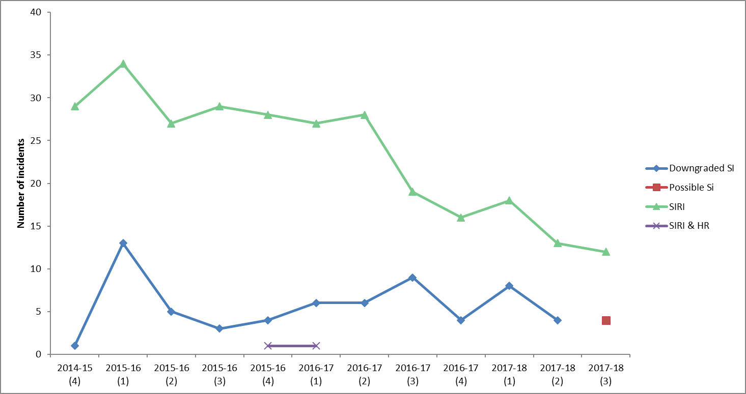

*Figure 24. Confirmed, downgraded and possible SIs, quarterly from January 2015 – December 2017*

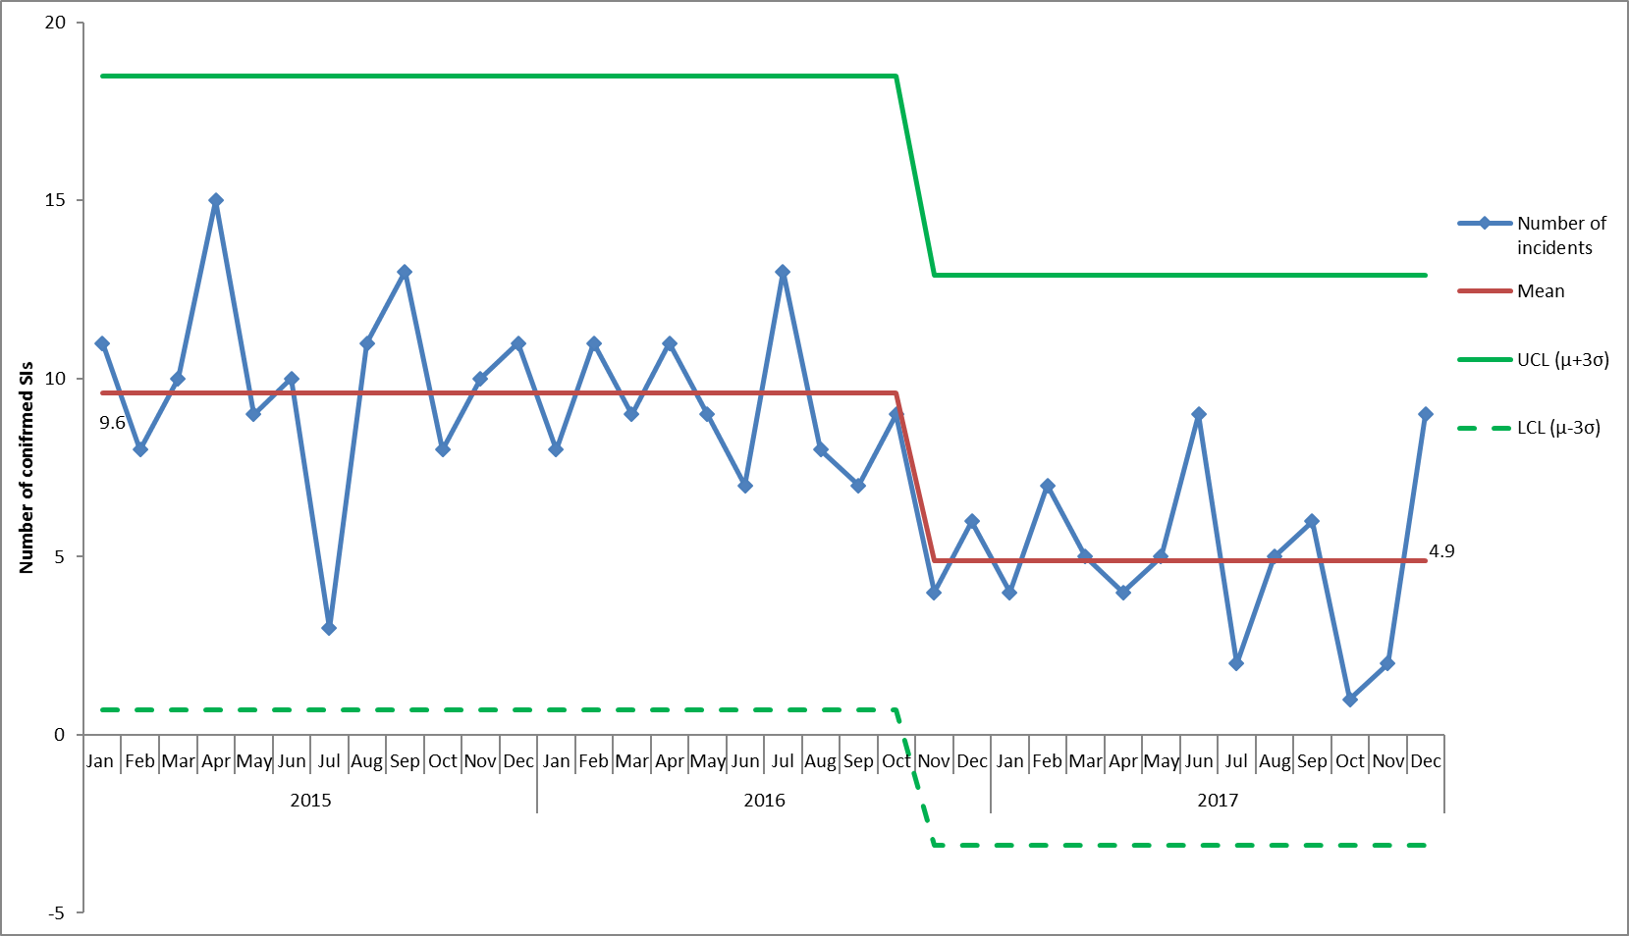

*Figure 25. Monthly numbers of confirmed serious incidents, January 2015 – December 2017*

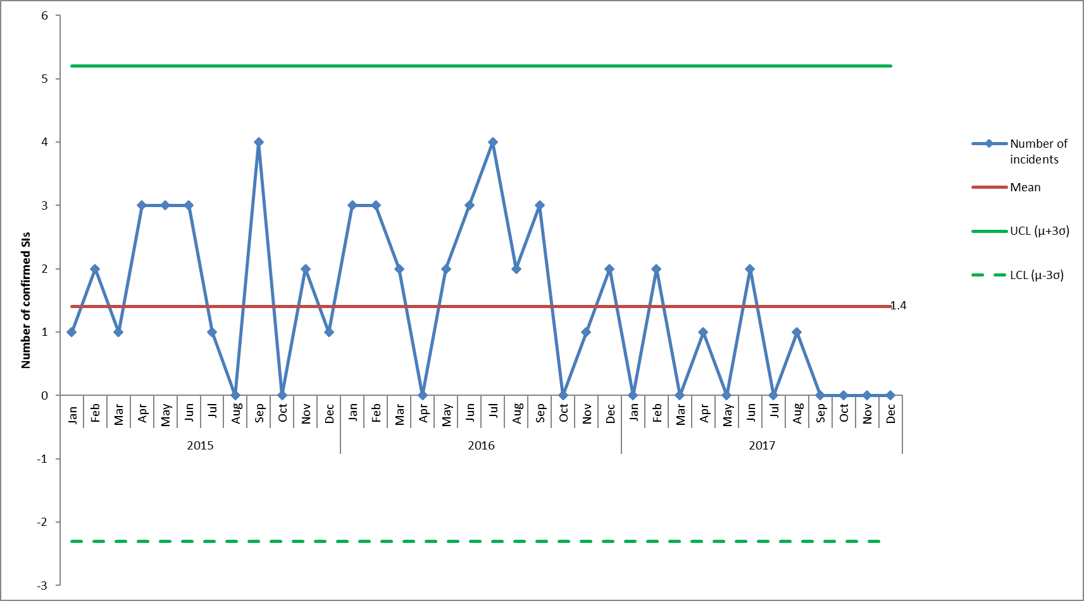

*Figure 26. Monthly numbers of confirmed SIs due to pressure ulcers, January 2015 – December 2017*

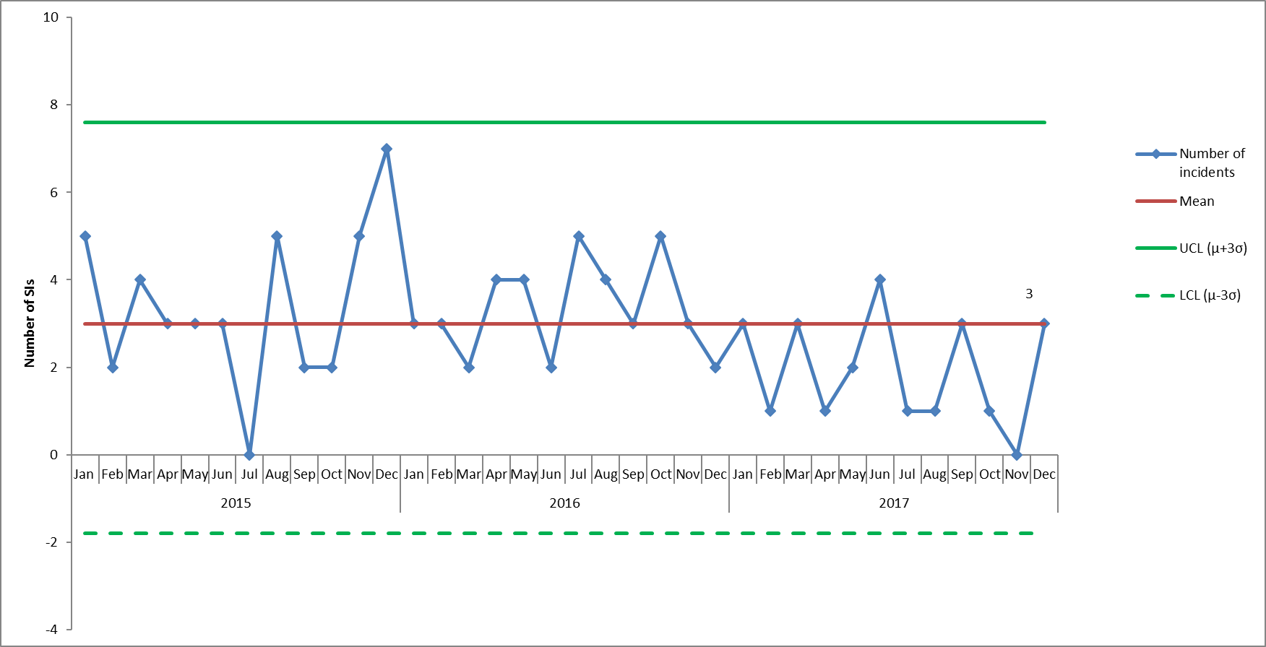

*Figure 27. Monthly numbers of confirmed SIs with Steis cause 'apparent/actual/suspected self-inflicted harm meeting SI criteria', January 2015 – December 2017*

7.5 Overdue Actions from Serious Incidents

There are a total of 45 overdue actions currently. Table 9 below summarises the number of actions currently outstanding for each directorate, this is reported weekly. Recent assurance visits by both Oxfordshire and Buckinghamshire commissioners have been positive around demonstrating actions have been taken and sustained.

*Table 9. Serious incidents with outstanding actions as of February 2018*

|  |  |  |
| --- | --- | --- |
| Directorate | Out of date Actions | Compared to last week |
| Children and Young people | 3 SI's with 11 individual outstanding actions. | No change |
| Adult | 18 SI's with 32 individual outstanding actions. | No change |
| Older People | 2 SI's with 2 individual outstanding actions. | Reduction |
| Total | 23 SI's with 45 individual outstanding actions. | Reduction |

**8.0 Homicide Reviews**

The Trust participates in multi-agency mental health homicide investigations and domestic homicide reviews as appropriate. Detailed information on the outcome and recommendations from each review/ investigation is provided on a 6 monthly basis to the Quality Committee. The number of reviews has increased since the Home Office revised their guidance in December 2016 which sets out that all suspected or confirmed suicides where there was coercive controlling behaviour in a personal relationship will now be subject to a domestic homicide review.

In summary between April 2011 (new legislation) to Jan 2018 we have;

* Participated in 16 reviews/ investigations
* Of which 10 were also investigated internally through the SI process
* Currently 6 reviews/ investigations not completed.

The root cause themes identified from both internal and independent reviews/ investigations are below. The key shows what type of review of investigation has been undertaken.

|  |  |  |  |  |  |  |
| --- | --- | --- | --- | --- | --- | --- |
|  | Theme | | | | | |
| Incident date | Leadership | Oversight of processes | Transitions/ hand-offs | Recording and documentation | Consideration of families/ dependents | Service Model |
| Aug 2011 (MHH) | x | x | x | x |  |  |
| Aug 2011 (DHR)  *Theme identified from local SI investigation* |  | x |  |  |  |  |
| Aug 2012 (DHR) | x | x | x | x |  |  |
| Jan 2013 (MHH) |  |  |  | x |  | x |
| Oct 2014 (DHR) | No recommendations | | | | | |
| April 2015 (MHH) | x | x | x | x | x |  |
| May 2015 (DHR) | No recommendations | | | | | |
| Aug 2015 (DHR) |  |  | X |  |  |  |
| Dec 2015 (MHH) |  | x | x |  |  | x |
| 2015 (DHR) |  |  | x |  |  |  |
| Jan 2017 (DHR) | Under review DHR, no SI completed | | | | | |
| Jan 2017 (DHR) | Under review DHR, no SI completed | | | | | |
| Feb 2017 (DHR) | Under review DHR, no SI completed | | | | | |
| Feb 2017 (DHR) | Under review DHR, no SI completed | | | | | |
| March 2017 (MHH)  *Themes identified from local SI investigation. Independent investigation underway* |  | x | x | x | x |  |
| Aug 2017 (DHR) | Under review DHR, no SI completed | | | | | |

1. This is based on more historic information from Oct 2016-March 2017.
2. This is based on more historic information from Oct 2016-March 2017.
3. In July 2016 changes were made to the Ulysses system to enable reporting on whether pressure ulcers were ‘acquired’ in the service of Oxford Health or ‘inherited’ before the patient came into our care.
4. Serious Incidents are nationally defined as incidents where there were acts or omissions identified in care that resulted in death, lead to abuse or serious harm requiring further treatment