BOD 35/2018
(Agenda item: 7)

Report to the Meeting of the

Oxford Health NHS Foundation Trust

Board of Directors

29th March 2018

Monthly Performance Report – M11 February 2018

For: Information

Executive Summary

The monthly performance report provides an overall view of the Trusts performance against both national and locally contracted indicators. In February, the Trust met 833 of 928 (90%) of the performance indicators. Although the number of indicators reported each month varies due to a number of factors, Oxford Health continues to achieve 90% compliance overall.

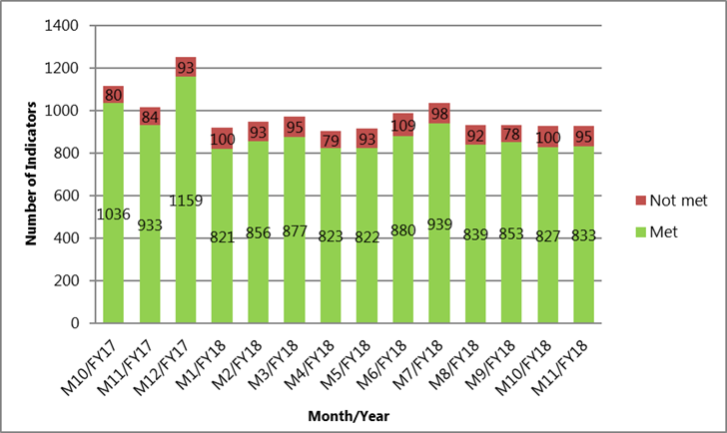

Changes to Board Report for March 2018

As part of our ongoing process to improve the information reported to the Board of Directors and the Trust, there have been a number of additions to this month’s Board Report.

From March 2018, the following will now be reported:

- Performance information for the S75 Agreements with Oxfordshire County Council and Buckinghamshire County Council. These are overseen by the Joint Management Group (JMG)

- Activity Information for the Older Peoples Directorate with exceptions based reporting. Adults and CYP will be included once data has been validated

Future planned changes:

- The existing Board Report will be updated to reflect the new Directorate structures in April 2018 and be presented in the May 2018 Board Report.

- Demand and Capacity reporting by Service Line and key areas of shared learning

- A scorecard to show performance against planned work within the Service Change & Delivery Team. (Projects & Programmes)

Performance Trends:

Although the Trust consistently achieves 90% compliance against contracted indicators, there are a small number of areas where performance is below the required levels. These areas of non-compliance are extracted from the Trust’s performance dashboard and presented in this report using an ‘exceptions’ based format. Further analysis continues on those indicators that are consistently being reported as ‘red’ so that the root causes can be identified and resolved. Progress updates are being included within this report as information becomes available.

National Position:

Following a review of the performance data, the following indicators continue to be highlighted as underperforming at a national level. This is primarily because the data published by NHS digital is not the latest information:

- Workforce – The difficulties in recruiting and retaining suitably qualified staff continues to have a direct impact on the Trust’s ability to deliver services. Work to address these issues continues to be led by HR under their Workforce Strategy.

- % of Clients in Paid Employment – According to nationally published data, performance for this indicator has been below target since September 2017. Work is now underway to understand if this is a data quality, reporting or a service delivery issue as it has not been reported via the standard Outcomes Based Contract reporting.

- Settled Accommodation - At a national level, performance is measured against a definition of settled accommodation. However, within the Outcomes Based Contract (OBC) the definition used by our Commissioners is stable accommodation. Although we are not compliant using the national definition, the Trust has achieved the locally contracted targets. We have recently asked the Oxfordshire Commissioners to assist in resolving this long term issue.

S75 Agreements with Oxfordshire County Council and Buckinghamshire County Councils

The Trust achieved 92% compliance in month 10 (reported one month in arrears) against the indicators used to measure and monitor performance for the S75 agreement in Oxfordshire. Buckinghamshire performance is reportable quarterly.

In looking at performance trends, the following areas (where specific targets have been set), are reported as exceptions:

- Number of care placement reviews completed (non-s117) – Work is underway to validate the data and investigate under-performance. The position will be checked and confirmed in preparation for the April 2018 Board Report.

- Buckinghamshire: Percentage of Clients receiving an annual review - Team managers are now receiving weekly reports of outstanding/overdue Community Based Services and Placement reviews and are working on these. In some instances, reviews have been carried out but there have been delays adding the information into the IT systems. New administrative staff are assisting with this and performance is expected to improve by the end of April 2018.

Older Peoples

The Older Peoples Directorate achieved 77% compliance in February against the contracted targets. This is consistent with the performance achieved in January with pressures continuing in particular in the Out of Hours and Continuing Health Care (CHC) services.

In looking at the performance trends and identifying areas where further action is required, the following issues have been highlighted and escalated to the Operations Management Team:

- The Out of Hours (OOH) Services. Services remain under pressure over the winter period and 3 of the 9 indicators continue to breach (unfilled shifts, face to face base visits & urgent triage for walk in patients). The service continues to ensure that every patient is safe whilst under OOH care and the team are continuing their improvement work. At the present time, the service continues to forecast compliance with all indicators by May 2018.

- Oxfordshire Continuing Health Care (CHC) Adults – There was a significant increase in January in the number of referrals that required a 7-day assessment. This has impacted on capacity both in January and February resulting in breaches in 3 of the 10 CHC performance indicators. The department and the service continues to work proactively to reduce the number of outstanding reviews and avoid any unnecessary delay. The remaining breach is not within the gift of the service to achieve and is therefore under negotiation with the commissioner.

- Estimated Discharge Date (EDD) – Although there has been an improvement in the recording of estimated discharge dates, further discussions continue with the Oxfordshire CCG about the changing of this target to a more clinically relevant timescale of 72 hrs.

- Stroke Therapy – Improvements in the stroke therapies continue with now only one indicator in breach (speech and language therapy). Two indicators that were previously of concern (Occupational Therapy and Physiotherapy) have now been successful achieved. This position will now be closely monitored to ensure sustainability.

- Physical Disabilities Physiotherapy Service. There has been a consistent increase in referrals to the Physical Disabilities Physiotherapy Service (due mainly to Parkinson’s). The Service has reviewed the current delivery model and has taken all steps possible to improve efficiency which has been overseen by the commissioners. A business case to justify an increase in investment has been submitted to Oxfordshire CCG and we await the outcome of their review.

- Delayed Transfers of care (DTOC) and Length of Stay (LOS) continue to be an issue across the system. Although there has been a significant impact due to the delays as a result of the HART service capacity issues, work continues to address the issues that are solely within the remit and control of Trust. The excellent performance reported last month has continued and the position as of the 15th March was 9 patients attributable to the Trust.

- Activity Headline - 80% of Older People’s services delivered activity YTD that was within or over 10% of the activity they delivered last year at the same point. Services that showed an increase over 10% more than last year were;

  - Falls Service – +83%
  - Bladder and Bowel – +19%
  - Respiratory Nursing - +13%
  - Continuing Care – +11%
  - Diabetes Specialist Nurse - +12%

Children & Young People

In February, CYP achieved 94% compliance against the combined performance assessment framework indicators and locally agreed contracted targets.

In looking at the performance trends and identifying areas where further action is required, the following issues have been highlighted and are now being overseen by the Operations Management Team:

- Autism Spectrum Disorder (ASD) – As reported last month. A new pathway for ASD is being introduced to overcome the considerable delays that have previously been seen within this service. The new pathway will have increased staffing and there is early confidence that patients will be seen within the 12 week targets that have been agreed with commissioners. The new pathway will be operational from April 2018.

- CAMHS 12 Week waiting times – During February the service completed 302 assessments. The ongoing performance issues are due to the work to clear the significant backlog of waiters who had already breached the 12 week wait time when they were assessed. A comprehensive plan is in place to achieve the agreed contractual targets and to address the backlog of referrals that are currently queued. This is being overseen by a joint CCG & Oxford Health mobilisation Team.

- CAMHS ‘Getting More Help’, 4 Week Waits – Buckinghamshire – Additional assessments are being offered in the Getting More Help Pathway with the expectation that the Service will achieve the 4 week waiting time target by April 2018.

- Buckinghamshire CAMHS 4 Week waiting times – The service is now offering additional assessments as part of a targeted effort to improve the 4 week wait times by April 2018.

- CAMHS 4 Week waiting times – There continues to be issues with the 4 week waiting time targets, in particular in Swindon, Wiltshire and Bath & North East Somerset (BaNES) (T2). Work is underway to introduce the new service delivery models and to resolve the current workforce issues. We expect to see an improvement in performance in Q2 2018.

Adults:

The Adults Directorate achieved 75% compliance against the contracted targets in February. A small increase in the performance reported in January.

In looking at the performance trends and identifying areas where further action is required in the Adults Directorate, the following issues have been highlighted and escalated to the Operations Management Team:

- Improving Access to Psychological Therapies (IAPT) CBT – The substantial reduction in the number of ‘hidden waits’ at step 3 has been held at 10 weeks during February which is excellent given the current conditions. Further work is underway to achieve the 8 week target.

- Improving Access to Psychological Therapies (IAPT) Counselling – Since November 2017, there has been an increase in waiting times for counselling. Against a target of 8 weeks, the Service are currently reporting 11 weeks. This is due to a shortage of accommodation which is being addressed in the short term with one of our partners – PML. This indicator will be closely monitored and updated next month.

- Cluster Reviews – The cluster reviews indicator in Oxfordshire continues to be below target though improvements are being steadily seen. Operational staff continue to be reminded of the importance of clustering within the agreed timescales. The services are currently forecasting to achieve the contracted target by April 2018.

- Care Reviews - Analysis of the performance data has shown that timescales for care reviews specifically in Aylesbury continue to be below target. Service leads continue to work with operational services to improve this position.

- Learning Disabilities – Work is currently underway to validate the data used as evidence for the new indicators. The position will be checked and confirmed in preparation for the April 2018 Board Report.

Recommendation

The Board of Directors is asked to review and note the monthly Board performance report.

Author and Title: Martyn Ward – Director of Performance & Strategy

