

# Report to the Meeting of the

# Oxford Health NHS Foundation Trust

**BOD 37/2018**  
(Agenda item: 9)

# Board of Directors

# 29th March 2018

# INPATIENT SAFER STAFFING Report Period 29th January 2018 to 25th February 2018

**For: Information**

**Executive Summary**

**Ward Staffing**

The purpose of this paper is to provide a report of the actual inpatient staffing levels to the Board of Directors. There is a national requirement on providers to be transparent in our monitoring and reporting of inpatient staffing levels and the impact on patient care. Ensuring sufficient staffing levels are in place is crucial to deliver safe, effective and high quality care. This report will be published on our website with a link from NHS Choices website.

The data within the report will outline the staffing levels (for both registered and unregistered nursing staff) on each ward. These figures will be measured against the required figures on a shift by shift basis for the 4 week period 29th January to 25th February 2018.

However, six wards were below 85% target for average daytime fill rates for registered nurse day shifts during this period. These were: Ashurst 60% ,Vaughan Thomas 69% ,Wintle 69%,Ruby 83%,Cotswold House Oxford 60%,Highfield 80%

All of wards above had above 85% of unregistered staff to ensure safe staffing numbers overall.

Average night shifts fill rates for registered nurse & unregistered staff were above the Trust target of 85% throughout this period. This included a mix of agency, bank and substantive staff to make up staffing numbers. Two wards Ashurst 70%and Glyme 77% were below 85% respectively for registered staff.

Each month the paper has a specific focus on one of the three clinical directorates. The paper will this month provide more specific focus on the staffing on the Children and Young Peoples and Adult Eating Disorder wards and provide information in relation to:

* Implementation of the SafeCare acuity and demand data collection module on Health Roster.
* An update on the skill mix reviews taking place in directorates

**Recommendations**

The Board is asked to note:

* The processes in place to ensure safe staffing levels on all the wards in the organisation, those wards where there are concerns and the actions being taken to ensure safe staffing including project work and wider recruitment and retention work. There are no exceptions to report that directly link actual staffing levels to adverse outcomes for patients which have been identified through our Governance Structures.

**Author and Title:** Kate Riddle, Deputy Director of Nursing and Clinical Standards

**Lead Executive Director:** Ros Alstead, Director of Nursing and Clinical Standards

*A risk assessment has been undertaken around the legal issues that this paper presents and there are no issues that need to be referred to the Trust Solicitors. This paper links to all of the five CQC Domains.*

***Strategic Objectives*** *– this report relates to or provides assurance and evidence against the following Strategic Objective(s) of the Trust*

*Driving Quality Improvement (Goals: patients will be safe from harm; patients will achieve the clinical outcomes they want; and patients and carers will have an excellent experience)*

*Delivering Operational Excellence (Goals: our services will be effective and efficient; information will be translated into knowledge; and our planned surplus will be delivered)*

**Inpatient Safer Staffing**

Period: 29th January to 25th February 2018

**Introduction**

This is the report to the Board of Directors outlining the staffing levels (registered and unregistered) on each ward against their required need on a shift by shift basis. This report covers the four week period: 29th January to 25th February 2018. This includes the half term spring holiday.

This month there is a more specific focus on the Children and Young Peoples wards and Adult Eating Disorder wards staffing to outline the current staffing and strategies in place to ensure safer staffing.

In addition, there is information covering:

* Implementation of the SafeCare acuity and demand data collection module on Health Roster
* Impact of maintaining safe staffing on patient care.

This report will focus on the percentage of day and night fill rates for registered and unregistered staff. This data is reported to NHSI and provides assurance of actual clinical staffing numbers being achieved.

This report will be published on our website with a link from NHS Choices website.

**Management of Staffing Levels**

Anescalation process for the management of staff shortages is in place within each clinical area, in order to manage staffing safely on a shift by shift basis. As part of this process, senior clinical staff are providing appropriate support to ward teams as and when required. In addition, senior ward staff and immediate team managers review ward staffing levels on an on-going basis; shift by shift basis, and where there are changes in patient acuity. Ward Matrons review staffing daily as a minimum and more frequently where required.

In-patient staffing levels continue to be reported every week and discussed within the Weekly Review Meeting (WRM), which takes place each Monday morning with the Director of Nursing and or Deputy present.

In order to ensure that staffing levels are under continual review, every ward undertakes a range of immediate actions on a daily basis to ensure safe staffing levels are maintained appropriate to the needs of patients. These actions include booking staff via staffing solutions via bank or agency, revising rotas, moving staff between wards and utilising additional staff that are not include in the ward numbers as required.

**Summary position of inpatients wards staffing levels.**

Appendix 1 shows the staffing levels for all wards by ward for the four week time period 29th January to 25th February 2018. The data presented includes details of staffing by shifts and also details of skill mix, agency, ward staff sickness and ward vacancy figures. The thresholds presented in the table are measured against trust/ national targets and used to highlight particular wards for further review.

During this period:

Average day shifts fill rates for registered staff & unregistered staff were above the Trust target of 85% with the lowest average fill rate at 96%.

Average night shifts fill rates for registered and unregistered were above the Trust target of 85% with the average lowest fill rate at 96%

The methods of filling these shifts includes substantive, bank and agency registered staff and further detail in provided later in the report.

The average % agency use was 17.6% with a peak of 19.1% in the week of 12.02.18 this relates to vacancies, patient acuity and staffing required for the additional beds opened within the community hospitals as part of the system wide winter pressures escalation plan. This is a further % increase on last month’s highest percentage of 18.3%.

Sickness rates for ward staff decreased in this period to 5.3% in the week of 25.02.18 from previous peak of 8.8% in the week of the 15/01/18.

**Day shifts fill rates**

Average day shifts fill rates for registered nurse & unregistered staff were above the Trust target of 85% throughout this period. This included a mix of agency, bank and substantive staff including ward managers and matrons where required to make up staffing numbers and provide safe care.

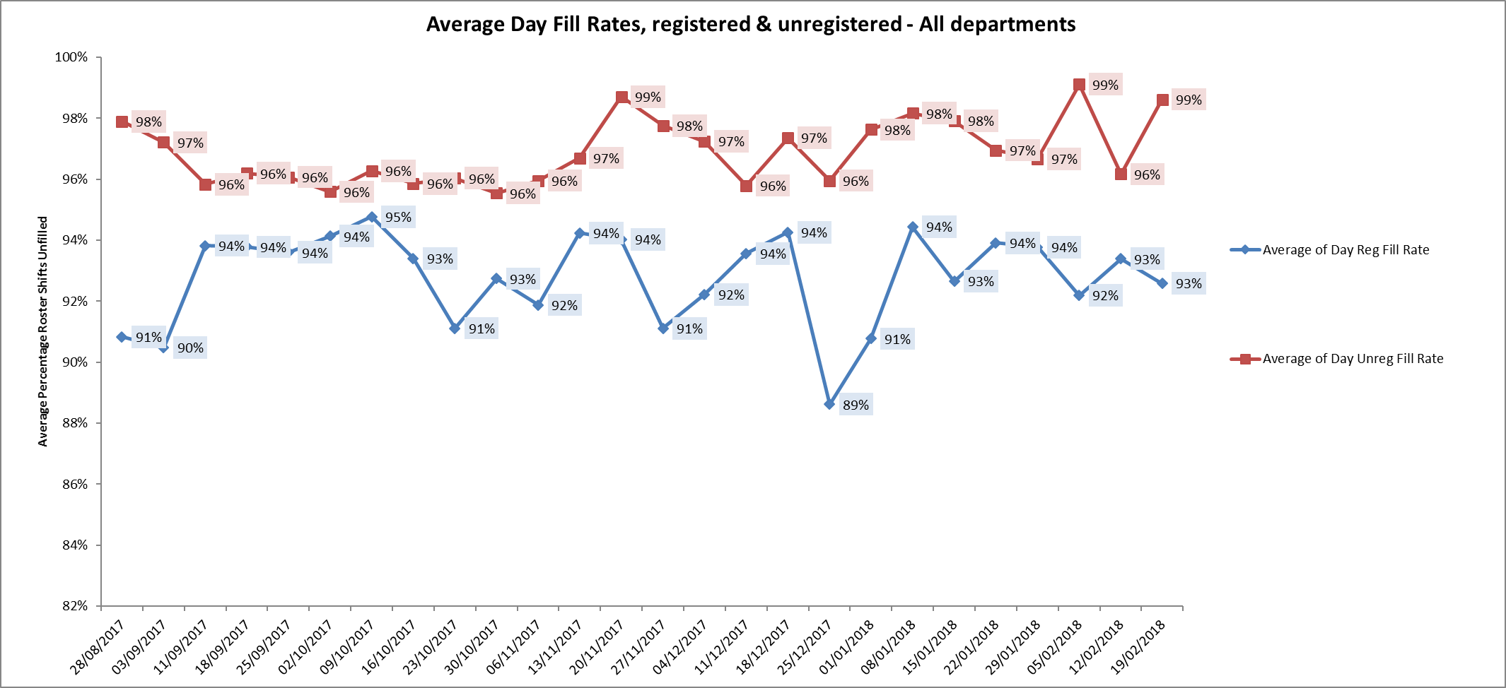

However, six wards were below 85% target for average fill rates for registered nurse day shifts during this period.

These were:

Adult wards

Ashurst 60% up from 56%

Vaughan Thomas 69% down from 74%

Wintle 69% down from 68%

Ruby 83% down from 85%.

Children and young peoples and adult eating disorders

Cotswold House Oxford 60% up from 54%

Highfield 80% up from 79%

All of wards above had above 85% of unregistered staff to ensure safe staffing numbers overall.

**Night shift fill rates**

Average night shifts fill rates for registered nurse & unregistered staff were above the Trust target of 85% throughout this period. This included a mix of agency, bank and substantive staff to make up staffing numbers.

Two wards Ashurst and Glyme were below 85% respectively for registered staff,

Ashurst 70% down from 77%

Glyme 71% up from 70%

This was managed with additional unregistered staff on 161% Glyme and 95% of unregistered staff on Ashurst



**Registered skill mix**

Six wards had in place 50% or above registered staff skill mix, this has remained static from the last reporting period of 1st January to 28th January.

This relates to continued registered nurse vacancies. Safe staffing is supported by the ward managers and matrons on the ward working clinically as part of the numbers where required to ensure registered nursing leadership is maintained.



**Agency use**

The average % agency use was above 17.6% for this period with a peak of 19.1% in the week of 12.02.18

Seven wards required more than 25% agency use to maintain fill rates, these is reduced from ten wards in the last reporting period. These were :

Allen 34.1% up from 27.9%,

Ashurst 29.6% up from 29.%

Highfield 49.7% up from 41.1%

Kingfisher 30.9% up from 29.9%

Kestral 32.4% down from 39.7%

Ruby 34% down from 35.5%

Sapphire 25.3% down from 31%

In Ashurst, Ruby, Highfield and Kestrel wards beds have been reduced to support safe staffing. In the other wards patient mix admission by admission is managed carefully.



**Adult Directorate wards**

There continues to be high levels of nursing vacancies.

Vacancies in total for the eight Adult Mental Health wards as reported on 14.01.18

* Band 6 - 9.3 WTE
* Band 5 – 53.2 WTE (3.3 appointed but not started)
* Band 3 – 22.74 WTE (4 appointed but not started)

Recruitment to the Ruby ward matron role and consultant has been successful and pending employment checks these roles will be filled and start date confirmed. The ward bed number remains at 18 during this time.

As previously reported the re-profiling of the skill mix is underway. More ward clerks are being recruited, business support mangers are supporting ward managers and Matrons and the balance of new B4 Associate Nurse roles, B5 roles with the new two-year preceptorship and more B6 roles. The role of ward based AHP’s and social workers will be finalised within the next few weeks. This will provide a better career structure for nurses and together with the new career framework we aim to attract and retain mental health nurses to inpatient care.

**Older Adult mental health wards and Community Hospital wards**

In February 2018 ward staffing report there was a detailed focus on these wards. There is nothing new to report. Local and national recruitment efforts continue.

**Total Nursing Vacancies for Older adult mental health and community hospital wards:**

Band 5 42.84 WTE

Band 3 19.55 WTE

**Children and Young Peoples Services**

This report will focus on these wards

There are four wards in the Children and Young Peoples Directorate

The bed numbers and staffing levels are shown below



**Average Skill Mix and Agency Use for 29th Jan – 25th Feb and vacancy data at week of 12.03.18**

|  |  |  |  |  |
| --- | --- | --- | --- | --- |
| **CYP and ED wards** | **Registered staff**  **Skill mix** | **Agency use** | **Nursing Band** | **Number of WTE vacancy** |
| **HFU** | 39.2% | 49.7% | Band 3  Band 5  Band 6 | 11.2 WTE  *5.0 recruited and further recruitment in progress*  13.8 WTE of establishment of 17 *3.2 recruited to commence late summer.*  *3.0 further applicants*  0 - 3.0 A*ll recruited to from internal band 5s* |
| **Marlborough House Swindon** | 45.3% | 16.2% | Band 3  Band 5  Band 6  Band 7 | *0 - 9 flexible workers recruited)*  *4.7- 2.0 flexible Band 5s recruited*  *1.0 as acting up to Band 7*  *1.0 but Band 6 acting up* |
| **Cotswold House Oxford** | 37% | 9.4.% | Band 3  Band 5  Band 6 | 0 vacancies (12.8 in post )  5.4 vacancies / 9 WTE in post but one mat leave & one career break  1.0 WTE to recruit to as part of new establishment figure of 3.0 |
| **Cotswold house Marlborough** | 48.1% | 0% | Band 3  Band 5 | 3.0  2.0 – student recruitment in progress . |

**Total vacancies across the four wards**

**Band 3 = 13.2 WTE**

**Band 5 = 25.9 WTE ( 7.2 recruitment in progress)**

In terms of safe staffing Highfield and Cotswold House Oxon have not been able to maintain 85% fill rates of registered nurses due to combination of vacancies, sickness and increased acuity particularly at Highfield. This has been mitigated by additional Band 3s, ward managers and Matrons working clinically to support. The use of agency is reflected by these factors too. No adverse outcomes for patients have been raised or identified relating to staffing.

Marlborough House Swindon however is showing a significant reduction in agency use since September 2017 from 30.2% to 13.4% - this has been achieved following increased recruitment particularly of flexible Band 3 workers. This is excellent news and marks a significant improvement.

Cotswold House Marlborough has maintained 0% agency use part from one week ( 1.3% week of 15.01.18) since 30.10.17. They are able to access a good pool of flexible workers and recruitment of Band 5 nurses has improved significantly,

**Sickness and Agency use- breakdown by ward**



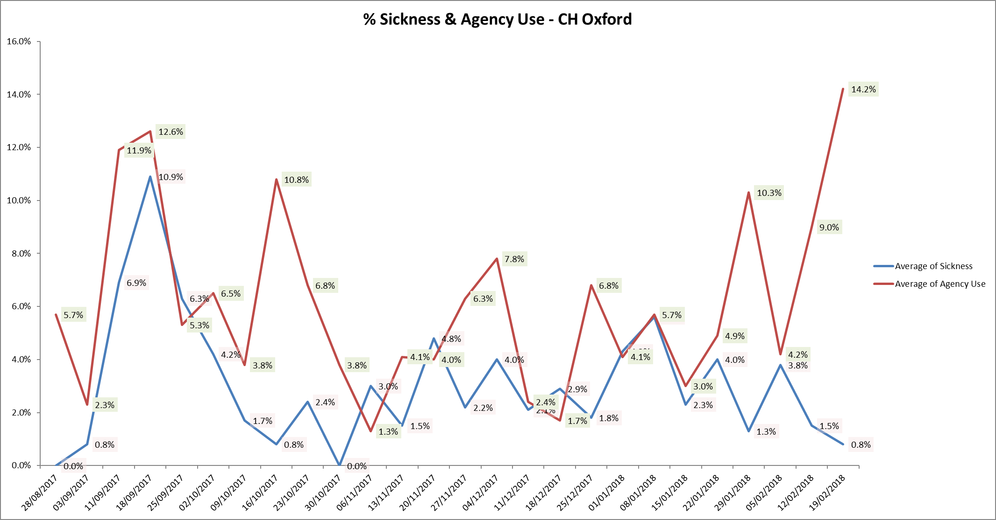





**Recruitment work**

All four wards have been actively engaged in ongoing recruitment work, teaching at universities and linking with students who are due to qualify this summer to encourage recruitment.

**Highfield specific actions.**

Highfield are setting 3 days a month for interviews so they can recruit as applications come in

Students are encouraged to attend this and have given positive feedback aObout the training.

All adverts have been reviewed and updated

An innovative recruitment video has been developed

Staff are offering teaching and have been involved in interviews and teaching at Oxord Brookes University to raise the ward profile

Unit holding an induction week every few months with core information about the unit and also teaching and training on attachment and mental health conditions. Students are encouraged to attend this and have given positive feedback about the training.

Actively working to encourage HCA agency staff to join Oxford Health as part of the reduction of agency HCA project. Four workers have moved across.

**Complaints**

The four wards have the following levels of complaints and concerns in Quarter Three 2017/18

The concerns have been managed through on site with support of the PALs team.

|  |  |  |  |  |
| --- | --- | --- | --- | --- |
| **Ward/Service** | **Complaints**  **Q3 2016’17** | **Concerns**  **Q3 2016’17** | **Complaints**  **Q3 2017’18** | **Concerns**  **Q3 2017’18** |
| CAMHS Highfield | 2 | 1 | 0 | 1 |
| CAMHS Marlborough House | 0 | 2 | 1 | 4 |
| Cotswold House Oxon Eating Disorders Inpatient | 0 | 7 | 0 | 4 |
| Cotswold House Marlborough Eating Disorders Inpatient | 0 | 0 | 0 | 0 |

**Serious Incidents**

There were no new Serious Incidents in this reporting period for these wards.

**Evenlode – LD medium secure ward**

The ward is now on Health Roster which enables weekly oversight of safer staffing in line with other ward The establishment is set at 6:6:5 but due to more recent increase in acuity the ward has been using agency staff to increase to 7 staff for day shifts.

During this period fill rates for registered and unregistered staff have been above 96%. Skill mix has been used flexibly to meet patient needs.

**Trust SafeCare project roll out update**

This additional module on the workforce management system enables units to:

* Capture actual patient numbers by acuity and dependency
* See if staffing levels match the demand.
* Action day-to-day staffing movements

Provides clear visibility of staffing issues Trust wide where staffing does not match the required patient demand for:

* in nursing hours
* skills
* temporary staff usage
* charge cover

Informs longer-term resource and establishment plans

* Enables the use different models or multipliers for different wards
* Provides reports to identify trends and causes, highlighting changes needed to ensure safe staffing levels.

The training programme for staff on inpatient units and 29 wards have completed their training and these wards are now able to collect patient acuity census data, inputting this into SafeCare and updating their staffing information through SafeCare.

There are some improvements in data entry by wards.  It is recognised this is a challenging time with conflicting priorities alongside teams managing high levels of vacancies, so continuing to support wards to improve with getting data entered consistently is a priority as the better compliance and reliability of data we achieve, the closer we will come to understanding whether the unit is staff correctly based on actual patients’ needs.

The data is being reviewed weekly by the Heads of Nursing to monitor census completion, acuity levels and will inform safer staffing reports once robustly embedded in practice.

Further specific support will be offered to the adults wards to improve census completion given the additional pressures of staffing vacancies and improving agency staff knowledge of the system.

Once the data is robust this will be reported as part of the safer staffing reports.

**Conclusion**

All ward staff and managers continue to make every effort to ensure wards continue to be staffed safely and that we focus efforts on retaining our staff whilst recruiting new nurses to join Oxford Health FT.

