# Annual Patient Experience & Involvement Report

# Oxford Health NHS Foundation Trust

**25 April 2018**

**BOD 52/2018**

(Agenda item: 8)

**For Information**

This annual report provides an overview on patient experience and involvement projects within the Trust and a brief summary of the feedback we have received which tells us how it feels for patients to receive care, and how we have used this to work with people to improve their experience of receiving care and treatment.

Across our services the key and consistent areas for improvement fed back from service users, patients and carers continue to be:

* Patients want to **feel informed, be given options and take part in decisions about their care** (critical element: respect of patient centred values, preferences and expressed needs)
* Patients want to be provided with **good information** that is tailored to them and is timely, and they also want **staff to communicate clearly** with them (critical element: information, communication and education)
* **Families and carers want to be involved,** listened to and respected as part of their loved ones care (critical element: Welcoming the involvement of family and friends)

**Author and Title:** Donna Mackenzie, Patient Experience and Involvement Manager

Jane Kershaw, Head of Quality Governance

**Lead Executive Director:** Ros Alstead, Director of Nursing and Clinical Standards

1. **Introduction**

A report on patient’s experience is presented to the caring and responsive quality sub-committee quarterly and also the Board of Directors as part of the quality report (Annual report in June 2017, quarterly update September 2017 and January 2018). An annual report was last presented to the Quality Committee in July 2017.

The reports focuses on patient experience and involvement projects and work streams and providing a summary of the feedback we have received which tells us how it feels for patients to receive care, and how we have used this to improve patient’s experience. The themes highlight the key areas for improvement identified in this report around communication and sharing information with patients and their families to enable joint decision making and involvement in care.

Feedback from patients, parents, families and carers is a very valuable source of information to measure patient experience however this report recognises that other sources for example activity data, clinical audit, staffing levels, incident data and staff feedback; are also important to measure and improve patients experience. The internal peer review programme continues to also be a useful source of feedback from patients and carers in addition to routine methods.

1. **Patient Experience and Involvement Strategy**

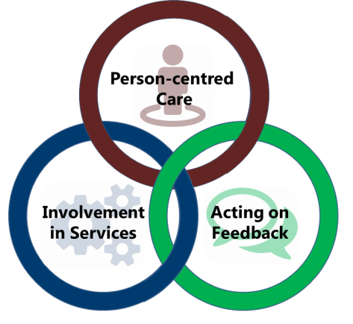The approved strategy which was co-developed with patients, families/ carers and staff is in its final complete year as it was launched in April 2016. The strategy outlines the key objectives around 3 domains identified as priorities by those involved in the development of the strategy; Person centred care, Involvement in services and Acting on feedback. The strategy is summarised in Appendix 1

The funding and resources required to deliver the aims and outcomes of the three year strategy approved in April 2016 have not been fully identified and this continues to be a challenge of the strategy work plan.

The identified directorate patient experience champions in clinical teams are working effectively to embed iwgc, support local reporting and identify areas for quality improvement with the support of the Directorate Patient Experience & Involvement Leads which were funded and recruited to from April 2017.

The trust wide ‘Taking Action on Patient Feedback’ group (TAPF) continues to be chaired by the Deputy Director of Nursing and meets bi-monthly. This group reports to the Caring and Responsive quality sub-committee with the purpose to;

* Monitor and give oversight on the objectives to deliver the patient experience strategy,
* to share good practice
* as a forum for clinical services to demonstrate how they are using feedback to improve the patient experience.

The membership of the group includes service users, carers, staff and governors and work is continuing to further develop patient/carer member representatives at the meeting by theming meetings, making the meetings more online accessible (skype, dial in) and setting dates for the year.

The TAPF group reviews the “Just Ask Me” Involvement and Experience Strategy 2016-2019 objectives and has discussed priorities going into the final year. . Appendix 2 gives a detailed update on progress with all the objectives/ actions identified for the strategy over the 3 year period. Many of the actions have been started but are not fully completed. The delay in completing objectives is due to year one of the strategy being focused on identifying and recruiting resources, so many of the actions did not start until year two, 2017/18. Overall the actions taken have had the impact in 2017/18 with increasing the mount of feedback received, this has doubled from 2016/17 to 2017/18 and the feedback has been more positive. The 2017 national staff survey results, asking staff how effectively they use patient feedback, were also good and the trust is in the top 20% of trusts nationally.

In 2017/18 overall 97% of patients receiving physical health services would recomend the care, higher than the national average and 91% of patients receiving mental health servces would recommend the care, this has improved from May 2017 and since this time has been higher than the national average.

Patient feedback from the annual national community mental health survey 2017 was also positive and showed improvemets in patients experiences from 2016.

The group has focused on;

* + Continuing to support collection of patient & carer feedback (see update on iwgc)
  + Developing accessible information for members
  + Celebrating and sharing actions taken as a result of patient feedback
  + Addressing challenges to involvement

The following achievements have been made in 2017/18;

* The ‘Taking Action on Patient Feedback Group’, consisting of patients and staff,
  + Supported development of the “Get Involved” pages on the trusts website, and inside the Trust’s “Insight” Magazine.
  + introduced ‘video’ minutes, alongside the more traditional written minutes
  + developed “accessible” terms of reference and sign up form which are now in use.
  + Reviewed and developed the content and look of involvement information on the trusts website

These can be found on the trust webpages:

<https://www.oxfordhealth.nhs.uk/getting-involved-with-oxford-health/patient-involvement/taking-action-from-feedback-group/>

* + Introduced an involvement survey for all patients and carers who take part in involvement activities. This survey will be used to evidence feedback about our involvement activities, help share good practice identified by patients and carers across the trust and develop “guides to involvement”.
  + Drafted a staff survey to benchmark the understanding and challenges facing staff in terms of patient experience and involvement work for quality improvement.
* The standardised feedback mechanism has been introduced across almost all services, giving staff direct access to feedback in a timely way (see update on iwgc)
* A patient story is shared at the board of directors meeting monthly, over the year the board has heard about the experiences of patients and their families receiving care from 19 different teams/services including Forensic’s, Community Hospitals, Mental Health Inpatient, CAMHS and Specialist Community Services.
* Examples of involvement include;
  + Young people have worked to promote equality for the LGBT community within Mental Health services by sharing their experiences with the local CAMHS teams as well as local and national news.
  + A number of patients and carers from across the trust have been involved in the recruitment of staff including nursing staff, consultants and 2 x leads for patient and carer experience.
  + Patients and their carers with lived experience of dementia have been involved in raising dementia awareness and a patient jointly chaired a patient and staff workshop to start the develop of a new trust-wide dementia strategy.
  + Patients have developed “virtual tours” of a number of the inpatient wards. These will be shared pre-admission to help to ease anxiety about what the ward environment is like.
  + Employing peer support workers in adult mental health teams.

In 2018/19 we will be continuing with the actions from the strategy with a focus on patients and families feeling involved in decisions about care.

1. **‘I Want Great Care’**

‘I want great care’ (IWGC) a standardised feedback mechanism was introduced across the majority of services in 2016/17. IWGC gives staff access to feedback in a timely way and produces one simple report showing the number of responses and level of satisfaction by team as well as more indepth data anaylsis through the dashboard view where required. The trust has also improved the structure and responsibility for patient experience and involvement, as part of the revised patient experience and involvement strategy. The structure includes a permanent trust-wide patient experience manager and in each clinical directorate a dedicated role for patient experience and involvement. Appointments to new posts for Learning Disabilities and Forensic Services as well as a Lead for Older Peoples directorate have now been completed. Each month the trust-wide patient experience manager and leads monitor, explore any reasons and report on response rates and satisfaction levels by team. The Caring and Responsive quality sub-committee also receives a quarterly report on feedback received. The trust-wide patient experience manager is working with iwgc to develop the wording of the questions, increasing the range of easy read options, looking at developing dementia friendly survey options, and reviewing the answer options for some questions e.g. gender which has been updated to better reflect our service user needs .

351 individual teams have been set up and trained to use iwgc. A limited number of services continue to utilise other collection methods e.g. survey monkey, due to local commissioning requirements. A summary of the overall annual results from iwgc are below.

This includes:

* 124 teams/services from Older People’s Directorate (up from 117 in Jun 2017
* 37 teams/ services from Adult Directorate (up from 19 in Jun 2017)
* 190 teams/ services from Children & Young People’s Directorate (up from 95 in Jun 2017)

Services not yet set up or currently using iwantgreatcare include those listed below. Over the coming months we will be working with these services to develop their use of the system.

* + - Phlebotomy
    - Psychological Services
    - Complex Needs Service
    - Luther street

The fixed question set in Iwgc surveys includes the following questions:

1.a “How likely are you to recommend our service to a friend or family member if they needed similar care or treatment?”

1.b “What was great about your care? What could be improved? *(open comments box for free text responses)*

1. “Were you treated with respect and dignity?”
2. “Did you feel involved enough in decisions about your care and treatment?”
3. “Did you receive timely information about your care and treatment?”
4. “Were you treated well by the staff looking after you?”

These are displayed on the app like this;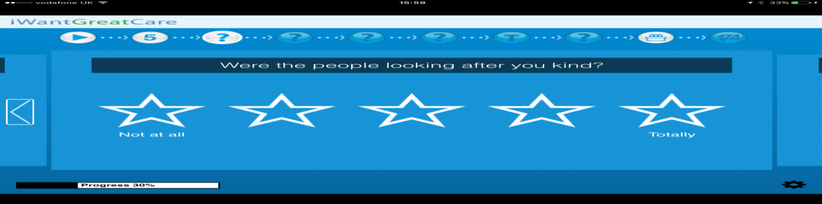

Or via paper copies on a variant of this form;

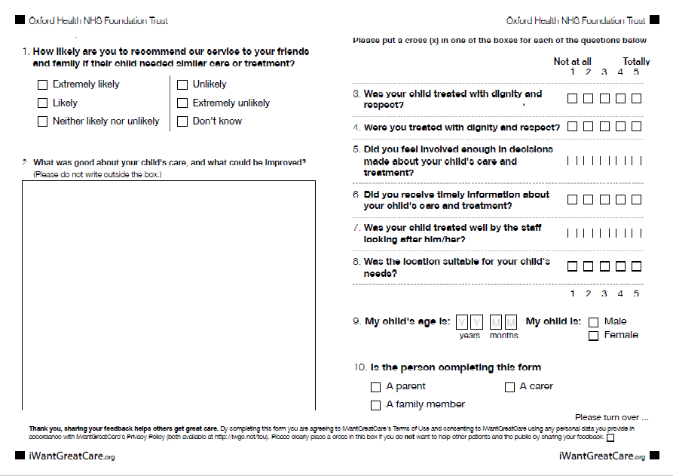

All services accessing IWGC are able to utilise surveys in 28 languages as well as download surveys in easy read and age appropriate format *for childrens services* as well as their individual team reports by month. All IWGC reports are available with information analysed by team, service line, care group, Directorate or Trust wide level.

The Trust have received 17,003 responses to date since the roll out of IWGC began in January 2017 with an overall average score of 4.77 out of 5 across all the questions asked. 94.41% of those reviewing services over that time are likely to recommend with 1.80% being unlikely to recommend. (3.79% report neither or don’t know)

This chart below shows information about the responses received between 1st April 2017 – 31st March 2018. In this time period 15,675 responses have been received.

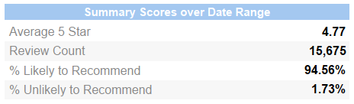

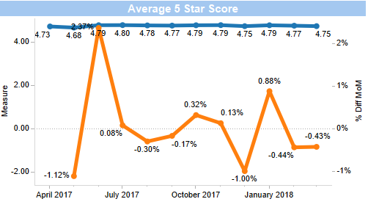

This graphs show that the average 5* score of the trust (blue line left hand graph) has remained consistently between 4.68 and 4.80 across the year. The same graph also shows that there has been a flucuaction of up to 3% + or - on the previous months average 5*.

The below review count graph shows an increase in the number of reviews collected via IWGC monthly from 453 in April 2017 to 1,546 in April 2018 (this includes a large increase in the number of teams accessing IWGC)

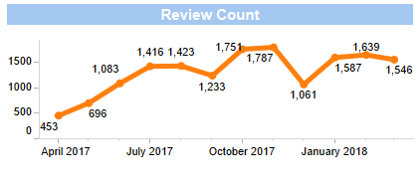

The below graph shows the overall demographic information of those reviewing and the way the review has been submitted**.** 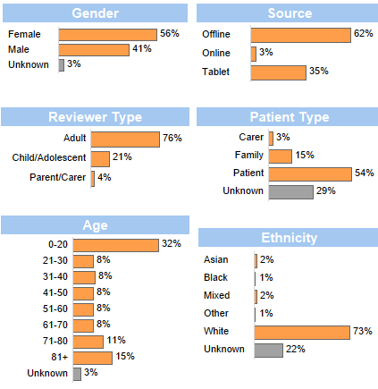

1. **Adult Mental Health Carers Survey**

|  |
| --- |
| The Adult Directorate also conduct a separate survey for all Carers accessing Mental Health Services across Oxfordshire and Buckinghamshire in line with commissioning requirements. |

The survey is available via an online link on the Trust wide site as well as in all mental health teams and our five partner organisations (as part of the mental health partnership in Oxfordshire).

418 carers have responded to the survey between 1st April 2017 – 31st March 2018 with a number of improvement comments and accolades. The feedback will be used to inform carers work within the directorate. Below is a summary of some of the results.

Adult services carers feedback will be collected by IWGC during 2018/19 due to the addition of a satisfaction question in line with commissioning requirements.

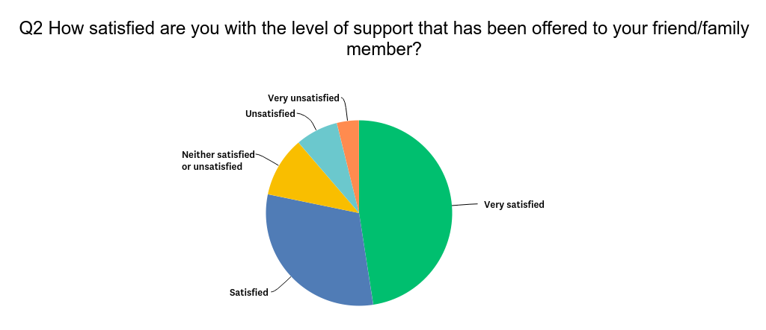

**Table showing results from level of support offered for carers.**

.

|  |  |  |
| --- | --- | --- |
| **How satisfied are you with the level of support that has been offered to your friend/family member?** | | |
| **Answer Options** | **Response Percent** | **Response Count** |
| Very satisfied | 47.57% | 186 |
| Satisfied | 30.69% | 120 |
| Neither satisfied or unsatisfied | 10.49% | 41 |
| Unsatisfied | 7.42% | 29 |
| Very unsatisfied | 3.84% | 15 |
| ***answered question*** | | **391** |
| ***skipped question*** | | **27** |

1. **Buckinghamshire recovery college**

The trust, Mental Health Foundation, Buckinghamshire MIND, University of Bedfordshire and Buckinghamshire Adult Learning have worked together to open and run the Buckinghamshire recovery college. The college takes an educational approach to mental health recovery and is run by people with experience or who live with a mental health illness. All courses delivered at the college are for patients, staff and visitors, and all courses are co-designed and co-delivered between a patient and a staff member. The Oxfordshire recovery college opened in September 2015 continues to grow.

In 2017/18;

* The Buckinghamshire recovery college was successfully launched in January 2017 and full courses started in March 2017.
* To date over 100 sessions have been run with over 300 students now enrolled.

“*The college has enabled me to leave the house and attend a safe, warm and comfortable setting. It has helped me with my low mood and has helped my confidence, Carol and all the tutors are so professional, friendly and caring. I don’t go out often but the recovery college has opened a special door, I feel the space is my life line*” - Student

1. **Triangle of Care**

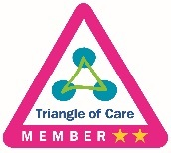In December 2015 the Carers Trust accredited the trust with two gold stars, the third (and last star) will be achieved when all mental health and community teams/ wards have completed the self-assessment and identified/ addressed any gaps. This has not yet been achieved by any Trust nationally.

The Directorate Carer Leads alongside Executive representative attended the National Triangle of Care meeting in November 2017 to present an update of work over the past year and take part in the re-accreditation process to maintain the 2 star rating. The Carers Strategy Forum continues to monitor progress and themes from the self-assessments, and work continues across the Trust to develop carer specific information within teams as well as training for staff around carer awareness and assessment in line with the triangle of care accreditation criteria.

A number of carers events took place during carers week in early June 2017 to launch the Trusts new “I Care, You Care” strategy including the introduction of a film highlighting the challenges and hopes of carers who are involved in our services. This was accompanied by a strategy document outlining the trusts 3 year strategy focusing on raising awareness and improving information and communication with our carers. Carer awareness training has been rolled out to staff across adult mental health services in conjunction with Rethink following positive feedback from the pilot sessions and is being rolled out across the Older Adults directorate and the Children and Young People directorate first training session was held in March 2017.

A Carers Involvement Lead has been recruited and joined the Trust in April 2018 with the aim of pushing forward the strategy objectives.

In addition the trust has completed a cross agency piece of work in Oxfordshire with carers to develop a carers statement of intent/ commitment to carers which will be launched in June 2018.

1. **Summary of feedback**

Overwhelming the feedback we have received from patients, families and carers is very positive with patients reporting feeling cared for by staff and that as a result they highly value the service provided. However some people do not receive the positive experience we expect every person to have and therefore we have more work to do. The themes highlighted from complaints mirror the key areas for improvement identified from the feedback we receive, and are focused on communication and sharing information with patients and their families/carers to enable joint decision making and full involvement in care.

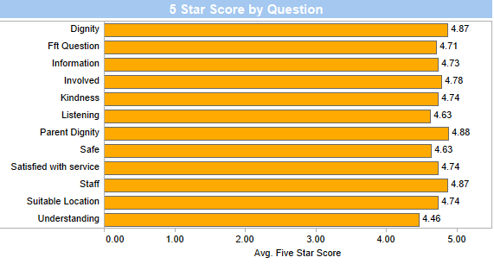

This graph shows the Trustwide average score for each question asked on IWGC out of 5 in the last 12 months. The first 5 questions (from top to bottom) are asked of all services – Dignity to kindness, the bottom 6 questions are those asked on the specific children and young people services surveys.

Below are the trends for the first 8 questions showing score over the 12 months period.

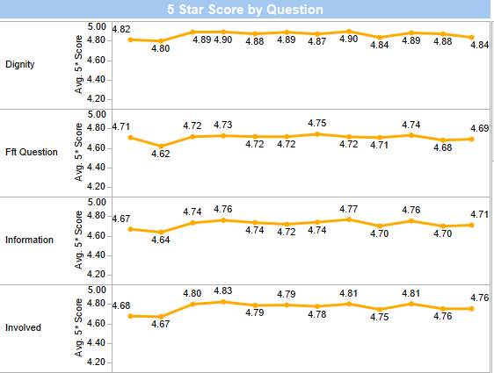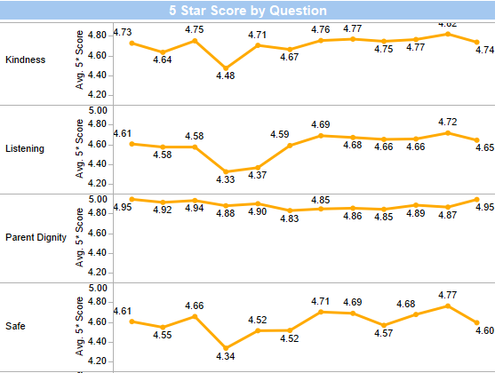

Each dot on the graph represents a month from April 2017 to March 2018. These graphs show that early in the time period there was a drop in a number of scores including the FFT question, feeling involved, being treated with kindness, listening and safe; however, all of these areas have generally stayed constant or improved towards the end of the time period. We will monitor the data going forward to look for trends / drops in certain time periods and have also started to look at the patient experience feedback alongside the staff survey information to inform further developments.

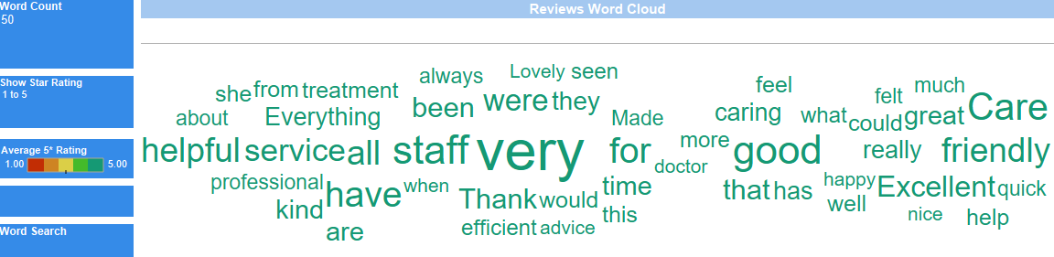

This word cloud shows the 50 most frequently used by patients who have given a 5* average score in the last 12 months. The darker green the word the more positive the review as a 5* average.

**Frequency of some common words used:**

Care/ caring – 2,482 times

Good – 2,057 times

Staff – 2,086 times

Friendly – 1,559 times

Helpful – 1521 times

**Some comments from patients who answered that they are extremely likely/ likely to recommend our services include:**

“Physiotherapist appointment to help me deal with Parkinson's disease symptoms + a back condition was very helpful. Careful attention was paid to my movement problems and a suitable exercise regime set up. Attention was also given to my facilities at home with a view to identification of any necessary changes. A device to help me get out of bed in the morning was supplied and has proved helpful. It may possibly have helped a little if the Physiotherapist ( who explained that her main expertise was in relation to Parkinson's disease: the condition on the basis of which I had been referred ) had full details of back surgery that I had about two years ago immediately to hand at the first consultation. Other than the possible need to find new or better ways of communicating details of co-morbidities between health practitioners I can say that my treatment was and is very good– Physical Disability Physiotherapy Service

“It was an opportunity to discuss my condition with a professional that can understand and explain all queries. My doctor was very reassuring and that gives me confidence.– North & West Oxon Older Adults Mental Health Service

|  |  |  |  |
| --- | --- | --- | --- |
| “Wonderful staff, but they should have even more of them” – Bicester Community Hospital Ward |  |  |  |
| “Very pleased with the care my dad is receiving. Great nurses very professional and caring.  Cannot fault them at all.” – Eynsham District Nursing Team  “I was on level 3 obs throughout my admission so always had someone to talk to, which helped a lot. Other patients said they found it more difficult to access staff. The staff seemed extremely busy - staff shortage. But I was given lots of time and good care. I'm very grateful  Perhaps you could cheer up the garden - patients without leave could help. It's very frustrating if you can't go outside. You helped me a great deal again. Thank you very much  – Allen ward  “No improvement needed in our experience”– Children’s Intergrated Therapies Occupational Therapy Team |  |  |  |

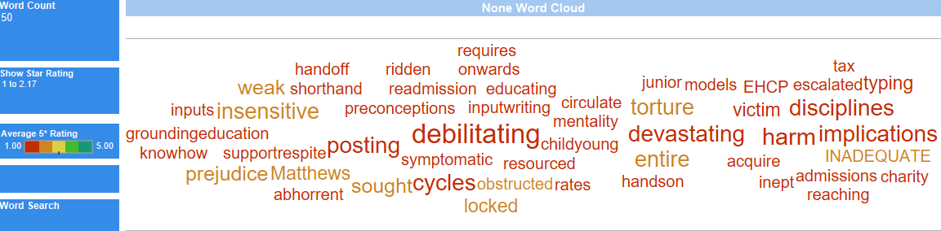

This word cloud shows the 50 most frequently used by patients who have given an average score of 2.5* or less. The darker red the lower overall score the for the full review.

Frequency of some common words used:

harm – 3 times

preduice – 2 times

Victim – 2 times

Weak – 2 times

All other words shown were used in a single review

An immediate automatic alert is created for any service who receives a review of less than 3 stars for any reason. This allows the service and Patient Experience Leads the opportunity to monitor, respond and action any improvement feedback which is received.

Services have begun to respond directly to a number of reviews which have been received and it is our aim to develop staff’s ability to response further over the next 12 months.

**Some comments from patients who’s overall review score was below 2:**

“The service could definitely be better because there is an on-sight gym but no instructor to facilitate it. I have put on weight due to the medication, over eating and lack of gluten free options on the menu and this has caused a lot of frustration and slight depression. I am disappointed that by the time I leave this place it will probably be amended however it should have been there in the first place to cater for my dietary needs; as well as other patients. I think that the staff are very friendly and I have built a very good rapport with the hospital and patients. I hope that if I was ever in need to return to this facility that they would understand my needs from my notes and be able to help me more. I have dealt with 5 assaults on the ward when staff aren't around and this should not have happened despite knowing that the patients are ill and it has led me to feel un-safe when staff are not present but aside from that I do feel safe here and the staff are perfectly trained to deal with conflict”– Ruby Ward

“Young people with mental health problems are constantly being encouraged to seek help, but when we do we are only greeted with closed doors and "no"s.

I came in to admit majorly in the ward due to suicidal thoughts and extreme self harm, only to be told no.

The blood will ultimately be `on your hands – North & West Oxon Adult Mental Health Team

“The physio team were very good and gave me my confidence back.

Most of the time the staff were good just a few were insensitive to older patients needs which to me was very upsetting and embarrassing.

The constant chit chat about other certain patients it’s discusting. Very unprofessional.

– Abingdon Community Hospital Ward 2

“Doctors need to improve. The waiting is just ridiculous. Doctors didn't bother to check me properly. A good comment would be from reception, they are very helpful and patient” – Banbury GP Out Of Hours

“Delay after delay - initial diagnosis at 11.5 years old. Ineffective medication and CBT with huge cycles of wasted time whilst condition worsened for years. Preventative measures non existent with huge wait times to see clinical staff. Escalated to debilitating levels impacting physical and mental health resulting in multiple hospital admissions by aged 15 onwards and devastating financial impact on the stability of family. Short hand of staff notes w/o handoff symptomatic of the lack of co-ordinated care across disciplines. Had to write up own notes and circulate to key clinical and educational leads for all CPA meetings as key information of continuity of care got lost. Sought advise from US experts outside of UK as treatment, clinical care pathways ineffective. Had to escalate directly to acquire T4 specialist support and make own recommendations based on US expert input into medication and therapy. Medication changed and treatment based on own inputs. Had to provide hands-on input/writing up EHCP” – Swindon CAMHS

“health visitors need to listen to parents. thanks to their not listening we have the fall out to deal with in terms of psychology if they say they will contact you then contact us, don't forget or ignore us. only focused on the required checks and difficult families. anyone else has to ask for help. you often don't feel like asking for help so don't. engage with all families. we all need help at times” – Chiltern Villages Health Visiting Team

1. **You Said, We did (YSWD)**

All services aim to feedback to service users on quality improvement work which has been led by patient experience feedback. We call this “you said, we did” and this can be displayed on boards, leaflets or posters.

102 of the 351 teams currently registered on IWGC have been recorded to have shared “You said, we did” information with their patients over the year.

YSWD actions are also shared via the monthly newsletters prepared by the Patient Experience & Involvement Leads

Some examples of changes made in the last 12 months:

**Children & Young People’s Directorate**

**BaNES CAMHS -** The Multi Family Therapy programme now sends reminders for sessions which runs over 6 months as service users fed back that they may forget the dates with time gaps in-between.

**Cotswold House Oxford** - A shared recycling bin for the ward and another bin for the Dining Room have been supplied and labelled following a patient request. Any recycling can be given to Staff.

**Witney Health Visiting Team** - 5 more Early Day’s sessions running for 90 minutes have been added following feedback that they are friendly and informative.

**Adult Directorate**

**North & West Oxon AMHT** – Staff from Oxfordshire Mental Health Partnership (of which Oxford Health Adult Service is part of) and people who have used those services have come together to organise an event celebrating the skills and talents of this people through workshops and activities following requests from service users after the first successful event in 2016.

**Wenric Ward** – patients took part in workshops run by artscape following feedback around privacy through the ward doors. Their designs were then used to obscure the glass but ensure light could still enter, as per the patients wishes.

**Learning Disabilities Services**

**Community LD** - Easy Read self referral forms have been created with involvement from people with lived experience to promote access to the services. These will be displayed in GP surgeries and Day services.

**Evenlode -** Patients ran a successful panel as part of the recruitment process for the Learning Disabilities and Forensic Services Patient Experience Lead. The new postholder should be in place in June 2018.

**Older Adult Directorate**

***Linfoot ward:*** Patients feedback that were not given enough notice if they were having to move rooms so a new process has been put in place to ensure that anyone affected by room moves will be notified earlier.

**CTS North** – A new phone numbers list has been added to the front of the patient information pack detailing other helpful telephones after requests that it was hard to find contact details for services outside our organisation.

**Feel good story:** A patient at Abingdon community hospital had a surprise video message from celebrity Peter Andre after staff tweated him requesting a message to help aid the recovery of an older person in their care. The personalised video message was emailed to the ward who used their ipads to show it to the patient!

1. **Friends and Family Test**

The results to the national friends and family test question (FFT), how likely are you to recommend this ward/ team to friends and family if they needed similar care or treatment? Are shown below. These results are submitted to NHS England on a monthly basis.

This data shows that the trust are performing consistently slightly better than the national average apart from in April 17 for MH services and October 17 for Community services. These do not correspond with dips in the overall feedback obtained via IWGC and could be due to a number of reasons. The data will be monitored to ensure any further dips are investigated alongside all other patient experience feedback.

Community Services

|  |  |  |  |  |
| --- | --- | --- | --- | --- |
| Month | National average % recommend | OHFT % recommend | National average % NOT recommend | OHFT % NOT recommend |
| January 18 | 95 | 97 | 2 | 1 |
| December 17 | 96 | 97 | 2 | 1 |
| November 17 | 96 | 97 | 1 | 0 |
| October 17 | 95 | 91 | 2 | 1 |
| September 17 | 95 | 97 | 2 | 1 |
| August 17 | 96 | 97 | 2 | 1 |
| July 17 | 96 | 97 | 1 | 1 |
| June 17 | 96 | 97 | 2 | 1 |
| May 17 | 96 | 97 | 1 | 1 |
| April 17 | 96 | 99 | 1 | 1 |

Mental Health Services

|  |  |  |  |  |
| --- | --- | --- | --- | --- |
| Month | National average % recommend | OHFT % recommend | National average % NOT recommend | OHFT % NOT recommend |
| January 18 | 89 | 93 | 4 | 2 |
| December 17 | 88 | 91 | 4 | 4 |
| November 17 | 88 | 92 | 5 | 4 |
| October 17 | 86 | 89 | 5 | 6 |
| September 17 | 89 | 91 | 4 | 3 |
| August 17 | 88 | 92 | 5 | 3 |
| July 17 | 89 | 91 | 4 | 3 |
| June 17 | 88 | 92 | 4 | 4 |
| May 17 | 89 | 92 | 4 | 3 |
| April 17 | 89 | 85 | 4 | 7 |

1. **Adult Community Mental Health Survey**

The National Community Mental Health Survey for 2018 started in February 2018 and will close in June 2018.

The survey is sent to a random sample of patients who have had more than one contact with a community mental health service aged 18 and over (no limit) and have an address in the UK. The main survey questions are similar to 2017 and are sent to 850 services users out of a possible 4869 who accessed services between 1st Sept-30th Nov 2017. (*The sample excludes specialist services e.g. drug and alcohol, forensic, and IAPT and current inpatients.)*

The Trust has also been identified as a pilot site for 2 further trial surveys being conducted which will firstly be piloting the use of a new “short” version of the main survey and secondly be piloting the use of text surveying. The aim of these pilots is to ascertain if response rates for the MH survey can be improved nationally.

There are some positive results from the 2017 survey, with significant improvement against a number of questions. More work can be done in regards to communication around staff changes/ family involvement/ physical health support but overall there is evidence of an improved experience from adult/ older people being treated by mental health services.

**Positives:**

* Seen often enough – improved from last year
* Listened to
* Person seeing them understood impact of their MH on other aspects of life
* Know who to contact
* Involved as much as they wanted to be
* Formal review in last 12 months (top 20% of trusts)
* Received therapy in last 12 months
* Involved in deciding on treatments or therapies
* Help or advice for finding and keeping work
* Agreed what care they would receive
* Help or advice with physical health needs
* Help patients with what is Important to them
* Growth in rating of very good
* treated with dignity and respect

**Areas to keep an eye on**

* Knowing who was in charge of organising your care.
* Getting the help that was needed when contacting the service out of hours in a crisis
* Being given information about support you can get from people who have experienced the same mental health difficulty as you. (peer support)
* Finding support with physical health needs

1. **PALs and Complaints**

The full Annual Complaints report will be shared at the Board meeting in May 2018.

1. **Internal audit results**

An internal audit was carried out in March 2017 by Tiaa to review the processes and governance around patient/ carer experience and involvement as well as public engagement. The key findings noted positives around the trusts commitment and clear objectives as detailed in the patient experience and involvement strategy and carer’s strategy, as well as the well-established peer review programme involving patients to be part of the review team. The areas for development were identified as;

* Complete development and launch of a membership engagement strategy to include a mapping exercise of stakeholders and how they wish to receive communication

-*under development by Community involvement manager, due to be published early 2018*

* Progress with the patient experience and involvement strategy has been slower than planned, reasons identified above. Work plan to be reviewed with identified leads.

-*Completed by TAPF group*

* Improve how patient experience and involvement leads/ champions share information and good practice

-*Newsletter and website are being used as well as social media*

* More consideration of barriers to involvement, to hear from and involve a wider range of patients including those harder to engage
* Carers strategy to be revised in 2017/18 – *Completed and live*
* Review the membership of the Carers Strategy Forum – *Completed & quarterly meetings now include carer governors*
* The Older People Directorate to review the membership of the patient experience and involvement group to promote patients attending and all services to be represented – *completed and membership has developed to include wider services.*

1. **EURIPRIDES**

The Trust were invited to be part of a national study that aims to understand which of the many different approaches to collecting and using patient experience data are the most useful for supporting improvements in inpatient mental health care.

The study interviewed Patient Experience managers across the UK and then used 6 sites to conduct indepth interviews with patients, carers and staff, off which we were one.

Initial findings have been shared with those who were part of the study and a full paper will be published later in 2018.

More information can be found on the website and a further update will be given once the full findings have been released:

[**https://warwick.ac.uk/fac/med/research/hscience/mhwellbeing/euripides/**](https://warwick.ac.uk/fac/med/research/hscience/mhwellbeing/euripides/)

1. **Conclusion**

The report shares a progress update against the patient experience and involvement strategy 2016-2019, overview of patient feedback, progress from the Carers Strategy Forum, an update on the national community mental health survey and a summary of recent feedback.

Three key areas are identified for improvement, also reflected in complaints received and learning from SI investigations; these are:

* patients being involved in decisions and choices about their care
* patients wanting good information and clear communication, and
* patient’s families and carers feeling listened to and involved in their loved ones care.

**Appendix 1**



**Appendix 2**

**Patient Experience and Involvement Strategy Year 2 Key objectives**

| **Objective** | **Action** | **Progress update - April 2018** | **RAG** |
| --- | --- | --- | --- |
| To ensure all people who use our services and their carers are involved and are valued as equal partners in the involvement activity. | Use the involvement ladder (Appendix 4) and the 4Pi National Involvement Standards (developed by the National Survivor User Network) to identify the level of patient involvement in Trust wide activities to role model expectations e.g. board meetings, training and education, serious incident investigations, complaints process, service developments, conferences and leadership programmes. Improvements to be identified following the exercise: a) The trust to explore staffs current beliefs in regard to involvement b) Complete a trust wide mapping of current involvement activities to establish a baseline measure to assess improvements and to share good practice. To also include an update of the mapping exercise of how services/ teams are collecting, sharing and using feedback | Mapping completed in 2016 to identify involvement across the trust. Think about questionnaire, focus on accountability (where does it go) and open comments available. Show the different levels of involvement. What are the challenges? Not what you'd like to be doing, what are you doing? |  |
|
| Developing of a designated budget for all services to use to pay for reimbursement of involvement work, so that funding does not potentially become a barrier to involvement |  |  |
| Develop a regular method for sharing and celebrating across teams and services excellent examples of person centred care, this could be a conference, learning event, emails, blogs, face book, tweet, periscope etc. | Development of Involvement webpages, regular area of Insight magazine and Patient experience Social media hastag #OHFTgetinvolved |  |
| Identify teams/ services which could employ peer support workers, initiatives for staff to mentor patients, taking young people for work experience, apprentices, and use volunteers. Support these teams to fully utilise the benefits of these roles e.g. peer support worker training (possibly from a voluntary organisation), peer support worker networking events, set up a volunteer service to coordinate volunteering etc. | Peer support workers are currently being trained and will start within adult mental health teams and wards shrtly. |  |
| Develop a scheme to identify ‘beacon teams’ demonstrating good practice for all aspects of patient feedback/ involvement to spread to other teams so clearly demonstrating why good involvement ‘looks like’ | A monthly incentive to identify three teams (one from each directorate) demonstrating good practice was intiatied in 2017/18. |  |
| Improve engagement of patients and carers in care planning in all teams so that All patients, and where appropriate carers, are offered the opportunity to develop their care plan and risk assessment as part of working in partnership. All care plans are personalised and meet the individual’s need and identify clear goals | Directorate level care planning forums to be established to identify/ share good examples of care plans and areas for improvement across teams and professionals to improve the quality of care plans | The CYP directorate have organized dates for care planning forums have been arranged for each locality, young people groups, patient groups and carers and parents. Further dates to be set up. Survey Monkey has been sent to all staff exploring ideas on best practice around care planning.  OP directorate reviewed the care and pathways across organisations for 15 patients with OCC and OUH colleagues in Oct/ Nov 2017. This exercise is going to be repeated in 2018. |  |
| Organise visits to other organisation to learn from them. | In 2017;   * Visit to Northampton NHS Trust. * NHS Elect event on Patient Experience. |  |
| All projects for service redesign/ developments will include people who use our services from the planning stage | All service redesign project plans will undertake a patient involvement assessment to ensure involvement of patients takes place from the outset of any project |  |  |
| Involvement assessment tools for service developments to be developed and agreed. |  |  |
| Information will be provided in a format which is easily understandable, so enabling accessibility for all | Service leaflets will be available as easy read and in the most commonly used languages as identified by NHS England/and locally, where English is not the first language | The complaints information leaflet is now available in easy read. |  |
| When replacing signage for services, new signs will include easy read format and where appropriate, in languages additional to English |  |  |
| Assessment of the most appropriate methods for sharing information will be undertaken and should consider audio, visual, written, Braille, according to peoples individual needs |  |  |
| To increase the use of ‘social media’ and modern technology as a means of engaging and involving people better so that people can share their experiences | Develop both the internet and staff intranet patient experience and involvement site on OHFT web sites so that results and learning (at service level) from patient experiences are able to be shared | Development of Involvement pages on Internet by TAPF group |  |
| Report and publish feedback received quarterly and the actions taken as a result of the feedback at directorate and service level. | Developing as part of the website Involvement pages and magazine |  |
| Develop both the internet and intranet patient experience and involvement pages on OHFT website so that the patient involvement activities are promoted e.g. using # on twitter | OHFT Patient Experience hastag in use |  |
| Show clearly and diagrammatically the tiers of management/ panels/boards that are responsible for the delivery of the strategy and commissioning of the Services. Their contact details should be shown. There should be a clear demonstration of the structure of management and how this sits in relationship to all of the patients, families and carers panels |  |  |
| To ensure those people who want to get involved are able to access information easily and in a format which they can understand | Information about involvement activities will be made available in a variety of places and in a range of ways. This will be updated regularly to promote involvement and to build a network e.g. social media, internet, newsletters, working closely with partner and voluntary organisations, discharge information etc….This will require a nominated person to maintain the information and details, contacts, purpose | Development of Involvement webpages, regular area of Insight magazine and Patient experience Social media hastag |  |
| Increase the amount of involvement activities offered and being taken up and peoples experiences of being involved, including focus groups to start the understanding | Introduce virtual/ actual ‘involvement centres’ across the trust to enable people to come and talk about involvement activities available and to share/ network with peers. It is important that we have consistency in the group |  |  |
| Work alongside trust membership team to implement new system and approach to increasing members and looking at how people ‘get involved’ in activities and developing services | work started with membership team and PE team to look at system use |  |
| To increase the number of people in involvement activities from the ‘harder to reach groups | Develop the use of demographic data to identify those harder to reach groups where we do not receive feedback |  |  |
| Explore with harder to reach groups how we can involve them better so that they have good experiences of care and can be involved as much as they wish |  |  |
| To work in closer partnership with voluntary /charitable agencies, who are experts by experience e.g. Personality Disorder Training & Emergence Charity , MIND, STARS, Age UK, Barnardos |  |  |
| Interview panels will include people who use or have used our services and carers, as equal partners | Scope adding ‘lived experience’ as desirable criteria in all job descriptions | HR discussion needed |  |
| Peer review visits will include people who have used our services as a normal part of the process | Peer review teams will include people who have used our services and will consider accessibility of information as part of their visits | Ad hoc patients, service users and carers have been part of peer review teams. |  |
| Guidance, mentoring and training will be provided for those on the peer review teams. Ensuing confidentiality addressed. | Information pack developed. |  |
| Trust governors will be active participants in involvement activities/ peer review visits. Aim by end of 2018/19 that 40% of peer review visits will include governors. | One Training session for governors has been delivered and dates for peer reviews shared with governors |  |
| Develop a structured framework and guidance for governors to use when undertaking ‘walk-rounds’ so enabling an assessment on experience, involvement and safety e.g. 15 step challenge | A governor information pack has been developed as part of undertaking peer review visits. |  |
| To explore development of a research/evidence based project (co-produced with patients and staff), based on the patient’s journey, working in partnership with patients, carers and families and partner organisations (e.g. OUH, BHT, OBU) so contributing to the national body of evidence in regards to patient experience and involvement | The Adult Mental Health wards took part in National Research involving staff, pa-tients and carers being interviewed about their experiences with an aim to improve how we use patient experience feedback. We were the only Trust with 100% recruit-ment and the findings will be published in March 2018. |  |
| To increase the amount of feedback from patients and making changes for improvements based on the feedback | Embed the quality improvement approach (plan, do, study, act) to better demonstrate at service/ team level the changes made as a result of feedback and how this impacts on people’s future experiences. |  |  |
| Report and monitor how changes are impacting on peoples experiences using different formats. Reporting to be at least quarterly to the Board of Directors. | In place quarterly |  |
| Review how the information from various sources of feedback is pulled together, presented and shared. Working to information being readily available at team/ service and trust wide level | Moving to a single mechanism for collecting and reporting feedback has started. |  |
| Develop approaches to how we feedback results and actions taken to patients/ carers |  |  |
| Patient experience/ involvement champion to be identified in every team/ ward or cluster of teams. JD to be developed to define expectations of the role. |  |  |
| Every team/ ward to introduce a standing agenda item on their business meeting to discuss positive and negative feedback from patients/ carers and what improvements will be introduced | In progress |  |
| Complete external re-tender for patient experience contract (software and hardware) to support teams with collecting and receiving information in a user friendly format and in a variety of ways according to patient need. | Tendering process started from Sept but halted in Dec 2016. Current contract with iwgc extended for 9 month while service specification further developed. |  |
| Make positive and less positive feedback more readily available to teams and develop how information is published |  |  |