

# Report to the Meeting of the

# Oxford Health NHS Foundation Trust

# Board of Directors

**BOD 82/2018**  
(Agenda item: 9)

# 27th June 2018

# INPATIENT SAFER STAFFING Report Period 23th April 2018 to 20th May 2018

**For: Information**

**Executive Summary**

**Ward Staffing**

The purpose of this paper is to provide a report of the actual inpatient staffing levels to the Board of Directors. There is a national requirement on providers to be transparent in our monitoring and reporting of inpatient staffing levels and the impact on patient care. Ensuring sufficient staffing levels are in place is crucial to deliver safe, effective and high quality care. This report will be published on our website with a link from NHS Choices website.

The data within the report will outline the staffing levels (for both registered and unregistered nursing staff) on each ward. These figures will be measured against the required figures on a shift by shift basis for the 4 week period 23rd April to 20th May 2018.

During this period:

Average weekly day shifts fill rates for registered staff & unregistered staff were above the Trust target of 85% with 92% or above for unregistered and 95% or above for registered staff throughout this period.

Average weekly night shifts fill rates for registered and unregistered were above the Trust target of 85% with the average lowest fill rate at 94% for unregistered staff

The methods of filling these shifts includes substantive, flexible workers and agency registered staff and further detail in provided later in the report.

The Trust moved to a new approach to reduce the use of unregistered agency staff in the week of 14.5.18, i.e. during his reporting period. Further detail of this project is provided in the HR workforce report.

The average weekly % agency use was 11.22% with a peak of 14.3% in the week of 23.04.18 but reducing to 4.3% in the week of 14.5.18, this is the lowest weekly % of agency use during the last year.

Average sickness rates for ward staff were at 5.0% decreased in this period from last month’s average of 5.65 % and remain below previous peak of 8.8% in the week of the 15/01/18.

The paper will this month provide information in relation to:

* Staffing establishment reviews
* Impact of maintaining safe staffing on patient care.
* CHPPD requirements and implementation of the Safe Care acuity and demand data collection module on Health Roster.

**Recommendations**

The Board is asked to note:

* There are processes in place to ensure safe staffing levels on all the wards in the organisation, those wards where there are concerns and the actions being taken to ensure safe staffing including project work and wider recruitment and retention work. There are no exceptions to report that directly link actual staffing levels to adverse outcomes for patients which have been identified through our Governance Structures.

**Author and Title:** Kate Riddle, Deputy Director of Nursing and Clinical Standards

**Lead Executive Director:** Ros Alstead, Director of Nursing and Clinical Standards

*A risk assessment has been undertaken around the legal issues that this paper presents and there are no issues that need to be referred to the Trust Solicitors. This paper links to all of the five CQC Domains.*

***Strategic Objectives*** *– this report relates to or provides assurance and evidence against the following Strategic Objective(s) of the Trust*

*Driving Quality Improvement (Goals: patients will be safe from harm; patients will achieve the clinical outcomes they want; and patients and carers will have an excellent experience)*

*Delivering Operational Excellence (Goals: our services will be effective and efficient; information will be translated into knowledge; and our planned surplus will be delivered)*

**Inpatient Safer Staffing**

Period: 23rd April to 20th May 2018

**Introduction**

This is the report to the Board of Directors outlining the staffing levels (registered and unregistered) on each ward against their required need on a shift by shift basis. This report covers the four week period: 23rd April to 20th May 2018.

In addition, there is information covering:

* Staffing establishment review
* Impact of maintaining safe staffing on patient care.
* CHPPD requirements and implementation of the Safe Care acuity and demand data collection module on Health Roster

This report will focus on the percentage of day and night fill rates for registered and unregistered staff. This data is reported to NHSI and provides assurance of actual clinical staffing numbers being achieved. This report will be published on our website with a link from NHS Choices website.

**Management of Staffing Levels**

Anescalation process for the management of staff shortages is in place within each clinical area, in order to manage staffing safely on a shift by shift basis. As part of this process, senior clinical staff are providing appropriate support to ward teams as and when required. In addition, senior ward staff and immediate team managers review ward staffing levels on an on-going basis; shift by shift basis, and where there are changes in patient acuity. Ward Matrons review staffing daily as a minimum and more frequently where required.

In-patient staffing levels continue to be reported every week and discussed within the Weekly Review Meeting (WRM), which takes place each Monday morning with the Director of Nursing and or Deputy present.

To ensure that staffing levels are under continual review, every ward undertakes a range of immediate actions daily to ensure safe staffing levels are maintained appropriate to the needs of patients. These actions include booking staff via staffing solutions via bank or agency, revising rotas, moving staff between wards and utilising additional staff that are not included in the ward numbers as required for example modern matrons.

**Summary position of inpatients wards staffing levels.**

Appendix 1 shows the staffing levels for all wards by ward for the four-week time period 23rd April to 20th May 2018. The data presented includes details of staffing by shifts and details of skill mix, agency, ward staff sickness and ward vacancy figures. The thresholds presented in the table are measured against trust/ national targets and used to highlight particular wards for further review.

During this period:

Average weekly day shifts fill rates for registered staff & unregistered staff were above the Trust target of 85% with 92% or above for unregistered and 95% or above for registered staff throughout this period.

Average weekly night shifts fill rates for registered and unregistered were above the Trust target of 85% with the average lowest fill rate at 94% for unregistered staff

The methods of filling these shifts includes substantive, flexible and agency registered staff and further detail in provided later in the report.

The average weekly % agency use was 11.22% with a peak of 14.3% in the week of 23.04.18 but reducing to 4.3% in the week of 14.5.18, this is the lowest weekly % of agency use during the last year. This is related to the new work to reduce agency usage of non-registered staff. Details of this are provided in the HR workforce report.

Average sickness rates for ward staff were at 5.0% decreased in this period from last month’s average of 5.65 % and remain below previous peak of 8.8% in the week of the 15/01/18.

There are processes in place to ensure safe staffing levels on all the wards in the organisation, those wards where there are concerns and the actions being taken to ensure safe staffing including project work and wider recruitment and retention work. There are no exceptions to report that directly link actual staffing levels to adverse outcomes for patients which have been identified through our Governance Structures.

**Day shifts fill rates**

Average weekly day shifts fill rates for registered nurse & unregistered staff were above the Trust target of 85% throughout this period. This included a mix of agency, flexible and substantive staff including ward managers and matrons where required to make up staffing numbers and provide safe care.

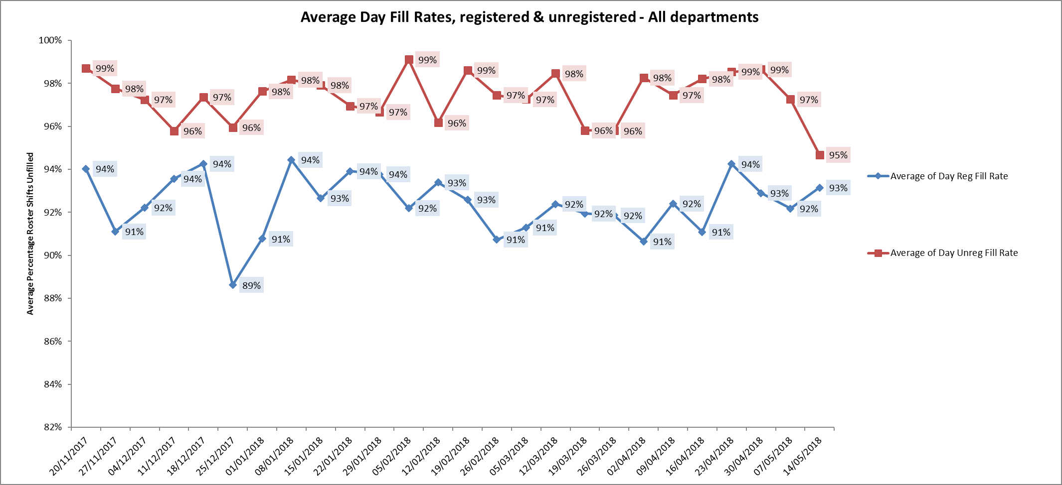

Eight wards were below 85% target for average weekly fill rates for registered nurse day shifts during this period. The fill rates for registered nurses have increased for six of these wards but are still below 85% target. These wards had 96% or above of unregistered staff to ensure safe staffing numbers overall.

Adult wards

Ashurst 62% up from 54%

Vaughan Thomas 68% up from 59%

Wintle 82% up from 67%

Ruby 78% down from 81%

Wintle 82% up from 67%

Children and young peoples and adult eating disorders

Cotswold House Oxford 58% up from 57%

Older Peoples

Cherwell 73% down from 81%

Sandford 74% up from 70%

**Night shift fill rates**

Average weekly night shifts fill rates for registered nurse & unregistered staff were above the Trust target of 85% throughout this period. This included a mix of agency, flexible and substantive staff to make up staffing numbers. This peaked to 102% for registered staff in the week of 14.5.18 in line with reduction of agency HCA usage as agency or flexible registered staff have been used by exception when needed to meet demand.

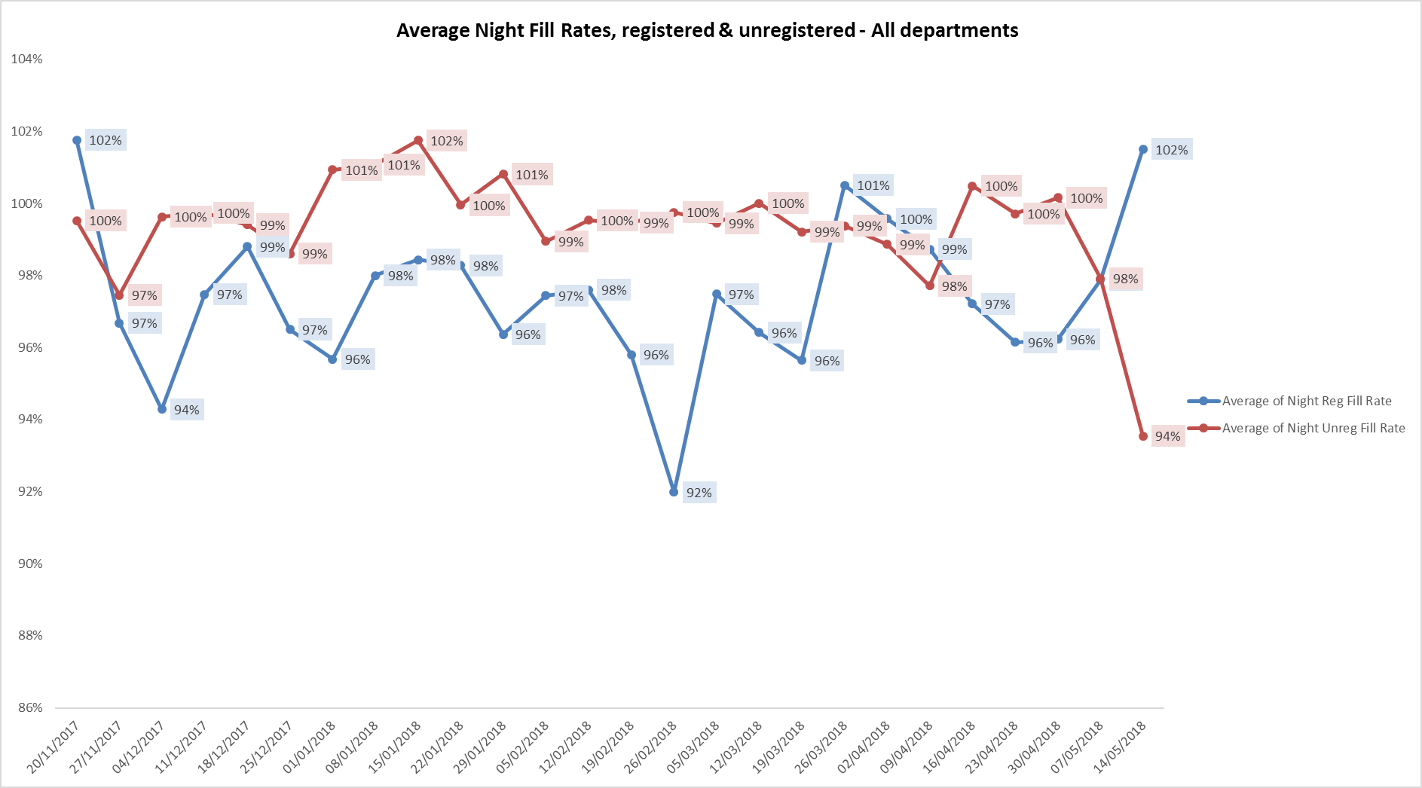

**Registered skill mix**

Nine wards had in place average 50% or above registered staff skill mix. There was an overall increase in the week of 14.05.18 to 47.2% due to increased use of registered staff as part of reduction of unregistered agency staff.

This is a positive increase in skill mix alongside increased providing more consistency of staffing through increased use of our flexible workers.

Abingdon Ward 2, Bicester, Didcot, Wenrisc and City all maintained above 50% registered skill mix, with Cotswold House Marlborough, Linfoot, Sanford and Sapphire increasing to above 50%. Two wards Opal and Phoenix dropped below 50% for this period.

The level of wards with below 50% registered skill mix is related to the continued registered nurse vacancies. Safe staffing is supported by the ward managers and matrons on the ward working clinically as part of the numbers where required to ensure registered nursing leadership is maintained.

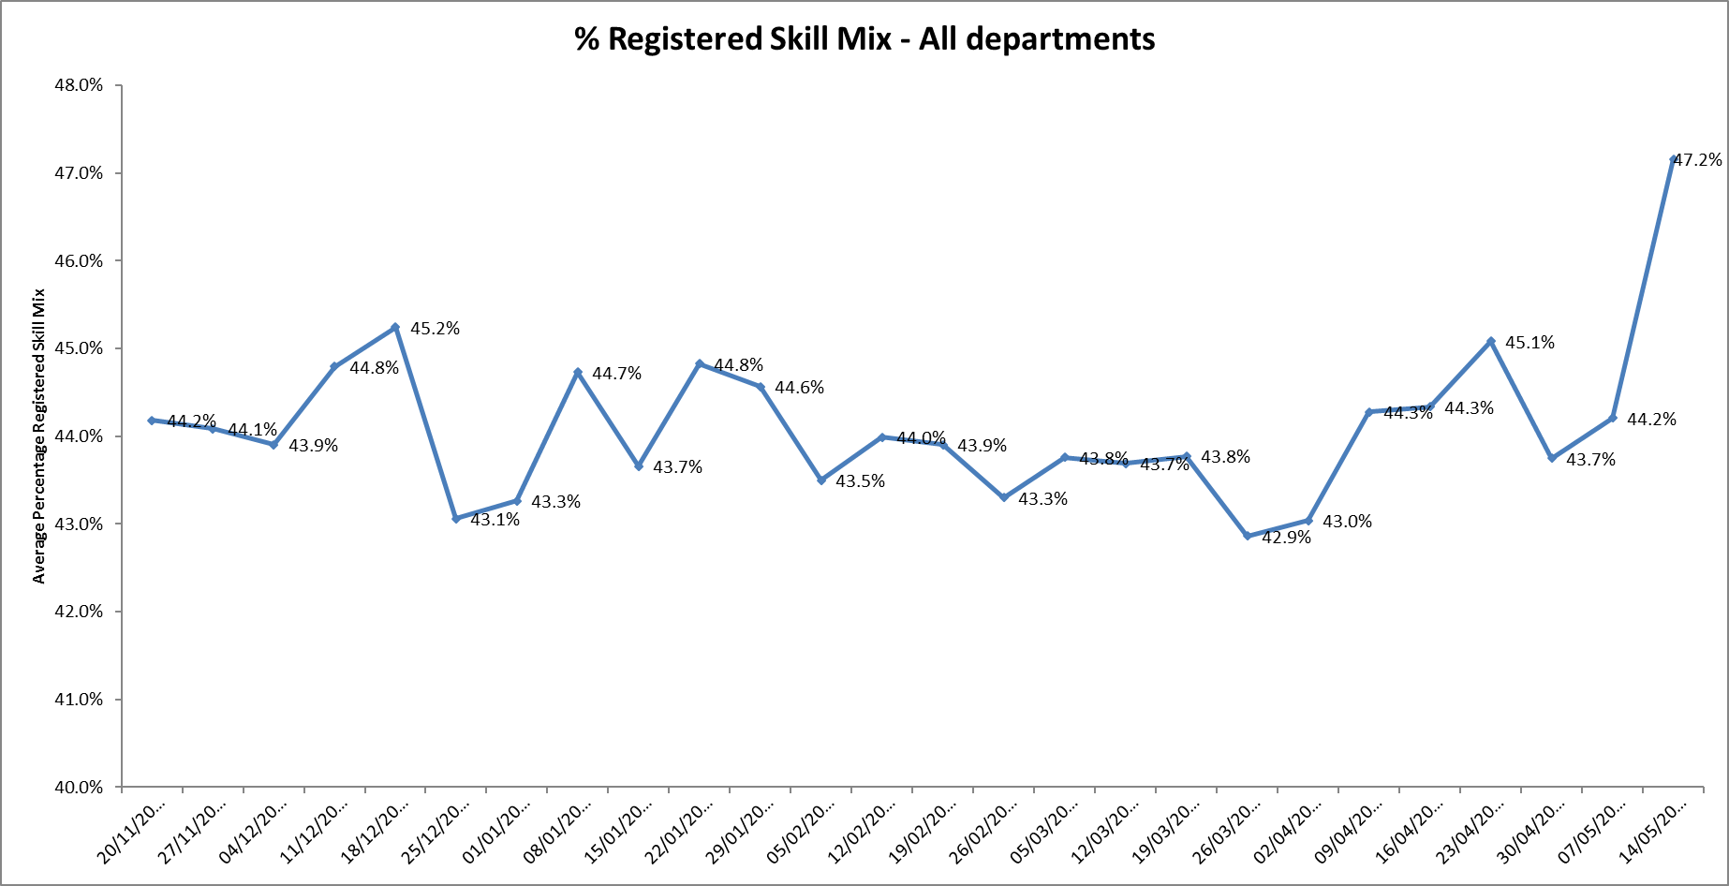

**Agency use**

The average weekly % agency use was 11.22% with a peak of 14.3% in the week of 23.04.18 but reducing to 4.3% in the week of 14.5.18, this is the lowest weekly % of agency use during the last year. This is related to the new work to reduce agency usage of non-registered staff. Details of this are provided in the HR workforce report.

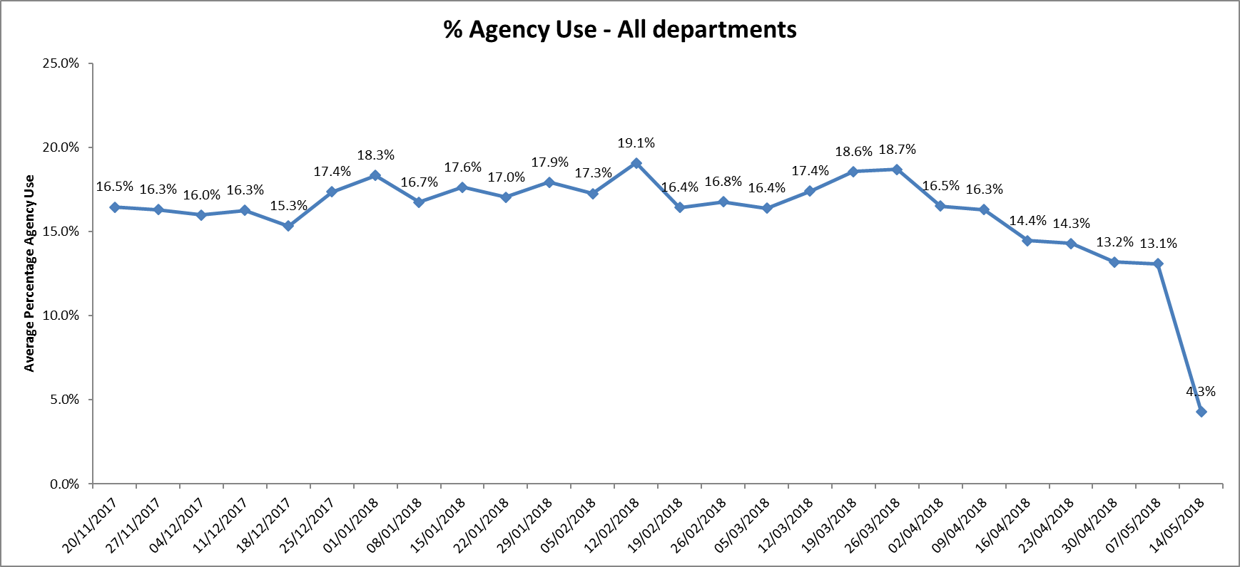

Nine wards were below trust target of 5%

Twenty three wards required 5-25% agency staff.

In the last reporting period six wards required more than 25% agency staff, in this period this has reduced to two wards Highfield and Allen.

It should be noted that these two wards have also had a substantial decrease over the four week period in line with the changes to HCA agency use. See graphs below:

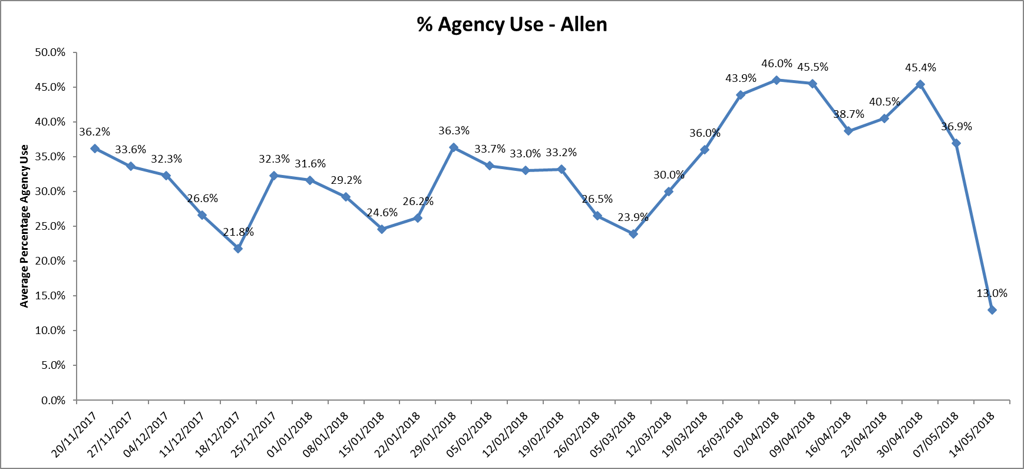

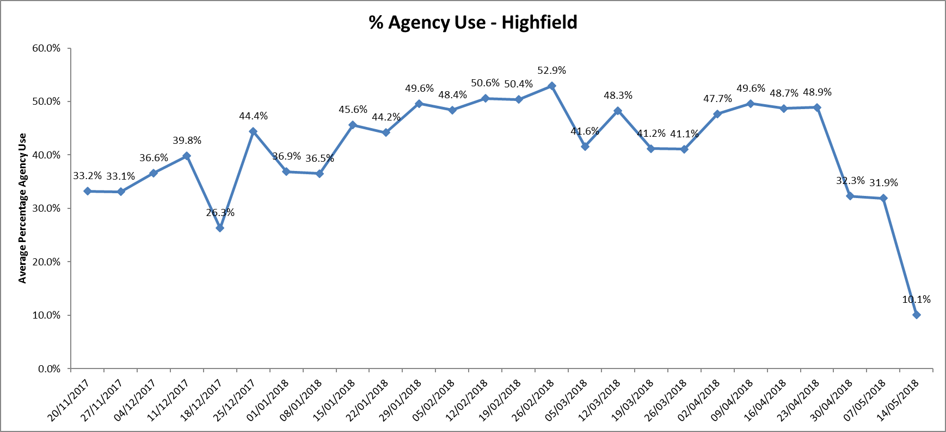

**Managing safer staffing**

The key risk has been in relation to registered nursing vacancies, there has been some improvement in this through ongoing recruitment work.

To date 33 student nurses have been provided with job offers to start post graduation in Summer 2018 including four on Vaughn Thomas ward and six on Highfield.

Social media campaign for Thames House has been successful for support worker recruitment across both wards.

The resilience project within forensics wards has begun and four cohorts will run through the year. The course will be evaluated on its completion, however initial feedback about the course has been positive.

City community hospital has reduced beds to 12 over the next 5 weeks and will use 3 lines of agency work as there still have a vacancy of 3.74 WTE Band 5.

Didcot Community Hospital has a temporary reduction in beds from 16 to 12 to manage safer staffing with 4.53WTE vacancies.

The cessation of agency staff which only relates to HCAs, has been carefully planned, is being carefully monitored, with twice weekly conference calls and is reviewed at various senior meetings including the workforce Exec meeting on 4 June. To date there has been no adverse impact on patient care. There are now over pure 800 flexible workers working for the Trust.

By using these staff instead of agency, we can manage, supervise, support and train them to our standards, which is in the longer term going to give us significantly better confidence in standards of patient care.

There has been weekly oversight of the HCA reduction work by senior staff, including oversight of incidents and to date the reduction in HCA agency has been overall successful with no significant changes in incidents- see graph below.

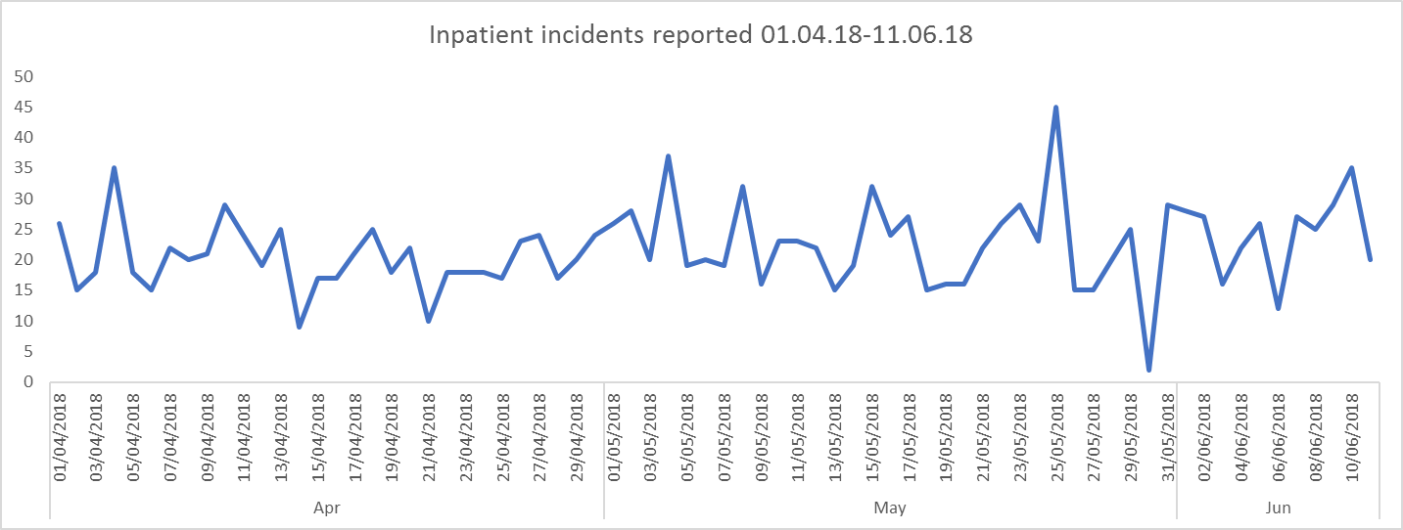

**Inpatient Nurse Staffing Establishment Review**

A recent staffing review has been completed to review previous planned staffing levels against actual use. This has been done using the Workforce Management Sytem data and based on bed numbers and patient acuity. This will enable nursing managers to construct their day to day staffing requirements with a clear understanding as to what is an accurate establishment against an updated budget. This review has also taken into account any known in future changes in bed numbers. There have been no significant changes in the overall staffing levels. There is a change to align the budget to the staffing levels and further review is being undertaken to finalise this work. This review process will be followed up by further work in Q2 to take into account the skill mix remodelling work with new roles including Band 4 Nursing Associates.

**Care Hours per Patient Day (CHPPD) requirements**

From April 2018, all trusts (acute, acute specialist, community and mental health) have been required to collect CHPPD monthly for all their inpatient wards. The Trust can submit this data using the census data collected as it has in place the Safe Care module on the workforce management system. We have started to submit this as required.

**Safe Care module update**

This additional module on the workforce management system enables units to:

* Capture actual patient numbers by acuity and dependency
* See if staffing levels match the demand.
* Action day-to-day staffing movements
* Provides clear visibility of staffing issues Trust wide where staffing does not match the required patient demand
* Informs longer-term resource and establishment plans
* Provides reports to identify trends and causes, highlighting changes needed to ensure safe staffing levels.

The data is being reviewed weekly by the Heads of Nursing to monitor census completion and acuity levels

Safe Care implementation and operational management going forward has been discussed at Operational SMT and is being taken forward with directorate SMTs to agree reporting and monitoring arrangements within the directorates, as whilst data input compliance has improved but there are still areas of inconsistencies and the data reliability in terms of acuity and patient demand v staffing.

**SafeCare census compliance graphs**

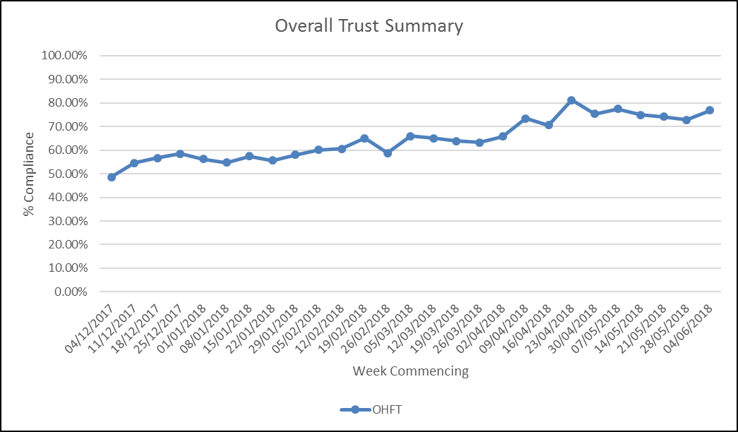

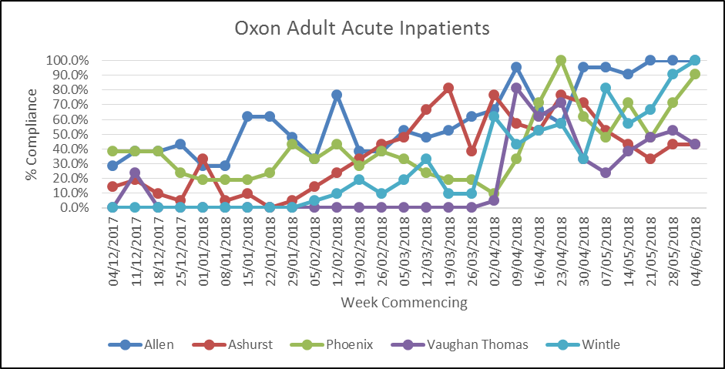

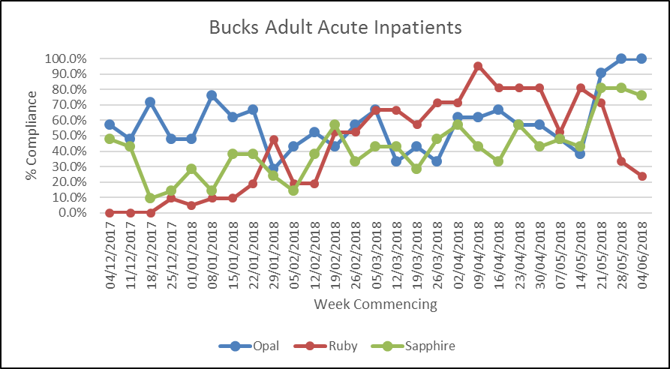

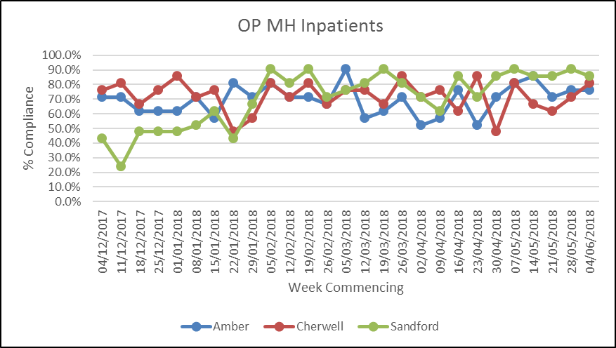

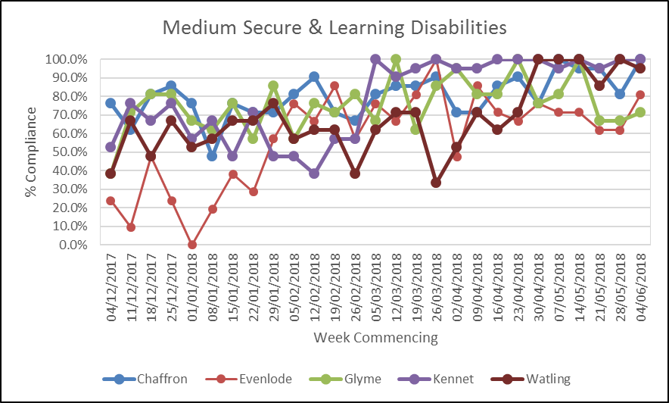

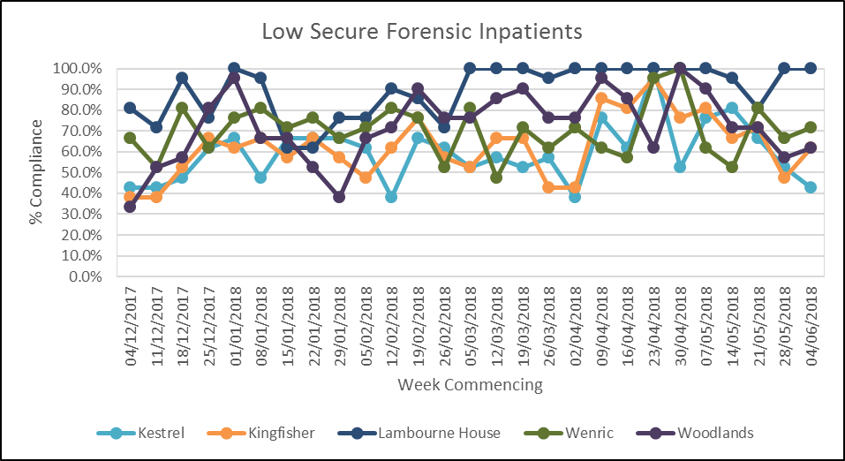

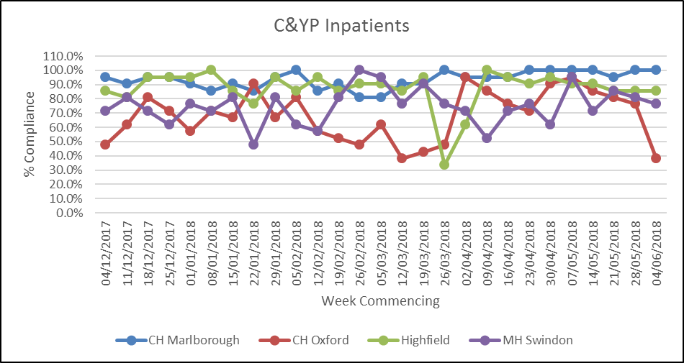

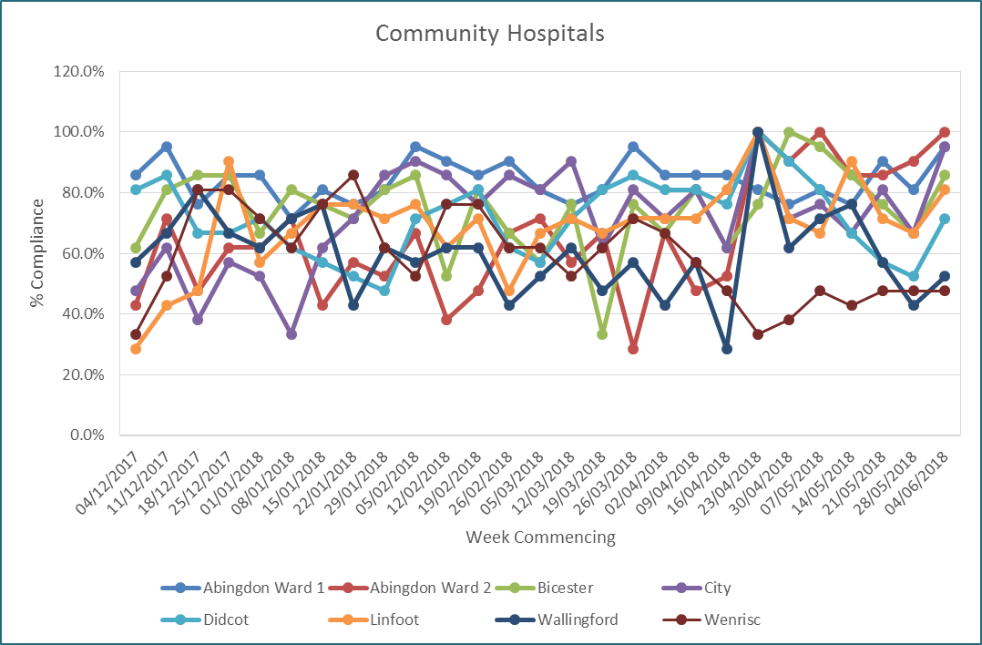

**Conclusion**

All ward staff and managers continue to make every effort to ensure wards continue to be staffed safely, fil rates remain high and that we focus efforts on retaining our staff whilst recruiting new nurses to join Oxford Health FT.



