

# Report to the Meeting of the

# Oxford Health NHS Foundation Trust

# Board of Directors

# 28th February 2018

# INPATIENT SAFER STAFFING Staffing 1st January 2018 to 28th January 2018

**For: Information**

**Executive Summary**

**Introduction**

The purpose of this paper is to provide a report of the actual inpatient staffing levels to the Board of Directors. There is a national requirement on providers to be transparent on our monitoring and reporting of inpatient staffing levels. Ensuring sufficient staffing levels are in place is crucial to deliver safe, effective and high quality care. This report will be published on our website with a link from NHS Choices website.

The data within the report will outline the staffing levels (for both registered and unregistered nursing staff) on each ward. These figures will be measured against the required figures on a shift by shift basis for the 4 week period 1st January to 28th January 2018.

The paper will this month provide more specific focus on the staffing on the older adult wards and provide information in relation to:

* Out of Hours Staffing
* Rollout of the SafeCare acuity and demand data collection module on Health Roster.

**Recommendations**

The Board is asked to note:

* The processes in place to ensure safe staffing levels on all the wards in the organisation, those wards where there are concerns and the actions being taken to ensure safe staffing including project work and wider recruitment and retention work.

**Author and Title:** Kate Riddle, Interim Deputy Director of Nursing and Clinical Standards

**Lead Executive Director:** Ros Alstead, Director of Nursing and Clinical Standards

*A risk assessment has been undertaken around the legal issues that this paper presents and there are no issues that need to be referred to the Trust Solicitors. This paper links to all of the five CQC Domains.*

***Strategic Objectives*** *– this report relates to or provides assurance and evidence against the following Strategic Objective(s) of the Trust*

*Driving Quality Improvement (Goals: patients will be safe from harm; patients will achieve the clinical outcomes they want; and patients and carers will have an excellent experience)*

*Delivering Operational Excellence (Goals: our services will be effective and efficient; information will be translated into knowledge; and our planned surplus will be delivered)*

**Inpatient Safer Staffing**

Period: 1st January to 28th January 2018

**Introduction**

This is the report to the Board of Directors outlining the staffing levels (registered and unregistered) on each ward against their required need on a shift by shift basis. This report covers the four week period: 1st January to 28th January 2018.

This month there is a more specific focus on the older adult wards staffing to outline the current staffing and strategies in place to ensure safer staffing. In addition, there is information in relation to:

* Out Of Hours staffing
* Roll out of the SafeCare acuity and demand data collection module on Health Roster.

This report will focus on the percentage of day and night fill rates for registered and unregistered staff. This data is reported to NHSI and provides assurance of actual clinical staffing numbers being achieved.

This report will be published on our website with a link from NHS Choices website.

**Management of Staffing Levels**

Anescalation process for the management of staff shortages is in place within each clinical area, in order to manage staffing safely on a shift by shift basis. As part of this process, senior clinical staff are providing appropriate support to ward teams as and when required. In addition, senior ward staff and immediate team managers review ward staffing levels on an on-going basis; shift by shift basis, and where there are changes in patient acuity. Ward Matrons review staffing daily as a minimum and more frequently where required.

In-patient staffing levels continue to be reported every week and discussed within the Weekly Review Meeting (WRM), which takes place each Monday morning.

In order to ensure that staffing levels are under continual review, every ward undertakes a range of immediate actions on a daily basis to ensure safe staffing levels are maintained appropriate to the needs of patients. These actions include booking staff via staffing solutions via bank or agency, revising rotas, moving staff between wards and utilising additional staff that are not include in the ward numbers as required.

**Summary position of inpatients wards staffing levels.**

Appendix 1 shows the staffing levels for all wards by ward for the four week time period 1st January to 28th January 2018. The data presented includes details of staffing by shifts and also details of skill mix, agency, ward staff sickness and ward vacancy figures. The thresholds presented in the table are measured against trust/ national targets and used to highlight particular wards for further review.

During this period:

Average day shifts fill rates for registered staff & unregistered staff were above the Trust target of 85%.

Average night shifts fill rates for registered and unregistered were above the Trust target of 85%

The methods of filling these shifts includes substantive, bank and agency registered staff and further detail in provided later in the report.

The average % agency use was 17.4% with a peak of 18.3% in the week of 01/01/18 this relates to sickness levels, vacancies and staffing required for the additional beds opened within the community hospitals as part of the system wide winter pressures work. This is the highest percentage agency use since 23.10.17

Sickness rates for ward staff were an average of 7.7% in this period with a peak of 8.8% in the week of the 15/01/18.

**Day shifts fill rates**

Average day shifts fill rates for registered nurse & unregistered staff were above the Trust target of 85% throughout this period. This included a mix of agency, bank and substantive staff including ward managers and matrons where required to make up staffing numbers.

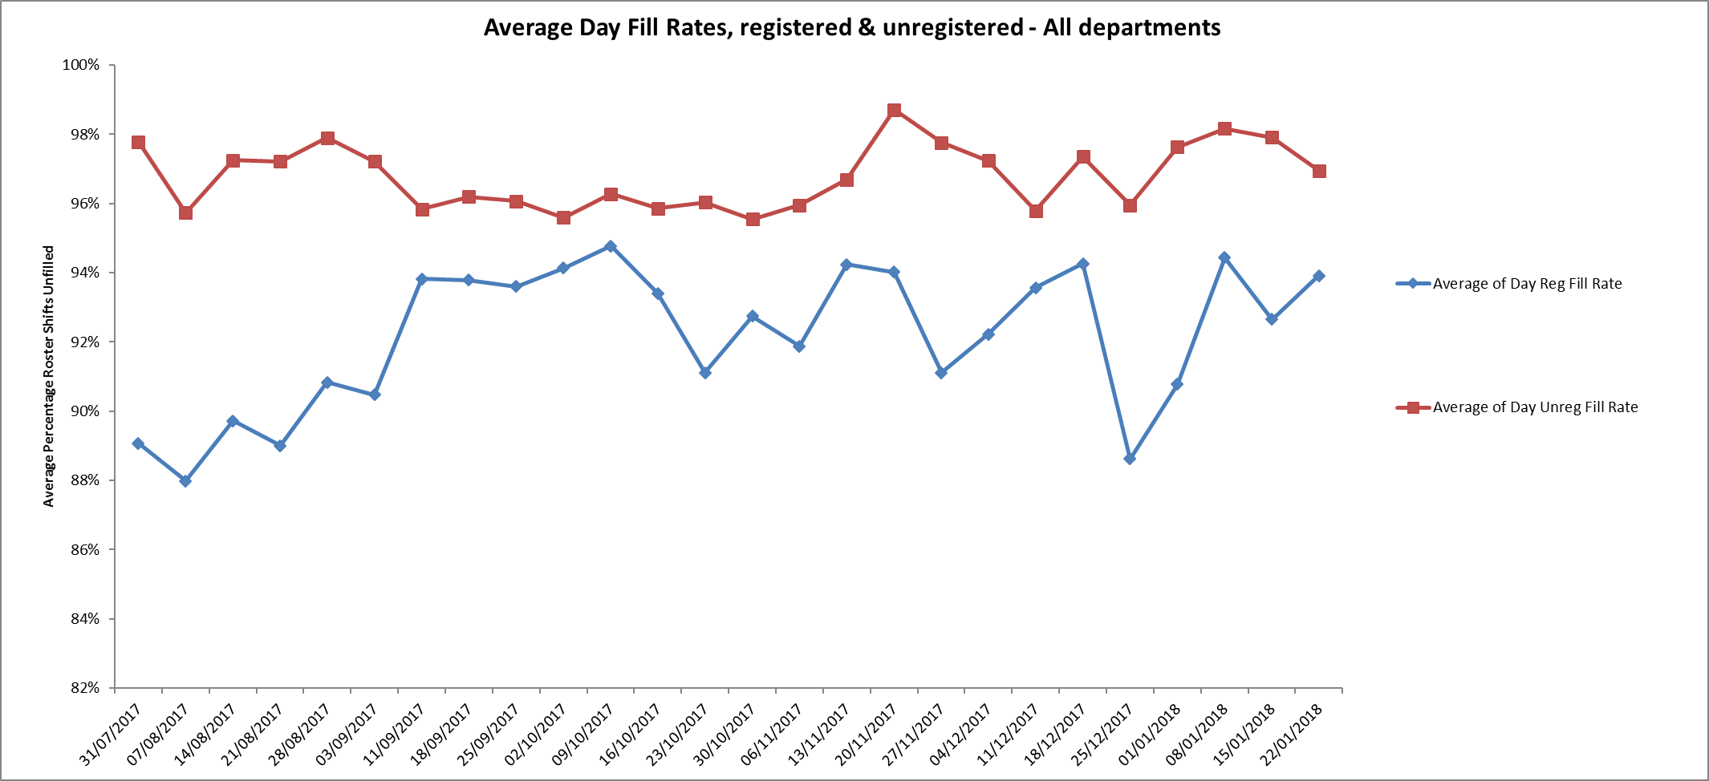

However, seven wards were below 85% target for average fill rates for registered nurse day shifts during this period.

These were:

Adult wards

Ashurst, Vaughan Thomas, Wintle, Ruby.

Children and young peoples and adult eating disorders

Cotswold House Oxford and Highfield

Older adult wards

Cherwell.

All of wards above had above 85% of unregistered staff to ensure safe staffing numbers overall.

**Night shift fill rates**

Average night shifts fill rates for registered nurse & unregistered staff were above the Trust target of 85% throughout this period. This included a mix of agency, bank and substantive staff to make up staffing numbers.

Two wards Ashurst and Glyme were below 85% at 77% and 70% respectively for registered staff, this was managed with additional unregistered staff on Glyme and 100% of unregistered staff on Ashurst.

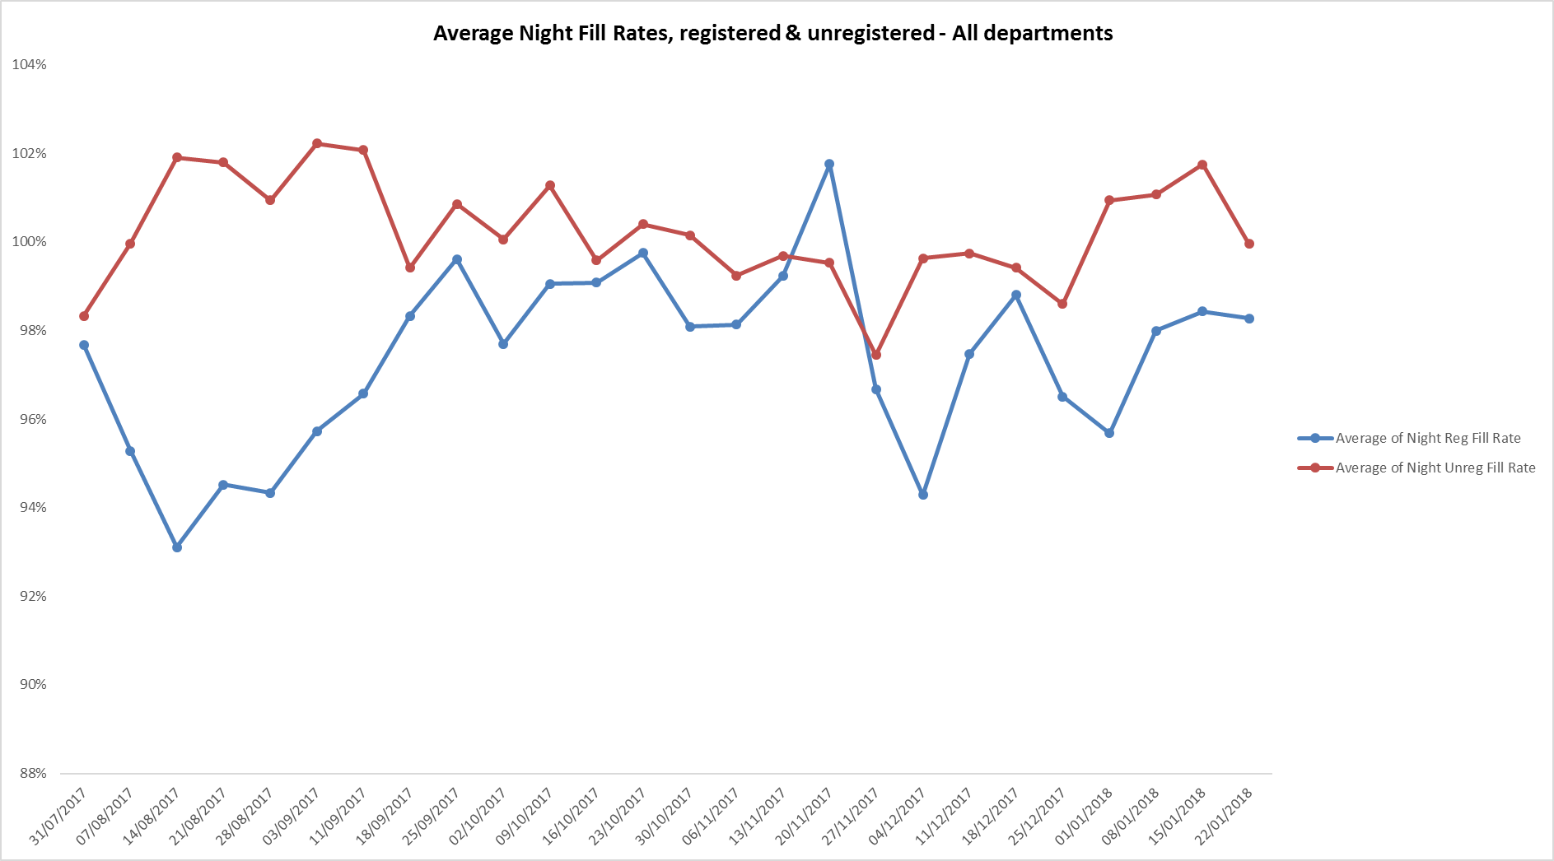

**Registered skill mix**

Six wards had in place 50% or above registered staff skill mix, this has declined from eight wards in the last reporting period of 4th December to 31st December.

This relates to continued registered nurse vacancies. Safe staffing is supported by the ward managers and matrons on the ward working clinically as part of the numbers where required to ensure registered nursing leadership is maintained.

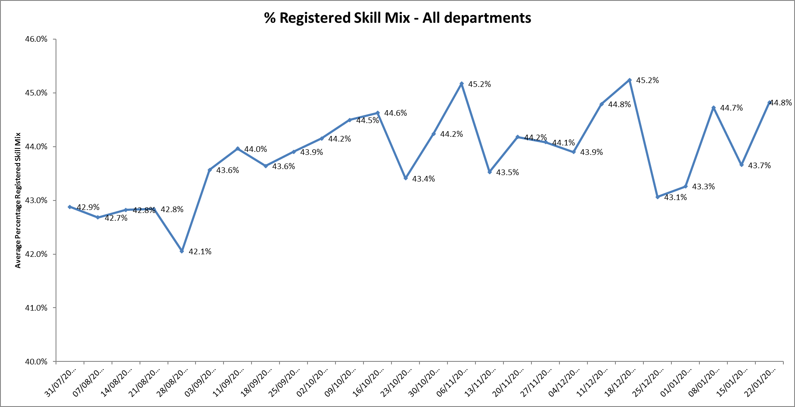

**Agency use**

The average % agency use was above 16% for this period with a peak of 18.3% in the week of 01/01/18

Ten wards required more than 25% agency use to maintain fill rates, these were

Allen 27.9%, Ashurst 29.%, Highfield 41.1%,Kestral 39.7% Kingfisher 29.9%, Phoenix 33%, Ruby 35.5%, Sandford 26.9%, Sapphire 31% and Vaughn Thomas 27.1%.

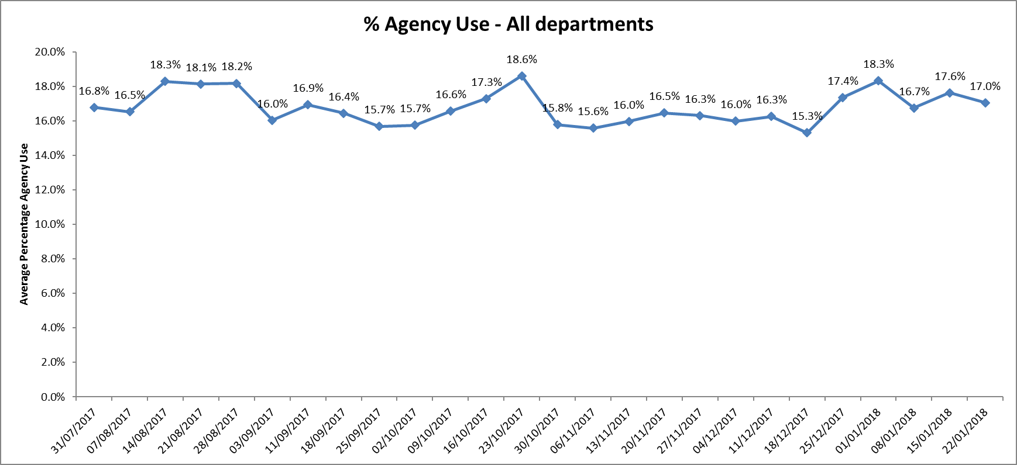

**Adult Directorate wards**

Last month there was a more in depth review of safer staffing on the adult mental health wards.

There continues to be high levels of Nursing vacancies.

Vacancies in total for the eight Adult Mental Health wards as at 14.01.18

* Band 6 - 9.3 WTE
* Band 5 – 53.2 WTE (3.3 appointed but not started)
* Band 3 – 22.74 WTE (4 appointed but not started)

Recruitment to the Ruby ward matron role has been taken forward and pending employment checks this role should be filled and start date confirmed.

**Older Adult wards and Community Hospitals**

This month there is a focus on these wards.

**Ward information**

There are three older adult mental health wards Amber, Sandford and Cherwell

The table below provides more detail of bed numbers and minimum expected staffing numbers for each shift. The staffing numbers are for registered nurses and unregistered staff with an expected skill mix of 50%:50% split.

**Table 1.**

|  |  |  |
| --- | --- | --- |
| **Ward** | **Bed numbers** | **Staffing numbers by shifts Early/Late/Night** |
| Amber | 20 | 6:6:4 |
| Cherwell | 17 | 6:6:4 |
| Sandford | 14 | 6:6:5 (fifth staff member on nights will cover Cherwell as needed) |

**Vacancies, skill mix and agency use**

The vacancy data provided in the report in Appendix 1 includes **all** ward staff vacancies excluding medical staff. In order to understand more detail of the nursing vacancies data was requested directly from the older adult ward managers for the week ending 16/02/18 and this is included in the table below to outline the details of the current vacancies.

This most significant area of challenge for older adult mental health continues to be Sandford ward where safe staffing levels are being maintained through a reliance on Bank and Agency Staff, only 20-22% of the rota is filled by substantive staff. However, a reduction in beds and additional psychology input has stabilised the situation over the past few months. Despite HCA recruitment to Amber Ward there is a high level of agency use.

All wards have long line agency RMNs supporting them to maintain continuity of care.

**Table 2.**

|  |  |  |  |  |
| --- | --- | --- | --- | --- |
| **Older Adult Mental Health Ward** | **Registered staff**  **Skill mix** | **Agency use** | **Nursing Band** | **Number of WTE vacancy** |
| **Amber** | 44.6% | 24.2% | Band 3  Band 5 | 3.0 recruited and further 3.0 planned  6.0 (one recruited not started) |
| **Cherwell** | 48.8% | 16.2% | Band 3  Band 5 | 1.0  3.0 |
| **Sandford** | 43.3% | 26.9% | Band 3  Band 5 | 4.0  5.0 |
|  |  |  |  | **Total:**  **Band 5: 14.0 WTE**  **Band 3: 5.0 WTE** |

Recruitment work has resulted in 3 newly qualified nurses have been appointed waiting completion of their training in summer 2018. They will be part of a rotation for 1 year between the wards and a choice of either community hospital or CMHT.

**Community Hospitals**

There have been significant pressures across the whole system during the winter period. In response to this the Older Peoples Directorate have opened additional beds across community hospitals. There are currently 151 community hospital beds being used compared to 135 open before Christmas. This has required additional agency expenditure and the use of incentive payments. There has been an increase in the incidence of respiratory disease in the community and this has correspondingly affected staffing levels in community hospitals. Agency staff have been used to support a number of patients at high risk of falls and with challenging behaviour. This has been particularly noticeable at Witney Community Hospital where there are a large number of patients that require Deprivation of Liberty Safeguards to be in place and at Wallingford Community Hospital there has been a number of patients that are highly dependent.

**Table 3.** Below shows current bed numbers, vacancies, expected shift staffing levels and average registered skill mix (for the period 1-28th January)

The established number of beds is 140-142 and will be budgeted for 142 beds next year. All bands of nursing staff are included in the shift numbers. The vacancy data shows only vacant WTE for RGN band 5 and HCA bands 2/3 as there are no vacancies currently at bands 6 and 7. Registered skill mix of 50% was achieved for four of the eight wards.

The table also does not show the impact of considerable level of therapy vacancy and locum cover.

|  |  |  |  |  |  |  |  |  |
| --- | --- | --- | --- | --- | --- | --- | --- | --- |
| **Ward** | **Established bed numbers** | **Current bed numbers with Winter beds** | **Early shift** | **Late Shift** | **Night shift** | **Band 5 Vacancy**  **WTE** | **HCA Vacancy WTE** | **Registered staff skill mix**  **(average)** |
| **Abingdon Ward 1 (stroke)** | 16 | 16 | 3 + 3 | 3 + 3 | 2 + 2 | 6 | 3 | 49.3% |
| **Abingdon Ward 2** | 18 | 21 | 4 + 3 | 3 + 3 | 2 + 2 | 2.11 | 3.58 | 51.5% |
| **Bicester** | 12 | 12 | 2 + 2 | 2 + 2 | 2 + 2 | 0 | 1 | 54.7% |
| **City** | 16 | 17 | 3 + 3 | 2 + 3 | 2 + 2 | 5.1 | 1.8 | 54% |
| **Didcot** | 16 | 18 | 3 + 3 | 2 + 2 | 2 + 2 | 4.76 | 1.46 | 49.2% |
| **Wallingford** | 18 | 22 | 4 + 4  Or  3 + 5 | 4 + 4 | 2+ 3 | 4.9 | 1.62 | 42.4% |
| **Linfoot** | 20 | 20 | 3 + 4 | 3 + 4 | 2 + 2 | 4.84 | +1 approx. (slight over established to compensate for RN) | 49.2% |
| **Wenrisc** | 24 | 24 | 4 + 4 | 4 + 4 | 3 + 2 | 1.13 | 2.09 | 55.2% |
| **TOTALs** | 140 beds | 150 beds |  |  |  | **28.84 WTE** | **14.55WTE** |  |

**Total Nursing Vacancies for Older adult mental health and community hospital wards:**

Band 5 42.84 WTE

Band 3 19.55 WTE

**Senior Oversight and risk management**

Daily safer staffing numbers are reviewed in all wards on the daily teleconference call at 08:00 hrs each day. Agreed actions to manage and mitigate any risks associated with staff shortfalls are agreed with the matron for community hospitals and the operational managers for the site. These include reduction in bed capacity (postponement or deferral of admissions) or use of additional agency staff to manage the shortfalls. Off framework agency spend is discouraged though when required authorised by head of nursing, clinical director or service director alone. Weekly safe staffing levels are reviewed by the directorate ‘Head of Nursing’ before submission to the Weekly review meeting.

**Safety Metrics Dashboard**

This is in place for community hospitals and brings together a range of metrics at ward level to enable overall quality and safety to be monitored (See Appendix 2)

**SafeCare**

All older adult and community hospital wards are using the Safe Care Module and many areas are achieving good compliance levels.

The Nurse in Charge of each shift updates the system with patient acuity and dependency data, any tasks that need to be carried out during the shift and actual staffing on shift. The information feeds directly into the main Health Roster system. SafeCare Live calculates how many hours are required to care for patients based on the information that has been entered (known as Required Care Hours) and compares this to the number of hours of care available based on their rostered staff (known as Actual Care Hours) to inform if the ward is under or over staffed.

SafeCare Live can support on call managers to identify if units are appropriately staffed, or support clinicians to find additional staffing.

Moving forward once robustly embedded this will enable improved real time monitoring of Care hours staffing levels and patient acuity.

**Complaints**

There are low number as of complaints and concerns for older adult wards and IWGC % for community hospitals is above 92% with patients likely to recommend the service

| **Ward/Service** | **Complaints**  **Q3 2016’17** | **Concerns**  **Q3 2016’17** | **Complaints**  **Q3 2017’18** | **Concerns**  **Q3 2017’18** |
| --- | --- | --- | --- | --- |
| Older Adult MH Amber Ward | 1 | 1 | 0 | 1 |
| Older Adult MH Cherwell Ward | 0 | 3 | 1 | 1 |
| Older Adult MH Sandford Ward | 0 | 3 | 0 | 1 |
| CH - Abingdon Ward One | 0 | 3 | 0 | 1 |
| CH – Abingdon Ward Two | 0 | 3 | 0 | 0 |
| CH – Bicester Ward | 0 | 0 | 0 | 1 |
| CH – City Ward | 0 | 6 | 1 | 3 |
| CH – Didcot Rehab Ward | 0 | 8 | 0 | 0 |
| CH – Didcot | 0 | 3 | 0 | 0 |
| CH – Witney Linfoot Ward | 1 | 3 | 1 | 0 |
| CH – Witney Wenric Ward | 0 | 5 | 0 | 1 |

**Serious Incidents**

There were no new Serious Incidents in this reporting period and the number of outstanding SI actions remained at 0 for the fifth month in a row.

**Out of Hours**

Out of Hours staffing levels were maintained over the holiday period at levels between 92% and 100%. This was achieved through continual focus of trying to maintain the rota. At weekends there have been some challenges staffing bases in the North and the whole rota has been dependant on Emergency Nurse Practitioners. There are indications of increasing pressures over the past few weeks.

**Children and Young Peoples Services**

**Highfield Unit**

There is a national shortage of CAMHS beds particularly PICU beds which has resulted in patients being cared for Tier 4 beds for prolonged periods whilst awaiting PICU beds. This is on the Trust risk register and has been escalated to NHSE.

The high average agency use of 41.1% is linked to the level of patient acuity, HDU staffing requirements and high level of staff vacancies, with sickness slightly increased to 4.5% from 3.9% at the end of the last reporting period.

In order to manage safe staffing levels and maximise staff retention, the ward was closed to admissions on 2.11.17 but has now reopened to admissions.

**Cotswold House Oxford**

This unit had the lowest average % of day shifts filled by registered nurses at 54%, this reflects a change to the staffing demand template from 5:5:4 to 6:6:4 whereby additional registered nursing shifts required filling.

**Evenlode**

The unit is now on Health Roster which enables weekly oversight of safer staffing in line with other units The establishment is set at 6:6:5 but due to more recent increase in acuity the ward has been using agency staff to increase to 7 staff for day shifts.

During this period fill rates for registered and unregistered staff have been above 96% except for unregistered staff for day shifts which was 86% but still above Trust target.

**Trust SafeCare project roll out update**

This additional module on the workforce management system enables units to:

* Capture actual patient numbers by acuity and dependency
* See if staffing levels match the demand.
* Action day-to-day staffing movements

Provides clear visibility of staffing issues Trust wide where staffing does not match the required patient demand for:

* in nursing hours
* skills
* temporary staff usage
* charge cover

Informs longer-term resource and establishment plans

* Enables the use different models or multipliers for different wards
* Provides reports to identify trends and causes, highlighting changes needed to ensure safe staffing levels.

The training programme for staff on inpatient units and 29 wards has been completed and these units are now able to collect patient acuity census data, inputting this into SafeCare and updating their staffing information through SafeCare.

There are some improvements in data entry by wards.  It is recognised this is a challenging time with conflicting priorities alongside teams managing high levels of vacancies, so continuing to support wards to improve with getting data entered consistently is a priority as the better compliance and reliability of data we achieve, the closer we will come to understanding whether the unit is staff correctly based on actual patients’ needs.

The data is being reviewed weekly by the Heads of Nursing to monitor census completion, acuity levels and will inform safer staffing reports once robustly embedded in practice.

Further specific support will be offered to the adults wards to improve census completion given the additional pressures of staffing vacancies and improving agency staff knowledge of the system.

Once the data is robust this will be reported as part of the safer staffing reports.



