Report to the Meeting of the
BOD 09/2018
(Agenda item: 10)

Oxford Health NHS Foundation Trust

Board of Directors

31 January 2018

INPATIENT SAFER STAFFING
Staffing 6th November 2017 to 31st December 2017
For: Information
Executive Summary
Introduction
The purpose of this paper is to provide a report of the actual staffing levels to the Board of Directors. There is a national requirement on providers to be transparent on our monitoring and reporting of in-patient staffing levels. Ensuring sufficient staffing levels are in place is crucial to deliver safe, effective and high quality care.
The data within the report will outline the staffing levels (for both registered and unregistered nursing staff) on each ward. These figures will be measured against the required figures on a shift by shift basis for the 8 week period 6th November 2017 to 31st December 2017.
The paper will this month provide more specific focus on the staffing on the adult mental health wards and provide information in relation to:
- Evenlode staffing levels
- Rollout of the SafeCare acuity and demand data collection module on Health Roster.
Recommendations
The Board is asked to note:
- The processes in place to ensure safe staffing levels on all the wards in the organisation, those wards where there are concerns and the actions being taken to ensure safe staffing including project work and wider recruitment and retention work.
Author and Title: Kate Riddle, Interim Deputy Director of Nursing and Clinical Standards
Lead Executive Director: Ros Alstead, Director of Nursing and Clinical Standards
A risk assessment has been undertaken around the legal issues that this paper presents and there are no issues that need to be referred to the Trust Solicitors. This paper links to all of the five CQC Domains.

Inpatient Safer Staffing
Period: 6th November to 31st December 2017

Introduction
This is the report to the Board of Directors outlining the staffing levels (registered and unregistered) on each ward against their required need on a shift by shift basis. This report covers the eight week period: 6th November 2017 to 31st December 2017
This month there is a more specific focus on the adult mental wards staffing to outline the current staffing and strategies in place to ensure safer staffing.
In addition, there is information in relation to:
- Evenlode staffing levels
- Urgent Care and Out of Hours staffing.
- Roll out of the SafeCare acuity and demand data collection module on Health Roster.
This report will be published on our website with a link from NHS Choices website.
Following a review with Staffing Solutions E- rostering team on the types of staffing data available, this report will now focus on the percentage of day and night fill rates for registered and unregistered staff. This data is reported to NHSI and provides assurance of actual clinical staffing numbers being achieved.
Previous reports have also included review of % fill rates for all shifts but this is not a reliable safety indicator as it includes cancelled unfilled duties, shifts not included in clinical numbers, e.g. Modern Matrons, Admin, Family Therapist, Psychologists, Housekeepers and optional duties (students). This data is available but will not be reviewed as part of the monthly Safer Staffing report.
Management of Staffing Levels

An escalation process for the management of staff shortages is in place within each clinical area, in order to manage staffing safely on a shift by shift basis. As part of this process, senior clinical staff are providing appropriate support to ward teams as and when required. In addition, senior ward staff and immediate team managers review ward staffing levels on an on-going basis; shift by shift basis, and where there are changes in patient acuity. Ward Matrons review staffing daily as a minimum and more frequently where required.

In-patient staffing levels continue to be reported every week and discussed within the Weekly Review Meeting (WRM), which takes place each Monday morning. Appendix 1 in the body of the report summarises the staffing position for the reporting period.

In order to ensure that staffing levels are under continual review, every ward undertakes a range of immediate actions on a daily basis to ensure safe staffing levels are maintained appropriate to the needs of patients. These actions include booking staff via staffing solutions via bank or agency, revising rotas, moving staff between wards and utilising additional staff that are not include in the ward numbers as required.

Summary position of inpatients wards staffing levels.
Appendix 1 shows the staffing levels for all wards by ward for the eight week time period 6th November to 31st December 2017. The data presented includes details of staffing by shifts and also details of skill mix, agency, ward staff sickness and ward vacancy figures. The thresholds presented in the table are measured against trust/ national targets and used to highlight particular wards for further review.

During this period:
Average day shifts fill rates for registered staff & unregistered staff were above the Trust target of 85%
Average night shifts fill rates for registered and unregistered staff were above the Trust target of 85%
The methods of filling these shifts includes substantive, bank and agency registered staff and further detail in provided later in the report.
The average % agency use was 16% during the weeks 6/11/17 to 24/12/17 but increased to 17.4% in the week ending 31/12/17, this relates in particular to staffing required for the additional beds opened within the community hospitals as part of the system wide winter pressures work.
Sickness rates for ward staff were at 5.8% in the week of 6th November and rose to a peak of 7.2% for week ending 31/12/17.

Day shifts fill rates
Average day shifts fill rates for registered nurse & unregistered staff were above the Trust target of 85% throughout this period. This included a mix of agency
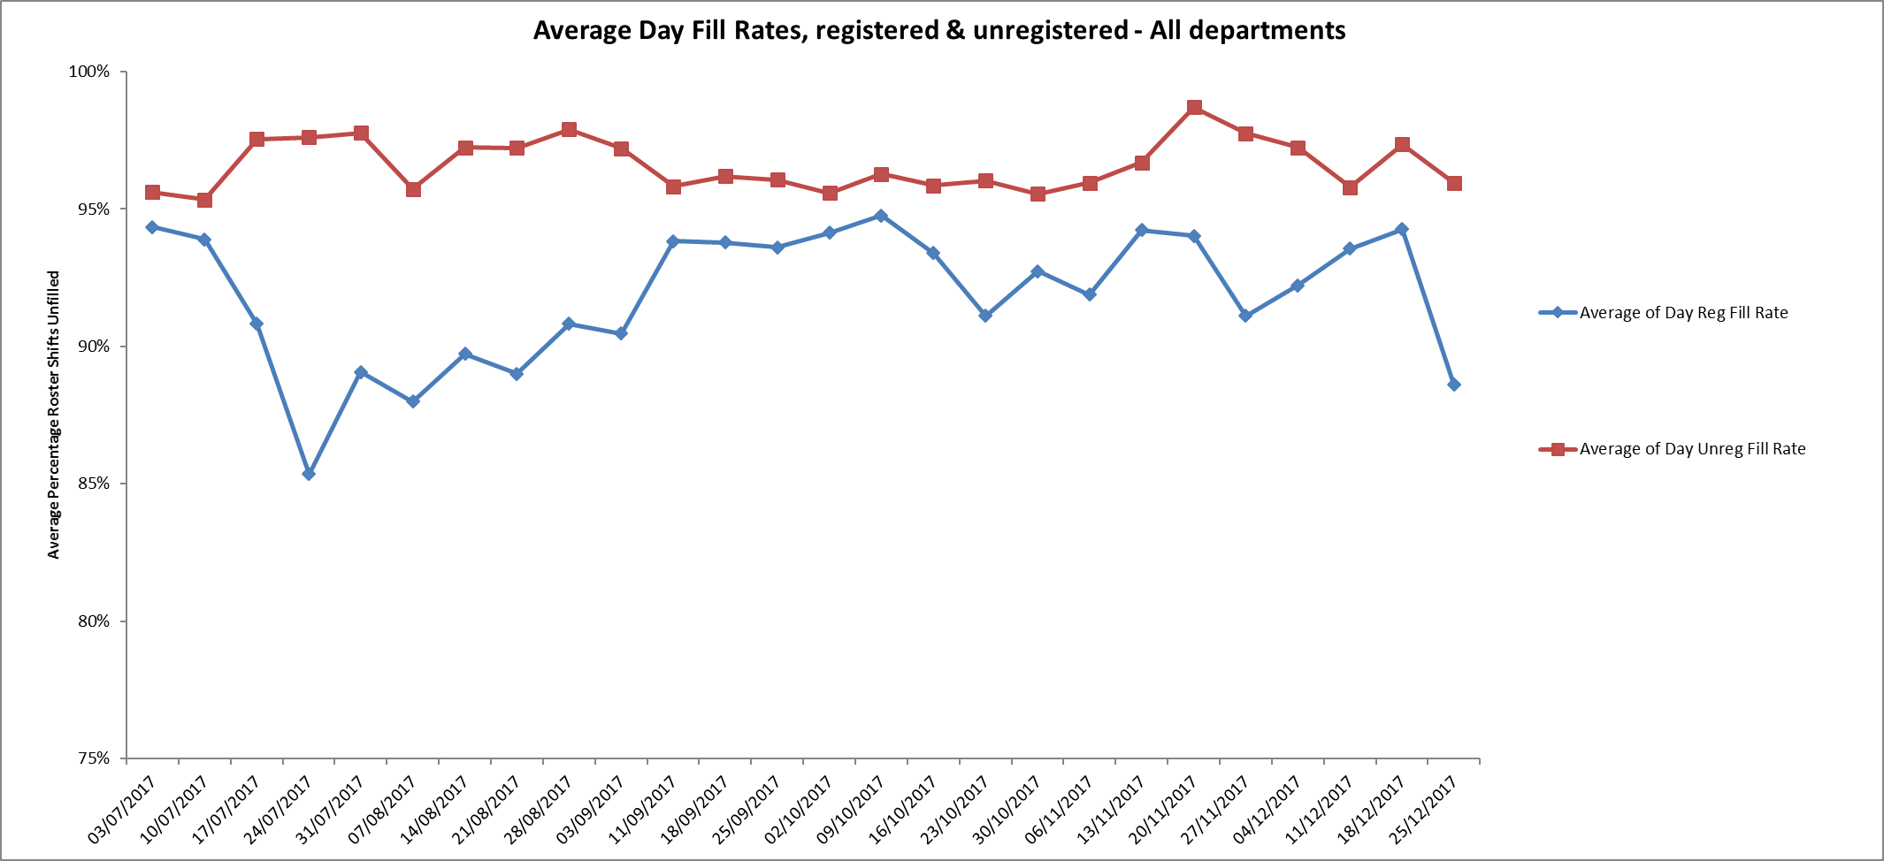
However, nine wards were below 85% target for average fill rates for registered nurse day shifts during.
These were:
Adult wards
Allen, Ashurst, Vaughan Thomas, Wintle.
Children and young peoples and adult eating disorders
Cotswold House Oxford and Highfield
Older adult wards
Cherwell, Sandford
Forensic wards
Kingfisher - this ward also had 81% fill rate for unregistered staff for the period 6th November to December 3rd, this improved in the second period to 84%
All of wards above had above 85% of unregistered staff to ensure safe staffing numbers overall.
Night shift fill rates
Average night shifts fill rates for registered and unregistered staff were above the Trust target of 85%
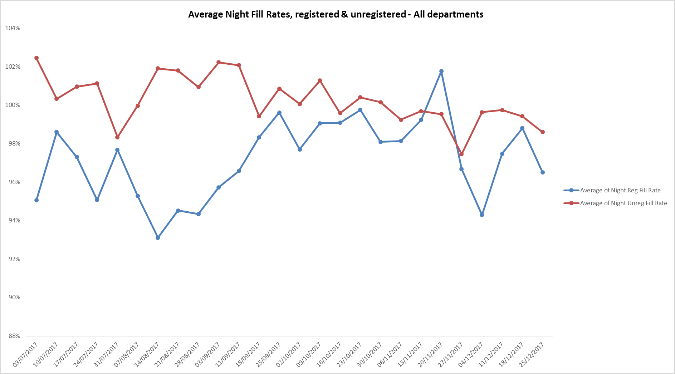

Twenty nine wards met the 85% night shift fill rates for registered nurses throughout this period.
Three wards were below this
- Ashurst 64% rising to 72% for 4th December to 31st December
- Kestral 79% for 4th December to 31st December
- Glyme 57% rising to 65% for 4th December to 31st December
Overnight staffing was supported by additional unregistered staff on these wards to provide overall safe staffing levels.
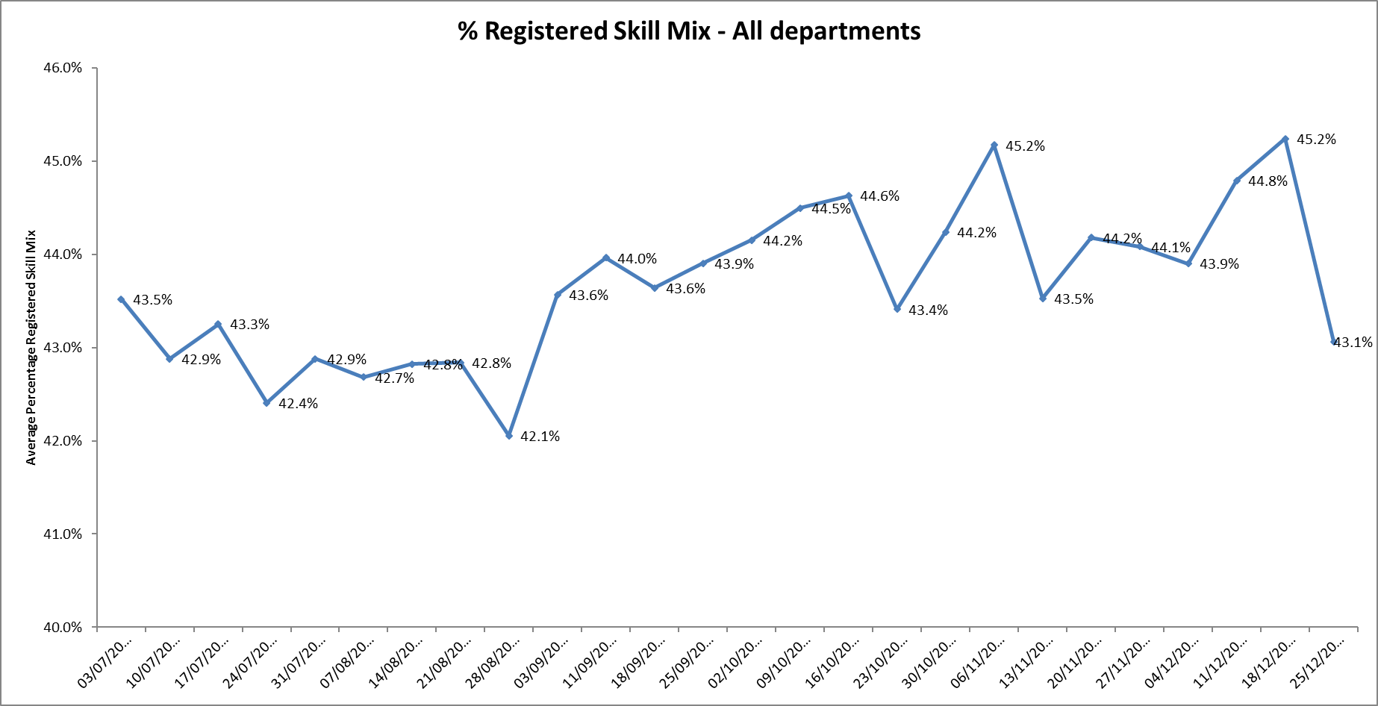
Registered skill mix

For the reporting period 6th November to 3rd December eleven wards had in place 50% or above registered staff skill mix, this declined to eight wards for 4th December to 31st December.
This relates to continued registered nurse vacancies. Safe staffing is supported by the ward managers and matrons on the ward working clinically as part of the numbers where required to ensure registered nursing leadership is maintained.

Agency use
Wards with high agency usage were Highfield,Kestral, Kingfisher and Sandford. More detail on adult wards is provided further in the report.
The average % agency use was 16% during the weeks 6th November to 24th December but increased to 17.4% in the week ending 31st December, this also related to additional staffing required for the additional beds opened within the community hospitals as part of the system wide winter pressures work.

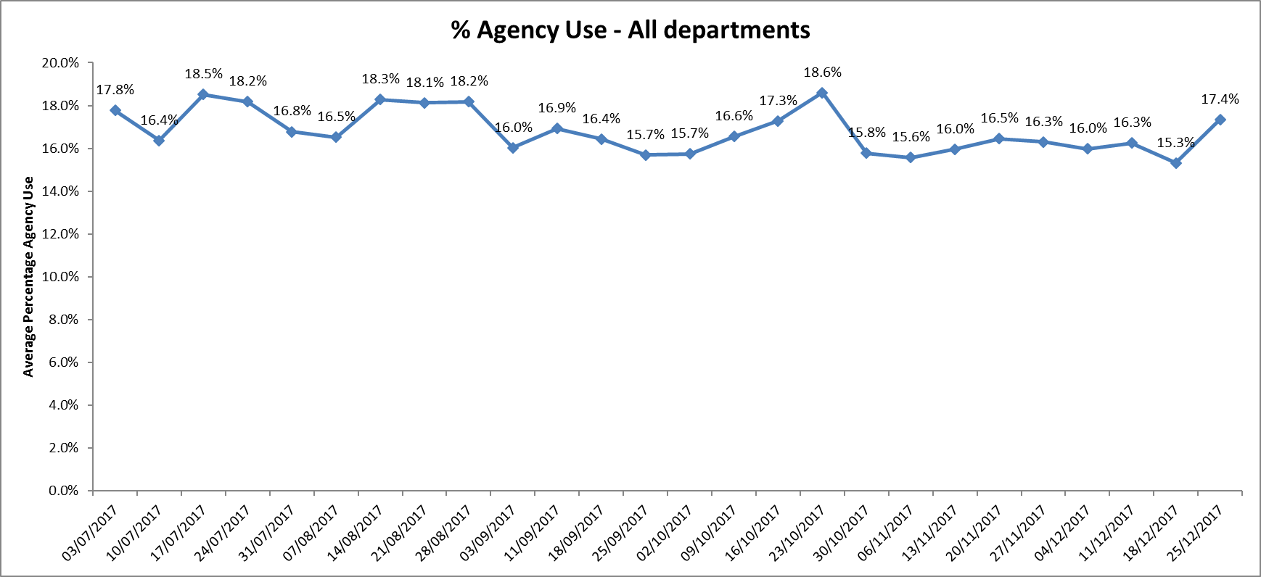

Adult Directorate wards
This month the Director of Nursing has requested a more in depth review of safer staffing on the adult mental health wards.
Ward information
Bed numbers, staffing numbers, skill mix and agency use.
There are eight adult mental health wards and the table below provides more detail of bed numbers and minimum expected staffing numbers for each shift. The staffing numbers are for registered nurses and unregistered staff with an expected skill mix of 50%:50% split.
- Phoenix was the only adult ward that had 50% registered staff, this was achieved with use of agency staff at 23.7.8% in period 6th November to 3rd December and 21.8% for the period 4th December to 31st December.
- Opal ward achieved this in the first period with a slight decline to 49.35 in the second period, they did not use any agency staff during this period
- The remaining six wards were below 50% registered staff skill mix and above % target use of agency staff.

 | 4th December to 31St December |  | 6th November to 3rd December
Ward | Skill mix | Agency use | Skill mix | Agency use
Ashurst | 29.9% | 32.9% | 25% | 40.1%
Allen | 45.4% | 28.4% | 35% | 36.8%
Ruby | 38.7% | 34.2% | 34.3% | 45.7%
Sapphire | 47.1% | 30.4% | 43.1% | 29.3%
Vaughn Thomas | 45% | 20.8% | 46% | 19%
Wintle | 36.5% | 14.4% | 33.7% | 25.1%

These figures need to be reviewed with the additional context of vacancy data and this is provided below

Vacancy data
The vacancy data provided in the report in Appendix 1 includes all ward staff vacancies excluding medical staff. In order to understand more detail of the nursing vacancies data was requested directly from the ward managers for the week ending 14/01/18 and this is included in the table below to outline the details of the current vacancies.
Vacancies in total for the eight Adult Mental Health wards:
- Band 6 - 9.3 WTE
- Band 5 – 53.2 WTE (3.3 appointed but not started)
- Band 3 – 22.74 WTE (4 appointed but not started)

In addition, Ruby ward has a locum consultant cover in place plus a part-time consultant. The substantive role has been challenging to recruit to despite active recruitment attempts and remains vacant.
Name | Type of ward | Bed numbers | Staffing numbers by shifts Early/Late/Night | 136 suite  (Staffed within main ward establishment) | Nursing vacancy data by band | Number of WTE
Phoenix | Male acute | 18 | 6:6:4 | Due to be put in place | Band 6  Band 5  Band 3 | 1.0  4.6  4.6 (3 appointed but not started
Allen | Female acute | 20 | 6:6:4 | No | Band 6  Band 5  Band 3 | 2.0  6.7  1.2
Wintle | Female acute | 16 | 6:6:4 | No | Band 6  Band 5  Band 3 | 1.0(from24/01/18)  9.0  1.0
Vaughan Thomas | Male Acute | 18 | 6:6:4 | Yes | Band 6  Band 5  Band 3 | 2.0  6.3  (2.7 appointed post qualifying summer 2018)  7.0
Ruby | Female acute | 20 | 6:6:4 | Yes | Band 6  Band 5  Band 3 | 0.2  7.6  4.5 (One recruited due to start)
Sapphire | Male acute | 20 | 6:6:4 | Yes | Band 6  Band 5  Band 3 | 1.1  5.0  2.74
Opal | Mixed rehabilitation ward | 20 | 5:5:4 | N0 | Band 5  Band 3 | 2.0 (0.6 recruited)  0.9 WTE
Ashurst | Mixed PICU | 11 | 8:8:6 | Yes | Band 6  Band 5  Band 3 | 2.0  12.0  0.8

Recruitment and preceptorship work
Ongoing recruitment work is in progress and there has been some success with job offers for mental health students who will graduate in the summer 2018
Preceptorship is in place for the newly qualified staff who were recruited in the autumn lead by matron on Vaughn Thomas and the Senior Matron for Buckinghamshire this will support retention of these staff.
Senior oversight and risk management
Matrons are in post on all wards except Ruby ward which has interview dates set for this month.
There is support in place from the matron on Phoenix ward for the ward manager on Ashurst whilst the matron is on maternity leave.
The two senior matrons for Oxfordshire and Buckinghamshire are in post and provide ongoing senior support and operational leadership to the wards in addition to the Head of Nursing for Adult Mental Health Services. Twice daily conference calls are held to review staffing and adjust levels in light of patient acuity and unfilled shifts.
The interim service directors with head of service have visited the wards at night to understand the pressures and talk to temporary staff about how they might move across to a substantive or even sessional contract if they are agency.
A strengthened admission process has been put in place to ensure robust decision making in relation to all admissions including in relation to patients with Emotionally Unstable Personality Disorder. This is in recognition that a hospital admission may increase the levels of risks, and joint care planning with community consultant and a community safety plan must be in place to reduce length of admissions where possible. This is line with NICE Guideline CG78 Borderline personality disorder: recognition and management January 2009
Risk panels are also convened to have senior clinical oversight and decision making where risk is a major factor and our ability to manage this is compromised due to patient factors. These are led by the Clinical Director, Associate Medical Director and Head of Nursing.
Bed numbers have been reduced on Ruby ward to sixteen, in order to manage the high patient acuity, the high level of self harm incidents, which peaked at 59 in November and to maintain safer staffing numbers.
The service model for Ashurst is also being reviewed as there are continued challenges to staff a mixed sex PICU with a 136 suite.
Skill Mix remodelling work
Work has started to look at revising the skill mix on the wards, to agree a new skill mix model for ward staffing including apprenticeships, associate nurses (Band 4 roles), senior staff nurse roles, activity coordinators, psychology assistant roles in recognition that new roles are needed to provide increased job opportunities and strengthen career developments for existing staff. This is part of the Trust wide recruitment and retention work
An action that has been taken include appointing three business and performance managers for cover the Oxon and Bucks wards. Their role is designed to release clinical time for ward staff and ensure key tasks are managed such as recruitment, oversight of audits, supervision and mandatory training attendance.
There is also a project in place to look to stop HCA agency usage this includes working with HCA staff to move onto Trust contracts to provide staff consistency alongside reducing costs.
Complaints
PALS surgeries are a valuable way of seeking feedback about people’s experiences, both positive and negative, and also about working with ward staff to resolve issues of concern at a local level, in a timely and positive manner There are weekly PALs clinics in place on Ruby Ward as a supportive measure to seek feedback and resolve any issues or concerns at local level. During quarter 3 there were 12 concerns, five of these related to all aspects of clinical care (four were about medication issues) and two related to communication issues. There was also positive feedback on the ward. There were no formal complaints in quarter 3.
Ward/Service | Complaints  Q3 2016’17 | Concerns  Q3 2016’17 | Complaints  Q3 2017’18 | Concerns  Q3 2017’18
Allen Ward | 2 | 8 | 2 | 5
Ashurst PICU | 0 | 6 | 3 | 5
Opal Ward | 1 | 3 | 0 | 0
Phoenix Ward | 0 | 2 | 0 | 4
Ruby Ward | 2 | 13 | 0 | 12
Sapphire Ward | 5 | 8 | 1 | 5
Vaughan Thomas Ward | 1 | 1 | 0 | 2
Wintle Ward | 1 | 9 | 0 | 12

In summary the adult wards are experiencing high levels of vacancies, require ongoing above target use of agency staff to maintain safer staffing levels, including additional duties being required to manage high levels of patient acuity particularly on the female wards.

Children and Young Peoples Services
Highfield Unit
There is a national shortage of CAMHS beds particularly PICU beds which has resulted in patients being cared for Tier 4 beds for prolonged periods whilst awaiting PICU beds. This is on the Trust risk register and has been escalated to NHSE.
The high average agency use (33.8% weeks 6th November to 3rd December and 35.1% weeks of 4th December to 31st December) is linked to the level of patient acuity, HDU staffing requirements and high level of staff vacancies, however sickness has decreased to 3.9% at the end of the period.
In order to manage safe staffing levels and maximise staff retention, the ward was closed to admissions on 2.11.17 and remained closed throughout this period.

Evenlode
The establishment is sent at 6:6:5 with a twilight shift but due to acuity and empty beds, the ward has been managing on 5 staff for day shifts.
During this period no staffing issues have been escalated This ward is now on the workforce management system and more detailed data will be reported in the next monthly report.

Urgent Care and Out of Hours staffing.
The Primary cover for the Out of Hours service is made up on GPs on a flexible worker contract.
In November the service achieved 96% cover, this is an improvement on the summer months when cover was at 90%.
During December the service achieved 92% cover for the GP shifts against that identified. The key challenges were the 25th and 26th December due to these being week days and not a normal out of hours working day. The service to attract GPs applied incentives payment. To manage this the service worked alongside PHL who provided some load share for the 12 and 24 hour end dispositions.
Moving forward rota cover is improving.
SafeCare project roll out update
This additional module on the workforce management system enables units to:
- Capture actual patient numbers by acuity and dependency
- See if staffing levels match the demand.
- Action day-to-day staffing movements
Provides clear visibility of staffing issues Trust wide where staffing does not match the required patient demand for:
- in nursing hours
- skills
- temporary staff usage
- charge cover
Informs longer-term resource and establishment plans
- Enables the use different models or multipliers for different wards
- Provides reports to identify trends and causes, highlighting changes needed to ensure safe staffing levels.
The training programme for staff on inpatient units and 29 wards has been completed and these units are now able to collect patient acuity census data, inputting this into SafeCare and updating their staffing information through SafeCare.
In the week of 8th January saw some improvements in data entry by wards. It is recognised this is a challenging time with conflicting priorities alongside teams managing high levels of vacancies, so continuing to support wards to improve with getting data entered consistently is a priority as the better compliance and reliability of data we achieve, the closer we will come to understanding whether the unit is staff correctly based on actual patients’ needs.
The data is being reviewed weekly by the Heads of Nursing to monitor census completion, acuity levels and will inform safer staffing reports once robustly embedded in practice.
Further specific support will be offered to the adults wards to improve census completion given the additional pressures of staffing vacancies and improving agency staff knowledge of the system.
Once the data is robust this will be reported as part of the safer staffing reports.

