

# Report to the Meeting of the

# Oxford Health NHS Foundation Trust

# Board of Directors

# 25th October 2017

# INPATIENT SAFER STAFFING Staffing 14th August to 10th September 2017

**For: Information**

**Executive Summary**

**Introduction**

The purpose of this paper is to provide a report of the actual staffing levels to the Board of Directors. There is a national requirement on providers to be transparent on our monitoring and reporting of in-patient staffing levels. Ensuring sufficient staffing levels are in place is crucial to deliver safe, effective and high quality care.

The data within the report will outline the staffing levels (for both registered and unregistered nursing staff) on each ward. These figures will be measured against the required figures on a shift by shift basis for the 4 week period 14th August to 10th September 2017.

The paper will also provide information in relation to:

* Evenlode staffing levels
* Staffing establishment review
* Rollout of the SafeCare acuity and demand data collection module on Health Roster.
* OHFT’s involvement in NHSI Carter 90 day rapid improvement programme with the aim of improving efficiency and productivity of e-rostering by ensuring the right staff are in the right place at the right time to align with patient needs.

**Recommendations**

The Board is asked to note:

* The processes in place to ensure safe staffing levels on all the wards in the organisation, those wards where there are concerns and the actions being taken to ensure safe staffing including project work and wider recruitment and retention work.

**Author and Title:** Kate Riddle, Interim Deputy Director of Nursing and Clinical Standards

**Lead Executive Director:** Ros Alstead, Director of Nursing and Clinical Standards

*A risk assessment has been undertaken around the legal issues that this paper presents and there are no issues that need to be referred to the Trust Solicitors. This paper links to all of the five CQC Domains.*

**Inpatient Safer Staffing**

Period: 14th August to 10th September 2017

**Introduction**

This is the report to the Board of Directors outlining the staffing levels (registered and unregistered) on each ward against their required need on a shift by shift basis. This report covers the 4 week period: 14th August to 10th September 2017.

In addition there is information about other work that is in progress in relation to staffing:

* Evenlode staffing levels
* Staffing Establishment review
* Roll of SafeCare acuity and demand data collection module on Health Roster.
* Trust involvement in NHSI Carter 90 day rapid improvement programme with the aim of improving efficiency and productivity of e-rostering by ensuring the right staff are in the right place at the right time to align with patient needs.

This report will be published on our website with a link from NHS Choices website.

**Management of Staffing Levels**

Anescalation process for the management of staff shortages is in place within each clinical area, in order to manage staffing safely on a shift by shift basis. As part of this process, senior clinical staff are providing appropriate support to ward teams as and when required. In addition, senior ward staff and immediate team managers’ review ward staffing levels on an on-going basis; shift by shift basis, and where there are changes in patient acuity. Ward Matron’s review staffing daily as a minimum and more frequently where required.

In-patient staffing levels continue to be reported every week and discussed within the Weekly Review Meeting (WRM), which takes place each Monday morning. Appendix 1 in the body of the report summarises the staffing position for the reporting period.

In order to ensure that staffing levels are under continual review, every ward undertakes a range of immediate actions on a daily basis to ensure safe staffing levels are maintained appropriate to the needs of patients. These actions include booking staff via staffing solutions via bank or agency, revising rotas, moving staff between wards and utilising additional staff that are not include in the ward numbers as required.

**Summary position of inpatients wards staffing levels.**

Appendix 1 shows the staffing levels for all wards by ward for the time period 14th August 2017 to 10th September 2017, together with figures for the previous 4 week period. The data presented includes details of staffing by shifts and also details of skill mix, agency, sickness and vacancy figures. The thresholds presented in the table are measured against trust/ national targets and used to highlight particular wards for further review.

During this period:

Twenty three wards staffing levels were at 85% or above of shifts filled against required numbers

Nine wards did not meet the required 85% of shifts filled: Ashurst, Cotswold House Oxford, Chaffron, Glyme, Highfield, Lambourne House, Ruby, and Sandford wards. This is an increase of two wards on the previous month. Note Lambourne House fill rate data is being checked as showing at 64.8% which is not corresponding to actual fill rates.

Staffing levels on Glyme, Sandford and Vaughn Thomas have not met the required 85% for three consecutive months but Glyme fill rates have improved over the last three months to now achieve 84.3%. This is related to an additional long line of agency staff.

It has been confirmed that throughout the four week period all wards were staffed to achieve safe staffing levels; however this continued to be achieved in some wards by our staff working additional hours and shifts, the high use of flexible or bank staff both from the trusts internal bank ‘staffing solutions’ and agency staff. Where there is high use of agency staff, the aim is to use long lines of agency cover which provides continuity of care and staff.

Chart 1 below outlines the % of shifts that were unfilled over the period 13/03/17- 10/09/17. This was at 9% or above for 15 weeks of this 26 week time period.

**Chart 1**



**Threshold targets**

There are agreed threshold targets 85% roster shifts filled, agency usage target is 5%, sickness 3.5%. Chart 2 below shows that these targets are not being achieved across all the wards.

**Chart 2**



More detail on key wards with high % above threshold targets is included in the charts below.

**Adult Directorate wards**

**Ruby ward**

Agency use increased over the four week period peaking at 47.2% this relates to continued nursing vacancies and high patient acuity, work has been taken forward to increase long lines of agency staff within the unit to reduce unfilled shifts and increasing staffing consistency. . Unfilled shifts have declined to 19.7% from a peak of 27.5%. Sickness levels have reduced from 7.9% to 4.2%.

**Chart 3**

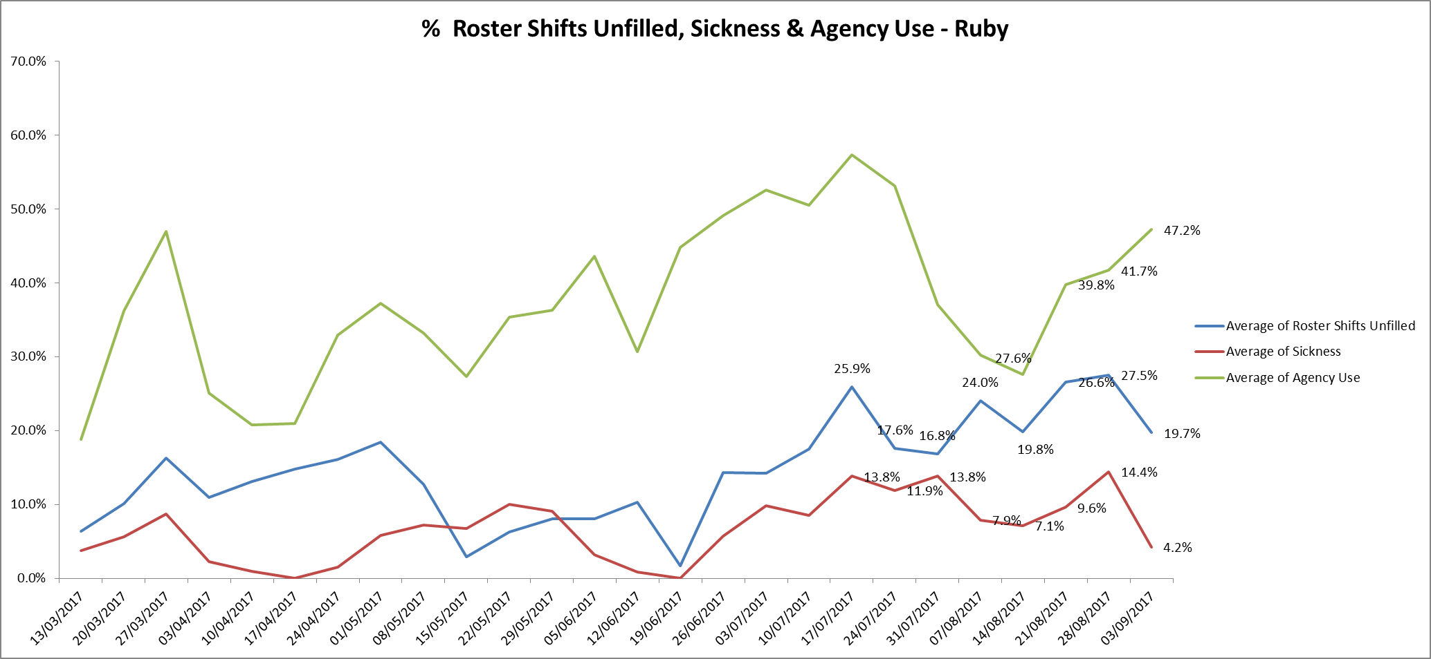

**Vaughan Thomas ward**

Agency use peaked at 41.5% during this reporting period but unfilled shifts remained at above 20% throughout. Sickness levels increased to 11.6% but there was a slight reduction in the last week to 6.3%.

**Chart 4**

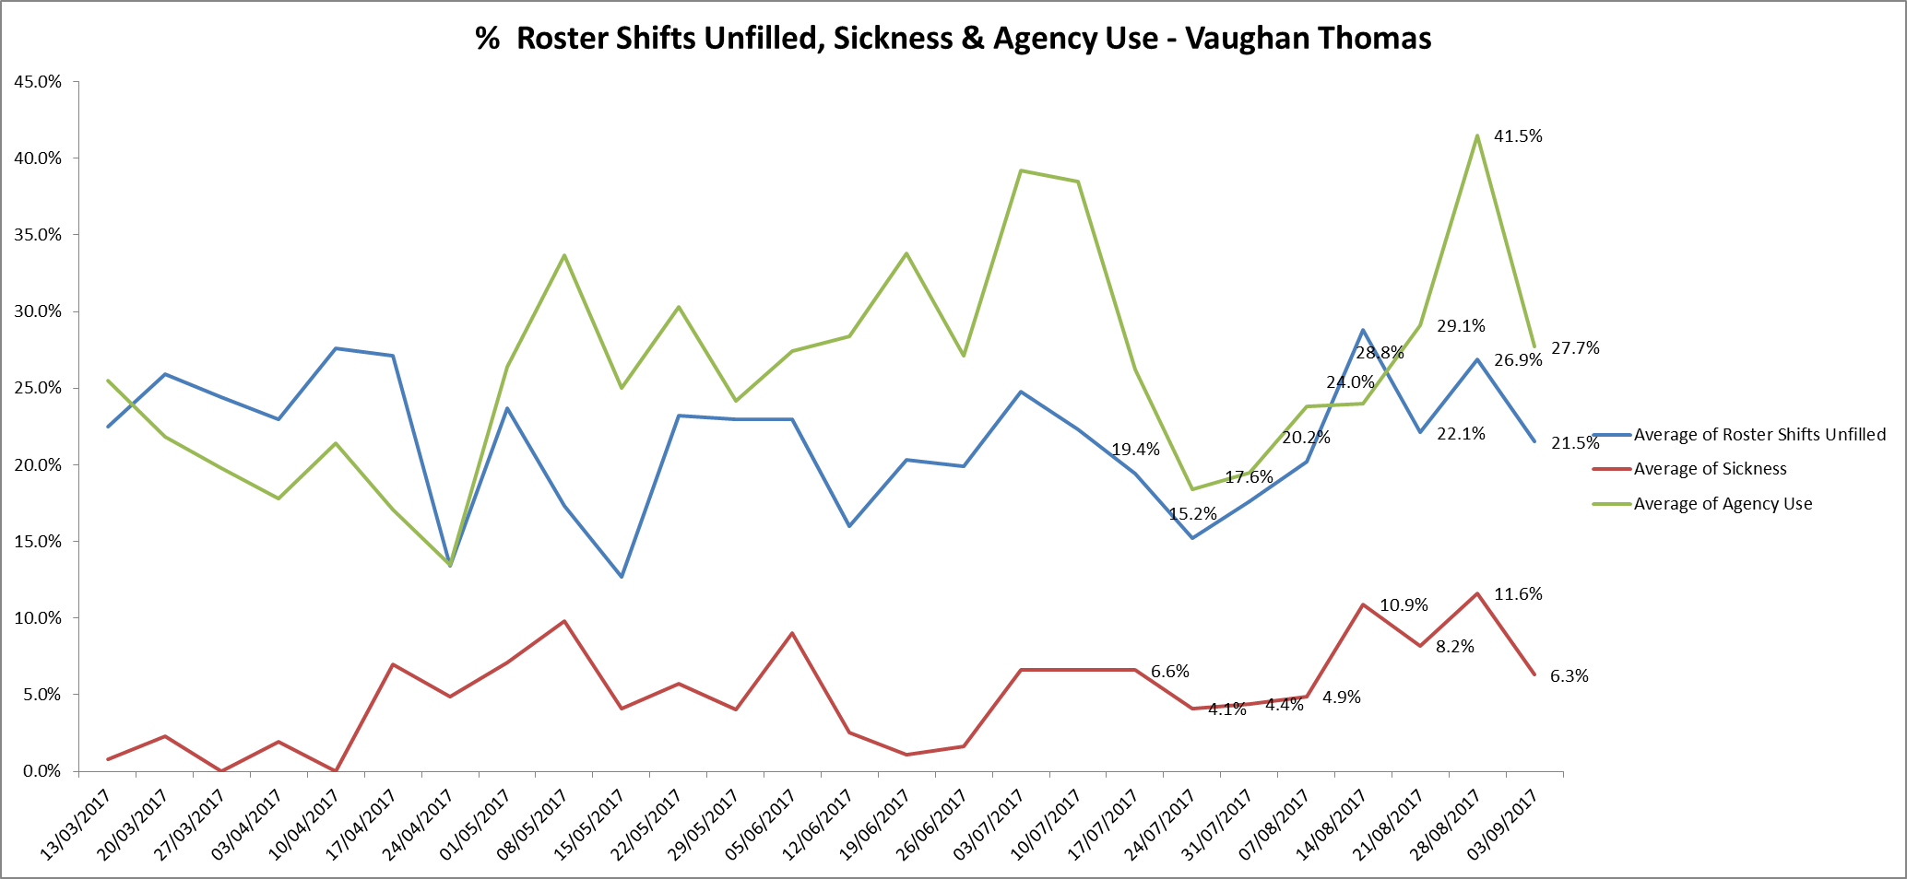

**Older adults**

**Sandford Ward** Agency use was above 24% throughout this reporting period and peaked at 34.9%. Unfilled shifts peaked at 31.4% in the week of 26.08.17.Sickness rates have reduced to 0%.

**Chart 5**

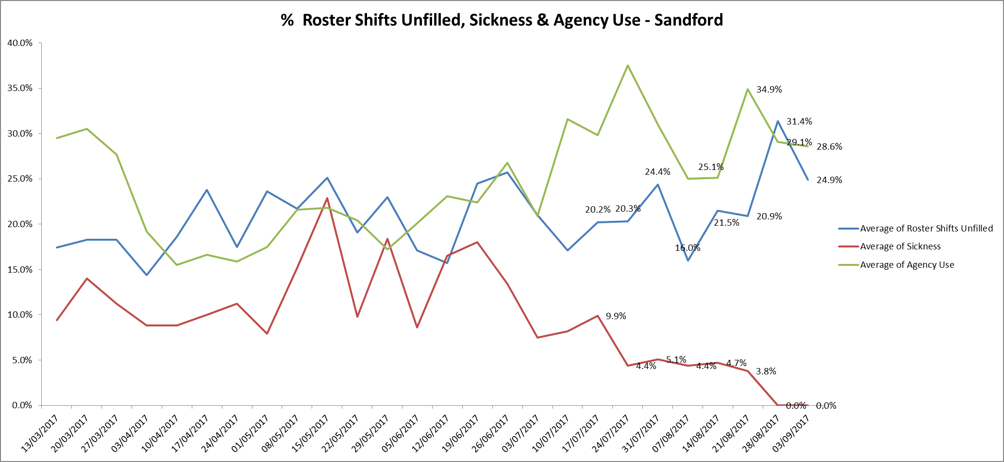

**Children and Young Peoples Services**

**Highfield Unit**

Agency use has been above 28% throughout this period, this is linked to high level of nursing vacancies and level of patient acuity and HDU staffing requirements. Unfilled roster shifts remained above 10%, sickness has decreased to 3.2% at the end of the period.

Decisions regarding ward admissions are overseen by senior staff in the light of this current picture and in the context of the national shortage of CAMHS beds particularly PICU beds which has resulted in patients being in the wrong due to lack of appropriate inpatient beds available nationally. This risk is on the Trust risk register.

**Chart 6**

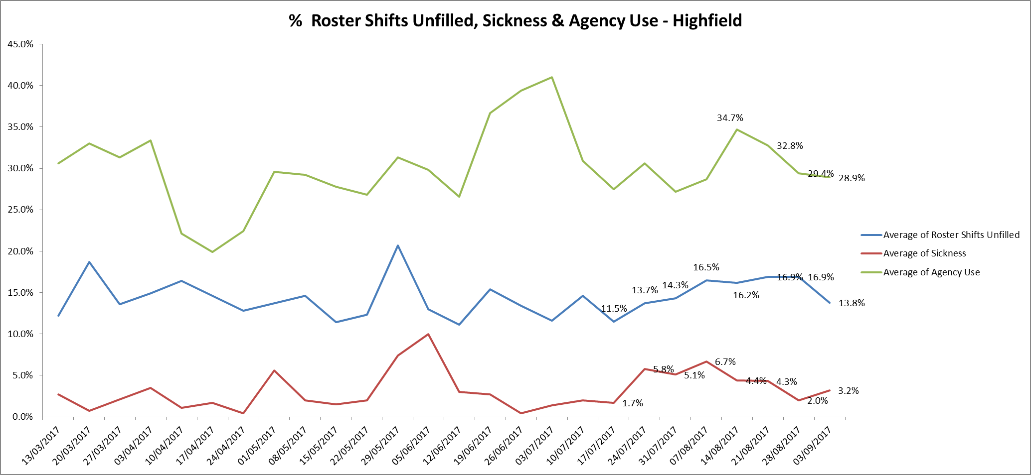

**Registered skill mix**

During this period the number of wards with 50% registered staff skill mix was four; Abingdon ward 2, Linfoot ward Witney, City and Bicester and the remaining wards are all below 50%.

**Chart 8**

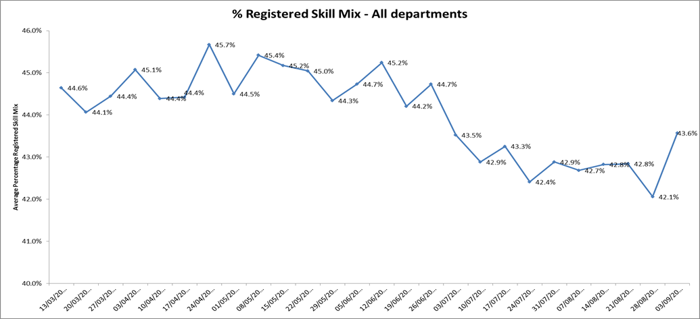

Seven wardsare below 35% in this period compared to five wards in the previous period 17th July - 13th August as follows:

* Ashurst 28.8% up from 24.4%
* Ruby 35.2% up from 27.7%
* Watling 29.7% up from 28.3%
* Cotswold House Oxford 34.4% down from 36%
* Highfield 33.2% down from 35.4%
* Kestrel 33.7% down from 37.1%
* Kennet 32.5% down from 34.2%

This relates to continued registered nurse vacancies. The Trust recruitment and retention work continues with the ‘Work with us’ and ‘Bank with us’ programmes plus more focussed work with student nurses to have job offers in place prior to qualification.

**Evenlode**

Oxford Health became the provider of this service on 1st July 2017. The ward is not currently on Health Roster so a narrative is provided on staffing levels. The e-rostering system is due to be rolled out on Evenlode ward in November 2017 so between now and then an exception report from the ward is being given on a weekly basis is reported into the weekly clinical review meeting chaired by an Executive Director or Deputy and any concerns escalated.

For the period 1st August 2017- 7th September 2017, the expected/ planned staffing levels for the ward have been: 6 staff on early and late shifts, and 4 on nights. All shifts to have at least one Registered Nurse. During this period, Registered Nurse cover has been provided for all shifts, and all night shifts have had the planned 4 staff on duty.

The staffing position for the day shifts is detailed below by month. The expected staffing level of 6 staff has not always been achieved however the ward is not full (9 patients are on the ward) and the acuity has been low due to limited new admissions (3 new admissions since March 2017).

The staffing model for the ward is currently being reviewed. At present the ward has two RN vacancies both of which have been appointed to and we are waiting for the new member of staff to start.

**August 2017**

Number of patients

1-9th August = 9 patients

10th- 31st August= 8 patients

Day shifts =62

31 -staffed as planned to 6 staff= 100% fill rate

25 -5 staff on duty= 83.3% fill rate

6 - 4 staff on duty= 66.6% fill rate

Average fill rate 90%

Night shifts 4 staff on duty =100% fill rate

Agency usage

Staff used on 7 day shifts and 14 night shifts.

**September 2017 1st – 7th**

Number of patients

1st- 6th Sept= 8 patients

From 6th Sept- to date 9 patients

Day shifts =14

7 staffed as planned to 6 staff =100% fill rate

4 -5 staff on duty =83.3% fill rate

3 - 4 staff on duty = 66.3% fill rate

Average fill rate 88%

Night shifts 4 staff on duty =100% fill rate.

Oversight of safer staffing is provided by the Head of Nursing for Forensics, support for the ward manager is in place through Modern matrons on forensic wards, the recruitment to the substantive modern matron post is in progress and medical cover is in place through an LD consultant.

PALs and SEAP advocacy service continue to provide a service to the ward and a peer review is planned for December 2017.

**Staffing establishment**

Staffing levels on inpatient wards have been reviewed against patient acuity and bed numbers. Details by ward are provided in the chart below. This has led to some minor changes in staffing levels and skill mix which have been reviewed and agreed by the heads of nursing and service directors. A bi-annual process for reviewing and agreeing planned staffing levels and budgets across all areas of the Trust including inpatient areas has been agreed. The next review will take place in December 2017 and January 2018 taking effect from 1 April 2018.

**Chart 9**



**SafeCare project roll out update**

**Current status**

There is a rolling programme to train staff on inpatient units and 20 wards are now live collecting patient census data, inputting this into SafeCare and updating their staffing information through SafeCare.

The continued roll out across all Adult mental health, Older Adult, CAMHs, Eating Disorder and Community Hospitals is in progress

**Current Implementation Plan**

|  |  |  |  |  |
| --- | --- | --- | --- | --- |
| **Directorate** | **Area** | **Inpatient Unit** | **Location** | **System Training W/C** |
| Adults | Medium Secure Services | Glyme | Littlemore | Live |
| Adults | Medium Secure Services | Kennet | Littlemore | Live |
| Adults | Acute Inpatient | Phoenix | Warneford | Live |
| Adults | Low Secure Services | Kestrel | Littlemore | Live |
| Adults | Low Secure Services | Kingfisher | Littlemore | Live |
| Adults | Low Secure Services | Lambourne House | Littlemore | Live |
| Adults | Low Secure Services | Wenric | Littlemore | Live |
| C&YP | Adolescent Inpatient Oxford | Highfield | Warneford | Live |
| C&YP | Eating Disorders Oxford | CH Oxford | Warneford | Live |
| C&YP | Eating Disorders SWB | CH Marlborough | Marlborough | Live |
| Older Peoples | MH -Oxon | Cherwell | Fulbrook | Live |
| Older Peoples | MH -Oxon | Sandford | Fulbrook | Live |
| Older Peoples | CH - North & City | City | Fulbrook | Live |
| Adults | Acute Inpatient | Opal | Whiteleaf | Live |
| Adults | Acute Inpatient | Ruby | Whiteleaf | Live |
| Adults | Acute Inpatient | Sapphire | Whiteleaf | Live |
| Older Peoples | CH - West | Linfoot | Witney | Live |
| Older Peoples | CH - West | Wenrisc | Witney | Live |
| Older Peoples | MH - Bucks | Amber | Whiteleaf | Live |
| Adults | Medium Secure Services | Chaffron | Milton Keynes | Live |
| C&YP | Adolescent Inpatient SWB | MH Swindon | Swindon | 30-Oct |
| Adults | Medium Secure Services | Watling | Milton Keynes | 09-Oct |
| Adults | Low Secure Services | Woodlands | Aylesbury | 09-Oct |
| Older Peoples | CH - Vale | Abingdon Ward 1 | Abingdon | 16-Oct |
| Older Peoples | CH - Vale | Abingdon Ward 2 | Abingdon | 16-Oct |
| Older Peoples | CH - North & City | Bicester | Bicester | 16-Oct |
| Older Peoples | CH  - South | Wallingford | Wallingford | 16-Oct |
| Adults | Acute Inpatient | Ashurst | Littlemore | 16-Oct |
| Older Peoples | CH  - South | Didcot | Didcot | 23-Oct |
| Adults | Acute Inpatient | Allen | Warneford | TBC |
| Adults | Acute Inpatient | Vaughan Thomas | Warneford | TBC |
| Adults | Acute Inpatient | Wintle | Warneford | TBC |

**Next steps**

* Senior Managers to be upskilled in SafeCare and the information available.
* A bi-annual process for review of Safe Staffing and demand templates to be agreed.
* Operational oversight process for staffing issues to be defined in each directorate.
* A review process to be agreed to ensure consistency and appropriateness of dependency model application across units.
* To agree the processes, roles and responsibilities for gathering, reviewing and reporting data from floor to board. This work is linked to the Carter 90 day Improvement programme which is described below.

**NHSI Carter 90 day Rapid Improvement Programme update**

Oxford Health is one of 23 Trusts participating in a 90 day rapid improvement programme with the aim of improving efficiency and productivity of e-rostering by ensuring the right staff are in the right place at the right time to align with patient needs.

Our improvement aim is to improve roster approval and publication times supporting our staff to plan their work and home life.

Through the improvement of rostering practice it is anticipated over time that the following benefits will be gained:

* Increased staff satisfaction and well-being by:
  + Ensuring the right staff are in the right time reducing work related stress.
  + Staff knowing sufficiently in advance their working arrangements enabling them to plan their home life.
  + Reducing levels of agency staffing and increasing levels of substantive employees and bank workers who are familiar with the units and ways of working making easier for all on the shift.
  + Where possible meeting the flexible needs of our staff.
  + Consistent management of working hours across all staffing groups.
* Increased patient and carer’s satisfaction by ensuring staffing levels meet patient demand.
* Improved efficiency and savings through:
  + Better management of unavailability and hours worked.
  + Better management of demand versus staffing levels.
  + Reduced agency use.

Work to date includes

* All inpatient units have been sent the Roster Building Guide and Roster Approval checklist. Units will be asked to use them when building and approving the next Roster w/c 16 October with Ward Managers and Modern Matrons reviewing and approving locally before publication by 23 October at the latest with all unfilled duties sent to bank.
* Managers asked to plan in Review and Challenge meetings 4 weekly from W/C 13 Nov to fall in line with the roster approval dates. Staffing Solutions team will be supporting these initial meetings.
* The staffing solutions team will be working in a detailed way with 3 units to identify if further improvements in roster building can be achieved with increased support including improved auto rostering or self rostering if required.

Oxford Health has presented its improvement work to the rest of the cohort on September 15th 2017 and at an NHSI’s Roadshow presenting the emerging findings from Lord Carter’s review into community and mental health trusts in October. The Trust is also presenting to the Healthcare Financial Management Association in November. Lord Carter is visiting the Trust to see the work that is in progress on 7 November.

Appendix 1

Tables1 All Metrics Roster Period August 14th to September 10th2017

Data source: electronic rostering system

|  |  |  |  |  |  |  |  |  |  |  |  |  |  |  |
| --- | --- | --- | --- | --- | --- | --- | --- | --- | --- | --- | --- | --- | --- | --- |
|  | % of shifts filled against required numbers (highlighted amber if less than 85%) | | | | | | | |  |  |  |  |  |  |
|  | Latest 4 week period - 14th August to 10th September 2017 | Latest 4 week period - 17th July to 13th August 2017 | 4 week period - 19th June to 16th July 2017 |  | Latest 4 week period - 14th August to 10th September 2017 | | | | | | | | | |
| Ward |  | % Registered day shifts filled by nurses (submitted to NHS England) | % Unregistered day shifts filled by nurses (submitted to NHS England) | % Registered night shift filled by nurses (submitted to NHS England) | % Unregistered night shifts filled by nurses (submitted to NHS England) |  | % Registered Skill Mix (target 50% or more) |  | % Agency Use   (thresholds based on Trust targets, 5%) | % Sickness   (thresholds based on Trust targets, 3.5%) | Vacancies Vs Budget (WTE)   (thresholds based on Trust targets, 9%) |
| Abingdon Ward 1 | 99.2% | 96.5% | 98.3% |  | 98% | 100% | 102% | 98% |  | 49.4% |  | 15.6% | 4.5% | 1 |
| Abingdon Ward 2 | 98.2% | 99.3% | 98.1% |  | 98% | 100% | 98% | 100% |  | 50.8% |  | 10.5% | 3.1% | 3.9 |
| Allen | 90.3% | 92.2% | 87.1% |  | 85% | 100% | 95% | 97% |  | 46.8% |  | 29.1% | 5.7% | 14 |
| Amber | 93.9% | 86.9% | 90.5% |  | 100% | 98% | 100% | 99% |  | 46.3% |  | 24.8% | 10.9% | 11.6 |
| Ashurst (PICU) | 82.4% | 84.9% | 87.1% |  | 57% | 105% | 60% | 100% |  | 28.8% |  | 23.6% | 6.2% | 15.1 |
| Bicester | 100.0% | 98.9% | 99.2% |  | 104% | 93% | 101% | 100% |  | 51.8% |  | 6.6% | 8.5% | 4.4 |
| Cotswold House Marlborough | 93.8% | 95.4% | 98.2% |  | 90% | 99% | 101% | 101% |  | 41.6% |  | 0.3% | 0.6% | 7.5 |
| Cotswold House Oxford | 83.3% | 81.0% | 86.8% |  | 78% | 97% | 97% | 90% |  | 34.4% |  | 8.8% | 0.8% | 5.2 |
| Chaffron | 77.9% | 80.8% | 89.5% |  | 124% | 62% | 100% | 100% |  | 42.9% |  | 0.0% | 5.6% | 6.9 |
| Cherwell | 90.4% | 92.0% | 96.7% |  | 86% | 95% | 98% | 102% |  | 47.6% |  | 13.9% | 6.7% | 7.2 |
| City | 99.4% | 88.2% | 99.0% |  | 100% | 100% | 100% | 100% |  | 51.6% |  | 17.8% | 4.5% | 12.9 |
| Didcot | 99.1% | 98.8% | 92.7% |  | 101% | 96% | 99% | 98% |  | 46.0% |  | 17.8% | 6.1% | 0.2 |
| Glyme | 84.3% | 82.9% | 79.7% |  | 77% | 83% | 58% | 181% |  | 39.6% |  | 8.1% | 8.1% | 6.9 |
| Highfield (CAMHS) | 84.1% | 86.0% | 86.3% |  | 79% | 103% | 95% | 98% |  | 33.2% |  | 31.4% | 3.5% | 25.6 |
| Kennet | 95.9% | 96.7% | 97.6% |  | 99% | 96% | 94% | 101% |  | 32.5% |  | 24.2% | 9.3% | 12.5 |
| Kestrel | 88.9% | 93.0% | 92.8% |  | 85% | 95% | 67% | 108% |  | 33.7% |  | 42.8% | 7.0% | 19 |
| Kingfisher | 89.6% | 88.0% | 79.9% |  | 101% | 88% | 109% | 90% |  | 38.8% |  | 26.6% | 11.0% | 13.1 |
| Lambourne House | 64.8% | 84.8% | 85.8% |  | 97% | 90% | 100% | 100% |  | 47.5% |  | 0.0% | 3.1% | 1.8 |
| Linfoot Witney | 97.6% | 96.2% | 96.5% |  | 95% | 98% | 98% | 99% |  | 50.2% |  | 10.6% | 7.8% | 4.2 |
| Marlborough House Swindon (CAMHS) | 95.8% | 92.1% | 89.6% |  | 97% | 98% | 102% | 98% |  | 47.4% |  | 28.6% | 8.5% | 6.9 |
| Opal (Rehabilitation) | 91.6% | 95.6% | 93.0% |  | 102% | 91% | 92% | 104% |  | 49.4% |  | 1.2% | 2.4% | 8.1 |
| Phoenix | 91.7% | 84.3% | 88.2% |  | 87% | 98% | 93% | 100% |  | 49.2% |  | 22.6% | 4.3% | 12.1 |
| Ruby | 76.7% | 79.0% | 87.4% |  | 65% | 93% | 70% | 98% |  | 35.2% |  | 39.6% | 8.8% | 8.8 |
| Sandford | 75.4% | 79.7% | 78.0% |  | 74% | 92% | 95% | 98% |  | 45.3% |  | 29.5% | 2.2% | 13.1 |
| Sapphire | 94.5% | 93.6% | 100.0% |  | 91% | 108% | 100% | 100% |  | 45.5% |  | 22.1% | 5.0% | 12 |
| Vaughan Thomas | 75.0% | 81.9% | 78.1% |  | 56% | 116% | 97% | 98% |  | 34.8% |  | 30.9% | 9.3% | 13 |
| St Leonards Wallingford | 96.1% | 95.9% | 97.2% |  | 97% | 105% | 98% | 100% |  | 46.1% |  | 14.2% | 5.9% | 5.1 |
| Watling | 99.0% | 92.9% | 90.5% |  | 96% | 100% | 102% | 101% |  | 29.7% |  | 12.3% | 6.9% | 10.5 |
| Wenric | 96.6% | 85.2% | 85.4% |  | 110% | 94% | 100% | 97% |  | 40.0% |  | 16.0% | 5.5% | 8.6 |
| Wenrisc Witney | 87.1% | 91.4% | 91.6% |  | 79% | 90% | 100% | 100% |  | 57.0% |  | 12.5% | 5.0% | 10.1 |
| Wintle | 96.6% | 94.1% | 96.2% |  | 66% | 133% | 101% | 99% |  | 37.6% |  | 14.3% | 1.8% | 9.3 |
| Woodlands | 98.6% | 97.5% | 96.8% |  | 104% | 96% | 99% | 98% |  | 38.8% |  | 9.8% | 5.9% | 9.5 |