

**Report to the Meeting of the**

**BOD 96/2018**  
(Agenda item: 9)

**Oxford Health NHS Foundation Trust**

**Board of Directors**

**26th July 2018**

# Quarterly Patient Experience & Involvement Report

**For: Information**

**Executive Summary**

This report provides an overview on the feedback received from patients and carers and the work to improve people’s experiences, as well as their involvement in service developments. The collection and use of patient, carer and family feedback continues to increase with over 5,000 survey responses in 2018/19 quarter 1. The majority of feedback is positive, 94% of people would recommend the service and care was rated 4.76 out of 5, however we are striving so that everyone receives a positive experience and patients are involved in every decision about their care and service changes. The number of complaints received is similar to last year, however the number of concerns resolved locally has significantly increased as more time is put into this area.

The feedback and complaints received identify a theme for improvement around communication and sharing information with patients and their families to enable joint decision making and involvement in care. We used the recent linking leader conferences in June 2018 as an opportunity for leaders to spend time to discuss and identify how to improve shared decision making. The outcome of this is informing the actions which will be monitored as part of the patient experience strategy.

**Recommendation**

To note.

**Author and Title:** Donna Mackenzie, Patient Experience and Involvement Manager

Jane Kershaw, Head of Quality Governance

**Lead Executive Director:** Ros Alstead, Director of Nursing and Clinical Standards

1. **Introduction**

A report on patient and carer experiences is presented to the caring and responsive quality sub-committee quarterly and also the Board of Directors as part of the monthly quality reports. This report focuses on patient and carer experiences and how we have involved people in service developments. Feedback identifies a theme for improvement around communication and sharing information with patients and their families to enable joint decision making and involvement in care.

1. **Patient Experience and Involvement Strategy**

The trust wide ‘taking action on patient feedback’ group (TAPF) continues to monitor and give oversight on the objectives to deliver the patient experience strategy.

The 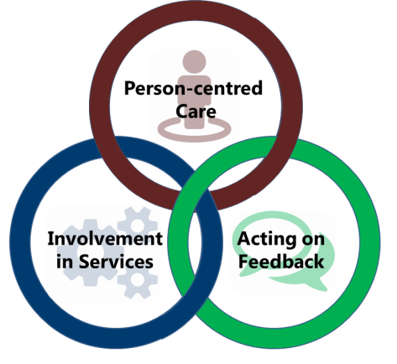group last met in May 2018 and heard from each of the directorates about the feedback received, action taken and involvement work being carried out, as well as from the Digital Exemplar Programme Manager about the trusts commitment to using IT to improve patient care.

Work has started to review and refresh the current strategy objectives which finish in March 2019 to ensure the new strategy document will be accessible to all patients, friends, family members and services. A summary of the aims of the strategy is in Appendix 1.

The funding and resources required to deliver the aims and outcomes of the three year strategy approved in April 2016 have taken time to get in place and some smaller funds are still to be identified. Our new Patient experience and involvement lead for Learning Disability services, Rachel Miller, joins the Patient Experience Team from July 2018 with an aim of continuing to support and further develop the involvement of people with a Learning Disability.

The Patient Experience Team are commencing monthly “drop in sessions” across the trust from July 2018 to support staff with collecting and using feedback, as well as developing involvement opportunities for service users.

NHS Improvement published a new patient experience improvement framework in June 2018 based on findings from CQC inspections. Accessible at <https://improvement.nhs.uk/resources/patient-experience-improvement-framework/> The framework includes a self-assessment tool which we will be completing to inform the above strategy work.

1. **‘I Want Great Care’ (strategy objective Acting on Feedback)**

The Trust has received 5,084 responses between 1st April – 30th June 2018 with an overall average score of 4.76 out of 5 across all the questions asked. The number of responses has slightly declined between April to June by 100 responses, however compared to last year there is still a large improvement. 93.71% said they would be likely to recommend with 1.57% being unlikely to recommend. (4.72% report neither or don’t know)

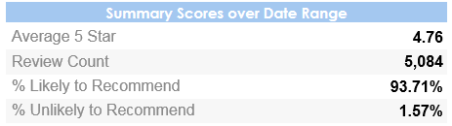

The below graphs show the overall demographic information of those reviewing and the way the review has been submitted. The source of ‘offline’ denotes those surveys completed via paper.

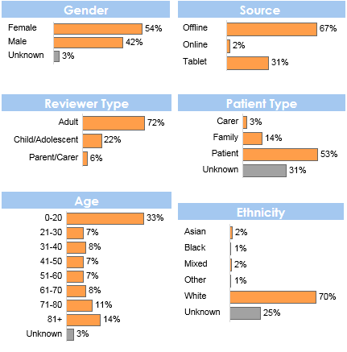

1. **Adult Mental Health Carers Survey (strategy objective Acting on Feedback)**

|  |
| --- |
| The Adult Directorate conduct a separate survey for all carers accessing mental health services across Oxfordshire and Buckinghamshire in line with commissioning requirements. |

The survey is available via an online link on the Trust wide site as well as in all mental health teams and our five partner organisations (as part of the mental health partnership in Oxfordshire).

42 carers have responded to the survey between 1st April 2018 – 30th June 2018 with a number of improvement comments and accolades. The feedback will be used to inform carers work within the directorate. Below is a summary of some of the results.

*“Experience of the Whiteleaf Centre inpatient as a carer visiting is much improved. Staff are now more friendly and approachable”* – Whiteleaf Centre

*“The regular carers forum gives positive support, education and information. Satisfied with the level of support”* – Chiltern AMHT.

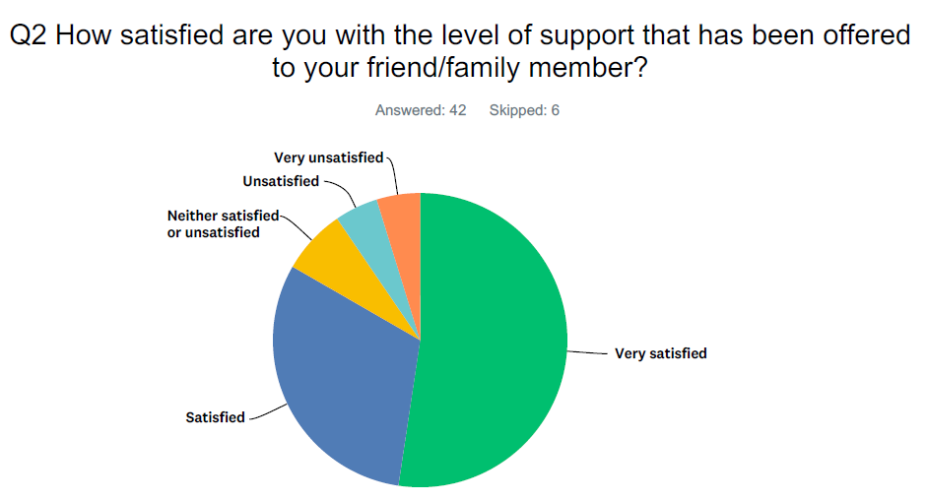

Table showing results from level of support offered for carers.

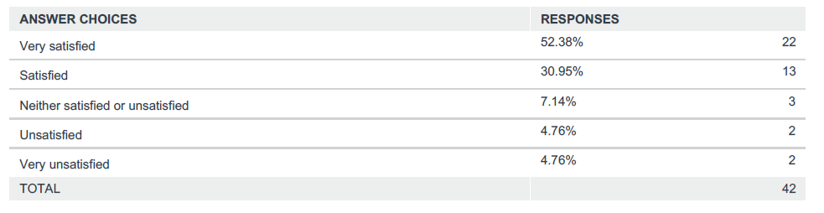

1. **Linking Leaders Conferences 2018 (all three strategy objectives)**

The last linking leader series in June 2018 focused on patient and carer experiences of care, with over 150 attendees. The format included internal and external speakers, stalls, a video patient story, group work and best practice examples being presented by teams, which were videoed to share wider. The group work was focused on leaders discussing and identifying solutions to a recourring theme to improve shared decision making with patients and families about their care. The outcome of the group work will be used to inform the work of the patient experience strategy for the next 12 months. We also launched new quarterly team awards for ‘improving how people experience our services’, 6 awards were given out across the three conferences, the team winners are listed below. Work is also underway to support patients and carers with nominating staff for the annual staff awards in 2018.

Congratulations to the award winners:

**Buckinghamshire-** North Buckinghamshire CAMHS

Ruby Ward

**Oxfordshire -** Abingdon Minor Injuries Unit

Family Nurse Partnership

Allen Ward

**South West -** Swindon Learning Disability CAMHS

Feedback from the events has been positive, and an evaluation will be completed. The videoed presentations at the events and the outcomes of the group work will be shared with attendees and posted on the intranet.

1. **I Care You Care Strategy**

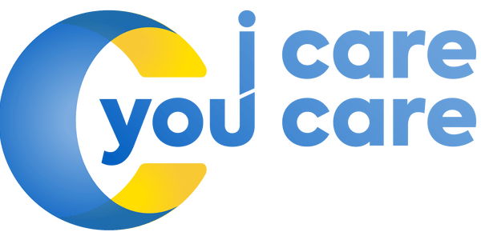A number of carers events took place across the trust during carers week in early June 2018. This included a carers conference to start the official “community of practice” for staff and carers organisations as well as review the Trusts “I Care; You Care” strategy. Carers shared their lived experiences of our services and teams shared good practice examples. A film highlighting the challenges and journey of a carer who has been involved with the adult mental health services was also launched. “Chris’s story” is being used to raise awareness of carer’s experiences within the trust. A draft annual report is being produced outlining the progress of year once since the strategy was launched which will be shared with board in September 2018.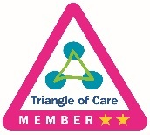

In addition, the trust has completed a cross agency piece of work in Oxfordshire with carers to develop a carers statement of intent/ commitment which was launched in June 2018. The Oxfordshire Commitment to Carers was developed in partnership with Oxfordshire County Council, Oxford University Hospitals Trust and Voluntary Services including Action for Carers Oxfordshire and Oxfordshire Young Carers Service. Each organisation has signed up to show that together we will recognise, value, support and listen to carers.

1. **Summary of feedback (strategy objective Acting on Feedback)**

Overwhelming the feedback, we have received from patients, families and carers is very positive with patients reporting feeling cared for by staff and that as a result they highly value the service provided. However, some people do not receive the positive experience we expect every person to have and therefore we have more work to do. The themes highlighted from complaints mirror the key areas for improvement identified from the feedback we receive, and are focused on communication and sharing information with patients and their families/carers to enable joint decision making and full involvement in care.

For more details about complaints, informal concerns and compliments, the annual complaints report is also being presented to Trust Board in July 2018.

The graph below shows the trust-wide average score for each question asked through the IWGC survey, out of a maximum of 5, over the last 3 months. The first 5 questions (from top to bottom) are asked by all services (‘dignity to kindness), the bottom 6 questions are those asked on the specific children and young people service surveys.

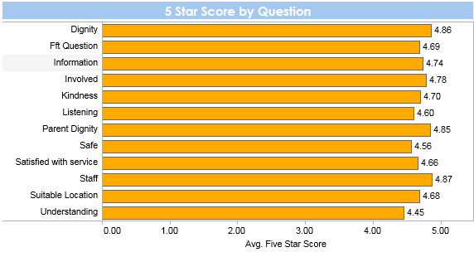

Below are the trends for the first 5 questions asked across all services, showing the average score over the 3-month period, April to June 2018. Further analysis looking at a longer time period by service and team is currently being carried out.

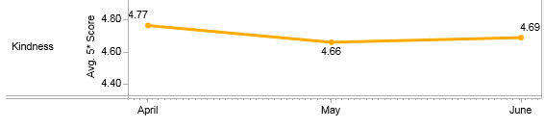

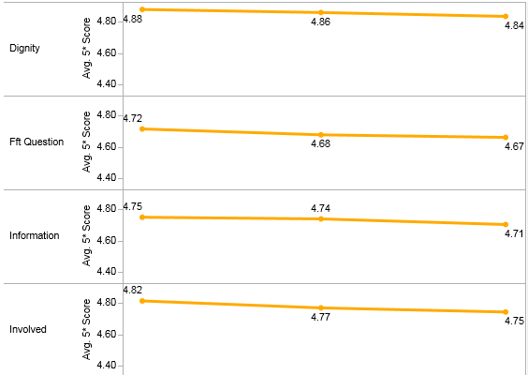

The feedback to the national friends and family test question, would you recommend the care received is positive and above national average, results by mental health and physical health services below. The national question is currently being reviewed by NHS England and Donna is part of the national development group.





Positive qualitative feedback

The below word cloud shows the 50 most frequently words used by patients who have given a 5* (star) average score in the last 3 months.

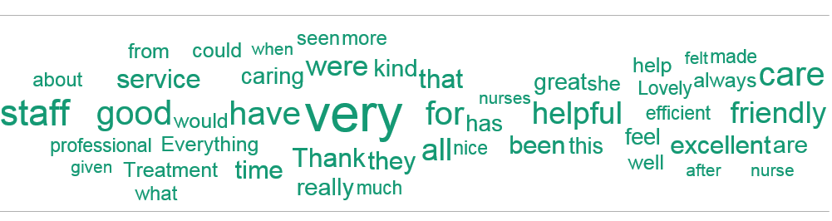

**Some comments from people who answered that they are extremely likely or likely to recommend our services include:**

*“Nurses and staff are very patient with us and personable”* – Vaughan Thomas Ward.

“Excellent care. This service is for recommendation” – Hospital at Home

“I have a major fear of dentists. I was made to feel at ease,the procedures were fully explained which helped to aliviate my fear. I was informed that if at time I wanted them to stop I could raise my left arm. The dentist and dental nurse treated me with dignity and respect” – East Oxford Dental Clinic Out of Hours

*“I have received excellent care. Everybody is totally dedicated and has my best interest at heart*” *–* Ruby Ward.

“I am very lucky that I went through this program. It helped me a lot in so many things, how to deal with my child's troubles, building up confidence in being a good mother and a role model for my child. I am very happy with our nurse, she has been very helpful during all the program for me and my family. I am very happy to recommend it to all my friends and those I know.” – Family Nurse Partnership

It's been very helpful that I and mywife/carer have been able to consult with the physiotherapist on the phone - PDPS

*“I have had a really nice time overall and time to reflect, which I needed, thank you*” *–* Phoenix Ward.

“Was told immediately waiting time. Staff very friendly and professional, assessed and treated quickly. After care explained too” – Abingdon Minor Injuries Unit

“We were seen quickly after initial assessment at a time when it was much needed. It has helped my daughter with strategies and generally understanding the wat she feels” – Swindon CAMHS

*“I was listened to" –* Chiltern Adult Mental Health Team.

*“do not feel I need medication, however the team recommended I take my time and consider some things in my life currently, they did not push they understood that it has to be my decision. Thank you for listening”* – North and West Oxon Adult Mental Health Team

Negative qualitative feedback

The below word cloud shows the 50 most frequently used by patients who have given an average score of 2.5* (star) or less. The mostly commonly used word “language” was used in 3 reviews and a high proportion of the other words shown were used in a single review.

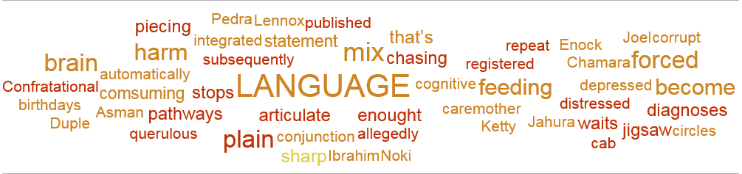

An immediate automatic alert is created for any service who receives a review of less than 3 stars for any reason. This allows the service and Patient Experience Leads the opportunity to monitor, respond and action any improvement feedback which is received in near real time.

Services have begun to respond directly to a number of reviews which have been received and it is our aim to develop staff’s ability to respond further over the next 12 months.

**Some comments from patients whose overall review score was below 2:**

**(all these comments have been reviewed and actioned by the team)**

“After a week of endless telephone calls and conversations along with unanswered visits - i.e not many answers or useful advice was given to us, We ended up here yesterday and the female Dr in her 50's had a rather sharp tongue in regards to our older and autistic daughter. Once I have mentioned she is autistic - another sharp smark followed ' well that explains her". - Abingdon GP Out Of Hours Service

“The waiting times are unacceptable How can a suicidal person with self harm be told to wait 18 months for help?!” – South Oxfordshire Adult Mental Health Team

“Feel extremely alone” – Highfield Unit, Oxford

“I am outraged by the level of care that you receive.” – North Buckinghamshire CAMHS

“Short discussion about care plan.” – Vaughan Thomas Ward

“Regularity re meals and activities; former were very routine. One to one monitoring and feedback. Setting targets and goals to achieve. The information regarding the drugs you have been prescribed could be improved (i.e why you have been given them and for what purpose. The rooms were not air-conditioned so became very warm. Heating not regulated well. Mattresses not very comfortable.” – Sandford Ward

1. **You Said, We did (strategy objective Acting on Feedback)**

All services aim to feedback to service users on quality improvement work which has been led by patient experience feedback. We call this “you said, we did” and this can be displayed on boards, leaflets or posters. Below are some examples of changes made in the last 3 months:

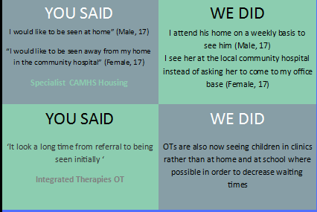

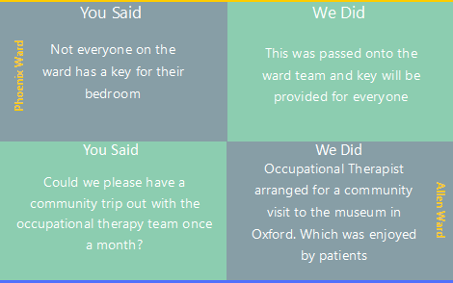

1. **Involvement (strategy objective Involvement in Services)**

Across the Trust involvement work is happening continuously as we strive to ensure patients, service users and carers are invited to be partners in the design, development, delivery and evaluation of services. Some examples of involvement work carried out between April and June 2018 include:

Service User Perspectives on LGBT Inclusion and Gender Identity in Health Services

Training delivered by young people and parents/carers to help educate staff around LGBT and service user inclusion. As a result of this training an LGBT action group is being set up to help improve the approach we take to support LGBT service users and their parent/carers.

Head Teacher conference: Building a better future for children in Buckinghamshire

Bucks County Council held an event for Head Teacher’s and SENCO’s to raise the importance of working in collaboration to support children and young people’s mental health. In partnership with Bucks Youth, young representatives from Bucks Youth Voice and Article 12 shared their experiences of suffering with their mental health in schools and gave their suggestions on how schools can really support student’s emotional wellbeing. One of our young people also shared a poem she’d wrote about her experience of mental health in schools. This was all really well received by schools and the young people were asked to support training for social workers around the topics they spoke about during the conference.

Royal college of Psychiatrists Public engagement board

The SWB CAMHS Participation team has supported the work of the Royal College of Psychiatrists and were involved in testing the new college website.

Year of Mental Health Swindon, Wiltshire and BaNES

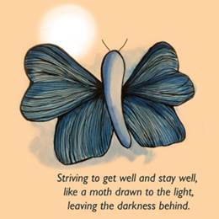

The SWB CAMHS Participation team were asked to design a logo to use in promotional materials for the STP’s Year of Mental Health. One of our young people came up with the logo below which represents for her the challenge to recover from mental ill health and stay well.

Recruitment

Young people were invited to be part of the panel for the post of CAMHS Head of Service for SWB and patients have been involved in recruitment in a number of the adult mental health wards and the CAMHS Highfield Unit.

Question of the Month

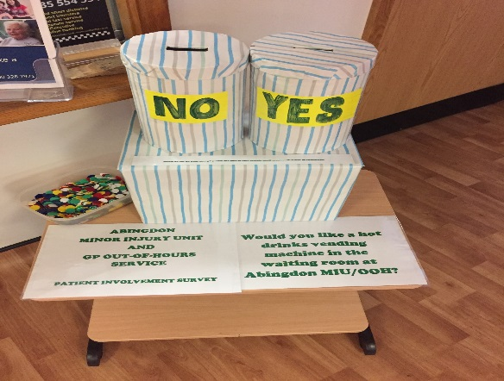Patients and carers have been giving feedback by answering “question of the month” in a number of areas. This is particularly effective in waiting areas where patients are likely to only visit a service once as in Minor Injury Units.

1. **National Adult Community Mental Health Survey**

The National Community Mental Health Survey for 2018 started in February 2018 and closed in June 2018.

The survey is sent to a random sample of patients who have had more than one contact with a community mental health service aged 18 and over (no limit) and have an address in the UK. The main survey questions are similar to 2017 and are sent to 850 services users out of a possible 4,869 who accessed services between 1st Sept-30th Nov 2017 (The sample excludes specialist services e.g. forensic, and IAPT and current inpatients). The Trust has also been identified as a pilot site for two further trial surveys being conducted on the use of a new “short” version of the survey and a change in method to try text surveying. The aim of these pilots is to ascertain if response rates for the survey can be improved nationally.

Unweighted results for internal use from our contractor will be available shortly however the results will not be published by the CQC until around November 2018.

**Appendix 1.**

