

# Report to the Meeting of the

# Oxford Health NHS Foundation Trust

**BOD 109/2018**  
(agenda item: 8)

# Board of Directors

# 27th September 2018

# INPATIENT SAFER STAFFING Report Period 18tH June to 15th July and 16th July to 12th August 2018

**For: Information**

**Executive Summary**

**Ward Staffing**

The purpose of this paper is to provide a report of the actual inpatient staffing levels to the Board of Directors. There is a national requirement on providers to be transparent in our monitoring and reporting of inpatient staffing levels and the impact on patient care. Ensuring sufficient staffing levels are in place is crucial to deliver safe, effective and high quality care. This report will be published on our website with a link from NHS Choices website.

The data within the report will outline the staffing levels (for both registered and unregistered nursing staff) on each ward. These figures will be measured against the required figures on a shift by shift basis for the 4 week periods 18th June to 15th July and 16th July to 12th August 2018.

During this period:

Average weekly day shifts fill rates for registered staff & unregistered staff were above the Trust target of 85% with 92% or above for unregistered as per July report and 93% or above for registered staff, slight decrease from 95% last period.

Average weekly night shifts fill rates for registered and unregistered were above the Trust target of 85% with the average lowest fill rate at 91% for unregistered staff and above 100% for registered staff.

The methods of filling these shifts includes substantive, flexible workers and agency registered staff and further detail in provided later in the report.

The Trust moved to a new approach to reduce the use of unregistered agency staff in the week of 14.5.18. Further detail of this project is provided in the HR workforce report and commented on in relation to changes in skill mix ratios.

The average weekly % agency use was 10.82% a rise from 9.85% in the July report with a peak of 11.5% in the week 09.07.18.

Average sickness rates for ward staff were decreased to 4.67% average reduced from 5.72% last month. but continue average of 5.0 % this remains below previous peak of 8.8% in the week of the 15/01/18.

The paper will this month provide information in relation to:

* Maintaining safe staffing
* Establishment and Skill Mix review work.
* Safe Care acuity and demand data collection module on Health Roster.

**Recommendations**

The Board is asked to note:

* There are processes in place to ensure safe staffing levels on all the wards in the organisation, those wards where there are concerns and the actions being taken to ensure safe staffing including project work and wider recruitment and retention work. There are no exceptions to report that directly link actual staffing levels to adverse outcomes for patients which have been identified through our Governance Structures.

**Author and Title:** Kate Riddle, Deputy Director of Nursing and Clinical Standards

**Lead Executive Director:** Ros Alstead, Director of Nursing and Clinical Standards

*A risk assessment has been undertaken around the legal issues that this paper presents and there are no issues that need to be referred to the Trust Solicitors. This paper links to all of the five CQC Domains.*

***Strategic Objectives*** *– this report relates to or provides assurance and evidence against the following Strategic Objective(s) of the Trust*

*Driving Quality Improvement (Goals: patients will be safe from harm; patients will achieve the clinical outcomes they want; and patients and carers will have an excellent experience)*

*Delivering Operational Excellence (Goals: our services will be effective and efficient; information will be translated into knowledge; and our planned surplus will be delivered)*

**Inpatient Safer Staffing**

Period 18th June to 15th July and 16th July to 12th August 2018

**Introduction**

This is the report to the Board of Directors outlining the staffing levels (registered and unregistered) on each ward against their required need on a shift by shift basis. This report covers the four week periods: Period 18th June to 15th July and 16th July to 12th August 2018.

In addition, there is information covering:

• Maintaining safe staffing

• Establishment and Skill Mix review work.

• Safe Care acuity and demand data collection module on Health Roster.

This report will focus on the percentage of day and night fill rates for registered and unregistered staff. This data is reported to NHSI and provides assurance of actual clinical staffing numbers being achieved. This report will be published on our website with a link from NHS Choices website.

**Management of Staffing Levels**

Anescalation process for the management of staff shortages is in place within each clinical area, in order to manage staffing safely on a shift by shift basis. As part of this process, senior clinical staff are providing appropriate support to ward teams as and when required. In addition, senior ward staff and immediate team managers review ward staffing levels on an on-going basis; shift by shift basis, and where there are changes in patient acuity. Ward Matrons review staffing daily as a minimum and more frequently where required.

In-patient staffing levels continue to be reported every week and discussed within the Weekly Review Meeting (WRM), which takes place each Monday morning with the Director of Nursing and or Deputy present.

To ensure that staffing levels are under continual review, every ward undertakes a range of immediate actions daily to ensure safe staffing levels are maintained appropriate to the needs of patients. These actions include booking staff via staffing solutions via bank or agency, revising rotas, moving staff between wards and utilising additional staff that are not included in the ward numbers as required for example modern matrons.

**Summary position of inpatients wards staffing levels.**

Appendix 1 shows the staffing levels for all wards by ward for the four-week time periods 18th June to 15th July and 16th July to 12th August 2018. The data presented includes details of staffing by shifts and details of skill mix, agency, ward staff sickness and ward vacancy figures. The thresholds presented in the table are measured against trust/ national targets and used to highlight particular wards for further review.

During this period:

Average weekly day shifts fill rates for registered staff & unregistered staff were above the Trust target of 85% with 92% or above for unregistered as per July report and 93% or above for registered staff, a slight decrease from 95% last period.

Average weekly night shifts fill rates for registered and unregistered were above the Trust target of 85% with the average lowest fill rate at 91% for unregistered staff and above 100% for registered staff.

The methods of filling these shifts includes substantive, flexible workers and agency registered staff and further detail in provided later in the report.

The Trust moved to a new approach to reduce the use of unregistered agency staff in the week of 14.5.18. Further detail of this project is provided in the HR workforce report and commented on in relation to changes in skill mix ratios.

The average weekly % agency use was 10.82% a rise from 9.85% in the July report with a peak of 11.5% in the week 09.07.18.

Average sickness rates for ward staff were decreased to 4.67% average reduced from 5.72% in the July report and this remains below previous peak of 8.8% in the week of the 15/01/18.

There are processes in place to ensure safe staffing levels on all the wards in the organisation, those wards where there are concerns and the actions being taken to ensure safe staffing including project work and wider recruitment and retention work. There are no exceptions to report that directly link actual staffing levels to adverse outcomes for patients which have been identified through our Governance Structures.

**Day shifts fill rates**

Average weekly day shifts fill rates for registered nurse & unregistered staff were above the Trust target of 85% throughout this period. This included a mix of agency, flexible and substantive staff including ward managers and matrons where required to make up staffing numbers and provide safe care.

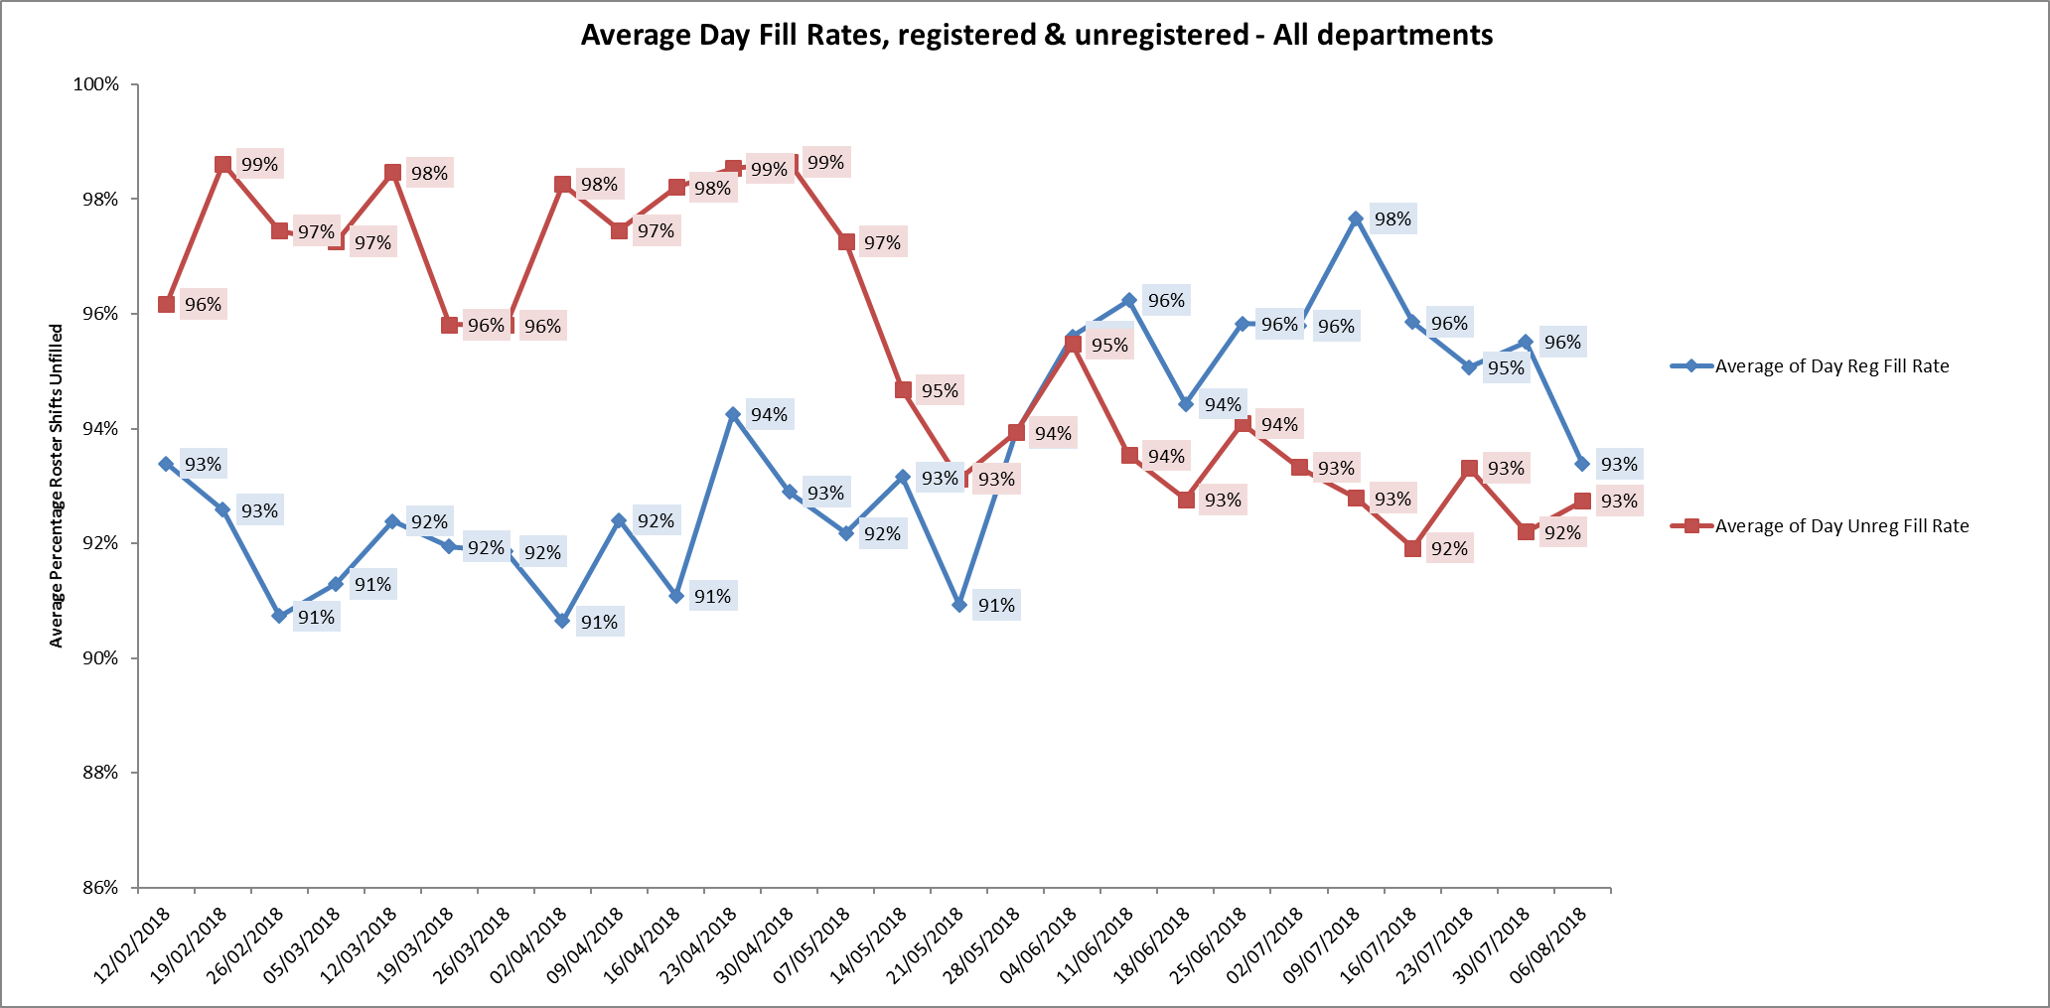

27 wards had above 85% average fill rates in the period June 18th to July 15th

25 wards had above 85% average fill rates in the period July 19th to August 12th

Six wards were below 85% target for average weekly fill rates for registered nurse day shifts during this eight week period.

These were:

Adult wards

Ashurst 77% and 73% but continued improvement from 67% in the July report.

Vaughan Thomas 66% and 67% slight decrease from 68% in the July report.

Ruby 74% and 79% a slight improvement in the second period from 78% in the July report.

Children and young peoples and adult eating disorders

Cotswold House Oxford 59% & 53% slight increase in second period from 58% from the July report.

Older Peoples

City 56% & 77% a decrease from 101% July report

Sandford continued improvement to 84% and 80% from 75% in the July report.

Two additional wards were below 85% during second period 16th July to 12th August

Marlborough House Swindon decrease to 83% - related to this one week at 70% remaining period fill rates were above 86%

Wenrisc ward Witney decreased from 93% to average 78% in the second period.

**Night shift fill rates**

Average weekly night shifts fill rates for registered nurse & unregistered staff were above the Trust target of 85% throughout this period. This included a mix of agency, flexible and substantive staff to make up staffing numbers. This remained above 100% for registered staff in line with reduction of agency HCA usage as agency or flexible registered staff have been used by exception when needed to meet demand.

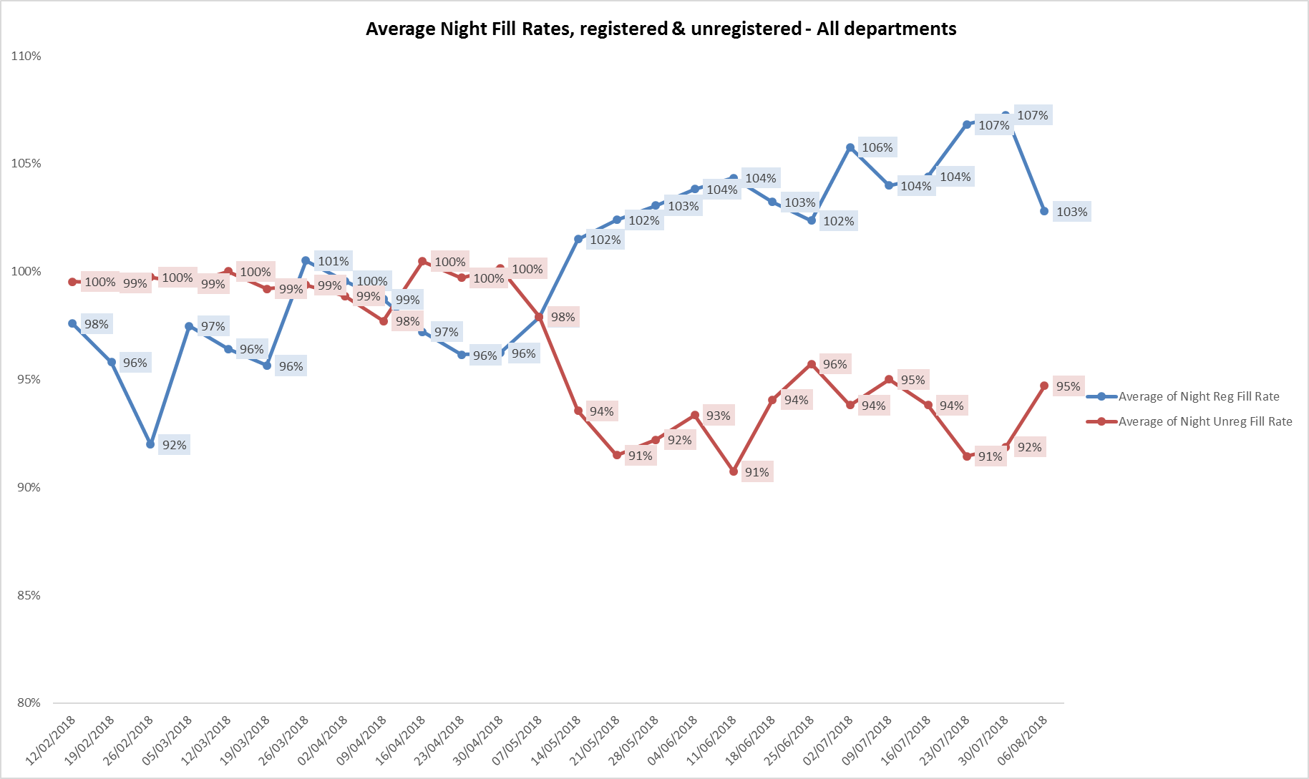

**Registered skill mix**

Thirteen wards had in place an average of 50% or above registered staff skill mix during weeks of 18th June to 15th July, this reduced to twelve wards in the weeks 16Th July to 12th August.

The level of wards with below 50% registered skill mix is related to the continued registered nurse vacancies. Safe staffing is supported by the ward managers and matrons on the ward working clinically as part of the numbers where required to ensure registered nursing leadership is maintained.

Skill mix is achieved through use of our own staff and trust employed flexible registered workers and agency registered nurses.

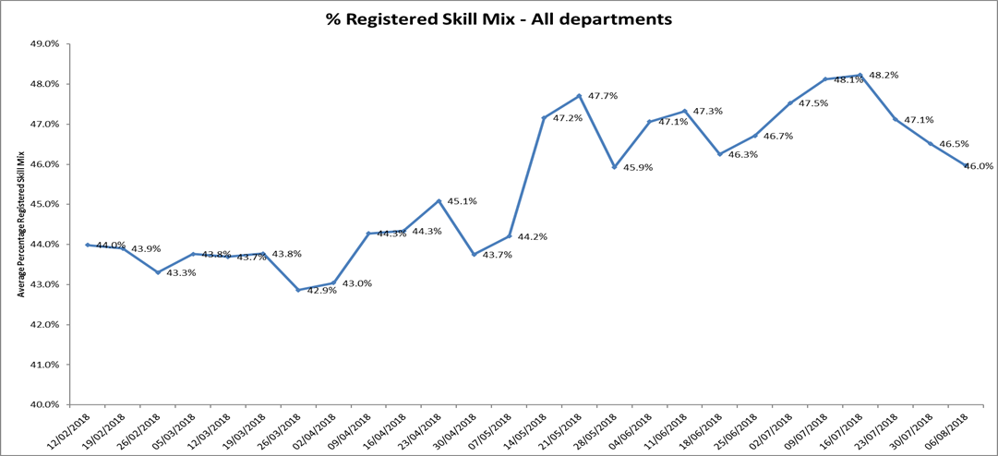

**Maintaining Safer Staffing, including update on recruitment:**

Community Hospitals

All eight wards: Abbey ward & Stroke Rehabilitation Unit at Abingdon, Bicester, City, Didcot, Linfoot, Wenrisc and Wallingford maintained above 50% skill mix for the whole period

Abbey ward had 18 beds open in August, including 4 stroke beds to support Oxford Stroke Rehabilitation unit who have 12 beds of 20 beds open as recruitment to 5.9 registered nurse and 6.52 HCA vacancies continues.

City Hospital has 12 beds of 20 open to support safe staffing levels being maintained as there are 6.31WTE registered nurse vacancies

|  |  |  |  |  |
| --- | --- | --- | --- | --- |
| Community Hospitals | Bed capacity | Open beds | Band 5 vacancies | HCA vacancies |
| TOTALs | 140 beds | 134 beds | 28.84 WTE | 14.55WTE |

Adult wards

There are currently 18 band 5 nurses with offers or due to start with the wards, this is improved from figure of 3.3 in January 2018

Ashurst was at skill mix was 40.1% and 41% and they continue to have high vacancies, agency longlines are in place to support staffing levels.

Further details on vacancies will be provided next month.

Older Adult wards

Cherwell and Sandford maintained above 50% skill mix for the whole period

Amber Ward was at 45% and 46.4%

More focus on these wards will be provided next month.

Children and Young Peoples wards.

Cotswold House Oxford was at 39.6% and 38.2% registered skill mix for this period. This skill mix reflects the Leadership team decision to manage with substantive staff and flexible workers and one long line agency as need to maintain consistency of staff where possible for Eating Disorder patients

Band 6 roles fully recruited

Band 5 vacancies 3.77 WTE following two recruited

HCAS – fully recruited.

New Band 3 dietetic assistant role out to advert as part of skill mix work

Cotswold House Marlborough

The ward is now up to full establishment

Highfield

Proactive recruitment of newly qualified nurses and HCAS have seen vacancy reductions

3.4 HCA vacancies when all staff whom have been offered HCA roles are in post. Currently awaiting checks to be completed on 10 HCA’s

9.6 vacancies improved from March figure of 13.8 WTE against 17.0 establishment.

Marlborough House Swindon

Continued recruitment:

3.7 WTE HCA vacancies but flexible workers looking to convert to substantive roles

2.2 Band 5 vacancies with interviews for two applicants, reduction from 4.7 in March 2018

Band 6 vacancy – interview in place.

**Forensic wards**

All ten wards were below average 50% skill mix registered nursing during this eight week period

More detailed information is provided on these wards

Vacancy data has been sourced from ward managers to review changes since last reported in April 2018

|  |  |  |
| --- | --- | --- |
|  | April 2018 | Sept 2018 |
| Band 6 | 2.62 WTE | 3.66 WTE |
| Band 5 | 42.54 WTE | 35.03 WTE |
| Band 3 | 19.29 WTE | 9.32 WTE |
| Totals (including Evenlode) | 64.45 | 48.01 |

Whilst there has been some improvement in substantive staffing numbers. Four wards remain with high vacancies at Band 5, Wenric, Kestrel, Kingfisher and Kennet.

**Breakdown by ward**

|  |  |  |  |  |
| --- | --- | --- | --- | --- |
|  | Establishment (WTE) | In Post (WTE) | Vacancies (WTE) | Update September 2018 |
| Forensics | | | | |
| Lambourne | | | | |
| Band 6 Charge Nurse | 2 | 2 | 0 | No Change |
| Band 5 Staff Nurse | 3.74 | 5.5 | +1.74 | No change |
| Band 3 Support Worker | 9.18 | 9.3 | 0 | No change |
| Wenric | | | | |
| Band 6 Charge Nurse | 4 | 3 | 1 | No Change |
| Band 5 Staff Nurse | 10.92 | 5.91 | 5.01 | No change.  5.01 vacancies remain  Currently using 2 x Long line agencies to cover |
| Band 3 Support Worker | 20.66 | 19.87 | 0.79 | No Change |
| Kennet | | | | |
| Band 6 Charge Nurse | 4 | 4 | 0 | 0 |
| Band 5 Staff Nurse | 10.92 | 3.2 | 7.72 | 5.7 (2 newly qualified due to start) |
| Band 3 Support Worker | 18.22 | 18.79 | 0 | Over establishment  19.79 |
| Glyme | | | | |
| Band 6 Charge Nurse | 4 | 3.6  one on secondment, from Kingfisher till March 2019 | 0.4 | No change |
| Band 5 Staff Nurse | 7.48 | 4 | 3.48 | 1 newly qualified to start in October  Vacancies =2.48 |
| Band 3 Support Worker | 12.63 | 14.57 | 0 | Inclusive of One is newly qualified nurse awaiting registration |
| Woodlands | | | | |
| Band 6 Charge Nurse | 4.23 | 3.91 | 0.22 | 0.22 |
| Band 5 Staff Nurse | 8.48 | 6.56 | 0 | X1 due to start 10th September.  X1 currently going through pre-employment checks. |
| Band 3 Support Worker | 13.92 | 13.9 | 0 | 0 |
| Kestrel | | | | |
| Band 6 Charge Nurse | 3 | 1 (although seconded to W/m role to cover MAT leave) | 2 | Vacancies covered by:  1 secondment from Kingfisher, 1 who has been seconded from Glyme for 6months, and 1 long line agency |
| Band 5 Staff Nurse | 11.92 | 1 | 10.92 | No Change |
| Band 3 Support Worker | 20.66 | 16 | 4.66 | 6.66 vacancies up from 4.66 |
| Kingfisher | | | | |
| Band 6 Charge Nurse | 3 | 3 | 0 | No Change |
| Band 5 Staff Nurse | 11.92 | 3 | 8.92 | No change  8.92 vacancies |
| Band 3 Support Worker | 20.66 | 15 | 5.66 | 17 in post – I due to leave =  4.66 vacancies  4 NATs out on placement |
| Watling | | | | |
| Band 6 Charge Nurse | 5.23 | 5 | 0 | No change |
| Band 5 Staff Nurse | 16.66 | 12 (2 seconded into band 6) | 2 | No change |
| Band 3 Support Worker | 22.96 | 16 | 6- | 0 vacancies as all going through recruitment |
| Chaffron | | | | |
| Band 6 Charge Nurse | 2 | 2 | 0 | No change |
| Band 5 Staff Nurse | 3.74 | 3 +1from Watling | 0 | No change |
| Band 3 Support Worker | 9.18 | 7 | 2.18 | 0 – vacancies recruited to |

Kennet registered nurse skill mix data from the last six months is outlined below as this ward has the lowest skill mix % from the all wards across the Trust.

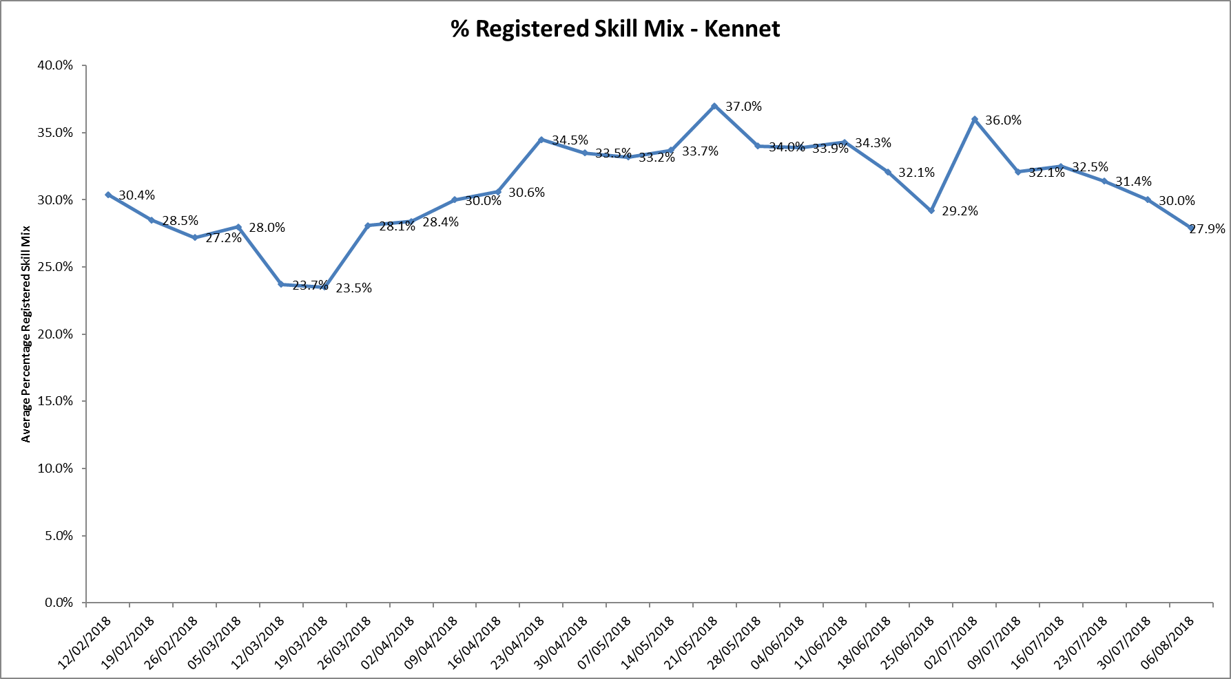

Staffing information from the ward manager as at 14.09.18 shows:

Four Band 6 roles are in place and fully staffed.

Band 3 HCA roles are above establishment at 19.79 WTE.

There has been recruitment to two band five posts who are newly qualified going through recruitment and this leaves 5.7 WTE Band 5 vacancies against establishment of 10.92 WTE

Four agency registered nurses have been employed as longline contracts to maintain staffing consistency and this will continue to provide additional registered nursing.

**Agency use**

The average weekly % agency use was 10.82% a rise from 9.85% in July report with a peak of 11.5% in the week 09.07.18.

Further detail of agency use is provided in the Workforce report. The reduction in agency use continues from peak of 19.1% in February 2018. However this related to continued vacancies and patient acuity.

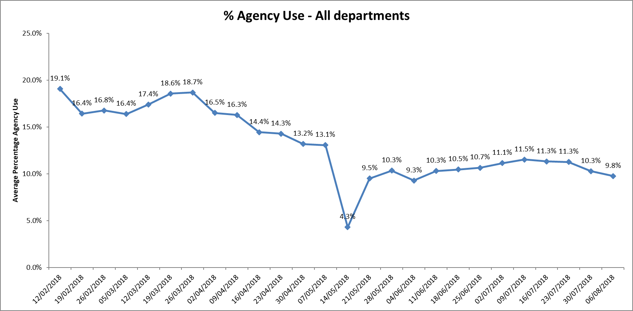

Twenty two wards required 5-25% agency staff.

Three wards required above 25% agency staff in the period June 16th to July 15th these were Allen, Kingfisher and Kestrel ward.

This reduced to zero wards above 25% in the period July 16th to August 12th

Nine wards were below trust target of 5% in the first period, this increased to 10 wards in the second period.

Community Adults

Bicester

Linfoot

Wenrisc

Adults

Opal

Wintle (second period only)

Adult Eating Disorders

Cotswold House Marlborough

Forensics

Chaffon

Lambourne House

Watling

Woodlands

**Evenlode**

There has been a significant reduction in agency use, recruitment to Band 5 and Band 3 roles have been successful, and in process for starting In October, more recently sickness and continued levels of patient acuity have impacted on need for agency use. One patient requires an alternative placement and this has been esclated with NHSE. Longlines are in place to maintain staffing consisitency for patient care.

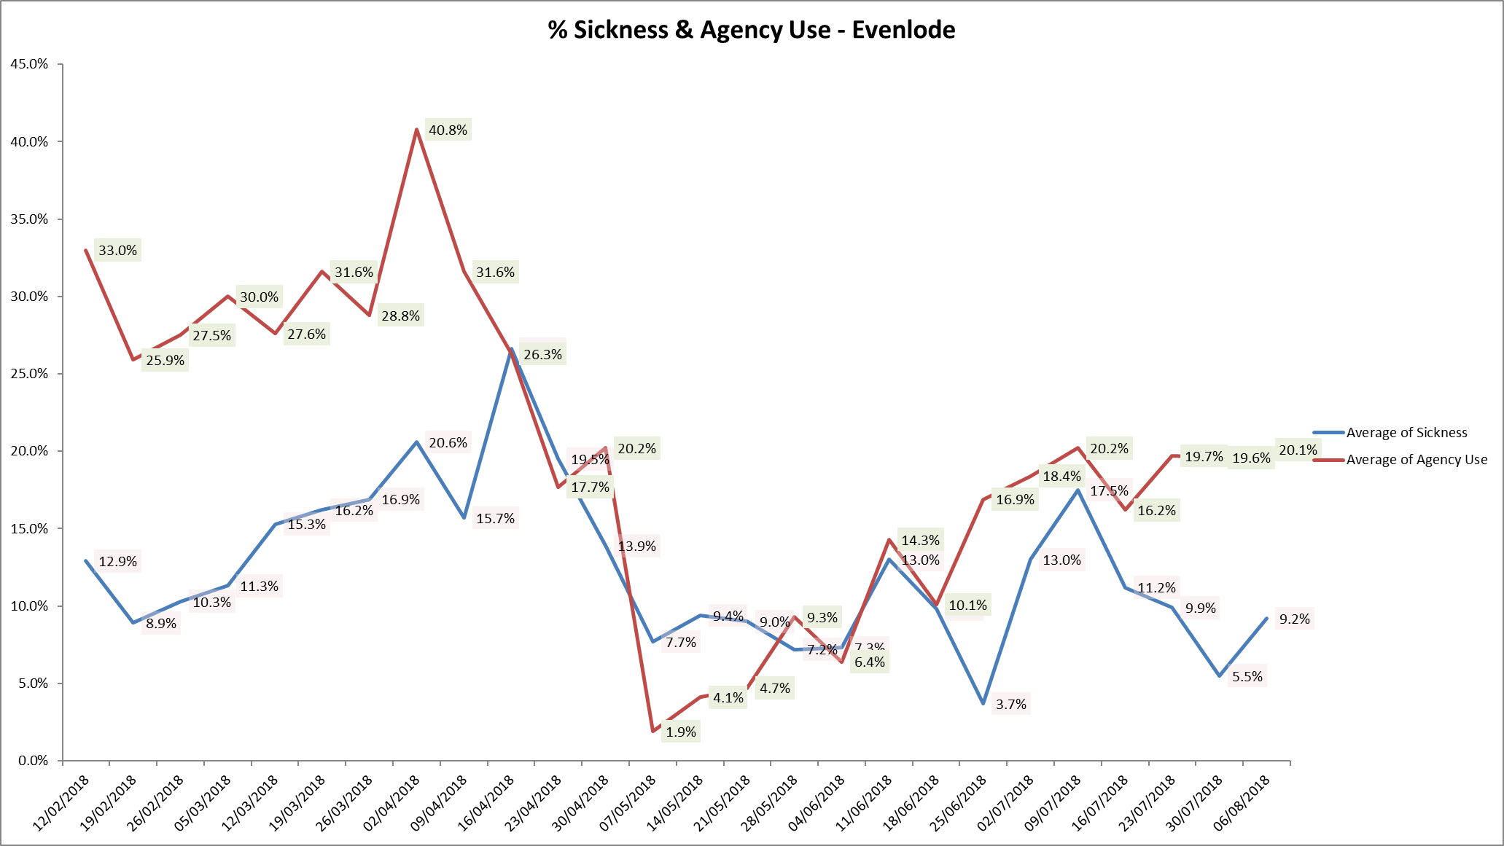

**Oxford Health Flyer Programme**



This is a new programme for Newly Qualified Nurses and AHPs and includes preceptorship. The framework for the programme has been developed and structured reflecting evidence and direction from the Department of Health and Health Education England. The programme commenced in September and is led by newly appointed preceptorship lead Steve Marcus working with service leads, matrons and within Learning and Development department.

**Safe Care module update**

This additional module on the workforce management system enables units to:

• Capture actual patient numbers by acuity and dependency

• See if staffing levels match the demand.

• Action day-to-day staffing movements

• Provides clear visibility of staffing issues Trust wide where staffing does not match the required patient demand

• Informs longer-term resource and establishment plans

• Provides reports to identify trends and causes, highlighting changes needed to ensure safe staffing levels.

The data is being reviewed weekly by the Heads of Nursing to monitor census completion and acuity levels

Safe Care implementation and operational management going forward has been discussed at Operational SMT and is being taken forward with directorate SMTs to agree reporting and monitoring arrangements within the directorates, as whilst data input compliance has improved but there are still areas of inconsistencies and the data reliability in terms of acuity and patient demand v staffing.

Further work is now needed to review the consistency of the use of the acuity tools and establish formal reporting through to Directorate operational meetings once the compliance is robust. A further Safe Care project group meeting has taken place on 21st September 2018 to take this forward.

**Skill mix Review Inpatient wards**

**Summary:**

To ensure that wards can provide effective nursing interventions and safe high-quality care to patients it is crucial that they have the staffing establishment and skill mix to ensure the right level of clinical skills to support the treatment and recovery of patients in their care.

The implementation of the Nurse associate role and Nurse associate trainees began in 2016, the first of these nurses will be qualifying next year. These roles need to be incorporated in a ward skill mix, which recognises the value they can bring to the ward team and patients, and the opportunities this presents to increase the level of seniority and clinical experience among the registered nursing group.

Each area, Adults, Forensics, Children and Young people and Community Hospitals has completed a skill mix review. Older People’s wards s due to be completed this quarter. This skill mix review was undertaken to incorporate implementation and development of new roles, and is supportive to the recruitment, advancement and retention of staff.

**Objective:**

To create a skill mix which ensures the full use of a variety of clinical roles on the inpatient wards, to offer evidenced best practise interventions to patients, and positive career structures to staff

**Consultation**

The creation of the new skill mix involved meetings with ward managers, matrons, senior matrons, Head of service, Head of Nursing, and Service Directors.

The skill mix review has had two stages:

1. Review of current establishment to align the workforce management system and financial budgets and establishments. Sign off for the 2018/19 budget and establishment.

2. Skill mix review with a revised staffing model, incorporating new roles.

**Next Steps**

Costings of proposed changes to be finalised and agreed prior to implementation.

**Conclusion**

All ward staff and managers continue to make every effort to ensure wards continue to be staffed safely, fill rates remain high and that we focus efforts on retaining our staff whilst recruiting new nurses to join Oxford Health FT. Skill mix review work will progress to include Nurse associates and our new Flyer programme is a key part of our retention work with newly qualified staff.

