BOD 110/2018
(Agenda item: 9)

Report to the Meeting of the

Oxford Health NHS Foundation Trust

Board of Directors

27th September 2018

Quality Report: Focus on Incident, Mortality and Patient Safety
(revised)
For: Information

Executive Summary
The following report provides a summary about the safety of care up to August 2018.

A more detailed version of the report was considered by the Safety quality-sub committee on 8th August 2018.

In summary;
- The incident reporting levels on Ulysses have continued to increase, with the majority of incidents relating to no harm (66%) or low harm in line with the national picture. This indicates a positive learning culture from teams who report incidents to learn.
- Most of the incidents in 17/18 related to skin integrity (16%), violence and aggression (16%), communication/confidentiality (10%) and self-harm (8%). A breakdown by cause group split by mental health services and physical health services is included in the report.
- Incidents resulting in major harm have reduced. In Q1 70% of skin integrity incidents were inherited prior to receiving care from services in the trust. The Trust has achieved a notable reduction in the number of serious incidents -acquired pressure ulcers with lapses in care following the success of a number of initiatives implemented across the District Nursing Service.
- In Q1 2018/19 there have been 6 RIDDOR reportable incidents where staff have been injured at work. The health, safety and security manager contacts each member of staff when they return from a RIDDOR reportable sickness to offer a debrief, support and guidance.
- The directorate mortality review processes are well embedded to identify learning from unexpected/ inpatient deaths. There have been two deaths of detained patients under the MHA in Q1 2018/19; one was a forensic inpatient who died in April 2018 of a drug overdose and an SI investigation is underway and the second a forensic patient living in the community who died in May 2018, an IRR and a mortality review was completed. The National Quality Board has published its first edition of ‘Learning from deaths-Guidance for NHS trusts on working with bereaved families and carers’ (July 2018). A review of the new standards is being completed with mortality leads from the directorates to identify improvements for 2018/19.
- The pattern of deaths is analysed quarterly and presented to the Trust board seminar in September 2018. The majority of deaths relate to people aged over 75 who had received treatment from one of our physical health services, such as the district nursing service. We saw an increase in deaths in January 2018 in line with the national picture. The key themes for learning from the review of deaths largely remain similar and these include: family engagement and communication, physical health for patients with a mental health illness, communication at points of transitions and changes in care between teams, services and organisations.
- The Trust continues to work collaboratively with the new national Healthcare Safety Investigation Branch (HSIB) around a theme on communication at points of transition during care, to ask. The report was published on the HSIB website in July 2018. Representatives of HSIB attended the Trust board seminar in September 2018 to present their findings and the national recommendations.
- A coroner will issue a regulation 28 to prevent any future deaths (PFD) if they feel any actions or learning is not being acted on sufficiently. The trust received two PFDs in 2017/18 and two so far in 2018/19. The cases in 2018/19 relate to the;
- Suicide of a male in 2015 receiving community treatment by an AMHT in Buckinghamshire. The Trust conducted an internal SI into the death which has been closed by the CCG and shared with the coroner. PFD received May 2018. Trust has responded to the coroner to address the additional areas identified at the inquest and is working with his family to commission an external investigation.
- Suicide of a female on an acute mental health ward in March 2017. External investigation completed and shared with the coroner. PFD received July 2018 and response being drafted.
- The reduction in restrictive practice has been maintained. A small number of patients are accounting for a large number of the restraints. Prone restraints are low except for in May 2018 relating to a specific patient. Most common reason for the use of restrictive practice is violence and aggression. Patient and staff harm during restraints has increased in Q1 which is being looking into by the PEACE team. The PEACE team are focusing on a number of work streams i.e. PEACE champions programme, implementation of Safewards interventions, developing new PEACE refresher training for ward staff.
- A review has been completed of all national Medicines and Healthcare Products Regulatory Agency (MHRA) alerts back to 2003, to ensure all relevant alerts have been identified and appropriate actions have been taken and then sustained. Following a recent letter from NHS Improvement in June 2018 about ensuring actions national alerts are sustained (two alerts were named of which once was relevant to Trust services), the Trust is systematically going back through all relevant national alerts and looking at the evidence submitted to close and whether the action resolves the risk.
- Further work is required on the management and oversight of medical devices across the Trust. Processes around purchasing, standardising equipment and maintenance/ collaboration through contracts has improved, although assurance around training/ staff competence is not robust in all services. The management and responsibility for prescribing equipment both for current patient and then patients who are discharged needs further work and investment. The contract with Millbrook (managed by Oxfordshire County Council) for providing prescribed equipment is under review with the development of better monitoring and input from clinicians at OHFT. More clarity is needed to improve prescriber responsibility. The medical devices committee oversees the work and has recently changed the chair and membership.
- In Q1 of 2018/19, 16 SIs were identified and reported, of these 5 were subsequently downgraded. Of the SIs reported in Q1, 5 involve a death of which 4 are suspected suicides. Of those SI investigations reported in Q1 2018/19 all investigation reports were submitted to the commissioners within the required time frame. An analysis of SI’s over the last 3 years is presented, showing a decline overall due to the reduction of SI’s relating to pressure damage. Self-harm and pressure damage remain the two main causes of SI’s.
- The SI team will continue to focus on ways of sharing the learning from SI investigations and sharing local learning for moderate incidents including attending team reviews, using the Quality and Risk team bulletin bi-monthly and contributing to directorate Quality and Safety meetings. Four listening events have been held for staff to share their experiences of being involved or on leading an SI investigation, the outcomes will be used to improve the approach and processes for SIs.
- The Trust has had three confirmed never events in the last 12 months;
- 2017/18 - Circumstances surrounding the tragic death of a disabled child at their home in November 2017 who was receiving support from the Children’s Integrated Therapies Service. The combined bedrail, bedframe and mattress dimensions did not comply with Medicines and Healthcare Products Regulatory Agency (MHRA) Safe Use of Bed rails 2013 guidance. SI investigation, CDOP process and coroner’s inquest completed. Action plan shared at the Quality Committee in May 2018. Progress against actions to be shared with the family and Coroner.
- 2018/19 - In August 2018 a member of the salaried dental service by accident extracted the wrong tooth of a child under a GA. The tooth was immediately re-implanted. SI investigated started.
- 2018/19 - In August 2018 a collapsible shower curtain rail on a CAMHS ward did not collapse under weight. We are in liaison with the manufacturer who is supporting the trust to investigate the circumstances and alternative products available. We have issued an external alert to inform other mental health trusts of a likely risk. SI investigation has started.
- In July 2018 there was an outbreak of an invasive group A streptococcal infection with a cluster of eight people affected in West Oxfordshire. The similarities across the people was that: all live alone, were over 70 years old, they used different care agencies on a regular basis, they were seen by the same district nursing team, they all have open wounds and they need dressings changed regularly. In total 18-19 OHFT staff were screened and all had negative results for carrying the infection. Two patients have subsequently died at the OUHFT. A review has been started.

Recommendation:
To note.

Author and title: Jane Kershaw, Charlotte Forder and Pam Treadwell (Quality and Risk Team)

Lead Executive Director: Ros Alstead Director of Nursing and Clinical Governance

1.0 Overview of Reported Incidents
1.1 Number of incidents
Figure 1 shows reporting levels have continued to increase from the point the Ulysses incident reporting system was introduced across all services from 2011. The increase in reporting in Q2 and Q3 of 17/18 relates to CAMHS, the adult mental health wards and community mental health teams, and the transfer of the learning disabilities service from July 2017.

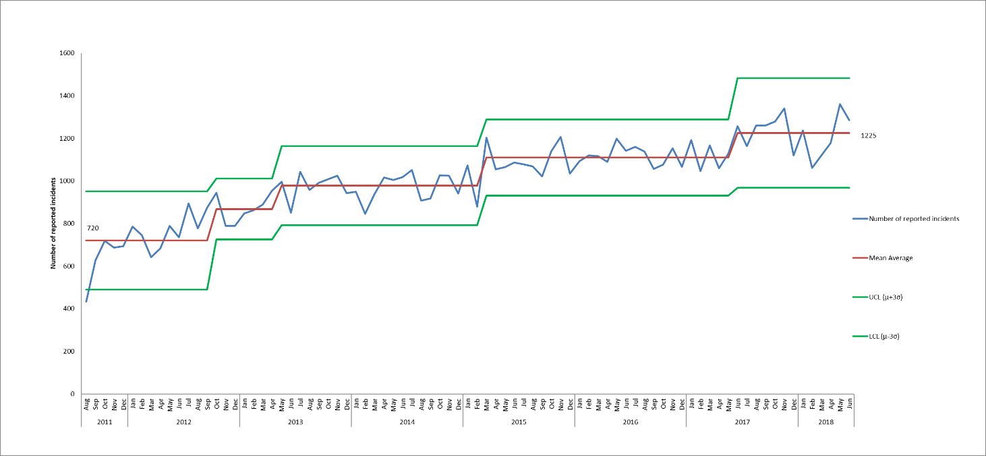
Figure 1. Control chart displaying monthly number of incidents reported on Ulysses system from August 2011- June 2018

Overall no seasonality has been observed in numbers of incidents reported. Similar numbers of incidents are reported as occurring from Monday – Friday, while reduced numbers are reported on weekends. A review of the times at which incidents were reported as occurring showed that 29% of all incidents in the past year occurred between 10am and 1pm. Looking at the timing of incidents within particular cause groups shows the following differences;
- Violence + Aggression on inpatient wards – high numbers of incidents occur throughout the day, with most occurring from 11am – 12pm, and numbers tailing off from around 8pm.
- Self-Harm on inpatient wards– Most incidents occur in the evening with 49% of incidents in the previous year occurring between 5pm and midnight, and 24% between 8pm and 11pm.
- AWOLs – Incidents tend to occur in the afternoon, 57% occurred between 1pm and 8pm with a peak between 2pm and 4pm when 19% of incidents occurred.
- Staffing on inpatient wards– The highest proportion of incidents in the previous year were reported as occurring between 8pm and 10pm (17%), and also between 7 and 8am (14%).

On average across the community hospital wards 2.7 incidents are reported per 100 bed days and across mental health wards 4.6 incidents are reported per 100 bed days.

There was an increase in incidents (92) in May and June 2018 reported by 10 different Health visiting services, of these 68 related to communication/confidentiality, with 35 incidents in the sub-category ‘poor communication patients affected and 14 in the sub-category of ‘delay in providing care/treatment/follow up’. Overall, across several categories, 47 incidents were reported in the quarter that related to health visitors not being notified of pregnancies by the midwifery service, meaning that patients were not contacted to arrange antenatal visits. The incidents were caused because of a change in electronic system by the OUHFT which has now been identified and resolved by the safeguarding teams in both organisations.

Within the AMHTs there has been general increase in incidents since March 2017, with an average of 37 incidents per month reported prior to this, and an average of 56 incidents per month from March onwards. Increases are seen in both AMHT Oxon City + NE, and in AMHT Bucks Aylesbury. Spikes were also seen in AMHT Oxon South in May and June of 2018 when 19 and 15 incidents were reported respectively, compared with a mean average of 5 per month. In total 45 incidents were reported in the quarter and of these 15 were incidents of violence/aggression, with 10 different patients involved.

  - Actual Impact of Incidents
Overall in Q1 2018/19, 3307 incidents were reported and 66% of these were reported as causing no harm. This is generally in line with the national picture, however, as discussed in the previous report, since Q4 16/17 a higher proportion of patient safety incidents have been reported by the trust in the category of major injury/severe property damage. This was as a result of the introduction of the category of SCALE in April 2017, and a decision within the older people directorate that grade 4 pressure ulcers be graded as major impact, even if there were no lapses in care.

In Q1 29 incidents were reported with major injury, compared with 35 in Q4 17/18. Of the 29 incidents with major injury/severe property damage reported in Q1, 11 were related to skin integrity with 8 incidents of grade 4 pressure damage 3 incidents of SCALE, and they were recorded across 9 different departments (8 DN teams and one podiatry team). Two of the incidents of grade 4 pressure damage are being investigated as serious incidents. There were 5 incidents of self-harm for which major injury were reported, 4 in 3 different AMHTs and one at CAMHS Marlborough House. 3 patients took overdoses and there was one incident of hanging and one incident of a patient jumping from a bridge, the patients were all treated in A+E. Four falls were reported with major injury in Q1, in one incident a patient fell from the homeless hostel window, one was on Cherwell ward while a patient was mobilising, one patient fell from a bed in a community hospital and the 4th incident occurred during a physio visit to a care home when a patient was mobilising. The one major incident of violence and aggression was in CAMHS and related to a stabbing, both the victim and the alleged instigator had been known to CAMHS services. The remaining incidents with major impact were reported across 7 different categories and departments, 2 of these related to damage to property and the others to injury to patients, one incident is being investigated via the complaints process.

1.3 Cause Groups of Incidents
Table 2 shows the three cause groups with most reported incidents across services in Q1. An analysis is carried out quarterly across all cause groups and reported to the Safety Quality Sub-Committee, with only a summary reported here. Violence/Aggression was the cause associated with 16.4% of all Q1 incidents (n=628) while 16% were incidents of Skin Integrity (n=612). As in Q4 the third highest cause of incidents in Q4 2017/18 was communication/confidentiality.

Table 2. Cause groups with most reported incidents, Q1 18/19
Trust-wide services | Mental health services | Physical health services
Violence/Aggression (n=628) | Violence and Aggression (n=585) | Skin Integrity (n=602)
Skin Integrity (n=612) | Self-Harm (n=318) | Communication/Confidentiality (n=206)
Communication/Confidentiality (n=367) | Security (n=274) | Fall related (n=150)

The CAMHS Highfield ward continues to have high numbers of self-harm incidents, with an increase in Q1 (67 compared to 36 in Q4). The majority of the incidents (43 of 67, 64%) were incidents of cutting, and there were also 11 ligature related incidents, 7 incidents of patients striking themselves/objects, and 3 overdoses. Fourteen different patients on the ward were involved in incidents, with 8 patients having more than one incident. For one patient 18 different incidents were reported, 16 of which were incidents of cutting. Six incidents were graded as moderate, 4 of which involved the same patient.

1.3.1 Violence and Aggression Incidents
Violence and aggression continues to be the highest cause of reported incidents with 628 incidents in Q1, 604 incidents in Q4 and 594 incidents in Q3. Most incidents are acts by patients towards staff with no injury (73% of incidents). There is no overall trend in numbers of incidents of violence and aggression over the past 3 years, however, since mid-2017 there has been an increase in incidents in the adult directorate, and a decline in incidents in the older people directorate, both of which have been maintained in Q1. The increase in incidents in the adult directorate (from an average of 125 per month to 155 per month) coincides with the transfer of learning disability services to Oxford Health in July 2018, spikes have also been seen in other adult wards over this time. On Evenlode ward 47 incidents were reported, compared with 40 in the previous quarter and 23 in the one before that. It seems that there has been an increase in incidents of violence and aggression at around the time of the transfer of the service from Southern Health to Oxford Health in July 2017, however this is thought to be as a result of a change in patient acuity rather than as a result of the transfer.

In Q1, the highest reporter of incidents of violence and aggression was CAMHS Highfield Ward, with 54 reported incidents, of the incidents 10 different patients were involved as instigators, and one patient was involved in 25 incidents. Of these 23 of them were in the sub-category of ‘violence no injury-patient on staff’.

Twenty incidents were reported with a moderate actual impact; these were across 16 different wards. Four wards had 2 incidents each (Wenric, Vaughan Thomas, Ashurst and Kestrel). A further incident of violence and aggression resulted in RIDDOR, this was on Evenlode as a result of a patient trying to pull a staff member over.

Reducing violence and aggression on adult acute mental health wards is a local quality objective for 2018/19. Work underway includes;
- Being part of the national ‘observation and engagement collaborative’ being led by NHS Improvement, looking at how observations are done, what patients understand and how staff feel about doing them. A key foundation of the work is to look at how to sustain quality initiatives.
- Work with staff to recognise early trigger points which can lead potentially to acts of violence and aggression
- ‘knowing me’ boards have been introduced across a number of the adult acute wards to improve relationships between staff and patients, so patients are less likely to be violent to staff.

1.3.2 Skin Integrity (pressure damage)
Since July 2016 57% of the reported pressure ulcers have been categorised as being inherited, rather than being acquired/developed whilst receiving treatment from our services, in Q1 18/19 - 70% of the reported pressure ulcers were inherited (figure 2).

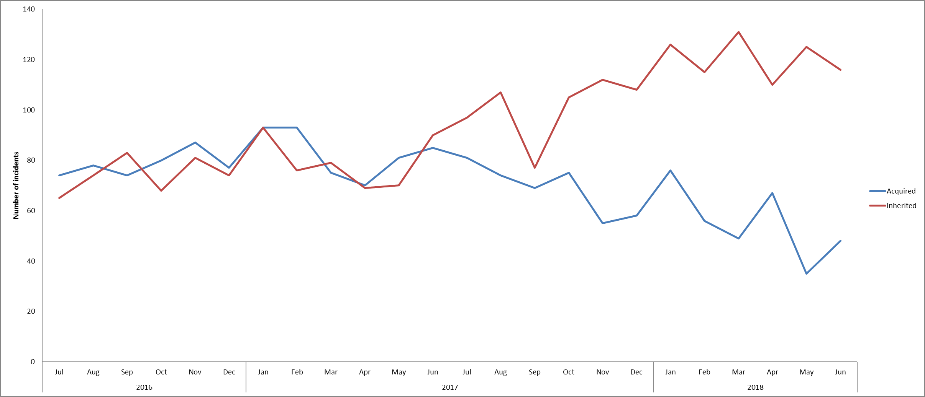
Figure: 2. Incidents of acquired and inherited pressure damage, July 2016 – June 2018

In 2017/18, the Trust achieved a notable reduction in the number of serious acquired pressure ulcers with lapses in care. There were 7 acquired category 3 or 4 pressure ulcers with lapses in care in 2017/18 compared to a total of 21 in 2016/17 and 28 in 2015/16. This is as a result of long term improvement work to increase the early identification and care planning particularly on lower grade damage, provide education to patients and their carers, focus work on prevention, update the handover process and improve staff training and quick time learning.

Of the 154 acquired pressure ulcers reported in Q1, 46 were graded as major. Lapses in care were reported for 6 incidents (5 in 5 different District Nursing teams and 1 in Podiatry), and 2 of these are being investigated as serious incidents, both in District Nursing service.

1.4 RIDDOR reportable incidents (staff injured at work)
In Q1 2018/19 six RIDDOR incidents were reported where staff were injured at work and off sick for more than 7 days, with 4 of these incidents occurring in the quarter before (Feb and March 2018). One of the incidents was reportable for two members of staff as both sustained injuries that resulted in them being off work for more than 7 days. Out of the 6 incidents, 4 were due to violence and aggression from patients and 2 were as a result of manual handling.
Of all RIDDOR incidents since April 2016 (see figure 3), 52% have been Violence/Aggression (33 of 63), 30% have been fall Related (n=19) and 16% (n=10) were manual handling. 14/ 63 incidents have occurred on adult acute mental health wards, eight on older people mental health wards, and five in the learning disability services (since taking on the service in July 2017), with 4/5 of these on the forensic LD ward, Evenlode.

The health, safety and security manager contacts each member of staff when they return from a RIDDOR reportable sickness to offer a debrief, support and guidance.
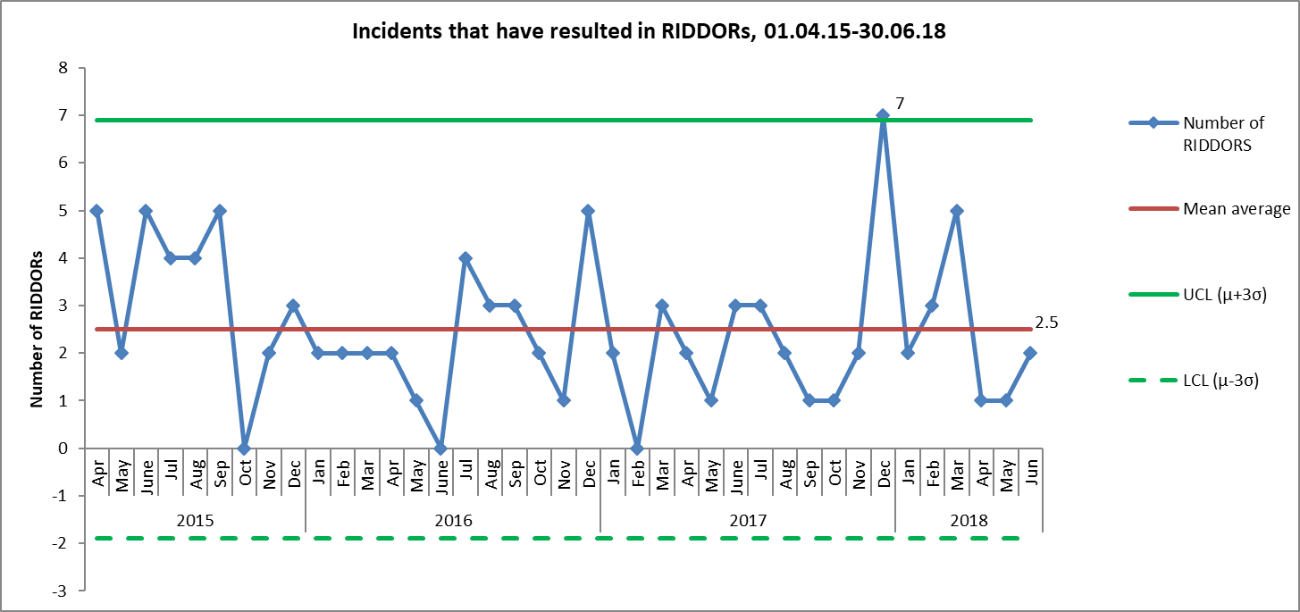
Figure 3. Number of incidents that have resulted in RIDDORS, based on reported date of the incident on Ulysses, from 01.04.15– 30.06.18

2.0 Restrictive Practice
The use of restrictive practice is reported to the weekly clinical review meeting and then on exception to the Executive Team. The most common reasons for using restraint continues to be violence and aggression on staff or self-harm.

2.1 Trends
Reductions in the use of restraint have been seen in both the adult and older people directorate since April 2015, whereas no overall change has been seen in children and young people (although below average numbers were reported between November 2017 and April 2018).

In the adult directorate the reduction was seen in 2016 and numbers have remained constant since then, whereas, in the older adult directorate the reduction was seen in August 2017, this was as a result in a decrease in incidents involving restraint on Sandford ward. The increase in restraints in the children and young people directorate in Q1 seems to be a result of multiple restraints on two patients, one of whom was restrained in 40 incidents, and the other in 29 incidents.

Since the decrease in use of prone and supine position in 2016 (figure 4), numbers have remained within normal levels of variation. An average of 19 incidents per month have included use of the prone position since June 2016 (compared with an average of 29 per month prior to that), but numbers were above average in May 2018 with 31 incidents in total. Of these 18 related to a particular patient on CAMHS Highfield ward, the reason given for use of the prone position for these incidents was IM medication. No change has been seen to the total duration of prone restraints in the previous year.

The number of forms recording the use of the highest level of hold, thumb-wrist hold has remained low at below 2.6% (9 restraints in Q1) maintaining the low usage of high level holds.

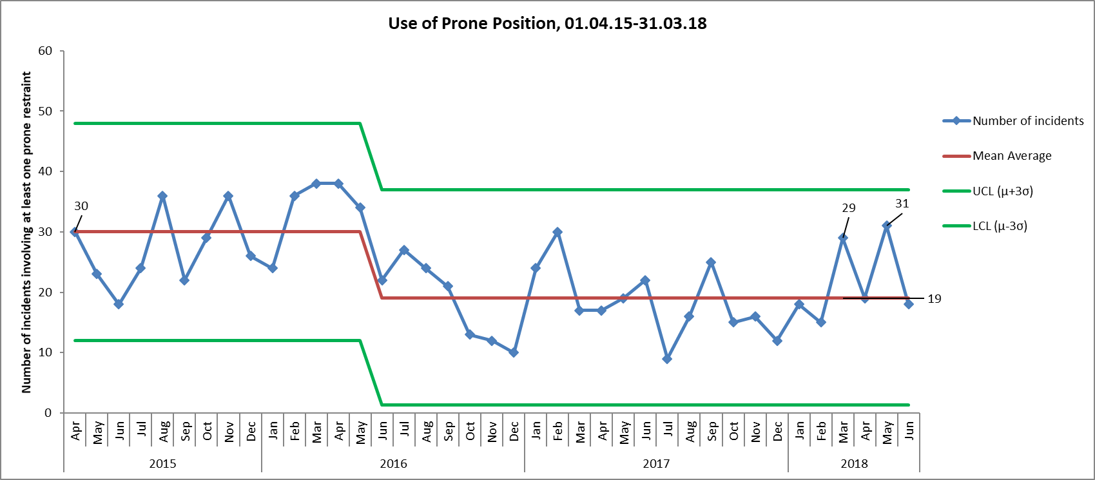Figure 4. Number of incidents in which prone restraint used, April 2015-June 2018

In 75% of incidents involving restraint in Q1, no injury or property damage was recorded (n=261). One incident of a patient being violent towards staff on Wenric was RIDDOR reportable due to resulting injuries to staff members. 12/ 70 incidents in Q1 resulted in moderate injury/damage to property, these were across 9 different wards. These incidents involved injuries towards staff and property damage as a result of violence and aggression, and 3 incidents of self-harm that resulted in restraint. Looking at injuries as a result of restraint, in Q1 - 7 different patients suffered an injury during 9 different restraint interventions. A focused review of staff injuries and patient injuries is currently taking place, both in relation to violence and aggression incidents and those involving restraint.

In Q1, 15 patients were restrained five times or more, accounting for 50% (172 out of 347) of all incidents involving restraint. Violence and aggression has consistently been the cause attributed to most incidents in which restraint is used, in Q1 55% of incidents attributed to this compared with 68% in Q4. The second highest cause of restraint in previous quarters has been self-harm, however, in Q1 this was ‘Health’. In total 22% of incidents (n=76) were in this category, compared with 7% in Q4 (n=18). Of the 76 incidents reported in this category, 63 (83%) were on CAMHS Highfield ward, and of these 58 were in the sub-category of ‘patient resisting treatment’. These incidents involved 5 different patients, but most interventions were on two patients, one of whom was resisting eating so was being fed through an NG tube (27 incidents) and the other who was resisting medication (19 incidents).

Although the number of incidents of violence and aggression increased in the middle of 2017, the decline in the proportion of these incidents in which restraint was used has been maintained at around 31% since January 2017, following a reduction from 39% prior to that (figure 5).

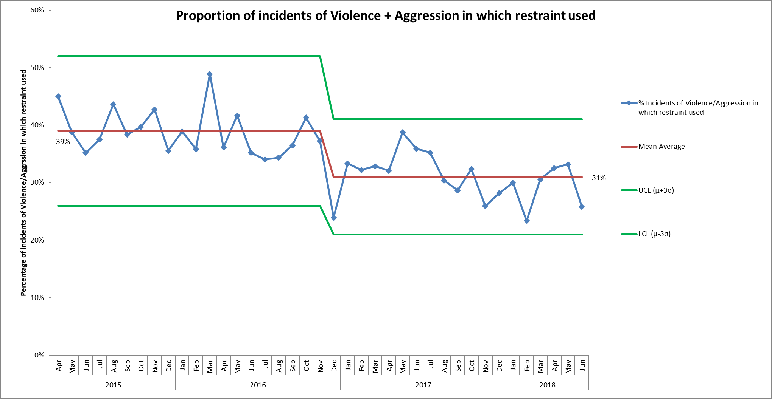Figure 5. Proportion of incidents of Violence/Aggression in which restraint used, April 2015-June 2018

Use of seclusion dropped towards the end of 2015 and has been variable over the past 2 years.
The Adult directorate consistently has the highest use of seclusion within the trust accounting for 95% of all seclusions. The cause group attributed to the majority of seclusions in Q1 was violence and aggression (98 of 109 incidents).

The chart, figure 6, below enables us to crudely compare use of restrictive practice. At present the overall picture from the data outlined in this report is that our restrictive practice is reducing albeit at a very steady rate.

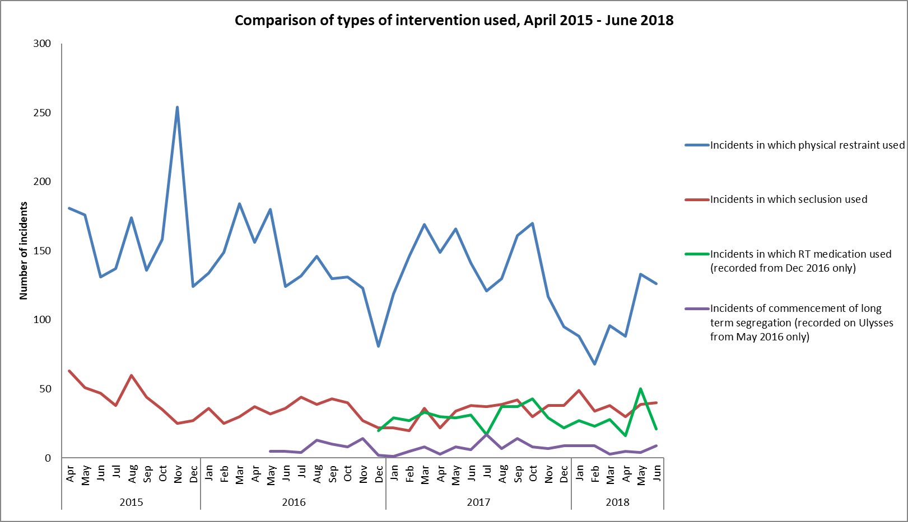Figure 6. Comparison of types of interventions used, April 2015-June 2018

2.2 PEACE Project
The PEACE steering group is working on the following work streams to minimise the use of restrictive interventions; workforce development, use of data, effective debrief, use of restrictive intervention reduction tools, leadership towards organisational change and service user experience.

Below summarises the current areas of focus and update on recent activities:
- PEACE Champions programme to harness the continued enthusiasm of frontline staff to be involved in supporting the ethos of PEACE approach.
A ‘Sharing Positive Practice’ Day was held in May 2018 for Champions and any aspiring Champions or interested staff. The day gave the Champions an opportunity to share their experience of the role. An overview will be circulated to teams.
- Provision of accurate and timely data through improved incident reporting systems and providing core data that teams can use to identify themes and support formulation of effective interventions.
Core team and Trust wide data has been agreed which forms the basis for teams on a monthly basis to identify themes and identify actions.
- Support implementation of Safewards interventions starting with Know Each Other across all inpatient areas. KEO is now visible in most clinical areas and Champions are working to introduce other Safewards interventions
- Close the gap between learning and practice, this will include provision of 2-day PEACE refreshers which focus on a simulation based approach designed to improve technical and non-technical skills while reinforcing PEACE ethos. This has been agreed in principle. The PEACE team have employed additional trainers who are experienced clinicians to support development of content following an extensive review of the literature and business case based on QI principles. Training to debrief and evaluate this approach has been sourced.
- Improve effectiveness of PEACE governance meeting by scrutiny of data to highlight complaints, hotspots and anomalies. A review of membership to ensure senior representation to account for use of restrictive practices in their area and deliver tangible actions where necessary.
Meeting now produces summary of actions to improve implementation. An action effect diagram has been developed to illustrate the program theory and theories of change and can be used to evaluate impact of interventions.
- Ensure PEACE training meets service needs and future commissioning standards. There is now an available pathway to accreditation which will provide assurance that future commissioning changes are met in terms of training provision. This is in part due to the inclusion of learning disability inpatient services but also the anticipated change in the BILD Code of Practice which will include training standards relevant to services with mental health provision. BILD project post has been developed and agreed. This post will ensure that PEACE is fully aligned and embedded in learning disability inpatient services and that training meets the standards required to achieve accreditation and meets the needs of all OH services within an agreed timeframe.
- Raise awareness of PEACE to increase level of positive engagement, improving morale and unhelpful stigmatising of staff and patients. Request for Communications team to support easily accessible resource area and positive presence on Intranet page. Involvement in Healthfest in September 2018, PEACE will have a stall where we can promote Champions work with Safewards interventions such as KEO, Positive Words, Safewords and use of sensory activities.

3.0 Data Quality
3.1 Contract with Ulysses Limited
The software licence contract with Ulysses Limited was renewed for one year from August 2018. Currently Ulysses is used for incident management system, and also to manage concerns/ complaints, legal claims, policy register, patient safety alerts and NICE implementation. The last upgrade to the system was implemented by Ulysses in March 2018 which included a number of improvements to options for questionnaires and dashboards within the system, the next upgrade is due in October 2018.

3.2 Ulysses system developments
The information analyst in the quality and risk team leads on system developments and on extracting and analysing data from Ulysses. The member of staff is currently seconded to work three days a week in the Business Intelligence team which enables a good transfer of knowledge and skills.

The incident management system is continually being developed and a change document is kept to catalogue changes made. A group of senior staff meet regularly to discuss and approve requests from users (staff), improve data quality, develop the design of the system, and discuss future development requirements.

4.0 Patient safety alerts and Risk Notes
In Q1 30 CAS alerts were issued (excluding high voltage alerts), of these 13 were applicable to the Trust and were cascaded and being actioned.

A review has been completed of all national Medicines and Healthcare Products Regulatory Agency (MHRA) alerts back to 2003, to ensure all relevant alerts have been identified and appropriate actions have been taken and then sustained. Following a recent letter from NHS Improvement in June 2018 about ensuring actions national alerts are sustained (two alerts were named of which once was relevant to Trust services), the Trust is systematically going back through all relevant national alerts and looking at the evidence submitted to close and whether the action resolves the risk and has been sustained.

Further work is required on the management and oversight of medical devices across the Trust. Processes around purchasing, standardising equipment and maintenance/ collaboration through contracts has improved, although assurance around training/ staff competence is not robust in all services. The management and responsibility for prescribing equipment both for current patient and then patients who are discharged needs further work and investment. The contract with Millbrook (managed by Oxfordshire County Council) for providing prescribed equipment is under review with the development of better monitoring and input from clinicians at OHFT. More clarity is needed to improve prescriber responsibility. The medical devices committee oversees the work and has recently changed the chair and membership.

5.0 Learning from Deaths
5.1 Overview
All known deaths are screened by senior clinicians. There is set criteria on the deaths that are reported internally for further review, in line with national guidelines and described in the Trust’s policy. All unexpected deaths of an inpatient are reviewed, all deaths of a person with a learning disability or a child are reviewed by the Trust. The Trust participates in a multi-agency review for all child deaths and the deaths of a person with a learning disability.

The directorate mortality review processes are well embedded to identify learning from unexpected/ inpatient deaths. If new complaints are received in relation to the care of a bereaved relative a mortality review is automatically triggered. There have been two deaths of detained patients under the Mental Health Act in Q1 2018/19; one was a forensic inpatient who died in April 2018 of a drug overdose and an SI investigation is underway and the second a forensic patient living in the community who died in May 2018, an IRR and a mortality review was completed. In addition to those deaths ‘in scope’ as defined by the Trust’s policy and national guidance, we will also be reviewing a random sample of deaths in 2018 not reported on Ulysses with a focus on those identified as an expected death to maximize our learning. The Trust-wide Mortality Review Group oversees learning across the Trust, last meeting in April 2018 and the next is in Sept 2018.

The Trust continues to work collaboratively with the new national Healthcare Safety Investigation Branch (HSIB) around a theme on communication at points of transition during care, to ask. The preliminary scoping exercise was completed in November 2017 and the HSIB considered there was a potential for national learning so a full investigation has started across the country. The draft report was received in May 2018 and the full report was published on the HSIB website in July 2018. Representatives of HSIB attended the Trust board seminar in September 2018 to present their findings and the national recommendations.

In addition to our own review of deaths, the local coroner will independently review all deaths where the cause of death is unknown, violent, unnatural, or sudden and unexplained. A coroner will issue a Regulation 28 to Prevent any Future Deaths (PFD) if they feel any actions or learning is not being acted on sufficiently. The trust received two Regulation 28 rules in 2017/18 and two so far in 2018/19. The cases in 2018/19 relate to the:
- Suicide of a male in 2015 receiving community treatment by an AMHT in Buckinghamshire. The Trust conducted an internal SI into the death which has been closed by the CCG and shared with the coroner. PFD received May 2018. Trust has responded to the coroner to address the additional areas identified at the inquest and is working with his family to commission an external investigation.
- Suicide of a female on an acute mental health ward in March 2017. External investigation completed and shared with the coroner. PFD received July 2018 and response being drafted.

The National Quality Board has published its first edition of ‘Learning from deaths-Guidance for NHS trusts on working with bereaved families and carers (July 2018). A review of the new standards is being completed with mortality leads from the directorates to identify improvements for 2018/19.

5.2 Trends
The pattern of deaths is analysed and reported quarterly and last presented to the Trust board seminar in September 2018. The pattern of the number of deaths is similar over time and in line with the national ONS data. In line with the national data the Trust saw more patient deaths for people aged over 75 in January 2015 and January 2018 when more deaths are expected due to the winter period and an increase in flu activity.

The majority of deaths relate to people aged over 75 who had received treatment from one of our physical health services, such as the district nursing service. The key themes following the reviews into deaths are:
- Physical healthcare for patients with a mental illness
- Family and carer involvement and communication
- Communication at points of transition and changes in care between teams, services and organisations

6.0 Serious Incidents
6.1 Number and themes from serious incidents (SI)
In Q1 2018/19, 16 SIs were identified and reported, of these 5 were subsequently downgraded. Of the SIs reported in Q1, 5 involve a death of which 4 are suspected suicides. The majority of SIs relate to self-harm and pressure damage.

In Q1 15 SI investigations were completed, reviewed at panel and submitted to the commissioner based on incidents that occurred in 2017/18, of these 3 were downgraded over the course of the investigation. No investigations were submitted to the CCG late in Q1 and so far in 2018/19, 5 investigations have been submitted early.

There has been a reduction in the number of confirmed serious incidents in the previous 3 years (figure 7). The decline has largely been seen in the Older People Directorate in relation to pressure ulcers however we have also seen a reduction in self-harm SIs. The reduction in the incidence of pressure damage in Older Peoples Directorate comes as a result of a dedicated focus within community nursing teams to assess and advise their patients and carers on the signs of pressure damage and to put in place preventive measures.

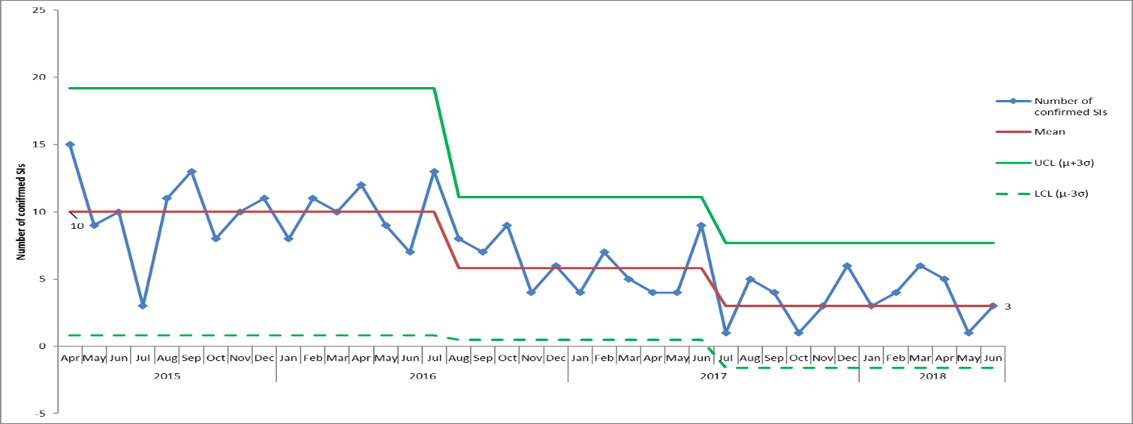Figure 7. Monthly numbers of confirmed serious incidents, based on date of incident, April 2015 – June 2018

The overall themes and learning from the serious incidents reviewed are:
- Challenges continue with staffing levels, use of temporary staff and transfer of patients between care co-ordinators where staff turnover is high. This continues to have a negative impact on the quality and continuity of care for patients and the morale of permanent staff.
- Variable completeness and standards of documentation for example- assessments, MEWS, care plans.
- Essential checks are not always completed fully and in line with trust polices for example inpatient environmental checks.
- Physical health care needs should be more routinely reviewed and monitored on mental health care settings
- Permission to share appropriate information with family and carers is not sought frequently and is often not clearly documented

The Trust has had three confirmed ‘never events’ in the last 12 months, detailed below with the action being taken;
- 2017/18 - Circumstances surrounding the tragic death of a disabled child at their home in November 2017 who was receiving support from the Children’s Integrated Therapies Service. The combined bedrail, bedframe and mattress dimensions did not comply with Medicines and Healthcare Products Regulatory Agency (MHRA) Safe Use of Bed rails 2013 guidance. SI investigation, CDOP process and coroner’s inquest completed. Action plan shared at the Quality Committee in May 2018. Progress against actions to be shared with the family and Coroner.
- 2018/19 - In August 2018 a member of the salaried dental service by accident extracted the wrong tooth of a child under a GA. The tooth was immediately re-implanted. SI investigated started.
- 2018/19 - In August 2018 a collapsible shower curtain rail on a CAMHS ward did not collapse under weight. We are in liaison with the manufacturer who is supporting the trust to investigate the circumstances and alternative products available. We have issued an external alert to inform other mental health trusts of a likely risk. SI investigation has started.

In July 2018 there was an outbreak of an invasive group A streptococcal infection with a cluster of eight people affected in West Oxfordshire. The similarities across the people was that: all live alone, were over 70 years old, they used different care agencies on a regular basis, they were seen by the same district nursing team, they all have open wounds and they need dressings changed regularly. In total 18-19 OHFT staff were screened and all had negative results for carrying the infection. Two patients have subsequently died at the OUHFT. A review has been started.

6.2 Developments to the SI process
The SI team continues to focus on ways of sharing the learning from SI investigations and sharing local learning from moderate incidents to prevent an SI by attending team reviews, sharing information through the Quality and Risk team bulletin bi-monthly and attending directorate quality meetings. The team has held four listening events from July-Sept 2018 to hear the experiences of staff being involved or on leading an SI investigation, the outcomes will be used to improve the approach and processes for SIs.

Additional processes and training are in place to improve working with patients and families in SI investigation. The SI team has also conducted its own internal audit to review the involvement of families in the conduct of investigation and was able to demonstrate the positive involvement of families in developing the terms of reference and identifying learning from investigations. This internal audit is being repeated in September 2018.

The SI team continue to work on improving how: -
- Families are engaged and involved in investigations.
- Learning is shared across the trust.
- Actions are sustained and their impact assessed in improving the safety and quality of patient care.
- The timeliness of sharing completed investigation reports with patients and families

In July 2016 changes were made to the Ulysses system to enable reporting on whether pressure ulcers were ‘acquired’ in the service of Oxford Health or ‘inherited’ before the patient came into our care.
Serious Incidents are nationally defined as incidents where there were acts or omissions identified in care that resulted in death, lead to abuse or serious harm requiring further treatment

