Report to the Meeting of the
CG 26/18
(Agenda item: 12)

Oxford Health NHS Foundation Trust

Council of Governors

September 5th 2018

Performance Report Q1
(April 2018 – June 2018)

For: Information

Executive Summary

This report provides a consolidated view of the Trusts performance against both national and local (contracted) indicators for April – June 2018 (Q1). A standard scorecard approach is used for all reporting within the Trust and compliance against targets are measured using a RAG rating system. This scoring system enables the performance team and operational services to identify areas for improvement and is supplemented by a narrative to explain any variation to targets and action plans. Performance reporting is presented monthly and scrutinised by various leadership and oversight committees up to and including the Trust Board and Commissioners. See Appendix 1 for a diagram showing the Performance Governance Process.

The Trust has achieved an average of 81% compliance against targeted indicators in April – June 2018 (Q1). A view on performance by Directorate is included as Fig 1. This evidence demonstrates that the Trust is consistently delivering a good performance against contractual targets set by Clinical Commissioning Groups (CCG’s).

In addition to the Trust’s locally contracted commitment, there is also a national requirement to report against targets defined within the NHS Single Oversight Framework. These indicators have been included within the reports provided so that there is a consistent format both within and external to the Trust. Further work to develop the reporting in this area continues.

Fig 1. Compliance against overall contracted targets:

Following the restructure of operational Directorates, this reports shows the new aggregated position so it is not possible to provide a comparison or trend at this time. However, this position will change for the Council of Governors report at the end of Q2.

At an individual Directorate level:
- Oxfordshire, Swindon, Wiltshire & BANES – All Ages Mental Health performance has averaged 75% during Q1 (April – June 2018)
- Buckinghamshire – All Ages Mental Health performance has averaged 88% during Q1 (April – June 2018)
- Oxfordshire Community Services Directorate performance has averaged 76% during Q1 (April – June 2018)
- Specialist Services Directorate performance has averaged 88% during Q1 (April – June 2018)
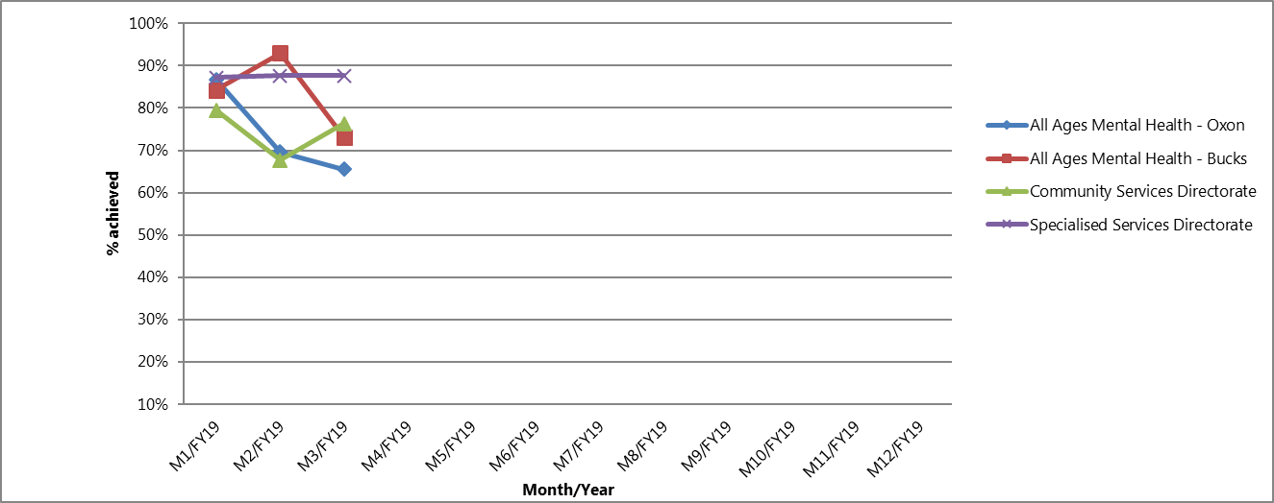

National Position

Following a review of the performance data, the following indicators have been reported to the Operations Management Team and the Trust Board as underperforming against national targets.

- Workforce – The difficulties in recruiting and retaining suitably qualified staff continues to have a direct impact on the Trust’s ability to deliver services. Work to address these issues continues to be led by HR under the Workforce Strategy

- Out of Area Placements (OAP’s) – Due to the pressures in Oxfordshire and Buckinghamshire, OAP’s are well above the targets set by NHSE. This increase has been due to operational pressures in both systems and a lack of alternative of community alternatives

Oxfordshire, Swindon, Wiltshire & BANES – All Ages Mental Health

In looking at the performance trends and identifying areas where further action is required, the following issues have been reported to the Operations Management Team and the Board of Directors:

- Oxfordshire CAMHS – Following the transition to the new model of care and the restructuring of the teams, the work to review and validate data has now been completed and signed off by operational services. Although the Trust is not currently achieving the performance targets as defined by the Oxfordshire CCG, plans are being developed in collaboration with the CCG to address the current issues on a short term basis. Discussions are also underway at an Exec to Exec level with commissioners regarding medium to longer term resolution options.

- Improving Access to Psychological Therapies (IAPT) CBT & Counselling – Ongoing accommodation issues have continued to prevent IAPT services from achieving access targets. Historically, the services have been delivered from GP surgeries, however, with space now being at a premium across the system, further investment will be required so that alternative accommodation can be found. This issue has been escalated to Commissioners and potential solutions are being reviewed.

- Percentage of non-urgent referrals that are assessed within 28 calendar days (Adult Community Mental Health) – Due to a significant increase in referrals and pressure within operational teams, the target for this indicator has been increased to 8 weeks (from 4 weeks). Against the revised target, the Trust has achieved 92% compliance during Q1.

- CAMHS – Swindon, Wiltshire, Bath and North East Somerset. Following the inclusion of the performance data in the monthly Board report, there are a number of indicators that are underperforming and require further investigation. A review is now underway and a report will be provided to the Operations Management and Trust Executive in September 2018.

Buckinghamshire – All Ages Mental Health

In looking at the performance trends and identifying areas where further action is required, the following issues have been highlighted and escalated to the Operations Management Team and Trust Board:

- Care Reviews (Adult Community Mental Health) - Analysis of the performance data has shown that timescales for care reviews across the county have continued to be below contracted target during Q1. Service leads continue to work with operational services to improve this position and performance is being closely monitored.

- DNA rates (Bucks CAMHs) – The service has noticed an increase in the DNA rate during the exam period and approaching the school summer holidays

Oxfordshire Community Services Directorate

In looking at the performance trends and identifying areas where further action is required, the following issues have been highlighted and escalated to the Operations Management Team and Trust Board:

- The Out of Hours (OOH) Services. Services remain under pressure but only 1 of the 9 indicators were below the exception reporting threshold at the end of Q1 (unfilled clinical shifts). The service continues to ensure that every patient is safe whilst under OOH care and work to improve performance continues. The OOH service has developed a smaller number of more appropriate indicators which will be reported on at the end of Q2.

- Physical Disabilities Physiotherapy Service (PDPS). A business case has been submitted to the CCG and is awaiting approval, however, the CCG are in the process of reviewing the full pathway. Whilst this is underway the CCG has agreed to suspend performance targets.

- Stroke Therapies – Workforce pressures continue to affect the Trust’s ability to achieve the targets throughout Q1 particularly in relation to speech and language therapy. Actions have already been taken to maximise the available appointments and this position will continue to be monitored closely.

- Continuing Care – a 30% increase in referrals in May impacted on existing resources to be able to undertake work in a timely manner. The review element of the work was impacted due to prioritising new referrals who may be in the discharge pathway from an acute setting or at home without care. The 3-month reviews were given priority above the yearly as no longer eligible for CHC is more likely at this point which would have a positive impact on the work flow and financial risk going forward.

Specialist Services Directorate

In looking at the performance trends and identifying areas where further action is required, the following issues have been highlighted to the Operations Management Team and Trust Board:

- Learning Disabilities – work continues to move from manual reporting for this service. The CCG continue to receive weekly updates from the service re: data accuracy/collation. The position in terms of data and performance has improved and work continues with services to develop further.

- Dental activity – activity will vary month on month, and will not show a true level of activity until the final episode of care is complete. Monthly breaches are reported for board purposes only and are not a cause for concern to NHSE commissioners, as targets will be met by year end.

Governance Route/Approval Process
This is a quarterly update report.

Recommendation
The Council of Governors is invited to note the report.

Author and Title: Claire Page, Head of Performance and Information
Lead Executive Director: Martyn Ward, Director of Strategy & Performance

Appendix 1 – Performance Reporting Structure

