BOD 125/2018
(Agenda item: 5)

Report to the Meeting of the

Oxford Health NHS Foundation Trust

Board of Directors

31st October 2018

Monthly Performance Report – M6 September 2018

For: Information

Executive Summary

The monthly performance report provides an overall view of the Trust’s performance against both national and locally contracted targets. Although the Trust is required to report against 2136 commissioner defined indicators at month 6, only 423 actually had specific targets.

Of those 423 targeted indicators (KPI – Key Performance Indicators), the Trust achieved 315. An overall performance of 74% which is consistent with M4 (July) but a decline from the 77% achieved in Month 3 (June). There are a number of reasons for this position including a shortage of available workforce, a change in the number of targeted indicators (which changes the baseline) and factors such as some indicators only being reported on a bi-monthly or quarterly basis.

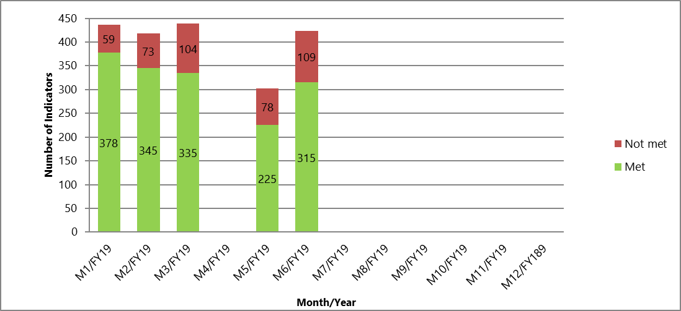

The work to reduce the overhead associated with the management of performance indicators continues with support from commissioners. A change in reporting approach for Oxfordshire Community Services has been agreed during the winter period to improve efficiency and reduce the burden on operational services. Further detail will be reported on these changes over the next few months.

Performance Trends:

National Position:

Following improvements within NHS Digital and the data submitted by the Trust, the information held nationally is more up to date in a number of areas.

After reviewing the data, the following indicators continue to be highlighted as underperforming at a national level.

- Workforce – The difficulties in recruiting and retaining suitably qualified staff continue to have a direct impact on the Trust’s ability to deliver services. However, figures recently published in August continue to show improvement with the Trust now at the best reported position this year. 13.76% against a 12% target.

The additional indicators currently being reported as exceptions are currently being worked on as part of a broader piece to update the national data sets with NHS Digital.

S75 Agreements with Oxfordshire County Council and Buckinghamshire County Councils

The Trust achieved 87% compliance against the indicators for the Oxfordshire S75 agreement in August 2018. Reports are one month in arrears.

The Trust was not required to report performance for Buckinghamshire County Council in M6 as performance is reported on a quarterly basis.

Oxfordshire, Swindon, Wiltshire & BANES – All Ages Mental Health

The Directorate achieved 69 of the 111 (62%) targeted indicators for September which is decrease in performance from the 66% reported for August.

Out of Area Placements (OAPs) in Oxfordshire continue to expose the Trust to significant financial risk and actions are being taken to address this issue as a priority. Figures are shown in Fig 1.

Fig. 1 – Out of Area Placements (FY 2019)

Quarter FY18/19 | Target | Actual | Variance
Quarter 1 | 302 | 388 | +86
Quarter 2 | 268 | 442 | +174

Particular areas that are highlighted to the Board are:

- Cluster Reviews – Following a discussion with the Trust Clinical Directors, there is limited clinical value in having a targeted performance indicator for cluster reviews. The clinical risk has been assessed as very low, however, the value of clustering has been recognised in terms of an operational/activity based measure. This issue has been referred for a clinical discussion with commissioners and then any changes formally approved at the monthly Quality Review Meeting.

- Adult Community Mental Health Teams – Due to long term under investment in mental health in Oxfordshire, the Trust is not able to achieve the 4 week waiting time target for referrals categorised as routine. The Trust notified the Clinical Commissioning Group (CCG) in the summer of 2018 and the target was changed to 8 weeks. Against the revised target, the Trust is now achieving consistently above 85% of patients seen and assessed.

- Letter Production – The Trust is required to provide letters to GPs and patients within commissioner specified timescales. Due to a lack of admin capacity, the Trust has not been able to produce and send the required letters within the contracted timescales. Steps have been taken to mitigate the clinical risk by providing advance summaries, however, further work is underway to reduce the time taken to produce the letters and improve overall efficiency (e.g. through digital dictation and electronic transfer of records). Currently the target is a 10 day response window, however, this will reduce to 7 days in line with the Standard Contract which will further impact on performance.

- Oxfordshire CAMHS – Routine 12 Week Wait – Due to a high demand for services and a shortage of workforce, the Trust is unable to meet the waiting time targets for routine referrals. Demand exceeds available capacity and work is underway with commissioners and internally with the Trust to tackle this issue. At the present time, it is not possible to say exactly when the backlog that has developed will be cleared without confirmation of non-recurrent investment to clear the backlog alongside recurrent investment to ensure the service has sufficient capacity to meet demand going forward.

- Swindon, Wiltshire, Bath & North East Somerset (SWB) CAMHS – The Trust is not achieving a number of waiting time targets for CAMHS in SWB. Service managers are reviewing work plans and with the recruitment of some new staff, performance is forecast to improve over the next few months. Performance is being monitored closely by the Directorate Senior Management Team and the Operations Management Team.

Buckinghamshire – All Ages Mental Health

The Directorate achieved 32 of the 47 (68%) targeted indicators in September which is a decrease in performance from the 72% reported in August.

Out of Area Placements (OAPs) in Buckinghamshire continue to expose the Trust to significant financial risk and actions are being taken to address this issue as a priority. Figures are shown in Fig 2.

Fig. 2 – Out of Area Placements (FY 2019)

Quarter FY18/19 | Target | Actual | Variance
Quarter 1 | 281 | 452 | 171
Quarter 2 | 249 | 494 | 245

Particular areas highlighted to the Board are:

- Urgent Referrals (7 day) – The Trust has consistently breached the target set for urgent referrals since April 2018. This has been for a variety of reasons including a lack of workforce, patient choice and patient availability. Reasons for breach are being reported on a regular basis and services are working to improve this position.

- Care Reviews (Adults and Older People) - Analysis of the performance data has shown that timescales for care reviews specifically in Aylesbury continue to be below target. Meetings to review the suitability of the indicator and to assess options have been scheduled for October and will be reported on in the November Board report.

- Memory Services – Although there has been a shortage of staff due to annual leave, performance has been in gradual decline since the start of the reporting year. Services are aware of the issue and it would appear that teams in the south of the county are most affected. Workshops are planned to understand what the issues are and to plan for recovery.

- Did not attend (DNA) – There has been an increase in DNAs in three of the major service pathways in CAMHS since the start of the year. Further work is underway to remind patients and families (e.g. using technology) to let services know if they are unable to attend appointments.

Oxfordshire Community Services Directorate

The Directorate achieved 96 of the 135 (71%) targeted indicators in September. This is a decline in the performance reported in August.

Looking at the overall position, there has been a noticeable shift in breach pattern with Oxfordshire Continuing Healthcare now being the primary source of underperformance in the Directorate. This is principally due to the increasing demand seen consistently since the start of the year.

Particular areas that are highlighted to the Board are:

- Nutrition and Dietetics – Due to a shortage of available workforce, the Nutrition and Dietetics service has not achieved 3 of their monthly contracted targets. Actions to mitigate any risks to patients and to improve the position has been taken and performance will now be closely monitored.

- Looked After Children (LAC) Assessments – A combination of children being transferred out of county (4 of 7) and a shortage of workforce resulted in a breach of the reporting indicator. Health Visiting Teams have been reminded that LAC assessments are a priority and performance is being monitored by local managers and the LAC Team.

- School Health Nursing – A number of indicators breached performance targets over the summer months due to a combination of staffing pressures, vacancy factor and the unavailability of patients.

- Continuing Health Care (CHC) – Referrals into the Oxfordshire CHC service continue to increase and there is insufficient capacity in the service to meet demand. The service is prioritising referrals based on need and work to produce a suitable business case for additional resource is being developed.

Specialist Services Directorate

The Directorate achieved 118 of the 130 (91%) targeted indicators in August. There was only one breach of target greater than 10% so a very good performance overall.

Out of Area Placements (OAPs) in the Learning Disabilities Service are performing well against the plan. Figures are shown in Fig 3.

Fig. 3 – Out of Area Placements (FY 2019)

Quarter FY18/19 | Target | Actual | Variance
Quarter 1 | Ceiling target of 9 | 3 | -6
Quarter 2 | Ceiling target of 9 | 4 | -5

Recommendation

The Board of Directors is asked to review and note the monthly Board performance report.

Author and Title: Martyn Ward – Director of Strategy & Chief Information Officer

