

# Report to the Meeting of the

# Oxford Health NHS Foundation Trust

# Board of Directors

# 31st October 2018

# INPATIENT SAFER STAFFING Report Period 13th August to 9th September 2018

**For: Information**

**Executive Summary**

**Ward Staffing**

The purpose of this paper is to provide a report of the actual inpatient staffing levels to the Board of Directors. There is a national requirement on providers to be transparent in our monitoring and reporting of inpatient staffing levels and the impact on patient care. Ensuring sufficient staffing levels are in place is crucial to deliver safe, effective and high quality care. This report will be published on our website with a link from NHS Choices website.

The data within the report will outline the staffing levels (for both registered and unregistered nursing staff) on each ward. These figures will be measured against the required figures on a shift by shift basis for the 4 week period 13th August to 9th September 2018.

During this period:

Average weekly day shifts fill rates for registered staff & unregistered staff were above the Trust target of 85% with 89% or above for unregistered and 92% or above for registered staff, slight decrease from 93% last period. Eleven wards were below 85% target for average weekly fill rates for registered nurse day shifts during this period. An increase from six wards in the previous reporting period.

Average weekly night shifts fill rates for registered and unregistered were above the Trust target of 85% with the average lowest fill rate at 92% for unregistered staff and above 100% for registered staff.

The methods of filling these shifts includes substantive, flexible workers and agency registered staff and further detail in provided later in the report.

The Trust moved to a new approach to reduce the use of unregistered agency staff in the week of 14.5.18. Further detail of this project is provided in the HR workforce report and commented on in relation to changes in skill mix ratios.

The average weekly % agency use was 10.4% a slight decrease from 10.85% in the September report with a peak of 11.2% in the week 20.08.18.

Average sickness rates for ward staff were increased to 5.4% increased from 4.67% average last month.

The paper will provide information in relation to:

* Maintaining safe staffing
* NHSI safer staffing resources for urgent and emergency care services

**Recommendations**

The Board is asked to note:

* There are processes in place to ensure safe staffing levels on all the wards in the organisation, those wards where there are concerns and the actions being taken to ensure safe staffing including project work and wider recruitment and retention work. There are no exceptions to report that directly link actual staffing levels to adverse outcomes for patients which have been identified through our Governance Structures.

**Author and Title:** Kate Riddle, Deputy Director of Nursing and Clinical Standards

**Lead Executive Director:** Ros Alstead, Director of Nursing and Clinical Standards

*A risk assessment has been undertaken around the legal issues that this paper presents and there are no issues that need to be referred to the Trust Solicitors. This paper links to all the five CQC Domains.*

***Strategic Objectives*** *– this report relates to or provides assurance and evidence against the following Strategic Objective(s) of the Trust*

*Driving Quality Improvement (Goals: patients will be safe from harm; patients will achieve the clinical outcomes they want; and patients and carers will have an excellent experience)*

*Delivering Operational Excellence (Goals: our services will be effective and efficient; information will be translated into knowledge; and our planned surplus will be delivered)*

**Inpatient Safer Staffing**

Period 13th August to 9th September 2018.

**Introduction**

This is the report to the Board of Directors outlining the staffing levels (registered and unregistered) on each ward against their required need on a shift by shift basis. This report covers the four week period 13th August to 9th September 2018.

In addition, there is information covering:

• Maintaining safe staffing

• NHSI safer staffing resources for urgent and emergency care services

This report will focus on the percentage of day and night fill rates for registered and unregistered staff. This data is reported to NHSI and provides assurance of actual clinical staffing numbers being achieved. This report will be published on our website with a link from NHS Choices website.

**Management of Staffing Levels**

Anescalation process for the management of staff shortages is in place within each clinical area, to manage staffing safely on a shift by shift basis. As part of this process, senior clinical staff are providing appropriate support to ward teams as and when required. In addition, senior ward staff and immediate team managers review ward staffing levels on an on-going basis; shift by shift basis, and where there are changes in patient acuity. Ward Matrons review staffing daily as a minimum and more frequently where required.

In-patient staffing levels continue to be reported every week and discussed within the Weekly Review Meeting (WRM), which takes place each Monday morning with the Director of Nursing and or Deputy present.

To ensure that staffing levels are under continual review, every ward undertakes a range of immediate actions daily to ensure safe staffing levels are maintained appropriate to the needs of patients. These actions include booking staff via staffing solutions via bank or agency, revising rotas, moving staff between wards and utilising additional staff that are not included in the ward numbers as required for example modern matrons.

**Summary position of inpatients wards staffing levels.**

Appendix 1 shows the staffing levels for all wards by ward for the four week period 13th August to 9th September 2018. The data presented includes details of staffing by shifts and details of skill mix, agency, ward staff sickness and ward vacancy figures. The thresholds presented in the table are measured against trust/ national targets and used to highlight particular wards for further review.

During this period:

Trust average weekly day shifts fill rates for registered staff & unregistered staff were above the Trust target of 85% with 89% or above for unregistered and 92% or above for registered staff, a slight decrease from 93% last period.

Eleven wards were below 85% target for average weekly fill rates for registered nurse day shifts during this period. An increase from six wards in the previous reporting period.

Average weekly night shifts fill rates for registered and unregistered were above the Trust target of 85% with the average lowest fill rate at 92% for unregistered staff and above 100% for registered staff.

The methods of filling these shifts includes substantive, flexible workers and agency registered staff and further detail in provided later in the report.

The Trust moved to a new approach to reduce the use of unregistered agency staff in the week of 14.5.18. Further detail of this project is provided in the HR workforce report and commented on in relation to changes in skill mix ratios.

The average weekly % agency use was 10.4% a slight decrease from 10.85% in the September report with a peak of 11.2% in the week 20.08.18.

Average sickness rates for ward staff were increased to 5.4% increased from 4.67% average last month.

There are processes in place to ensure safe staffing levels on all the wards in the organisation, those wards where there are concerns and the actions being taken to ensure safe staffing including project work and wider recruitment and retention work. There are no exceptions to report that directly link actual staffing levels to adverse outcomes for patients which have been identified through our Governance Structures.

**Day shifts fill rates**

Average weekly day shifts fill rates (all departments) for registered nurse & unregistered staff were above the Trust target of 85% throughout this period. This included a mix of agency, flexible and substantive staff including ward managers and matrons where required to make up staffing numbers and provide safe care.

Eleven wards were below 85% target for average weekly fill rates for registered nurse day shifts during this period. An increase from six wards in the previous reporting period these were:

Allen, Ashurst, Cotswold House Oxford, City, Lambourne House, Opal, Ruby, Sandford, Vaughn Thomas, Wensric and Wintle

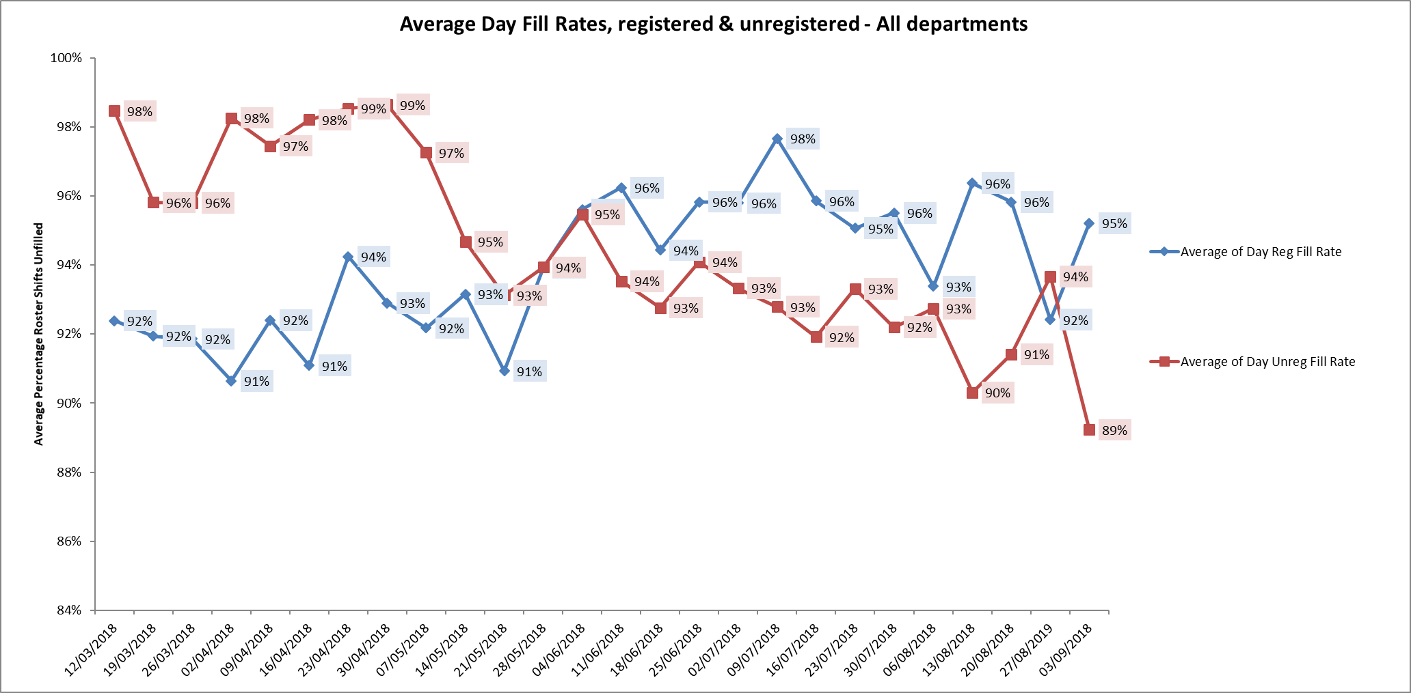

**Night shift fill rates**

Average weekly night shifts fill rates for registered nurse & unregistered staff were above the Trust target of 85% throughout this period. This included a mix of agency, flexible and substantive staff to make up staffing numbers. One ward Glyme was below 85% for registered nurses. The average fill rate was 81% this was mitigated through additional unregistered staff at 129%.

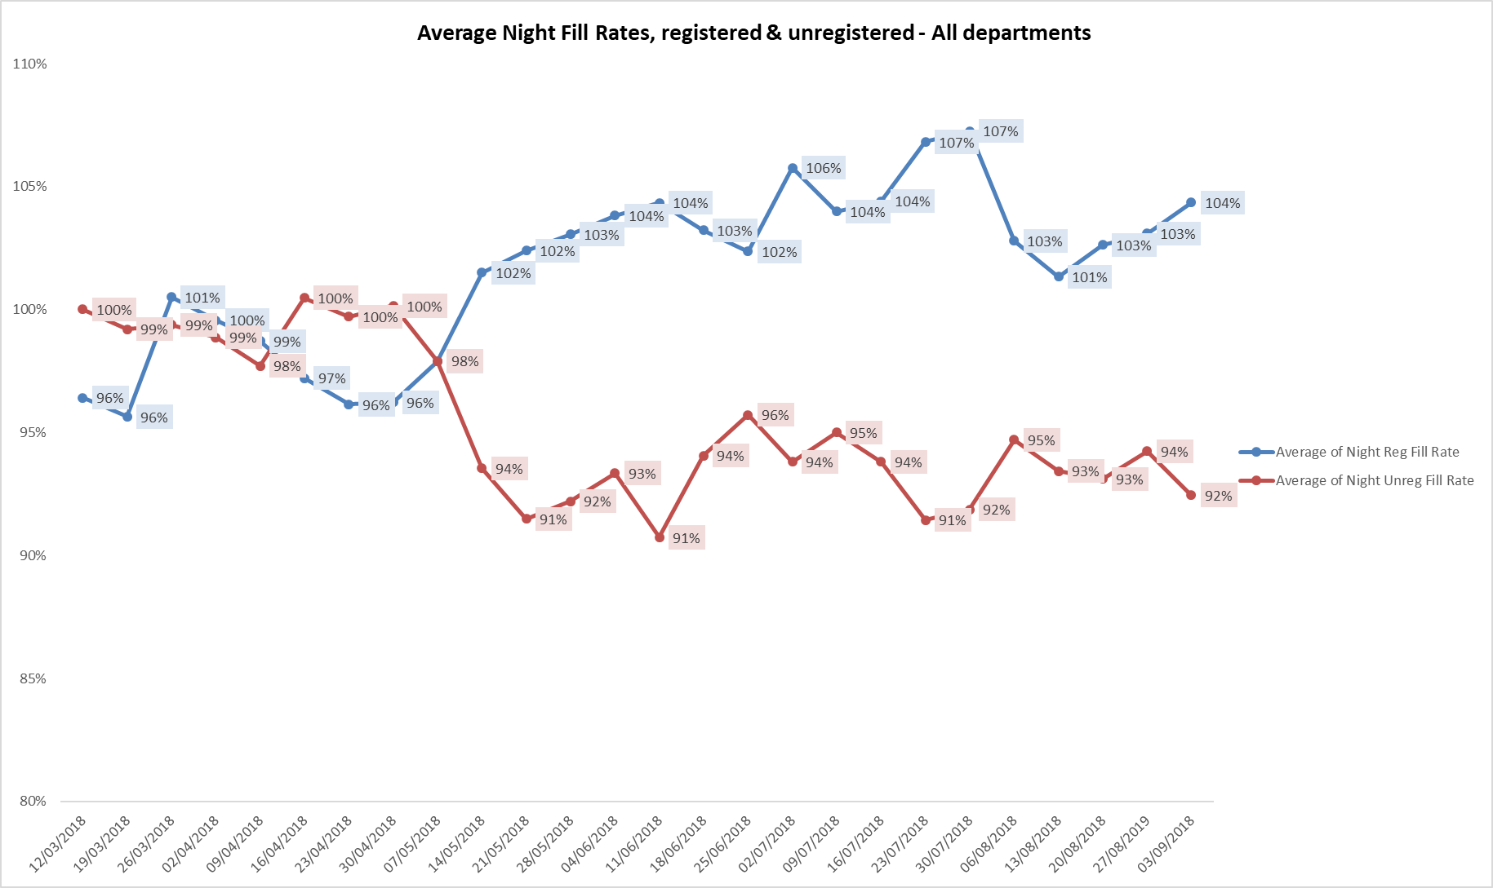

**Registered skill mix**

Thirteen wards had in place an average of 50% or above registered staff skill mix. The level of wards with below 50% registered skill mix is related to the continued registered nurse vacancies. Safe staffing is supported by the ward managers and matrons on the ward working clinically as part of the numbers where required to ensure registered nursing leadership is maintained.

Skill mix is achieved through use of our own staff and trust employed flexible registered workers and agency registered nurses.

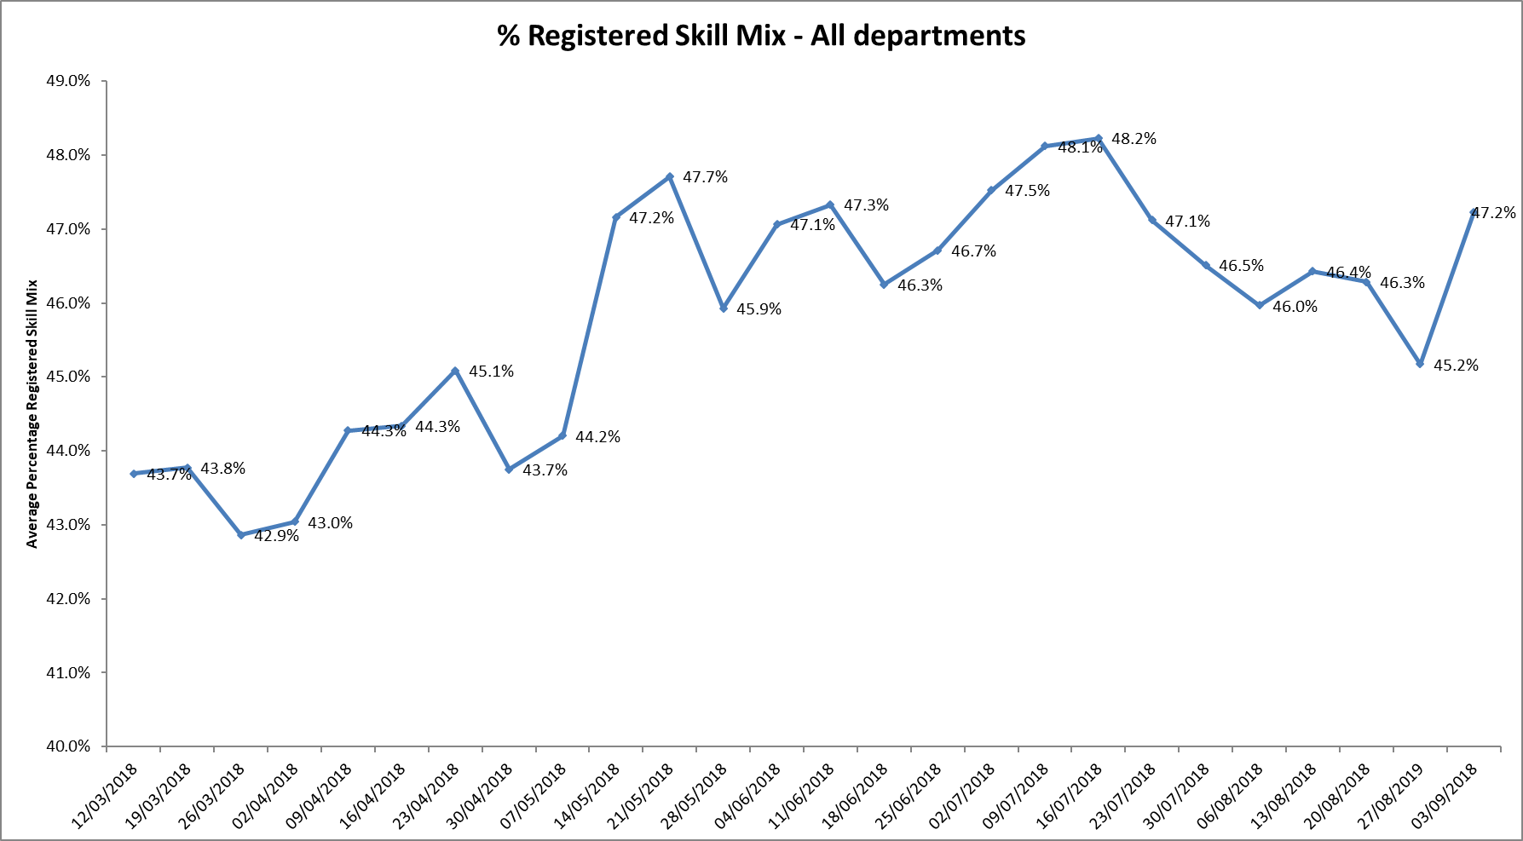

**Agency use**

The average weekly % agency use was 10.4% a slight decrease from 10.85% in the September report with a peak of 11.2% in the week 20.08.18.

Further detail of agency use is provided in the Workforce report. The reduction in agency use continues from peak of 19.1% in February 2018. This is related to continued vacancies and patient acuity.

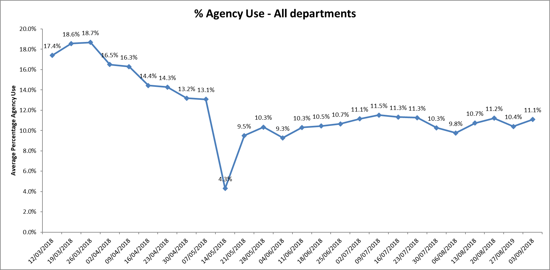

Twenty two wards required 5-25% agency staff.

One ward Allen ward required above 25% agency staff in the period,

Ten wards were below trust target of 5% in this period.

Community Adults

Bicester

Linfoot

Wenrisc

Adults

Opal

Wintle

Adult Eating Disorders

Cotswold House Marlborough

Forensics

Chaffron

Lambourne House

Watling

Woodlands

**Maintaining Safer Staffing, including update on recruitment:**

Community Hospitals

All eight wards: Abbey ward & Stroke Rehabilitation Unit (OSRU) at Abingdon, Bicester, City, Didcot, Linfoot, Wenrisc and Wallingford maintained above average 50% skill mix for this period.

Bed numbers have been at Bicester and OSRU reduced to manage safer staffing in the context of vacancies as outlined below:

|  |  |  |  |  |
| --- | --- | --- | --- | --- |
| **Ward** | **Established bed numbers** | **Current bed numbers with Winter beds** | **Band 5 Vacancy**  **WTE** | **HCA Vacancy WTE** |
| **Abbey Ward** | 18 | 18 (including 4 for OSRU) | 3.89 (1.8 waiting to start) | 2.02 |
| **OSRU** | 20 | 12 | 5.9  To staff at 20 beds  **10** | 1.0  To staff at 20 beds  **4** |
| **Bicester** | 12 | 12 | 1.0 |  |
| **City** | 16 | 12 | 6.31 | 1.8 |
| **Didcot** | 16 | 16(+2) | 4.59 | 1.0 |
| **Wallingford** | 18 | 18 (+4) | 2.96  (1 waiting to start) | 0.63 |
| **Linfoot** | 20 | 18 (+4) | 1.13 | 2.6 |
| **Wenrisc** | 20 | 18 (+4) | 3.4 | 1.77 |

City ward has experienced low fill rates for registered nurse day shifts since July 2018 as outlined below, there remains 6.31WTE registered nurse vacancies and the ward is operating on reduced bed numbers to 12 from 20 to support safe staffing levels being maintained. There are additional unregistered staff in place and two Nursing Associates and 3rd Year students.

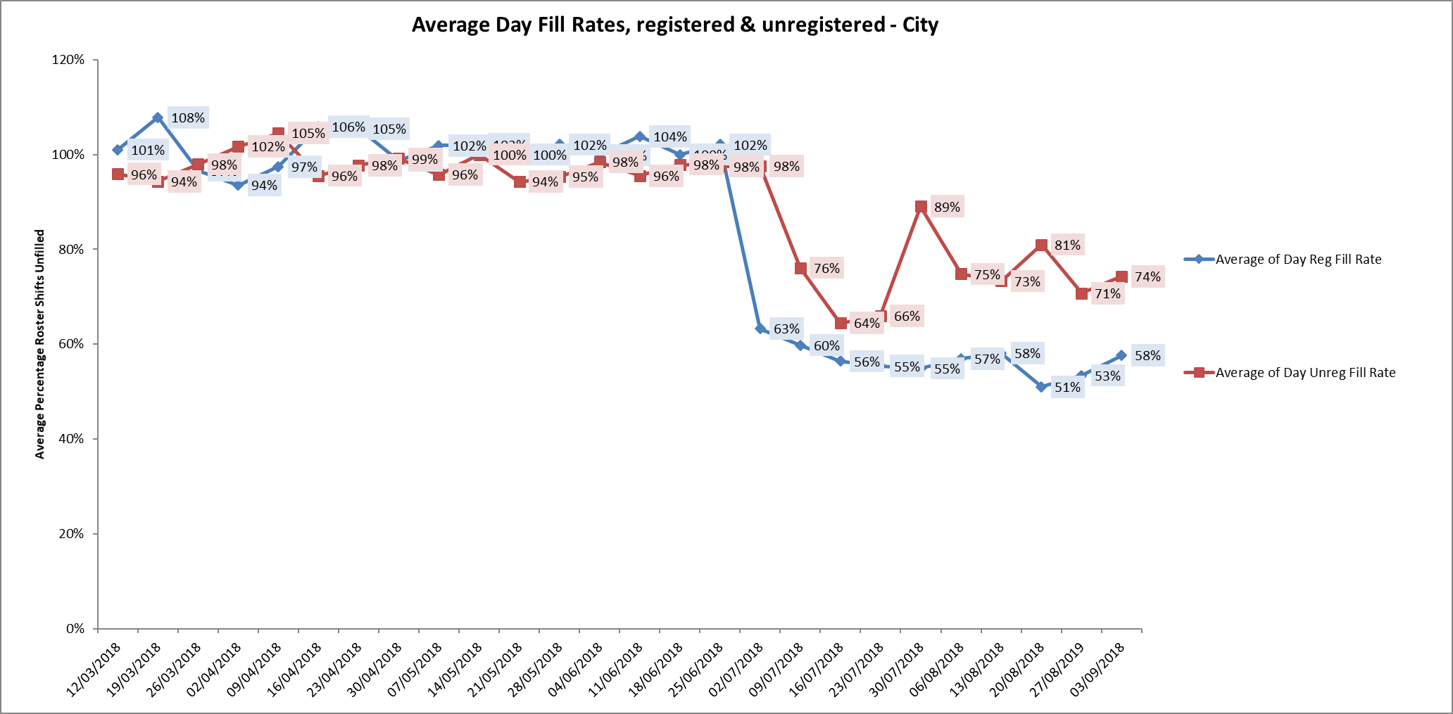

Children and young peoples and adult eating disorders

Cotswold House Oxford 57% slight decrease from September but the Matron is managing staffing with increased bank or substantive HCAs where possible (average 115%) to maintain staffing continuity for the patients.

Adult wards

Allen, Opal and Wintle average day shift fill rates for registered staff decreased from September but all three wards had above 85% of unregistered staff.

Ashurst

The fill rates for registered nurses fluctuated during this four week period from 66%, 93%,71% and70% respectively. The ward has continued vacancies, to support safe staffing the ward is now operating as male only and longline agency staffing is in place. Twice daily conference calls for the adult wards are in place to support staffing across the wards when shifts cannot be filled with registered staff. Support is in place from Phoenix ward which is co-located on the same site.

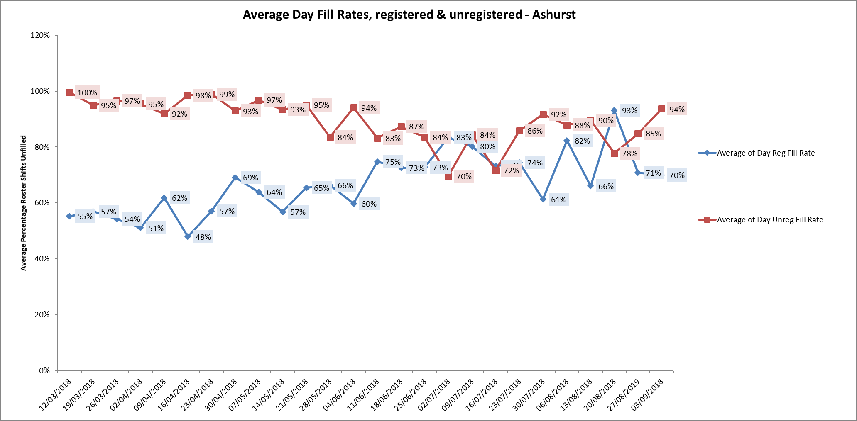

Vaughan Thomas 74% and Ruby 79% a slight increase in fill rates from the September report. Both wards were above 100% for unregistered staff to support overall staffing.

Older Adult wards

Cherwell and Sandford maintained above 50% skill mix for the whole period.

Amber Ward was at 49.5% increased from 45% last month.

Sandford showed a decrease to 77% registered nurse dayshift fill rates from previous improvement of 84% last month.

**Forensic wards**

All ten wards continued to be below average 50% skill mix registered nursing during this last period.

As reported last month vacancies continue to be high.

Kennet ward registered nurse skill mix data continues to have the lowest the average skill mix 31% of all wards across the Trust. There has been recruitment to two band five posts who are newly qualified who started in September this leaves 5.7 WTE Band 5 vacancies against establishment of 10.92 WTE

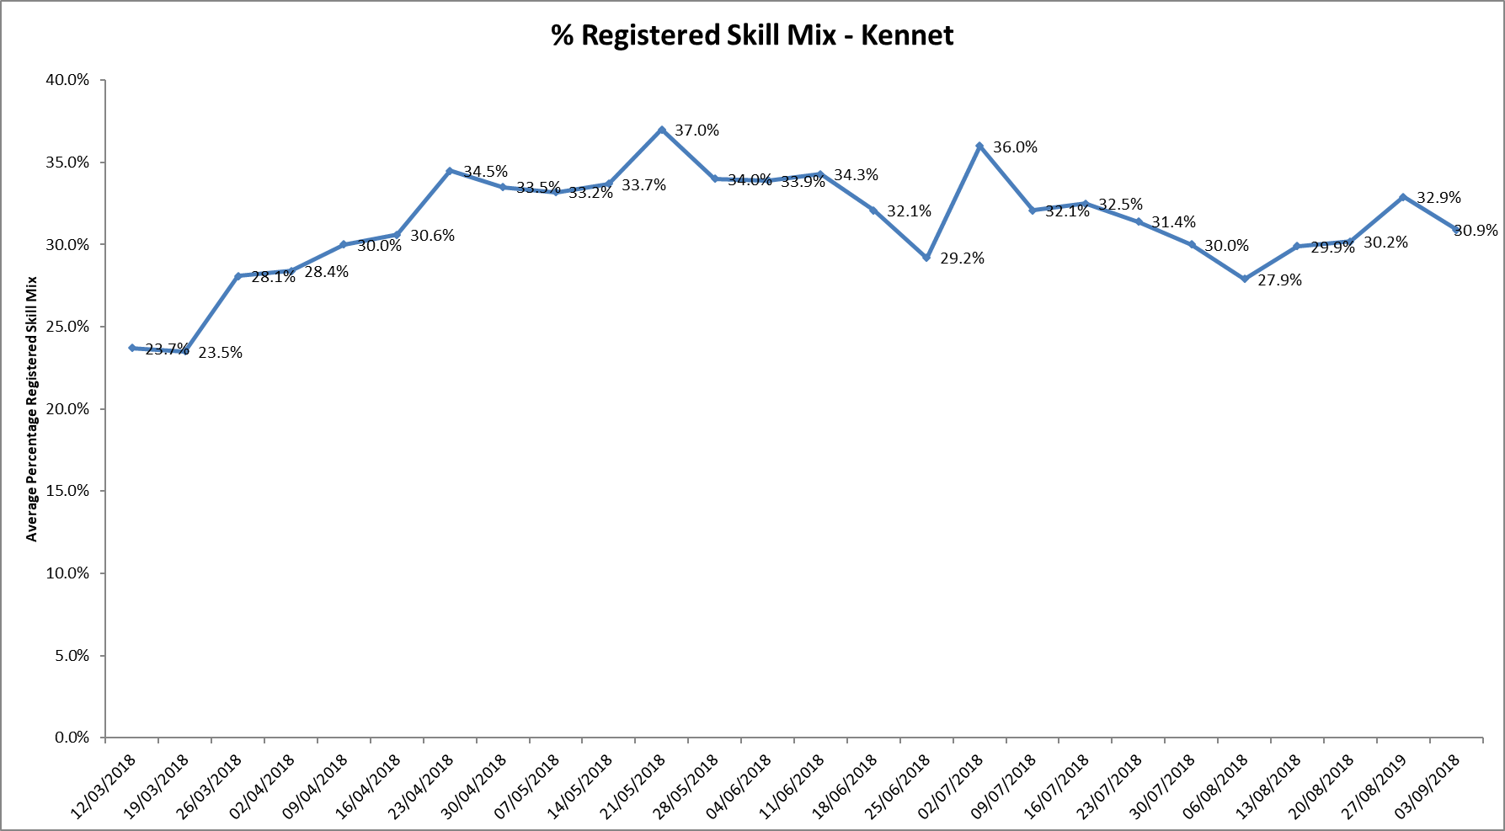

Fill rates were above 89% for both registered and unregistered staff.

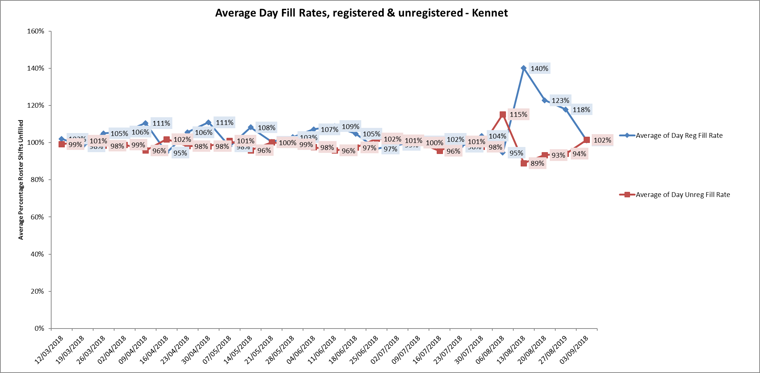

A research approved Resilience programme has been running as a pilot within Forensic Services for Band 5 & 6 Nurses, which will help to inform the Trust with an ongoing strategy of support for our staff. Four cohorts are being currently delivered of a 6 Session Programme and during the 12 week programme, the Mentees are supported by Senior Nurse volunteers, Band 8 and above from outside of their Directorate

Cohorts 1 and 2 have been received well and are currently being evaluated the positive impact this has had upon attendees.

**Evenlode**

Agency use during this period is related to continued levels of patient acuity and sickness rates have impacted on need for agency use. Longlines are in place to maintain staffing consisitency for patient care One patient required an alternative placement and this was esclated with NHSE.. The patient was able to move to the alternative placement in the week of the 17/09/18. Sickness rates have decreased in the last week of the reproting period.

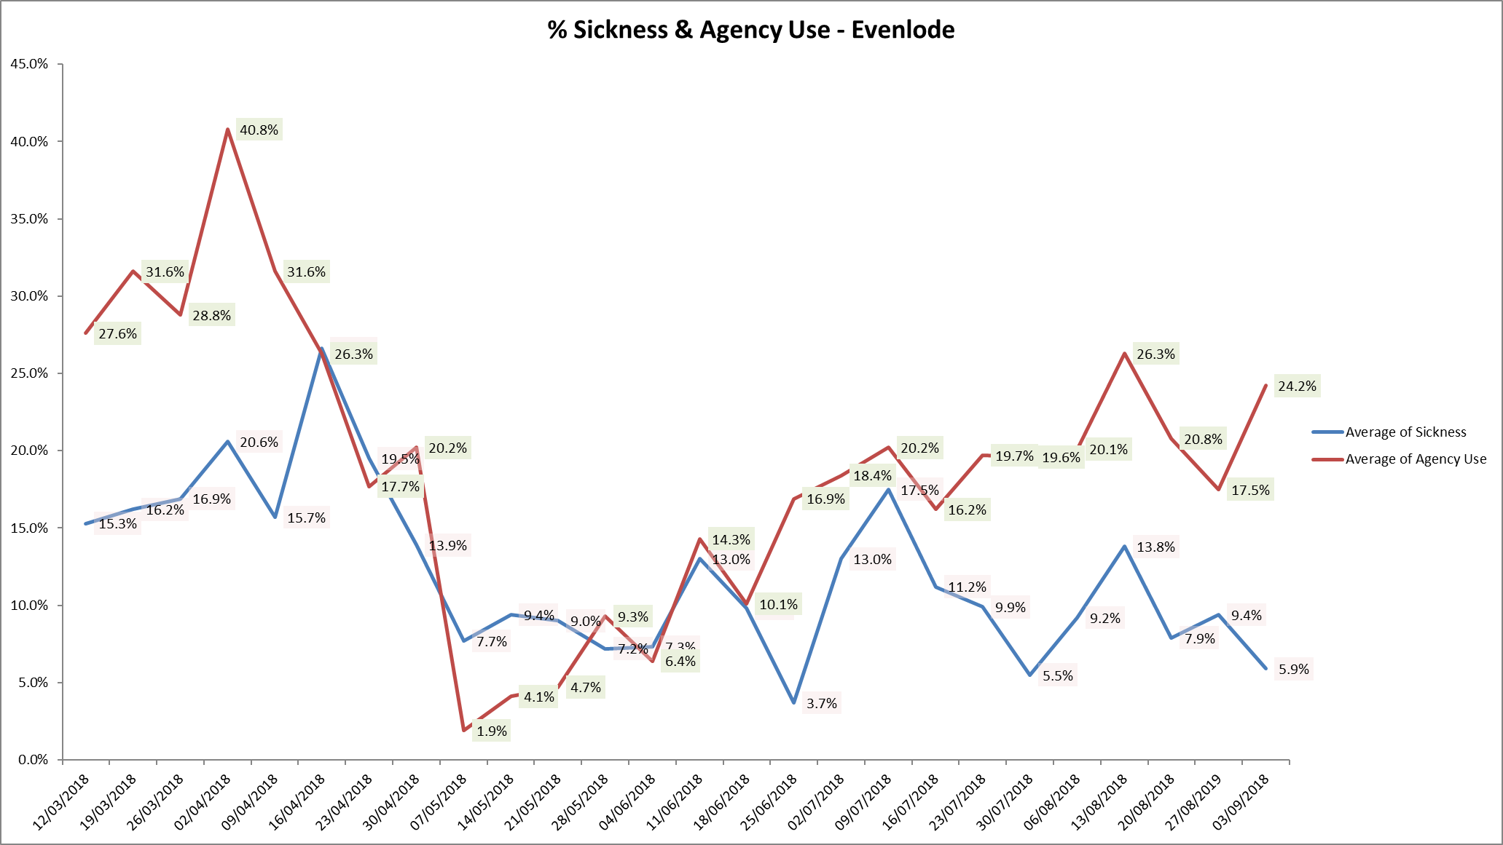

**NHSI safer staffing resources for urgent and emergency care services**

The urgent and Ambulatory Carer service have reviewed the new NHSI safer staffing improvement resource for urgent and emergency care services (June 2018) with the application of the recommendations being primarily reviewed against the Minor injury and first aid units. A further review will be progressed against Emergency Medical Units and Hospital at home over the next months. there is an ongoing review of the OOHs services and were applicable the MIU review will take improvement resource into account. Going forward a workforce planning project will be moved forward for the MIU/FAU services.

**Conclusion**

All ward staff and managers continue to make every effort to ensure wards continue to be staffed safely, fill rates remain high for most wards and that we continue to focus efforts on retaining our staff whilst recruiting new nurses to join Oxford Health FT. Skill mix review work as reported last month will be progressed to include Nurse associates and other roles.

