BOD 137/2018
(Agenda item: 6)

Report to the Meeting of the

Oxford Health NHS Foundation Trust

Board of Directors

30th November 2018

Monthly Performance Report – M7 October 2018

For: Information

Executive Summary

The monthly performance report provides an overall view of the Trust’s performance against both national and locally contracted targets. Although the Trust is required to report against 2137 commissioner defined indicators at month 7, only 305 actually had specific targets.

Of those 305 targeted indicators (KPI – Key Performance Indicators), the Trust achieved 222. An overall performance of 73% which is slight decrease from the 74% reported in October. There are a number of reasons for this position including a shortage of available workforce, a change in the number of targeted indicators (which changes the baseline) and factors such as some indicators only being reported on a bi-monthly or quarterly basis.

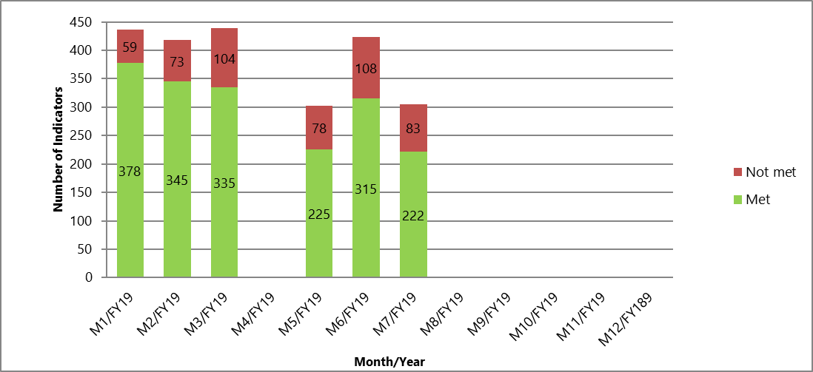

The work to reduce the overhead associated with the management of performance indicators continues with support from commissioners. A change in reporting approach for Oxfordshire Community Services has been agreed during the winter period to improve efficiency and reduce the burden on operational services. Further detail will be reported on these changes over the next few months.

Performance Trends:

National Position:

Following improvements within NHS Digital and the data submitted by the Trust, the information held nationally is more up to date in a number of areas.

After reviewing the data, the following indicators continue to be highlighted as underperforming at a national level.

- Workforce – The difficulties in recruiting and retaining suitably qualified staff continue to have a direct impact on the Trust’s ability to deliver services. However, figures recently published in October continue to show improvement with the Trust at the best reported position this year. 13.68% against a 12% target.

The additional indicators currently being reported as exceptions are currently being worked on as part of a broader piece to update the national data sets with NHS Digital and an improvement has been seen in October 2018.

S75 Agreements with Oxfordshire County Council and Buckinghamshire County Councils

The Trust achieved 100% compliance against the indicators for the Oxfordshire S75 agreement in September 2018. Reports are one month in arrears.

The Trust was not required to report performance for Buckinghamshire County Council in M7 as performance is reported on a quarterly basis.

Oxfordshire, Swindon, Wiltshire & BANES – All Ages Mental Health

The Directorate achieved 76 of the 117 (65%) targeted indicators for October which is an improvement from the 62% reported for September.

Out of Area Placements (OAPs) in Oxfordshire continue to expose the Trust to significant financial risk and actions are being taken to address this issue as a priority.

In October, there were 19 OAPs in Oxfordshire. This is an increase from September when there were 5.

Particular areas that are highlighted to the Board are:

- Cluster Reviews – Following a clinical discussion, cluster reviews are still of value, however, there is still a question about the value of a timescale. The Trust’s Information Management and Technology Team (IM&T) are currently developing a solution that will enable clinical staff to be notified when patients are due a review which will help the Trust to improve its performance against this target.

- Non-urgent waiting times for Adult Mental Health – The revised target continues to be 8 weeks (a change from 4 weeks) which the Trust is now consistently achieving. Until further investment is received, it will not be possible to achieve the 4 week waiting time target.

- Letter Production – Continues to be an issue due to a lack of admin capacity. Work is underway to introduce technology solutions to improve this position and reduce risk.

- Oxfordshire CAMHS – Routine 12 Week Wait – Due to a high demand for services and a shortage of workforce, the Trust remains unable to meet the waiting time targets for those routine referrals not assessed as urgent/emergency. Demand exceeds available capacity and work continues with commissioners and internally within the Trust to tackle this issue. At the present time, it is not possible to say exactly when the backlog that has developed will be cleared but forecasts still suggest early 2019.

- Swindon, Wiltshire, Bath & North East Somerset (SWB) CAMHS – The Trust is not achieving a number of waiting time targets for CAMHS in SWB. This has been due to a large number of vacancies in Salisbury and Melksham. The majority of these vacancies have now been filled but due to a backlog, it will take some time for the services to achieve the required targets. Performance is being monitored closely by the Directorate Senior Management Team and the Operations Management Team.

Buckinghamshire – All Ages Mental Health

The Directorate achieved 30 of the 47 (64%) targeted indicators in October which is a decrease in performance from the 67% reported in September.

Out of Area Placements (OAPs) in Buckinghamshire continue to expose the Trust to significant financial risk and actions are being taken to address this issue as a priority.

In October, there were 9 OAPs in Buckinghamshire. This is an increase from September when there were 5.

Particular areas highlighted to the Board are:

- Urgent Referrals (7 day) – The Trust has consistently breached the target set for urgent referrals since April 2018. This has been for a variety of reasons including a lack of workforce, patient choice and patient availability. Reasons for breach are being reported on a regular basis and services are working to improve this position.

- Care Reviews (Adults and Older People) – As with the solution for the cluster reviews, the Trust’s Information Management and Technology Team (IM&T) are currently developing a solution that will enable clinical staff to be notified when patients are due a care review which will help the Trust to improve its performance against this target.

- Memory Services – Following the recruitment of two new staff, performance in the Buckinghamshire Memory Service has significantly improved in September. A backlog has developed whilst the service was operating with vacancies but this is expected to clear over time. It is forecast that the target will be achieved in early 2019.

- Did not attend (DNA) – There has been a slight improvement in DNA rates in Buckinghamshire with a number of indicators moving from exception (red) to the amber category. Performance will continue to be monitored closely by Directorate Service Managers.

Oxfordshire Community Services Directorate

The Directorate achieved 52 of the 71 (73%) targeted indicators in October. This is an improvement in the performance reported in September.

It should also be noted that with support from Oxfordshire CCG, the number of targeted indicators has been significantly reduced. It has been agreed that over the winter period, to reduce the reporting overheads, only indicators that have clinical value will be reported on. The reduction represents approximately 40% which has been welcomed.

Looking at the overall position, there has been a noticeable shift in breach pattern with Oxfordshire Continuing Healthcare now being the primary source of underperformance in the Directorate. This is principally due to the increasing demand seen consistently since the start of the year.

Particular areas that are highlighted to the Board are:

- Falls Service – Although this is considered a preventative service and therefore no patients are at direct risk, there is still a significant demand vs capacity issue. Where risks are identified, a referral process is in place which signposts clients back to their GP or an appropriate service. Further investment will be required to achieve the targets set by commissioners for this service.

- Continuing Health Care (CHC) – Referrals into the Oxfordshire CHC continue to increase and there is insufficient capacity in the service to meet demand. Due to the significant pressures that have built up on the service, the Performance Team will arrange a review with the service and commissioners and agree an appropriate action plan.

Specialist Services Directorate

The Directorate achieved 64 of the 70 (91%) targeted indicators in October. There was only one breach of target greater than 10% so a very good performance overall.

Recommendation

The Board of Directors is asked to review and note the monthly Board performance report.

Author and Title: Martyn Ward – Director of Strategy & Chief Information Officer

