

**Report to the Meeting of the**

**BOD 140/2018**  
(Agenda item: 9)

**Oxford Health NHS Foundation Trust**

**Board of Directors**

**30 November 2018**

# Quarterly Patient Experience & Involvement Report

**For: Information**

**Executive Summary**

This report provides an overview on the feedback received from patients and carers and the work to improve people’s experiences, as well as their involvement in service developments. The collection and use of patient, carer and family feedback continues to increase with over 8,000 survey responses in 2018/19 quarters one & two combined. The majority of feedback is positive, 91% of people would recommend the service and care was rated 4.72 out of 5, however we are striving so that everyone receives a positive experience and patients are involved in every decision about their care and service changes. The number of complaints received is similar to last year, however the number of concerns resolved locally has increased as more time is put into this area.

The feedback and complaints received identify a theme for improvement around communication and sharing information with patients and their families to enable joint decision making and involvement in care. We continue to strive to involve patients and their families in the quality improvement work we do and incorporate the patient voice into service design. The patient experience strategy is currently under review and work is underway to refresh and refocus its objectives from April 2019.

**Recommendation**

To note.

**Author and Title:** Donna Mackenzie - Brown, Patient Experience and Involvement Manager

Jane Kershaw, Head of Quality Governance

**Lead Executive Director:** Ros Alstead, Director of Nursing and Clinical Standards

1. **Introduction**

A report on patient and carer experiences is presented to the caring and responsive quality sub-committee quarterly and also the Board of Directors as part of the monthly quality reports. This report focuses on patient and carer experiences and how we have involved people in service developments. Feedback identifies a theme for improvement around communication and sharing information with patients and their families to support better joint decision making so people are an active partner in their care.

1. **Patient Experience and Involvement Strategy**

The trust wide ‘taking action on patient feedback’ group (TAPF) continues to monitor and give oversight on the objectives to deliver the three year patient experience strategy. A summary of the aims of the current three year strategy are described in Appendix 1.

The 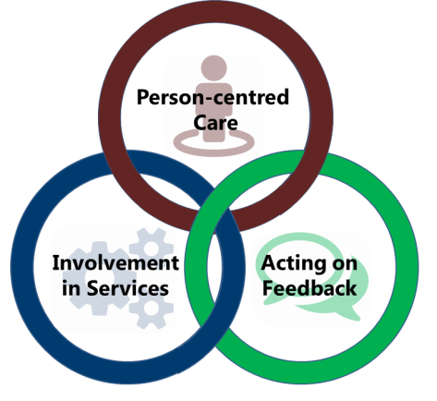TAPF group met in September 2018 and heard from each of the directorates about the feedback received, action taken and involvement work being carried out. The November 2018 meeting was focused on reviewing progress with the current strategy and starting to develop a new strategy to start from April 2019. The strategy will be developed and consulted on with patients, families, the general public and staff over the next few months with a plan for the Trust Board members to approve a new strategy in March 2019.

We are working with patients/ clients to ensure the new strategy document will be accessible to all patients, friends, family members and services.

The funding and resources required to deliver the aims of the current strategy approved in April 2016 have taken time to put in place and some smaller funds ie a dedicated involvement activity fund, are still to be identified. This has had an impact on the progress with the strategy, as shown in the below table as year 1 was focused on identifying, recruiting and embedding new resources so many of the actions were carried into year 2. The new strategy from April 2019 will build on the work achieved and also review the relevance of carrying forward the actions in progress and not yet started from the current strategy. The self-assessment from the NHS Improvement patient experience framework published in June 2018 and the recent group work at the Linking Leader conferences in June 2018 will all be used to inform the new strategy.

**Table showing strategy objectives:**

|  |  |  |  |  |
| --- | --- | --- | --- | --- |
| Progress update |  |  |  |  |
|  | Not started -red | In progress - amber | Completed - green | total |
| 2016 | 8 | 15 | 13 | 36 |
| 2017 | 3 | 8 | 5 | 16 |
| 2018 | 2 | 6 | 1 | 9 |
|  |  |  |  |  |
| **Total** | **13** | **29** | 19 | 61 |
|  |

1. **‘I Want Great Care’ (strategy aim Acting on Feedback)**

The Trust has received 2,899 responses between 1st July – 30th September 2018 with an overall average score of 4.72 out of 5 across all the questions asked. The number of responses has slightly declined, however compared to last year there is still a large improvement. 91.65% said they would be likely to recommend (slight decrease from previous quarter <1%) with 2.31% being unlikely to recommend (slight increase from previous quarter <1%). (6.04% report neither or don’t know – slight increase from previous quarter by 2%)

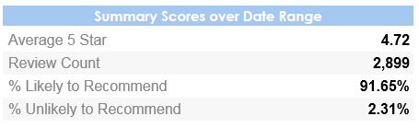

The below graphs show the overall demographic information of those giving feedback and the way this has been provided ie a paper survey (off line), on-line or via the apt on a tablet. Quarter 1 information is on the left, Quarter 2 information is on the right.

The source of ‘offline’ denotes those surveys completed via paper and the below graphs show that there has been a large increase in the collection via “tablet” (Ipad) and a reduction in the use of paper (67% to 48%)

.

**Quarter 1 information Quarter 2 information**

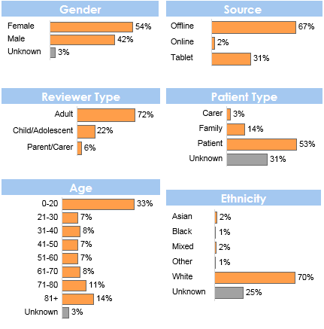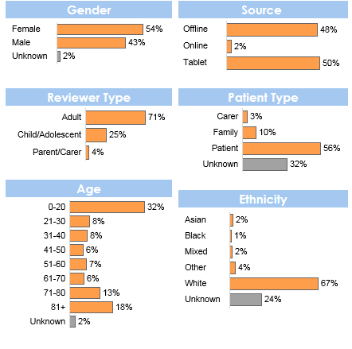

1. **Adult Mental Health Carers Survey (strategy aimActing on Feedback)**

|  |
| --- |
| The Adult Mental Health Services currently conduct a separate survey for all carers accessing mental health services across Oxfordshire and Buckinghamshire in line with commissioning requirements. This information is stored separately to the IWGC data and the “recommend” question data (FFT) is added manually to the monthly national Friends and Family return. |

The survey is available via an online link on the Trust wide site as well as in all mental health teams and our five partner organisations (as part of the mental health partnership in Oxfordshire).

53 carers have responded to the survey between 1st July 2018 – 30th September 2018 with a number of improvement comments and accolades. The feedback is used to inform carers work within the directorate. Below is a summary of some of the results.

*“We were offered weekly family sessions in the ward round. Our views were taken into account. dr XXXX was excellent and Treated our relative in a compassionate and caring way. The staff always seemed to have time for us. We were offered family therapy which was very helpful. Our relative was given lots of 1 to1 time especially when distressed.”* – Family Member

*“All the staff have been so helpful while my partner has been here, they allowed him to be himself without feeling crazy , I have notice so much improvement under the care of the Warneford”* – Family Member

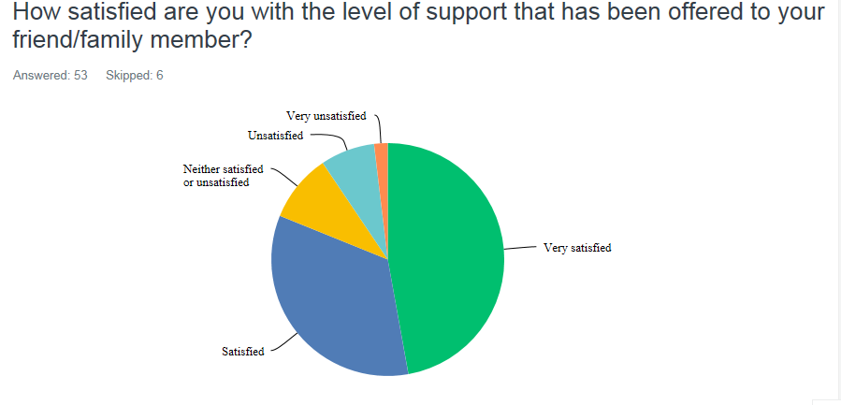

Table showing results from level of support offered for carers.

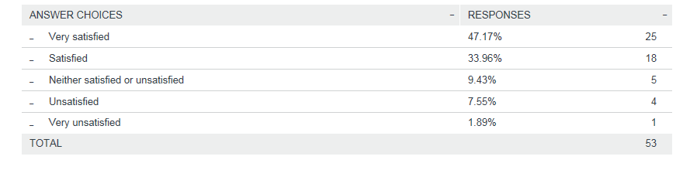

1. **Improving how people experience our services awards (all three strategy aims)**

The new quarterly team awards for ‘improving how people experience our services’, were given during the last Linking Leaders conferences in September 2018. 2 awards were given out across the conferences this time, the team winners are listed below.

Congratulations to the award winners:

**Buckinghamshire-** PIRLS

**Oxfordshire -** Witney Community Hospital Wards (Linfoot & Wenrisc)

**South West -** None awarded in September 2018, last award in June 2018.



1. **I Care You Care (Carer, Family and Friends) Strategy**

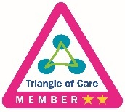The “I Care You Care” carer annual report has been published and is available on the trust intranet here: <http://ohftintranet.oxfordhealth.nhs.uk/D/Comms/trustnews/Pages/i-care-you-care-annual-report.aspx> and externally on the trust webpages. This outlines the work of the first year of the friends, family and carer strategy. It includes a report on the carers conference held in June 2018 and other events held during carers week 2018, updates against the trust objectives and information about theTriangle of care self assessment which we are accreditated as a 2 star member meaning our mental health services meet the Carers Trust required standards. Work is underway to self assess and support the community services to work towards achieving 3 stars.

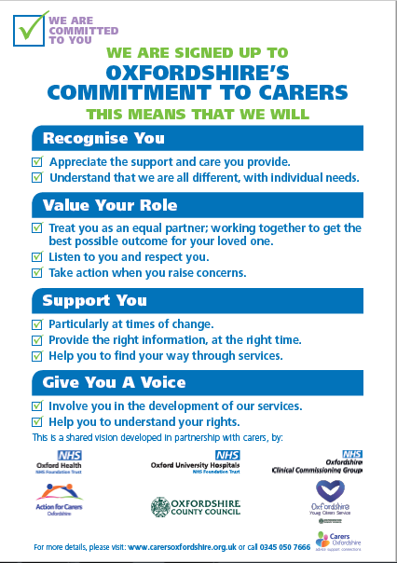The Oxfordshire system “Commitment to Carers” continues to be publicised within services to ensure teams and friends, families and carers are aware of the cross organisation work we are undertaking. The commitment was developed throughout 2017 alongside carers and partner organisations. It was launched in June 2018 and the Trust are promoting the valves it outlines.

There is a network of staff Carer Champions within the Trust (these are staff members who have dedicated time in their substantive roles for carers activities) who are working closely with the friends, family and carers strategy and have been having discussions on ways to grow the Carer Champion role throughout the Trust and develop carer events, the first of which will be taking place in February 2019.

In conjunction with the Carers Champions role, we are currently developing a volunteer carer support role. This role will be providing carers with the appropriate support and information when in contact with our services and to offer a friendly conversation and signposting where needed.

A Carers Handbook has been developed for adult mental health services in Oxfordshire which is now widely in use across inpatient and community settings. The aim is to roll out further handbooks for services so that Carers can receive useful information about the service, and for them as a Carer. There are two further handbooks currently being developed in consultation with carers and staff for Community Hospitals and the Children’s mental health Inpatient Services.

A new carers newsletter has also been developed to help keep staff informed of anything and everything carer related, this will be published quarterly with the first edition available now. It include sections on ‘meet the team and the work they have been doing to support carers’, ‘how to’ guides, carers rights and needs, events/courses, signposting information, meet a carer champion and much more.

1. **Summary of feedback (strategy aim Acting on Feedback)**

Overwhelming the feedback, we have received from patients, families and carers is very positive with patients reporting feeling cared for by staff and that as a result they highly value the service provided. However, some people do not receive the positive experience we expect every person to have and therefore we have more work to do. The themes highlighted from complaints mirror the key areas for improvement identified from the feedback we receive, and are focused on supporting better joint decision making so people are an active partner in their care.

For more details about complaints, informal concerns and compliments, the annual complaints report was presented to Trust Board in July 2018 and a brief summary of quarter 2 information is available within this report below.

The graph below shows the trust-wide average score for each question asked through the IWGC survey, out of a maximum of 5, over the last 3 months (July to September 2018). The first 5 questions (from top to bottom) are asked by all services (‘dignity to kindness), the bottom 6 questions are those asked on the specific children and young people service surveys.

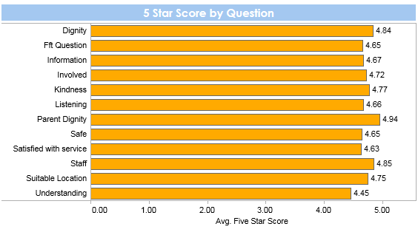

Below are the trends for the first 5 questions asked across all services, showing the average score over the 3-month period, July to September 2018. These graphs show that the ratings stay very stable over the time period with less than 0.10% change in any of the questions scores. This is a trend which is true of the year to date. Full year anaylsis is available in the annual report that was presented to Trust Board in April 2018

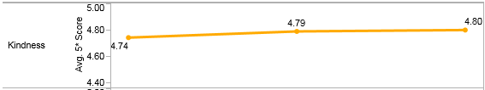

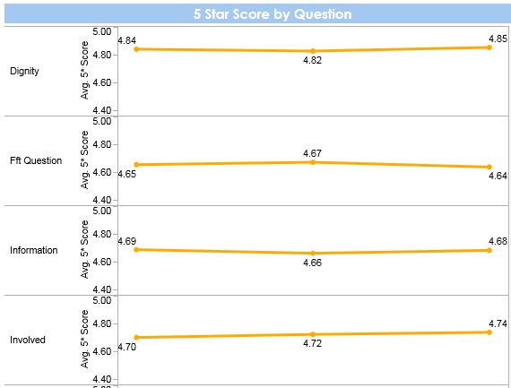

The below graphs show the Trust overall data from the start of our use of IWGC:

The trend of the amount of feedback has steadily increased due to the roll out of the new software IWGC and teams finding value and therefore using feedback to make changes.

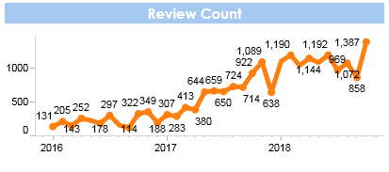

The graph below shows that the average 5 star score has consistantly remained between 4.50 and 4.82 out of 5, as shown by the blue line on the top.

The difference in percentage (%) for scores has ranged by 10%, especially at the end of 2016 but more recently the difference in average overall scores has been less than 2% + or – each month, on the previous months data.

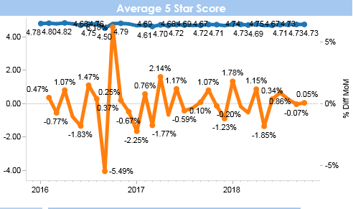

The feedback to the national friends and family test question (FFT), “would you recommend the care received” remains positive and above national average, results by mental health and community physical health services are below. The national question is currently being reviewed by NHS England and The Patient Experience Manager is part of the ongoing national development group who are aiming to release new guidance in early 2019. This is likely to include a change to timing for when some services can offer the FFT question and the possibility of a change of wording to the FFT question.

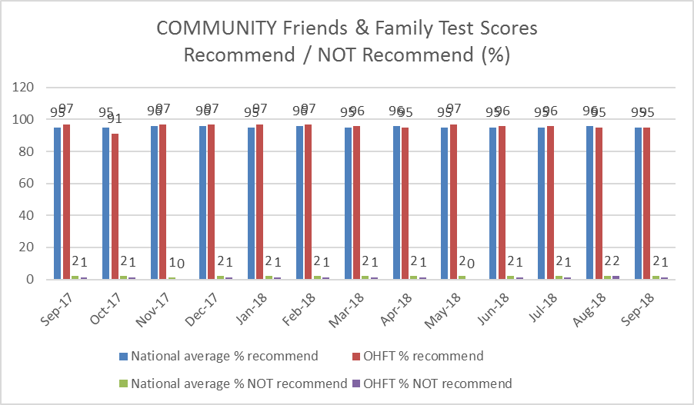

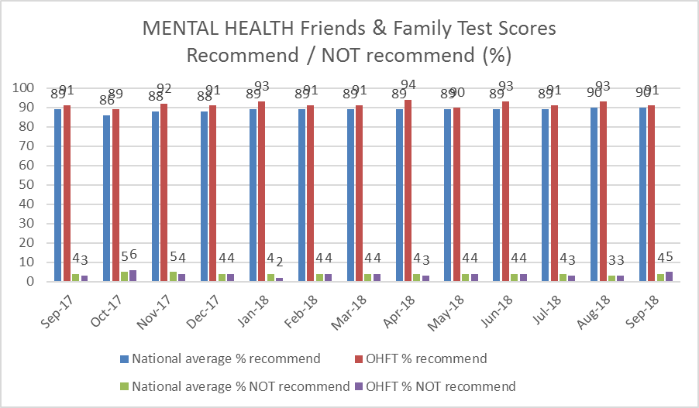

Positive qualitative feedback

The below word cloud shows the 100 most frequently words used by patients who have given a 5* (star) average score in the last 3 months.

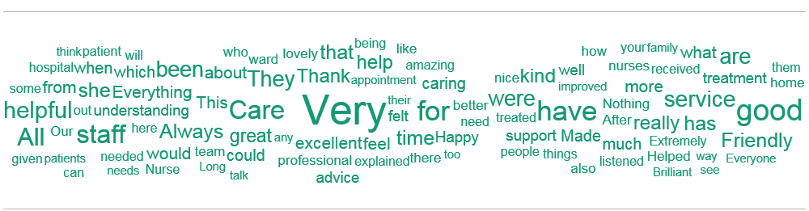

**Some comments from people who answered that they are extremely likely or likely to recommend our services include:**

*“Nurses and staff are very patient with us and personable”* – Vaughan Thomas Ward.

“Excellent care. This service is for recommendation” – Hospital at Home

“I have a major fear of dentists. I was made to feel at ease,the procedures were fully explained which helped to aliviate my fear. I was informed that if at time I wanted them to stop I could raise my left arm. The dentist and dental nurse treated me with dignity and respect” – East Oxford Dental Clinic Out of Hours

*“I have received excellent care. Everybody is totally dedicated and has my best interest at heart*” *–* Ruby Ward.

“I am very lucky that I went through this program. It helped me a lot in so many things, how to deal with my child's troubles, building up confidence in being a good mother and a role model for my child. I am very happy with our nurse, she has been very helpful during all the program for me and my family. I am very happy to recommend it to all my friends and those I know.” – Family Nurse Partnership

It's been very helpful that I and mywife/carer have been able to consult with the physiotherapist on the phone - PDPS

*“I have had a really nice time overall and time to reflect, which I needed, thank you*” *–* Phoenix Ward.

“Was told immediately waiting time. Staff very friendly and professional, assessed and treated quickly. After care explained too” – Abingdon Minor Injuries Unit

“We were seen quickly after initial assessment at a time when it was much needed. It has helped my daughter with strategies and generally understanding the wat she feels” – Swindon CAMHS

*“I was listened to" –* Chiltern Adult Mental Health Team.

*“do not feel I need medication, however the team recommended I take my time and consider some things in my life currently, they did not push they understood that it has to be my decision. Thank you for listening”* – North and West Oxon Adult Mental Health Team

Negative qualitative feedback

The below word cloud shows the 100 most frequently used by patients who have given an average score of 2.5* (star) or less. The mostly commonly used word “Didcot” was used in 2 reviews and all of the other words shown were used in a single review.

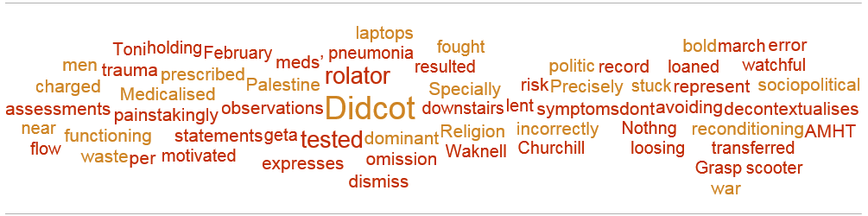

An immediate automatic alert is created for any service who receives a review of less than 3 stars for any reason. This allows the service and Patient Experience Leads the opportunity to monitor, respond and action any improvement feedback which is received in near real time.

Services have begun to respond directly to a number of reviews which have been received and it is our aim to develop staff’s ability to respond further over the next 12 months.

**Some comments from patients whose overall review score was below 2:**

**(all these comments have been reviewed and actioned by the team)**

“Feel extremely alone” – Highfield Unit, Oxford

“I am outraged by the level of care that you receive.” – North Buckinghamshire CAMHS

“Short discussion about care plan.” – Vaughan Thomas Ward

“Regularity re meals and activities; former were very routine. One to one monitoring and feedback. Setting targets and goals to achieve. The information regarding the drugs you have been prescribed could be improved (i.e why you have been given them and for what purpose. The rooms were not air-conditioned so became very warm. Heating not regulated well. Mattresses not very comfortable.” – Sandford Ward

1. **You Said, We did (strategy aim Acting on Feedback)**

All services aim to feedback to service users on quality improvement work which has been led by patient experience feedback. We call this “you said, we did” and this can be displayed on boards, leaflets or posters. Below are some examples of changes made in the last 3 months:

Mental Health Services:

**You Said:** There is no hand gel outside for visitors

**We Did:** This has now been refilled and is fully functioning

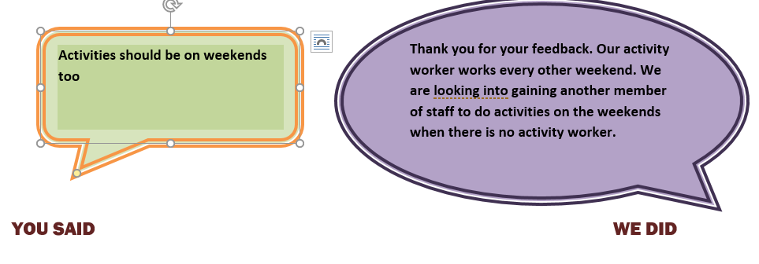

**Review of ASD Information**: In response to feedback, a pilot will be run in September to deliver the 6 week Post Diagnostic Course to 10 parents in the form of a conference via web link. This will be run with the support of the Digital Exemplar Team. A checklist to help parents identify what the next steps are following diagnosis has also been developed and is being shared with parents for feedback.

**You Said:** The waiting area needs to be improved at Raglan House.

**We Did:** Young people have created a picture to hang up in the waiting area. Fidgets spinners / stress toys have been purchased to help stress relief.

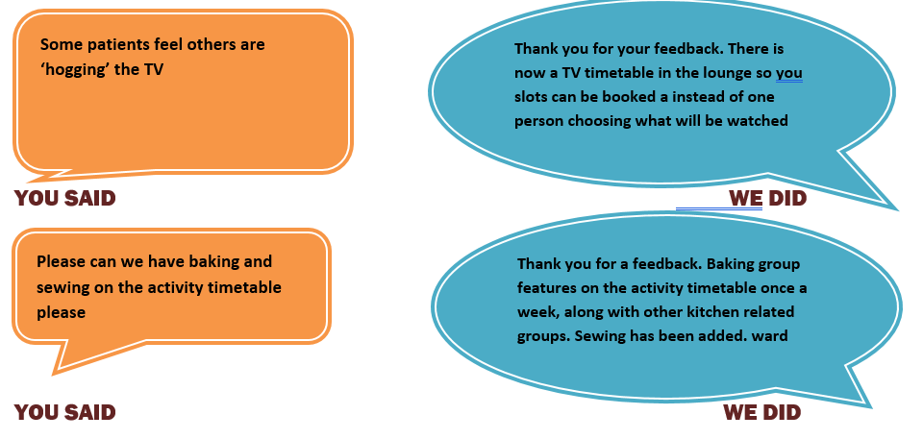

Community Directorate:

**You Said:** *“Efficient, caring staff. Would be good if there was an x-ray machine here.”*

**We Did:** *“Currently we are only commissioned to serve as a First Aid Unit (FAU) [which are not required to provide X ray facilities].  Although there are X ray facilities on site, these are only commissioned to be open for a limited number of hours 4 days a week for GPs to refer their patients into.  The radiographers are provided by the Oxford University Hospital’s Trust. Patients identified by the FAU clinician as needing can be directly referred to our sister minor injury units at Witney, Abingdon or Henley for x rays. In the long term the hope is that Bicester will become either a Minor injuries unit or an urgent care treatment center, both of which would offer X ray facilities with the services provided on site. Currently there is no suggestion that this is forthcoming imminently.  The local clinical commissioning group would provide the decision on this in the future”* – Bicester First Aid Unit

**You Said**: “My rehab spread over 3 stages. 1. John Radcliffe service was poor. 2. Since leaving John Radcliffe tried to organize equipment had a total of 15 contact numbers to ring without conclusion. 3. Finally after 5 weeks they rang and concluded the matter. Thank you”

**We Did:** *“Thank you for your feedback. We have looked into this for you. The NE Community Therapy team received the referral through SPA on 25/7/2018 and responded the following day with a follow up review and discharge on 3/8/2018 . The patients comments have been documented on CareNotes. The Community therapy team also received an accolade from the patient which has been sent on to our PALS Team*” - North East Oxfordshire Community Therapy Service

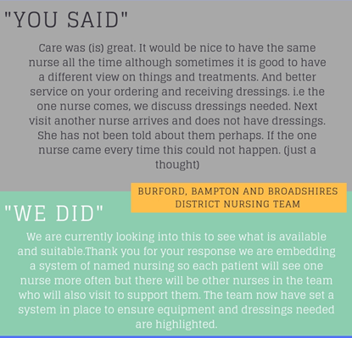

1. **Involvement (strategy aim Involvement in Services)**

Across the Trust involvement work is happening continuously as we strive to ensure patients, service users and carers are invited to be partners in the design, development, delivery and evaluation of services. Some examples of involvement work carried out between July toSeptember 2018 include:

Staff Awards

A group of patients and carers have been part of the staff awards decision process. The mixed group of 3 patients and 2 carers, together with the Patient Experience Manager held a shortlisting group to assess and score the nominations for the “Improving Patient Experience” Award. The winners were then decided by the awards panel with the results being given at the Staff awards Event later this year.

Getting Involved: The Patient Experience Team have developed a Trust-wide ‘Involvement Brochure’ with people who use our services and friends and family members being consulted on design, content and layout. This has been distributed among teams from January 2019 , and is aimed to better inform patients, families and carers of all the ways they can get involved with Oxford Health.

Service’s Focus Group’s: The Patient Experience & Involvement Leads have been supporting the development of a number of focus groups within a variety of service lines. These are formed around specific projects to ensure the patient voice is heard in the development of services and in qulaity improvement work. PDPS, Pulmonary Rehabilitation, various Oxfordshire secondary schools (alongside CAMHS Inreach), Learning Disability Services for carers and people who use services and Dentistry Services have all been utilising service users and carer involvement. This is alongside the regular Involvement/participation/have your say meetings which happen across the trust; predominently in adult mental health community and inpatient settings, CAMHS, forensic services and learning disability teams.

Patient Stories: The Patient Experience Team have interviewed a wide range of patients, carers and service users over the previous 3 months including a patient seen by the Physical Disability Physiotherapy Service, a carer from the Childrens Integrated Therapies Service, a parent from CAMHS, a person who uses Learning Disability Services, an Inpatient and carer on a community hospital ward. Some of these participants would like their stories used locally and some consent for them to being shared publically, including at Trust Board where a story is sharedmonthly.

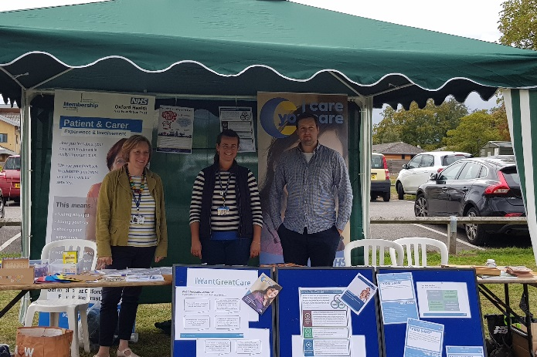‘HealthFest 2018’ at the Warneford Hospital. The event ran all day and was an opportunity to engage with the local community, staff, families and colleagues. The event was part of the Oxford Open Doors programme run by the Oxford Preservation Society and was an opportunity for people to come ‘behind the wall’ to help breakdown stigma around mental health. Members of the patient experience team ran a stall alongside a young person from the Oxfordshire CAMHS Participation Group and a carer who both attended for part of the day to talk to visitors about Involvement within Oxford Health.

Older Peoples Day: 'Oxford 50+Network: OLDER PEOPLE DAY’ at the Oxford Town Hall was attended by a member of the patient experience team to promote OHFT services, patient experience feedback and how to get involved with the trust through membership, volunteering and involvement opportunities. The event ran throughout the day and was a great opportunity to engage with the local community.

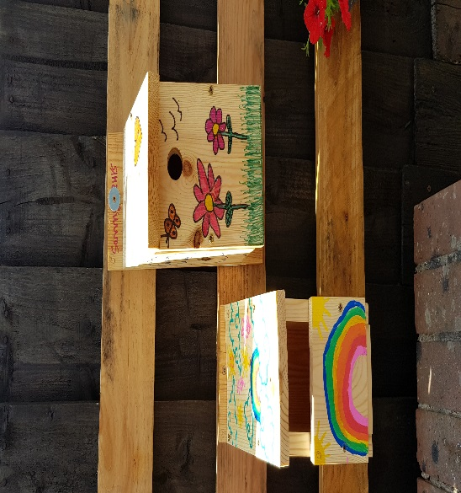Harlow House Garden. Young people from Article 12 CAMHS Participation Group designed and then worked to update the outside area at Harlow House in High Wycombe. They worked alongside “Chiltern Rangers” and included their priorities for sensory equipment, good amount of seating area and garden art in their work.

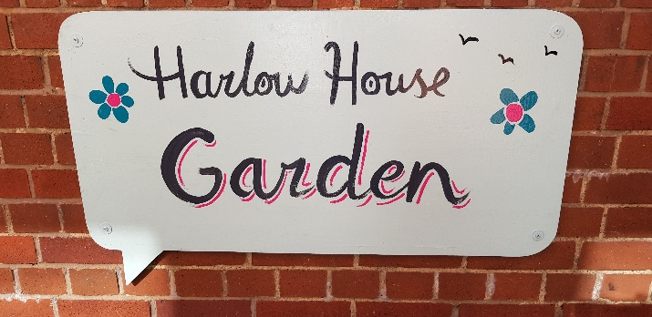

The Garden was officially opened with a small garden party and lots of cake and can now be utilised by staff and young people throughout the year.

The Patient Group at Cotswold House Oxford have been making welcome cards for new patients

Safety Plans with SWB Particiption Team Following on from a training session, members of the Participation team were invited to join liaison staff from Royal United Hospital (Bath), Great Western Hospital (Swindon) and Salisbury General hospital to look at safety plans and how they might be improved and developed. The hope is to develop a template that can be used across Swindon, Wiltshire and BaNES.

1. **National Adult Community Mental Health Survey**

The National Community Mental Health Survey for 2018 started in February 2018 and closed in June 2018.

The survey is sent to a random sample of 850 patients who have had more than one contact with a community mental health servicebetween 1st September to 30th November 2017, aged 18 and over (no limit) and have an address in the UK. The main survey questions are similar to 2017.Our response rate was 27% with 225 patients responding. The Trust also participated as a pilot site for two further national trial surveys being conducted on the use of a new “short” version of the survey and a change in method to try text surveying. The aim of these pilots is to ascertain if response rates for the survey can be improved nationally.

The full results to be published are embedded in Appendix 2, these are presented based on a score from 0-10 for each question (with 10 being the best). In comparison with the other 56 mental health NHS trusts our results are similar, with only the results to 1 question better and 1 question worse. Our results are also similar to last year (2017). The CQC will be publishing the results on 22nd November 2018.

An overview of the results is below

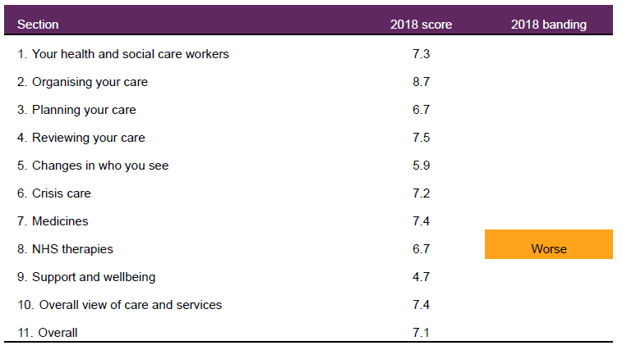

1. **Complaints and Pals information**

The Trust receives complaints relating to services provided by the Trust. The Trust also receives a variety of enquiries and requests for help and information through PALS and also from local MP’s. The Trust’s complaints procedure is working well throughout the Trust. Many concerns/complaints continue to be resolved locally and promptly by front line members of staff,this can also prevent an escalation of the complaint. In summary the Trust received:

* 56 complaints during Q2 2018’19, which is the same number of complaints received in Q2 2017’18. All (100%) formal complaints were acknowledged by the Complaints Team within the NHS Complaints Regulations (2009) of three working days. In Q2, of the 23 complaints which have been investigated and responded to, all (100%) of these were within a timescale agreed with the complainant, 33 complaints remain open at the time of writing this report. Of the 23 complaints which have been responded to within Q2, 11 complaints were upheld (48%), ten complaints were not upheld (43%) and for two complaints, there was no evidence to prove or disprove (9%). There continues to be a number of extension requests across the Directorates, all extensions are agreed with the complainant. 10 MP enquiries during Q2 2018’19, which is a decrease when compared to 21 in Q2 2017’18.
* PALS received 488 contacts during Q2 2018’19, which is a decrease when compared to Q2 2017’18 when 670 contacts were received.
* 671 compliments in Q2 2018’19, a small decrease from 761 in Q1 2018’19.

The graph below shows the number of combined complaints and concerns received by Directorate since January 2016 to 30th September 2018, including those upheld and not upheld.

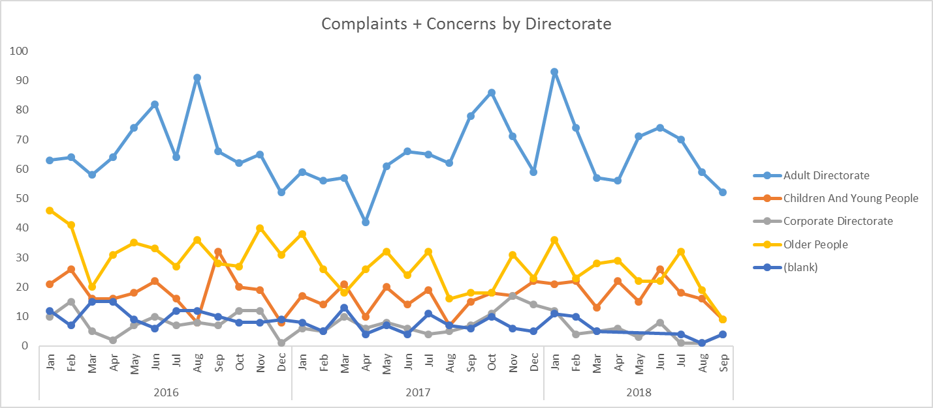

In looking at the themes/trends in Q2 across both concerns and complaints the chart below shows the primary categories of complaints and concerns within this time period.

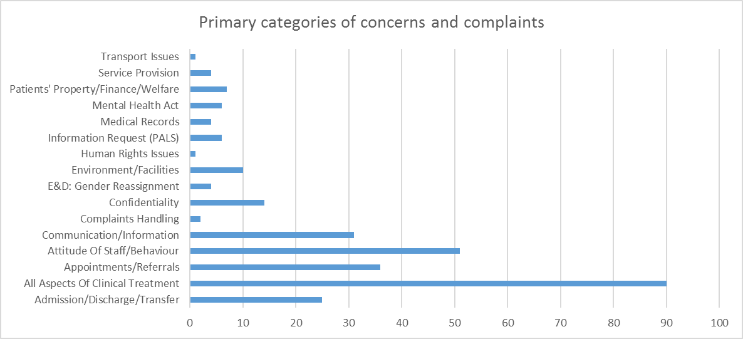

The Trust receives high numbers of concerns and complaints about all aspects of clinical care (90) of which 40 related to insufficient care in the community, nine related to insufficient care as an inpatient, six related to an assessment, eight related to diagnosis and seven related to medication issues.

51 cases related to staff attitude/behaviour of which 14 cases related to lack of professionalism, 11 related to uncaring/uncompassionate behaviour, nine related to a rude manner and five related to being unhelpful/disinterested. 36 cases related to appointments/referrals of which ten related to length of wait for an appointment, five related to cancelled appointments, five related to a delay in responding to a referral and four related to waiting times for therapy. 31 cases were about communication/information sharing of which 12 were about poor communication with service users, eight related to poor communication with relative/carers and four related to poor communication externally. 25 cases were about admission/discharge/transfer, of which seven related patients disagreeing with being discharged, six related to a patient being discharged too early and four related to poor discharge arrangements.

A detailed report on complaints and concerns is presented to the Caring and Responsive quality sub-committee every quarter.

Compliments

The Complaints and PALS Team centrally collates the compliments sent to teams within the Trust including thank you letters and cards. In Q2 a total of 671 compliments were received; Adult Services received 153 compliments, Older Peoples Services received 268 and Children & Young People’s Services received 238. There continues to be an increase in the number of compliments being received about the Trust’s services.

Extracts from compliments

*“My nurse without any exaggeration has saved my life. During my breakdown over a weekend, she held my hand over the phone, she was exceptional and called me frequently over the phone to encourage me and keep focussed. Subsequently, she has called me regularly and I couldn't manage, as I am without her visits in which she provides practical advice and compassionate care. She is my angel and with her help and care, I would not be making the baby steps I am making today. Thank you.”* South Oxfordshire Adult Mental Health Team

*“A big thank you for lending me the time and expertise of H and R this week. The two days went very well and their observations and findings are spot on and very useful. They are a credit to your service and also a pleasure to spend time with”.* Kennet/Kestrel

*“I was seen on the day I needed help. I was immediately put at ease by the friendliness and professionalism of the dentist and his assistant. The anaesthetisation and extraction were carried out with great expertise and professionalism. Having my head help during extraction was more calming and reassuring. I don't think I have ever laughed during a tooth extraction as I did today!”* Dental – Witney

**Appendix 1.**



**Appendix 2.**

**Annual Community MH Survey Results 2018.**

