

**BOD 03/2019**

(Agenda item: 5)

# Report to the Meeting of the

# Oxford Health NHS Foundation Trust

# Board of Directors

**31 January 2019**

**Monthly Performance Report – M9 December 2018**

**For: Information**

**Executive Summary**

This report summarises and provides assurance against the Trust’s national and locally contracted key performance indicators (KPIs) for Month 9 (December). Overall, the Trust achieved 286 of the 384 targeted indicators (74%). This is broadly consistent with the performance achieved in Months 7 and 8 but a decline since the start of the financial year and reflects the ongoing pressures (particularly a lack of a workforce).

**Performance Trend:**

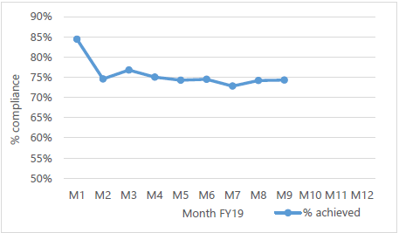

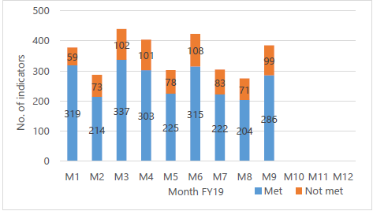

The number of indicators varies throughout the year as is illustrated in the graph above. This is due to some indicators only being reportable on a quarterly basis.

**National Position:**

The table below shows how the Trust is performing against a selection of the national operational performance indicators and the national averages. In many cases the Trust is performing better than the national average with MIUs and IAPT in particular standing out. Out of Area Placements (OAPs) continue to be a major issue for the Trust and is due to a lack of community alternatives.



**Local Position:**

**Patient Access and Patient Flow**

The table overleaf shows performance in relation to the Trust’s core mental health community services concerning demand, patient access and patient flow. Key headlines;

* **Demand**

The number of **Adult Mental Health** referrals received in **Oxfordshire** is significantly higher than Buckinghamshire (24% YTD), despite comparable population sizes

The number of referrals received by the **Oxfordshire CAMH service** continues on an upwards trend with referrals having increased significantly since the start of the year. This is having a direct impact on patient access to the service and increasing waits.

* **Access/Waits**

Access to the Oxfordshire CAMHS service is challenging, with patients waiting in excess of the targeted 12 weeks for routine referrals. This is a direct result of the increase in demand on the service. Emergency and urgent referrals are being prioritised within available resources and performance is good.

* **Delayed Transfers of Care (DTOC)**

A significant number of bed days have been lost this year to date due to DTOC; 1,819 days in mental health and 11,169 days in community. This equates to 6.6 beds in mental health and 41 beds in community. This data will be contextualised going forward; represented as a % of bed days lost.



**S75 Agreements with Oxfordshire County Council and Buckinghamshire County Councils**

The Trust achieved **100%** compliance against the indicators for the Oxfordshire S75 agreement in December 2018. Reports are one month in arrears.

The Trust was not required to report performance for Buckinghamshire County Council in M9 as they are bi-monthly reports.

**Performance by Directorate in December:**

**Oxfordshire, Swindon, Wiltshire & BaNES – All Ages Mental Health** achieved 82 of the 114 targeted indicators (72%).

**Highlights for the Board:**

1. **Urgent & Emergency Referrals (All areas & ages) – Waiting Times.** The Trust continues to prioritise and achieve the waiting time targets for urgent (7 days) and emergency (4 hour) mental health referrals.
2. **Waiting Times (SWB)** - There has been an improvement in 4 week (first appointment) and 8 week (referral to treatment) waiting times in Swindon, Wiltshire and BaNES. Although not yet at target, good progress has been made following the recruitment of additional workforce.
3. **Adult Mental Health (OXON)** – A significant underfunding of mental health in Oxfordshire has resulted in considerable pressure building up for mental health services. In mid 2018, commissioners were notified that the routine target would have to change from 4 – 8 weeks due to insufficient resources, however, even achieving 8 weeks is not consistently possible. The Trust will not be able to achieve the performance targets for routine referrals in Oxfordshire until further funding and workforce is available. This position is being discussed as part of the annual contracting process with Commissoners.
4. **Children & Young People Mental Health (OXON)** – Although Oxfordshire has been awarded additional funding through the national trailblazer scheme, further investment is still required in order to achieve the national access and treatment targets. As with the position reported for Adults, the Trust will not be able to achieve all of the required targets unless further investment is received. This position is being discussed as part of the annual contracting process with Commissoners.

**Buckinghamshire – All Ages Mental Health** achieved 38 of the 52 targeted indicators (73%).

**Highlights for the Board:**

1. **Memory Services** – Performance has improved since the low reported in September 2018 and although not yet at target, progress is being consistently made. Further improvements are expected to reported in February 2019.
2. **4 week waiting times for CAMHS Getting Help** – There has been a continual decrease in performance reported since October 2018, however the issue is now believed to be a reporting error following the change in organisational structures. Reporting rules are now being reviewed and reports will be corrected as necessary.

**Oxfordshire Community Services Directorate** achieved 74 of the 103 targeted indicators (72%).

**Highlights for the Board:**

1. **Oxfordshire and Buckinghamshire Continuing Health Care (CHC**) – Detailed discussions are now underway with commissioners in Oxfordshire and Buckinghamshire to resolve a number of long standing issues in both counties. A new specification for CHC services has been drafted by commissioners and a PIN (procurement information notice) has been published to the market place notifying potential competitors that an opportunity exists but there is an intention to award to Oxford Health unless other potential suppliers step forward.

**Specialist Services** achieved 72 of the 88 targeted indicators (82%).

**Highlights for the Board:**

1. **Routine Dental Checkups for Low Secure (LSU) and Medium Secure Units (MSU)**. The Trust has consistently breached the 70% target for routine dental checkups for patients in the low secure and medium secure units. Patients are receiving urgent and emergency dental care when required and are offered routine dental checkups (some patients refuse) but further focused work is required.

**Recommendation**

The Board of Directors is asked to review and note the monthly Board performance report.

**Author and Title:** Martyn Ward – Director of Strategy & Chief Information Officer