

# Report to the Meeting of the

# Oxford Health NHS Foundation Trust

**BOD 08/2019**

(Agenda item: 10)

# Board of Directors

**31st January 2019**

**Quality Report: Incident, Mortality and Patient Safety**

**For: Information**

**Executive Summary**

This is a quarterly quality report focused on the safety of care.

Key risks and issues:

* There continues to be a high level of violence and aggression incidents by patients towards inpatient staff. Evenlode and Kestrel wards report a high number of violent and self-harm incidents. A quality improvement project has started.
* Increase in the number of medication administration incidents reported by the adult acute mental health wards. Work on reducing medicine omissions across the adult wards has started.
* Abingdon and Witney MIUs - there has been an increase in incidents, Serious Incidents (SI) and complaints relating to incorrect/missed/delayed diagnosis. A series of actions have and are being implemented and the Community Directorate is carrying out a deep dive into the quality of care in the service in January 2019. OCCG carried out a routine assurance visit to Abingdon MIU on 16th January 2019 and rated the outcome as good and said it was assuring to discuss improvements being implemented.
* There are key areas for further learning from unexpected deaths in relation to: better involving families in patient’s care, physical health for patients with a mental health illness, and improved communication at points of transition. A series of different work streams are underway.
* Challenges with staffing levels are coming through as a theme in SIs. Further details on the actions are covered in the monthly safer staffing report.
* Need to ensure the timely completion of actions from SIs.

Key areas of good practice:

* Incident reporting levels continue to be positive, suggesting a learning culture.
* Most incidents result in no or low harm.
* Patient safety incidents are reported to the national NRLS on average within 1.5 days.
* There is a robust process of identifying, disseminating and monitoring the implementation of national patient safety alerts. All alerts have been closed within the specified timescales.
* Learning from deaths is well embedded in the clinical directorates and the Trust-wide Mortality Review Group meets quarterly to keep an oversight and to share learning across the Trust.
* The SI process embedded in the Trust is thoughtful, rigorous and focused on the engagement and learning with patients/ families and staff.
* No SI investigations have been submitted past the stipulated time frame to date in 2018/19.
* There have been no changes in trends for the overall use of restrictive practices across the trust. The previous reductions have been maintained.

**Governance Route/Escalation Process**

A more detailed version of this report was reviewed and discussed by the Safety Quality Sub-Committee on 22nd January 2019.

**Recommendation**

The Board is asked to note the paper and work happening.

**Author and Title:** Jane Kershaw, Head of Quality Governance and Pam Treadwell, Patient Safety Service Manager

**Lead Executive Director:** Kate Riddle, Acting Director of Nursing

1. *A risk assessment has been undertaken around the legal issues that this report presents and there are no issues that need to be referred to the Trust Solicitors*
2. *Strategic Objectives – this report relates to or provides assurance and evidence against the following Strategic Objective(s) of the Trust:*

*1) Driving Quality Improvement (Goals: patients will be safe from harm; patients will achieve the clinical outcomes they want; and patients and carers will have an excellent experience)*

**Incident, Mortality and Patient Safety Quality Report**

# Introduction

This is a quarterly report with the purpose of providing a summary of the themes and learning from incidents and deaths and our response to patient safety alerts.

A detailed summary of the report is provided below;

* Reporting levels have continued to increase from the point the Ulysses incident reporting system was introduced across all services from 2011.
* A review of the timing of incidents is summarised below by type of incident;
  + Violence + Aggression on inpatient wards – high numbers of incidents occur throughout the day, with most occurring from 10am – 1pm (22%), and numbers tailing off from around 7pm.
  + Self-Harm on inpatient wards– Most incidents occur in the evening with 49% of incidents in the previous year occurring between 5pm and midnight, the majority of which are between 8pm and 11pm.
  + AWOLs – Incidents tend to occur in the afternoon, 63% occurred between 12pm and 8pm with peaks between 2pm and 4pm and 6pm and 7pm
  + Staffing on inpatient wards– The highest proportion of incidents in the previous year were reported as occurring between 8pm and 10pm (21%), and between 7am and 8am (20%).
* Most patient safety incidents resulted in no harm (64%) which is similar to the national picture. As reported previously the Trust continues to report a higher number of incidents with major harm compared to other NHS Trusts, this relates to a decision to report all grade 4 pressure ulcers as major regardless of whether there have been omissions in care, and the introduction of the category of SCALE from April 2017. The new national guidance on definitions and measurement of pressure ulcers will reduce the variability of reporting nationally (to be implemented from April 2019). Of the patient safety incidents graded as major in October/November 13 out of a total of 21 related to skin integrity incidents and one of these is being investigated as a serious incident.
* Most incidents related to; skin integrity (17%) (41% developed in service/ 59% inherited) and violence/aggression (15%) largely patient toward staff, followed by medication incidents (11%), self-harm (9%) and communication/confidentiality (9%). A breakdown by cause group split by mental health services and physical health services is included in the report.
* Overall the highest number of incidents are reported by the Community Health Directorate (44% in October & November), followed by Oxon & West Mental Health services with 26%. The service lines reporting the most incidents are District Nursing, Community Hospitals, Oxfordshire CAMHS, Oxfordshire and Buckinghamshire adult acute mental health wards.
* The number of incidents appear to be increasing for community hospitals however when compared to activity the number incidents per number of patients treated has not changed, therefore indicating the wards are treating more patients. Most incidents relate to falls and pressure ulcers.
* The forensic wards have seen an increase in incidents however this mostly relates to a new service being transferred an LD forensic ward, Evenlode. Evenlode reports a high number of incidents most relating to violence/ aggression with a large number involving one patient. In addition, Kestrel ward consistently reports the highest number of incidents per bed day across the Trust around self-harm and violence and aggression (the majority of incidents relate to four patients).
* Since Feb 2018 there has been an increase in the number of medication administration incidents (including delays, omissions and medication given at the wrong frequency) reported by the adult acute mental health wards, particularly VT, Sapphire and Ruby wards. A number of the incidents relate to temporary and agency staff which is being addressed and the Directorate is carrying out some work on reducing medication omissions.
* The wards/ teams highlighted with a notifiable increase in incidents reported are:
  + Cherwell Ward - a large number relating to a single patient in relation to violence/ aggression and resisting treatment.
  + District Nursing South - relate to pressure ulcers although most were inherited.
  + Abingdon and Witney MIUs - there has been an increase in incidents, SIs and complaints relating to incorrect/missed/delayed diagnosis. A series of actions and deep dive activities are underway. The OCCG carried out a routine assurance visit to Abingdon MIU on 16th January 2019 and rated the outcome as good and said it was assuring to discuss improvements being implemented.
  + Oxon Eating Disorder Inpatient Unit – incidents relate to self-harm and security with over half of the incidents relating to a single patient.
* There is continued work to improve the timeliness of managers grading incidents. The NRLS requires NHS trusts to upload all patient safety incidents at least monthly and recommends any deaths or incidents with major impact should be uploaded within 2 working days. In October & November 2018 the mean average number of days between the incident date and the reporting to NRLS was 1.5 days.
* In October & November 2018 - 14 national CAS new alerts were issued, of these 10 were applicable to the Trust (most relating to medical devices) and cascaded for action. 20 alerts were closed in the same period. Three risk notes were also issued.
* A summary of the work in 2018/19 on maximising the learning from deaths is included, covering the never event in Nov 2017, coroner notices and new national guidance. A brief overview of trends on deaths in mental health and physical health services up to December 2018 is provided; the majority of deaths relate to people aged over 75 who had received treatment from one of our physical health services, such as the district nursing service. The key themes for learning from the review of deaths largely remain similar and these include family engagement and communication, physical health monitoring for patients with a mental health illness, communication at points of transitions and changes in care between teams, services and organisations.
* In October-November 2018, 15 SIs**[1]** were identified and reported (2 of which occurred in previous months, 1 in July and 1 in September). One SI was subsequently downgraded. Of the remaining SIs, 6 involved a death of which 4 are suspected suicides. A total of 7 SI investigations were completed, reviewed at panel and submitted to the relevant commissioner during Oct/ Nov. The overall themes from SIs are presented; challenges with staffing levels, variable completeness of documentation, essential checks not always being carried out consistently, sharing information with families and involving families/ carers in care and safety planning and physical health care in mental health settings.
* The SI team continue to focus on; engaging with bereaved families, sharing learning across the trust and ensuring actions/ changes from SIs are sustained. The number of overdue actions from investigations has significantly decreased from the last quarter.
* The Trust participates in multi-agency homicide and domestic homicide reviews as appropriate. There are currently 8 active cases being independently investigated. A 6-monthly update on every review is provided to the Quality Committee, this is next due in January 2019. A boarder review looking at themes across all multi-agency investigations (homicides, child serious case reviews and safeguarding adult reviews) will be presented to the Quality Committee in May 2019.
* There has been no changes in trends for the overall use of restrictive practices across the trust. The previous reductions have been maintained.

# Overview of Reported Incidents

## 2.1 Number of incidents

Figure 1 shows reporting levels have continued to increase year on year from 2011.The increase in reporting in Q2 and Q3 of 17/18 relates to CAMHS, the adult mental health wards and community mental health teams, and the transfer of the learning disabilities service from July 2017.

No seasonality has been observed in numbers of incidents reported. Similar numbers of incidents are reported as occurring from Monday – Friday, while reduced numbers are reported on weekends. A review of the times at which incidents were reported as occurring showed that 29% of all incidents in the past year occurred between 10am and 1pm. Looking at the timing of incidents within particular cause groups shows the following differences;

* Violence + Aggression on inpatient wards – high numbers of incidents occur throughout the day, with most occurring 10am – 1pm (22%), and numbers decreasing from 7pm.
* Self-Harm on inpatient wards– Most incidents occur in the evening with 49% of incidents in the previous year occurring between 5pm and midnight, mainly between 8pm and 11pm.
* AWOLs – Incidents tend to occur in the afternoon, 63% occurred between 12pm- 8pm with peaks between 2pm -4pm and 6pm -7pm
* Staffing on inpatient wards– The highest proportion of incidents in the previous year were reported as occurring between 8pm -10pm (21%), and 7am -8am (20%).

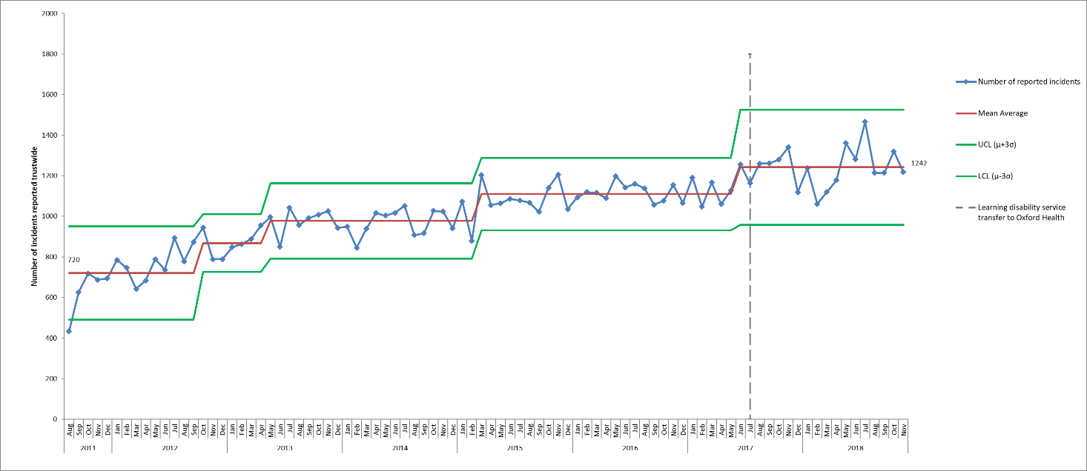

*Figure 1. Control chart displaying monthly number of incidents reported on Ulysses system from August 2011- November 2018*

### Actual Impact of Incidents

In October + November of Q3 2018/19, 2537 incidents were reported and 63% of these were reported as causing no harm. Of the 2537 incidents 1259 of these (45%) were flagged as patient safety incidents and reported nationally. Of the patient safety incidents 64% resulted in no harm, 27% resulted in minor harm and 5% resulted in moderate harm. This is generally in line with the national picture**[2]** according to the NRLS information up to March 2017. However, as discussed in previous reports, since Q4 16/17 a higher proportion of patient safety incidents have been reported in the category of major injury/severe property damage. This is because of the introduction of the category of SCALE in April 2017, and a decision within the community directorate that grade 4 pressure ulcers be graded as major impact, even if there were no lapses in care. New national guidance was published at the end of June 2018 to standardise pressure ulcers reporting and categorisation which should improve the accuracy of national comparison data once implemented from 1st April 2019. The pressure ulcer steering group is leading on reviewing staff training, updating the policy as required and updating the incident categories on Ulysses in response to the national guidance.

In October & November 2018, 30 incidents were reported with major harm (excluding incidents of inherited pressure ulcers), and of these 21 were flagged as patient safety incidents. Of the patient safety incidents 13 were in the category of skin integrity, 11 of which were grade 4 acquired pressure ulcers and one of which is being investigated as a serious incident. The other 2 major skin integrity incidents were as a result of SCALE. The incidents occurred across 10 different teams (8 district nursing, one podiatry and one EMU).

There were 4 incidents of self-harm with major injury (2 in Bucks Aylesbury, one in Bucks Chiltern and 1 in CAMHS Banes) and 2 patient safety incidents in the category ‘health’ for which major injury were reported, one due to a patient resisting treatment and one to delayed diagnosis. An incident of insufficient staffing was reported as major due to the delay to a patient’s palliative care, and a further incident in the category ‘found with injury’ was graded as major due to a baby being found to have multiple fractures by the health visiting service, the case is progressing with the social care team.

The categories of patient safety incidents resulting in major harm is given in table 1 below.

*Table 1. Categories of patient safety incidents reported with an actual impact of major injury/severe property damage, October + November 2018*

|  |  |
| --- | --- |
| Cause 1 | Number of incidents |
| SI08 Grade 4 Pressure Ulcer Acquired/developed In Service | 11 |
| SI10 Skin Changes At End Of Life (SCALE) | 2 |
| SH009 Self Harm - Striking Self Or Object/Surroundings | 1 |
| H14 Patient Resisting Treatment | 1 |
| SH011 Self Harm - Ingestion Of Harmful Item/substance | 1 |
| H06 Diagnosis Failure / Delayed Diagnosis | 1 |
| ST001 Standards Of Care I.E. Insufficient Staffing | 1 |
| SH002 Self-Harm - Ligature | 1 |
| G04 Found With Injury (Cause Unknown) | 1 |
| SH005 Self Harm - Overdose | 1 |
| Total | 21 |

### Incidents reported by Directorate

The clinical directorates went through a reconfiguration from 01.10.18. Figure 2 shows the number of incidents before and after this time based on where services are now managed within the new directorate structure.

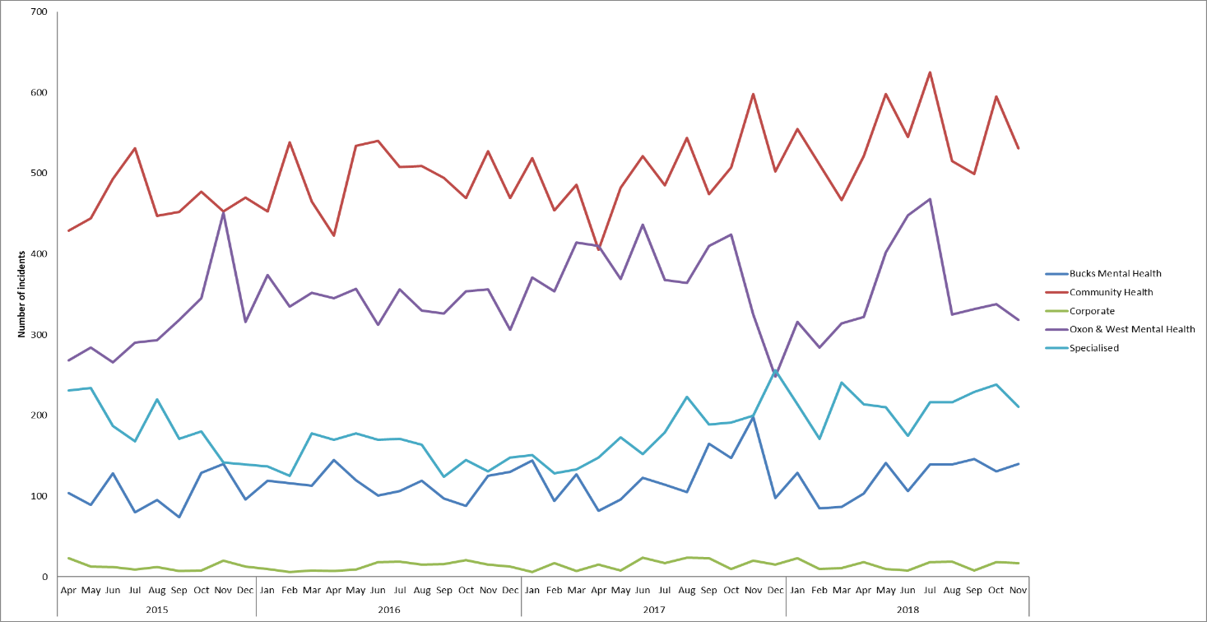

*Figure 2. Reported incidents based on where teams are management within the new directorate structure (following changes from 01.10.18), April 2015 – November 2018.*

Community Health Directorate

Most incidents are reported by teams in the Community Health Directorate. Within this directorate numbers of incidents have increased within various services in the past year, including GP OOHs, MIUs, Podiatry and Health Visiting, as discussed in previous reports.

Most incidents are reported by District Nursing with an average of 222 incidents per month, and Community Hospitals with an average of 123 incidents per month. Above average numbers have been reported by Community Hospitals in the past 8 months but there have been no trends on any particular ward and the increase reflects an increase in activity.

Oxon & West Mental Health Directorate

Most incidents are usually reported by adult acute mental health wards and CAMHS teams and numbers tend to fluctuate over time. In October + November of 2018 incidents increased on Cherwell ward. Incidents have also increased in the Oxford + West AMHTs over the previous year.

In the Oxon & West Mental Health Directorate most incidents since April 2015 have been reported in the category of Violence/Aggression (27%), followed by Self-Harm with 20% and Security with 12%. In October & November of 2018 656 incidents were reported in the directorate, 119 because of Violence/Aggression and 118 because of Self-Harm.

Bucks Mental Health Directorate

Most incidents are reported by adult acute mental health wards and again mainly the incidents reported since April 2015 have been in the category of Violence/Aggression (23%). In October + November 2018, 271 incidents were reported and 61 of these were in the category of violence/aggression (23%), followed by medication incidents (18%, n=50) and then security incidents (11%, n = 28).

Specialised Service Directorate

Most incidents are reported by forensic wards (). In July 2017 the learning disability service transferred to Oxford health, and the LD community teams are within the Specialised Service Directorate along with Evenlode Unit. As a result of the transfer incidents have increased within forensic wards and in the Directorate as a whole.

Most incidents are also reported in the categories of violence & aggression (35% since April 2015), Self-Harm (16%) and Security (14%). In October & November 2018 a total of 449 incidents were reported and 149 (33%) were because of Violence/Aggression and 72 (16%) were because of self-harm.

### Service and Team level of analysis

Overall reporting has been reviewed for all departments since April 2015. For inpatient wards incident numbers have also been reviewed in the context of occupied bed days, trends remain the same as when looked at in terms of incident numbers alone. Overall the ward that reports the highest number of incidents in relation to bed days is the forensic ward **Kestrel**, where a mean average of 13.3 incidents/100 bed days per month have been reported since April 2015.

Adult Acute Mental Health Wards

Following the spike in incidents on **Vaughan Thomas** in June 2018, when 43 incidents reported compared with an average of 21 per month, numbers remained above average in October + November of Q3. Overall 51 incidents were reported, of these there were 17 Security incidents and 15 medication incidents. Of the security incidents 12 related to AWOLS/attempted AWOLs and 5 to patients being found with alcohol/drugs/weapons, all were graded as no harm. Of the 15 medication incidents 12 related to medicines administration. The pharmacy team are working with staffing solutions to ensure temporary staff complete a competency check as well as medicine management training whilst being rostered onto the wards.

An increase in incidents occurred on **Sapphire** ward in August / September2018, and this continued in October /November when 33 and 29 incidents were reported compared with a mean average of 18 per month since April 2015. Most of the increase related to medication incidents Of the medication administration incidents -11 in total - resulted in no harm. There were 16 incidents of Violence/Aggression on Sapphire in this time, all resulting in no harm or minor harm.

Overall most incidents were reported by **Ruby** with 66 in total in October/ November, of these 22 (33%) were because of violence/aggression, 10 were due to self-harm and 10 to medication incidents. Again, all graded as low or no harm to patients.

The majority of medication incidents relate to omissions and the two mental health directorates have started a focused piece of work on understanding this better and reducing the number of omissions.

Older People Mental Health Wards

In older adult mental health wards incidents declined on **Sandford** ward in the middle of 2017 and this has been maintained. Following the peak in incidents on **Amber** ward in July2018, numbers have now returned to normal levels. However, an increase in incidents was seen on **Cherwell ward** in October/ November, with 34 and 49 incidents respectively, compared with a mean average of 22 per month. The increase was in incidents of Violence + Aggression and Health. In October/November 35 incidents were reported by **Cherwell** in the category of Health, and 24 of these related to the same patient resisting treatment. Of the 25 incidents of Violence/Aggression reported on **Cherwell**, 16 of these involved the same patient.

Forensic Wards

Of the forensic wards, following the increase in incidents on **Wenric** and **Kennet** earlier in the year incidents returned to around average in Q2 and Q3. Following the peak in incidents on the LD forensic ward, **Evenlode**, numbers decreased in October/November, as discussed further in the next section of this report.

**Kestrel ward** reported most incidents in October/November with 54 and 57 incidents respectively (mean average = 44/month). Of the incidents 52 related to Self-Harm (47%) and 35 to Violence/Aggression (32%). All the **Kestrel** incidents were graded as resulting in no harm or minor harm. The ward has been selected to work with the Royal College of Psychiatrists, NHSI, and the CQC on a national Reducing Restrictive Practice Project.

AMHTs

Within the AMHTs there has been a general increase in incidents since March 2017, with an average of 37 incidents per month reported prior to this, and an average of 59 incidents per month from March 2018 Increases were seen in both AMHT Oxon City + NE, AMHT Bucks Aylesbury, and more recently in AMHT Oxon South.

In October/November 2018 32 incidents were reported by AMHT Oxon City & NE, and 26 by AMHT Oxon South. Of the **AMHT City + NE** incidents 12 related to medication administration and storage errors, all of these were graded as no harm. **The AMHT Oxon South** incidents were across 18 different categories.

Five incidents reported in October + November by AMHTs are being investigated as serious incidents, 3 in **Bucks Chiltern**, and 2 in **Oxon South**, all the incidents related to unexpected deaths in the community.

CAMHS

Following the spike in incidents on CAMHS Highfield in July when 165 incidents were reported compared with a mean average of 63 per month, numbers dropped in subsequent months and 35 incidents were reported in October and 19 in November. Of the 54 incidents 25 related to self-harm (8 patients) and 13 to violence/aggression (7 patients). No trends have been seen in other CAMHS services, but one October incident in **CAMHS Melksham** is being investigated as an SI because of a patient who assaulted their mother.

Community Hospitals

Above average numbers of incidents have been reported by Community Hospitals in the past 8 months, but no trends have been seen on any particular ward and the increase reflects an increase in activity (and the number of patients being seen). In October/November most incidents were reported by **Abbey ward** (n=46, 16%) and **Witney Wenrisc** (n=35, 12%). Of the 46 Abbey incidents, 46 were fall related, and 3 patients fell on more than one occasion. Eleven of the incidents on **Wenrisc** were fall related, and one patient fell on 3 occasions.

One community hospital incident is being investigated as an SI, due to a grade 3 acquired pressure ulcer on Abbey ward.

District Nursing

Following the spikes in incidents in the district nursing teams in East Oxford and Witney & Eynsham in July of Q2, incidents returned to normal levels in October/November Q3. In **DNC South** 27 incidents were reported in October and 16 in November (mean average 13/month). Of the 46 incidents reported by DNC South, 38 related to skin integrity, but 27 of these related to inherited pressure ulcers.

Other Service and Departments

Incidents in **MIUs** increased in 2017, partly because of an increase in medication incidents. In October + November 38 incidents were reported by MIUs, and 13 of these (34%) were medication incidents, all relating to storage, and all graded as minor. Four MIU incidents from October/November are being investigated as serious incidents, 3 were reported in the category Health and 1 in ‘poor discharge’, all related to diagnostic errors. An incident with major injury was reported by an MIU due to a safeguarding concern for a baby with on-accidental injuries.

Above average numbers of incidents were also reported by **EMUs** in October/November. In total 67 incidents were reported by EMUS and RACU in October/November 21 relating to skin integrity, 12 to conveyance and 12 to communication/confidentiality. Five of the skin integrity incidents were graded as major (4 inherited, 1 acquired).

Following the peak in incidents in **GP OOH** in Q2, numbers dropped in October/November with 21 and 19 incidents reported respectively (average 15/month). Of the October/November incidents 9 related to communication/confidentiality (23%), 8 to medication, and 8 to health.

As reported previously, incidents increased in the **Health visiting** service in 2017 because of the service not being notified of new births. In October/November 62 incidents were reported by the service and 51 of these related to communication/confidentiality, the majority of which related this same issue. This is reportedly due to a change in electronic system by the OUHFT which has been resolved between the safeguarding teams.

**Luther street homeless GP** had an unusually high number of incidents in October 2018 with 26 compared with an average of 11 per month. Of the incidents 17 related to violence/aggression and this was apparently a result of several patients with issues with drugs/alcohol. All of the incidents resulted in no injury or minor injury.

In September 2018, 16 incidents were reported by the **Oxon eating disorders inpatient unit**, compared with an average of 7 incidents per month since April 2015. In October and November 2018, 22 incidents were reported in each month. Of the 44 incidents, 19 related to self-harm (5 patients) and 10 to security (4 patients). Of all the incidents 25 involved the same patient.

### Incidents reported in Learning Disability Services

In July 2017 learning disability services were transferred to Oxford Health from Southern Health. The services transferred were 3 community teams, an intensive support team, vison outreach team, step down care home and a forensic inpatient ward (Evenlode).

In October 2018, above average numbers of incidents were reported by the LD intensive support team with 23 in total, of these 9 related to the same patient.

Overall in the LD community teams 63 incidents were reported in October and November, 11 of which related to violence/aggression, and 7 to medication. Of the 63 incidents, 55 (87%) were graded as no harm or minor harm. Six deaths were reported, 2 of which were initially reported as SIs but were subsequently downgraded. All deaths of a person with a learning disability receive a multi-agency review (LeDeR).

Incidents have increased on **Evenlode ward** in the past year and this is because of an increase in incidents of violence/aggression, as discussed in previous reports. Following the spike in incidents in August 2018 when 59 incidents were reported, numbers have dropped and 29 and 35 were reported in October and November respectively. Of the 64 incidents 38 related to violence/aggression, and 29 involved a particular patient. One of the incidents of violence/aggression was graded as moderate due to damage to a door.

### Cause Groups

The trends across all cause groups are reviewed quarterly and, in this report, just the most reported incident types or those areas where there has been a change are included. Table 3 shows the three cause groups with most reported incidents in different services, and figure 9 provides the number of incidents by month for the six groups that feature in table 2.

Skin integrity was the cause associated with 17% of all October & November incidents (n=442) while 15% were incidents of Violence/Aggression (n=370). As in Q2 the 3rd highest cause of incidents was medication, unlike previous quarters when it was self-harm or communication/confidentiality.

*Table 2. Cause groups with most reported incidents, October & November of Q3 18/19*

|  |  |  |
| --- | --- | --- |
| Trust-wide services | Mental health services | Physical health services |
| Skin Integrity (n=442) | Violence and Aggression (n=326) | Skin Integrity (n=437) |
| Violence and Aggression (n=370) | Self-Harm (n=214) | Communication/Confidentiality (n=221) |
| Medication (n=275) | Security (n=162) | Medication (n=106) |

The cause groups skin integrity and violence and aggression are looked at in more detail later in the report.

A review across all other cause groups highlighted the following:

* **Medication Incidents:**

Although the Q2 medication incident levels were within the levels of normal variation, above average numbers were reported in October + November meaning that they were the 3rd highest cause of all incidents in the trust.

A spike was seen in adult acute mental health wards in October when 43 incidents were reported compared with a mean average of 19 per month, the number remained above average in November with 34 incidents of the 77 incidents 17 were reported by Sapphire, 15 by Vaughan Thomas and 10 by Ruby. Of the 77 incidents 56 related to medication administration, 23 of which related to medication being delayed/omitted/given at the wrong time/frequency. An incident on Opal was graded as moderate due to medication being given to the wrong patient.

In total in October/ November 2018, 275 medication incidents were reported across the trust and 63% of these related to medicines administration i.e. omissions, 14% to medicines storage), and 12% to prescribing incidents The incidents were reported across 80 different departments and 96% were graded as no injury/minor injury. Eight of the incidents were graded as moderate and these were across 8 different departments (3 medication administration, 2 prescribing incidents, 1 controlled drug incident, 1 pharmacy supply incident and 1 regulatory due to drugs being delivered to the wrong customer.

* **Communication/Confidentiality:**

Incidents increased in previous quarters, largely because of the incidents of health visitors not being notified of pregnancies, and this issue continued in October / November 2018 with 27 of 51 health visiting incidents mentioning this in the incident details.

Incidents also increased in the specialised service in October/November with 31 incidents reported in total. Of these 18 were in LD community teams and largely related to record keeping and IT issues. A further 9 incidents were reported by Kestrel ward relating to the emergency green bag checklist not being completed.

Two communication incidents were graded as major, these related to the same patient in AMHT Oxon North and West and it was considered that there were treatment/care issues that had resulted in the patient going missing.

* **Self-Harm:**

The number of incidents of self-harm continue to be variable across the trust, although below average numbers have been reported in 11 of the past 12 months. This is largely because of lower numbers of incidents being reported by the Bucks Mental health throughout 2018.

Self-Harm - CAMHS

Incidents in CAMHS Highfield dropped in October / November when 18 and 7 incidents were reported respectively (compared with 51 in September and an average of 28/month). The incidents involved 8 different patients, and one patient was involved in 9 different incidents.

On CAMHS Marlborough house 14 different incidents were reported and one patient was involved in 9 of these.

Six different CAMHS community teams reported one incident each and one of these, in CAMHS BANES was graded as major as a patient needed CPR following a ligature incident. An incident in CAMHS Wiltshire was graded as moderate following a patient overdose.

Self-Harm - Adult Mental Health Wards and AMHTS

Incidents of self-harm remained low on adult acute wards, most were reported by Ashurst and Ruby however one incident of cutting on Allen ward was graded as moderate.

In the AMHTS 16 incidents were reported in October & November, most were in Oxon City & NE with 7. Two incidents in Aylesbury and 1 in Chiltern were graded as major.

Self-Harm – Forensic services

In forensic services most incidents were reported by Kestrel ward with 52 incidents. Four patients were involved in the Kestrel incidents. All incidents were graded as no harm/minor harm. Ten incidents in October/November were reported by Kingfisher and 1 of these was graded as moderate as a patient harmed themselves while out on leave.

Type of self-harm

Since new categories of self-harm were introduced in October 2017, the use of the self-harm ‘other’ category has reduced from being used in an average of 45 incidents per month, to an average of 10 per month. In October/November most incidents were again ligature incidents (28%,) as shown

* **Security**:

In October and November of Q3 185 security incidents were reported, these were across 29 sub-categories. Most of these (12%,) were reported in the category of attempted AWOL. There were also 21 incidents of patients being found with banned items, and 20 incidents of AWOL by detained unescorted patients.

Of the 185 Security incidents 92% resulted no injury or property damage. One incident was reported as resulting in major harm because a patient went missing in the community after they had been assessed. Two of the incidents were graded as moderate and both were because of vandalism (one to a bike outside Wenric and one to a car windscreen outside the Whiteleaf).

CAMHS Marlborough House was the department with most security incidents. Of the 18 CAMHS incidents 6 related to risk of AWOL or attempted AWOL., There were also 4 incidents of patients being found with banned items.

The security incidents are looked at in a separate security report presented to the security group, which also includes all incidents with police involvement.

* **Conveyance/ Transport:**

A spike was seen in incidents in the podiatry service in September when 29 incidents were reported (average = 12.5/month), numbers remained high with 20 incidents in October and 28 in November.

Overall in October & November 89 incidents were reported, 60 by podiatry, 19 by AMHTs and 18 by community hospitals. Most incidents were because of transport not arriving and patients being picked up late by patient transport. The themes are reported into the ambulance contract meeting with SCAS (South Central Ambulance Service).

* **Equipment/Property/Medical Devices**:

Above average numbers reported in the sub-category ‘Faulty Equipment - Non-Medical Device’ in November of these 6 related to the lift in the East Oxford Health Centre Dental department being broken meaning that patients were unable to access the clinic. This has been followed up with the private landlord by the estates team.

In previous months’ spikes have been seen in the category of unsafe condition in building, this has now been split into 2 categories, one for conditions inside buildings and one for conditions outside of buildings. In October/November 3 incidents of unsafe conditions in a building were reported. In one case in Luther street the same incident was reported twice, one in each of these categories. This was because of no reply being received from NHS property services regarding external vents not being covered meaning that staff inside were exposed to noxious fumes because of patients smoking outside. Overall 8 of the 9 incidents of unsafe condition outside building were reported by Luther street, mostly relating to the ongoing issue of drug paraphernalia being found. This issue has been escalated at a senior level with NHS property services who have confirmed the works are scheduled, date to be confirmed.

The other 2 incidents of unsafe conditions within buildings were on Glyme where a bed had been stored by a fire escape and on Vaughan Thomas where a light switch wasn’t working for over 6 days meaning that a torch had to be used to assess a patient’s safety overnight.

Two of the incidents in this cause group resulted in major harm, one involving a patient who was hit by a car, and one due to a staff car accident. Six further incidents resulted in moderate injury and 4 of these were traffic incidents and the other two related to faulty equipment.

All medical device incidents are reviewed by the medical device committee to identify improvements.

* **Sexual:**

In total 24 incidents were reported in October & November of Q3. The incidents were reported across 14 different departments, with most again being reported on Wenric House with 5 in total. A community hospital incident was reported as moderate, this was because of allegations by a patient towards a member of staff and the incident is being investigated further. A working group has been established to consider new national guidance and benchmark wards against the standards around sexual safety.

* **Sharps/needlestick**:

Incidents in this category increased in 2017, from an average of 6 per month to an average of 13 per month. In October/November 26 incidents were reported in total over 18 different departments, 6 of which were Podiatry. PODS SW Witney reported most with 5 in total. Most incidents (62%) were due to inappropriate sharps disposal. There were 4 incidents of contaminated needlestick or sharps. One incident on Vaughan Thomas was graded as moderate when a doctor fainted due to fatigue/ hunger and temperature of the clinic room following a needlestick injury.

* **Falls**:

The reduction in the number of patients falling in community hospitals has been maintained with an average of 37 incidents per month being reported. Overall in October & November 2018, 148 patient falls were reported across 38 different departments. Of the falls, 90 were in physical health services (61%) and 57 falls (39%) were in mental health services (with one in a non-clinical service). The previous Falls Prevention Steering Group agreed on new falls sub-categories to help make the data more meaningful and these were put in place from April 2018. Most falls occurred when patients were mobilising/walking to the toilet (19%) or while mobilising/walking in the ward or department (15%).

Abbey ward was the highest reporter of patient falls with 18, followed by Amber ward with 13. One of the patients falls on Amber resulted in a RIDDOR because of a staff injury when the patient fell. Three incidents were graded as moderate (on Cherwell, Amber and Abbey), but none were graded as major and none are being investigated as serious incidents.

* **Health:**

In Q2 an increase in incidents was seen in this category, largely because of a spike in incidents of patients resisting treatment on CAMHS Highfield. Numbers dropped on Highfield in Q3 with only 4 incidents reported in October and November (compared with 105 in Q2).

An increase in incidents was seen in Cherwell, however, in this time, with 19 incidents in October and 16 in November (average = 2/month). Of the 35 Cherwell incidents, 24 related to one patient who was resisting treatment.

Three of the October/November incidents are being investigated as Serious incidents, 2 in Abingdon MIU and one in Witney MIU, all because of incorrect/missed/delayed diagnosis. A further 3 incidents were graded as major (on Wenric, Ashurst, and GP OOH Witney).

* **Manual Handling**:

Following the increase in incidents in this category in Q1, above average numbers were also reported in October (n=10), but numbers decreased in November with 2 incidents reported. The 12 incidents were reported across 11 different departments, and most incidents were because of moving /handling patients. All incidents were graded as resulting in no harm or minor harm, but one of the incidents was reported as a RIDDOR due to a back injury to a staff member. The increase in manual handing incidents and RIDDORs was reviewed by the health and safety advisor and individual staff supported to review practice.

**Further detail into the top 2 incidents types - Violence/Aggression and Skin Integrity:**

### Violence + Aggression

Within this category, 178 incidents were reported in October and 193 in November, this is compared with an average of 201 incidents per month since April 2015. No overall trend in numbers of incidents of Violence/Aggression has been seen in this time, but changes have been seen in specific teams/services. As in Q2 most incidents in October & November were reported by the LD forensic ward, Evenlode, discussed earlier in the report.

Looking at incidents based on the new directorate structure incidents have increased in the specialist service directorate, because of the Evenlode incidents but declined in Oxon + West mental health. The decline in Oxon + West is largely because of a decline in incidents on the older adult ward Sandford seen in 2017.

In Q2 an increase in Violence/Aggression had been seen on Amber Ward when 66 incidents were reported (an average of 22 per month), this decreased to 9 incidents in October and 3 in November. A small spike in incidents had also been seen on Sandford ward in July when 18 incidents were reported, compared with an average of 9 per month since May 2017, but numbers declined here also with 4 incidents in October and 6 in November.

The forensic ward Kestrel was the second highest reporter in October/November with 35 incidents in total, all the incidents were graded with no injury/damage or minor injury/damage.

Luther street homeless GP had an unusually high number of incidents of violence/aggression in October with 17 incidents, compared with a mean average of 4 per month since April 2015, the number of incidents dropped to 3 in November (figure 5). Of the 20 incidents 14 different patients were involved, with one patient instigating 4 of the incidents. Of the incidents 19 resulted in no injury/damage and one resulted in minor injury.

Categories of Violence/Aggression

Of all incidents of Violence and Aggression, 67% were related to Violence/Aggression directed towards staff. Most resulted in no harm (78%) or minor harm (19%). The October/November incidents occurred across 17 different departments with the most being reported by Ruby with 5 and the older adult ward Cherwell with 4.

Of the 9 incidents graded as moderate, 2 were on Kennet ward and the others were all in different departments. One of the Kennet incidents and an incident on Watling were RIDDOR reportable.

### Skin Integrity (pressure ulcers)

Since July 2016 59% of the reported pressure ulcers have been categorised as being inherited, rather than being acquired/developed in the service of Oxford Health. In October & November 2018 69% of the reported pressure ulcers were inherited.

Two skin integrity cases from October/November are being investigated as serious incidents, a category 4 pressure ulcer in podiatry, a category 3 pressure ulcer on Abbey ward.

Alongside pressure ulcer incidents 33 moisture legions, 32 incidents of SCALE, and 3 medical device related incidents were reported in October & November. Five of the incidents of SCALE were graded as major.

In October & November 98.9% of skin integrity incidents were reported by the community health directorate. Three incidents were reported in Bucks Mental Health (2 grade 2 pressure ulcers on Ruby and one on Amber). There was also one incident in Oxon +West (device related damage on Sandford) and one in Specialised Services (grade 1 pressure ulcer in an LD community team).

# Data Quality

## 3.1 Incidents waiting to be graded by managers

There is continued work to improve the timeliness of managers grading incidents. As of 09.01.19 the number of incidents awaiting to be graded by the reporters’ manager for more than 7 days was 1210 compared with 1338 at the end of Q2.

CAMHS Highfield is the department with most incidents awaiting grading with 94 in total, this reflects the fact that they are also the highest reporter of incidents. All incidents are emailed to the manager of the reporting person, plus all ungraded incidents are reviewed by the central quality and risk team to ensure serious incidents are not missed and a regular report of all ungraded incidents is sent to managers.

In October 2018 the requirement for the manager to enter the risk rating was removed. This was not being reported or used internally or externally and required a subjective judgement that seemed to be a barrier to incidents being graded. The impact of the change will be reviewed over the year ahead and further work will be done with departments to try to close the older incidents (including incidents reported prior to this change). There remains the requirement for managers to review and assess level of harm or impact of the incident.

In October + November 2018 the mean average number of days between an incident being reported on Ulysses and closed by the manager was 14 days (median = 9 days) against the expectation in the policy of 7 days. The NRLS requires NHS trusts to upload all patient safety incidents at least monthly and recommends any deaths or incidents with major impact should be uploaded within 2 working days. In October & November 2018 the mean average number of days between the incident date and the reported date to NRLS was 1.5 days.

# 4.0 National Alerts

The Trust uses a central system to manage all national alerts. In October + November 14 CAS alerts were issued (excluding high voltage alerts), of these 10 were applicable to the Trust and were cascaded appropriately for action. These alerts concerned a range of topics from drug safety alerts, medical devices, and supply and distribution issues. Of the 10 alerts deemed applicable to the trust 6 have been actioned and closed. The 4 remaining alerts are as follows -Supply disruption for EpiPen and EpiPen Junior, Vernacare Macerator with a potential for contamination to mains water, potential breach in sterile packaging for suction catheters, urinary catheters and urine drainage bags, updated battery information for T34 ambulatory syringe pumps. These alerts are being actioned and in date.

Three Risk notes were issued in October & November of Q3:

Risk Note 10 - Ligature Point Notification – collapsible magnetic curtain rail. Issued: 09/10/2018

Risk Note 11 - Good medicines management practice -reminder. Issued: 1st November 2018

Risk Note 12 - (republication November 2018) Christmas Trees and Decorative Lights

A review has been completed of all national Medicines and Healthcare Products Regulatory Agency (MHRA) alerts back to 2003, to ensure all relevant alerts have been identified and appropriate actions have been taken and then sustained. Following a recent letter from NHS Improvement in June 2018 about ensuring actions from national alerts are sustained (two alerts were named of which one was relevant to Trust services), the Trust is systematically going back through all relevant national alerts and re-reviewing the evidence submitted to close the alert and address the risk.

# 5.0 Learning from Deaths

The directorate mortality review processes are embedded to identify learning from unexpected/ inpatient deaths. If new complaints are received in relation to the care of a bereaved relative a mortality review is automatically triggered. The Trust-wide Mortality Review Group oversees learning across the trust, the last meeting was held in December 2018 and included a review of the groups terms of reference and a review of themes from external Learning Disability Mortality Reviews. The group is also overseeing the reviews of the trusts position against the following national guidance’s and resulting actions; extended guidance for child deaths reviews (October 2018), learning from deaths guidance; engagement with bereaved families (July 2018) and NHS Resolution thematic review; learning from suicide incident related claims (Sept 2018).

The Trust continues to be involved in the following multi-agency forums including; Oxfordshire vulnerable adult mortality group, Buckinghamshire ICS learning from deaths and the south regional mortality review group.

The trust has reported one death as a ‘never event’ in 2017/18 (none in 2018/19). The child died in Nov 2017 and had been receiving support from the Children’s Integrated Therapy Service. The inquest process has been completed and the coroner commented on the thoroughness and professionalism of the report. The clinical director has maintained on-going contact with the parents of the child, they were content with the scope and findings of the internal investigation. The action plan has been shared widely and continues to be monitored closely, a 6-monthly update was provided to the Coroner, CCG and CQC in November 2018. Final actions are due for completion at the end of Jan 2019.

The local coroners will independently review all deaths where the cause of death is unknown, violent, unnatural, or sudden and unexplained. Because of the reviews a coroner has issued two Regulation 28 ruling so far in 2018/19;

* Suicide of a male in 2015 receiving community treatment by an AMHT in Buckinghamshire. The Trust conducted an internal SI into the death which has been closed by the CCG and shared with the coroner. PFD received May 2018. Trust has responded to the coroner to address the additional areas identified at the inquest and is working with his family to commission an external investigation.
* Suicide of a female on an acute mental health ward in March 2017. An external investigation has been completed and shared with the coroner. PFD received July 2018. Trust has responded to the coroner.

## Overview of Trends

The pattern of deaths is analysed quarterly and the position up to June 2018 was presented to the Trust board seminar in September 2018. Most deaths relate to people aged over 75 who had received treatment from one of our physical health services (figure 3), such as the district nursing service. We saw an increase in deaths in January 2018 in line with the national picture (winter excess deaths period). The key themes for learning from the review of deaths are in line with those identified during SI investigations: family/ carer engagement, physical health care for mental health patients, communication including access to electronic health records at points of transitions between teams, services and organisations.

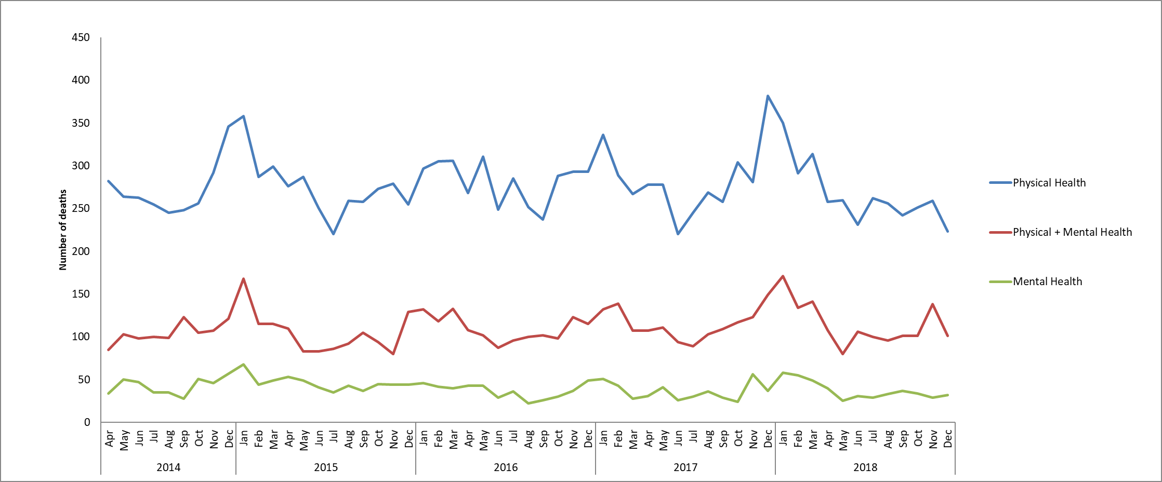

*Figure 3. Deceased patients by service type (for patients with open referrals and patients who were discharged but seen in the 6m prior to death).*

# Serious Incident Reviews

## 6.1 Summary of number of serious incidents and themes

In October & November of Q3, 2018/19, 15 SIs**[3]** were identified and reported (2 of which occurred in previous months, 1 in July and 1 in September). One SI was subsequently downgraded. Of the remaining SIs, 6 involved a death of which 4 are suspected suicides. A total of 7 SI investigations were completed, reviewed at panel and submitted to the relevant commissioner during Oct/ Nov.

The overall themes and learning from serious incidents are:

* Challenges continue with staffing levels, use of temporary staff and transfer of patients between care co-ordinators where staff turnover is high. This continues to have a negative impact on the quality and continuity of care for patients and the morale of permanent staff.
* Variable completeness and standards of documentation for example- assessments, MEWS, care plans.
* Permission to share appropriate information with family and carers is not sought frequently and is often not clearly documented within the Safety planning for patients at risk of self-harm or suicide.
* Transition points and communication between external organisations and services within the Trust have been raised as an area of concern in several SI investigations where the interface between record systems does not provide clinical staff with ready access to vital information.

## Timeliness of process

In 2018/19 no SI investigations have been completed/ submitted outside the submission date planned with the commissioner. The SI team will continue to focus on and give added support to authors during the draft phase of the reports to minimise the risk of this re-occurring.

## Developments to the SI process

The revised RCA training sessions have been positively received by attendees and will continue to be delivered over 2 consecutive days with a focus on human factors recognition, duty of candour and involvement of families and carers in the investigation process. A total of six 2-day sessions are being offered in 2018/2019. In Q2 17 different staff members led or supported serious incident investigations.

An internal audit was repeated in November 2018 and demonstrated evidence that all patients/families were offered an opportunity to be involved. In the SI’s, which were randomly selected, the results for Q3 show that 75% of IRR’s demonstrated that the patient and or family had been contacted to seek their views of the incident or death and in completed SI investigations, 100% of SI investigations demonstrated that either patients or family members had contributed their concerns to the investigation. The SI team will continue with an internal audit on a bi-annual basis to monitor if this improvement has been sustained.

Areas for future improvement: -

1. Families are engaged and involved in investigations
2. Learning is shared more widely across the trust.
3. How actions are completed and their impact assessed on preventing recurrence of incidents.
4. Assurance around when completed reports are shared with patients, family members and or carers.

The SI team will consider how best this information can be captured via the SI database and communicate this to the SI authors to assess against the expected standard of reports being shared within 10 working days of completion.

## Review of Serious Incidents

Prior to Q2 of 18/19 there had been a further reduction as below average numbers were reported in 11 of 12 months from July 17 to June 18, however, numbers have increased over three months recently, see figure 4.

The decline in serious incidents in 2016 was largely in relation to pressure ulcers. The reduction in the incidence of pressure ulcers in the Community Health Directorate (previously Older Peoples Directorate) comes because of a dedicated focus within community nursing teams to assess and advise their patients and carers on the signs of pressure ulcers and to put in place preventive measures.

In the category of ‘apparent/actual/suspected self-Inflicted harm’, numbers were average or below average for 12 of the 13 months up to July 2018, however, numbers have been more variable since then and 4 incidents were reported in November of 2018.

Of the serious incidents reported in October & November 4 occurred in Minor Injury Units, all were diagnostic incidents. These incidents have been reviewed in depth by the Urgent Care service and an assurance visit is planned by OCCG in January 2019.

Five of the October/November incidents occurred in AMHTS, 3 of which were in the Chiltern AMHT. This may reflect the increased demand on the AMHT with the referral rate rising month on month.

Since January 2018 5 serious incidents have occurred in the Chiltern AMHT, and 5 have occurred in AMHT Oxon City and NE, this is followed by the Abingdon Minor injuries unit where 4 serious incidents have occurred.

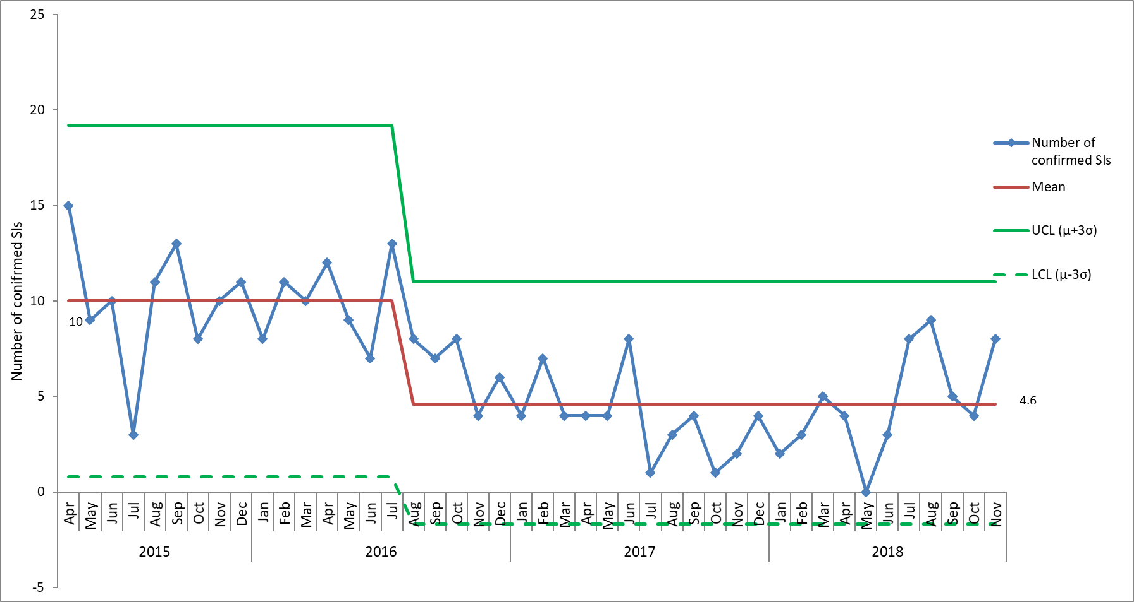

*Figure 4. Monthly numbers of confirmed serious incidents, based on date of incident, April 2015 – November 2018*

## Overdue Actions from Serious Incidents

There is a total of 31 overdue actions currently as 07.01.2019 across all directorates.

Regular reminders are sent to action leads and a regular report on all outstanding actions to senior managers. Work continues to ensure all actions are closed in a timely way.

# 7.0 Homicide Reviews

The Trust participates in multi-agency mental health homicide and domestic homicide reviews as appropriate. There are currently 8 active cases being independently investigated. There were 2 new DHR cases commenced in November 2018 and the requested information has been prepared in readiness for submission to the respective DHR panels.

In 2018/2019 a Mental Health Homicide review was commissioned by NHS England into the care of a mother who killed her child in March 2017. The review is looking at the care offered by three NHS trusts since 2011. The death of the child has also been subject to a Serious Case Review (SCR). The report from the SCR has been received for comment and the final report was published at the end of September 2018. The draft MHHR report has been received and is being commented on by the trust. A date for the final publication of the Mental Health Homicide review has not yet been confirmed by NHS England.

A 6-monthly update on every review is provided to the Quality Committee, this is next due in January 2019. A boarder review looking at themes across all multi-agency investigations (homicides, child serious case reviews and safeguarding adult reviews) will be presented to the Quality Committee in May 2019.

1. Restrictive Practice

* There have been no changes in trends for the overall use of restrictive practices across the trust. The previous reductions have been maintained.
* Violence and aggression from patients remains the main reason for using restrictive practices.
* Numbers of restraints were below average in October & November 2018, but a spike in incidents was seen on Cherwell ward in November 2018. This was linked to individuals on the ward requiring high numbers of restraints. Individuals with high numbers of restraint is always the main factor contributing to the wards that have the highest rates. This information is reviewed weekly to identify wards / individuals where there are ‘hotspots’ in order for support to be provided.
* Kestrel was the highest reporter of restraints, although has maintained its overall reduction since 2016.
* Health was the second highest course group for restraint incidences after violence and aggression with 46 incidences (20%) 34 of which were as a result of patients resisting treatment. Of these 24 related to a patient resisting medication on Cherwell ward. Further analysis of the higher level of incidents with the course group of health needs to take place to understand any learning.
* The reduction in prone restraint seen in 2016 continues to be maintained. The most common reason for Prone restraint continues to be IM medication. The PEACE team along with pharmacy are reviewing alternatives to prone restraint for administering IM medication, including efficacy of injection sites.
* There were 81 reported administrations of rapid tranquilisation, with 25 individuals. Cherwell had the highest usage with 45 incidents.
* In October/November 2018 the number of seclusions reported as incidents was 71, with 37 patients being secluded. Kestrel ward was the highest reporter.
* A Quality Improvement project is being undertaken on Phoenix, Kestrel, Kennet and Evenlode with a focus on looking at reducing violence and aggression and the associated restrictive practice.
* The PEACE work plan previously shared continues to be implemented.

1. Serious Incidents are nationally defined as incidents where there were acts or omissions identified in care that resulted in death, lead to abuse or serious harm requiring further treatment
2. This is based on information from October 2017 - March 2017.
3. Serious Incidents are nationally defined as incidents where there were acts or omissions identified in care that resulted in death, lead to abuse or serious harm requiring further treatment