CoG 08(i)/2019
(Agenda item: 14)

Membership Strategy
- – 2024
Executive Summary

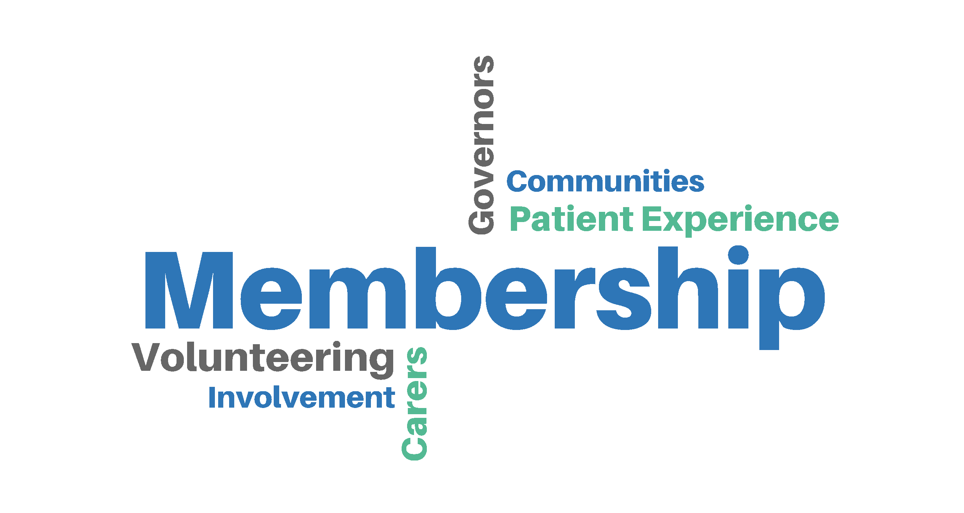



This strategy outlines our vision for membership at the Oxford Health NHS Foundation Trust. The members are our closest representation of the communities we serve, and are themselves represented within the trust by our council of governors.

- Aims of the strategy

  - Ensure that membership is meaningful and members feel they are making a difference

Membership is the way by which those who have an interest in the trust’s work and developments can stay informed and get involved to the extent they prefer.

We will inform our members about the trust’s strategy, current changes in mental health, learning disability, urgent and community physical health plus community services, and the challenges we face.

We will organise members-only events but also engage our partners and stakeholder groups to promote membership as a way to stay informed, have their voice heard and contribute to a community of like-minded people.

  - Ensure that membership is representative of the community served and that all constituency classes are given equal opportunity to become involved

Since its formation in 2002 the trust has expanded both geographically and in terms of services we provide. We will engage all service divisions within mental health and community health to promote membership, and work with our partners to recruit new members. The key message is that as a member you can have a say in your local services, most importantly through your governors.

We will articulate to patients, carers, staff and interested members of public how they can get involved and why it is meaningful both for them and for the trust. Staff are members automatically, but can opt out if they wish to.

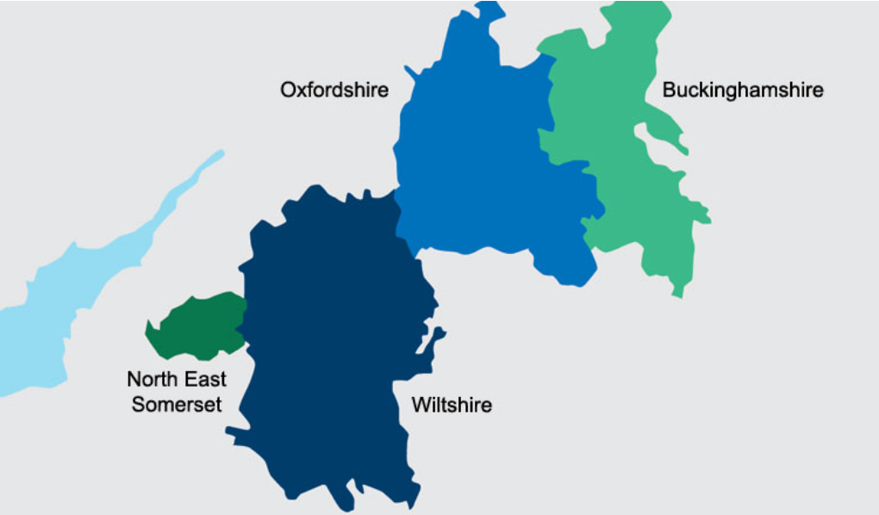

Counties where Oxford Health NHS Foundation Trust provides services.

  - Deliver a public membership that is realistic for size of population served and nature of the trust and that reflects the diversity of our population

As a foundation trust we need our members’ views when we are developing our services. We have set ourselves a target to grow our membership to reflect the size and diversity of population we serve.

We will tailor our communication and promotions in such a way that they convey what membership can mean to our audience locally or individually, and also why the trust wants their input – in other words, why their voice matters and how they can make it heard.

  - Deliver contested elections to the Council of Governors

Only members can stand for election to the Council of Governors, and becoming a governor is the main way in which they can directly influence the trust’s strategy.

This opportunity, and the role of governors, will be made clear in all membership promotions and related communications. Governors will be encouraged and supported to become ambassadors for membership, and we will facilitate two-way communication between members and governors.

- Responsibilities

The membership office is led by the communications and engagement manager. The responsibility for the recruitment and development of membership and the operational delivery of this strategy sits with the senior communications and engagement officer.

Overseeing implementation of this strategy falls with the Membership Involvement Group (MIG), which is a formal governor sub-group reporting up to the full Council of Governors.

Our success will require that membership office works effectively with other teams at the trust, particularly community involvement, volunteering and patient experience teams, HR, equality and diversity functions and the Patient Advice and Liaison Services.

- Measuring success

Membership Involvement Group will evaluate the success of the strategy. We will produce a detailed communications and action plan to follow the strategy, and will report quarterly to the MIG on our progress.

