CoG 8(ii)/2019
(Agenda item: 14)

Membership Strategy
2019 - 2024


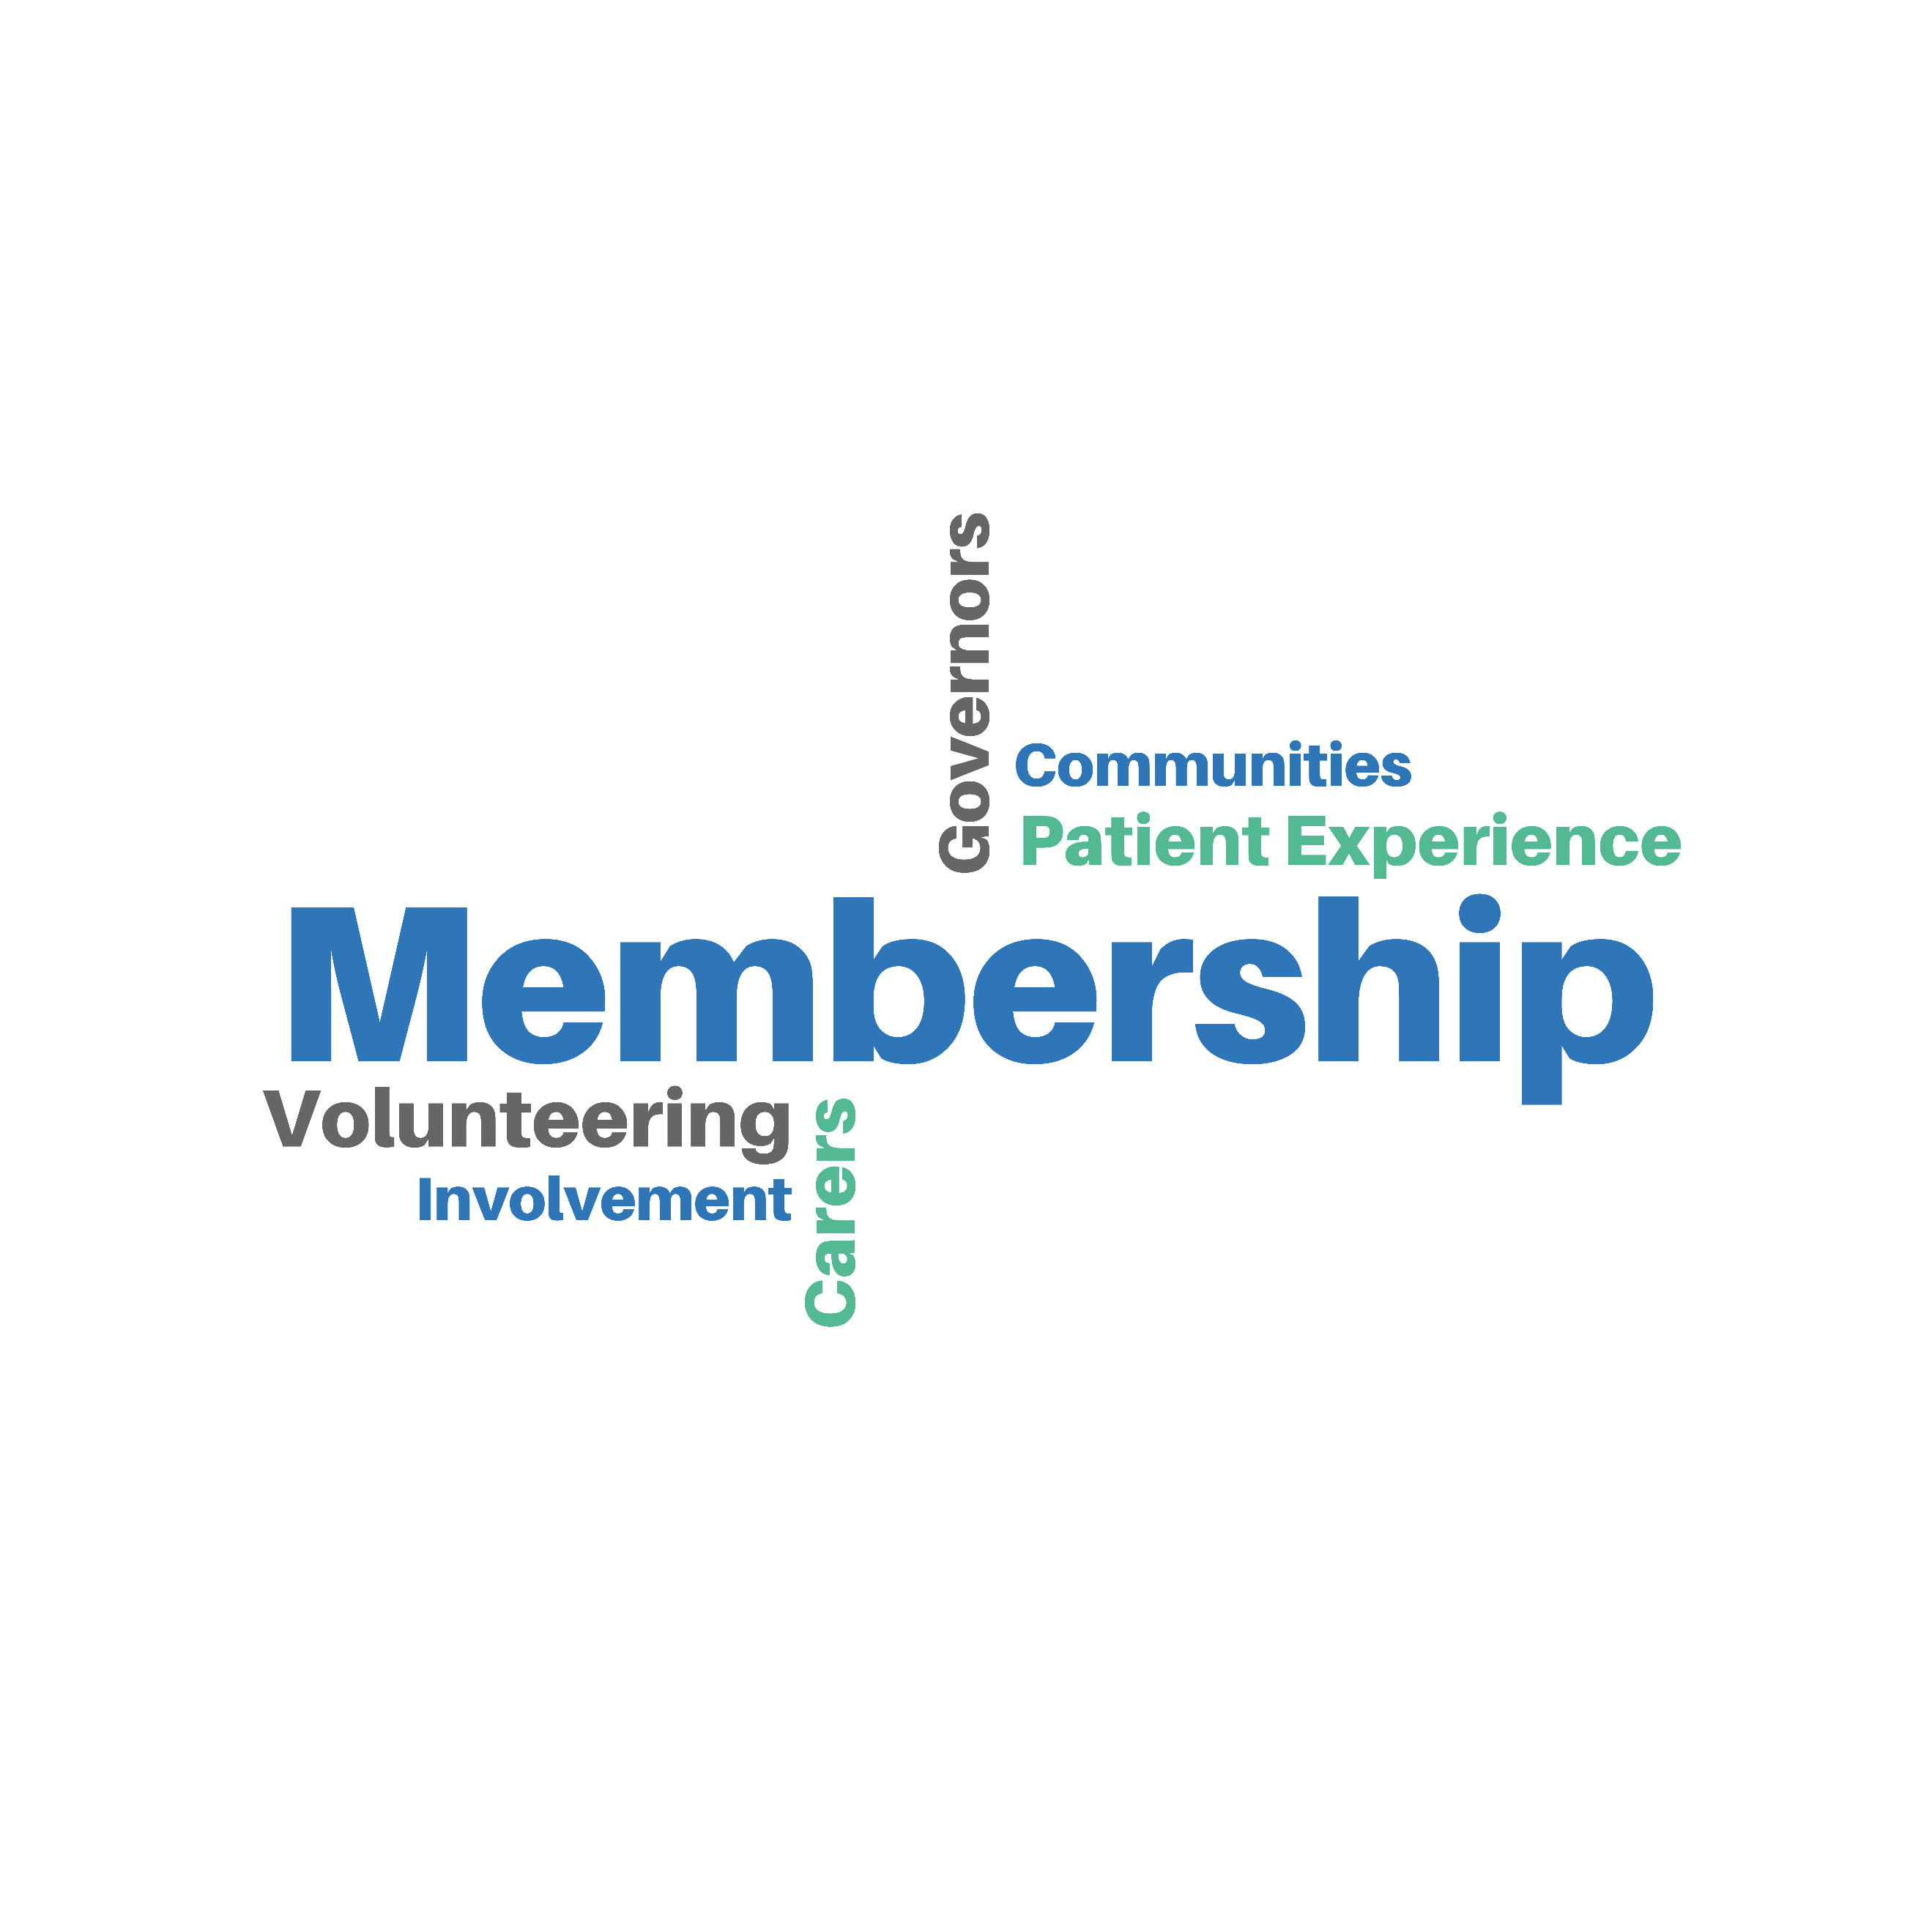

Purpose
We recognise the need to communicate and involve our public, specifically through our members – who we need to work with to ensure they are interested in developments at the trust and ultimately become involved. To do this we need a coordinated focused approach. For member communications to have an impact in the longer term, what the trust says and promises it will do needs to be followed by visible actions, involvement opportunities and continuous service improvements as a result. The trust will need to continue to listen actively and respond appropriately to its patients, staff, members and other stakeholders in order to make involvement ‘real’, and we recognise how fundamental membership is in enabling us to reach such wide audiences.

Only by creating a virtuous circle – where one positive relationship feeds another (i.e. where a member becomes a donor, a donor becomes a volunteer, a volunteer becomes an ambassador or a peer support worker and so on) - will we make the most of our limited resources to ensure that the relationship we have with our members supports the delivery of the trust’s mission, objectives and values and is directed to support the delivery of our multiple strategies.

This strategy outlines our vision for membership at the Oxford Health NHS Foundation Trust. The members, as our closest representation of the communities we serve, are after all the “owners” of the trust, and are themselves represented within the organisation by our council of governors who hold certain statutory decision-making powers. This document will outline the methods we intend to use to identify and develop a more effective, responsive and representative membership body for our Foundation Trust thereby connecting us, and our Council of Governors more closely and deliberately to our communities.

Membership provides the trust with a vehicle to discharge its responsibility to local communities of accountability for the services provided in their area. Members are able to make a valuable contribution to the way in which the trust is run and build on the trust’s successful past practice of user and carer involvement in service developments.

It is intended that this strategy mobilises an integrated membership communications, engagement and involvement approach – with clear objectives and deliverables that support the delivery of key corporate strategies - and that the appropriate team and resources be co-ordinated to ensure effective implementation of the strategy along with support from wider trust teams and from our governors.

As we raise our aspirations with regard to membership we will raise the expectations of these stakeholder groups and we will need to deliver tangible results for everyone to see. This strategy will help do that and should ensure widespread communication of, and involvement in, our successes and our improvement activity. Its success will depend on effective working through the communication and engagement lead for membership with the teams and services across the trust. Key relationships exist between this strategy and extant strategies

for community involvement; fundraising; volunteering; equality and inclusion; patient experience and the function of the Patient Advice and Learning Services and opportunities for alignment with these for membership development activity needs to be mobilised.

The purpose of this Oxford Health NHS Foundation Trust Membership Strategy is to set out the way the trust will increase membership of the foundation trust and develop the membership offer over the next five years, such that membership becomes a meaningful endeavour making a difference to the trust, its patients, service users and its community. It addresses how the trust recruits, engages, maintains and develops its membership community. It is expected to change over time and develop alongside membership itself.

Responsibility for overseeing implementation of this strategy falls with the Membership Involvement Group (MIG), which is a formal governor sub-group reporting up to the full Council of Governors. The sub-groups’ constituent members and departments include governors, Communications and Engagement, Community Involvement, Corporate Governance and Patient Experience.

Accountability for the effective delivery of this strategy sits within the directorate accountabilities of the Director of Corporate Affairs and Company Secretary, with responsibility for its delivery sitting with the Director of Communications and Engagement. The membership office is led by the Communications and Engagement Manager and the responsibility for the recruitment and development of membership and the operational delivery of this strategy sits with the Senior Communications and Engagement Officer.

Introduction
Oxford Health NHS Foundation Trust is committed to continuing to develop NHS foundation trust (FT) membership to engage and support members to participate fully in the activity of the trust and have their views considered when planning and shaping services. NHS FT’s were created to devolve decision making from central government to local communities. By becoming a member of Oxford Health NHS FT, people are able to have a say in how their local health services are developed and to support the trust in its ambitions to deliver outstanding care.

The membership should be representative of the trust’s patient, carer, public and staff communities. From these members, governors are elected who form the Council of Governors, who represent members’ interests and influence the way that services are developed. The trust is committed to resourcing membership and support for the council of governors appropriately.

All FT’s have a responsibility to engage with their local communities and encourage local people to become members. We need members in order to support and help shape the future of Oxford Health NHS FT and the services that we offer. In order to do so, our members should feel included, engaged and listened to in our work, allowing room for a healthy dialogue to take place.

Since becoming a Foundation Trust in April 2008 the trust has evolved to cover a larger geographical area and offer a wider range of services.

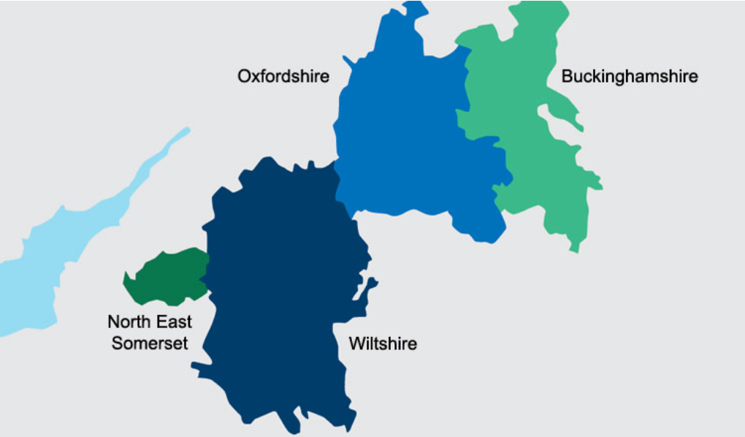

2008 | Expanded services, particularly Children and Adolescent Mental Health Service (CAMHS) and specialist services, which we now provide in Swindon, Wiltshire, and Bath and North East Somerset (BaNES) alongside Oxfordshire and Buckinghamshire.
2011 | Integrated with Community Health Oxfordshire (CHO) providing community health services to 640,000 people in Oxfordshire. This brought with it a change to the types of care offered to include both mental and physical care services.
2014 | Began providing a number of key mental health services in partnership with local professional and third-sector providers further expanding our ways of working and the network and diversity of experience of the people we serve.
2017 | Welcomed Oxfordshire Learning Disability Service which supports around 670 people with a learning disability aged over 18, their families, friends and carers, as well as other care providers.
2018 | Launched the NIHR Oxford Health Biomedical Research Facility – one of only two National Institute for Health Research BRC’s in the country focusing exclusively on mental health research and building upon the trust’s long-standing partnership with the University of Oxford.  In addition, the trust launched Oxfordshire School of Nursing and Midwifery continuing its 150 year nursing education relationship with Oxford Brookes University, also in partnership with Oxford University Hospital NHS Trust.

The Membership Strategy now needs to consider how staff, patients, carers, and members of the public in our communities can be better represented and involved in the work of the trust.

Furthermore, communication with our communities, through our membership, is not a ‘nice to do’, it is a strategic imperative. This is amplified by the requirement for health economies to create five-year plans by autumn 2019, to set out how they will improve services and achieve financial sustainability. Sustainability and transformation partnerships and integrated care systems will be expected to develop and agree their plans during the first half of 2019-20. Trusts are being given sufficient time to consider the outputs of the NHS long term plan in late autumn and the spending review 2019 capital settlement (in the spring); and to engage with patients, the public and local stakeholders before finalising strategic plans.

As a public benefit corporation, OHFT has both a statutory duty and a moral and strategic requirement to communicate with and involve our various stakeholder groups. For OHFT, this is more than just a way of protecting and enhancing reputation; it is more fundamentally a requirement of the way we operate.

Amplified in the guidance on section 242 (1B) of the NHS Act 2006, our duty to involve is clear, and service user involvement – patients, carers, the public and other key partners – must be moved from the margins to the mainstream with membership strategy aligned with our patient experience and involvement strategy.

The NHS Constitution underlines the fact that public and user involvement should be part of the fabric of the NHS and it talks about ‘having the right to be involved’. The guidance calls for NHS providers to think about proportionality and appropriateness, to understand and use a spectrum of involvement, and know when to use the different activities which range from giving information through to active participation in planning the provision of services. Membership is our vehicle to achieve this in a more targeted and focussed way.

It also reminds providers what good involvement practice looks like:
- It happens early and continues through the process
- Is inclusive
- Is informed
- Is fit for purpose
- Is transparent
- Is influential – it makes a difference
- Is reciprocal – includes feedback
- Is proportionate to the issue

Update on previous membership strategy
The previous Membership Strategy, as part of the trust’s application to become a foundation trust aimed to develop an active FT membership and establish a Council of Governors (consisting of Governors representing members and key stakeholders).

Recent achievements have included:
- a move to digital sign-up enabling members to self-apply online;
- communication with all members, including a regular magazine and monthly e-bulletin;
- opportunities for members to participate in health consultations and elections;
- opportunities for members to attend health information events;
- bringing the management of the membership database in-house, to help manage costs;
- a reconfiguration and data cleanse of the membership base ensuring members are assigned to the correct constituency and more likely to engage;
- improved member segmentation around protected characteristics, enabling colleagues to build a profile of existing members, in which to target specific information according to the type of activity or involvement each group or individual is interested in, i.e. trust events, elections, volunteering and sharing personal experiences of general health or long term conditions, to educate others;
- an established Council of Governors which undertakes its statutory duties and is helping to influence the direction of the trust;
- a refresh of all membership digital and non-digital marketing collateral and merchandise;
- membership information merged into the trust’s magazine, available in public areas, to enable non-members to learn more about membership, to increase involvement, as well as articulating the benefits of membership in each edition, and
- the annual governor elections, trust’s Annual General Meetings (AGM), Annual Member Meeting (AMM), Health Matters events, HealthFest and conferences have been used as a means to engage and recruit members;
- mitigated the impact of tighter data handling requirements resulting from the implementation of the General Data Protection Regulation (GDPR) (EU) 2016/679 in May 2018.

Even with these achievements, particular challenges still remain with more work required to develop the patient constituency and, more needs to be done to ensure that hard to reach groups are recruited to the membership, and given the support and opportunity to stand for election to the Council of Governors. This requires activity and engagement from more than the communications and engagement team and beyond the oversight function of the immediate Membership Involvement Group members.

The trust’s membership vision, aims and objectives
Membership Vision
We recognise that building a representative membership body is an opportunity for our organisation to learn from, respond to and cater for our stakeholders. It is also the ideal opportunity for the trust to build a loyal base of people who want to use and support this trust as patients, carers, members of the public, members of staff and volunteers.
However, we also recognise that for membership to really work we must offer benefits and reasons for people to join us in our work. Under our membership scheme, our members will:
- Be given the opportunity to get involved with trust activities to the level they choose through stratification;
- Be given the opportunity to change their level of involvement at any time according to their wishes;
- Be updated regularly on trust activities via the membership magazine and membership bulletins;
- Be given the opportunity to vote for their Governor representative;
- Be given the opportunity to stand for election to the Foundation Trust’s Council of Governors;
- Be given the opportunity to learn more about the trust and how it is run through regular talks and presentations, the topics of which should ultimately be chosen by members;
- Be included in consultations regarding trust and service developments – both internally for staff and externally for our public membership;
- Be given avenues to discuss topics informally with other members;
- Only members are able to be appointed to Non-Executive Director roles when vacancies arise.
Members taking on the role of Governor will:
- Receive training in relation to the role they are undertaking;
- Be supported in communicating with members and organisations within their constituency;
- Be expected to join governor sub-committees and working groups within the trust;
- Be expected to raise issues from the membership within Council of Governor meetings;
- Have the opportunity to broaden their knowledge in relation to:
          - the NHS as a whole;
          - the workings of the Foundation Trust;
          - the healthcare needs of the local community;
- Have the opportunity to work with the wider community (i.e. with other public, staff and partner organisation governors) in establishing a greater understanding of local healthcare needs.
Aims
This membership development strategy aims to:
- Ensure that membership is representative of the community served and that all constituency classes are given equal opportunity to become involved;
- Deliver a public membership that is realistic for size, population served and nature of the trust and that reflects the diversity of our population;
- Ensure that membership is meaningful and members feel they are making a difference;
- Deliver contested elections to the Council of Governors;

Objectives
Building on previous achievements, this strategy sets out the trust’s membership objectives that will deliver on the above aims, and lists a series of actions to help the trust achieve these over the next five years. It outlines how the trust will continue to build upon digital membership engagement as outlined in the NHS Five Year Forward View, encourage a genuine two-way relationship between governors and members and ensure that membership is diverse and representative of the areas we serve. This strategy will outline how the trust will monitor its progress to continue to develop an active and engaged membership.

Over the next five years the trust intends to:
Objective 1 – Grow membership in accordance with targets (detailed later) and continue to develop a more informed and engaged membership.
Objective 2 - Ensure membership information is widely and easily accessible
Objective 3 – Develop a representative membership that is diverse and inclusive
Objective 4 - Capacitate the Council of Governors to develop membership engagement realising the benefits of membership through a two-way relationship with members
Objective 5 - Empower members to act as ambassadors for the trust by sharing and highlighting membership and services both online and offline

- Membership targets
The trust is legally obliged and morally determined to continue to grow a representative membership. Based on analysis of previous experience, evaluation of earlier recruitment campaigns, comparison with other FTs, and advice from staff working within both mental health and community services, the trust will work towards the projected membership targets for each constituency as shown in Table 2.

Table 2 – Projected yearly membership targets by constituency
Constituency | Year
Constituency | 2018/19 | 2019/20 | 2020/21 | 2021/22 | 2022/23
Public
At year start (April 1) | 2,422 | 3,857 | 5,292 | 6,727 | 8,162
New members | 1,508 | 1,551 | 1,594 | 1,637 | 1,683
Members leaving | 73 | 116 | 159 | 202 | 245
At year end (March 31) | 3,857 | 5,292 | 6,727 | 8,162 | 9,600
Staff
At year start (April 1) | 6,110 | 6,110 | 6,110 | 6,110 | 6,110
New members
Members leaving
At year end (March 31) | 6,110 | 6,110 | 6,110 | 6,110 | 6,110
Patient
At year start (April 1) | 511 | 889 | 1,267 | 1,645 | 2,023
New members | 393 | 405 | 416 | 427 | 438
Members leaving | 15 | 27 | 38 | 49 | 61
At year end (March 31) | 889 | 1,267 | 1,645 | 2,023 | 2,400
Total  At year start (April 1)  New members  Members leaving | 9,043  755  88 | 9,710  708  108 | 10,310  726  126 | 10,910  744  144 | 11,510  762  162
Grand Total ending March 31 | 10,856 | 12,669 | 14,482 | 16,295 | 18,110
* Figures in italics are actual numbers from April 2018.

These targets will be reviewed on an annual basis once benchmarking data can be collated. They reflect an attrition rate of three per cent. All projections are based upon achievement of proceeding annual target.

These targets have been calculated using the following assumptions:

Our services treat more than 137,000 people a year and the core five counties we serve are home to 1.2 million people. We anticipate that people within our communities, including those who do not currently access our health services, will be willing to support the foundation trust as a public member.

We employ more than 6,000 staff (whole time equivalent more than 4,500) which includes medical staff, therapists, registered nurses, health care workers, support staff and 16 other types of professionals including dental staff, social workers and paramedics. We have over 260 clinical teams and operate services across over 150 sites. Staff are automatically enrolled as members, but have the option to cancel their membership if they choose.

Ensuring membership information is accessible

The trust will ensure membership information is readily available to members and people considering becoming a member. This includes increasingly making information available in a digital format in line with the NHS digital strategy.
Information is available via the trust’s website and throughout its locations and services in all the areas covered by the trust. For example:
- digital webpages, social media, email
- information will be widely distributed in a variety of formats, tailored to the interests and needs of different audiences, and will articulate the benefits of membership;
- membership materials will be clear, simple and engaging; and
- membership material will provide information and choices about how members can be involved with the trust;
- campaigns will take place targeting particular geographical areas or services, to ensure a representative socio-demographic mix of members;
- members can join the trust via online self-enrolment
- face-to-face recruitment will take place at patient forums and public events;

The rights and responsibilities of membership

Members have the right to:
- elect representatives to the council of governors;
- communicate with and be consulted by their elected governor;
- receive regular information from the trust about its plans and activities;
- be involved in the further development of specific services; and
- give feedback to the trust on how it is performing.

Members have a responsibility to:
- challenge governors if they do not feel that they have been adequately consulted on issues of importance that come to the council of governors; and
- acknowledge and respect that across the membership there will be a wide variety of priorities and views, and that the council of governors will seldom be able to accommodate the wishes and views of all members

Members making a difference

Members will have information, lived experience and, in some cases, networks, which could be of value to the trust. The intention is to make the best possible use of that expertise by:
- continuing to provide governors with the support and resources they need to communicate and engage regularly with members;
- maintaining transparent procedures to govern how members can be involved in service improvement and development projects;
- developing a management and leadership ethos across the trust which positively encourages members to offer feedback and suggestions for improvement, and which encourages managers to seek members’ ideas and opinions;
- helping members to communicate and engage with the wider community about the trust and its work; and
- enhancing feedback mechanisms for members to, without prejudice, express their views on the trust’s services and how it is performing, and;
- encouraging members to stand for election to the Council of Governors, which is the main way in which members can directly influence the trust’s strategy.

Maintaining an accurate and informative database of members

The trust recognised the need to maintain an accurate and informative database of members, and in 2016 purchased an off-the-shelf customer relationship management (CRM) system to manage its membership database in-house. This decision was based primarily on improving the quality of data, whilst aiming to increase efficiency and minimise costs. The CRM replaced the system whereby the trust outsourced the management and maintenance of its database to an external body.

This new CRM system has facilitated improved segmentation, targeting of prospective members, and also digital engagement with existing members on issues of specific interest to them. This new system also has the capability to track and measure multichannel campaigns, including email, social media, telephone and direct marketing campaigns. The CRM system has the capability to produce an array of reports including the annual membership report.

To ensure that the trust’s membership data is accurate, the trust has (in accordance with Data Protection law) from time-to-time used a credible data screening supplier to screen the membership data against The Bereavement Register, to identify members who have passed away and remove their details from the database. Data cleanse has also been conducted to remove members who have moved out of area and no longer wish to engage with the trust. This has resulted in a reduction of the number of public and patient members in the last year. However, going forward, the updated database will enable more meaningful membership engagement.

Defining the Membership Community
Developing a representative membership will require the trust to ensure that efforts are made to ensure that people from different backgrounds and circumstances are actively recruited as members.

April 2018 |  | Public members  (Total 2,422) | Eligible base population
Age | 0-16 | 2 | 252,602
Age | 17-21 | 4 | 73,444
Age | 22+ | 1,814 | 899,689
Age | Not stated | 602
Gender | Male | 1,011 | 606,124
Gender | Female | 1,392 | 619,610
Gender | Not stated | 19
Ethnicity | White | 1,806 | 1,030,674
 | Asian | 66 | 74,926
 | Black | 45 | 21,914
 | Mixed | 25 | 25,593
 | Not stated | 7

Oxford Health’s membership needs to reflect the ranges of communities the trust serves. For this reason, we will aim to recruit members from our wide geographic area.

We will monitor the membership, and will work to ensure that populations which are
under-represented are encouraged to become involved. We will do this by targeting communications in particular geographical areas and through actively recruiting e.g., through existing public engagement events in those areas. As our active membership grows we will also support our Governors in working to engage with our members.

Oxfordshire and neighbouring counties have lower levels of social deprivation than a number of other areas in England. There are, however, pockets of deprivation within for instance Oxford City. The trust will target particular recruitment campaigns at these areas as necessary so that its membership represents the whole community proportionately.

Younger members
The need to ensure a proportionate membership in terms of age also means that we will need to tailor specific campaigns to fill any gaps in our membership profile. We will develop sustainable plans for recruiting younger members. This is likely to include working with Article 12 members as ambassadors, and working with secondary schools and universities across Oxfordshire, Buckinghamshire and beyond.

Diversity
We are committed to supporting representation from black and minority ethnic communities and from white non-British communities. Where there are particular ethnic minority groups who appear to be under-represented in the membership in comparison to their presence in the population, every effort will be made to find ways of encouraging members of that particular community to join.

Involvement in community meetings may include presentations about health conditions of particular interest for certain ethnic minority groups. As with all trust leaflets, translations will be made of FT membership leaflets and other documents if requested. The standard membership form will take account of accessible information needs. We will work closely with the Head of Equality and Inclusion in order to meet these aims.

Infrastructure to support Membership Development
Whilst membership development is everyone’s business and will require ownership across the entire organisation, there is a clear and urgent need for a membership strategy and a dedicated resource to deliver it with a deliberate focus that reflects the priorities of the trust and supports the delivery, and interconnectedness, of other corporate strategies and ‘involvement’ teams.

The skills, techniques and experiences required to recruit a representative membership and to retain them by achieving good communication and engagement practice must be delivered by, and co-ordinated through the trust’s communication and engagement function, which has experience in surveying and monitoring opinion, consultation, providing information and understanding the communication process – who, when, where, why, what and for what outcome. This will also need support from the work of community involvement, patient experience, and governor leads.

It is important to recognise the membership is the platform through which we can more easily stratify, target, reach and understand our public because it should be representative of the public we serve. Therefore communication with members supports and complements the work that all staff and organisational representatives are doing every day to engage with our communities. Membership engagement is fundamental to achieving access to a representative sample of our communities with whom we can engage and involve more directly and meaningfully than we might attempting to reach our entire community in an untargeted way.

The membership development function within the Communications and Engagement team is being enhanced to provide resource and dedicated focus to tangibly contribute to the effectiveness and future success of membership by reconciling its goals with the expectations of the trust’s stakeholders. We should not deliver services without talking to service users and the public and involving them in the process. We cannot improve services responsively without consulting with the various publics. The Senior Communications and Engagement Officer role will focus on membership recruitment and development and on building relations with other trust teams and functions to integrate member development.

The aim of this membership strategy, and therefore the modus operandi of the roles that lead in its delivery, is to establish a deliberate, planned and sustainable effort to develop and maintain positive relationships and communications between the organisation and its public, and to increase membership in so doing.

A survey of FT membership as far back as 2007, then three years after inception of the Foundation Trust model, highlighted the importance attached by the public and patients to the quality of our services, as judged by the proxy of reputation which scored as the most important factor influencing choice. Promoting and protecting the trust’s reputation through the lens of quality services needs to be integral to everything the trust does. The trust’s membership target to have over 10,000 members will prove to be an increasingly useful and powerful perspective on service delivery and service development, and the strategy is to harness this powerful voice.

In order to deliver the trust’s Membership Strategy objectives, the Senior Communications and Engagement Officer will mobilise the support of the Corporate Governance Officer responsible for governor engagement and involvement; the Community Involvement Manager responsible for fundraising and voluntary services, and for community involvement; the Patient Experience team responsible for engaging directly with patients and service users, the Head of Inclusion responsible for equality, diversity and inclusion, and directly with governors who have a responsibility to engage with their members.

It will also be important to engage and involve the wider directorate teams and corporate service functions, given that public engagement needs to be everyone’s business, especially when re-designing services or models of healthcare.
Strategic direction and support will be provided by the Director of Corporate Affairs as the lead executive, with day to day leadership and support from the Director of Communications and Engagement and the Communications and Engagement Manager undertaking direct line management of the membership role.

Delivering the Strategy’s Objectives

The below summarises the main actions that the trust will take to successfully deliver the objectives of this Membership Strategy.
A communications and action plan with timescales will follow the approval of the strategy.

Objective 1 – Grow membership and continue to develop a more informed and engaged membership.
Action | Lead
Increase membership across all categories, recognising staff are co-opted as members as part of their employment with the trust.  - Ensure that all new staff are informed of their membership status and option to Opt-out  - Develop a system to contact departing staff members (leaving the trust) to become members of the public constituency  Establish a membership advocate scheme and processes to engage all service divisions within mental health and community health services to promote the benefits of membership and to recruit patient members by:  - Sharing information about FT membership at staff meetings and events;  - Promoting the benefits of FT membership to patients;  - Working with staff to identify appropriate and effective ways to inform, engage and recruit patients;  - Working with staff to identify member involvement with the trust, i.e. patients / service users / carer interested in standing as governor; and  - Working with staff to identify ways to develop the membership ambassador scheme.  - Working with internal and external partners to move towards opting in membership of a wider range of people working with the trust in all capacities, e.g. volunteers, service user groups, third sector.  Enhance the variety of additional media for communicating with members - including online notice-boards on the trust website, focus groups and questionnaires to get feedback about the member magazine and bulletins; attendance at local service user and carer forums, articles for inclusion in newsletters of partner organisations, notification of events etc. This work is ongoing to make this function more focused and relevant to members’ interests.  Priorities will be set for targeted recruitment campaigns, and strategies and initiatives will be reviewed to ascertain their effectiveness, especially where these relate to attracting the more difficult to engage populations. Continued communication with local communities and stakeholder groups, including service user and carer forums and local networks will form the backbone of the promotional work, supplemented by targeted recruitment campaigns where appropriate. | Senior Communication and Engagement Officer  Supported by: Community Involvement, Patient Experience Team, Patient Advice and Liaison Service, Spiritual and Pastoral Care, E&I team, Governors
Further develop service user/patient and governor involvement links to:  - enable governors to share information and promote the benefits of FT membership to patients out in the community encourage them to become members.  - Ensure each service within the trust which has identified a Patient Experience Lead is encouraged to act as a focal point so that patient and public involvement activity, includes membership involvement/development activity.  In order to recruit more service user and carer members will work with local services for them to assume a greater role in promoting membership to the people they come into contact with through their clinical work. By highlighting the areas where members can get involved this should encourage more people to become members. | Senior Communication and Engagement Officer with support from:  Community Involvement; Patient Experience leads; Carers Lead, Corporate Governance Officer and Governors
Work with the Patient and Liaison Services (PALS) to engage with and recruit potential members by:  - Establishing appropriate systems to recruit patients and carers who have already expressed views about the trust’s services. | Senior Communication and Engagement Officer  Supported by:  Patient Advice and Liaison Service
Work with Patient Experience to engage and recruit potential members by:  - Establishing appropriate systems to inform and recruit patients and carers participating in activities such as Taking Action From Patient Feedback forums to share views about the trust’s services.  - Establish membership as a conduit to providing patient feedback. | Senior Communication and Engagement Officer supported by:  Patient Experience Team
- Work with Spiritual and Pastoral Care to engage and recruit potential members by:  - Establishing appropriate systems to inform and recruit patients and carers accessing spiritual and pastoral care to share views about the trust’s services.  - Establish membership as a conduit to providing patient feedback. | Senior Communication and Engagement Officer  Supported by:  Spiritual and Pastoral Care
Work with Community Involvement Manager regarding trust volunteers and charity to engage and recruit potential members by:  - Establishing appropriate systems to inform and recruit volunteers and fundraisers as members.  - Establish membership as a conduit to becoming a trust volunteer. | Senior Communication and Engagement Officer  supported by:  Community Involvement Manager.
Develop communications between the trust and partner educational/training/recruitment organisations to inform and recruit potential members e.g..  - The University of Oxford  - Oxford Brookes University  (Oxford School of Nursing and Midwifery)  - New Buckinghamshire University | Senior Communication and Engagement Officer with support from:  Community Involvement, Research and Development team, Partnership Manager, Governors (incl partner governors)
Identify and develop links between the trust research partners to inform and recruit potential members, e.g.  - Department of Psychiatry, University of Oxford  - The Oxford Institute of Nursing, Midwifery and Allied Health Research (OxINMAHR)  - for Leadership in Applied Health Research and Care Oxford ( CLAHRC)  - NIHR Oxford Health Biomedical Research Centre  NIHR Oxford cognitive health Clinical Research Facility  - NIHR Clinical Research Network: Thames Valley and South Midlands (CRN: ThamesValley) | Senior Communication and Engagement Officer with support from:  Research and Development team, Governors
Continue to use Patient / Service User / Carer surveys as a means to promote the benefits of FT membership and recruit more members. | Senior Communication and Engagement Officer with support from:  Community Involvement, Patient Experience Team, Patient Advice and Liaison Service, Corporate Governance Officer, and Governors
- Identify public events associated with community health services across the public constituencies, in which to promote FT membership, its benefits and to recruit public members associated with these areas and constituencies; and  - On an ongoing basis, develop and implement targeted campaigns to recruit people interested in health services. | Senior Communicationand Engagement Officer with support from:  Community Involvement, Patient Experience Team, Governors, Directorates, Partnership lead

Objective 2 - Ensuring membership information is widely and easily accessible
Action | Lead
Make sure membership information is widely available in all major trust sites, i.e. reception areas, wards, community health services and within the trust’s operational areas, i.e. café/restaurant, libraries, universities and colleges, and within stakeholder communications and sites. | Senior Communication and Engagement Officer with support from:  Governors and Directorates
Continue to hold or attend public events in which to share information about the trust’s services, engage with members of the public face-to-face and recruit new members. | Senior Communications and Engagement Officer with support from:  Community Involvement, Patient Experience Team, Engagement and Involvement Team, Governors
Continue to make membership information available electronically via the trust’s website, intranet, and social media platforms. | Senior Communications and Engagement Officer
Ensure that membership information promotes and explains the benefits of membership involvement and provides a number of different involvement opportunities within the trust. | Senior Communications and Engagement Officer supported by:  Community Involvement, Patient Experience, Patient Advice and Liaison Service, Spiritual and Pastoral Care, Governors.

Objective 3 – Develop a representative membership that is diverse and inclusive

Action | Lead
Develop existing and emerging trust delivery partnerships and member organisations to engage and recruit potential FT members including a mass invitation of members and staff to trust membership.  E.G.  - Team Oxford  - Oxfordshire Mental Health Partnership  - Restore  - Response  - Oxfordshire Mind  - Connections  - Ellmore  - Oxfordshire and Buckinghamshire CAMHS partnerships  - Barnardo’s  - Autism Family Support  - Response  - Oxfordshire Youth  - SOFEA (South Oxfordshire Food and Education Association)  - TRAX  - RAW  - Ark T  - Synolos  - BYHP (Banbury Young Homeless Project)  - Oxfordshire Recovery College  - Buckinghamshire Recovery College | Senior C&E Officer supported by:  Community Involvement, Patient Experience Team, Research and Development team, Partnership Manager, Governors
Identify and establish links with existing community based patient and carer involvement / support groups eg listed below to increase the number of members:-  - League of Friends;  - Long term conditions support groups, that support diabetes, Parkinson’s disease, asthma, cardiac, ME, cardiac conditions;  - Physical health voluntary groups;  - Ridgeway Carers Support Group;  - Mental Health Service User and Carer Forum; and  - Voluntary led Carer, Service User / Patient groups. | Senior Communications and Engagement Officer supported by:  Community Involvement, Patient Experience Team, Partnership Manager, Carers Lead, Governors.
Identify and establish links with existing BAME community-based patient and carer involvement / support groups and community groups to inform and recruit members.  Translation and interpretation needs of members will be identified to ensure that those for whom the English language is problematic or have learning disabilities are not excluded from engagement. Further work will be undertaken to flag these needs on the membership database. Links will be made with local community groups to establish closer relationships to promote mental health issues and use as an opportunity to promote membership amongst communities which might otherwise not readily engage. | Senior Communications and Engagement Officer with support from:  Community Involvement, Patient Experience Team, Partnership Manager, Head of Equalities and Inclusion, Governors
Establish appropriate systems, resources and membership offer to inform and recruit members aged 12 to 18 including the creation of a youth liaison governor on the Council of Governors to enable young people to have a voice in the FT and services. | Senior Communications and Engagement Officer supported by:  Corporate Governance Officer, Community Involvement, Patient Experience CAMHS, Governors
Create FT information leaflets in Easy Read for people with Learning Difficulties. | Senior Communications and Engagement Officer supported by:  LD service and LD service users

Objective 4 - Capacitate the Council of Governors to develop membership engagement realising the benefits of membership through a two-way relationship with members

Action | Lead
Continue to provide support to new and existing governors to support membership recruitment and identify any training needs. | Corporate Governance Officer, with support from governors.
Support Governors in actively engaging with their constituents. | Corporate Governance Officer with support from:  Senior Communications and Engagement Officer, governors.
Use the monthly members e-bulletin to enable members and governors to communicate with each other and share information about the trust, and develop ways to have an input toward the development of the trust’s services. | Senior Communications and Engagement Lead and Corporate Governance Officer supported by:  the governors
Continual review of governor induction programme to ensure understanding of the role of governors in membership development. | Director of Corporate Affairs and Company Secretary

Objective 5 - Empower members to act as ambassadors for the trust by sharing and highlighting membership and services both online and offline

Action | Lead
Member Involvement Group members commit to provide updates to the Communications and Engagement Team to be shared externally and internally to empower members to share information about the trust’s services, communicate with governors and engage other people to be involved with the trust. | Community Involvement, Patient Experience Team, Governors, Corporate Governance supported by Communications and Engagement Team.
A governor to provide a monthly report of their activity on behalf of members for the membership e-bulletin. | Governors, Corporate Governance supported by Communications and Engagement Team.
PALS and Patient Experience to share the benefits of membership with patients and families, empowering them to share with others. | Patient Experience Team,  PALS
Identify members with a keen interest in supporting the work of the trust to act as member ambassadors.  - Record more specific member involvement interests on the membership database in order to identify potential member ambassadors.  - Consider other sources to identify potential member ambassadors, i.e. members already involved in trust service design and planning groups.  - Membership Involvement Group to create a governance framework to support the training and development of member ambassadors, and set out the principles of their role. | Senior Communications and Engagement Officer supported by:  Community Involvement, Patient Experience Team, Governors, Corporate Governance Officer

Evaluating Success
The Board of Directors and Council of Governors will approve the membership strategy and will review progress on at least an annual basis, examining whether adequate resources are provided for its implementation.

Key performance measures to be used in monitoring progress will include:
- membership analysis reports, covering numbers, age, gender, ethnicity and geography as a minimum;
- turnover of membership;
- membership engagement in activities;
- governor election data; and
- surveys of members’ views.

The Membership Involvement Group will oversee and evaluate the success of the Membership Strategy.

The MiG’s oversight of this strategy will include receiving reports on:
- number of new members recruited
- number of membership communication activities targeted to a specific group in our communities identified in this strategy
- feedback from governors who attended/participated on their specific involvement, including a tally of number of governors who participate
- evaluation metric which counts the number of membership activities and members recruited by MIG teams, for example: number recruited via volunteering, by participating in patient experience, by raising money for Oxford Health Charity, by governor elections.
- Information regarding member only events; member surveys; feedback opportunities via surveys etc through member communications
- ongoing breakdown of member profiles – age, gender, diversity, socio-economic and geographic

Qualitative benefits:

- Strengthening our duty to involve in line with legislation and the NHS Constitution to build mutually beneficial relationships with all stakeholders (moving people from casual to committed supporters).

- Recruitment and retention of increasingly proactive Members who get involved in service development, consumer research and become donors/volunteers.

- Increasing evidence of patient-led service development – you said, we did and learn lessons from the people who use our services. If you said and we didn’t, we communicate and explain.

- Employer of Choice – more people have heard of us and want to join us on our exciting journey.

- Supportive and engaged patients/visitors – we care what they think; they know they can have their say; we encourage criticism, comments and compliment. We don’t always get it right, but we are learning and improving

- ‘Getting Involved’ will encourage the virtuous circle. Working as a team who have close relationships with volunteers, members (and governors), donors, community groups, patients, the general public and staff, we should not miss an opportunity to engage with stakeholders and we should deliver a consistent view of OHFT at any one time.

- Informed employees, governors and members – those who have consciously chosen to be part of the trust, need to become able ambassadors for the trust. By galvanising and mobilising the collective power of members particularly through the articulation of the trust’s key successes and how they contributed to them, and thus the benefits of a local healthcare trust in order to maximise their awareness and, therefore, their influence within the local healthcare sector.

- Persistent communication of a distinct, consistent, persuasive, engaging and aspirational brand will ensure an understood and recognised identity through periods of transformational change, thus ensuring members are clear the trust’s mission and ambitions.

Conclusion

We need to work with our membership to develop two-way communication which means we learn from each other and we have mutual benefit from being involved. We need member input to develop services, to shape strategy, to engage in consultation at many levels and members want a trust that meets (and exceeds) expectations, particularly as when they need us, they are at their most vulnerable.

Whilst there will always be work to do in recruiting members, particularly from underrepresented groups, the main focus must be on developing the mutually beneficial relationship and ensuring there is a cohesive approach to membership development.

To ensure the opportunities to develop mutually beneficial relationships are maximised, a more rounded and inclusive approach to membership development will tap into the virtuous circle that takes the role beyond engagement primarily with the membership base. With communications, community involvement and patient experience teams, PALs , membership and volunteering, to name but some participants, all focused on OHFT reaching out into the community, to coordinate the effort and impact, we should coordinate the activities and ensure everyone can see the benefits of ‘getting involved’ with OHFT.

Appendix

Membership constituencies

The trust has continued to develop an actively engaged and involved membership currently drawn from the following group(s):
- Public constituency– members of the public that live in Oxfordshire, Buckinghamshire or the rest of England and Wales;

- Service user or carer constituency – members who have used any of the trust’s services as a patient or service user within the five years immediately preceding the date of application, or if they care for someone who has used any of the trust’s services within the five years immediately preceding the date of application;

- Staff constituency – members of staff working for the trust or who are seconded to the trust, i.e. county council employees.

Members must be aged 12 years or over and can only become a member of one constituency.

Anyone eligible to be a member of the staff constituency is automatically enrolled as they join the trust and are not be able to register as a member in any other constituency, unless they are appointed on an honorary contract. Staff have the option to opt out of trust membership. Individuals on honorary contracts with the trust who are also eligible to register in the public constituency may choose which category of membership they wish to join.

Specific criteria relating to membership may be found in the trust’s constitution.

Member representation on the Council of Governors

The structure of the council of governors has evolved as the trust has expanded to more fully reflect the organisation and our communities as a whole.

Each membership constituency is broken down into classes. Members belong to a particular class (so long as they meet the relevant criteria) and are able to elect governor(s) to represent their constituency and class on the council of governors.
Table 1 shows the structure of the current council of governors.

Table 1 – Current structure of the council of governors.

Board of Governors
Constituency | Class | No of governor seats
Public | Oxfordshire | 7
 | Buckinghamshire | 4
 | Rest of England | 1
Patient | Service-users/patients Oxfordshire | 2
 | Service-users/patients Buckinghamshire and other counties | 2
 | Carers | 3
Staff (subject to change following restructure) | Adult services | 2
 | Older People's services | 4
 | Children and Young People's service | 2
 | Corporate services | 1
Subtotal elected |  | 28
Appointed governors
Oxfordshire Clinical Commissioning Group |  | 1
Buckinghamshire Clinical Commissioning Group |  | 1
Oxfordshire County Council |  | 1
Buckinghamshire County Council |  | 1
Oxford Brookes University |  | 1
Buckinghamshire Healthcare Trust |  | 1
Buckinghamshire Mind |  | 1
Age UK Oxfordshire |  | 1
Oxford University Hospitals NHS FT |  | 1
Total appointed |  | 9
Total governors |  | 37

Patients may be members of either the patient or public category according to their choice.

Article 12 is an involvement group for under 25-year-olds.
The Rest of England and Wales class is designed to allow the following people to join: those associated with Wiltshire, Swindon and BaNES CAMHS; and people from across Wales and England who access or are interested in our specialist services, such as our forensic services.

