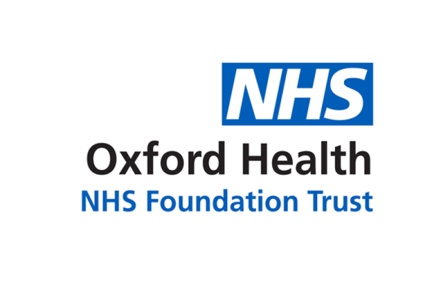

# Report to the Meeting of the

# Oxford Health NHS Foundation Trust

**BOD 11/2019**

(Agenda item: 14)

# Board of Directors

**31 January 2019**

**2018/19 OPERATIONAL PLAN – Q3 update**

**For: Information/Discussion**

**Executive Summary**

NHS Trusts are required by NHSE/I to produce 1 year operational plans and to monitor on progress against the plan. OHFT submitted its 2018/19 Operational Plan in April 2018. This report provides an update on the key sections of the plan for Q3 2018/19 for Board information and comment.

**Governance Route/Escalation Process**

This report has been prepared for Board only.

**Statutory or Regulatory responsibilities**

NHS Trusts are required by NHSE/I to produce 1 year operational plans and to monitor on progress against the plan. Progress against the plan can inform Trust planning activity and Board assurance measures including the Board Assurance Framework (BAF).

**Recommendation**

The Board is asked to note and discuss the report and provide comment on any areas of feedback and/or actions to inform Trust activity and planning.

**Author: Ben Cahill (compilation of content sourced from relevant service)**

**Lead Executive Director: Martyn Ward (Director of Strategy & CIO)**