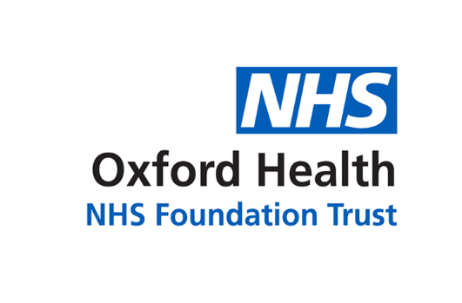

# Report to the Meeting of the

**CoG 15/2019**

(Agenda item: 13)

# Oxford Health NHS Foundation Trust

# Council of Governors

**12 June 2019**

**Governor Elections**

**For: Information**

**Executive Summary**

The Council of Governors’ election process this year began with nominations running from 18 March – 16 April. Candidates’ statements were published from 17 April and polls opened 9 - 30 May, with results posted on 31 May 2019.

There were 15 vacancies, and 13 governors were elected. Seven seats were filled uncontested, and six in a contested poll. Two seats – in the public constituency in Buckinghamshire - remain vacant.

The election was run independently from the Trust by Electoral Reform Services, and promoted through media, web, social media, press, events and advertising, by the Trust’s Communications and Engagement team.

**Recommendation**

The Council of Governors is invited to note the report.

**Author:** Katariina Valkeinen, Senior Communications and Engagement Officer

**Lead Director:** Lorcan O’Neill, Director of Communications and Engagement

**Lead Executive Director:** Kerry Rogers, Director of Corporate Affairs

1. **Membership engagement in the election and results**

The Trust had 15 seats up for election, which attracted a total of 21 candidates.

Thirteen governors were elected. Two seats remain vacant; these are in the public constituency in Buckinghamshire. Four of the governors were re-elected and nine are new to the role.

The table below shows engagement and results by constituency and class.



1. **Election timetable**

The election was managed by an independent company Electoral Reform Services. The election timetable was as follows:

Nominations opened 18 March 2019

Nominations closed 16 April 2019

Polls opened 9 May 2019

Polls closed 30 May 2019

Results published 31 May 2019

1. **Communications and promotion of the election**

The nomination period and voting period were promoted by:

* weekly features and news stories on the Trust website;
* related posts on social media: Facebook, Twitter, LinkedIn;
* weekly stories on the Trust intranet and in the all-staff email newsletter;
* press releases to local media in three counties; and
* two governor evenings – Oxford and Buckinghamshire – which were promoted online, through the Membership Matters newsletter, in the Daily Info and Oxford Mail events listings and by press releases. Thank you to governors Madeleine Radburn and Geoff Braham who joined the governor evening in Oxford.

Apart from promoting the election itself, our communications featured the following topics:

* What does the role of the governor entail – how much time do I need to put it?
* Am I qualified to be a governor? Explaining that you don’t need to have any formal qualifications, just be a member and have an interest in developing our Trust, but there are certain disqualifying criteria
* What inspires our current governors? Thank you to governors Alan Jones, Abdul Okoro, Richard Mandunya, Neil Oastler and Soo Yeo for taking part in this feature.

In internal communications we clarified to staff how the recent changes in Trust directorate structures affected where they could stand as a candidate, explaining how the new directorate structure relates to the classes in the staff constituency.

The results of the election, along with the successful candidates’ statements and photographs, were published soon after lunchtime on Friday 31 May. This was done online on our website and intranet, in social media and by press release to our news desk contact list across all counties served.

**RECOMMENDATION**

The Council is invited to note the report*.*