

**BOD 19/2019**

(Agenda item: 5)

# Report to the Meeting of the

# Oxford Health NHS Foundation Trust

# Board of Directors

**27th February 2019**

**Monthly Performance Report – M10 January 2019**

**For: Information**

**Executive Summary**

This report summarises and provides assurance against the Trust’s national and locally contracted key performance indicators (KPIs) for Month 10 (January 2019). Overall, the Trust achieved 219 of the 297 targeted indicators (74%). This is broadly consistent with the performance achieved since the start of the financial year and reflects the ongoing pressures (particularly a lack of a workforce).

**Performance Trend:**

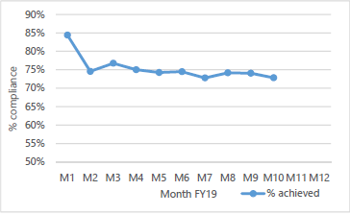

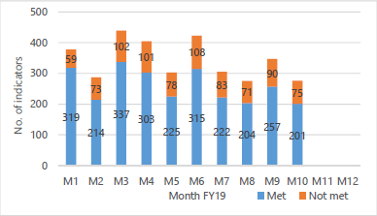

The number of locally contracted indicators varies throughout the year as is illustrated in the graph above. This is due to some indicators only being reportable on a quarterly basis. Of the 75 indicators not met, 36 were more than 10% away from the commissioner defined target and almost half of those were due to a lack of workforce.

**Areas to highlight to the Board from an overall Trust perspective**:

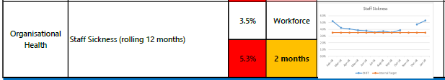

There was an increase in staff sickness reported via the national Single Oversight Framework in September and that trend has continued throughout the winter months. The national targets do not appear to adjust for seasonal fluctuations and further details on sickness is included in the Workforce Management Reports.

**National Position:**

The table below shows how the Trust is performing against the **operational performance** indicators within the NHSI Single Oversight Framework (as at the latest available position) and how performance also compares to the national average. The Trust is achieving all indicators with the exception of Out of Area Placements (OAPs) which continue to be a major issue for the Trust and is due to a lack of community alternatives.



**Local Position:**

**Patient Access and Patient Flow**

The table below shows performance in relation to the Trust’s core mental health community services concerning demand, patient access and patient flow. Key headlines;

* **Demand**

The number of **Adult Mental Health** referrals received in **Oxfordshire** is significantly higher than Buckinghamshire (42% in January), despite comparable population sizes

The number of referrals received by the **Oxfordshire CAMH service** continues on an upwards trend with referrals having increased significantly since the start of the year. The service received over 1000 referrals in January which is the third highest figure this year to date. This is having a direct impact on patient access to the service and increasing waits. **Overall referrals to the Trust’s CAMH services across Oxon, Bucks and BSW were 2215 in January; the third highest overall figure year to date.**

* **Access/Waits**

Access to the Oxfordshire CAMHS service continues to be challenging, with only 32.3% of patients who were referred on the routine pathway being seen in January within 12 weeks and 60% of patients referred on the urgent pathway being seen in January within 1 week. This is a direct result of the increase in demand on the service. Emergency referrals are being prioritised within available resources and all patients are seen within the 4 hour target.

* **Delayed Transfers of Care (DTOC)**

A significant number of bed days have been lost this year to date due to DTOC; 2026 days in mental health and 12,577 days in community. This equates to 7 beds in mental health and 46 beds in community.



**S75 Agreements with Oxfordshire County Council and Buckinghamshire County Councils**

The Trust achieved **100%** compliance against the indicators for Oxfordshire and Buckinghamshire for January 2018. Reports are one month in arrears.

**Performance by Directorate in January 2019:**

**Oxfordshire, Swindon, Wiltshire & BaNES – All Ages Mental Health** achieved 77 of the 114 targeted indicators (68%).

**Highlights for the Board:**

1. **Emergency Department Psychiatric Service (EDPS)** – Horton General Hospital (HGH). Staffing pressures have resulted in a number of breaches of the 60 min and 90 min waiting time targets at the HGH. The pressures will be reported to the Quality Review Meeting (Oxfordshire CCG) so that risk to patients can be understood and mitigated.
2. **CAMHS Waiting Times (Wiltshire)** – Although there was some steady improvement seen in 4 week (first appointment) and 8 week (referral to treatment) waiting times in Wiltshire, performance appears to have taken a sharp decline in December and January. Further work to confirm data accuracy is now underway.
3. **Adult Mental Health (OXON)** – A significant underfunding of mental health in Oxfordshire has resulted in considerable pressure building up for mental health services. **The Trust was not able to achieve the originally contracted 4 week waiting time target for routine referrals and is now under pressure to achieve even the 8 week target.** This position continues to be discussed with Commissoners.
4. **Children & Young People Mental Health (OXON)** – Although Oxfordshire has been awarded additional funding through the national trailblazer scheme, **further investment is still required to meet the existing demand** and to achieve the national access and treatment targets. As with the position reported for Adults, **the Trust will not be able to respond to the existing demand and achieve all of the required targets unless further investment is received**. This position is being discussed with Commissoners.
5. **GP Outpatient Letters sent within 10 days** – Performance against this target continues to improve and the trajectory suggests compliance within the next month or two. However, at a national level, the NHS target has been changed and the Trust will be required to send letters within 7 days from March 1st. Staff are being reminded of the need to ensure that letters are sent in a timely way but this change of target is likely to result in a further period of non-compliance. Work is underway within the Trust’s IM&T Service to support productivity and efficiency improvements.

**Buckinghamshire – All Ages Mental Health** achieved 32 of the 47 targeted indicators (68%).

**Highlights for the Board:**

1. **Memory Services** – Performance continues to improve since the low reported in September 2018 and if the trend continues, the service will achieve their target of 85% in either March or April 2019.
2. **Care Reviews (Clusters)** – A new dashboard is currently being piloted prior to rollout within front line teams. The aim is to proactively provide clinicians with a view on when care reviews need to be carried out. The pilot is expected to complete in late February and then a review carried out in March to decide next steps. A further update will be provided in March 2019.

**Oxfordshire Community Services Directorate** achieved 31 of the 43 targeted indicators (72%).

**Highlights for the Board:**

1. **Physical Disabilities Physiotherapy Service (PDPS)** – Due to a significant increase in referrals to the PDPS service (Parkinson’s patients) the Trust has not been able to achieve the waiting time targets. This has been discussed with commissioners and further investment has been requested. To date, no additional funding has been available so the waiting time targets continue to be suspended. The number of patients referred continues to be high and waiting times are increasing due to the additional pressure.
2. **Oxfordshire and Buckinghamshire Continuing Health Care (CHC**) – Detailed discussions are now underway with commissioners in Oxfordshire and Buckinghamshire to resolve a number of long standing issues in both counties. A new specification for CHC services was drafted by commissioners and following a PIN (procurement information notice) there has been some interest from the market so commissioners will undertake a procurement exercise.

**Specialist Services** achieved 61 of the 72 targeted indicators (85%).

**Highlights for the Board:**

1. **Eating Disorders (Bed Occupancy)** – The Trust is not able to use all of its available bed stock due to high levels of patient acuity and a lack of workforce. Commissioners (NHS England) have been notified and further work needs to be done to identify how this issue will be addressed in the medium to long term.

**Recommendation**

The Board of Directors is asked to review and note the monthly Board performance report.

**Author and Title:** Martyn Ward – Director of Strategy & Chief Information Officer