

# Report to the Meeting of the

# Oxford Health NHS Foundation Trust

**BOD 21/2019**  
(agenda item: 7)

# Board of Directors

# 27th February 2019

# INPATIENT SAFER STAFFING Report Period 31st December 2018 – 27th January 2019

**For: Information**

**Executive Summary**

**Ward Staffing**

The purpose of this paper is to provide the Trust Board with an interim exception report in line with the requirements of: “How to ensure the right people with the right skill are in the right place at the right time”, Chief Nursing Officer for England & National Quality Board November 2013. From June 2014 there has been a Department of Health requirement for trust boards to receive monthly updates on ward staffing levels. Ensuring sufficient staffing levels are in place is crucial to deliver safe, effective and high quality care. This report will be published on our website with a link from NHS Choices website.

The data within the report will outline the staffing levels (for both registered and unregistered nursing staff) on each ward. These figures will be measured against the required figures on a shift by shift basis for the period 31st December 2018 – 27th January 2019 in line with the requirements of the DoH Unify reporting process and the data extract is attached (Appendix 1).

During this period:

Average weekly day shifts fill rates for registered staff & unregistered staff were above the Trust target of 85% with 91% or above for unregistered and 97% or above for registered staff.

Four wards were below 85% target for average weekly fill rates for registered nurse day shifts during some of this period. This is improved from eleven wards in the last period. The wards were Ashurst 66%, Cotswold House Oxford 83%, Cherwell 82% and City 71%. These wards all had above 90% fill rates on unregistered staff.

Average weekly night shifts fill rates for registered and unregistered were above the Trust target of 85% with the average lowest fill rate at 91% for unregistered staff and remained above 100% for registered staff for each week. Two wards, Ashurst and Opal ward were at 84% just below expected 85% for registered staff. Unregistered staff fill rates were 93% and 112% respectively.

The methods of filling these shifts includes substantive, flexible workers and agency registered staff and further detail in provided later in the report.

The average weekly % agency use was 9.925% a decrease from the last reporting period December 3rd to December 30th average agency use was at 10.55%.

Average sickness rates for ward staff were 6.4% an increase from 6% last month

**Recommendations**

The Board is asked to note:

* There are processes in place to ensure safe staffing levels on all the wards in the organisation, those wards where there are concerns and the actions being taken to ensure safe staffing including project work and wider recruitment and retention work. There are no exceptions to report that directly link actual staffing levels to adverse outcomes for patients which have been identified through our Governance Structures.

**Author and Title:** Kate Riddle, Acting Director of Nursing and Clinical Standards

**Lead Executive Director:** Kate Riddle, Acting Director of Nursing and Clinical Standards

*A risk assessment has been undertaken around the legal issues that this paper presents and there are no issues that need to be referred to the Trust Solicitors. This paper links to all the five CQC Domains.*

***Strategic Objectives*** *– this report relates to or provides assurance and evidence against the following Strategic Objective(s) of the Trust*

*Driving Quality Improvement (Goals: patients will be safe from harm; patients will achieve the clinical outcomes they want; and patients and carers will have an excellent experience)*

*Delivering Operational Excellence (Goals: our services will be effective and efficient; information will be translated into knowledge; and our planned surplus will be delivered)*

**Inpatient Safer Staffing**

Period 31st December 2018 – 27th January 2019.

**Introduction**

This is the report to the Board of Directors outlining the staffing levels (registered and unregistered) on each ward against their required need on a shift by shift basis. This report covers the period 31st December 2018 – 27th January 2019.

This report will focus on the percentage of day and night fill rates for registered and unregistered staff. This data is reported to NHSI and provides assurance of actual clinical staffing numbers being achieved. This report will be published on our website with a link from NHS Choices website.

**Management of Staffing Levels**

Anescalation process for the management of staff shortages is in place within each clinical area, to manage staffing safely on a shift by shift basis. As part of this process, senior clinical staff are providing appropriate support to ward teams as and when required. In addition, senior ward staff and immediate team managers review ward staffing levels on an on-going basis; shift by shift basis, and where there are changes in patient acuity. Ward Matrons review staffing daily as a minimum and more frequently where required.

In-patient staffing levels continue to be reported every week and discussed within the Weekly Review Meeting (WRM), which takes place each Monday morning with the Director of Nursing and or Deputy present.

To ensure that staffing levels are under continual review, every ward undertakes a range of immediate actions daily to ensure safe staffing levels are maintained appropriate to the needs of patients. These actions include booking flexible or agency staff via Staffing Solutions, revising rotas, moving staff between wards and utilising additional staff that are not included in the ward numbers as required for example modern matrons.

**Summary position of inpatients wards staffing levels.**

Appendices 1-3 show the staffing levels for all wards by ward for the period 31st December 2018 – 27th January 2019. The data presented includes details of staffing by shifts and details of skill mix, agency, ward staff sickness and ward vacancy figures. The thresholds presented in the table are measured against trust/ national targets and used for exception reporting.

During this period:

**Day shifts fill rates**

Average weekly day shifts fill rates (all departments) for registered nurse & unregistered staff were above the Trust target of 85% throughout this period. This included a mix of agency, flexible and substantive staff including ward managers and matrons where required to make up staffing numbers and provide safe care.

Average weekly day shifts fill rates for registered staff & unregistered staff were above the Trust target of 85% with 91% or above for unregistered and 97% or above for registered staff.

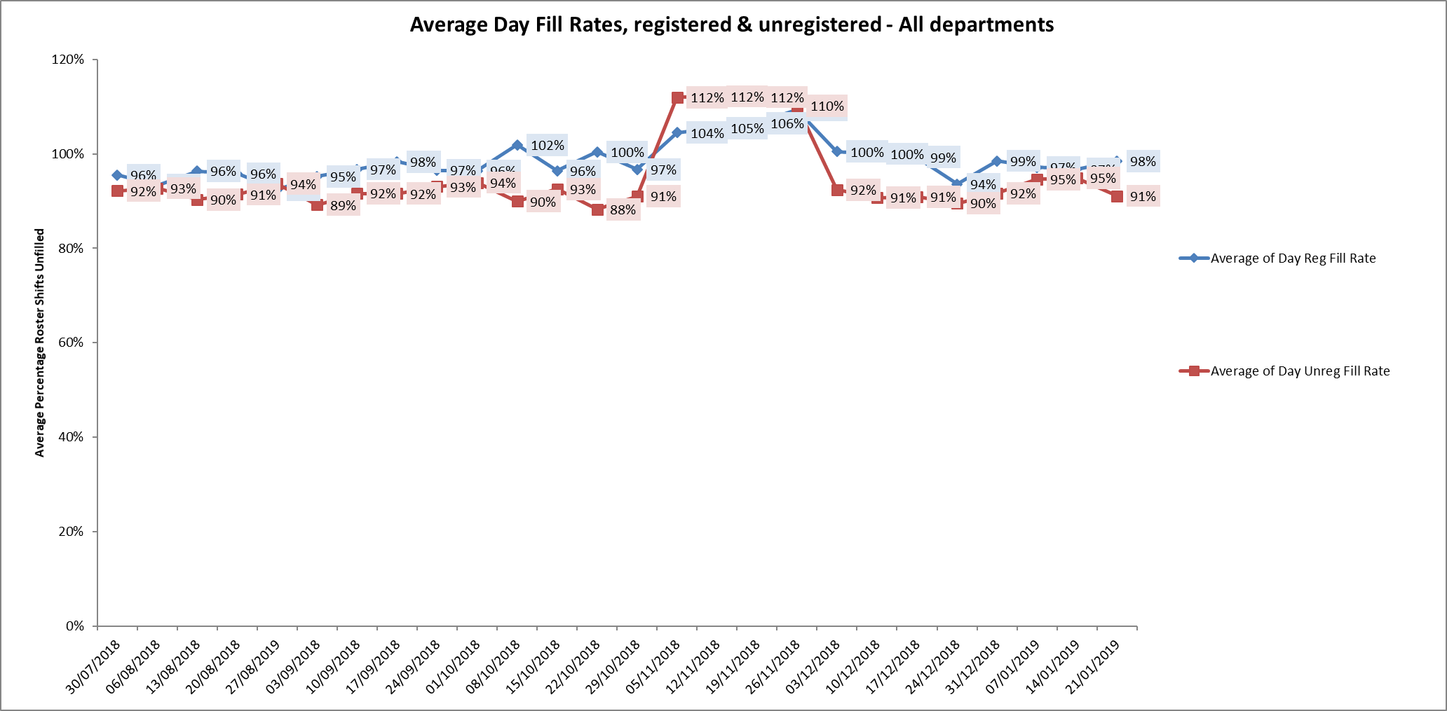

Four wards were below 85% average weekly fill rates, The wards were Ashurst 66%, Cotswold House Oxford 83%, Cherwell 82% and City 71%. These wards all had above 90% fill rates on unregistered staff and addititional support from ward managers or matrons to support safe staffing.

Ashurst

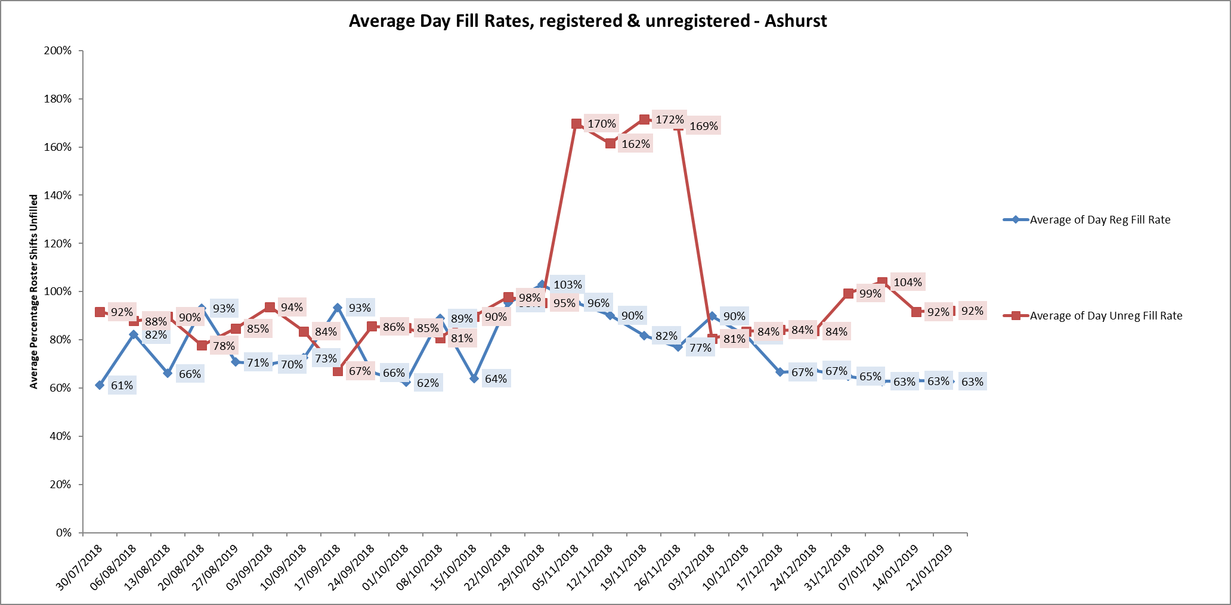

City ward

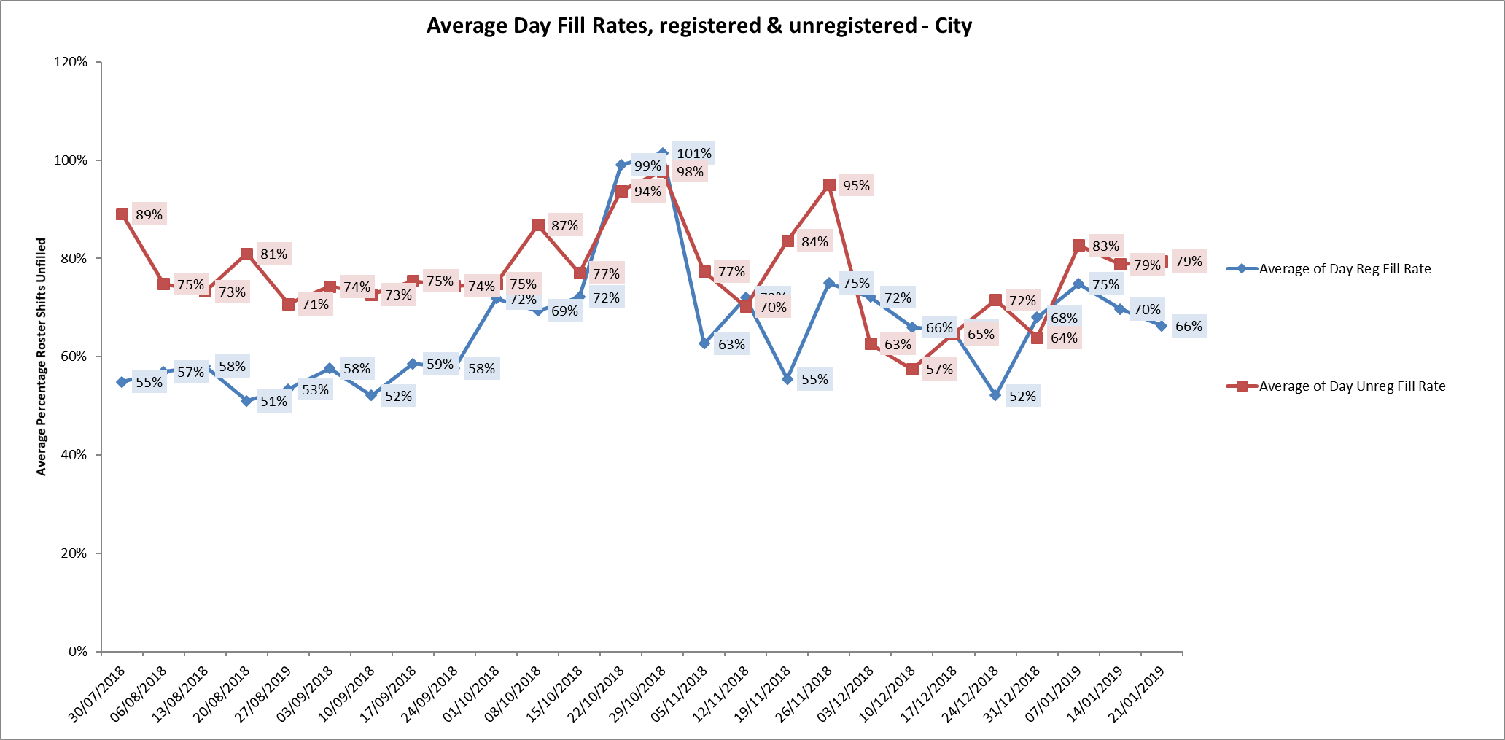

**Night shift fill rates**

Average weekly night shifts fill rates for registered nurse & unregistered staff were above the Trust target of 85% throughout this period. This included a mix of agency, flexible and substantive staff to make up staffing numbers.

**Registered skill mix**

Thirteen wards had in place an average of 50% or above registered staff skill mix.

Wards with below 50% registered skill mix is related to the continued registered nurse vacancies. Safe staffing is supported by the ward managers and matrons on the ward working clinically as part of the numbers where required to ensure registered nursing leadership is maintained.

Skill mix is achieved through use of our own staff and trust employed flexible registered workers and agency registered nurses.

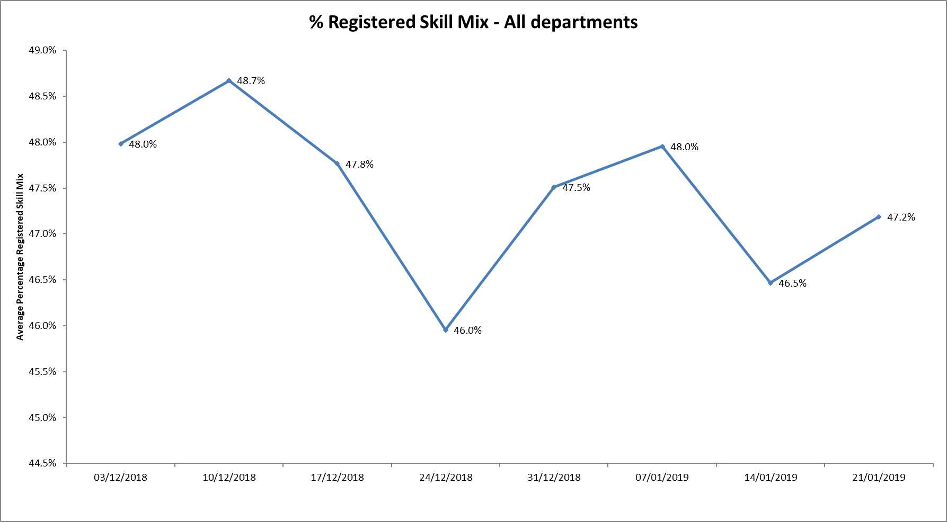

**Agency use**

The Trust moved to a new approach to reduce the use of unregistered agency staff in the week of 14.5.18. Further detail of this project is provided in the HR workforce report and commented on in relation to changes in skill mix ratios.

The average agency use was 9.925% during this period

This remains below the peak of 19.1% in February 2018.

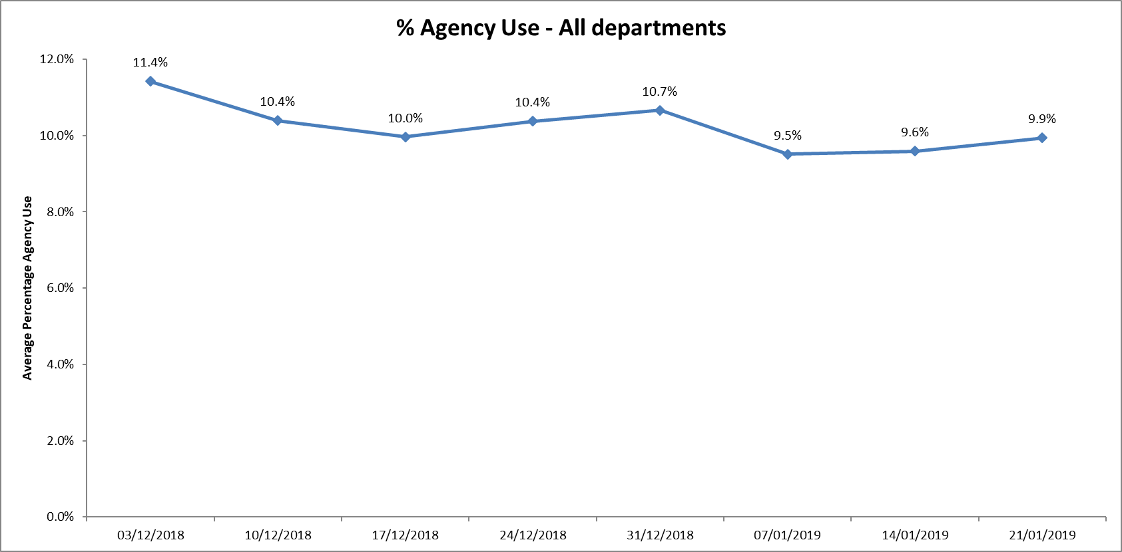

Eleven wards required less than 5% agency use (Trust target)

Seventeen wards required more than 10% agency usage

Adult wards Allen, Phoenix, Forensic wards Kestrel, Kingfisher and older adult ward Amber required above 20% of agency staff in the period, this was related to sickness, vacancies and patient acuity

Highfield agency use increased to 26.8% in the final week. This is related to NHSE funded specialist care packages, for example 1:1 observations for a patient who is awaiting more appropriate placement or in HDU requiring increase in overall shift staffing levels.

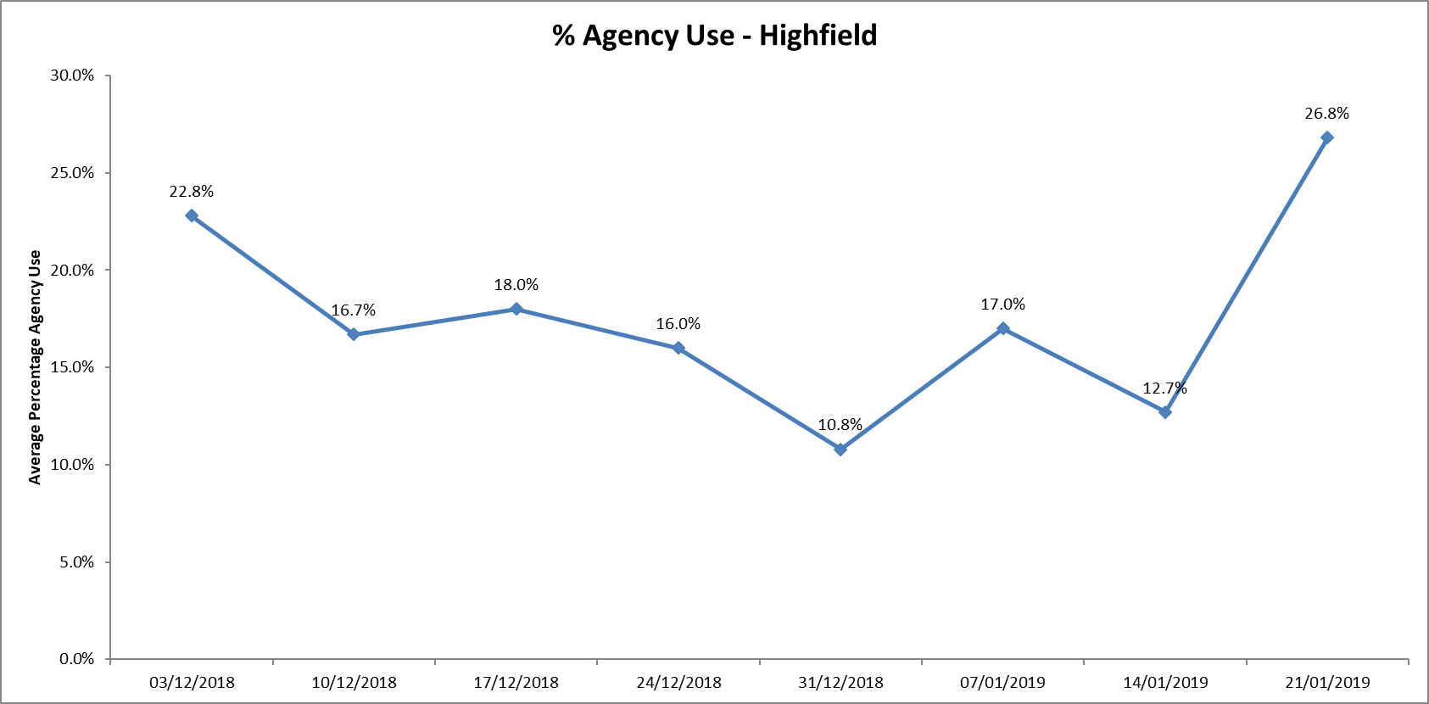

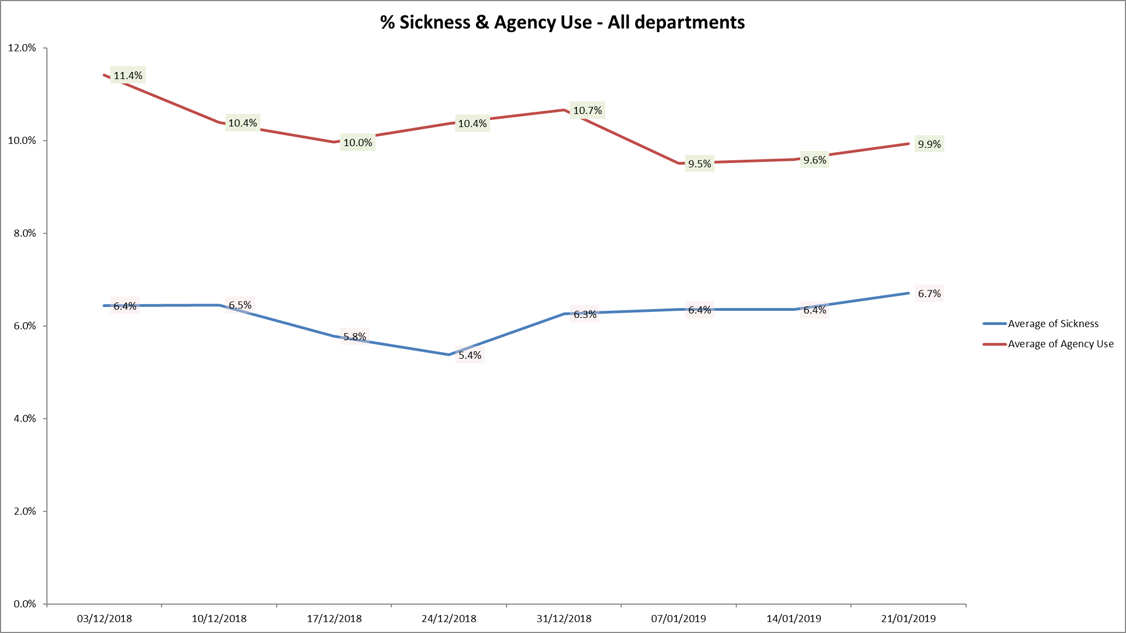

Further detail of agency use and spend is provided in the Workforce report.

**Maintaining Safer Staffing.**

**Community Hospitals.**

Rolling advertisements for staff vacancies are in place.

Substantive staff are covering some vacant shifts, lines of work are covering existing vacancies at City, Wallingford and OSRU

Unfilled shifts are escalated early and a plan is put in place to ensure they are filled

Senior staff are increasing number of clinical shifts.

Peer review of safer staffing tool in progress to ensure all sites are completing the information consistently and that the tool is giving a true reflection of the dependency and capacity to manage safely

City ward

The ward was operating on reduced bed numbers to 12 from 18 to support safe staffing levels being maintained. This has since been increased to 14 beds as part of systemwide winter planning work. Staffing has been supported with lines of work and substantive staff picking up several available shifts.

Oxfordshire Stroke Unit (Abingdon)

Some improvement has occurred in nurse recruitment and student nurses working on the ward have applied for permeant positions and have supported overall staffing levels. Lines of work from staffing solutions have further supported the opening of 4 more beds bringing the total to 16. This has enabled Abbey ward to provide 4 more generic beds to the system.

Witney Community Hospital

Linfoot ward have been very successful in supporting flow with a get me home initiative. Several patients have been successfully discharged home early with support from the ward HCA and therapy teams. It is hoped to replicate this scheme in the Wallingford/Didcot area once we have sufficient therapy staff in post

**Adult Wards**

Ashurst

The ward has continued high nursing vacancies, to support safe staffing the ward is now operating as male only and longline agency staffing is in place. In addition, there was increased use of unregistered staff at a time of increased acuity. Further work is planned to review the model of care for the ward.

Ashurst and Phoenix wards are co-located and staff work flexibly across to support patient needs on both wards. This is overseen by the Matron and ward managers for the wards. Twice daily conference calls for the adult wards are in place to support staffing across the wards when shifts cannot be filled with registered staff

**Forensic wards**

All ten wards continued to be below average 50% skill mix registered nursing during this last period.

The current establishments do not cover a 50/50 split. This has been rectified with the new skill mix review, as this goes forward into implementation into the roster system with the new establishment and shift patterns this will increase the qualified ratio.

As reported in January registered nurse vacancies continue to be high.

Kennet ward registered nurse skill mix data continues to have the lowest the average skill mix of all wards across the Trust. There has been recruitment to two band five posts who are newly qualified who started in September this leaves 5.7 WTE Band 5 vacancies against establishment of 10.92 WTE

Thames House (Kingfisher and Kestrel wards) has been reliant on long lines of agency to provide stability within the staffing and deliver a safe service. There have been long line agency staff that have worked full time within Thames house since 2015. The Thames House proposal for payment for qualified staff was signed off by executive team and will be implemented.

**Retention**

A clear focus on staff retention and workforce development continues to be a priority for the Trust. A further student recruitment is planned for March 2019.

A plan to transition Nurse Associates who will qualify in March 2019 into substantive Band 4 roles is being taken forward with HR support and local managers led by the Heads of Nursing.

**Conclusion**

All ward staff and managers continue to make every effort to ensure wards continue to be staffed safely, fill rates remain high for most wards and that we continue to focus efforts on retaining our staff whilst recruiting new nurses to join Oxford Health FT. Skill mix review work will be progressed to include Nurse associates and other roles.

**Author and Title:** Kate Riddle, Acting Director of Nursing and Clinical Standards

**All Metrics Period 31st December 2018 to 27th January 2019**

