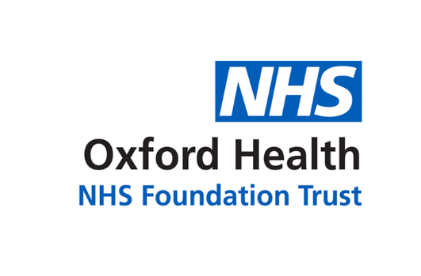

# Report to the Meeting of the

**CoG 31/2019**

(Agenda item: 11)

# Oxford Health NHS Foundation Trust

# Council of Governors

**People issues**

**21 November 2019**

Performance against key indicators

* Sickness absence levels remain very constant at around 4%. The main causes of sickness absence remain stress and musculo-skeletal issues.
* Staff Turnover has stabilised at around 13% - this is considerably better than the 15% level of 2017 but there remains more that we can do to persuade people to stay with us.
* Temporary Staffing remains an area of big focus. We are gradually growing our Bank and trying to reduce the use of agency staff, particularly the high cost agencies.

CEO Appointment

We have appointed a search firm to help us identify qualified and suitable candidates for the CEO position, given Stuart Bell’s decision to retire in early 2020. We are designing a selection process which will take account of stakeholder perspectives including patients, carers, staff, governors, commissioners, regulators, partners and others.

Flu Jabs

With winter approaching we have put a renewed effort into promoting flu jabs for our staff. We have more peer vaccinators helping the Occupational Health team this year but we were hampered by the fact that only a limited quantity of vaccine was received compared to that ordered, due to a national shortage. This forced us to cancel some drop-in clinics. Priority is being given to patient-facing staff. We recently had more vaccine delivered to the Trust and are working hard to catch up. We are ahead of where we were this time last year.

Brexit

In October we wrote a letter from the CEO to around 400 staff who our records tell us are of EU origin, reassuring them that we very much want them to remain in the UK and employed by us. We have also offered help with the “settled status” application process and a few colleagues have accepted that help.

Staff Survey

The annual survey Is now open and response rates are being closely monitored. As of 15 November we were at 42% and we are trying to raise awareness and encourage people to have their say before it closes at the end of November.

Employee Assistance Programme

Procurement process for this is now in its final stages ( down to 2 suppliers) so likely launch Jan 2020.

Schwartz Rounds

We have recently launched this initiative and 3 rounds have been held so far, feedback is extremely positive.

Staff Awards

Around 360 nominations received, a similar level to last year. Process for judging now underway alongside preparations for Awards evening on 3 December.

Management Toolkit

Practical training sessions for managers successfully delivered by HR and L&D. Over 160 line managers have applied for future programmes which are scheduled well into 2020.

New People Meeting

Terms of Reference are being developed, working title of “People, Culture and Leadership”, first meeting anticipated Jan 2020, replacing the Well-Led sub committee.

Equality, Diversity and Inclusion

A Board Seminar was held in November. The Board was updated on the Workforce Race Equality Standard and the new Workforce Disability Equality Standard. Two of the recently appointed “Cultural Ambassadors” attended the meeting to discuss their role in helping us to deliver improvements in our EDI performance.

Around 250 leaders are attending Linking Leaders programmes in Aylesbury, Swindon and Oxford on the subject of Gender. The conferences have focused on flexible working, the gender pay gap, case studies relating both to women’s health and men’s health and the role of leaders in promoting equal treatment and equal opportunity. The feedback has been very positive.

Bullying and Harassment

Roz O’Neil, who leads for the Trust on Stress and Wellbeing, will attend the Governors’ meeting to explain programme around culture change and some of the initiatives within it which are specifically aimed at reducing bullying and harassment. The plans are contained in a document which we will circulate to the Council of Governors.

**For: Information**

**Executive Summary**

**Recommendation**

**Author and Title:**

**Lead Executive Director: Tim Boylin**

**SITUATION**

The results of the 2018 NHS Staff Survey show that bullying and abuse, from the public or from colleagues, remains an issue and at the same level here as across the NHS. There is a Staff Support Hub which can be accessed through the intranet.

Examination of HR processes shows that in 2018:

* There were 5 concerns raised under the Trust’s Dignity at Work policy
* There were 14 grievances raised which cited bullying or discrimination from managers or colleagues

The outcome from these investigations is summarised below:

|  |  |  |  |  |
| --- | --- | --- | --- | --- |
| **Case Type** | **Upheld** | **Not Upheld** | **Partially Upheld** | **Informal Remedial Action** |
| Dignity at Work | 1 | 1 | 2 | 1 |
| Grievances | 2 | 3 | 4 | 5 |

To date in 2019, 5 grievances have been raised. The majority of these relate to concerns about bullying or discrimination. These are currently being managed under grievance procedure.

**PLAN**

The ‘HSE Management Standards - A framework for improving organisational culture’ document shows initiatives, programmes and support activities are all live or being developed in Oxford Health.