

**CoG 32/2019**

(Agenda item: 12)

# Report to the Meeting of the

# Oxford Health NHS Foundation Trust

# Council of Governors

**21 November 2019**

**Performance Report Q2 (Jul 2019 – Sept 2019)**

**For: Information**

**Executive Summary**

This report provides a consolidated view of the Trust’s operational performance against both national and local (contracted) indicators for July – Sept 2019 (Q2).

A standard scorecard approach is used for all reporting within the Trust and compliance against targets are measured using a RAG rating system. Performance reporting is presented monthly and scrutinised by various leadership and oversight committees up to and including the Trust Board and Commissioners. See Appendix 2 for a diagram showing the performance governance process.

The report is divided into three major sections:

**Section 1**: an update on the **overall position** and trends for the Trust

**Section 2**: an update on the Trust’s performance against the Single Oversight Framework (SOF) which is the **National (NHSI) criteria**

**Section 3**: an update on the individual **directorate performance** against targeted key performance indicators.

**Section 1 – The Trust’s Overall Position**

In Q2, the Trust achieved 76% compliance which is broken down by directorate below;

|  |  |  |
| --- | --- | --- |
| **Directorate** | **Quarter 1** | **Quarter 2** |
| All Ages Mental Health - Oxon | 74% | 70% |
| All Ages Mental Health - Bucks | 64% | 70% |
| Community Services Directorate | 67% | 77% |
| Specialised Services Directorate | 87% | 85% |
| **Grand Total** | **76%** | **76%** |

The underlying graphs show the performance trend by month;



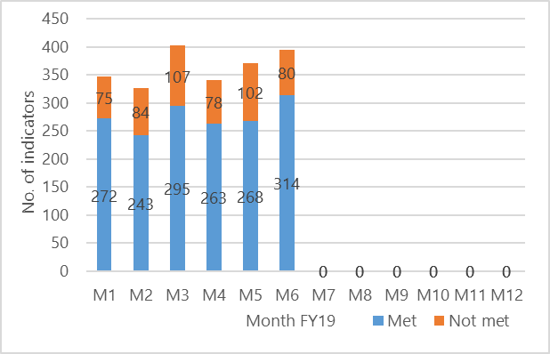

**Section 2 – The National Position**

**NHS Single Oversight Framework (SOF)**

There is a national requirement for Trust’s to report against NHSI defined targets which is called the Single Oversight Framework. The first SOF was published in Sept 2016 to help NHSI identify where NHS Trusts may benefit from, or require, improvement support. It sets out how NHSI will identify providers’ potential support needs under the following themes; **Quality of Care, Operational Performance and Organisational Health.** In the majority of cases NHSI will be sourcing Trust performance data from publicly available sources e.g. CQC, NHS Digital, NHS England, and Unify.

The Trust recently revised its approach to the RAG rating of its performance against the SOF. Previously if indicators did not have targets/thresholds, we measured our performance against the national average, however, this is potentially misleading. Therefore, in order to more accurately reflect our performance, the Trust has made a clear distinction between measures that have a target and measures that do not. The Trust will only report its performance as non-compliant where a target exists.

**The Trust was achieving 80% of the SOF indicators at Q2;**

|  |  |  |  |  |  |  |
| --- | --- | --- | --- | --- | --- | --- |
| Service | Below target >10% | Below Target 1-9% | Target Met | No Target | Total | % Met |
| Quality of Care | 1 | 1 | 2 | 9 | 4 | 50% |
| Operational Performance | 0 | 0 | 6 | 3 | 6 | 100% |
| Organisational Health | 0 | 0 | 0 | 3 | 0 | n/a |
| **Sub-Totals** | **1** | **1** | **8** | **15** | **10** | **80%** |

The one red indicator in Q2 which was a ‘never event’ associated with wrong site dental surgery.

Highlights include;

* The Minor Injuries Unit performance remained at 97% in September. This is above the 95% national target and the second month there has been an improvement.
* Out of Area Placements (OAPs) is monitored on a quarterly basis within the SOF and the Trust has substantially improved its performance over the past 6 months. There has been a significant reduction in the number of patients sent out of area due to a shortage of available beds. The Trust is on track to achieve the planned improvement and progress against plan is shown in the table below.

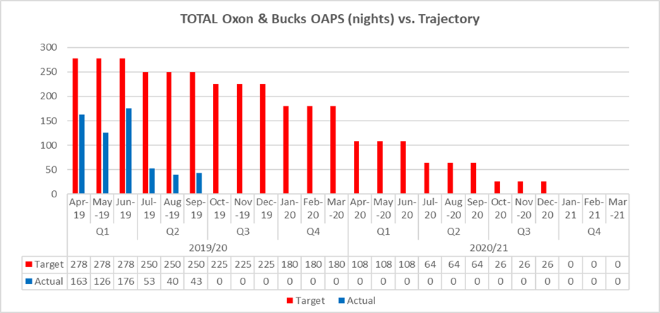

**Section 3 – Individual Directorate performance against** **targeted KPIs**

**3.1 Oxfordshire, Banes, Swindon & Wiltshire - All Ages Mental Health**

The directorate achieved 90 of the 124 targeted indicators (73%) as at the end of Q2. A breakdown by contract is illustrated in the table below;



**Key messages:**

* **Emergency Department Psychiatric Service (EDPS).** Staffing pressures continue to affect performance at both the John Radcliffe and Horton General Hospitals.  The pressures have been reported to the Quality Review Meeting (Oxfordshire CCG) so that any identified risks to patients can be understood and mitigated. Until workforce shortages are resolved (through additional investment), the service will not be able to achieve the commissioner defined targets.
* **CAMHS (Swindon, Wiltshire, Bath and North East Somerset) –** A comprehensive waiting time improvement plan has been put in place by the service and shared with the commissioners (from April 2019). Implementation is being overseen by a new Outcomes Performance and Improvement Group chaired by the Head of Service. Regular updates on performance are provided to commissioners at bi-monthly Contract Review Meetings. The plan is beginning to have a positive impact on waits with improvements continuing.

**3.2 Buckinghamshire – All Ages Mental Health**

The directorate achieved 37 of the 47 targeted indicators (79%) as at the end of Q2. A breakdown by contract is illustrated in the table below;



**Key points to note;**

* **Buckinghamshire Care Reviews** – ensuring that Care Reviews are carried out within the timeframes set out in the clusters continue to be an area of underperformance for the Directorate. This issue also affects performance in Oxfordshire. A new Carenotes dashboard has gone live in September that will give clinicians greater visibility of their caseload which will include early warning of when care reviews are required. As at September 60% had their review within time. Now that the new dashboard is operational, performance against this particular indicator is expected to improve.
* **Bucks CAMHS** – There has been a change to the measure of routine referrals assessed within 4 weeks from September to “The count of routine referrals offered within 4 weeks”. The percentage for September is 94.6%, with a target of 90%.

**Oxfordshire Community Services Directorate**

The directorate achieved 66 of the 88 targeted indicators (75%) as at the end of Q2. A breakdown by contract is illustrated in the table below;



**Key points to note;**

* **Buckinghamshire Continuing Health Care (CHC)** – The Trust continues to underperform against the referrals completed within 28 days target. However continuous improvement has been seen since May 2019.
* **Oxfordshire CHC** –TheOxfordshire CCG has recognised the challenges of the 28 day target and is now organising a system-wide Task & Finish group that will have oversight of 4 different workstreams:

1. Reducing potentially unwarranted variation in CHC
2. Improving commissioning and procurement
3. Personalisation;
4. Sustaining and improving quality

The latter workstream will be addressing performance against the contracted KPIs. The CCG has acknowledged that some of the contributing factors are external and that a collaborative approach is required to achieve a system wide improvement.

**Specialist Services Directorate**

The directorate achieved 121 of the 135 targeted indicators (90%) as at the end of Q2. A breakdown by contract is illustrated in the table below;



**Key point to note;**

* **Eating Disorders (Bed Occupancy)** – The service has implemented a Single Point of Access (SPA) as part of the New Care Models improvement work and expect bed status to improve as patient flow becomes established across the network. There is a monitoring mechanism in place that is overseen by the Forensic Senior group.

**Author and Title:** Claire Page, Head of Performance and Information

**Lead Executive Director:** Martyn Ward, Director of Strategy and CIO

**Appendix 1 – Performance Reporting Structure**

