

# Report to the Meeting of the

# Oxford Health NHS Foundation Trust

**BOD 33/2019**  
(Agenda item: 8)

# Board of Directors

# 27th March 2019

# INPATIENT SAFER STAFFING Report Period 28th January to 24th February 2019

**For: Information**

**Executive Summary**

**Ward Staffing**

The purpose of this paper is to provide the Trust Board with an interim exception report in line with the requirements of: “How to ensure the right people with the right skill are in the right place at the right time”, Chief Nursing Officer for England & National Quality Board November 2013. From June 2014 there has been a Department of Health requirement for trust boards to receive monthly updates on ward staffing levels. Ensuring sufficient staffing levels are in place is crucial to deliver safe, effective and high quality care. This report will be published on our website with a link from NHS Choices website.

The data within the report will outline the staffing levels (for both registered and unregistered nursing staff) on each ward. These figures will be measured against the required figures on a shift by shift basis for the period 28th January to 24th February 2019 in line with the requirements of the DH Unify reporting process and the data extract is attached (Appendix 1).

During this period:

Average weekly day shifts fill rates for registered staff & unregistered staff were above the Trust target of 85% with 90% or above for unregistered and 95% or above for registered staff.

Two wards were below 85% target for average weekly fill rates for registered nurse day shifts during some of this period. This is improved from four wards in the last period. The wards were Cotswold House Oxford 74% and City 66%. City had 72% fill rates on unregistered staff.

Average weekly night shifts fill rates for registered and unregistered for all wards were above the Trust target of 85% with the average lowest fill rate at 90% for unregistered staff and remained above 100% for registered staff for each week. The methods of filling these shifts includes substantive, flexible workers and agency registered staff and further detail in provided later in the report.

The average weekly % agency use was 11.3% an increase from 9.925% in the last reporting period.

Average sickness rates for ward staff were 5.8% a decrease from 6.4% last month.

This report also includes an update Forensics and adult Mental Health wards registered nursing vacancies and an update on nursing workforce development update as part of the nursing strategy to provide assurance as part of the Trust CQC Well Led Inspection ‘Should’ action *All efforts are made to reduce the level of vacancies, particularly of qualified nurses.*

**Forensics wards vacancies March 2019**

|  |  |  |  |
| --- | --- | --- | --- |
| Forensic Wards | Vacancies (WTE)  March 2018 | March 2019 | Change WTE |
| Band 6 Charge Nurse | 2.62 | 5 | +2.38 |
| Band 5 Staff Nurse | 42.54 | 42.98 | +0.44 |

**Oxon Adult Mental Health wards March 2019**

|  |  |  |  |
| --- | --- | --- | --- |
| Oxon Adult wards | Vacancies (WTE)  January 2018 | March 2019 | Change WTE |
| Band 6 Charge Nurse | 8 | 5 | -3.0 |
| Band 5 Staff Nurse | 38.60 | 34.1 | -4.5 |

**Bucks Adult Mental Health Wards March 2019**

|  |  |  |  |
| --- | --- | --- | --- |
| Bucks Adult wards | Vacancies (WTE)  January 2018 | March 2019 | Change WTE |
| Band 6 Charge Nurse | 1.3 | 1 | -0.3 |
| Band 5 Staff Nurse | 14.6 | 16.0  10 offers in place for Sept 2019 graduates | +1.4. |

**Recommendations**

The Board is asked to note:

* There are processes in place to ensure safe staffing levels on all the wards in the organisation, those wards where there are concerns and the actions being taken to ensure safe staffing including project work and wider recruitment and retention work. There are no exceptions to report that directly link actual staffing levels to adverse outcomes for patients which have been identified through our Governance Structures.

**Author and Title:** Kate Riddle, Acting Director of Nursing and Clinical Standards

**Lead Executive Director:** Kate Riddle, Acting Director of Nursing and Clinical Standards

*A risk assessment has been undertaken around the legal issues that this paper presents and there are no issues that need to be referred to the Trust Solicitors. This paper links to all the five CQC Domains.*

***Strategic Objectives*** *– this report relates to or provides assurance and evidence against the following Strategic Objective(s) of the Trust*

*Driving Quality Improvement (Goals: patients will be safe from harm; patients will achieve the clinical outcomes they want; and patients and carers will have an excellent experience)*

*Delivering Operational Excellence (Goals: our services will be effective and efficient; information will be translated into knowledge; and our planned surplus will be delivered)*

**Inpatient Safer Staffing**

Period 28th January to 24th February 2019.

**Introduction**

This is the report to the Board of Directors outlining the staffing levels (registered and unregistered) on each ward against their required need on a shift by shift basis. This report covers the period 28th January to 24th February 2019.

This report will focus on the percentage of day and night fill rates for registered and unregistered staff. This data is reported to NHSI and provides assurance of actual clinical staffing numbers being achieved. This report will be published on our website with a link from NHS Choices website.

**Management of Staffing Levels**

Anescalation process for the management of staff shortages is in place within each clinical area, to manage staffing safely on a shift by shift basis. As part of this process, senior clinical staff are providing appropriate support to ward teams as and when required. In addition, senior ward staff and immediate team managers review ward staffing levels on an on-going basis; shift by shift basis, and where there are changes in patient acuity. Ward Matrons review staffing daily as a minimum and more frequently where required.

In-patient staffing levels continue to be reported every week and discussed within the Weekly Review Meeting (WRM), which takes place each Monday morning with the Director of Nursing and/or Deputy present.

To ensure that staffing levels are under continual review, every ward undertakes a range of immediate actions daily to ensure safe staffing levels are maintained appropriate to the needs of patients. These actions include booking flexible or agency staff via Staffing Solutions, revising rotas, moving staff between wards and utilising additional staff that are not included in the ward numbers as required for example modern matrons.

**Summary position of inpatients wards staffing levels.**

Appendix 1 shows the staffing levels for all wards by ward for the period 28th January to 24th February 2019. The data presented includes details of staffing by shifts and details of skill mix, agency, ward staff sickness and ward vacancy figures. The thresholds presented in the table are measured against trust/ national targets and used for exception reporting.

During this period:

**Day shifts fill rates**

Average weekly day shifts fill rates (all departments) for registered nurse & unregistered staff were above the Trust target of 85% throughout this period. This included a mix of agency, flexible and substantive staff including ward managers and matrons where required to make up staffing numbers and provide safe care.

Average weekly day shifts fill rates for registered staff & unregistered staff were above the Trust target of 85% with 90% or above for unregistered and 95% or above for registered staff.

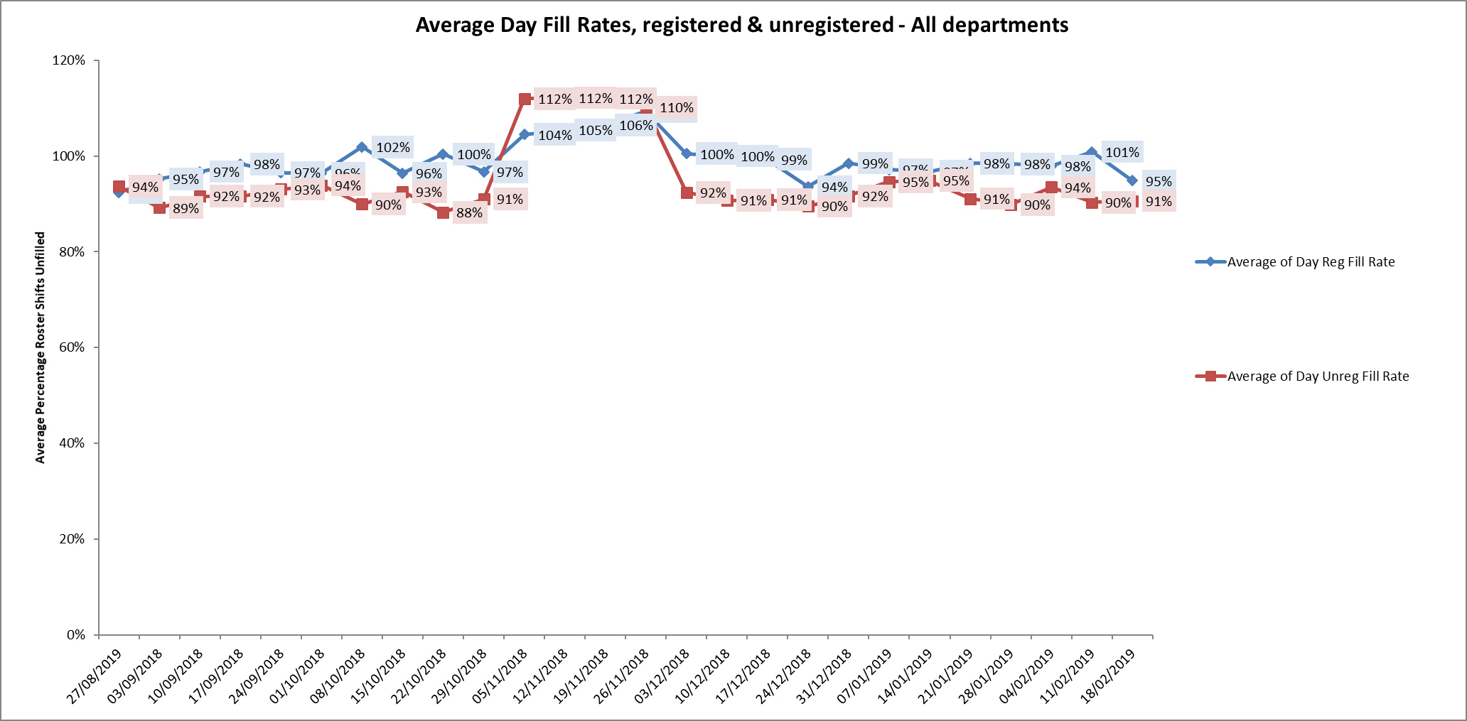

Two wards were below 85% average weekly fill rates, these were Cotswold House Oxford 74% and City 66%. City had 72% fill rates on unregistered staff. There was addititional support from ward managers or matrons to support safe staffing.

**Night shift fill rates**

Average weekly night shifts fill rates for registered nurse & unregistered staff were above the Trust target of 85% throughout this period for all wards. This included a mix of agency, flexible and substantive staff to make up staffing numbers.

**Registered skill mix**

Fifteen wards had in place an average of 50% or above registered staff skill mix.

Wards with below 50% registered skill mix is related to the continued registered nurse vacancies. Safe staffing is supported by the ward managers and matrons on the ward working clinically as part of the numbers where required to ensure registered nursing leadership is maintained.

Skill mix is achieved through use of our own staff and trust employed flexible registered workers and agency registered nurses.

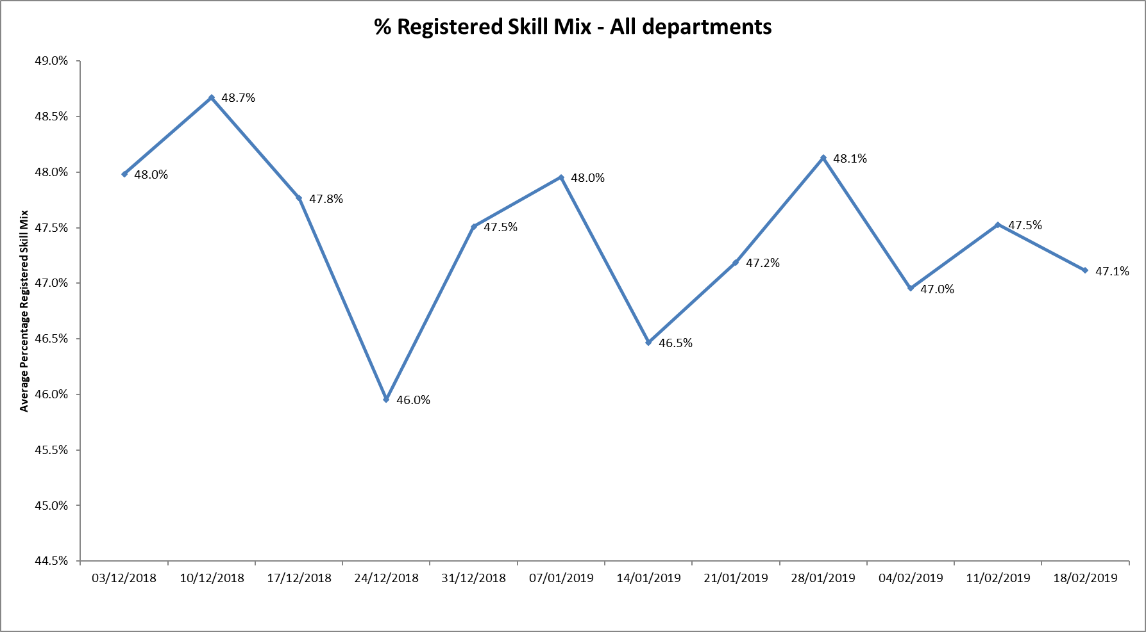

**Agency use**

The Trust moved to a new approach to reduce the use of unregistered agency staff in the week of 14.5.18. Further detail of this project is provided in the HR workforce report and commented on in relation to changes in skill mix ratios.

The average weekly % agency use was 11.3% an increase from 9.925% in the last reporting period. This remains below the peak of 19.1% in February 2018.

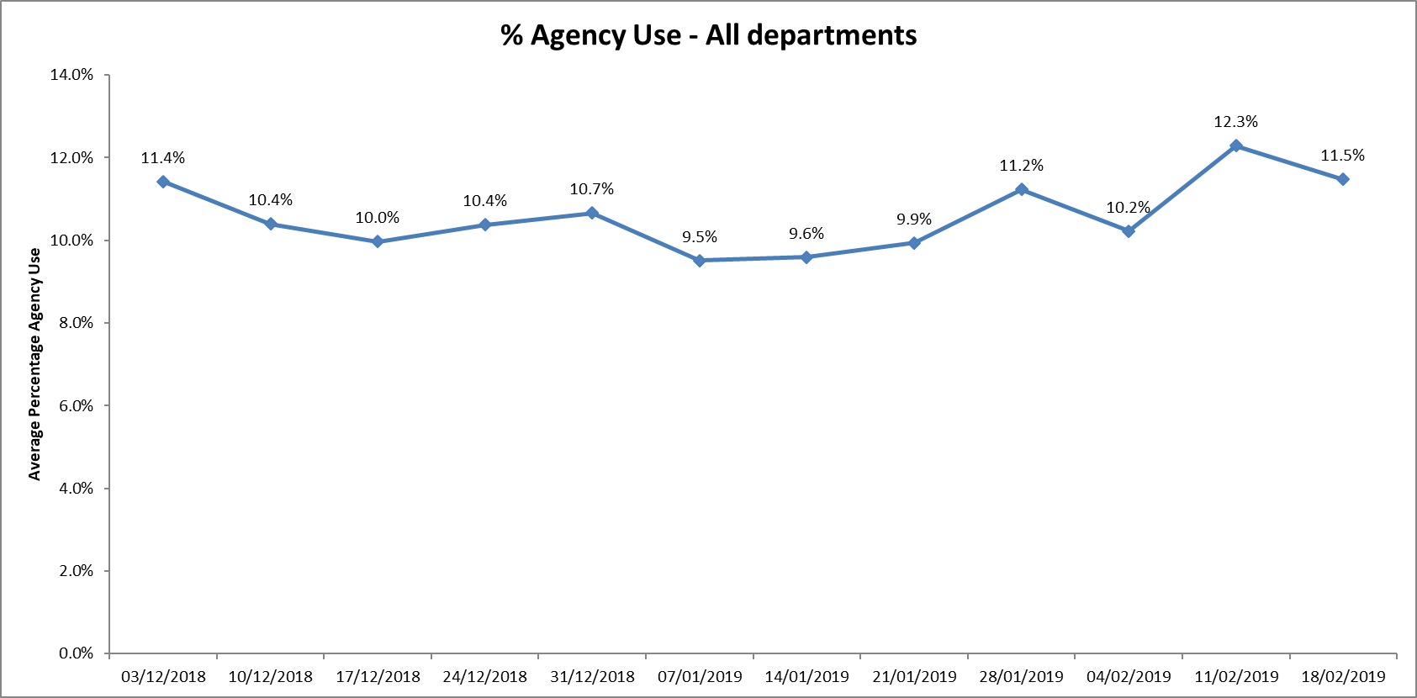

Nine wards required less than 5% agency use (Trust target)

Seven wards between 5-9% agency use

Ten wards required between 10% -20% agency usage

Six wards Allen, Phoenix, Forensic wards Kestrel, Kingfisher, Highfield and older adult ward Amber required above 20% of agency staff in the period, this was related to sickness, vacancies and patient acuity

Highfield agency use reduced during this period from 25.2% to 16.6% in the final week. This is related to NHSE funded specialist care packages, for example 1:1 observations for a patient who is awaiting more appropriate placement or in HDU requiring increase in overall shift staffing levels.

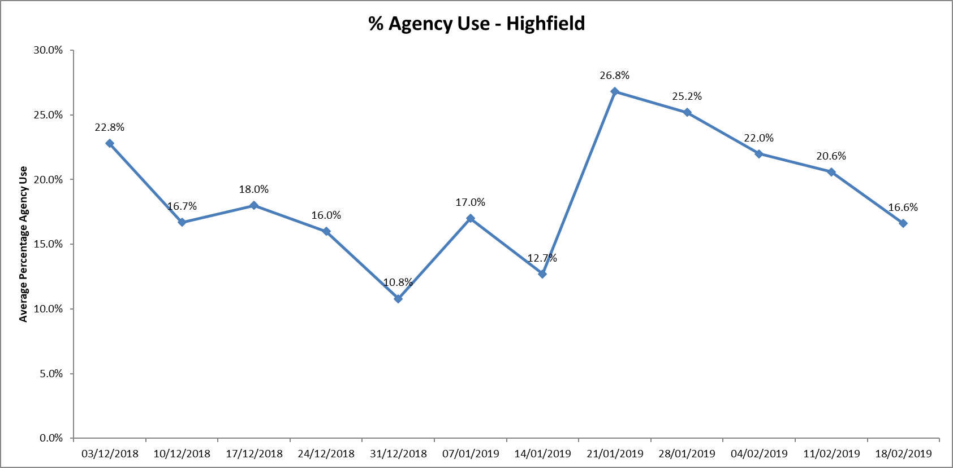

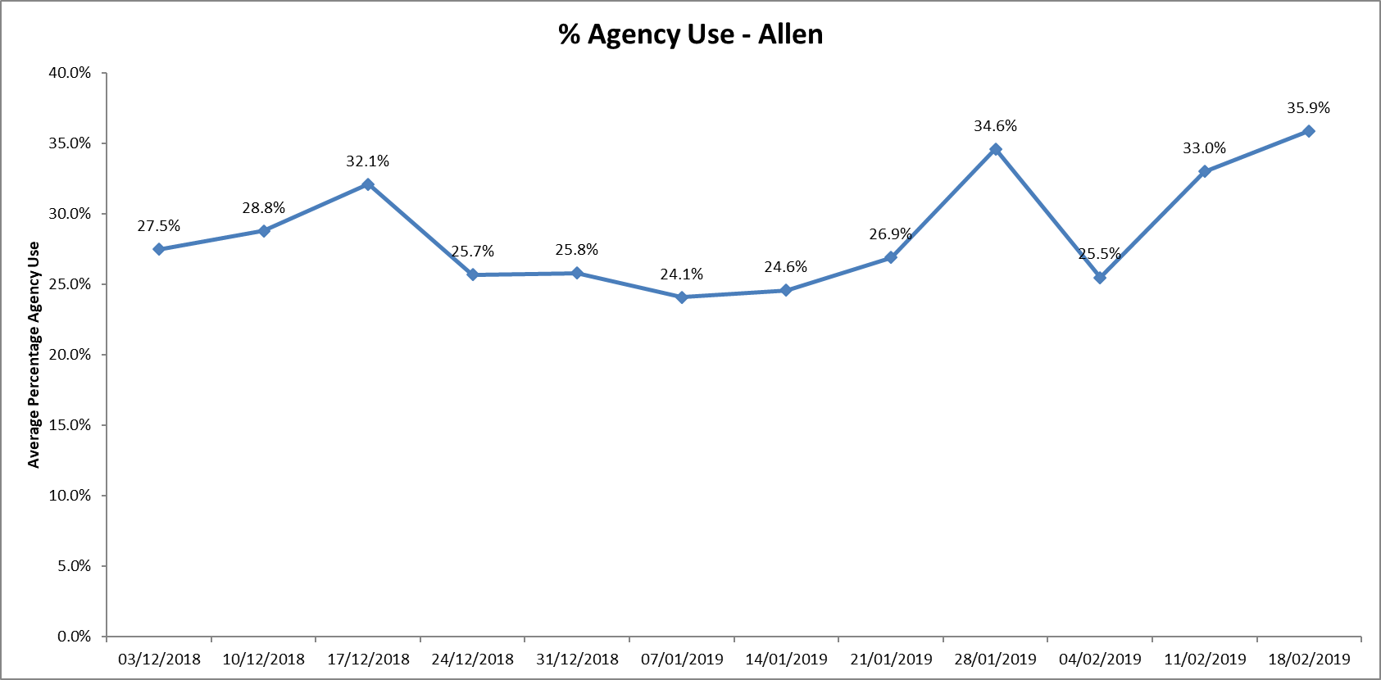

Further detail of agency use and spend is provided in the Workforce report.

**Maintaining Safer Staffing.**

**Community Hospitals.**

Rolling advertisements for staff vacancies are in place.

Substantive staff are covering some vacant shifts, lines of work are covering existing vacancies at City, Wallingford and OSRU

Unfilled shifts are escalated early and a plan is put in place to ensure they are filled

Senior staff are increasing number of clinical shifts.

Peer review of safer staffing tool in progress to ensure all sites are completing the information consistently and that the tool is giving a true reflection of the dependency and capacity to manage safely

City ward

The ward was operating on reduced bed numbers to 12 from 18 to support safe staffing levels being maintained. This has since been increased to 14 beds as part of systemwide winter planning work. Staffing has been supported with lines of work and substantive staff picking up several available shifts.

**Forensic wards**

All ten wards continued to be below average 50% skill mix registered nursing during this last period.

The current establishments do not cover a 50/50 split. This has been rectified with the new skill mix review, as this goes forward into implementation into the roster system with the new establishment and shift patterns this will increase the qualified ratio.

Forensics Band 5 & 6 Nursing Vacancies update March 2019

The number of vacancies has remained overall high for this service over the last year,

|  |  |  |  |
| --- | --- | --- | --- |
| Forensic Wards | Vacancies (WTE)  March 2018 | March 2019 | Change |
| Band 6 Charge Nurse | 2.62 | 5 | +2.38 |
| Band 5 Staff Nurse | 42.54 | 42.98 | +0.44 |

The details by ward evidences there are continued high vacancies in Thames house (Kingfisher and Kestrel)

A Recruitment and Retention premium is being introduced £1,500 per annum for Band 5 & 6 qualified nursing staff. This is aimed to incentivise new staff whilst also enhancing the retention of the existing staff

Evenlode more recently has high Band 5 vacancies but with job offers in place for four new qualified staff in September 2019 this should improve if these translate into new starters.

Kennet ward registered nurse skill mix data continues to have the lowest the average skill mix of all wards across the Trust at 31.3%. The ward has Band 5 starters and vacancies have reduced but remain below establishment.

Safer staffing is supported by long lines of agency staff, ward managers and matrons working clinically

**Details by ward**

|  |  |  |  |  |
| --- | --- | --- | --- | --- |
|  | Establishment (WTE) | Vacancies March 2018 | Vacancies March 2019 | Change |
| Lambourne | | | | |
| Band 6 Charge Nurse | 2 | 0 | 1 | +1 |
| Band 5 Staff Nurse | 3.74 | 1.74 | 0 | - 1.74 |
| Wenric | | | | |
| Band 6 Charge Nurse | 4 | 1 | 1 | Static |
| Band 5 Staff Nurse | 10.92 | 5.01 | 3 | -2.01 |
| Kennet | | | | |
| Band 6 Charge Nurse | 4 | 0 | 0 | 0 |
| Band 5 Staff Nurse | 10.92 | 7.72 | 4.43 | -3.29 |
| Glyme | | | | |
| Band 6 Charge Nurse | 4 | 0.4 | 0 | -0.4 |
| Band 5 Staff Nurse | 7.48 | 3.48 | 4.78 | +1.3 |
| Evenlode | | | | |
| Band 6 Charge Nurse | 4 | 1 seconded till Aug | 2 | Static |
| Band 5 Staff Nurse | 7.48 | 0.75 | 5.77 | +5.02  4 offers in place for Sept 2019 graduates |
| Woodlands | | | | |
| Band 6 Charge Nurse | 4.23 | 0.22 | 0 | 0 |
| Band 5 Staff Nurse | 8.48 | 2 | 1 | -1.10 |
| Kestrel | | | | |
| Band 6 Charge Nurse | 3 | 2 | 1 | -1.0 |
| Band 5 Staff Nurse | 11.92 | 10.92 | 11 | +0.8 |
| Kingfisher | | | | |
| Band 6 Charge Nurse | 3 | 0 | 0 | 0 |
| Band 5 Staff Nurse | 11.92 | 8.92 | 10 | +1.08 |
| Watling | | | | |
| Band 6 Charge Nurse | 5.23 | 0 | 0 | 0 |
| Band 5 Staff Nurse | 16.66 | 2 | 2 | Static |
| Chaffron | | | | |
| Band 6 Charge Nurse | 2 | 0 | 0 | 0 |
| Band 5 Staff Nurse | 3.74 | 0 | 1 | +1.0 |

**Adult Wards**

Oxon Adult wards Band 5 & 6 Nursing Vacancies

The number of vacancies have reduced but remain overall high for this service over the last year

**Totals**

|  |  |  |  |
| --- | --- | --- | --- |
| Oxon Adult wards | Vacancies (WTE)  January 2018 | Vacancies March 2019 | Change |
| Band 6 Charge Nurse | 8 | 5 | -3.0 |
| Band 5 Staff Nurse | 38.60 | 34.1 | -4.5 |

**Details by ward**

|  |  |  |  |  |
| --- | --- | --- | --- | --- |
| Ward | Grade | Vacancies (WTE)  January   2018 | Vacancies March 2019 | Change |
| Phoenix | Band 6  Band 5 | 1.0  4.6 | 0  4.6 | -1.0  Static |
| Allen | Band 6  Band 5 | 2.0  6..7 | 2.0  9.5 | Static  +2.8 |
| Wintle | Band 6  Band 5 | 1.0(from24/01/18)  9.0 | 0  2.0 | -1.0  -7.0 |
| Ashurst | Band 6  Band 5 | 2.0  12.0 | 2.0  12.0 | Static  Static |
| Vaughan Thomas | Band 6  Band 5 | 2.0  6.3 | 0 + 1.0 above establishment have three days funded for a research post separate from our budget  6.0 | -2.0  -0.3 |

Ashurst ward has continued high nursing vacancies, to support safe staffing the ward is now operating as male only and longline agency staffing is in place. In addition, there was increased use of unregistered staff at a time of increased acuity. Further work is planned to review the model of care for the ward.

Ashurst and Phoenix wards are co-located and staff work flexibly across to support patient needs on both wards. This is overseen by the Matron and ward managers for the wards. Twice daily conference calls for the adult wards are in place to support staffing across the wards when shifts cannot be filled with registered staff

Ashurst and Phoenix wards will be two of ten wards with high off Framework agency use where a deep dive will be undertaken by Heads of Nursing working with ward staff and HR to review key areas of; incidents, complaints, concerns, admissions/ discharges, bed occupancy, training by course, appraisals, supervision, patient/ carer feedback, and detention rates. These will be reviewed alongside staffing levels, skill mix and patient acuity to provide an overall picture and action plan of support for the ward.

Bucks Adult Mental Health wards Band 5 & 6 Nursing Vacancies

|  |  |  |  |
| --- | --- | --- | --- |
| Bucks Adult wards | Vacancies (WTE)  January 2018 | Vacancies March 2019 | Change |
| Band 6 Charge Nurse | 1.3 | 1 | -0.3 |
| Band 5 Staff Nurse | 14.6 | 16.0  10 offers in place for Sept 2019 graduates | +1.4. |

**Details by ward**

|  |  |  |  |  |
| --- | --- | --- | --- | --- |
| Ward | Grade | Vacancies January 2018 | Vacancies  March 2019 | Change |
| Ruby | Band 6  Band 5 | 0.2  7.6 | 0  5.0 | -.0.2  -2.6 with 4 appointed  due to start Sept 2019 |
| Sapphire | Band 6  Band 5 | 1.1  5.0 | 0  5.0 | -1.1 Unchanged – 5 appointed due to start Sept 2019 |
| Opal | Band 6  Band 5 | 0  2.0 (0.6 recruited) | 0  1.0 from 31.03.19 | 0  -1.0 |

Proactive work by the clinical teams working with HR and the University of Bedfordshire has resulted in recruitment of 9 newly qualified staff for September 2019, this will improve the overall staffing levels for these wards once staff in place.

**Workforce development update as part of the nursing strategy.**

Nurse Associate Roles

The trust was part of the national Fast Follower Pilot of Associate Nurses in 2017 and the 23 trainees are due to qualify in April 2019. They will be working as Band 4 Nurse Associates, 21 in their home teams, 2 requested move to a new area;

Job locations for first cohort of Qualfied Nurse associates

|  |
| --- |
| * Allen Ward |
| * Bicester Community Hospital |
| * Cherwell Ward |
| * Cotswold House Marlborough x2 |
| * Oxford EMU |
| * Phoenix Ward x 2 |
| * Didcot Community Hospital |
| * DN team Abingdon |
| * Glyme Forensic inpatient ward x 2 |
| * Wenric Forensic inpatient x2 |
| * Highfield Unit Warneford Hospital |
| * MIU Henley |
| * Ruby ward Whiteleaf Aylesbury x2 |
| * Sapphire ward Whiteleaf Aylesbury |
| * Wallingford CH |
| * Abingdon wards x 2 |

A second wave of 28 trainee Nurse Associates started June 2018, they are due to complete in May 2020 and a further cohort of 55 commenced in October 2018 and further cohort of 55 have been recruited to commence in May 2019. This recruitment includes external applicants.

These roles have been included in the skill mix review work that has occurred across the inpatients wards which is being finalised.

The National Quality Board has recently published a resource to support directors of nursing (DoNs) in deploying the new NA role safely and effectively using good governance and good practice. We are participating in the monthly Monthly NHSI led Webex to learn and share how we are deploying the new NA role in our Trusts.

Key actions that have been taken

* Workshops for staff managers and front line staff led Heads of Nursing working with L& D and HR have been set up to support existing staff and the nurse associates into their new roles to ensure as shared understanding of roles, responsibilites and accountabity, inlcduing the NMC standards.
* The Trust NMC link advisor attended the February Senior nurse forum and presented the NMC Standards of proficiency published 10 October 2018 for registered Nurse Associates.
* A model of preceptorship is in development for Nurse Associates post qualifying.

Further actions required:

A Quality Impact assessment in line with national guidance will be undertaken and reported to Trust executive team and Trust Board.

Re-procurement work is commencing of the education and training programme for Nursing Associate Trainees, this will include the top-up to Registered Nurse programme for at least 50 nursing associates.

Recruitment and retention

1. The new Flyer programme commenced on 19.10.18 (for newly qualified Nurses and AHPs) with 72 staff in cohort One. Cohort Two will commence in March 2019 lead by new Preceptorship Lead Stephen Marcus. This is a Trust wide programme which will work alongside service level preceptorship and provide staff with opportunity to obtain masters level accreditation the end of the year programme. This is key retention initiative for nursing & AHPs.

2.Proactive student nurse recruitment continues following on from last year’s approach– working with the OUH and Oxford Brookes University. In November 2018 events were held to meet students from all nursing pathways and work towards providing them with a job offer to start post qualification in Summer 2019. To date this work and specific work in community nursing has resulted in 38 job offers for summer graduates

This is in addition to the work was undertaken in January 2019 with University of Bedfordshire.

A further Brookes event is planned for March 2019.

Continuing Professional Development

The Learning & Development team is developing a suite of modules at Masters level which will be responsive to service need and provide a cost effective, relevant mode of training. These modules will be led by a member of L&D or service leads and will be taught in house by experts from service. This will allow OHFT to shape the curricula and ensure it meets educational needs. This work is being undertaken with the Oxford School of Nursing and Midwifery modules will be accredited by Oxford Brookes University)

Accredited and ready for delivery

|  |  |
| --- | --- |
| **Module** | **Credits** |
| Comprehensive Geriatric Assessment | 20 |

In development for delivery early summer 2019

|  |  |
| --- | --- |
| **Module** | **Credits** |
| Brief Interventions in Psychosis | 20 |
| Leadership in Quality Improvement | 20 |
| Applied Leadership | 20 |
| Self as an emergent practitioner | 20 |

In development for delivery October 2019

|  |  |
| --- | --- |
| **Module** | **Credits** |
| Coaching, preceptorship and mentorship | 20 |
| Risk Management in Mental Health | 20 |
| Caring for Service Users with Autism | 20 |
| Supporting People with Personality Disorders | 20 |
| Quality Improvement Project | 40 |
| Physical Health Skills | 20 |
| Positive Behavioural Support | 20 |

**Further Module topics under consideration for development**

* Minor Illness
* Minor Injuries
* Dementia

**Conclusion**

All ward staff and managers continue to make every effort to ensure wards continue to be staffed safely, fill rates remain high for most wards and that we continue to focus efforts on retaining our staff whilst recruiting new nurses to join Oxford Health FT. Skill mix review work will be progressed to include Nurse associates and other roles.

**Author and Title:** Kate Riddle, Acting Director of Nursing and Clinical Standards

