Report to the Meeting of the
BOD 35/2019
(Agenda item: 10)

Oxford Health NHS Foundation Trust

Board of Directors

27th March 2019

Quarterly Patient Experience & Involvement Report

For: Information

Executive Summary
This report provides an overview on the feedback received from patients and carers and the work to improve people’s experiences, as well as their involvement in service developments. The collection and use of patient, carer and family feedback continues to increase with just under 12,000 survey responses from April 2018 to February 2019. The majority of feedback is positive, 93% of people would recommend the service, with the quality of care being rated 4.72 out of 5, however we are striving so that everyone receives a positive experience and patients are involved in every decision about their care and service changes. The number of complaints received is similar to last year, and over the year the number of concerns resolved locally has increased as more time is put into this area.

The feedback received from patients and carers, formal complaints and serious incidents identify a common theme for improvement around communication and sharing information with patients and their families to enable joint decision making and involvement in care. We continue to strive to involve patients and their families in the quality improvement work we do and incorporate the patient voice into service design.

The current three-year patient experience and involvement strategy is coming to an end. We can demonstrate the positive impact the strategy has had and are going through internal and external consultation to review and set out a new strategy. A final draft of the new strategy will be presented to Trust Board in April 2019 for approval. The new strategy will be focused on improving how patients and their families feel involved in decisions about their care.

The report also details the work and progress against the dedicated carers strategy, the imminent changes to the national Friends and Family Test question to be introduced over the next 6 months, and information that the fieldwork for the 2019 national community mental health patient survey has just started.

Recommendation
To note.

Author and Title: Donna Mackenzie - Brown, Patient Experience and Involvement Manager
Jane Kershaw, Head of Quality Governance

Lead Executive Director: Kate Riddle, Acting Director of Nursing and Clinical Standards

- Introduction
A report on patient and carer experiences is presented to the Caring and Responsive Quality Sub-Committee quarterly and the Board of Directors as part of the series of quality reports. This report focuses on patient and carer experiences and how we have involved people in service developments. Feedback identifies a theme for improvement around communication and sharing information with patients and their families to support better joint decision-making, so people are an active partner in their care.

- Patient Experience and Involvement Strategy
The current Trust-wide three year strategy is coming to an end which has had a positive impact on; the amount of feedback collected, how this feedback is used by staff (the results to questions in the 2018 national staff survey in relation to receiving regular feedback and using this to make improvements are above average compared to other NHS trusts) and an increase in the amount and range of involvement in service changes. Some of the achievements include;

- Strengthened and improved leadership from the Experience & Involvement Team
- Increased awareness and routine collection of patient and carer feedback across a broader range of services
- Increase in feedback collected and reviewed by clinical teams
- Development of Involvement webpages and intranet pages, regular area of Insight magazine and #OHFTgetinvolved social media hastag
- Adult mental health services have developed peer support roles across Oxfordshire and a trust-wide strategy for peer support is in development
- Quarterly awards introduced to celebrate and share good practice
- Good practice shared in directorate newsletters, linking leaders’ events and on social media
- Peer reviews have included service users as part of the review team and some governors have also been trained to take part in peer reviews.
- The tender process, introduction and development of the use of IWGC as a single patient experience feedback mechanism
- Office 365 used as an enabler, offering greater usability on iPad, and a number of patient facing apps have been co-produced and are promoted where available.
- All feedback (except from children) is published to develop a culture of transparency
- All teams have access to their own patient experience feedback at all times
- New guidance for use of charity funds has a section around patient experience; bids have been actively encouraged and approved.
- Service users and carers are routinely involved in trust induction and when developing training. Process agreed on how to engage service users at the start of new quality improvement projects led through the Oxford Healthcare Improvement Centre.
- Patient stories are presented monthly to Trust Board and used locally for quality improvement with clinical teams
- Introduction of Carers Involvement Lead role
- ‘Icareyoucare’ carers strategy developed
- ‘Commitment to carers’ pledge has been co-produced and adopted across multiple organisations in Oxfordshire.

A new draft strategy is being co-produced with patients, families and clinical staff across the Trust and builds on the current strategy in place as well as national guidance (patient experience improvement framework June 2018), the themes coming from feedback/ complaints/ incidents and in-depth group work on shared decision making led through the staff linking leader conferences. Relevant objectives not completed in the current strategy will be carried over into the new strategy. The draft strategy has been produced in an accessible format and is being consulted on with governors, patients, families, staff and external partners until the end of March 2019. The aim of the strategy is to improve how patients and carers feel involved in their care and decision-making, achieved through the following proposed priority areas;
- Leadership at every level
Ensuring staff at all levels have opportunities to involve people who use our services and are empowered to make changes locally.

Expectation of co-production

We want to develop skills and training to grow confidence in the use of co-production and ensure we are sharing good practice across services and teams.

- Resources
We want to develop more self-management and self-education resources, alongside reviewing the quality and accessibility of information we currently provide to people who use our services.

- Every team takes action on feedback received
We want to review internal systems to identify and challenge those that don’t support positive experiences and develop the use of feedback data to be ‘proactive rather than reactive’.

We are currently working on the baseline data by service line to ensure the % improvement identified in the aim is sufficiently challenging and also engages staff. The proposal is that the following indicators will be used to monitor the success and impact of the strategy;
- Patients and carers feedback an improvement in being involved in their care
- Increase the amount of patient and carer feedback received
- Each service/ team is better able to demonstrate the actions they have taken as a result of feedback
- Improvement or sustained high performance in the feedback received to the core questions used across all surveys
- Increase the number of patients and carers being involved in activities such as interviews, training, decision making meetings, writing newsletters, service developments etc...
- An increase in the number of volunteers, apprentices and peer support workers employed within the trust

Trust Board will be asked to approve a final version of the new strategy in April 2019. The ‘taking action on patient feedback’ group (TAPF) has continued to monitor and provide oversight on the progress with the current strategy and will do so as we move into the new strategy.

- I Care, You Care (Carers Strategy)
The Icareyoucare (carers) strategy is in its second year with two out of the twelve objectives being completed and the remaining ten in progress.

Year two of the strategy has seen a focus on improving the range and quality of literature available for family, friends and carers, developing our online training tool for staff, focusing on getting more dedicated posts and ringfenced resources.

A ‘community of practice’ was launched with the first Carers Conference held during Carers Week in June 2018 and we are continuing this with a programme of conferences and events for 2019, with carer representatives as an integral part of their design and delivery.

The Carer champions are being identified and will collaborate through forums and online networking to support each other, share learning and best practice and organise events.

The Buckinghamshire Adult and Older Adult Mental Health Carers event was held on 25th February 2019 and marked the first of a programme of events for 2019. The aim of these events is to support carers that come into contact with our services by raising awareness, sharing valuable information, and providing them with the opportunity to have a voice. Additionally, these events are to support our staff to help increase their knowledge and awareness, with the expectation that it will enable them to carefully consider carers’ needs and their approach to care planning and delivery. The plan is to hold these events throughout the year with a focus on service line and geography.
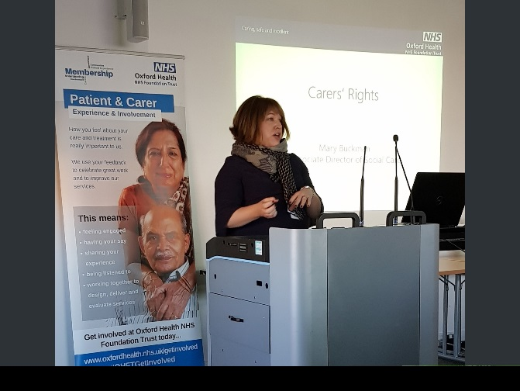
The Bucks event programme focused on some of the challenges that carers face and included talks on Carers Rights, Consent and Confidentiality, along with the role of the Approved Mental Health Practitioner including Nearest Relative. Wellbeing ‘taster’ sessions were facilitated by Healthy Minds, Carers Bucks and the Adult Mental Health Team. The attendees also had the valuable opportunity to hear from a husband and wife who have cared for their son with a mental health condition and who is now under the care of Opal Ward.

The event was well attended with a mixture of carers and staff. Evaluation of the event concluded that 50% of carers said the information would ‘most definitely’ be useful in their caring role, with 25% saying ‘mostly’ and 25% saying ‘somewhat’. Nearly 80% of staff that attended said the information would be ‘most definitely’ useful/applicable in their work.

Comments received for future events included; “you are all lovely people”, “good day, really helpful and enjoyable”, “brilliantly organised, buzzy atmosphere, good education and care tools to use”, “more events like this to hear from other services” and “to make more time to listen to carers opinions”. All comments and suggestions will be used to help us improve for future events.

The next event will be the annual carers conference which will be held during carers week in June 2019 and will mark the 2nd year of the Icareyoucare strategy, plans for this event are currently underway.

A Volunteer Carer Support role is currently being developed. The profile for the volunteer role is in place and its aim will be to support families, friends and carers in their caring role and to support services by being accessible to families, friends and carers during times when they need someone to talk to, to receive additional support and signposting to external support organisations. The role will be piloted within one of our Community Hospitals and one of our Mental Health Inpatient wards in the Whiteleaf Centre, discussions are currently underway with these services and recruitment is anticipated shortly.

A carer awareness online training tool for staff has been co-developed with carers and is undergoing its first review by clinicians across the organisation with the next stage to be reviewed by family, friends and carers. The training tool allows staff to role play several situations with a fictional family and understand how their actions and behaviours can change the outcome.

Family, Friends and Carers service handbooks are a way of sharing useful information about the service and a way of providing information to carers as individuals including details on carers’ assessments and the local carers organisation and support. Oxford Health currently have an Adult Mental Health Service inpatient and community handbook available and we are in the process of developing one for our community hospitals in consultation with staff and carers. The plan is to roll out the family, friends and carers handbooks to other services across the organisation.

Services throughout the Trust are continuously looking to improve their work with family, friends and carers by identifying priorities for improvement, some of the focussed work which is underway includes;

- The Forensic Services have established an MDT working group to keep an oversight of the family, friends and carers work. This work includes the development of a new and improved information leaflet for families, friends and carers, reinstatement the carers’ support group/forum, offering information, education on mental health issues, medication, Mental Health Act and reinstatement the Carer’s council to focus on service development.

- The Buckinghamshire Memory Clinic are looking to improve the signposting and support of carers accessing the Memory Clinic as it has been have identified through feedback that there is a gap in post diagnostic support to carers. The service is currently looking at how they can feasibly develop carer support initiatives within the context of the current commissioning limitations, as they are commissioned for assessment and diagnosis only. Feedback has shown that the current signposting information is not sufficiently meeting carers’ needs and to address this, the service is in the process of developing a concise signposting document in consultation with carers as a starting point for improvement work.

- The Complex Needs Service ran a ‘Psychoeducational Training weekend’ for carers. 21 people attended over the course of two days. 11 sessions were held on a range of topics with one session run by ex-service users. The feedback from the event averaged a score of just over 9/10.

- The Eating Disorders Service, Cotswold House hold a Carers Forum with a ‘closed membership’ in the sense carers can join but need to make a commitment to attending monthly. This is a formal group, with established terms of reference, and a focus on being a resource that promotes carers voices and wellbeing through contributions to the Cotswold House service. The group is accountable to the Cotswold House management team, and provide quarterly feedbacks, and a yearly report. Areas of past work have included: - a ‘Carer to Carer’ leaflet for inpatient admissions and an audit of ward staff skills and approaches to work with carers. Their ongoing work includes: - a carers role description, a ‘who is responsible for what’ guide when a loved one is admitted, - a carer to carer guide on the transition from ward to home post admission and a proposal to pilot a past carer to current carer support service, available during the initial weeks of admission.

- Summary of feedback received (current strategy aim Acting on Feedback)
Overwhelming the feedback, we have received from patients, families and carers is very positive with patients reporting feeling cared for by staff and that as a result they highly value the service provided. However, some people do not receive the positive experience we expect every person to have and therefore we have more work to do. The themes highlighted from complaints and serious incidents mirror the key areas for improvement identified from the feedback we receive, with people wanting to be an active partner in their care and being supported to make joint decisions.

The Trust has received 3,142 responses through the software ‘I Want Great Care’ between 1st December – 28th February 2019 with an overall average score of 4.75 out of 5 across all the questions asked. The number of responses has slightly increased and compared to last year there is a significant increase. 93.76% said they would be likely to recommend (slight increase from previous quarter >2%) with 1.75% being unlikely to recommend (slight decrease from previous quarter <0.5%). (4.49% report neither or don’t know – slight decrease from previous quarter by 1.5%)

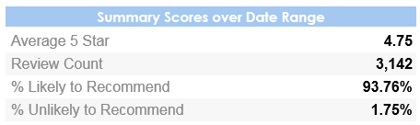

The below graphs show the overall demographic information of those giving feedback and the way this has been provided i.e. a paper survey (off line), on-line or via the apt on a tablet. Quarter 2 information is on the left, Quarter 3 information is on the right. The source of ‘offline’ denotes those surveys completed via paper and the below graphs show that there has been a large increase in the collection via “tablet” (iPad) and a reduction in the use of paper (67% to 48% over the year).

Quarter 2 information Quarter 3 information
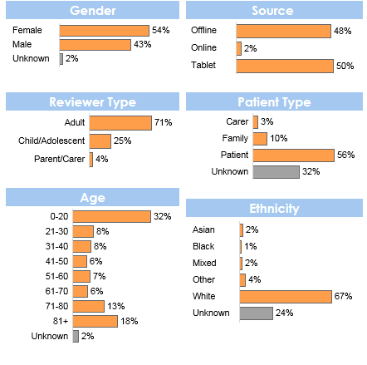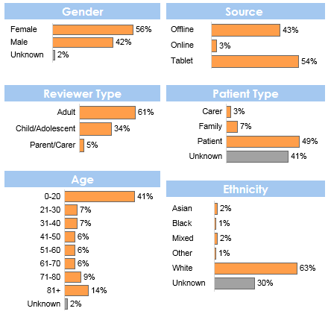

The graph below shows the trust-wide average score for each question asked through the IWGC survey, out of a maximum of 5, over the last 3 months (December 2018 - February 2019). The first 5 questions (from top to bottom) are asked by all services (‘dignity to kindness), the bottom 6 questions are those asked on the specific children and young people service surveys. FFT question refers to the national Friends and Family Test, further details below.

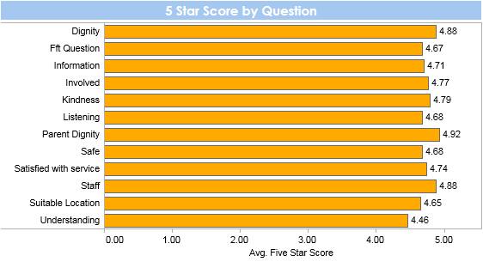

Below are the trends for the first 5 questions asked across all services, showing the average score over the financial year 2018/19 so far. These graphs show that the ratings stay very stable over the time period with less than 0.20% change in any of the questions scores. This is a trend which is true of the year to date.

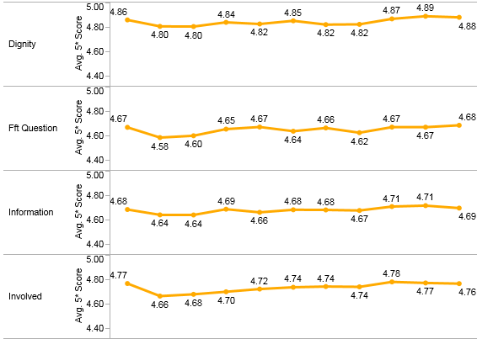
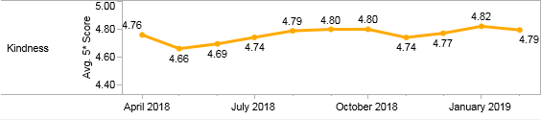

The below graph shows the number of responses received from 1st April 2018, the amount of feedback has remained steady. Almost every clinical service/ team has been set up to collect feedback using ‘I want great care’. Those teams who do not collect feedback within each quarter are contacted to identify any issues or challenges and to offer support. The teams which have collected 0 feedback in a quarter are also reported and discussed at the Caring and Responsive Quality Sub-Committee.

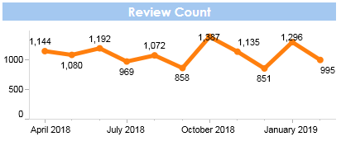

The graph below shows that the average 5-star score has consistently remained between 4.66 and 4.75 out of 5, as shown by the blue line on the top. The difference in percentage (%) for scores shown by the orange line has ranged by 3%, especially at the beginning of 2018 but more recently the difference in average overall scores has been less than 2% + or – each month, on the previous months data.
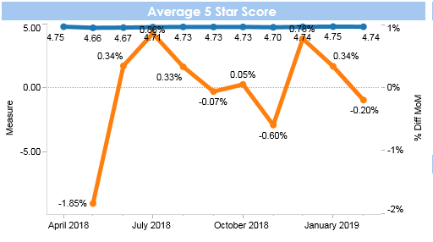

National Friends and Family Test Question
The feedback to the national Friends and Family test question (FFT), “would you recommend the care received” remains positive and above national average, in this quarter 93.76% said they would be likely to recommend (slight increase from previous quarter >2%).

The national question is currently being reviewed by NHS England and the Patient Experience Manager is part of the national development group. The recommendation is for the question to be changed and timing of when to ask the question, this is likely to be introduced from April/ May 2019. NHS Trusts will have 6 months to implement the change in question and guidance.

Positive qualitative feedback
The below word cloud shows the 100 most frequently words used by patients who have given a 5* (star) average score in the last 3 months. The 5 most used words are:
Good – 384, Care – 312, staff – 303, helpful – 297 and friendly - 218

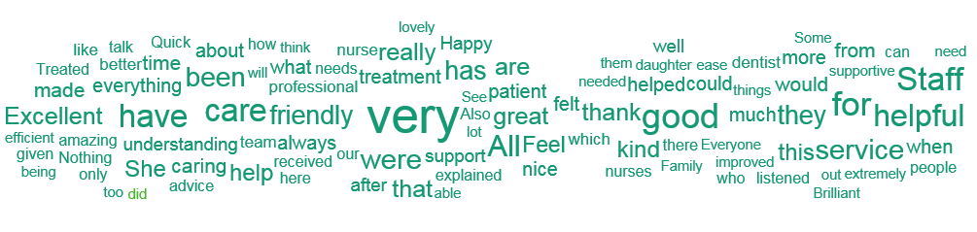

Some comments from people who answered that they are extremely likely or likely to recommend our services include:

“Only just started treatment and already the care I have received has included specifying my expectations from the service and the specification of theirs, it is a very patient focused environment and staff are very supportive of individuals and the aim of treatment itself.
Thank you” – Cotswold House, Marlborough

What a good service. Great to see this happening – Buckingham Street Triage Team

I can’t thank Neil enough for helping my 11-year-old to work through his anxiety especially with bed time. We have noticed a difference, thank you – Buckinghamshire CAMHS

It has helped me to understand more about how I feel and what I’m going though at this point at my life and also helped me to see things that I can and can’t control – Oxfordshire in reach BYHP

Thank you for the kind care and cheerful helpful staff – Wenrisc Ward
Reassuring – Witney Health Visiting Team

Very good service and helpful – Physical Disability Physiotherapy Service

Put at ease. Had everything explained to me – East Oxford Health Centre Dentist Out of Hours

A very good and kind service lovely to work with – Family Nurse Partnership

We had a negative view of coming to the Warneford as our friend took her own life after being discharged to our care, but memory clinic was very helpful and reassuring. It has balanced my previous – Central & North East Oxford Older Adult Mental Health Team

Absolutely wonderful care, professional. minor point- it would be helpful to know when you are coming by means of brief phone call or text – Deddington and Bloxham District Nursing Team

Negative qualitative feedback
The below word cloud shows the 100 most frequently used by patients who have given an average score of 2.5* (star) or less in the last 3 months. The mostly commonly used word was “dismissive” used in 2 reviews and all of the other words shown were used in a single review.

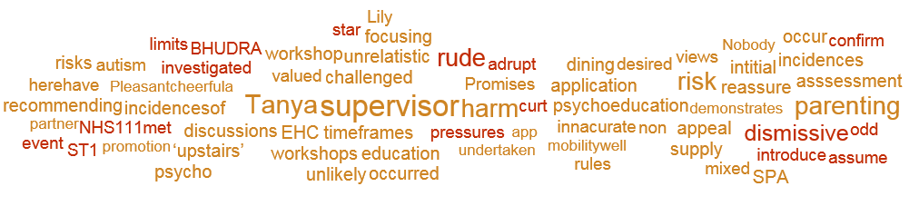

An immediate automatic alert is created for any service who receives a review of less than 3 stars for any reason. This allows the service and Patient Experience Leads the opportunity to monitor, respond and action any improvement feedback which is received in near real time. Services have begun to respond directly to a number of reviews which have been received and it is our aim to develop staff’s ability to respond further over the next 12 months.

Some comments from patients whose overall review score was below 2, all these comments have been reviewed and actioned by the team:

“Felt like I was in prison, no leave and stuck in here. Force to take medication, but was not ill” – Sapphire Ward

“Your services came far too late to be any great help to me. Your physio was a very nice lady” – Central Oxfordshire Community Therapy Service

“Some staff treated me with dignity and respect and worked hard to ensure my welfare. However, others were dismissive. My partner was not listened to or kept informed” – Wintle Ward

The top 3 improvement themes from open comments in the last 3 months are:
- Appointment/Referrals/Wait times/Discharge
- Communication/Information
- Environment/Facilities/Parking
These are being used to inform quality improvement work locally in teams and “you said we did” actions.

National Patient Survey
The Trust is participating in the national community mental health survey in 2019, the fieldwork has just started and is due to finish in June 2019. We should receice our results in the autumn.

- You Said, We did (current strategy aim Acting on Feedback)
All services aim to feedback to service users/ patients/ families on quality improvement work which has been initiated from feedback. We call this “you said, we did” and this is often displayed on boards, posters or in leaflets. Below are some examples of changes made in the last 3 months:

Mental Health Directorates:
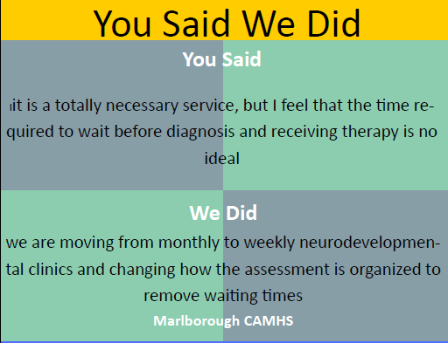

Marlborough CAMHS team YSWD

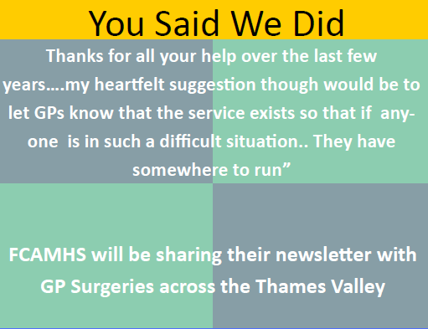

Forensic CAMHS team YSWD

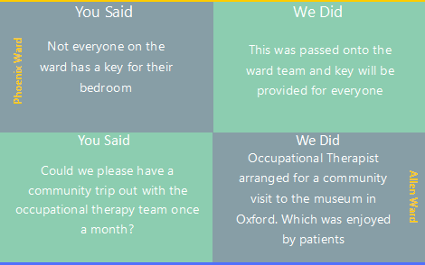

Phoenix ward

Allen Ward

Community Directorate:

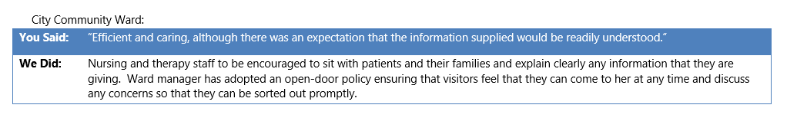
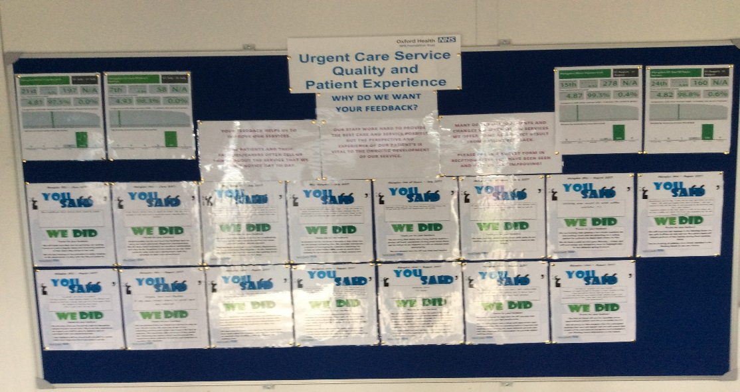

Urgent Care board in the entrance to one of the MIUs

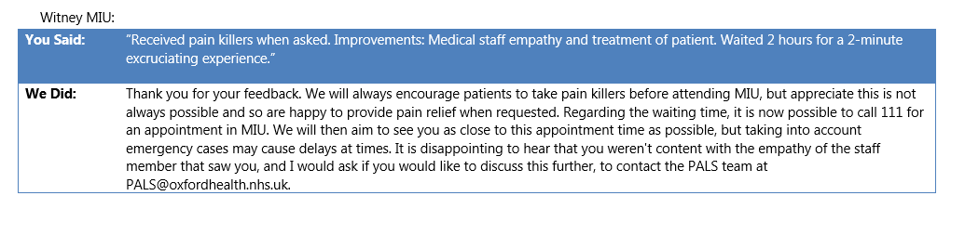

- Involvement work (current strategy aim Involvement in Services)
Across the Trust involvement work is happening continuously as we strive to ensure patients, service users and carers are invited to be partners in the design, development, delivery and evaluation of services. Some examples of involvement work carried out in the last 3 months include:

- SEND Pathway: The Health Visiting Service have written a new SEND pathway (children with Special Educational Needs or Disability) which was launched at the 0-5 Conference on 16th October 2018 and is now live. The Health Visiting Service are now seeking feedback from parents to be used when the pathway is reviewed to help improve quality of the pathway. A survey monkey questionnaire was also designed to seek further feedback on the new model. So far there have been 5 home visits to speak with parents and use their experiences to shape our future work.

- CAMHS Participation Group - Article 12: At this year’s Article 12 Christmas Party, the group decided they wanted to make paperchains for the waiting area at CAMHS, decorate their own baubles and play lots of festive games. They also put together this video of a round up of all of the group’s achievements throughout the year which you can watch here. https://www.youtube.com/watch?v=hAjzLv-Z4fM&feature=youtu.be

- Focus Groups: planning has started to setup focus group for various services including; Pulmonary Rehabilitation, Physical Disability Physiotherapy Service, and School Health Nursing. The focus groups will be aimed at helping each service in identifying areas they are doing well in and areas that could be improved.

The Buckinghamshire Early Intervention Service (EIS) has recently held their first carers focus group to understand what improvements they should be making to better support carers that are linked to their service, the group was well attended, and the following feedback was gathered and will be used to improve service experience;
- Confusion over names of teams and what everyone’s role was
- the website being very poor
- lack of links between EIS and CAMHS
- need for a booklet at start to understand what EIS does
- poor continuity of doctors, lack of information on medication
- need for advance agreement of loved one’s that family/ carers can be informed/pick up medication before they are back in crisis.

- Getting Me Home: Patient Experience Team supported the Getting Me Home initiative by visiting Witney Community Hospital to interview and film a patient that was getting ready to go home. The video is still being edited and will soon be launched.

- Governors & Membership: Service users and staff who completed the first learning disability leading together course have started using their co-production skills to try to increase involvement of people suffering from a learning disability and also look at how we could make becoming a governor accessible.

- Involvement Leaflet (Trust wide): The Patient Experience Lead has been working with the Trust Patient Experience Manager to develop a ‘Patient Involvement leaflet’. The aim of the leaflet is to better inform patients, families and carers of all the ways they can get involved with Oxford Health. The leaflet has now been finalised and printed by the Communications Team, ready to be rolled out.

- Autism Experience Group: The first group for people with lived experience of autism to work collaboratively on aspects of the Trust’s autism strategy is being held at the end of March 2019.

- CAMHS Community Eating Disorders Service: 3 young people were supported to attend the Team Away Day. The young people took an active part in discussions throughout the day and their feedback has been included in plans to:
- Explore the possibility of developing Peer Support Worker Roles for the Team
- Reviewing the Eating Disorder Information Leaflet and the Parent Information Pack
- Discuss how Participation Leads could be involved in getting feedback from young people as part of a follow up phone call following discharge.

- Mental Health Transformation Event: A young person from the CAMHS BSW Participation team joined adult service users and parents and carers at a Transformation event organised by NHS England. The event was very participative and enabled those present to highlight key priorities for ongoing development of mental health services across our region. The issue of transition was a key theme and it was really helpful to therefore include the experience and perspective of a young person with personal experience in the discussions.

- Boys in Mind: Boys involved in the project met to discuss and identify key messages and information they would like to see shared with young men. They talked about the barriers young men face in feeling able to reach out for help. They are therefore keen to offer encouragement and support to young people and highlight some of the organisations that may be able to help them. A film event is scheduled for late January at which we will showcase some of the short films the boys have continued to make to reinforce the positive messages about opening up and seeking support.

- Complaints, Concerns and Compliments
The Trust receives complaints relating to services provided by the Trust. The Trust also receives a variety of enquiries and requests for help and information through PALS and also from local MP’s. The Trust’s complaints procedure is working well throughout the Trust. Many concerns continue to be resolved locally and promptly by front line members of staff, this can also prevent an escalation of the complaint. A detailed report is discussed quarterly at the Caring and Responsive Quality Sub-Committee, in summary the Trust received:

- OHFT received 59 complaints during Q3 2018’19, compared to 49 in Q3 2017’18.
- OHFT received 11 MP enquiries during Q3 2018’19, compared to 13 in Q3 2017’18.
- PALS received 512 contacts during Q3 2018’19, compared to Q3 2017’18 when 666 contacts were received.
- OHFT received 684 compliments in Q3 2018’19.
- There are currently eight cases being reviewed by the PHSO/LGO.
- In Q3, 11 new actions have been identified across the Directorates following an investigation into a complaint.

The graph below shows the number of combined complaints and concerns received by Directorate since January 2016 to 30th December 2018, including those upheld and not upheld.

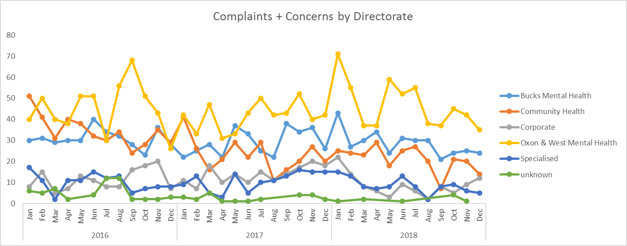

In looking at the themes/trends in Q3 across both concerns and complaints the chart below shows the primary categories, with the most common being all aspects of clinical care.
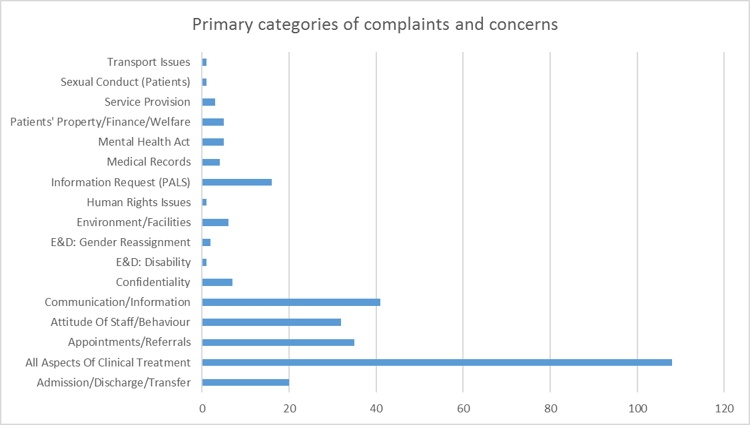

In looking at the categories from complaints alone, we are able to look at the outcomes from investigations and whether a complaint was upheld or not and what learning has been identified and what actions need to be undertaken. The main themes from complaints in Q3 remain about all aspects of clinical care (32), of which six related to insufficient care within the community (one upheld, one not upheld and four remain open). Eight cases related to diagnosis issues, of which two were upheld, one was not upheld and five are open. Five cases related to an inadequate assessment of which three cases were not upheld and two cases are open. Each individual complaint which has upheld elements has an action plan developed (or immediate actions taken) to ensure that we improve and learn from people’s experiences. The progress with actions is monitored centrally with reports on weekly progress.

Compliments
The Complaints and PALS Team centrally collates the compliments sent to teams within the Trust including thank you letters and cards. In Q3 a total of 684 compliments were received; Oxfordshire, BaNES, Swindon and Wiltshire Mental Health Services received 226, Community Services received 311, Bucks Mental Health Services received 90, Specialised Services received 51 and Corporate Services received six. There continues to be an increase in the number of compliments being received about the Trust’s services.

“I think that CAMHS is a very good place to seek advice because it helps you with various problems and helps you understand them.” South Oxfordshire CAMHS

“Only just started treatment and already the care I have received has included specifying my expectations from the service and the specification of theirs, it is a very patient focused environment and staff are very supportive of individuals and the aim of treatment itself. Thank you.” Cotswold House Marlborough

“The staff are friendly and approachable for children. L listens to both us and our child. Feel very supported. They were only a phone call away when things got bad.” Salisbury Getting Help

“It was really good because I was able to talk about some of the issues I was experiencing and was able to seek help. I always felt I had someone to talk to regarding my issues with mental illness.” Oxfordshire Early Intervention Service

“I really appreciated the kindness and understanding that was shown towards me, this really helped to calm me down. The assessment was very accurate, this showed that I was being listened to. I am being proactive in dealing with my situation, but I know that I can contact healthy minds should I need further help and support.” Healthy Minds

“Staff are amazing, kind, approachable and they really understand.” Psychiatric in Reach Liaison Team (PIRLS)

“I can’t thank Neil enough for helping my 11-year-old to work through his anxiety especially with bed time. We have noticed a difference, thank you.” North Buckinghamshire CAMHS

“Everything is really good here and the staff are angels, this place is amazing.” Ruby Ward

