

**BOD 43/2019**

(Agenda item: 6)

# Report to the Meeting of the

# Oxford Health NHS Foundation Trust

# Board of Directors

**25 April 2019**

**Monthly Performance Report – M12 March 2019**

**For: Information**

**Executive Summary**

This report summarises and provides assurance against the Trust’s national and locally contracted key performance indicators (KPIs) for Month 12 (March 2019). Overall, the Trust achieved 335 of the 430 targeted indicators (78%). This is an improvement on the performance achieved in the preceding months. Overall, the Trust achieved 75% of its indicators this year.

**Performance Trend:**

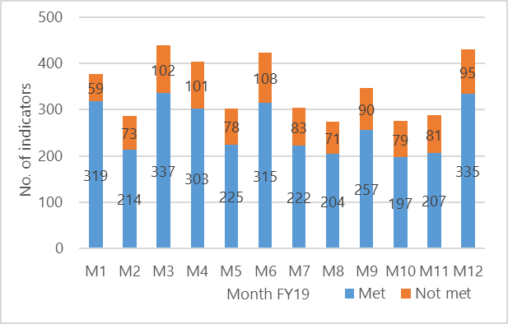

The number of locally contracted indicators varied throughout the year as is illustrated in the graph above. This is due to some indicators only being reportable on a quarterly basis. Of the 95 indicators not met in March, 46 were more than 10% away from the commissioner defined targets and workforce shortages continue to have a major impact on service delivery.

**Areas to highlight to the Board from an overall Trust perspective**:

**National Position:**

The table below shows how the Trust is performing against the **operational performance** indicators within the NHSI Single Oversight Framework (as at the latest available position) and how performance also compares to the national average. The Trust is achieving all indicators with the exception of Out of Area Placements (OAPs) which continue to be a major issue for the Trust and is due to a lack of community alternatives. However, the number of bed days lost to out of area placements in March across both Oxfordshire and Buckinghamshire has continued to reduce to its lowest levels; notably in Oxfordshire which was at 84 bed days lost in March compared to 287 in October.

The 4 hour target in relation to Minor Injuries Units fell below the 95% threshold for the first time this year at 94.3%, however, full year/YTD performance remains above target.



**Local Position:**

**Patient Access and Patient Flow**

The table below shows performance in relation to the Trust’s core mental health community services concerning demand, patient access and patient flow. Key headlines;

* **Demand**

The number of Adult Mental Health referrals received in Oxfordshire continues to be higher than Buckinghamshire (32% higher in March), despite comparable population sizes

The number of referrals received by CAMH services increased significantly in March to its highest level for the year. Overall referrals to the Trust’s CAMH services across Oxon, Bucks and BSW were 2614 in March. The average number of referrals between April 2018 and February 2019 was 2027.

* **Access/Waits**

Access to the Oxfordshire and Buckinghamshire CAMH services continues to be challenging, with only 43% and 75% of patients who were referred to the respective routine pathways being seen in March within 12 weeks. Performance did, however, improve in March against previous months which could be attributed to the reduced number of referrals received in December; 12 weeks previous which illustrates the direct correlation between access performance and increased demand on services. Emergency referrals are being prioritised within available resources and all patients since October have been seen within the 4 hour target.

An action plan is in place with Buckinghamshire CCG in relation to Bucks CAMHS waits. A review of the waiting times report rules is in progress as part of this plan.

* **Delayed Transfers of Care (DTOC)**

A significant number of bed days have been lost this year due to DTOC; 2556 days in mental health and 15,444 days in community. This equates to 7 beds in mental health and 42 beds in community. The number of days lost to DTOC in community continued to be at one of its highest levels for this year. Conversely, the DTOC position in mental health was at one of its lowest levels for the year.

* **Out of Area Placements (OAPs)**

13 patients were placed out of area in March which is the lowest level since September. Moreover, the number of bed days lost to out of area placements in March across both Oxfordshire and Buckinghamshire has reduced from previous months; notably in Oxfordshire which was at its lowest level YTD



**S75 Agreements with Oxfordshire County Council and Buckinghamshire County Councils**

The Trust achieved **100%** compliance against the indicators for Oxfordshire and Buckinghamshire for March 2018. Reports are one month in arrears.

**Performance by Directorate in March 2019:**

**Oxfordshire, Swindon, Wiltshire & BaNES – All Ages Mental Health** achieved 81 of the 118 targeted indicators (69%) which is an increase in performance from M11 (62%).

**Highlights for the Board:**

1. **Emergency Department Psychiatric Service (EDPS)** – Horton General Hospital (HGH). Staffing pressures continue to affect performance against the 90 min waiting time targets at the HGH. The pressures have been reported to the Quality Review Meeting (Oxfordshire CCG) so that any identified risks to patients can be understood and mitigated. An update on this issue will be provided at the May Board following the review at the QRM.
2. **Children & Young People Mental Health (OXON)** – Due to the long term under-investment in mental health in Oxfordshire, the Trust is not able to achieve the 12 week routine waiting time target. At the present time, the waiting time for a routine referral is C16 weeks +. As reported last month, even with Trailblazer funding at a national level, it will be several months before waiting times are seen to reduce.
3. **Part 1 and Part 2 Summaries sent to GPs within 10 days of discharge** – Performance has improved by 10% over the past month. If the improvements are maintained, the Trust should achieve the commissioned target by Q2 or Q3 2019/20.
4. **Adult Mental Health (OXON)** – A significant underfunding of mental health in Oxfordshire has resulted in considerable pressure building up for mental health services. **The Trust is not able to achieve the 4 week waiting time target with the levels of investment available.** This position and potential resolutions continue to be discussed with Commissioners.
5. **GP Outpatient Letters sent within 7 days** – Performance against this target continues to be challenging due to a lack of workforce. This issue has been compounded by the change in target (from 10 days to 7 days) at a national level. The service is actively recruiting additional staff.

**Buckinghamshire – All Ages Mental Health** achieved 38 of the 54 targeted indicators (70%). This is a decrease in the performance reported in M11 (82%).

**Highlights for the Board:**

1. **Care Reviews (Clusters)** – A new dashboard has been piloted that proactively provides clinicians with a view on when care reviews need to be carried out. Initial results from the pilot have been positive and planning is now underway for further deployment to operational teams.

**Oxfordshire Community Services Directorate** achieved 94 of the 119 targeted indicators (79%) which was a significant increase in performance from the 69% reported in March.

**Highlights for the Board:**

1. **Oxfordshire and Buckinghamshire Continuing Health Care (CHC**) – Detailed discussions continue with commissioners in Oxfordshire and Buckinghamshire to resolve a number of long-standing issues in both counties. Although some improvements have been made, achieving the commissioned targets remains a challenge. The Oxfordshire CCG are planning a competitive procurement exercise over the next few months.
2. **Falls Service –** Performance has improved significantly since the service has been fully staffed. The Service has achieved 70% against their target of 90% and at the current rate, it is expected that the Trust will delivering services at the required levels by the end of May 2019.

**Specialist Services** achieved 122 of the 139 targeted indicators (88%).

**Highlights for the Board:**

1. **Eating Disorders (Bed Occupancy)** – As reported in February 2019, the Trust is still not able to use all its available bed stock due to high levels of patient acuity and a lack of workforce. Commissioners (NHS England) have been notified and a decision is now required in relation to lowering the target or investing further funding so that additional workforce can be recruited.

**Recommendation**

The Board of Directors is asked to review and note the monthly Board performance report.

**Author and Title:** Martyn Ward – Director of Strategy & Chief Information Officer