

# Report to the Meeting of the

# Oxford Health NHS Foundation Trust

# Board of Directors

**BOD 45/2019**  
Agenda item: 8

# 25th April 2019

# INPATIENT SAFER STAFFING Report Period 25th February to 24th March 2019

**For: Information**

**Executive Summary**

**Ward Staffing**

The purpose of this paper is to provide the Trust Board with an interim exception report in line with the requirements of: “How to ensure the right people with the right skill are in the right place at the right time”, Chief Nursing Officer for England & National Quality Board November 2013. From June 2014 there has been a Department of Health requirement for trust boards to receive monthly updates on ward staffing levels. Ensuring sufficient staffing levels are in place is crucial to deliver safe, effective and high quality care. This report will be published on our website with a link from NHS Choices website.

The data within the report will outline the staffing levels (for both registered and unregistered nursing staff) on each ward. These figures will be measured against the required figures on a shift by shift basis for the period 25th February to 24th March 2019 in line with the requirements of the DH Unify reporting process and the data extract is attached (Appendix 1).

During this period:

Average weekly day shifts fill rates for registered staff & unregistered staff were above the Trust target of 85% with 91% or above for unregistered and 95% or above for registered staff.

Four wards were below 85% target for average weekly fill rates for registered nurse day shifts during some of this period. This is an increase from two wards in the last period. The wards were Cherwell, City Watling and Wintle. City also had only 69% average fill rate for unregistered staff.

Average weekly night shifts fill rates for registered and unregistered for all wards were above the Trust target of 85% with the average lowest fill rate at 92% for unregistered staff and remained above 100% for registered staff for each week. The methods of filling these shifts includes substantive, flexible workers and agency registered staff and further detail in provided later in the report.

The average weekly % agency use was 11.5% slight increase from 11.3% in the last reporting period.

Average sickness rates for ward staff were 5.2% a decrease from 5.8 last month.

This report also includes an update on Community Hospitals registered nursing vacancies and an update on nursing workforce development update as part of the nursing strategy to provide assurance as part of the Trust CQC Well Led Inspection ‘Should’ action *All efforts are made to reduce the level of vacancies, particularly of qualified nurses.*

**Recommendations**

The Board is asked to note:

* There are processes in place to ensure safe staffing levels on all the wards in the organisation, those wards where there are concerns and the actions being taken to ensure safe staffing including project work and wider recruitment and retention work. There are no exceptions to report that directly link actual staffing levels to adverse outcomes for patients which have been identified through our Governance Structures.

**Author and Title:** Kate Riddle, Acting Director of Nursing and Clinical Standards

**Lead Executive Director:** Kate Riddle, Acting Director of Nursing and Clinical Standards

*A risk assessment has been undertaken around the legal issues that this paper presents and there are no issues that need to be referred to the Trust Solicitors. This paper links to all the five CQC Domains.*

***Strategic Objectives*** *– this report relates to or provides assurance and evidence against the following Strategic Objective(s) of the Trust*

*Driving Quality Improvement (Goals: patients will be safe from harm; patients will achieve the clinical outcomes they want; and patients and carers will have an excellent experience)*

*Delivering Operational Excellence (Goals: our services will be effective and efficient; information will be translated into knowledge; and our planned surplus will be delivered)*

**Inpatient Safer Staffing**

Period 25th February to 24th March 2019.

**Introduction**

This is the report to the Board of Directors outlining the staffing levels (registered and unregistered) on each ward against their required need on a shift by shift basis. This report covers the period 25th February to 24th March 2019.

This report will focus on the percentage of day and night fill rates for registered and unregistered staff. This data is reported to NHSI and provides assurance of actual clinical staffing numbers being achieved. This report will be published on our website with a link from NHS Choices website.

**Management of Staffing Levels**

Anescalation process for the management of staff shortages is in place within each clinical area, to manage staffing safely on a shift by shift basis. As part of this process, senior clinical staff are providing appropriate support to ward teams as and when required. In addition, senior ward staff and immediate team managers review ward staffing levels on an on-going basis; shift by shift basis, and where there are changes in patient acuity. Ward Matrons review staffing daily as a minimum and more frequently where required.

In-patient staffing levels continue to be reported every week and discussed within the Weekly Review Meeting (WRM), which takes place each Monday morning with the Director of Nursing and/or Deputy present.

To ensure that staffing levels are under continual review, every ward undertakes a range of immediate actions daily to ensure safe staffing levels are maintained appropriate to the needs of patients. These actions include booking flexible or agency staff via Staffing Solutions, revising rotas, moving staff between wards and utilising additional staff that are not included in the ward numbers as required for example modern matrons.

**Summary position of inpatients wards staffing levels.**

Appendix 1 shows the staffing levels for all wards by ward for the period 25th February to 24th March 2019.The data presented includes details of staffing by shifts and details of skill mix, agency, ward staff sickness and ward vacancy figures. The thresholds presented in the table are measured against trust/ national targets and used for exception reporting.

During this period:

**Day shifts fill rates**

Average weekly day shifts fill rates (all departments) for registered nurse & unregistered staff were above the Trust target of 85% throughout this period. This included a mix of agency, flexible and substantive staff including ward managers and matrons where required to make up staffing numbers and provide safe care.

Average weekly day shifts fill rates for registered staff & unregistered staff were above the Trust target of 85% with 91% or above for unregistered and 95% or above for registered staff.

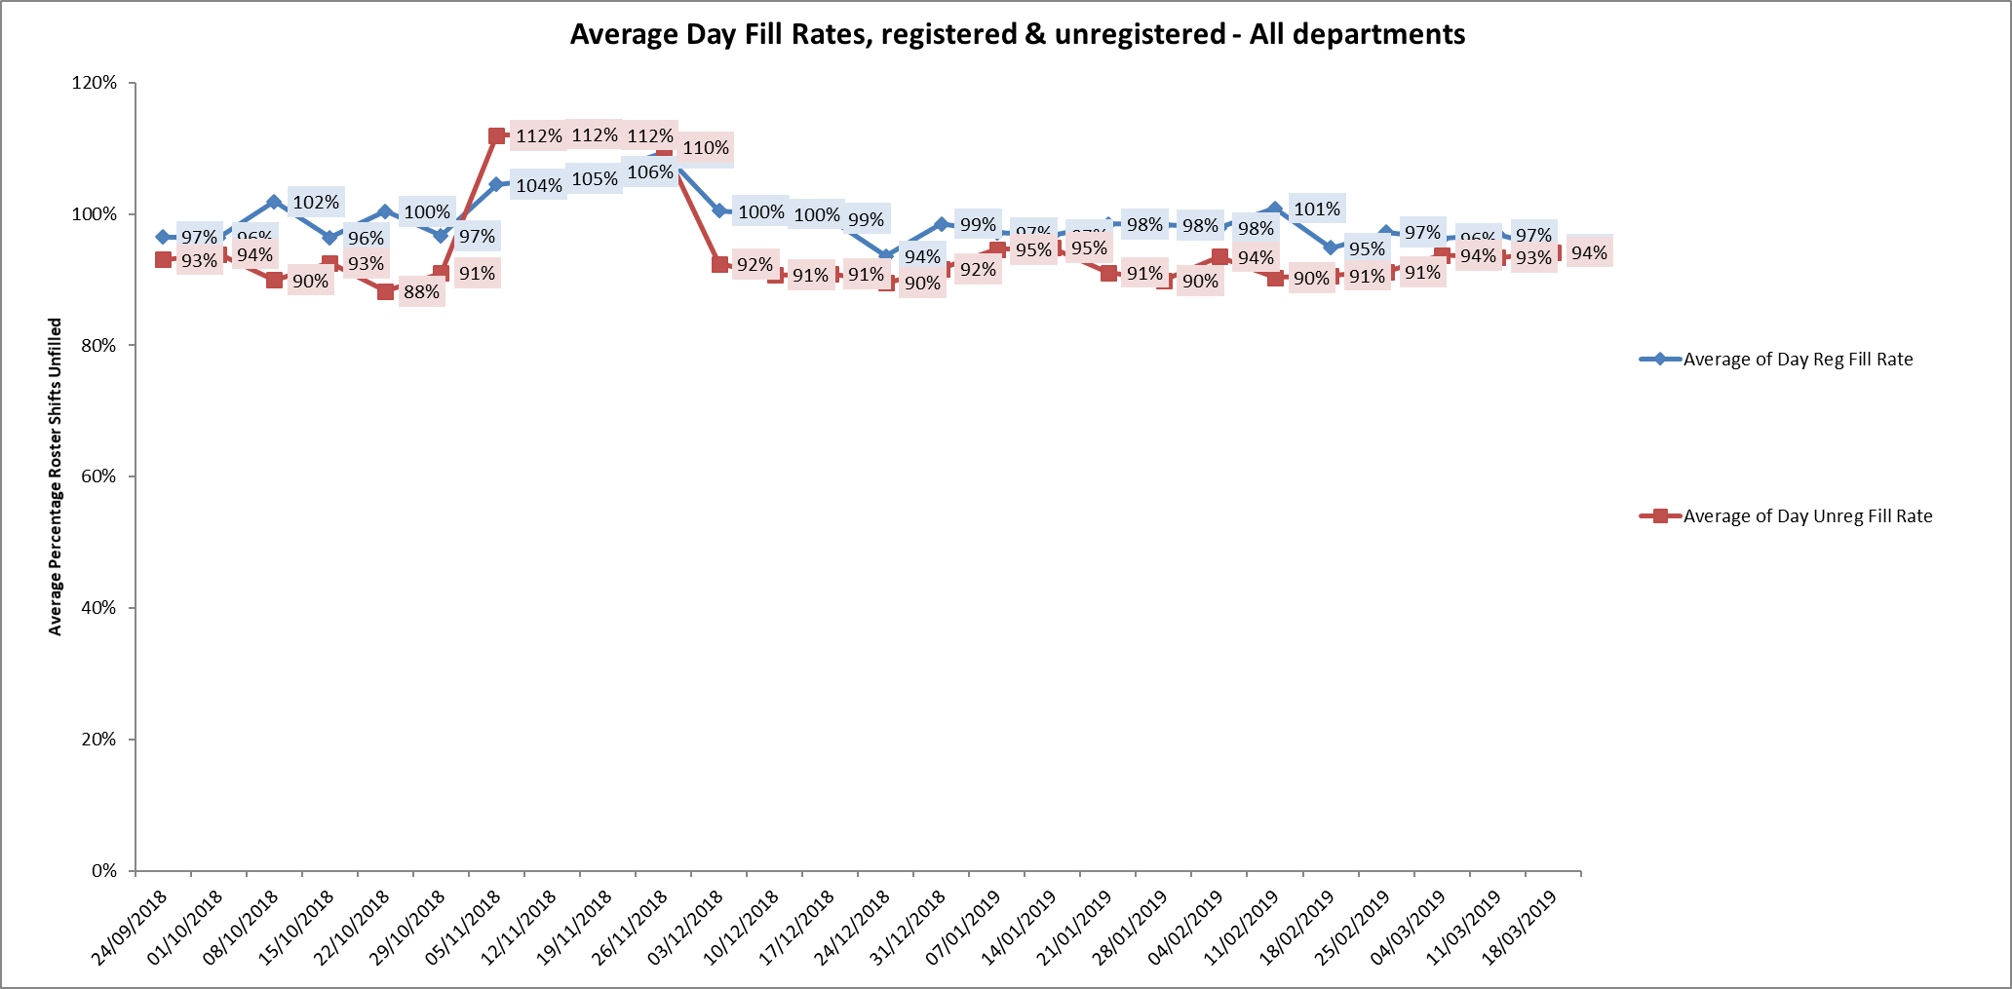

Four wards were below 85% target for average weekly fill rates for registered nurse day shifts during some of this period. This is an increase from two wards in the last period. The wards were Cherwell, City Watling and Wintle. City also had only 69% average fill rate for unregistered staff. There was addititional support from ward managers or matrons to support safe staffing.

**Night shift fill rates**

Average weekly night shifts fill rates for registered nurse & unregistered staff were above the Trust target of 85% throughout this period for all wards. This included a mix of agency, flexible and substantive staff to make up staffing numbers.

**Registered skill mix**

Fifteen wards had in place an average of 50% or above registered staff skill mix.

Wards with below 50% registered skill mix is related to the continued registered nurse vacancies. Safe staffing is supported by the ward managers and matrons on the ward working clinically as part of the numbers where required to ensure registered nursing leadership is maintained.

Skill mix is achieved through use of our own staff and trust employed flexible registered workers and agency registered nurses.

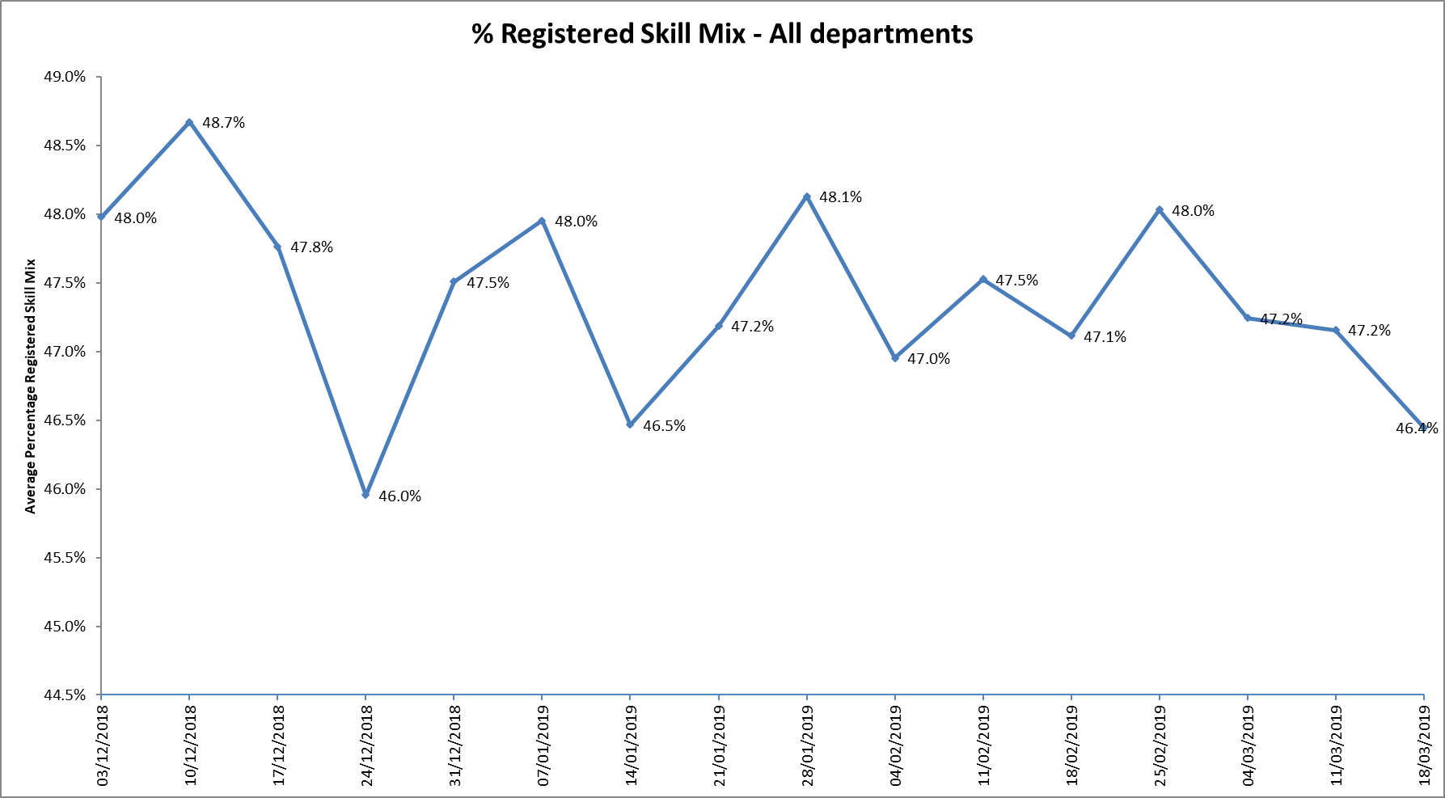

**Agency use**

The Trust moved to a new approach to reduce the use of unregistered agency staff in the week of 14.5.18. Further detail of this project is provided in the HR workforce report and commented on in relation to changes in skill mix ratios.

The average weekly % agency use was 11.5% an increase from 11.3% in the last reporting period. This remains below the peak of 19.1% in February 2018.

* Eleven wards required less than 5% agency use (Trust target)
* Three wards between 5-9% agency use
* Thirteen wards required between 10% -20% agency usage
* Six wards Allen, Ashurst, Phoenix, City, and Forensic wards Kestrel and Kingfisher, required above 20% of agency staff in the period, this was related to sickness, vacancies and patient acuity

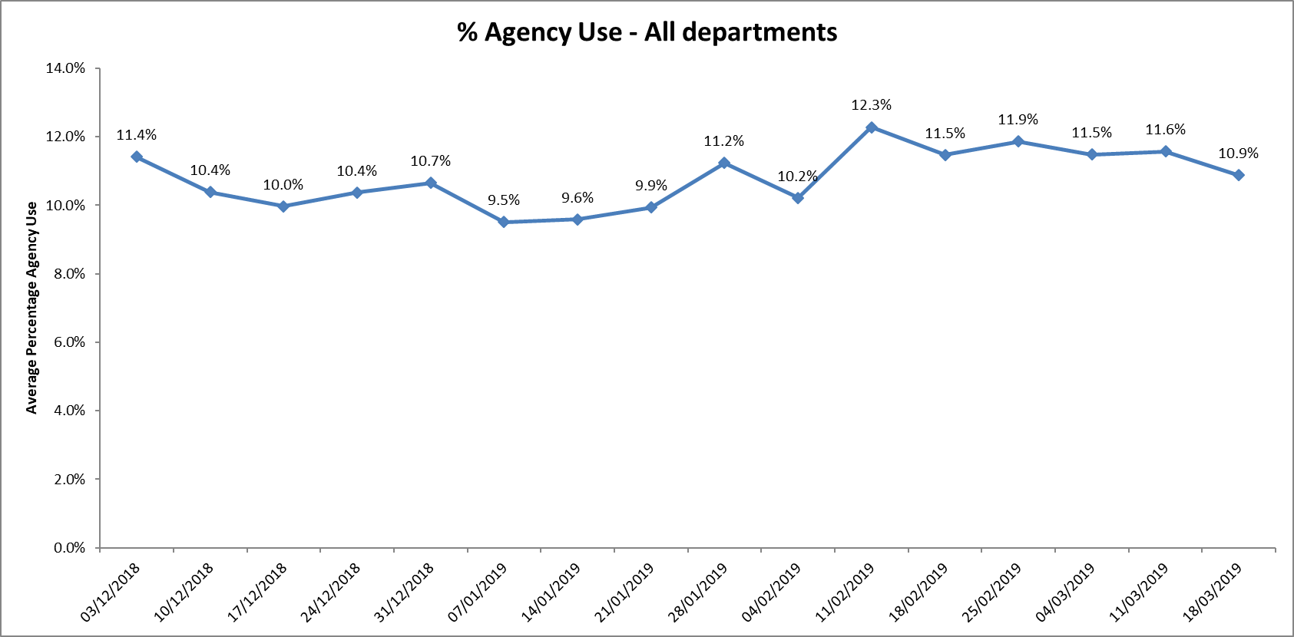

Further detail of agency use and spend is provided in the Workforce report.

**Maintaining Safer Staffing.**

**Community Hospitals.**

Vacancy update

|  |  |  |  |  |  |  |
| --- | --- | --- | --- | --- | --- | --- |
| **Ward** | **Established bed numbers** | **Current bed numbers with Winter beds** | **January 2018** | | **September 2018** | **April 2019** |
| **Oxfordshire Stroke Rehabilitation Unit (Abingdon) OSRU** | 20 | 16 | Band 5 6  Band 3 3 | | Band 5 6.59  Band 3 6.52 | Band 5 5.3  Band 3 0 |
| **Abbey ward Abingdon** | 18 | 19 | Band 5 2.11  Band 3 3.58 | | Band 5 2.89  Band 3 0.2 | Band 5 2.4  Band 3 0.8 |
| **Bicester** | 12 | 12 | Band 5 0  Band 3 1 | | Band 5 0  Band 3 1.6 | Band 5  Band 3 0.5 |
| **City** | 16 | 12 | Band 5 5.1  Band 3 1.8 | | Band 5 6.31  Band 3 1.8 | Band 5 8.55  Band 3: 1.8 |
| **Didcot** | 16 | 18 | Band 5 4.76  Band 3 1.46 | | Band 5 4.59  Band 3 1.11 | Band 5 : 0  Band 3 1.37 |
| **Wallingford** | 18 | 19 | Band 5 4.9  Band 3 1.62 | | Band 5 2.96  Band 3 0 | Band 5 2.96  Band 3 0 |
| **Linfoot** | 20 | 28 | Band 5 4.84  Band 3 +1 | | Band 5 1.13  Band 3 0.3 over | Band 5 1.12  Band 3: 1.3 over |
| **Wenrisc** | 24 | 18 | Band 5 1.13  Band 3 2.09 | | Band 5 3.33  Band 3 0.75 | Band 5 1.8  Band 3 1.48 |
| **TOTALs** | 140 beds | **April 2019**  **142 beds** | **Band 5 28.84 WTE** | **Band 3**  **14.55WTE** |  | **April 2019**  **Band 5 23.62**  **Band 3**  **3.86** |

There has been a reduction overall in Band 5 from 28.84 (Jan 2018) to 23.62 April 2019 but there are two wards with continued high vacancies OSRU and City

OSRU

Beds remain at 16 to maintain safe staffing numbers due to registered nursing vacancies and staffing issues.

City ward

The ward was operating on reduced bed numbers to 14 (including two winter pressure beds) from 18 to support safe staffing levels being maintained, but day fill rates are remaining below 85% average.

Linfoot Ward

Beds escalated from 20-22 for winter. As part of fire evacuation mitigation plans on Wenrisc 6 patients were transferred to Linfoot this is temporary until a full independent fire survey is completed.

Actions in place

Rolling advertisements for staff vacancies are in place.

International recruitment is being investigated as an option through use of a recruitment agency.

Band 3 recruitment has improved and there is active engagement with providing nurse associate trainee placements across all sites.

Substantive staff are covering some vacant shifts, lines of work are covering existing vacancies at City, Wallingford and OSRU

Unfilled shifts are escalated early and a plan is put in place to ensure they are filled

Senior staff are increasing number of clinical shifts.

Peer review of safer staffing tool in progress to ensure all sites are completing the information consistently and that the tool is giving a true reflection of the dependency and capacity to manage safely

**Forensic wards**

All ten wards continued to be below average 50% skill mix registered nursing during this last period.

The current establishments do not cover a 50/50 split. This has been rectified with the new skill mix review, as this goes forward into implementation into the roster system with the new establishment and shift patterns this will increase the qualified ratio.

A Recruitment and Retention premium has been introduced from 1.4.19, £1,500 per annum for Band 5 & 6 qualified nursing staff. This is aimed to incentivise new staff whilst also enhancing the retention of the existing staff

**Adult Mental Health Wards**

Ashurst ward has continued high nursing vacancies, to support safe staffing the ward is now operating as male only and longline agency staffing is in place. In addition, there was increased use of unregistered staff at a time of increased acuity. Further work is planned to review the model of care for the ward.

Ashurst and Phoenix wards are co-located and staff work flexibly across to support patient needs on both wards. This is overseen by the Matron and ward managers for the wards. Twice daily conference calls for the adult wards are in place to support staffing across the wards when shifts cannot be filled with registered staff

Ashurst and Phoenix wards will be two of ten wards with high off Framework agency use where a review will be undertaken by Heads of Nursing working with ward staff and HR to review key areas of; incidents, complaints, concerns, admissions/ discharges, bed occupancy, training by course, appraisals, supervision, patient/ carer feedback, and detention rates. These will be reviewed alongside staffing levels, skill mix and patient acuity to provide an overall picture and action plan of support for the ward.

**Workforce development update as part of the nursing strategy.**

Nurse Cadets Pilot Project

The Trust has been allocated funding to set up a nurse cadet scheme across the Thames Valley region.  The money will be used to host a Band 7 Project Manager to take this work forward a small cohort of 16-18 year olds in Thames Valley FE colleges/schools and NHS Trusts.The cadets would undertake a Level Three Apprenticeship and this would be the opportunity to subsequently develop their career into nursing.This project is being proposed in the light of current and future workforce challenges, particularly in the nursing ‘family’.

Nurse Associate Roles

Further actions required:

A Quality Impact assessment in line with national guidance will be undertaken and reported to Trust executive team and Trust Board.

Re-procurement work is commencing of the education and training programme for Nursing Associate Trainees, this will include the top-up to Registered Nurse programme for at least 50 nursing associates.

Recruitment and retention

Proactive student nurse recruitment continues following on from last year’s approach– working with the OUH and Oxford Brookes University. In November 2018 events were held to meet students from all nursing pathways and work towards providing them with a job offer to start post qualification in Summer 2019. To date this work and specific work in community nursing has resulted in 38 job offers for summer graduates. A further Brookes event was undertaken in March 2019 which resulted in six job offers to mental health nurse students graduating in Summer 2019 .

**Conclusion**

All ward staff and managers continue to make every effort to ensure wards continue to be staffed safely, fill rates remain high for most wards and that we continue to focus efforts on retaining our staff whilst recruiting new nurses to join Oxford Health FT. Skill mix review work will be progressed to include Nurse associates and other roles.

**Author and Title:** Kate Riddle, Acting Director of Nursing and Clinical Standards

Appendix One All Metrics Period 25th February to 24th March 2019

