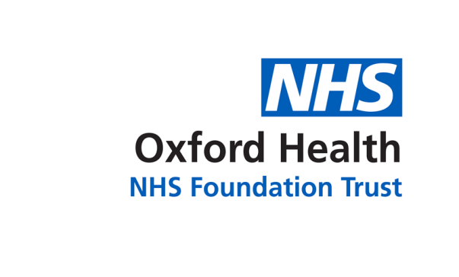

Report to the meeting of the

Oxford Health NHS Foundation Trust

Board of Directors
BOD 46/2019
(Agenda item: 9)

25 April 2019

Complaints & PALS Annual Report

1 April 2018 to 31 March 2019

Executive Summary
This is the annual report on formal complaints, PALS contacts, MP enquiries and compliments received by Oxford Health NHS Foundation Trust during 1 April 2018 to 31 March 2019. This paper provides assurance that the Trust is meeting the legal regulations for the Care Quality Commission’s outcome 16: complaints. Local Authority Social Services and NHS Complaints (England) Regulations 2009, the NHS Constitution and patient’s rights, and the Ombudsman’s principles of good complaint handling 2008.

Key highlights:

- 215 complaints were received between 1 April 2018 and 31 March 2019 which is an 7% decrease compared to the previous year.
- 55 MP enquiries were received during the reporting period which is a 17% reduction compared to 2017/18.
- The patient advice and liaison service (PALS) received 1,800 contacts during 2017/18 which is a 39% decrease compared to the previous year.
- Ten current ombudsman (PHSO or LGO) cases.
- OHFT received 3,011 compliments in between 1 April 2018 and 31 March 2019.
- Over the year 256 actions were identified across the Trust following the completion of a complaint investigation. The completion of actions are monitored centrally with weekly and monthly reporting.

There continues to be a high number of extension requests across Directorates (53%) resulting from a delay in allocation of complaints and a lack of availability of staff to undertake the investigation due to annual leave, sickness and current work pressure. The impact of this is that on average it is taking 70 days to respond to a complaint.

Oxfordshire, BaNES, Swindon and Wiltshire Mental Health Services received the highest number of complaints (94) and sought the most extension requests during the time. Trust-wide of the 171 complaints investigated and responded to, 52% had elements which were upheld. One new ombudsman referral was received in Q4 2018/19 and two cases was closed by the ombudsman with no further actions required by the Trust. There has been a continued reduction in the number of PALS cases being received across the year. The adult mental health teams continue to receive the highest numbers of concerns/complaints. Most complaints were made by carers/ family members. The category of ‘all aspects of clinical care’ received the highest number of concerns/complaints (507) of which 143 related to people feeling that they do not receive enough care within the community. 207 cases related to an appointment/referral, of which 58 related to the length of wait for an appointment. 198 cases related to communication/information sharing, 91 related to poor communication with a patient. 179 cases were about staff attitude/behaviour.

Governance Route/Approval Process
A quarterly report is reviewed by the Caring and Responsive Quality Sub-Committee chaired by the Chief Operating Officer.

Strategic Objectives
This report relates to or provides assurance and evidence against the following Strategic Objective(s) of the Trust:

1) Driving Quality Improvement
(Goals: patients will be safe from harm; patients will achieve the clinical outcomes they want; and patients and carers will have an excellent experience)

Recommendation
The committee is asked to approve the report prior to being published.

Author and title: Claire Price, Complaints & PALS Manager
Lead Executive Director: Kate Riddle, Interim Director of Nursing & Clinical Standards

Complaints & PALS Annual Report: 1 April 2018 to 31 March 2019
Themes and Outcome

Situation
This is the annual report on formal complaints, patient advice and liaison service (PALS) contacts, MP enquiries and compliments received by Oxford Health NHS Foundation Trust (OHFT) between 1 April 2018 and 31 March 2019. This paper provides assurance that the Trust is meeting the legal regulations for the Care Quality Commission’s outcome 16: Complaints.

Background
OHFT receives complaints relating to services provided by the Trust. The Trust also receives a variety of enquiries and requests for help and information through PALS and from local MP’s. The Trust remains up to date with complaints management, although there continues to be a constant flow of complaints being received. Many concerns and complaints continue to be resolved locally by front line members of staff that can resolve these promptly. This can also prevent an escalation of the complaint.

Key highlights from the report are as follows:

- Between 1 April 2018 and 31 March 2019, OHFT received 215 complaints which is an 7% decrease when compared to the previous year when 232 complaints were received. The number of complaints received by quarter is broken down as follows; 48 complaints in Quarter One (April to June 2018), 53 complaints were received in Quarter Two (July to September 2018), 58 complaints in Quarter Three (October to December 2018) and 57 complaints were received in Quarter Four (January to March 2019).
- OHFT received 55 MP enquiries from 1 April 2018 to 31 March 2019, which is a 17% decrease when compared to the previous year when 67 enquires were received from MP’s.
- PALS received 1,800 contacts during the year which is a significant decrease (39%) when compared to the previous year (2017/18) when 2960 contacts were received.
- OHFT received 3,011 compliments between 1 April 2018 and 31 March 2019.
- Ten current ombudsman (PHSO/LGO) cases.
- Over the year 256 actions were identified across the Trust following the completion of a complaint investigation. The completion of actions are monitored centrally with weekly and monthly reporting.

The Trust continues to actively monitor the key themes identified within complaints received alongside information produced through other sources of feedback such as Serious Incidents, Legal Claims, Inquests and HR investigations. Discussions to triangulate the information take place on a weekly basis at the Trust-wide Clinical Weekly Review Meeting. The main reoccurring theme for improvement across the Trust is how involved patients and families feel in decisions about their care, including related matters around confidentiality, information provided and communication with staff members.

Assessment
Complaints
There has been a decrease in the number of complaints between 1 April 2018 and 31 March 2019 when 215 complaints were received, compared to the previous year when 232 complaints were received. This is an 7% decrease over a 12-month period. Looking at the data month by month as shown in the graph below, the number of complaints received by month as broadly remained the same although there was a drop in May 2018 (n=8) and then an increase in both November 2018 (n=25) and January 2019 (n=25). 19 complaints were re-opened and further investigations were undertaken to resolve the concerns raised. 26 complaints were withdrawn during this period and were dealt with locally through the PALS.

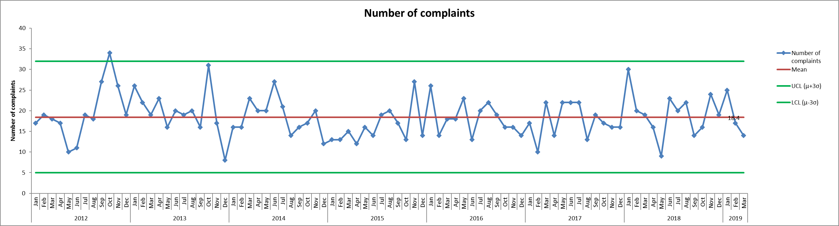

Between 1 April 2018 to 31 March 2019, 215 complaints have been received, of which 100% were acknowledged by the Complaints & PALS Team within the NHS Complaints Regulations (2009) of three working days.

Of the 171 complaints which have been investigated and responded to, all of these (100%) were within a timescale agreed with the complainant. There continues to be a high number of requests for extensions by investigating officers across the Trust. Out of the 171 complaints which have been investigated and responded to, 91 cases had an extension in place. This is 53% of the complaints which we have responded to and impacts on the timeliness of complaint responses. The issues relate to either a delay in the allocation of a complaint, an investigating officer being unable to complete the investigation within time due to their workloads or the case being complex. The figures broken down by Directorates are as follows; Buckinghamshire Mental Health Services 23, Oxfordshire, BaNES, Swindon and Wiltshire Mental Health Services 47, Community Services 14 and Specialised Services five. The number and themes from complaints, as well as extensions and delays are monitored and reported on a weekly basis. There are concerns around the length of time is takes for formal complaints to be investigated and responded to. In Oxfordshire, BaNES, Swindon and Wiltshire Mental Health Services the average number of days from 1 April 2018 for responding to a complaint is 61 days (currently the longest time it has taken is 221 days). Within Buckinghamshire Mental Health the average number of days for responding to a complaint is 45 days and the longest timescale was 103 days. Within Community Services the average number of days for responding to a complaint is 35 days and the longest timescale since 1 April 2018 was 105 days. In Specialised Services the average number of days is 33 days and the longest time is has taken is 66 days.

All complaints are graded based on severity using a national risk matrix with a rating of green, yellow, orange or red. From the 215 complaints received, 153 (71%) were graded green, 41 (19%) were graded yellow; 17 (8%) complaints were graded orange and four (2%) complaint was graded red. The graph below shows the number of complaints received by month and by risk rating.

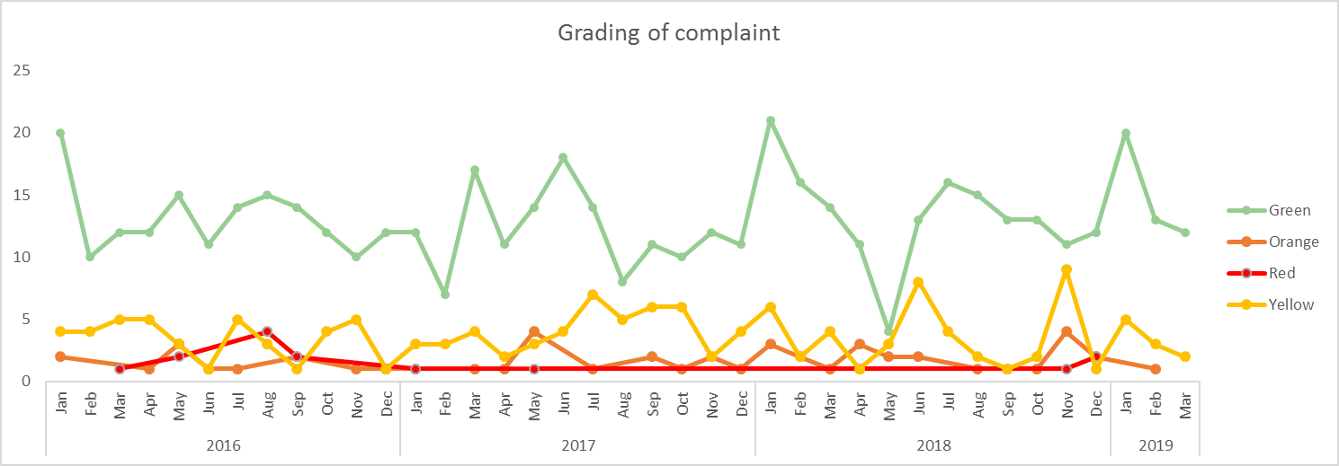

The largest group of complaints were received from relatives/carers (n=112) and 70 complaints were received from patient’s/service users.

Oxfordshire, BaNES, Swindon and Wiltshire Mental Health Services received the highest number of complaints (21 in Q4 and 94 in 2018/19), Community Services (16 in Q4 and 49 in 2018/19), Buckinghamshire Mental Health Services (14 in Q4 and 54 in 2018/19), Specialised Services (4 in Q4 and 13 in 2018/19) and Corporate Services (1 in Q4 and 5 in 2018/19).

Of the 171 complaints which have been responded to, 88 complaints were upheld (52%), 79 complaints were not upheld (46%) and for four cases there was no evidence to prove or disprove (2%). The graph below shows the outcomes of complaints since January 2016.

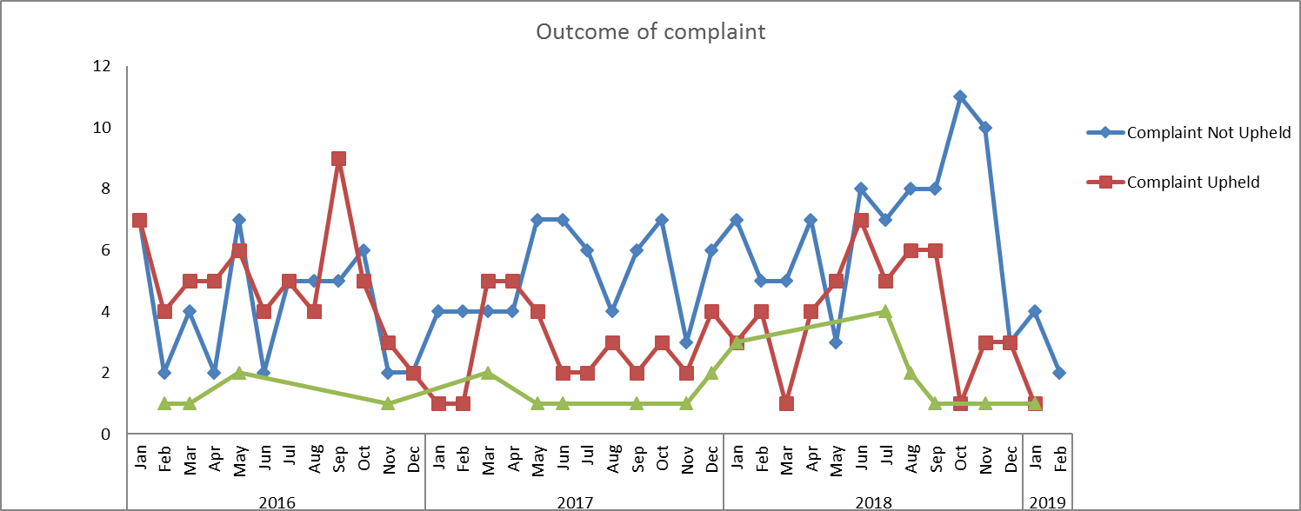

After the investigation into each complaint, if there are any upheld elements or any improvements in practice identified then an improvement plan is developed by the investigating officer, in liaison with the relevant service manager/ward manager. Between 1 April 2018 and 31 March 2019, of the 171 complaint which have been
responded to, 256 actions have been identified. The number of actions broken down by Directorate are as follows; Buckinghamshire Mental Health Services (n=60), Oxfordshire, BaNES, Swindon and Wiltshire Mental Health Services (n=130), Community Services (n=59), Specialised Services (n=4) and Corporate Services (n=4). At the time of writing this report, there are 28 actions which require completion. Of these, 20 actions are within time and eight actions are outside of the timescale agreed and being actively followed up.

Detailed below are some actions which have been taken following the completion of an investigation:

- Internal review by Healthy Minds of existing standard operating procedures and use of these by staff covering the content of continuation notes referencing complaints and how clinical matters might be entered sensitively and separately when necessary. (Healthy Minds, Oxon)
- Adult mental health teams (AMHT) to consider ways in which medical staff can handover their caseloads in a safe and effective way at the end of a period of locum appointment. (AMHT Bucks Aylesbury Team)
- Staff to be reminded of the importance of developing collaborative crisis and contingency plans at an early stage of engagement. This is important to ensure that the AMHT and the patient have a point of reference on how to best respond to developing crisis. (AMHT Oxon City & NE)
- To develop safety planning material and resources that are suitable to use with younger children. (Salisbury child and adolescent mental health services)
- Staff member to ensure mandatory training is completed with Information Governance and understands the guidelines on protecting patient confidentiality. (child and adolescent mental health services Bucks Eating Disorder)
- Dental Website pages need updating to ensure that contacting the OOH dental service is easier to access and that redundant numbers are removed from the website. (Community Dental Service)
- To use CSE templates on care notes and document CSE discussions with young people. (School Health Nursing, North)
- Escalation practices around patient deterioration and differing opinion on escalation criteria to be reviewed, relayed and embedded. (Linfoot Ward, Community Hospital)

Parliamentary Health Service Ombudsman (PHSO) & Local Government Ombudsman (LGO)
At the time of writing this report, there are ten current cases which are open with the Parliamentary Health Service Ombudsman (PHSO) and Local Government Ombudsman (LGO). Between 1 April 2018 and 31 March 2019, the PHSO/LGO made 17 enquiries relating to closed complaints. Of these 17, six have commenced an investigation. During Q4, there was one new referral from the PHSO requesting information from the Trust. Two cases were closed in this period and the details of these cases are below.

C17/0162 (City Community Hospital) Green
Mother feels that daughter is inappropriately placed on the ward. Concerns also raised about staff attitude and communication.
Outcome: PHSO advised the Trust that the patient had now died and that they would not be undertaking an investigation into the case. The case has been closed with no further action required.

C16/0211 (Cotswold House, Marlborough) Green
Concerns raised in relation to a dairy free diet not being followed on the ward and this being inaccurately recorded in medical records. There were further concerns raised regarding discharge planning and communication
Outcome: The investigation concluded that the unit attempted both to help increase the patient’s weight and provide a non-restrictive diet by gradually introducing dairy products, the patient consented to this and tolerated these well. The health records also show that until the late stage of admission that time out of the unit was not allowed due to the patient’s low weight. This is to be expected. It is recommended that all patients do not take leave from the unit if they are not within their weight band. There is no evidence if failings in relation to the care and treatment provided. The complaint was not upheld by the ombudsman, and no actions were required by the Trust.

Patient Advice & Liaison Service (PALS)
Between 1 April 2018 and 31 March 2019, the PALS Team managed 1,068 local concerns, 364 general enquiries, 346 PALS Surgery feedback/comments (not including concerns) and 22 pieces of feedback via social media. The PALS team are continuing to look at expanding the availability of PALS Surgeries held in clinical services across the Trust to help to resolve concerns and issues at a local level, if possible, before a complaint is raised. The Team has started the process to introduce PALS Surgeries onto some of the Minor Injury Units.

Across the year, there continues to be a reduction (36%) in the number of PALS cases when compared to the previous year when 2,829 contacts were received. At present further analysis is being looked at to try to understand why this has occurred. The PALS team continue to run the same number of PALS surgeries monthly. The graph below shows the number of concerns received since 2015.

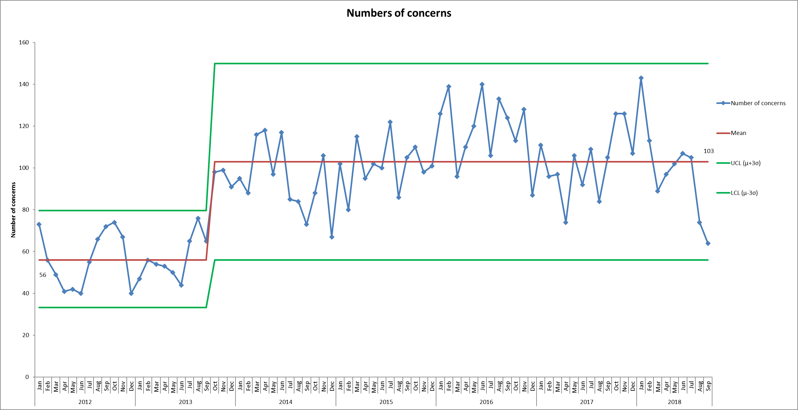

The team also runs the PALS volunteer initiative which focuses on volunteers attending PALS surgeries and being given the opportunity to listen to people’s experiences on our wards. At present the team has seven volunteers going onto the following wards months; Didcot Community Hospital, Abbey Ward, Oxfordshire Stroke Rehabilitation Unit, Wallingford Community Hospital, Linfoot Ward, Wenrisc Ward, Woodlands House, Opal Ward, Ruby Ward, Vaughan Thomas, Amber Ward, Ward and Wintle Ward). Currently there is one new volunteer going through the HR process/interviews. In Q4 the team has also run three events across the Trust including a Pizza and DVD afternoon on Vaughan Thomas Ward, Valentines card making on Allen Ward and pancake making on Wintle Ward. They also ran a tombola at the Cowley Shopping Centre to raise funds to continue to run theme events across the Trust.

PALS Surgeries:
The PALS Team currently runs 38 PALS surgeries across the Directorates. PALS surgeries are a valuable way of seeking feedback about people’s experiences, both positive and negative, and about working with ward staff to resolve issues of concern at a local level, in a timely and positive manner. This is a snapshot of some of the themes/trends following the feedback received from PALS Surgeries across the Trust. Each piece of feedback is discussed and shared with the ward/team manager or deputy and resolved. Any issues concerning are also appropriately escalated;

Day Hospitals across Oxfordshire & Buckinghamshire
There has been predominantly positive feedback from the patients using this service who often praise the staff for their supportiveness and caring attitude. Many have commented that staff will always give them time for a one to one session, if needed, and that they are easily approachable. The activities that the patients have access to has also been a source of high praise as they find these useful and therapeutic.

Forensic Wards
A theme that seems to be emerging in this area is leave, patients commented that they often must wait a long time to get leave, due to the levels of staffing on the ward, which they find frustrating. When visiting the Milton Keynes wards recently, issues around the poor quality of food was being raised and three people commented that they had changed to the Halal menu (not due to religious believes) as the food was far better and there were more choices. Following this, a new menu was created in which they now get three options a day, two of which are vegetarian which meets the needs of the patient group. Patients on Woodlands House have praised the reactiveness of staff to their needs.

Children & Young People’s Mental Health Services (CAMHS)
Within Cotswold House in Oxford, patients have commented that agency staff often do not know the rules within the dining room which can be disruptive to them. Issues continue to be raised about the showers within Cotswold House Oxford and Swindon in relation to low water pressure. Estates are aware of these issues. Patients have been making positive comments about staff attitude and state that staff are helpful and that they feel properly cared for.

Mental Health Wards
Across the wards at the Warneford Hospital, patients have raised concerns that there is no furniture in the garden areas, which makes it look very bare and whilst patients are encouraged to use the garden, they are reluctant to because of this.

Praise was received in relation to Opal Ward and the groups which are run on the ward and the activities provided which patients find very engaging.

Community Hospitals
Most of the feedback across the community hospitals are overwhelmingly positive, with people praising the staff, quality of care, cleanliness and food.

Issues were raised in relation to Oxfordshire Stroke Rehabilitation Unit at Abingdon Community Hospital relating to the management of the ward overnight which led to an immediate investigation and actions.

City Adult Mental Health Team
The has been several concerns raised about people not being able to contact the service on occasions, with the telephone lines ringing without being answered.

Combined number of complaints and concerns
The graph below shows the number of combined complaints and concerns received by Directorate since January 2016 to 31 March 2019, including those upheld and not upheld. The number of complaints and concerns received by team is analysed by the Caring and Responsive Quality Sub-Committee, with a summary provided later in the report of those teams which have received higher numbers.

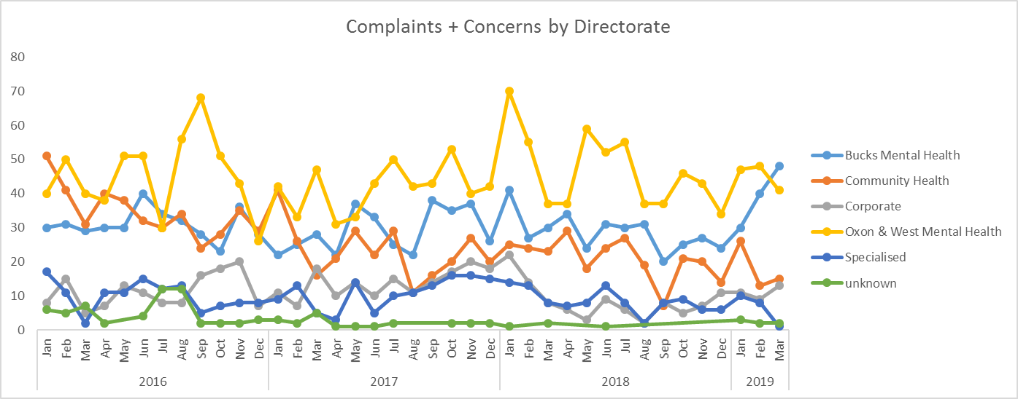

Analysis of themes from concerns and complaints
Ten teams are identified as receiving a higher number of complaints and concerns in 2018/19, highlighted below;

AMHT Bucks Aylesbury Team: Ten complaints, eight graded green and two graded yellow (nine closed, five upheld) and 67 concerns. 33 related to all aspects of clinical care (15 related to insufficient care within the community, four related to medication issues, three were requests for a change of care team and two related to care planning), 13 related to communication (nine were about poor communication with a patient and three were about communicating with a carer/relative). 12 cases related to an appointment/referral (six related to cancelled appointments and four related to the length of wait for an appointment), then cases related to staff attitude/behaviour.

AMHT Bucks Chiltern Team: 12 complaints, 11 graded green and one graded red (nine closed, three upheld) and 33 concerns. 25 cases related to all aspects of clinical care (11 related to insufficient care in the community, four related to medication issues, three related to inadequate assessments and two were requests for a change of care team). Seven related to staff attitude/behaviour and four related to discharges.

CAMHS Bucks Neuro: Six complaints, three graded green, one graded yellow and two graded orange (all closed and three upheld) and seven concerns. Five related to appointment/referral (two related to the length of wait for an appointment and two related to a delay in responding to a referral) and four related to communication (three of these were about communicating with a carer/relative).

Ruby Ward: Five complaint, two graded green and three graded yellow (three closed and two upheld) and 27 concerns. Eight related to all aspects of clinical care (two related to physical care needs not being met and two related to an incorrect diagnosis) and five related to discharge issues.

Sapphire Ward: 20 concerns, of which give related to clinical care (four were about medication issues), four related to discharge arrangements and three related to staff attitude/behaviour.

Allen Ward: Two complaints, one graded green and one graded yellow (closed and not upheld) and 56 concerns. 15 related to staff attitude/behaviour (six related to a lack of professionalism), 11 related to all aspects of clinical care (four related to insufficient care on the ward, two related to medication issues and two related to an inappropriate risk assessment). Nine related to communication/information sharing (seven of these cases were about communicating with a patient).

AMHT Oxon City & North East: 18 complaints, 17 graded green and 1 graded yellow (14 closed and six upheld) and 113 concerns. 51 related to all aspects of clinical care (30 related to insufficient care within the community, seven related to a request for a change to a care team, four related to medication issues and four were about diagnosis issues), 27 related to communication/information (18 of these were about poor communication with a patient), 15 related to staff attitude/behaviour and 11 of these were about appointments (three related to cancelled appointments and three related to the length of wait for an appointment).

AMHT Oxon North & West: Seven formal complaints, five graded green and two graded yellow (five cases closed and two were upheld) and 29 concerns. 25 cases related to all aspects of clinical care (15 related to insufficient care within the community, three related to medication issues and three related to a patient being discharged too early).

CAMHS Oxon Getting More Help North: Four formal complaints, three graded green and one graded yellow (all closed and one upheld) and 17 concerns. Five related to all aspects of clinical care, five related to communication/information sharing, five related to staff attitude/behaviour (three of these were about a lack of professionalism) and two related to an inadequate assessment.

Emergency Department Psychiatric Service: Seven complaints, five graded green and two graded yellow (five closed and two upheld and six concerns. Eight related to all aspects of clinical care (five were about an inadequate assessment and two related to medication issues) and three cases were about inaccurate information within medical records.

Reason for complaint or concern (category)
The Trust receives the most concerns and complaints in the category of ‘all aspects of clinical care’ (507) of which 143 related to insufficient care within the community, 99 related to medication issues, 26 related to insufficient care as an inpatient, 29 related to an inadequate assessment and 23 related to a disagreement with a diagnosis.

207 cases related to an appointment/referral, of which 58 related to the length of wait for an appointment, 35 related to a cancelled appointment, 30 related to being kept waiting for an appointment, 28 related to a delay in responding to a referral, 26 related to the length of wait for therapy and 23 related to a request for a referral. 198 cases related to communication/information sharing (91 related to communication with a patient, 46 related to communication with a carer/relative, 21 related to no information being provided and 15 related to a lack of involvement of patient. 179 cases were also received about staff attitude/behaviour.

In looking at the themes/trends in the reporting period, in both concerns and complaints, the chart below shows the primary categories of complaints and concerns within this time.

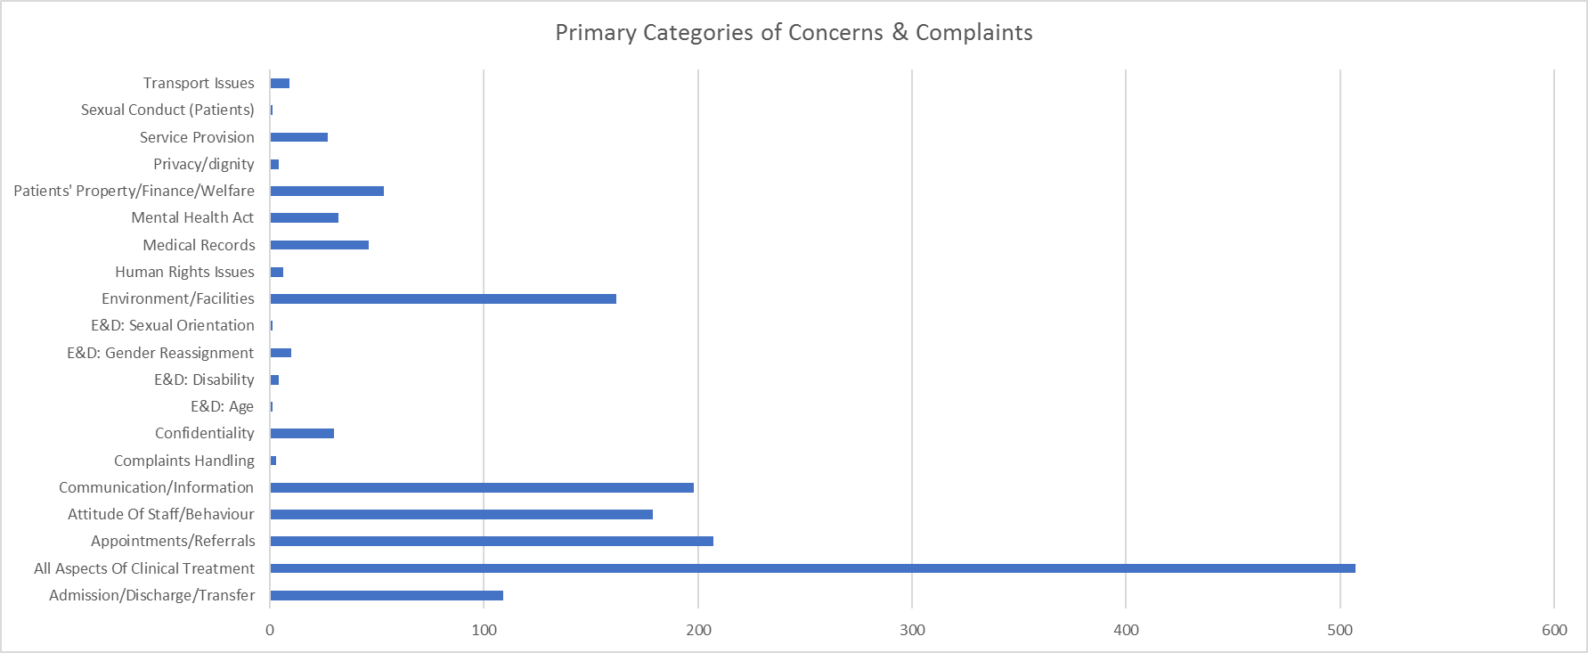

In looking at the categories from complaints alone, we can look at the outcomes from investigations and whether a complaint was upheld or not and what learning has been identified and what actions need to be undertaken. This therefore gives us the opportunity to look at themes, against the outcomes of complaints. The main themes from complaints in Q4 remain about all aspects of clinical care 27, of which five relate to an inadequate assessment (two were closed and not upheld, whilst three remain open) and four related to insufficient in the community (two were closed and upheld, whilst two remain open). Each individual complaint which has upheld elements has an action plan (or quick time learning which has been completed) to ensure that we improve and learn from people’s experiences. Each Directorate receives an updated spreadsheet containing details of actions resulting from complaints and these are shared on a regular basis. The chart below shows a further breakdown of complaints received within the category of ‘all aspects of clinical care’.

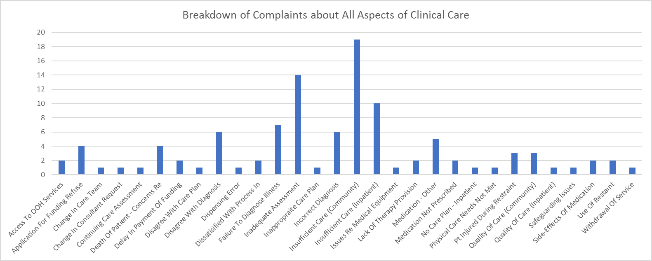

Themes from upheld complaints
It is important that the Trust learns from the complaints that they received. Complaints provide us with valuable feedback and should be viewed by staff and the Trust as positive agents for change. This may arise from review of themes/trends analysis but on occasion issues can be identified from individual complaints which have implications for other patients, their relatives/carers, as well as services provided by the Trust. The focus of themes/trends/learning will be based on complaints received in the previous quarter (Q3) when more investigations will have been completed.

Of the 58 complaints which were received in Q3, 19 had upheld elements, of these eight related to Oxfordshire, BaNES, Swindon and Wiltshire Mental Health Services, six related to Community Services and five related to Buckinghamshire Mental Health Services. Nine complaints related to all aspects of clinical care (three related to insufficient care in the community and two related to a failure to diagnose).

Compliments
The Complaints and PALS Team centrally collates the compliments sent to teams within the Trust including thank you letters and cards. In 2018/19 a total of 3,011 compliments were received; Oxfordshire, BaNES, Swindon and Wiltshire Mental Health Services received 1029, Community Services received 1349, Buckinghamshire Mental Health Services received 445, Specialised Services received 155 and Corporate Services received 33. There continues to be an increase in the number of compliments being received about the Trust’s services.

Extracts from compliments
“This is a really good service, when you come out of the ward you need something to back you up, it can be an unsure time when being discharged and it can be scary, but this really helps.” Aylesbury Day Hospital

“Just to say thank you for being so nice to me and my son, nobody has been nice to me for a long, long time.” Carers Assessment Team

“Thank you so much for all the support and advice you gave me throughout my time at CAMHS. It really helped me to grow and when things went wrong, it was nice to have you to talk to and help me with it all. You and the service as a whole has made a much happier and healthier person and I have regained so much of my confidence that I lost a few years back. Once again thank you so much. CAMHS Eating Disorder

“Thank you from very appreciative grandparents for some really good advice on iPad usage for our autistic 8-year-old grandson” BaNES Community Child & Adolescent Mental Health Service

“I just wanted to say a huge thank you for yesterday and all you do for my family. You really are very good in your chosen career and it’s rare to see in a world full of targets budgets and deadlines. Never lose that passion you have to help children with additional needs.” CAMHS Neuro Development Care Pathway

“I wanted to write and let you know how excellent V has been in supporting our daughter since her illness. V has been professional, caring, very well organised, efficient and reliable. She has always responded to our texts and phone messages. I don’t know how our daughter would have managed without her input. The recent months have been very stressful for us as parents, but V has kept us informed and always been available for help and advice. It has felt that, V has been as concerned for our daughter as we have.” Early Intervention Service Team

“Heartfelt thanks to you for all you have done for Dad while in the Hospital. You have been so helpful, giving great advice and support through all the complexities of managing Dad’s care. Thank you very much.” Wallingford Community Hospital

“Thank you so much for all the kindness, help and support you gave to our Mum in the last two weeks of her life. You listened and reacted to her concerns and couldn’t have been kinder to us. You made our sad loss as good an experience as it could have been, respecting our privacy to share our last hours. Once again many thanks to all.” Abbey Ward, Abingdon Community Hospital

“I am extremely grateful for the practical help and support I have had. The strength I now have in my legs is helping with my balance. In fact, when I saw my GP recently she was surprised at the strength I now have in my lower limbs, so thank you again.” Community Therapy Service

“I am so much happier now I am on this ward; all staff have been great.” Kestrel Ward

“The staff here are good, if situations arise they are good at dealing with them quickly. They are also friendly.” Woodlands, Forensic ward

“Thank you for the huge impact that your service LD and Autism has had on our lives directly through the support of K, her interventions with our son have made an enormous difference to his self-esteem, confidence and trust. I can only say that this service is totally invaluable, and we are extremely grateful.” Learning Disability Services

Recommendation
The committee is asked to discuss the performance and themes from complaints and concerns received in the annual report.

Claire Price, Complaints & PALS Manager
16 April 2019

