

# Report to the Meeting of the

# Oxford Health NHS Foundation Trust

**BOD 47/2019**

(Agenda item: 10)

# Board of Directors

**25th April 2019**

**Quality Report: Incident, Mortality and Patient Safety**

**For: Information**

**Executive Summary**

This is a quarterly quality report focused on the safety of care.

Key risks and issues:

* There continues to be a high level of violence and aggression incidents by patients towards inpatient staff, although the majority result in no or low harm. Particularly on Ruby, Sapphire and Highfield wards. The Trust has more recently started to work in a national collaborative led by NHS Improvement with learning being initially shared across three other trust wards. Elements of the national safewards model have started to be implemented to improve relationships between staff and patients such as ‘know each other’ and use of ‘soft words’.
* Increase in the number of medication administration incidents reported by the adult acute mental health wards. Work on reducing medicine omissions, including patients reducing to take medication, is underway.
* Themes for learning have been identified from reviews of unexpected deaths, with actions details in the report focused around improving: physical health care for patients with a severe mental illness, better involving families in their loved one’s care, communication at points of transition and awareness of sepsis for learning disability patients.
* Need to ensure the timely completion of actions from SIs. The Patient Safety Service Manager has been following up all outstanding actions to offer support and to ensure central records are up to date. As a result, the number of outstanding actions has reduced in the last two weeks from 53 to 37.

Key areas of good practice:

* Incident reporting levels continue to be positive, suggesting a learning culture. We have made a number of design changes to the incident reporting system to improve ease of reporting for users and to develop our analysis of incidents which has enabled better conversations on how to address concerns and a better shared understanding of the reasons for incidents.
* Most incidents result in no harm (62%) or minor harm (27%), in line with the national picture.
* Patient safety incidents are reported to the national NRLS timely.
* The process for identifying, disseminating and managing actions from national patient safety alerts is robust, this has included reviewing if past closed actions have been sustained. All national alerts have been closed within the specified timescales.
* Over the last year there has been an overall reduction in restrictive practice. The report details the improvement work underway and the national change required in relation to staff training in 2019.
* Infection rates remain low.
* Directorate level and Trust-wide processes to review and learn from deaths have been further strengthened. The Trust is also involved in the following multi-agency forums; Oxfordshire vulnerable adult mortality group, Buckinghamshire ICS learning from deaths and the south regional mortality review group.
* The SI process embedded in the Trust is thoughtful, rigorous and focused on how we engage and learn with patients/ families and staff. The training for root cause analysis/ human factors for Serious Incident investigators has been reviewed and revised with four courses ran in 2018/19. There has also been focused work on supporting and training Serious Incident investigators to better engage with beavered families. The themes and learning from SIs are detailed in the report.
* The Trust has seen a sustained decline in the overall number of Serious Incidents particularly around pressure ulcers following focused quality improvement work, and an early indication of a reduction in self-harm incidents in Buckinghamshire mental health directorate.
* No SI investigations have been submitted past the stipulated time frame to date in 2019/20

**Governance Route/Escalation Process**

This is a summary of three detailed reports reviewed by the Safety Quality Sub-Committee in April 2019.

**Recommendation**

The Board is asked to note the paper and work happening.

**Author and Title:** Jane Kershaw, Head of Quality Governance, Pam Treadwell, Patient Safety Service Manager and Charlotte Forder, quality and risk data analyst

**Lead Executive Director:** Kate Riddle, Acting Director of Nursing

1. *A risk assessment has been undertaken around the legal issues that this report presents and there are no issues that need to be referred to the Trust Solicitors*
2. *Strategic Objectives – this report relates to or provides assurance and evidence against the following Strategic Objective(s) of the Trust:*

*1) Driving Quality Improvement (Goals: patients will be safe from harm; patients will achieve the clinical outcomes they want; and patients and carers will have an excellent experience)*

**Incident, Mortality and Patient Safety Quality Report**

# Introduction

This is a quarterly report with the purpose of providing a summary of the themes and learning from incidents and deaths and our response to patient safety alerts. This report is submitted to initiate discussion and action.

# Overview of Reported Incidents

## 2.1 Number of incidents

Figure 1 shows reporting levels have continued to increase from the point the Ulysses incident reporting system was introduced across all services from 2011. The increase in reporting in Q2 and Q3 of 17/18 is largely a result of the transfer of the learning disabilities service from July 2017.

No seasonality has been observed in numbers of incidents reported. Similar numbers of incidents are reported as occurring from Monday – Friday, while reduced numbers are reported on weekends. A review of the times at which incidents were reported as occurring showed that 29% of all incidents in the past year occurred between 10am and 1pm. Looking at the timing of incidents in FY 18/19 within particular cause groups shows the following differences;

* + Violence + Aggression on inpatient wards – high numbers of incidents occur throughout the day, with most occurring from 10am – 1pm (22%), and numbers tailing off from around 7pm.
  + Self-Harm on inpatient wards– Most incidents occur in the evening with 56% of incidents in the previous year occurring between 5pm and midnight, most of which (27%) are between 8pm and 11pm.
  + AWOLs – Incidents tend to occur in the afternoon, 75% occurred between 12pm and 8pm with peaks between 3pm and 5pm and 6pm and 7pm
  + Staffing on inpatient wards– The highest proportion of incidents in the previous year were reported as occurring between 8pm and 10pm (28%), and also between 7am and 8am (15%), with a lower peak between 1 and 2pm when 10% of incidents occurred.

*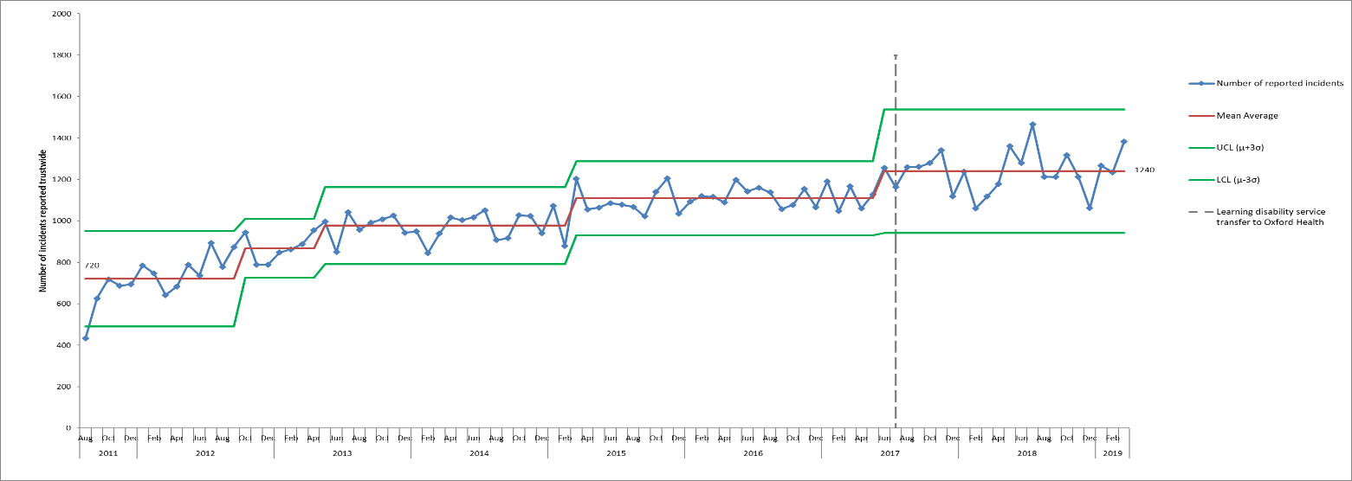Figure 1. Control chart displaying monthly number of incidents reported on Ulysses incident reporting system from August 2011-March 2019*

### Actual Impact of Incidents

From December 2018 to March 2019, 4946 incidents were reported and 62% of these were reported as causing no harm. Of the 4946 incidents, 2503 (51%) were flagged as patient safety incidents and reported nationally. Of the patient safety incidents 63% resulted in no harm, 29% resulted in minor harm and 5% resulted in moderate harm. This is generally in line with the national picture**[1]** according to the NRLS information up to September 2019 (see table 1 below), however, as discussed in previous reports, since Q4 16/17 a higher proportion of patient safety incidents have been reported by the trust in the category of major injury/severe property damage. This is as a result of the introduction of the category of SCALE in April 2017, and a decision within the directorate that grade 4 pressure ulcers and SCALE be graded as major/severe impact, even if there were no lapses in care. New national guidance was published at the end of June 2018 to standardise pressure ulcers reporting and categorisation which should improve the accuracy of national comparison data once implemented from April 2019. The Trust’s existing policy reflected the majority of the new revised definitions and measurement guidelines, and the pressure ulcer steering group is leading on reviewing staff training, updating the policy as required and updating the incident categories on Ulysses.

*Table 1. Percentage degree of harm of incidents reported in Oxford Health from December 2018 to March 2019 for all incidents and for incidents flagged as Patient Safety Incidents (PSIs). This is displayed against proportions of harm reported by the NRLS in Mental Health Trusts and Community Health trusts (for PSIs only) from 01.04.18-30.09.18.*

|  |  |  |  |  |
| --- | --- | --- | --- | --- |
|  | **1. No Harm / No Property Damage** | **2. Minor Harm / Minor Property Damage** | **3. Moderate Harm / Moderate Property Damage** | **4. Major Harm / Severe Property Damage** |
| **Oxford Health December 18 to March 19 - All incidents** | 62.35% | 27.29% | 6.09% | 2.02% |
| **Oxford Health December 18 to March 19 - PSIs only** | 63.28% | 29.40% | 4.99% | 1.32% |
| **NRLS Mental Health Average (April 18-September 18)** | 65.9% | 28.0% | 5.0% | 0.3% |
| **NRLS Community Health Average (April 18 - September 18)** | 55.0% | 38.2% | 6.1% | 0.4% |

Between December 2018 and March 2019- 47 incidents were reported with major harm (excluding incidents of inherited pressure ulcers), and of these 33 were flagged as patient safety incidents (listed in table 2). Of the patient safety incidents 17 were in the category of skin integrity, 16 of which were grade 4 pressure ulcers developed in service while the other was a grade 2 pressure ulcer. The skin integrity incidents occurred in 13 different district nursing teams, with most reported in DN South East Oxford with 3 in total. None of the skin integrity incidents are being investigated as serious incidents.

There were 6 incidents of self-harm with major injury, all reported by different departments, one of these, reported by Healthy Minds, is being investigated as a serious incident. The categories of patient safety incidents resulting in major harm are detailed in table 2 and details of all serious incidents are provided later in the report.

Physical injuries for patients have also been reviewed for this report (staff injuries are looked at as part of the Health and Safety report). No trends have been seen in numbers of physical injuries since April 2015. From December 2018 to March 2019, 1245 physical patient injuries were reported within 1068 incidents. Of these 59% were injuries because of skin integrity incidents, 18% were a result of self-harm, 7% related to a fall and 6% to violence/aggression. Most incidents with physical injuries are reported in District Nursing (47%) and Community Hospitals (15%), followed by child and adolescent mental health services (CAMHS) with 8%.

*Table 2. Categories of patient safety incidents reported with an actual impact of major injury/severe property damage, December 2018 – March 2018*

| **Cause 1 Category** | **Number of Incidents** | **Number of Serious Incidents** |
| --- | --- | --- |
| SI08 Category 4 Pressure Ulcer Developed In Service | 16 |  |
| SH005 Self Harm - Overdose | 2 |  |
| CM002 Delay In Providing Care/Treatment/Follow Up | 2 |  |
| VA021 Violence - Patient Towards Property | 2 |  |
| SI04 Category 2 Pressure Ulcer Developed In Service | 1 |  |
| SH007 Self Harm - Other | 1 | 1 |
| H12 Self-Neglect | 1 |  |
| IC03 C-Diff | 1 |  |
| SH011 Self Harm - Ingestion Of Harmful Item/substance | 1 |  |
| SX13 Sexual Allegations Other | 1 |  |
| Fi01 Fire - Wilful/Arson | 1 | 1 |
| AD03 Poor Admission | 1 |  |
| F004 While Mobilising/walking In Department Or Ward | 1 |  |
| SH003 Self-Harm - Cutting | 1 |  |
| SH004 Self Harm - Jumping | 1 |  |
| **Total** | **33** | **2** |

### Incidents by Directorate

Figure 2 shows the number of incidents reported based on where teams are managed within the new directorate structure, implemented from 1st October 2018.

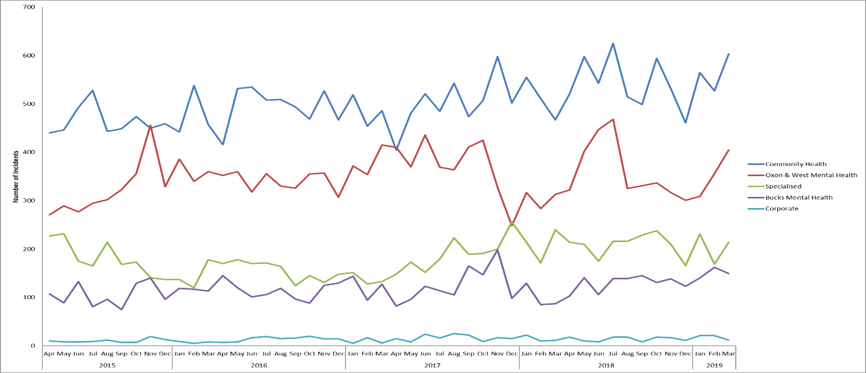

*Figure 2. Reported incidents based on where teams are managed within the new directorate structure (following the changes in 01.10.18), April 2015 – March 2019*

Community Health Directorate

Most incidents are reported by teams that now sit in the Community Health Directorate. Within this directorate numbers of incidents have increased within various services in the past year, including Community Hospitals, GP OOHs, MIUs, Podiatry and Health Visiting.

Figure 3 shows the Community Health incidents by service line and shows that most incidents are reported by District Nursing with an average of 220 incidents per month, followed by Community Hospitals with an average of 126 incidents per month. Above average numbers of incidents have been reported by Community Hospitals in 8 of the past 9 months, with a particular increase over Q4 18/19, including a spike March of Q4 when 194 incidents were reported (Jan 19 = 166, Feb 19 = 156). The increase was related to an increase in incidents reported by the Stroke Rehab unit, and to a lesser extent Abbey ward.

Within this directorate most incidents are reported in the cause group ‘Skin Integrity’ (35% from December 2018 to March 2019, n= 756). In this reporting period this was followed by ‘communication/confidentiality’ with 11% (n=229) and then falls with 9% (n=191) and medication incidents (8%, n=187).

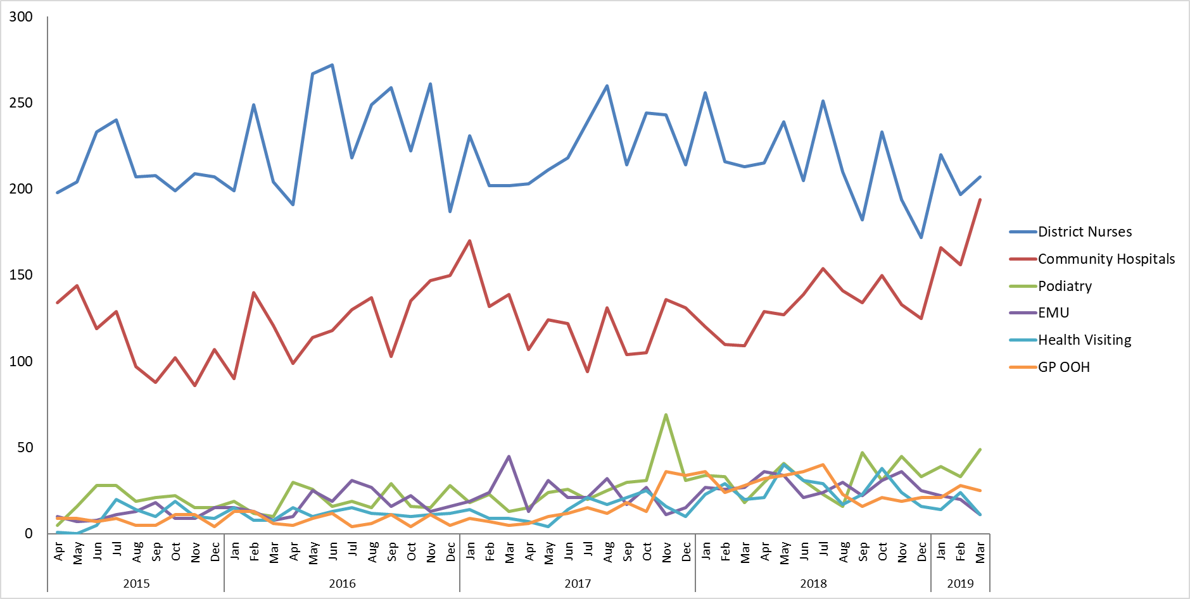

*Figure 3. Incidents reported in the Community Health Directorate in services with most incidents, April 2015 – March 2019.*

Oxon & West Mental Health Directorate

In this directorate most incidents are usually reported by adult acute mental health wards and CAMHS teams (figure 4), and numbers tend to fluctuate over time, often depending on the patient mix. In February and March CAMHS incidents increased due to an increase in incidents on CAMHS Highfield unit, and in March there was an increase in incidents in the eating disorder service as a result of increases in incidents in the Oxon eating disorder inpatient unit. Incidents have also increased in the adult mental health teams (AMHTs) over the previous year.

In the Oxon & West Mental Health Directorate most incidents since April 2015 have been reported in the category of Violence/Aggression (26%), followed by Self-Harm with 20% and Security with 12%. From December to March 1371 incidents were reported in the directorate, 267 as a result of Violence/Aggression and 256 as a result of Self-Harm.

*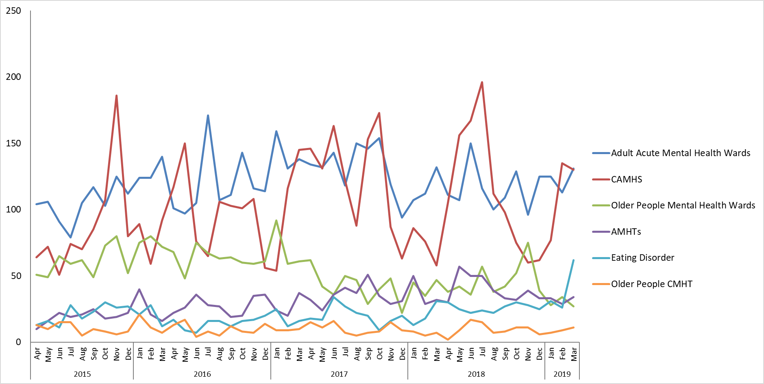Figure 4. Incidents reported in the Oxon & West Mental Health Directorate in services with most incidents, April 2015 – March 2019*

Bucks Mental Health Directorate

In the Bucks Mental Health Directorate most incidents are reported by adult acute mental health wards (figure 5). As with the Oxon & West Mental Health Directorate most incidents since April 2015 have been in the category of Violence/Aggression (24%). From December 2018 to March 2019, 574 incidents were reported in the Directorate and 181 of these were in the category of violence/aggression (31%), the next highest cause group was medication incidents (11%, n=64), followed by self-harm and communication/confidentiality with 55 incidents reported in each.

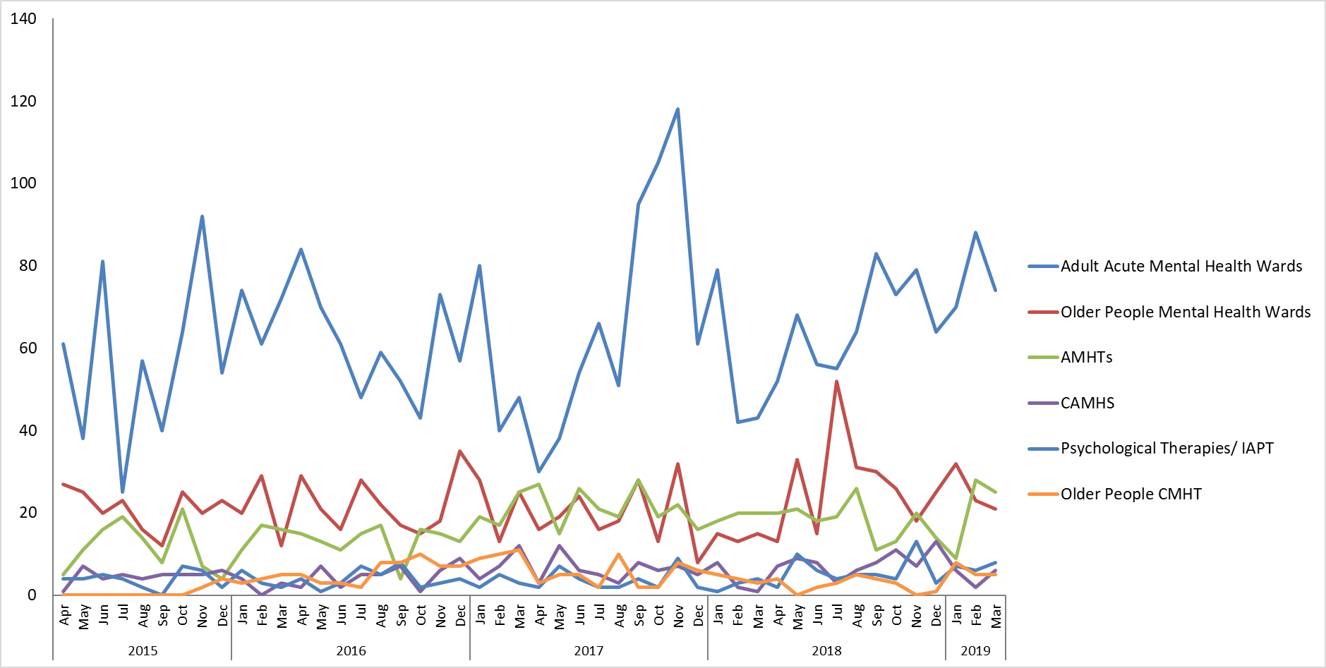

*Figure 5. Incidents reported in the Bucks Mental Health Directorate in services with most incidents, April 2015 – March 2019.*

Specialised Service Directorate

Most incidents in this directorate are reported by forensic wards (figure 6). In July 2017 the learning disability service transferred to Oxford health, and are managed within the Specialised Service Directorate, along with the Forensic learning disability ward Evenlode that sits within the Forensic service. As a result of the transfer incidents have increased within forensic wards and in the Directorate as a whole.

Most incidents within this directorate are again reported in the categories of violence & aggression (36% since April 2015), Self-Harm (16%) and Security (14%). From December 2018 to March 2019 a total of 780 incidents were reported and 282 (36%) were as a result of Violence/Aggression and 95 (12%) were as a result of self-harm.

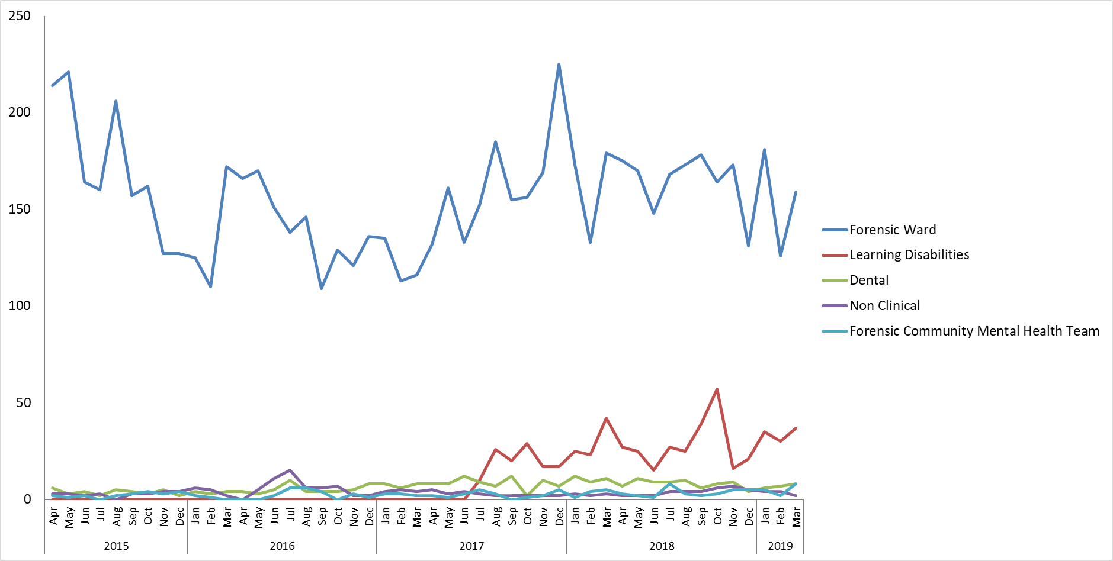

*Figure 6. Incidents reported in the Specialised Service Directorate, April 2015 – November 2018.*

### Service and Team level of analysis

Overall reporting has been reviewed for all departments since April 2015.

For inpatient wards incident numbers have also been reviewed in the context of occupied bed days, trends remain the same as when looked at in terms of incident numbers alone. The rate of reporting on community hospital wards increased in 2018, with an average of 3.6 incidents per 100 bed days reported since June 2018, compared with 2.6 per month prior to that. Most community hospital incidents overall are reported by Linfoot ward with an average of 3.9 incidents/100 bed days since April 2015. However, since a dedicated Stroke Rehabilitation Unit was opened the ward has had on average 5 incidents per 100 bed days.

On mental health wards an average of 5 incidents/100 bed days have been reported per month over the same timeframe. Overall the ward that reports the highest number of incidents in relation to bed days is on CAMHS Highfield where an average of 15 incidents per 100 occupied bed days have been reported since April 15 (including bed days on Highfield and Highfield HDU). Previously Kestrel ward had the highest proportion of incidents per occupied bed days, but incidents here have now reduced and from December to March an average of 7 incidents per 100 bed days were reported.

Departments that have reported no incidents have also been reviewed for this report, 68 of the 424 active departments on Ulysses have not reported any incidents (excluding newly added departments). Further analysis of these needs to be done to establish whether any these departments are out of date/no longer required, or whether incidents would be expected.

Adult Acute Mental Health Wards

Above average numbers of incidents have been reported on **Sapphire** ward in the past 9 months, with a peak in January 2019 when 38 incidents were reported, compared with a mean average of 18 per month since April 2015. This was as a result of an increase in incidents of Violence/Aggression; in January 21 incidents were reported in this category compared with an average of 7 per month in the past 4 years, and 52 incidents were reported in total from December to March. One of the incidents was graded as moderate when a patient threw a side table towards a staff member causing injuries.

Overall most incidents on Adult Mental Health wards continue to be reported by **Ruby,** where 131 incidents occurred between December and March, of these 65 (50%) were as a result of violence/aggression, 14 were due to self-harm, 13 to medication and 12 to security. One Ruby incident was graded as major as a result of damage towards property. A further 2 incidents in the service were graded as major, one on Phoenix as a result of a patient starting a fire, and one on Wintle due to a patient fall in which they broke their knee-cap.

Older People Mental Health Wards

In older adult mental health wards incidents declined on Sandford ward in the middle of 2017 and this has been maintained, meaning there has been an overall reduction in incidents in the service. Most incidents occurred on **Amber** ward from December to March with 101 incidents in total. Of these 32 (32%) were as a result of violence/aggression, and 28 (28%) were fall related. Following the peak in incidents on Cherwell ward in November of Q3, numbers returned to on or below average from December to March. An incident on Sandford was graded as major due to Infection Control (patient was C-Diff positive and was transferred to the JR), ten incidents in the service were graded as moderate harm, and the rest (95%) as no harm or minor harm.

Forensic Wards

**Kestrel** ward is generally the highest reporter in the Forensic service, however, numbers were below average from December to March and only 12 incidents were reported in February and 7 in March, compared with an average of 33 per month over the past 4 years. This meant that **Wenric house** reported most incidents in the reporting period with 82, followed by Watling with 77.

A spike in incidents was seen at **Woodlands House** in January 2019 when 25 incidents were reported, this dropped to 9 in February but increased again in March to 21 (average = 9/month since April 15). In total 67 incidents were reported by Woodlands, 25 due to Violence/aggression and 12 in the category of Security. Six of the Woodlands incidents were graded as moderate, and one of these was reported as a RIDDOR due to violence towards a staff member. Two incidents in the service were graded as major, one on Chaffron due to an incident of self-harm and one on Evenlode due to damage to the unit TV.

Adult Mental Health Teams (AMHT)

Within the AMHTs there has been a general increase in incidents since March 2017, with an average of 37 incidents per month reported prior to this, and an average of 57 incidents per month from March onwards. Increases were seen in both **AMHT Oxon City + NE**, **AMHT Bucks Aylesbury**, and more recently in **AMHT Oxon South**. Each of these three departments reported 44 incidents from December 2018 to March 2019. AMHT Oxon N&W was the next highest reporter with 21 incidents.

All the AMHT incidents, 19% (39 of 205) were in the category of self-harm, 29 (14%) were in the category of communication/confidentiality, and 28 (14%) deaths were reported. Eight of the deaths were reported as serious incidents and one of these has subsequently been downgraded. Of the 7 serious incidents 3 were in **Oxon City & NE**, 3 in **Bucks Chiltern**, and 1 in **Bucks Aylesbury**. Two further AMHT incidents were graded as major, one due to an overdose and one due to patient self-neglect.

Child and adolescent mental health service (CAMHS)

Numbers of incidents in CAMHS are generally very variable, and the peaks that are seen tend to be associated with high numbers of incidents for particular individuals. **CAMHS Highfield unit** is consistently the highest reporter, with 57% of incidents in the past 4 years. Below average numbers of incidents were reported on Highfield from October 18 to January 19, but numbers increased in February and March with 106 and 108 incidents reported respectively (average = 62/month).

Overall 296 incidents occurred on Highfield in the reporting period, of these 110 were in the category ‘Health’. Of the Health incidents, 101 were as a result of patients resisting treatment, 95 of which related to one individual.

Three CAMHS community incidents are being investigated as SIs, 2 are unexpected deaths and 1 due to a delay in providing treatment.

Community Hospitals

A spike in community hospital incidents was seen in March 2019 when 186 incidents were reported (average = 125 /month, figure 7). This seems so be largely as a result of incidents on the Stroke Rehabilitation Unit (OSRU), where 57 incidents where reported in March, with a total of 116 incidents in the reporting period. Generally, in community hospitals most incidents are fall related (25% in the reporting period), however, on OSRU most incidents were reported in the following categories: staffing (n=16, 14%), Health (n=15, 13%) and Medication (n=14, 12%). There were also 12 incidents of violence/aggression on OSRU, 11 of which occurred in March, and all of which related to the same patient.

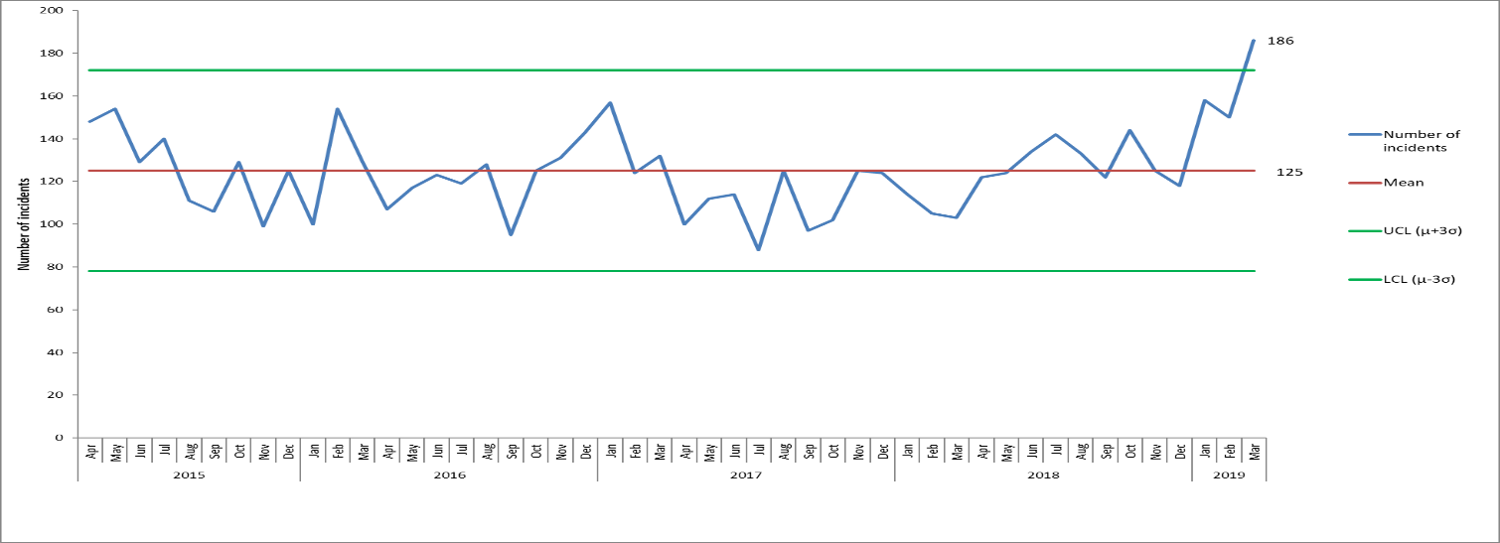

*Figure 7. Control chart displaying monthly number of incidents reported by community hospitals, April 2015-*

*March 2019*

District Nursing

Following the spikes in incidents in the district nursing teams in East Oxford and Witney & Eynsham in July of Q2, incidents returned to normal levels in Q3 of 18/19. From January 2019 the departments on Ulysses have been amended for District Nursing and incidents are now reported based on the neighbourhood team structure, so as a result it’s more difficult to look at trends. Since January 2019 73% of incidents have been in the cause group of skin integrity (580 of 796 incidents), and DN Abingdon reported most incidents with 71.

One District Nursing incident is being investigated as an SI as a result of a developed category 3 Pressure Ulcer in **DN Henley.**

Other Service and Departments

Incidents reported by the **Oxon eating disorders inpatient unit** increased in 2018 and an average of 18 incidents per month have been reported since June 2018, compared with 6 per month prior to that. A particular spike was seen in March 2018 when 47 incidents were reported. Overall 88 incidents were reported from December to March and 52% of these (n=45) were in the category ‘health’, 43 of which related to patients resisting treatment. There were also 13 incidents of self-harm, one of which was graded as major as the patient had to go to the JR following an overdose. Of all the incidents in the department 42 involved one patient, and 19 involved a second patient.

Numbers of incidents increased in **GP OOH** towards the end of 2017, following the particular peak in Q2 of 18/19, numbers stabilised in Q3 and Q4 with an average of 27 incidents reported per month (compared with 8 per month prior to October 2017).

Incidents also increased in **MIUs** in 2017, partly as a result of an increase in medication incidents. Since June 207 an average of 16 incidents per month have been reported compared with 6 per month previously,

As reported previously, communication incidents increased in the **Health visiting** service in 2018 as a result of the service not being notified of new births, this is reportedly due to a change in electronic system by the acute trust, OUHFT which has been resolved between the safeguarding teams. From December to March 65 incidents were reported and 52 of these related to communication/confidentiality, most of these related to this same issue, but there were also 18 IT related incidents.

A spike in incidents occurred in **PODS City Raglan House** in March 2019 when 25 incidents were reported (mean average 10 per month since August 17). Of these 23 related to transport (largely not arriving or arriving late).

Above average numbers of incidents were reported by **Bucks Early Intervention** with 21 in total from December to March, of these 7 were incidents of violence/aggression and there was one unexpected death. There were also 5 incidents of self-harm, all overdoses, and 4 incidents relating to uncomfortably high temperatures in the Whiteleaf.

### Incidents reported in Learning Disability Services

In July 2017 learning disability services were transferred to Oxford Health from Southern Health. The services transferred were 3 community teams, an intensive support team, vison outreach team, step down care home and a forensic inpatient ward (Evenlode).

Following the peak in incidents in October 2018, when above average numbers of incidents were reported by the LD intensive support team (a number of which related to the same patient), numbers stabilised in the service from November onwards. The intensive support team remained the highest reporter from December to March with 41 incidents, followed by the North community team with 37. Most incidents in the intensive support team related to violence/aggression (63%, n=26), whereas in the Community North team most incidents were in the non-Oxford Health safeguarding category (n=9).

Overall in the LD community teams 123 incidents were reported from December to March 2019- 38 of which related to violence/aggression, and 23 to Non-Oxford Health safeguarding. Eleven deaths occurred in the reporting period, 4 of which were unexpected, all deaths of a person with a learning disability receive a multi-agency review.

Since the transfer of the service incidents have increased on **Evenlode ward** in the past year (figure 8), and this is as a result of an increase in incidents of violence/aggression, as discussed in previous reports. Following the particular spike in incidents in August 2018 when 59 incidents were reported, numbers have subsequently dropped; below average numbers were reported from December 18 to March 19, with 68 incidents in total. Of the 68 incidents 44 related to violence/aggression, and 18 involved a particular patient. One of the incidents of violence/aggression was graded as major due to damage to a television.

For a significant period prior to the transfer of the service Evenlode admissions were very carefully managed by NHSE and the patient population was not typical of a medium secure patient profile. The acuity has now increased, as the unit is now admitting medium secure patients, which explains the increase in incidents seen from December 2018.

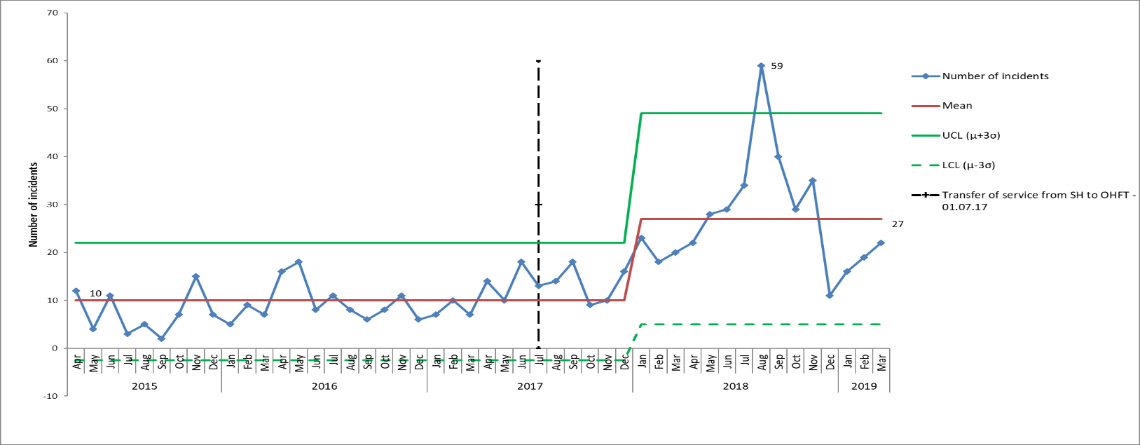

*Figure 8. Control chart displaying monthly number of incidents reported by Evenlode Forensic LD ward before and after transfer from Southern Health to Oxford Health (on 01.07.17). Incident data prior to July 2017 was transferred from Southern Health within the Ulysses incident reporting system (used by both trusts).*

### Cause Groups

The trends across all cause groups are reviewed quarterly in detail by the Safety Quality Sub-Committee and in this report just the two most reported incident types are reported on. Table 3 shows the three cause groups with most reported incidents in different services, and figure 9 provides the number of incidents by month for the seven cause groups with most reported incidents.

Violence/Aggression was the cause associated with 17% of all incidents from December to March (n=817), while 16% were Skin Integrity incidents. The 3rd highest cause of incidents was communication/confidentiality (n=440), followed closely by Medication (n=434).

*Table 3. Cause groups with most reported incidents, December 2018 to March 2019*

|  |  |  |
| --- | --- | --- |
| Trust-wide services | Mental health services | Physical health services |
| Violence/Aggression (n=817) | Violence and Aggression (n=730) | Skin Integrity (n=756) |
| Skin Integrity (n=773) | Self-Harm (n=407) | Communication/Confidentiality (n=233) |
| Communication/Confidentiality (n=440) | Security (n=252) | Fall Related (n=191) |

*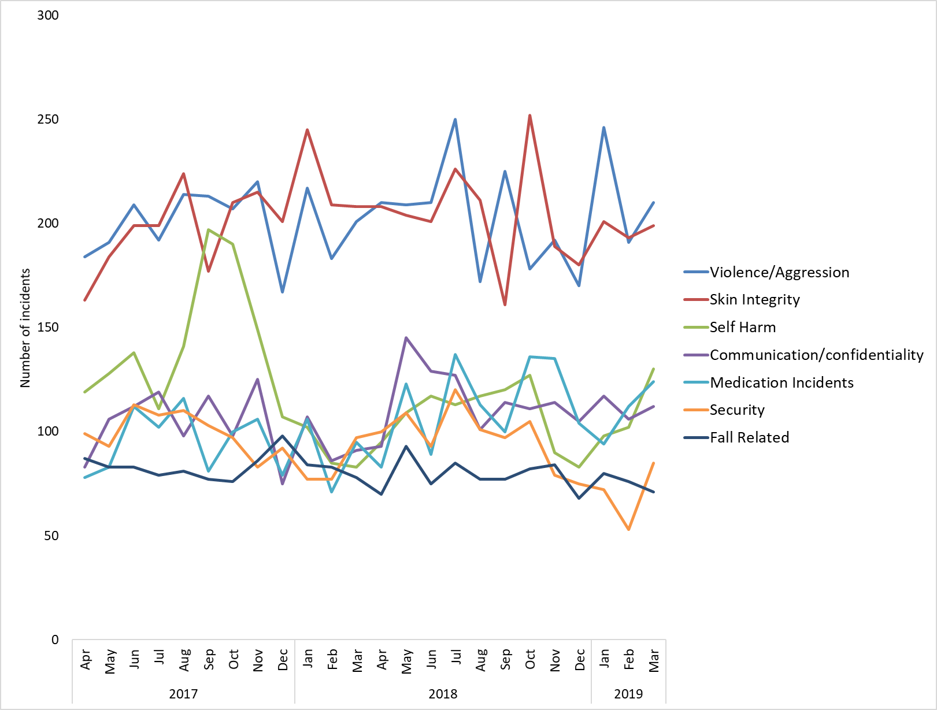Figure 9. Number of incidents reported in the 7 cause groups with most reported incidents on Ulysses from April 2017 to March 2019.*

### Violence + Aggression

The highest reported cause of incidents continues to be violence and aggression, and 814 incidents were reported across the Trust from December 18 to March 19. An average of 201 incidents per month have been reported since April 2015, with some changes over time seen as ward level.

Looking at incidents based on the new directorate structure (figure 11), incidents have increased in the specialist service directorate, as a result of the Evenlode incidents, but declined in Oxon + West mental health. The decline in Oxon + West is largely as a result of a decline in incidents on the older adult ward Sandford seen in 2017. More recently incidents have increased in the Bucks Directorate, as a result of incidents on Sapphire and Ruby wards.

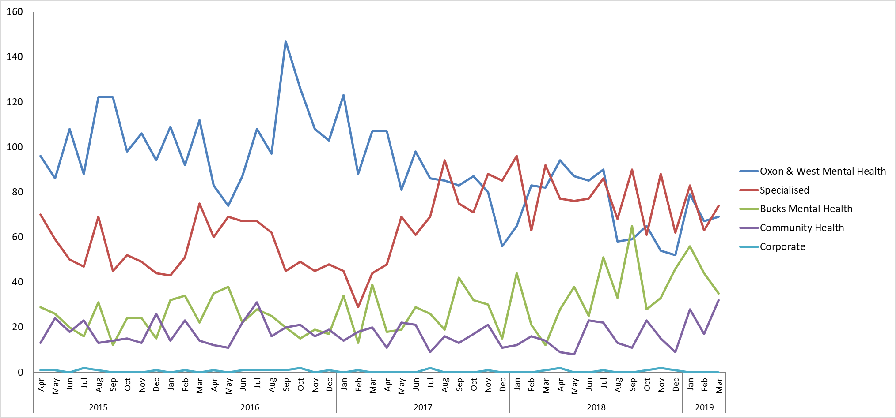

*Figure 11 Breakdown of incidents of Violence & Aggression by Directorate, based on new Directorate structure, 01.04.15-31.03.19.*

Over the last 12 months (2018/19) there has been an average of 31.2 violence and aggression incidents by patients on staff reported per month across the six adult acute mental health wards, of which 82%, n=307 caused no harm, 16%, n=60 minor harm and 2%, n=7 moderate or major harm. Ruby and Sapphire wards have the highest reported levels. We believe incidents are under-reported by staff, so the quality improvement work using the learning from the national collaborative may see an increase in all levels of reported harm however we would hope to reduce the number of incidents with moderate or major harm. The improvement work will use the national safewards model to implement actions to improve relationships between staff and patients which should then reduce violence and aggression. From April 2019 new national reporting requirements have been introduced through the MHSDS submission which will enable the Trust to compare levels with other similar NHS trusts. The graph below shows the number of incidents and number of patients involved in violence and aggression incidents across the six adult acute mental health wards.



From December 18 to March 19 most incidents were reported by Ruby ward with 65 incidents in total. An average of 9 incidents per month have been reported by Ruby since April 15, and, although there is no trend, above average numbers have been reported in each of the past 4 months (Dec=11, Jan = 14, Feb = 21, March = 19). Of the Ruby incidents 1 was reported as moderate due to damage to a window and cars in the carpark, remaining incidents were graded with no impact or minor impact. Twenty-nine patients were involved in the Ruby incidents, with one patient being involved in 20 in total over the 4 months (16 as instigator, 2 as victim and 2 as witness).

Above average numbers of incidents were also reported by Sapphire ward in this reporting period, another of the Bucks Adult Mental Health wards. From December to March 52 incidents were reported in total, with 18 in December and 21 in January (compared with an average of 7 per month since April 15). One of the Sapphire incidents was graded as moderate when a patient threw a side table causing injury to a member of staff. In total 25 patients were involved in the Sapphire incidents, with one patient being involved in 9 incidents as the instigator. Figure 4 shows the incidents on all of the Bucks Adult Mental Health wards.

Another high reporter across the Trust in the reporting period was CAMHS Highfield, but there has been no overall trend on this ward. Of the 55 incidents reported, 34 involved one particular patient (30 as instigator and 4 as victim). All incidents involving this patient were graded as no harm or minor harm, but an incident involving a different patient was graded as moderate due to damage to property when a patient threw a tennis table bat.

Within the community health directorate, following the peak in incidents at Luther Street GP in October when 17 incidents were reported, numbers have returned to average levels since then, however, a peak in incidents was seen in community hospitals in March 2019, with 17 incidents reported compared with an average of 5 per month. In total 34 incidents were reported in community hospitals from December to March 2019- 12 of these were on the Stroke rehabilitation unit, 11 of which involved the same patient. All of the community hospital incidents were graded as no harm or minor harm.

Categories of Violence/Aggression

Of all incidents of Violence and Aggression, 60% were related to Violence/Aggression directed towards staff. The categories with most reported incidents were once again ‘VA009 Violence No Injury - Patient on Staff’, with 26% of incidents, and ‘VA002 Verbal Abuse Patient On Staff’ with 20%. Ten percent of incidents were reported under ‘VA009 -Threat of Violence’, however, this category is not broken down in to threats against staff or threats against other patients.

Impact/ Harm caused by Violence/Aggression

Looking at the actual impact[2] of incidents of Violence and Aggression in October/November, in 78% of incidents there was no harm or damage to property (n=631), 19% of incidents caused minor injury or property damage (n=155), and 2.8% were graded as moderate (n=23, across 15 departments) and 0.23% as major (n=2). Three of the incidents remain ungraded. The major incident on Ruby was discussed earlier in the report, the other major incident was reported by Evenlode ward, when a patient smashed the ward’s television.

Two of the incidents from December to March were identified as RIDDORS due to injuries to staff, one in the AMHP service in Bucks and one on Woodlands.

### Skin Integrity (pressure ulcers)

Since July 2016 60% of the reported pressure ulcers have been categorised as being present on admission (previously called inherited), rather than being new (previously called acquired/developed in the service of Oxford Health). From December 2018 to March 2019- 69% of the reported pressure ulcers were present on admission (n=109) (Figure 12)**[3]**. New national reporting requirements have been introduced from 1st April 2019 with first national reporting for Q1 in July 2019, this should improve the comparison that is possible across NHS trusts.

Of the 193 pressure ulcer that developed in service in the reporting period, one, reported by DN Henley, is being investigated as serious incident.

Alongside pressure ulcer incidents 74 incidents of SCALE, 66 incidents of moisture associated skin damage, and 3 medical device related incidents were reported. Nine of the incidents of SCALE were graded as major.

In October & November 98% of skin integrity incidents were reported by the community health directorate(n=756). Eleven incidents were reported by Oxon + West Mental Health, 5 in Bucks Mental Health, and 1 in the Specialised Directorate (an LD community team).

Of the Community Health Directorate incidents 76% were reporting in District Nursing (n=580) and 16% by community hospitals (n=119).

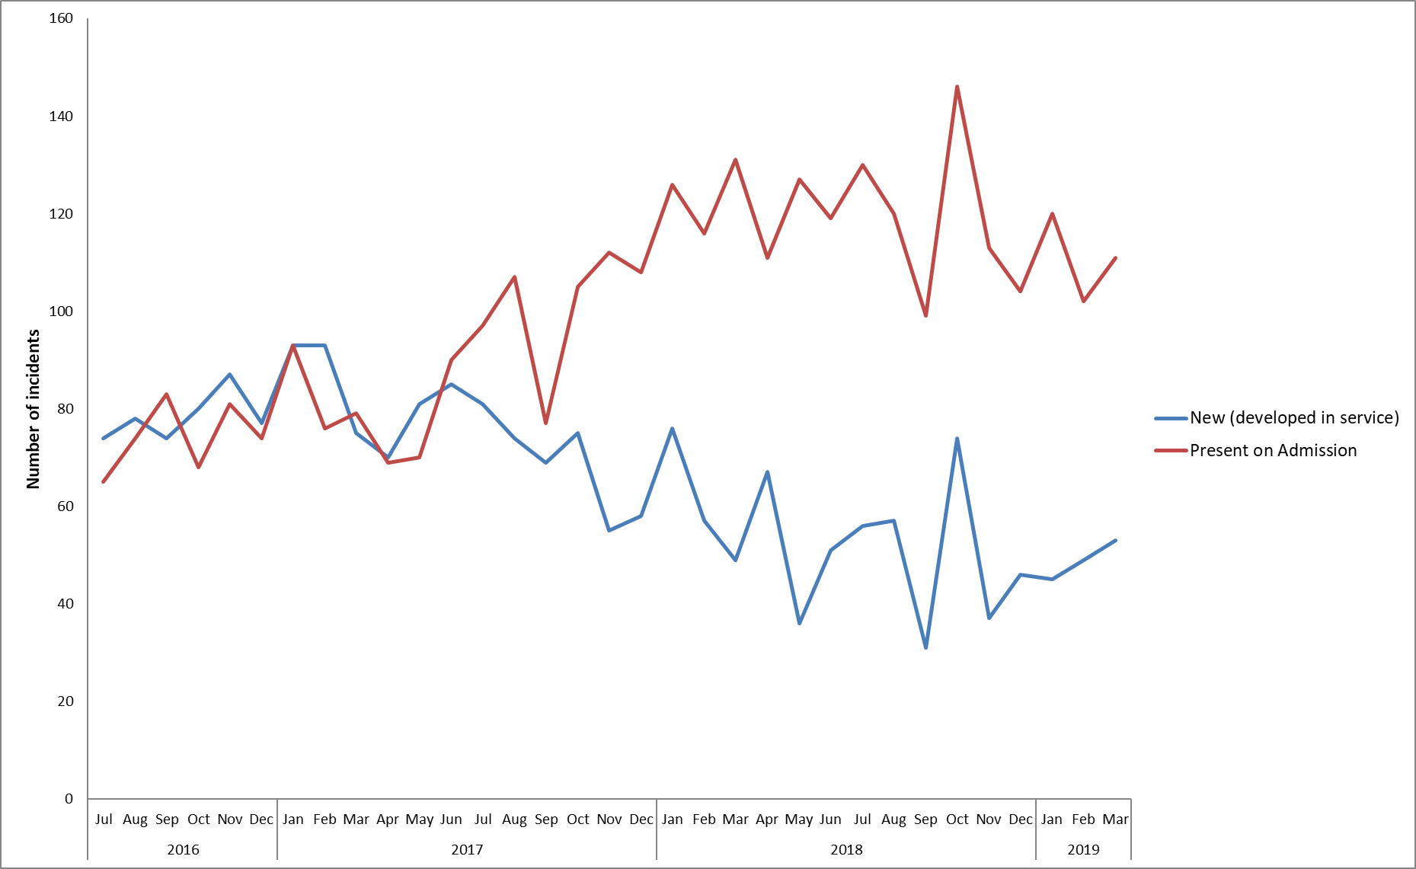

*Figure: 12. Incidents of pressure ulcers, July 2016 – March 2019*

# Data Quality

The quality and risk team continue to make design and configuration changes to the Ulysses system to improve the use for reporters of incidents and the analysis of information to make quality improvements. An open Ulysses system user group for staff was held in April 2019 to support this work. All incidents are reviewed by a member of the quality and risk team to ensure data is complete, consistent and accurate.

**4.0 Reducing Restrictive Practice**

# The Trust reviews the use of restrictive practice across the trust on a weekly basis and then reviews trends on a quarterly basis. Violence and aggression from patients, followed by patients resisting treatment are the main reasons for using restraint.

# Over the last year there has been an overall reduction in restrictive practice, with over 15 of the last 17 months suggesting a downwards shift. The trend for physical restraints is shown in the graph below. The previous reductions in older people wards and forensic wards have been maintained. The Trust continues to note a small number of patients accounting for the majority of restrictive practice.

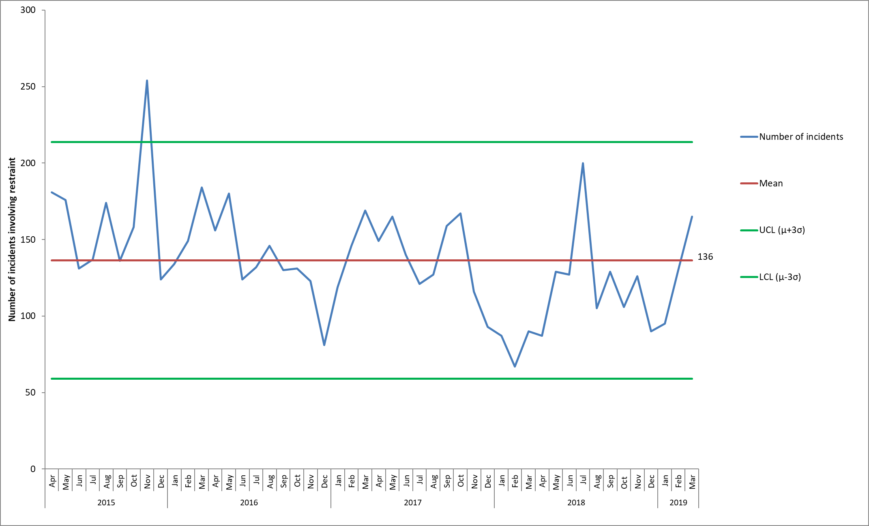Figure 2. Trust wide incidents involving physical restraint reported on Ulysses from 01.04.15-31.03.19

# The most common position of restraint is standing; however, we have seen an increase in prone restraints in March 2019 in relation to one patient to administer medication. The average duration of prone restraints has remained static. There have been no complaints or Serious Incidents (SI) in relation to restrictive practice in Q4, 2018/19.

# The Trust has joined a national collaborative on reducing restrictive practice, focused on four wards looking at how to reduce violence and aggression which often leads to restrictive practice having to be used.

The CQC is currently undertaking a thematic review and will make recommendations about the use of force and restrictive interventions in settings that provide inpatient and residential care for people with mental health problems, a learning disability and/or autism. This work is being undertaken in 3 phases the Trust was selected to be involved in phases 1 and 2 of the review related to submitting data on restrictive interventions.

In 2018 there has been a national focus on reducing restrictive interventions around three workstreams; collection and use of data, identifying quality improvements and staff training. In 2019 training provided to staff will need to be accredited by the Restraint Reduction Network. The Trust is starting a review of the content and frequency of the current restrictive intervention staff training (called PEACE) and will plan to apply to be a provider of accredited training.

**5.0 Infection prevention and control**

In 2018/19 we had;

* Eight cases of C.Diff however all were deemed unavoidable.
* Zero cases of MRSA bacteraemia, although in one case a person transferred from another hospital to one of our older people wards with the bacteraemia. This was investigated and considered unavoidable.
* Zero cases of MSSA bacteraemia.

The Trust was involved in a recently completed project to reduce risks for catheter associated urinary tract infections in the community alongside our acute hospital partner. The joint project focused on building staff knowledge through training, standardising the patient pathway and developing a patient catheter passport. We are currently involved in a national collaboration to develop decontamination guidelines for managing toys in healthcare.

# 6.0 National Alerts

The process for identifying, disseminating and managing actions from national patient safety alerts is robust, this includes a regular process of reviewing closed actions to ensure as relevant changes have been sustained. All national alerts have been closed within the specified timescales.

From December 2018 to March 2019- 35 CAS alerts were issued, of these 21 were applicable to the Trust and were cascaded appropriately. These alerts concerned a range of topics from drug safety alerts, medical devices and Estates and Facilities alerts. Of the 21 alerts deemed applicable to the trust 14 have been actioned and closed. In total 8 remain open (1 of which was issued prior to the reporting period, in August 2018). The completion dates for these fall in May, June and September of 2019, the alerts are being actioned and remain under review.

Ten internal risk notes were issued from December 2018 to March 2019, detailed below:

Risk Note 13- Carrying Patient details securely in the community setting. Issued: 3/12/2018

Risk Note 14- Fire risk from personal rechargeable electronic devices. Issued: 18/12/2018

Risk Note 15- Potential Peanut allergy and Desogestrel.  Issued: 19/12/2018

Risk Note 1- Emollient cream build up. Issued: 24/01/2019

Risk Note 2- Risk of harm to patients not receiving oxygen therapy. Issued: 11/02/2019

Risk Note 3- Up to date risk assessments. Issued: 11/02/2019

Risk Note 4- Ligature point from locked back bathroom doors on Mental health wards. Issued: 19/02/2019

Risk Note 5- Use of portable electric fans in clinical areas. Issued: 26/02/2019

Risk Note 6- Fentanyl patches. Issued: 26/02/2019

Risk Note 7: Mobile air conditioners risk of infection. Issued: 28/03/2019

# 7.0 Learning from Deaths

The Trust has implemented a stepped process to the screening, review and then investigation of deaths. Each clinical directorate manages their own mortality review process to identify learning from unexpected and inpatient deaths. If new complaints are received in relation to the care of a bereaved relative a mortality review is automatically triggered. The Trust-wide Mortality Review Group oversees learning across the Trust. The Trust-wide Mortality Review Group oversees learning across the Trust, the last meeting was held in February 2019 and included feedback from the Mental Health Directorates and the Community Directorate. Deaths amongst the homeless community in Oxford, served by Luther St practice were highlighted, 2 of these deaths are under review and a further 5 deaths are subject to adult safeguarding reviews. A detailed review of all child deaths was given by the trusts’ Children’s Safeguarding lead nurse. The group is also overseeing the reviews of the Trusts position against the following national guidance’s and resulting actions; extended guidance for child deaths reviews (October 2018), learning from deaths guidance; engagement with bereaved families (July 2018) and NHS Resolution thematic review; learning from suicide incident related claims (Sept 2018).It was noted that Structured Judgement Reviews are being piloted in the community directorate and will be tried also in the Mental Health Directorates.

The Trust continues to be involved in the following multi-agency forums including; Oxfordshire vulnerable adult mortality group, Buckinghamshire Integrated Care System learning from deaths group, our neighbouring acute provider’s mortality and morbidity group (for community hospital deaths) and the south regional mortality review group.

In addition to our own review of deaths, the local coroner will independently review all deaths where the cause of death is unknown, violent, unnatural, or sudden and unexplained. As a result of the reviews a coroner has issued two Regulation 28 rulings in 2018/19 to prevent any future deaths as they concluded further actions or assurance were required. The rulings related to a death in 2015 and a death in 2017, both had been investigated and the Trust has responded and taken further actions as requested. All deaths of a person with a learning disability or autism and all deaths of a person aged under 18 are reviewed externally by a multi-agency group in addition to our own review.

## 

## Overview of Trends

The pattern of deaths is reviewed quarterly and the position up to December 2018 was reported in detail and discussed at the last Trust-wide Mortality Review Group in Feb 2019. We have seen a static trend in the number of deaths (expected and unexpected) over the last four years in-line with the national data, shown in the graph below. The majority of deaths relate to people aged over 75 who had received treatment from one of our physical health services, such as the district nursing service. We saw an increase in deaths in January 2018 (one month) in line with the national picture (the winter period is nationally called the winter excess deaths period when a higher number of deaths is forecasted).

Suicide rates in Oxfordshire and Buckinghamshire are similar to national averages (rates have reduced from 2013-2015 to 2014-2016). In 2018/19 we have had 26 suspected or confirmed suicides by a Coroner for patients known to the Trust.

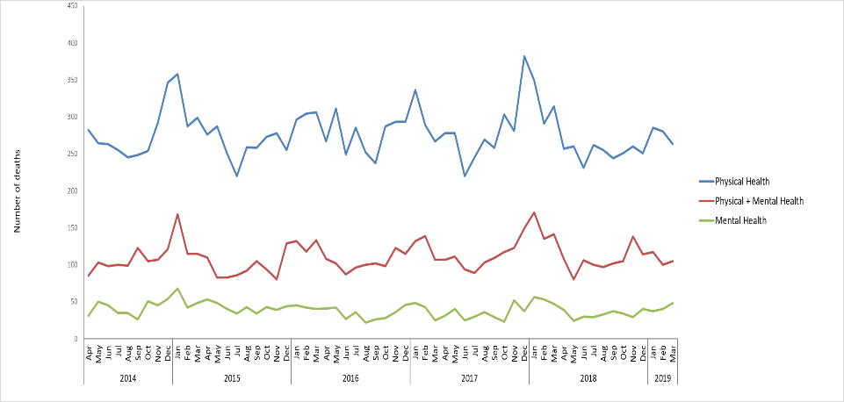

*Figure 13. Deceased patients by service type (for patients with open referrals and patients who were discharged but seen in the 6m prior to death).*

From the deaths reviewed in 2018/19 we have identified the following overall themes and learning;

* Physical healthcare for patients with a mental illness
* Family and carer involvement and communication
* Communication at points of transition and changes in care between services
* Awareness of sepsis for learning disability patients

**7.2 Actions from learning**

A number of actions have been taken to address the overall themes for learning from deaths, a few are detailed below with our assessed impact of these.

The Trust joined the national quality improvement collaborative called ‘closing the gap’ to support work to reduce the number of deaths for patients with a serious mental illness. There has been significant work completed with adult and older people mental health community teams and inpatient wards to support staff in carrying out the physical health monitoring required for our patients with a serious mental illness aligned with the Lester tool (monitoring diet, exercise, smoking, alcohol and drug use, BMI, Blood pressure and blood tests for lipids and glucose). This has included; whole team training, enhanced training for physical health leads in each team, a network for physical health leads has been developed, a physical health handbook was developed, team bases were provided with the physical health monitoring equipment required, changes were made to make it easier to document physical health monitoring in a patient’s health record and resources were developed and put on a new physical health page on the staff intranet. Since the first physical health in mental health conference in January 2018 we have seen a shift attitude, staff awareness and levels of screening, however feedback from some staff is that there is a lack of confidence in when to and how to intervene when issues are identified. A second conference is being planned for June 2019 with a focus on ‘don’t just screen, intervene’.

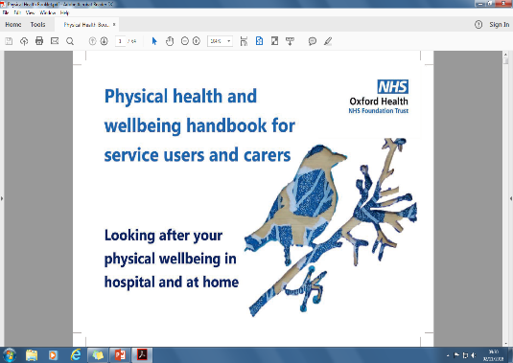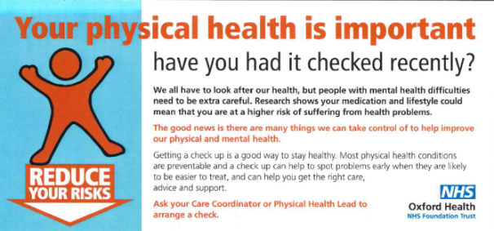

The Trust launched a carers strategy in 2017 and identified new funding to lead on better engaging and working with carers and families. The aim is to raise awareness and change attitudes on the importance of a carers role and to improve how carers are identified and support provided. The actions taken in 2018/19 include; a library of carer stories to support staff training have been developed, the introduction of carer champions in teams, a carer awareness on-line training tool for staff has been co-developed with carers due to be launched shortly, and a new carer handbook has been co-developed with staff and patients for the community hospital wards to share useful information about the service and support available to carers.

Due to a number of deaths linked to sepsis for people with a learning disability we are working on ensuring that we alert patients, care staff and families to the early signs of symptoms. As a service we have reviewed the sepsis information and made this more easily available on the Trust internet for staff, patients and other health professionals to support with making adjustments. We are also co-developing an easy read version of the information. Early indications are showing a reduction in deaths from sepsis, but continued monitoring will be required in 2019/20.

# Serious Incident Reviews

## 8.1 Summary of number of serious incidents and themes

From December of Q3 to March Q4, 2018/19, 23 Serious Incidents (SI)**[4]** were identified and reported to STEIS (4 of which occurred prior to this, in November 18). Of these 7 were subsequently downgraded (an average of 2.6 incidents per month have been downgraded since April 2015). Out of the 23 SIs, 11 involved a death, of these 9 were confirmed or suspected suicides.

From December to March 2019- a total of 20 SI investigations were completed, reviewed at panel and submitted to the relevant commissioner. Two of these incidents (diagnostic incidents on MIUs) were downgraded over the course of the investigation.

The overall themes and learning from serious incidents are:

* Challenges continue with staffing levels, use of temporary staff and transfer of patients between care co-ordinators where staff turnover is high. This continues to have a negative impact on the quality and continuity of care for patients and the morale of permanent staff.
* Variable completeness and standards of documentation for example- risk assessments, safety planning, consent to share with family members, pressure ulcer risk assessments, MEWS, care plans.
* Transition points and communication between external organisations and services within the Trust have been raised as an area of concern in several SI investigations where the interface between record systems does not provide clinical staff with ready access to vital information.
* A further area of concern which has been highlighted in several investigations is the accessibility for staff of both historic and current risk assessments in Carenotes which can hinder staff when clinically assessing patients at a point of crisis.

## 8.2 Timeliness of process

No SI investigations have been submitted past the stipulated time frame in 2018/19.

## Developments to the SI process

* The revised RCA training sessions continues to be delivered over 2 consecutive days with a focus on human factors recognition, duty of candour and involvement of families and carers in the investigation process. Four 2-day RCA training sessions were provided in 2017/2018 and total of eight 2-day sessions are being offered in 2019/2020. In Q3/4 22 different staff members led or supported serious incident investigations.
* A second external audit was completed by Tiaa in Feb 2018 to review progress against the Mazar’s recommendations and the Tiaa audit in May 2017. This audit demonstrated reasonable assurance that the actions have been progressed. A further external audit has been commissioned and carried out by Price Waterhouse Cooper in Jan /Feb 2019 and the results are awaited.
* The SI team has also conducted its own internal audit to review the involvement of families in the conduct of investigation and was able to demonstrate the positive involvement of families in developing the terms of reference and identifying learning from investigations. An internal audit was repeated in November 2018. In the SI reports which were randomly selected the results for Q3 show that 75% of IRR’s demonstrated that the patient and or family had been contacted to seek their views of the incident or death and in the remaining instances either family members were not available or the patient expressed a wish that they were not to be contacted concerning the incident , Also in reviewing resulting completed SI investigations, 100% of SI investigations demonstrated that either patients or family members had contributed their concerns to the investigation. This internal audit of 10 completed SI reports will be repeated in June 2019 to monitor if the improvement noted has been sustained.

Plans for future improvement include: -

1. That families are fully engaged and involved in investigations at all stages of the process.
2. Learning is shared widely across the trust.
3. How actions arising are completed and the impact is assessed on preventing recurrence of incidents and improving the quality and safety of care
4. Timeliness of when completed reports are shared with patients, family members and or carers.

## Trend for Serious Incidents

In 2016 a reduction was seen in the number of confirmed serious incidents in the trust (from an average of 10 per month prior to November 2016 to an average of 4 per month subsequently). Prior to Q2 of 18/19 it seemed there had been a further reduction as below average numbers were reported in 11 of 12 months from July 17 to June 18, however, this has not been maintained (figure 14).

The decline in serious incidents in 2016 was largely in relation to pressure ulcers (figure 15). The reduction in the incidence of pressure ulcers in the Community Health Directorate (previously Older Peoples Directorate) comes because of a dedicated focus within community nursing teams to assess and advise their patients and carers on the signs of pressure ulcers and to put in place preventive measures.

In the category of ‘apparent/actual/suspected self-Inflicted harm’, numbers were average or below average for 12 of the 13 months up to July 2018, however, numbers have been more variable since then and 9 incidents were reported in this category between December 2018 and March 2019 (figure 16).

Of the serious incidents in the previous reporting period, (October & November 2018) 4 were diagnostic incidents that occurred in Minor injury departments, 2 in Abingdon and 2 in Witney. These incidents have been reviewed in depth by the Urgent Care service and an assurance visit has been carried out by OCCG in January 2019 who were satisfied at the safety and quality of care of the service. These four incidents were subsequently downgraded.

Of the incidents that occurred in this reporting period, from December 2018 to March 2019, 3 were in AMHT Bucks Chiltern and 3 were in AMHT Oxon City + NE. All of these related to self-harm and may be a reflection of the increased demand on the AMHT with the referral rate rising month on month.

Of the confirmed SIs in the whole of 2018/19, 5 serious incidents occurred in Oxon City & NE AMHT, 4 occurred in both AMHT Bucks Chiltern and AMHT Bucks Aylesbury, and 3 occurred in AMHT Oxon South and in the Abingdon Minor injuries unit.

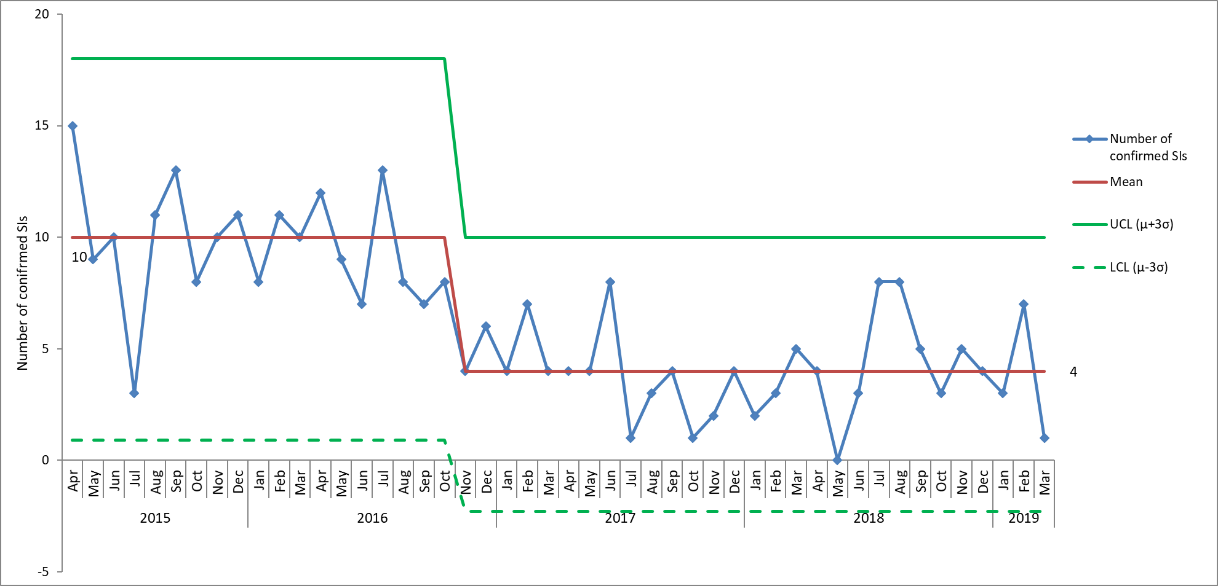

*Figure 14. Monthly numbers of confirmed serious incidents, based on date of incident, April 2015 – March 2019*

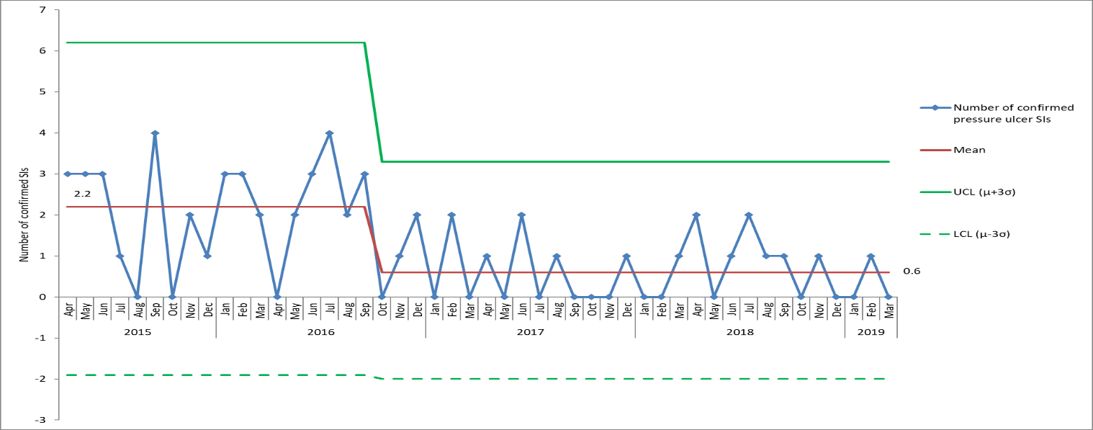

*Figure 15. Monthly numbers of confirmed SIs due to pressure ulcers, April 2015 – March 2019, based on date of incident.*

*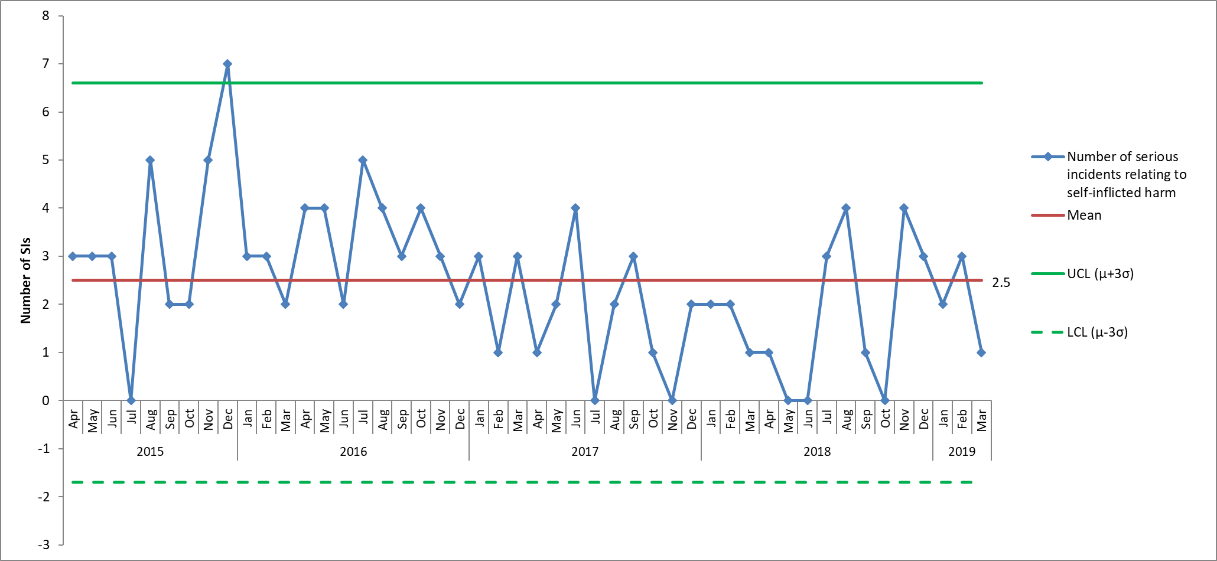Figure 16. Monthly numbers of confirmed SIs with Steis cause 'apparent/actual/suspected self-inflicted harm meeting SI criteria', April 2015 – March 2019, based on date of incident.*

## Overdue Actions from Serious Incidents

There is a total of 37 overdue actions at the time of writing the report currently, relating to 17 different Serious Incidents. The Service Manager for Patient Safety has followed up the leads for all outstanding actions with a further follow-up planned in April 2019.

# 9.0 Homicide Reviews

The Trust participates in multi-agency mental health homicide (MHH) and domestic homicide reviews (DHR) as appropriate. A summary of all investigations backdated to 2011 with outcomes and progress against any recommendations is reported 6 monthly to the Quality Committee. There are currently 8 active cases being independently investigated. The number of domestic homicide investigations has increased since the Home Office revised their guidance in December 2016 which sets out that all suspected or confirmed suicides where there was coercive controlling behaviour in a relationship will be subject to a domestic homicide review. There were 2 new DHR cases commenced in November 2018 and the requested information has been prepared in readiness for submission to the respective DHR panels.

In 2018/2019 a Mental Health Homicide review was commissioned by NHS England into the care of a mother who killed her child in March 2017 who was under the care of an AMHT and GP. The review looked at the mental health care of the mother by three NHS trusts since 2011. The death of the child has been subject to a Serious Case Review (SCR). The report from the SCR was published at the end of September 2018. The draft MHHR report has been received and has been commented on by the trust. A date for the final publication of the Mental Health Homicide review has not yet been confirmed by NHS England.

# 10.0 Conclusions

The group is asked to note the report and to continue to encourage the reporting and learning from incidents and deaths. Representatives from the clinical directorates are asked to disseminate the information through their quality groups.

1. This is based on information from April 2018 – September 2019.
2. The actual impact which includes both property damage and injury as a result of physical or psychological harm, physical injuries are recorded separately.
3. In July 2016 changes were made to the Ulysses system to enable reporting on whether pressure ulcers were ‘developed’ in the service of Oxford Health or ‘present on admission’.
4. Serious Incidents are nationally defined as incidents where there were acts or omissions identified in care that resulted in death, lead to abuse or serious harm requiring further treatment