Who we are  Oxford Health NHS Foundation Trust provide physical, mental health and social care for people of all ages across Oxfordshire, Buckinghamshire, Bath and North East Somerset, Swindon & Wiltshire.  - Our services are delivered at community bases, hospitals, clinics and in people’s homes. We focus on delivering care as close to home as possible |  |  | Experience & Involvement Strategy

Contact Us
If you have any questions or would like any other information please contact:
Donna Mackenzie-Brown
Patient Experience & Involvement Manager
Phone: 07766 360547
Email: Getinvolved@oxfordhealth.nhs.uk
Web: https://www.oxfordhealth.nhs.uk/get-involved/

Oxford Health NHS Foundation Trust
May 2019 – April 2021

BAckground  People who use our services and their families are central to everything we do.  The theme of involvement runs through every aspect of what we do in the Trust and we encourage all staff to be curious about the experiences of people who use our services.  We all strive to provide the best possible care and outcomes for the people we work with and believe that involvement in co-design, co-development and co-production is simply the right thing to do.  Evidence shows a strong link between staff experience and patient experience, hence we want to ensure staff feel valued by the positive feedback they receive and empowered to make changes where improvements are needed.  This is the third strategy to be produced and the Trust are able to celebrate the impact of the previous work which has been achieved. |  |  |  |  | Strategy Objectives
The Strategy has 4 main objective areas and these show our priorities for the next 2 years:

- Leadership at every level
Ensuring staff at all levels have opportunities to involve people who use our services and are empowered to make changes locally.

Expectation of Co-production
We want to develop skills and training to grow confidence in the use of co-production and ensure we are sharing good practice across services and teams.

- Resources
We want to develop more self-management and self-education resources, alongside reviewing the quality and accessibility of information we currently provide to people who use our services.

4. Every team acts on feedback
 |  |  |  |  | We want to review internal systems to identify and challenge those that don’t support positive experiences and develop the use of feedback data to be ‘proactive rather than reactive’.

What we know
We have looked at our previous patient feedback to see how involved people who use our services currently feel.
Using I Want Great Care (a patient and carer feedback tool) during the previous strategy between 2016 – 2019.
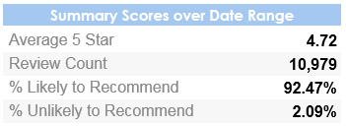
The below graph shows how involved the 10,979 people who responded to our questionnaire felt between April 2018 and March 2019.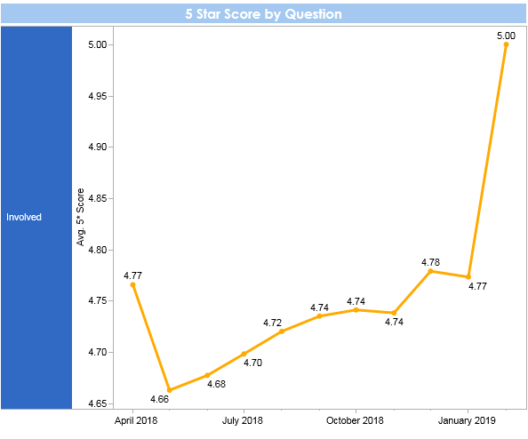

Our Aim
“To ensure 10% more people who use our services tell us that they have been given opportunities to be involved and empowered to make shared decisions about their care, treatment and support, as well as to work with staff in developments to services by April 2021.”
We have also identified the below indicators to monitor the success and impact of this Strategy, which will be monitored by a shared service user and staff group;

- People feedback an improvement in being involved in their care.
- Increased amount of patient and carer feedback received.
- Each service/ team is better able to demonstrate the actions they have taken as a result of feedback.
- Improvement or sustained high performance in the feedback received to standard questions used across all surveys.
- Increase the number of people being involved in activities such as interviews, training, decision making meetings, writing newsletters, service developments and other activities.
- Increase in the number of volunteers, apprentices and peer support workers employed within the Trust.

Getting Started  Every staff member has a responsibility for improving the experience and involvement of people who use our services and we are developing a culture of “I am the Patient Experience” which recognises the importance of every individual contact, every conversation, every interaction. We feel the below description of good quality care by National Voices (a charity) defines the care we want to deliver.  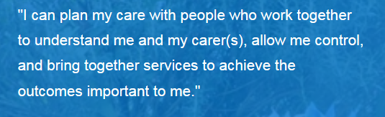  Patient Experience Team  The Trust has a (Patient) Experience and Involvement Team who are there to lead, support and facilitate projects and “skill up” staff to embed on going work. |  |  | actions  We have identified 28 specific actions; 7 under each of the Strategy objectives, to deliver our aim.  All of these actions will be monitored by a shared service user and staff group called the “Taking Action from Patient Feedback Group”. This is a group which meets bi-monthly and is attended by patients, carers and staff.  For more information about joining the group or finding out about the specific actions in the Strategy go to the below link on the Trust’s website or contact us using the details overleaf.  https://www.oxfordhealth.nhs.uk/getting-involved-with-oxford-health/patient-involvement/taking-action-from-feedback-group/
2 |  |  | 3

