

# Report to the Meeting of the

# Oxford Health NHS Foundation Trust

**BOD 06/2019**  
(Agenda item: 8)

# Board of Directors

# 31ST January 2019

# INPATIENT SAFER STAFFING Report Period 8th October – 30th December 2018

**For: Information**

**Executive Summary**

**Ward Staffing**

The purpose of this paper is to provide a report of the actual inpatient staffing levels to the Board of Directors. There is a national requirement on providers to be transparent in our monitoring and reporting of inpatient staffing levels and the impact on patient care. Ensuring sufficient staffing levels are in place is crucial to deliver safe, effective and high quality care. This report will be published on our website with a link from NHS Choices website.

The data within the report will outline the staffing levels (for both registered and unregistered nursing staff) on each ward. These figures will be measured against the required figures on a shift by shift basis for the period 8th October – 30th December 2018. (Note a Board report was not produced for December 2018)

During this period:

Average weekly day shifts fill rates for registered staff & unregistered staff were above the Trust target of 85% with 88% or above for unregistered and 94% or above for registered staff.

Eleven wards were below 85% target for average weekly fill rates for registered nurse day shifts during some of this period. Four wards were below 85% average weekly fill rates for two of the four-week periods, these were Adult wards Allen, Ashurst, Community hospital wards City and Wenrisc.

Average weekly night shifts fill rates for registered and unregistered were above the Trust target of 85% with the average lowest fill rate at 69% for unregistered staff and remained above 100% for registered staff for each week.

The methods of filling these shifts includes substantive, flexible workers and agency registered staff and further detail in provided later in the report.

The Trust moved to a new approach to reduce the use of unregistered agency staff in the week of 14.5.18. Further detail of this project is provided in the HR workforce report and commented on in relation to changes in skill mix ratios.

The average weekly % agency use was 10.06% in the period 8th October – November 4th a slight increase on 9.65% in the November report. Data is not available for the period November 5th to December 2nd, 2018.

In the final period December 3rd to December 30th average agency use was at 10.55%.

Average sickness rates for ward staff were 5.5% in the first period and increased to 6% in the final period

This paper will also provide an update on nursing workforce developments.

**Recommendations**

The Board is asked to note:

* There are processes in place to ensure safe staffing levels on all the wards in the organisation, those wards where there are concerns and the actions being taken to ensure safe staffing including project work and wider recruitment and retention work. There are no exceptions to report that directly link actual staffing levels to adverse outcomes for patients which have been identified through our Governance Structures.

**Author and Title:** Kate Riddle, Acting Director of Nursing and Clinical Standards

**Lead Executive Director:** Kate Riddle, Acting Director of Nursing and Clinical Standards

*A risk assessment has been undertaken around the legal issues that this paper presents and there are no issues that need to be referred to the Trust Solicitors. This paper links to all the five CQC Domains.*

***Strategic Objectives*** *– this report relates to or provides assurance and evidence against the following Strategic Objective(s) of the Trust*

*Driving Quality Improvement (Goals: patients will be safe from harm; patients will achieve the clinical outcomes they want; and patients and carers will have an excellent experience)*

*Delivering Operational Excellence (Goals: our services will be effective and efficient; information will be translated into knowledge; and our planned surplus will be delivered)*

**Inpatient Safer Staffing**

Period 8th October to 30th December 2018.

**Introduction**

This is the report to the Board of Directors outlining the staffing levels (registered and unregistered) on each ward against their required need on a shift by shift basis. This report covers the period 8th October to 30th December 2018.

This report will focus on the percentage of day and night fill rates for registered and unregistered staff. This data is reported to NHSI and provides assurance of actual clinical staffing numbers being achieved. This report will be published on our website with a link from NHS Choices website.

**Management of Staffing Levels**

Anescalation process for the management of staff shortages is in place within each clinical area, to manage staffing safely on a shift by shift basis. As part of this process, senior clinical staff are providing appropriate support to ward teams as and when required. In addition, senior ward staff and immediate team managers review ward staffing levels on an on-going basis; shift by shift basis, and where there are changes in patient acuity. Ward Matrons review staffing daily as a minimum and more frequently where required.

In-patient staffing levels continue to be reported every week and discussed within the Weekly Review Meeting (WRM), which takes place each Monday morning with the Director of Nursing and or Deputy present.

To ensure that staffing levels are under continual review, every ward undertakes a range of immediate actions daily to ensure safe staffing levels are maintained appropriate to the needs of patients. These actions include booking flexible or agency staff via Staffing Solutions, revising rotas, moving staff between wards and utilising additional staff that are not included in the ward numbers as required for example modern matrons.

**Summary position of inpatients wards staffing levels.**

Appendices 1-3 show the staffing levels for all wards by ward for the period 8th October to December 30th, 2018. The data presented includes details of staffing by shifts and details of skill mix, agency, ward staff sickness and ward vacancy figures. The thresholds presented in the table are measured against trust/ national targets and used to highlight particular wards for further review.

During this period:

**Day shifts fill rates**

Average weekly day shifts fill rates (all departments) for registered nurse & unregistered staff were above the Trust target of 85% throughout this period. This included a mix of agency, flexible and substantive staff including ward managers and matrons where required to make up staffing numbers and provide safe care.

Average weekly day shifts fill rates for registered staff & unregistered staff were above the Trust target of 85% with 88% or above for unregistered and 94% or above for registered staff.

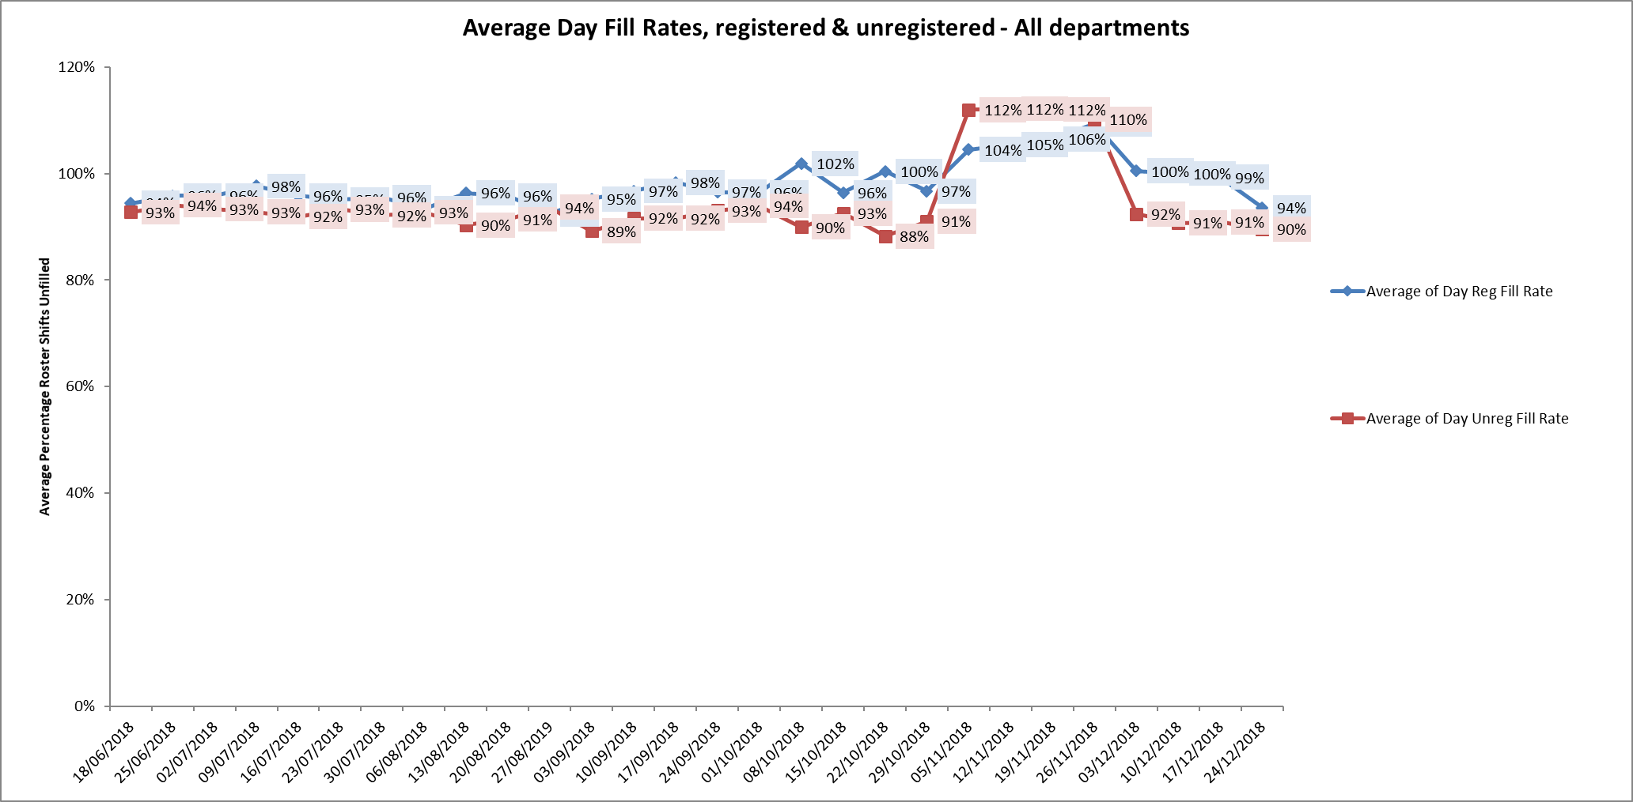

Eleven wards were below 85% target for average weekly fill rates for registered nurse day shifts during some of this period. Three wards were below 85% average weekly fill rates for two of the four-week periods, these were adult wards Allen, Ashurst and Community Hospital ward Wenrisc. There were increased unregistered staff numbers for these wards or additional support from ward managers or matrons to support safe staffing.

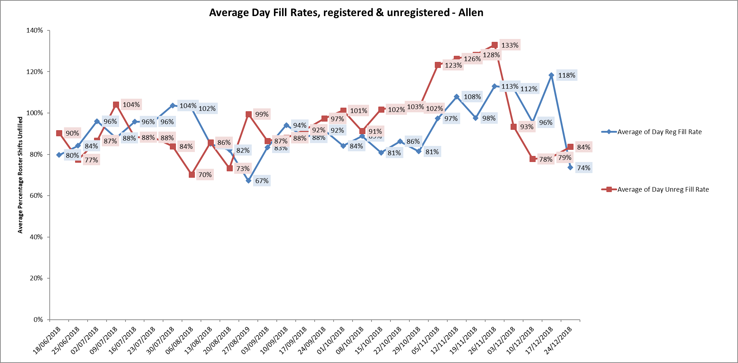

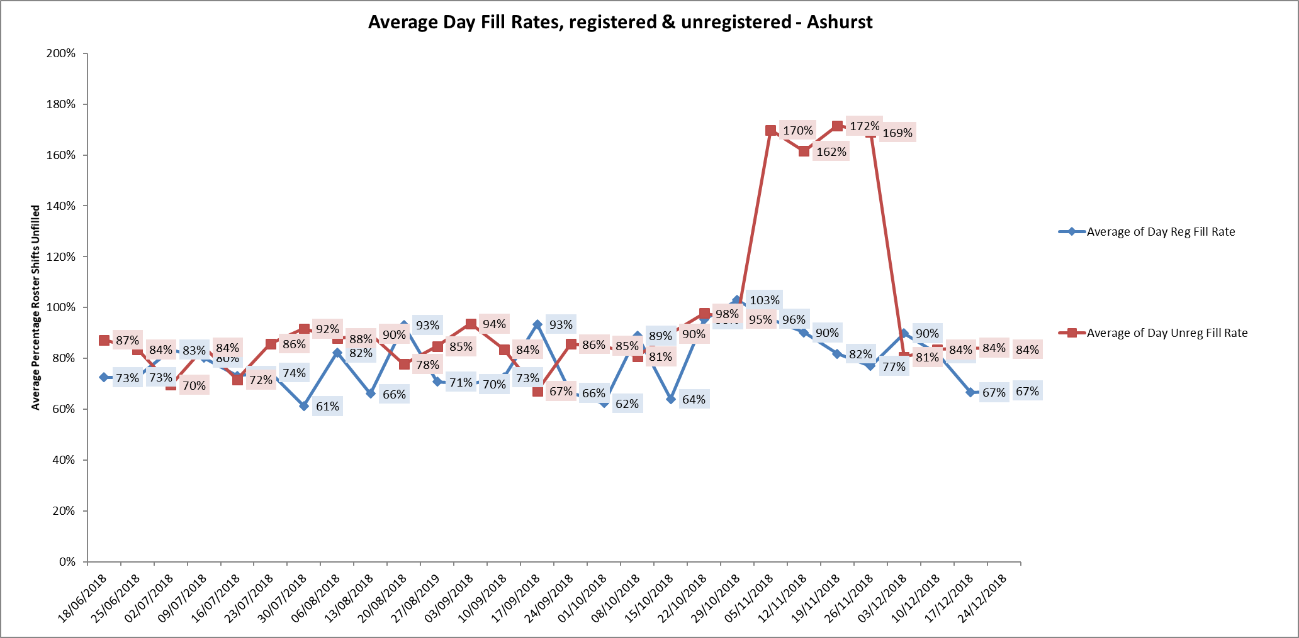

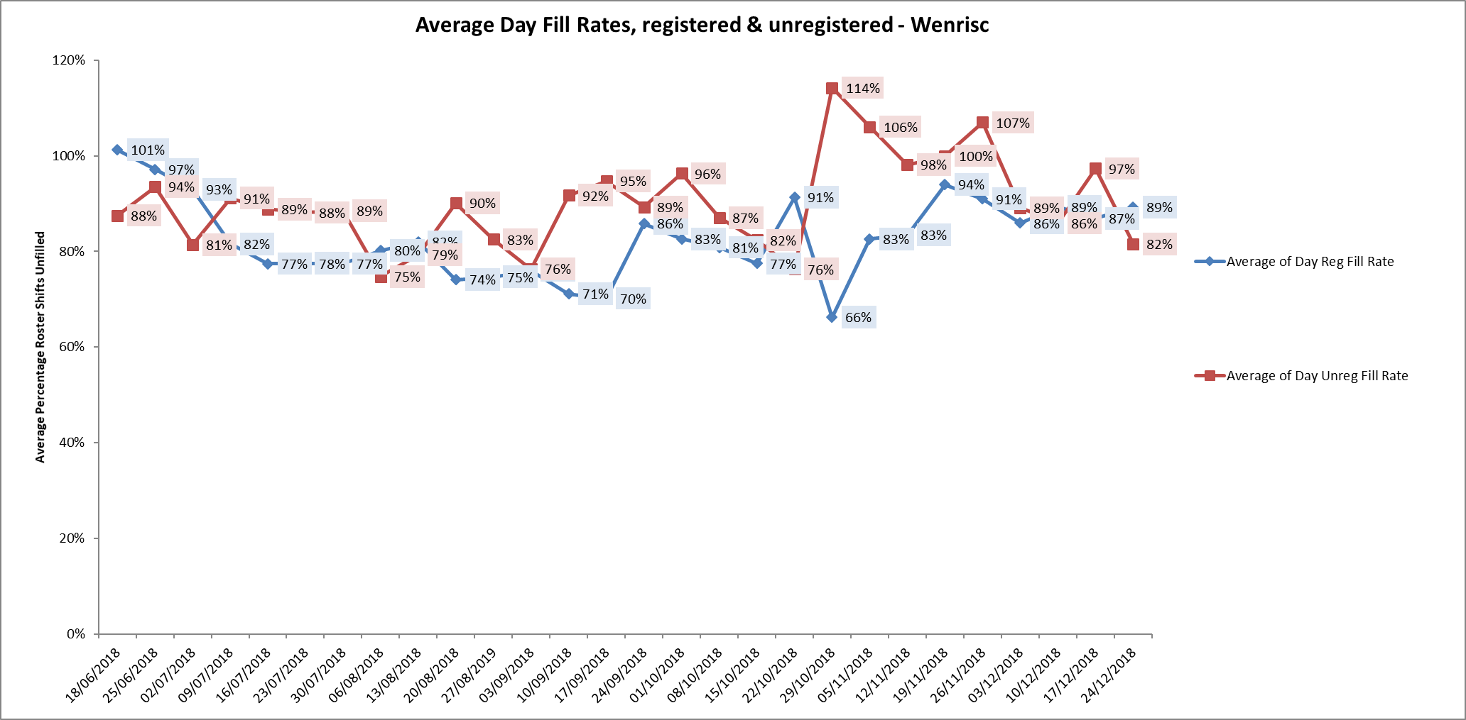

City ward registered nurse fill rates were below 85% for ten weeks of the twelve week period. Unregistered staff fill rates were below 85% for six weeks of the period.

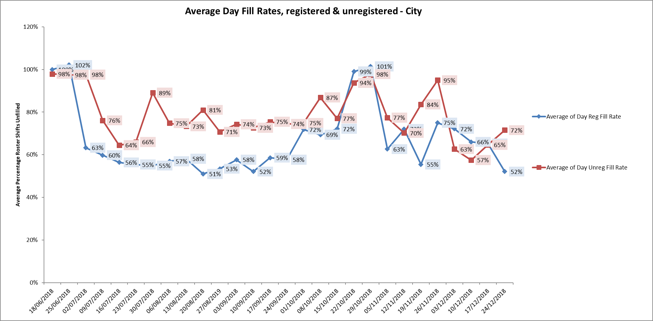

**Night shift fill rates**

Average weekly night shifts fill rates for registered nurse & unregistered staff were above the Trust target of 85% throughout this period. This included a mix of agency, flexible and substantive staff to make up staffing numbers.

**Registered skill mix**

8th October – 4th November

Eleven wards had in place an average of 50% or above registered staff skill mix.

5th November -2nd December – No data available at times of reporting.

3rd December – 30th December

Fifteen wards had in place an average of 50% or above registered staff skill mix.

Wards with below 50% registered skill mix is related to the continued registered nurse vacancies. Safe staffing is supported by the ward managers and matrons on the ward working clinically as part of the numbers where required to ensure registered nursing leadership is maintained.

Skill mix is achieved through use of our own staff and trust employed flexible registered workers and agency registered nurses.

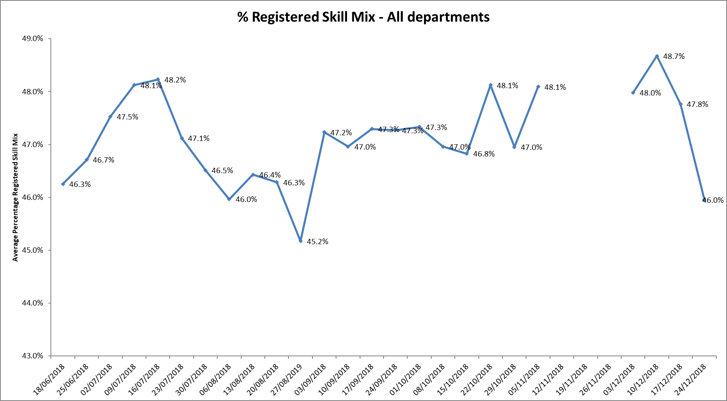

**Agency use**

The Trust moved to a new approach to reduce the use of unregistered agency staff in the week of 14.5.18. Further detail of this project is provided in the HR workforce report and commented on in relation to changes in skill mix ratios.

8th October – November 4th

The average weekly % agency use was 10.06%, a slight increase on 9.65% in the November report.

November 5th to December 2nd. Data is not available for the period

December 3rd to December 30th

The average agency use was at 10.55%.

This remains below the peak of 19.1% in February 2018.

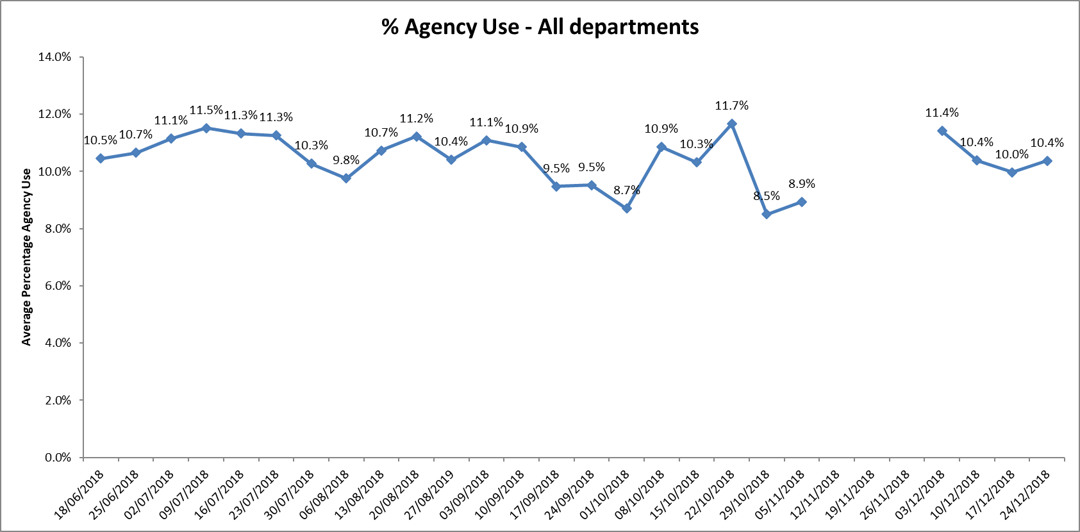

Adult wards Allen, Ashurst, Ruby, Sapphire, forensic wards Kestrel, Kingfisher and older adult ward Amber required high levels of agency staff in the period, this was related to sickness, vacancies and patient acuity

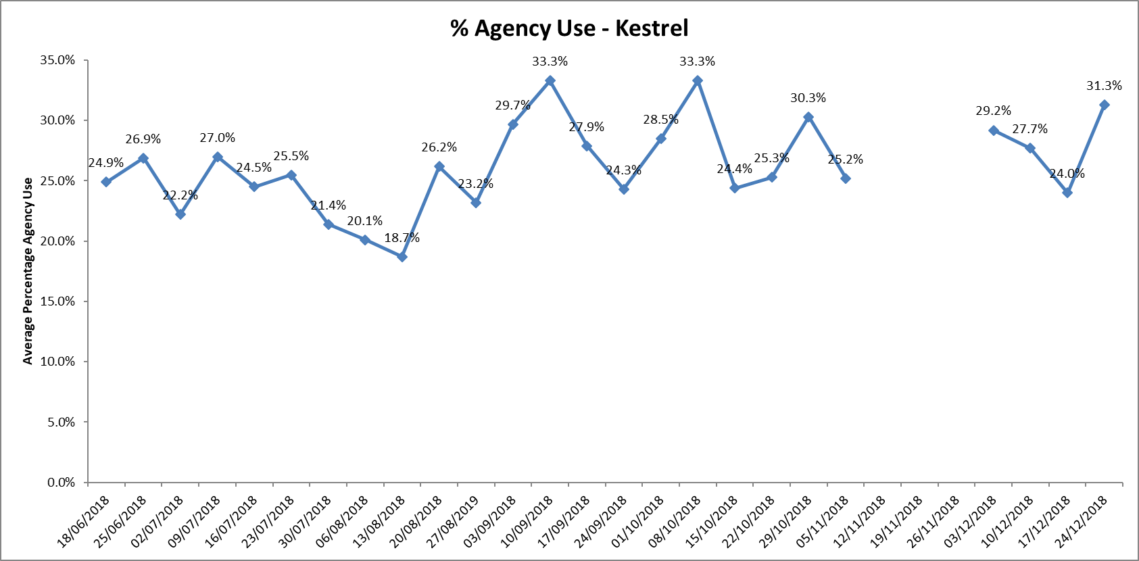

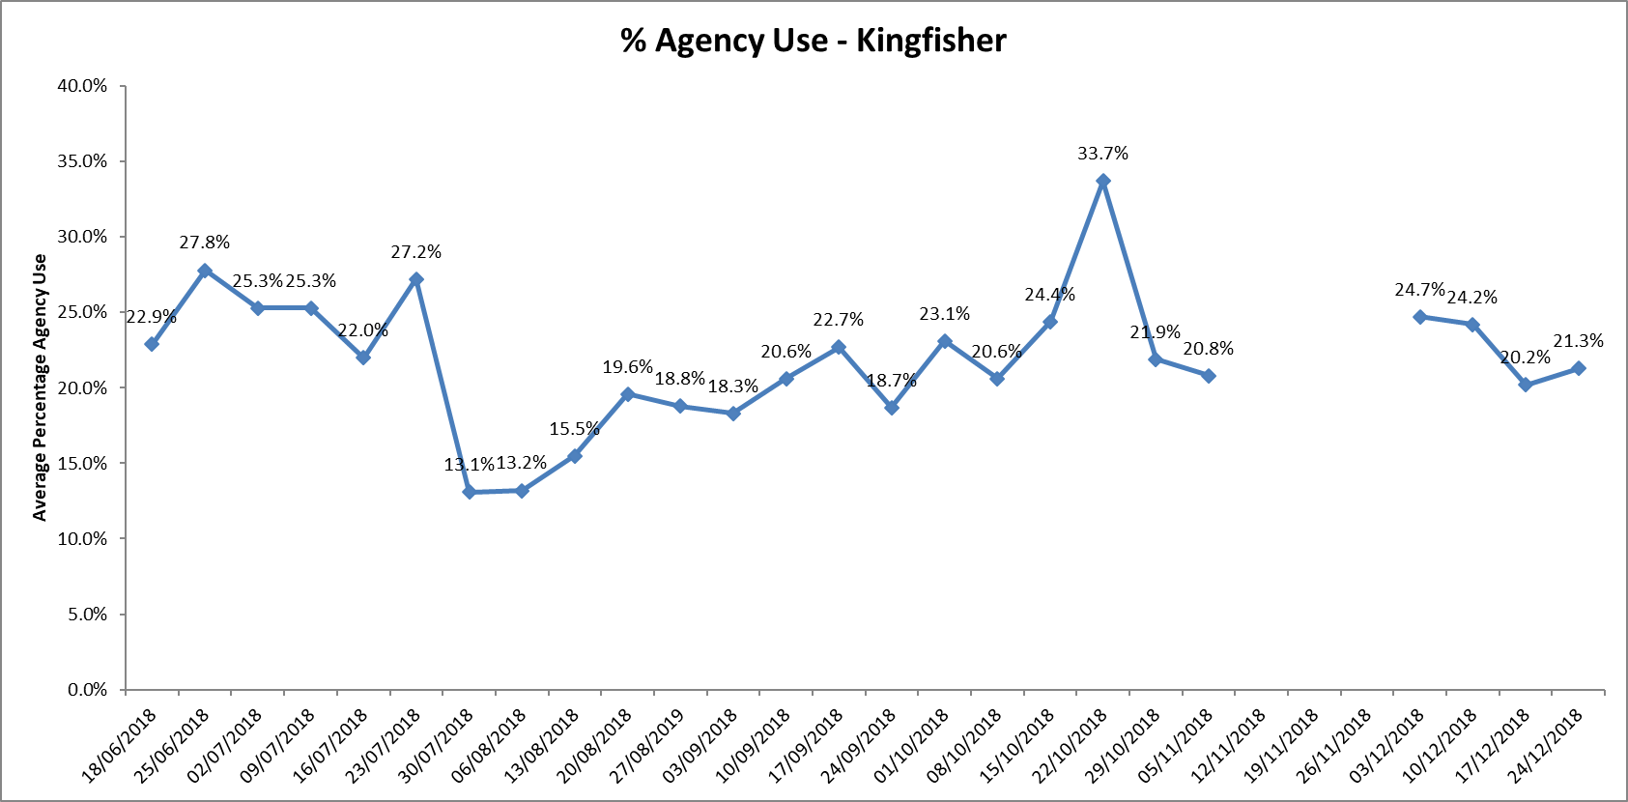

Further detail of agency use and spend is provided in the Workforce report.

**Maintaining Safer Staffing.**

**Community Hospitals.**

City ward

The ward was operating on reduced bed numbers to 12 from 20 to support safe staffing levels being maintained. This increased to 14 beds during the end to the period as part of systemwide winter planning work.

Oxfordshire Stroke Unit (Abingdon)

Some improvement has occurred in recruitment and student nurses working on the ward has supported overall staffing levels

An incentive initiative for additional hours is being developed to further support increased hours from substantive staff.

At time of reporting 144 beds across the community hospitals were open to support winter pressures and staffing

**Adult Wards**

Ashurst

The ward has continued high nursing vacancies, to support safe staffing the ward is now operating as male only and longline agency staffing is in place. In addition, there was increased use of unregistered staff at a time of increased acuity. Further work is planned to review the model of care for the ward.

Ashurst and Phoenix wards are co-located and staff work flexibly across to support patient needs on both wards. This is overseen by the Matron and ward managers for the wards. Twice daily conference calls for the adult wards are in place to support staffing across the wards when shifts cannot be filled with registered staff

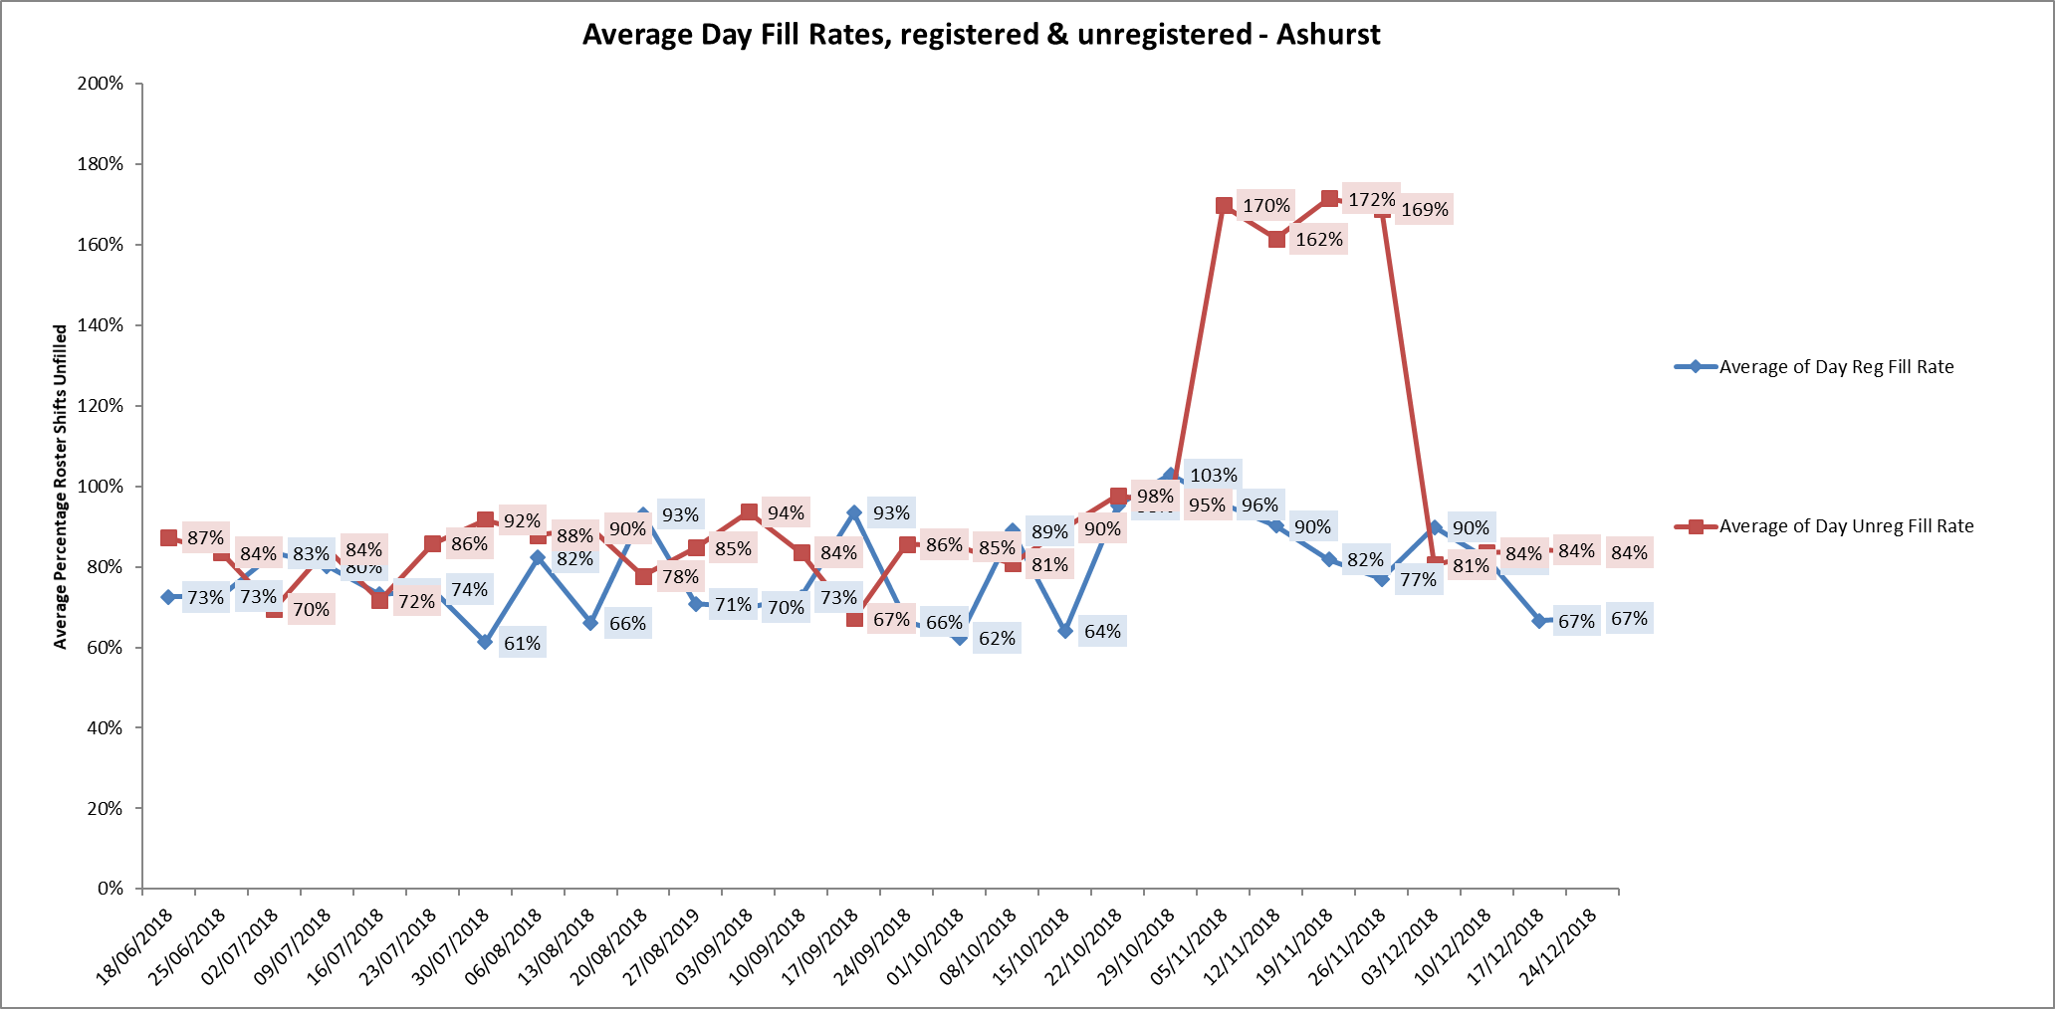

**Forensic wards**

All ten wards continued to be below average 50% skill mix registered nursing during this last period.

As reported in November vacancies continue to be high.

Kennet ward registered nurse skill mix data continues to have the lowest the average skill mix of all wards across the Trust. There has been recruitment to two band five posts who are newly qualified who started in September this leaves 5.7 WTE Band 5 vacancies against establishment of 10.92 WTE

Thames House (Kingfisher and Kestrel wards) has been reliant on long lines of agency to provide stability within the staffing and deliver a safe service. There have been long line agency staff that have worked full time within Thames house since 2015. Further work is being undertaken via the Executive team to review recruitment and retention initiatives.

**Workforce development update as part of the nursing strategy.**

Career pathways for nurses from band 2 through to Consultant Nurses**.**

1.New nursing leadership roles have been created in 2018.

* Deputy Director of Nursing Mental Health, Britta Klinck appointed.
* Nurse Consultant CAMHs Matt Kent appointed.
* Nurse Consultant Eating Disorders
* Nurse Consultant Urgent Care
* Physical Health Care Lead Nurse Bucks Alison Murray

These are in addition to the existing Nurse Consultant in Suicide Prevention Karen Lascelles.

2. Nurse Associate Trainees

The trust was part of the national Fast Follower Pilot of Associate Nurses in 2017 and 23 trainees are due to qualify and move into Band 4 Nurse Associate roles in April 2019.

The nursing associate is a new generic nursing role in England that bridges the gap between healthcare support workers and registered nurses, to deliver hands-on, person-centred care as part of the nursing team.

Nursing associates are members of the nursing team, who have gained a Nursing Associate Foundation Degree awarded by a Nursing and Midwifery Council (NMC) approved provider, typically involving two years of higher-level study.

The role has been introduced to help build the capacity of the nursing workforce and the delivery of high-quality care while supporting nurses and wider multidisciplinary teams to focus on more complex clinical duties. Nursing associates are subject to regulatory requirements such as revalidation and fitness to practise.

A second wave of trainees Nurse Associates recruitment was completed and a new cohort commenced October 2018 and further cohort of 60 is planned for May 2019. This recruitment includes external applicants.

These roles have been included in the skill mix review work that has occurred across the inpatients wards which is being finalised.

Skill Mix work in Out of Hours service

Towards the end of 2016 the Out of Hours (OoHs) service decided to recruit Band 7 Advanced Emergency Practitioners (AEPs) who would provide an additional experienced workforce to the team and be employed into dedicated shifts within OoHs.

AEPs can consult with an increased number and complexity of patients currently being managed by the Band 6 EPs.

This provides a career progression for EPs, including additional training and development and ensures the service has additional flexibility to cover shifts which would previously have been covered by GPs.

The service has also commenced the use of Emergency Nurse assistants in the evening and overnight period to undertake home visits within their competence.

Further work has been completed to propose changes to the skill mix in the Minor Injury Units to include Assistant Practitioners and Associate Nurses. It will also explore the possibility of implementing Band 7 Advanced Urgent Care Practitioners.

**Recruitment and retention**

1. The new Flyer programme commenced on 19.10.18 (for newly qualified Nurses and AHPs) with 72 staff in cohort One. Cohort Two will commence in March 2019 lead by new Preceptorship Lead Stephen Marcus. This is a Trust wide programme which will work alongside service level preceptorship and provide staff with opportunity to obtain masters level accreditation the end of the year programme. This is key retention initiative for nursing & AHPs.

2.Proactive student nurse recruitment continues following on from last year’s approach– working with the OUH and Oxford Brookes University. In November 2018 events were held to meet students from all nursing pathways and work towards providing them with a job offer to start post qualification in Summer 2019. To date this work and specific work in community nursing has resulted in 38 job offers for summer graduates

Further work was undertaken in January 2019 with University of Bedfordshire and 20 jobs offers made to mental health students.

A further Brookes event is planned for February 2019.

Resilience work in place for Forensic ward staff

A research approved Resilience programme has been running as a pilot within Forensic Services for Band 5 & 6 Nurses, which will help to inform the Trust with an ongoing strategy of support for our staff. Four cohorts are being currently delivered of a 6 Session Programme and during the 12 week programme, the Mentees are supported by Senior Nurse volunteers, Band 8 and above from outside of their Directorate

Cohorts 1 and 2 have been received well and are currently being evaluated the positive impact this has had upon attendees.

Evaluation to be completed with first two cohorts and plan to extend to other wards led by Senior Nursing Research Fellow Aim to improve resilience and staff wellbeing & retention.

Key priorities for Q 3& 4 2018/19

* Develop model of preceptorship for Nurse Associates post qualifying April 2019
* Continue proactive student nurse recruitment to other universities
* Implementation of skill mix remodelling work for inpatient wards
* Competency and skill mix work to be progressed by new leads within Learning & Development
* Continue to work with Executive on recruitment and retention work including overseas recruitment work and career clinics.

**Update on CHPPD**

The care hours per patient day (CHPPD) metric was developed to provide a consistent way of recording and reporting deployment of nursing staff providing care in inpatient ward settings.

From September 2018, for mental health and community trusts NHSI have extended the national CHPPD data collection to include all registered and non-registered AHPs**.** The monthly nursing CHPPD data will be published on My NHS and NHS Choices, the trust’s November 2018 CHPPD data for will be published on these platforms on 31 January 2019.

**Conclusion**

All ward staff and managers continue to make every effort to ensure wards continue to be staffed safely, fill rates remain high for most wards and that we continue to focus efforts on retaining our staff whilst recruiting new nurses to join Oxford Health FT. Skill mix review work as reported last month will be progressed to include Nurse associates and other roles.

**All Metrics Period 8th October to 4th November 2018**



