

# Report to the Meeting of the

# Oxford Health NHS Foundation Trust

**BOD 139/2018**

(Agenda item: 8)

# Board of Directors

# 30th November 2018

# INPATIENT SAFER STAFFING Report Period 10th September to 7th October 2018

**For: Information**

**Executive Summary**

**Ward Staffing**

The purpose of this paper is to provide a report of the actual inpatient staffing levels to the Board of Directors. There is a national requirement on providers to be transparent in our monitoring and reporting of inpatient staffing levels and the impact on patient care. Ensuring sufficient staffing levels are in place is crucial to deliver safe, effective and high quality care. This report will be published on our website with a link from NHS Choices website.

The data within the report will outline the staffing levels (for both registered and unregistered nursing staff) on each ward. These figures will be measured against the required figures on a shift by shift basis for the 4 week period 10th September to 7th October 2018.

During this period:

Average weekly day shifts fill rates for registered staff & unregistered staff were above the Trust target of 85% with 92% or above for unregistered and 96% or above for registered staff, an increase from the last period. Eight wards were below 85% target for average weekly fill rates for registered nurse day shifts during this period. A decrease from eleven wards in the previous reporting period.

Average weekly night shifts fill rates for registered and unregistered were above the Trust target of 85% with the average lowest fill rate at 94% for unregistered staff and remained above 100% for registered staff for each week.

The methods of filling these shifts includes substantive, flexible workers and agency registered staff and further detail in provided later in the report.

The Trust moved to a new approach to reduce the use of unregistered agency staff in the week of 14.5.18. Further detail of this project is provided in the HR workforce report and commented on in relation to changes in skill mix ratios.

The average weekly % agency use was 9.65% a decrease from 10.4% in the October report with a peak of 10.9% in the week 10.09.18 reducing to 8.7% in the week of 01.10.18.

Average sickness rates for ward staff were increased to 5.6% increased from 5.4% average last month.

This paper will provide an update on CHPPD reporting requirements.

**Recommendations**

The Board is asked to note:

* There are processes in place to ensure safe staffing levels on all the wards in the organisation, those wards where there are concerns and the actions being taken to ensure safe staffing including project work and wider recruitment and retention work. There are no exceptions to report that directly link actual staffing levels to adverse outcomes for patients which have been identified through our Governance Structures.

**Author and Title:** Kate Riddle, Deputy Director of Nursing and Clinical Standards

**Lead Executive Director:** Ros Alstead, Director of Nursing and Clinical Standards

*A risk assessment has been undertaken around the legal issues that this paper presents and there are no issues that need to be referred to the Trust Solicitors. This paper links to all the five CQC Domains.*

***Strategic Objectives*** *– this report relates to or provides assurance and evidence against the following Strategic Objective(s) of the Trust*

*Driving Quality Improvement (Goals: patients will be safe from harm; patients will achieve the clinical outcomes they want; and patients and carers will have an excellent experience)*

*Delivering Operational Excellence (Goals: our services will be effective and efficient; information will be translated into knowledge; and our planned surplus will be delivered)*

**Inpatient Safer Staffing**

Period 10th September to 7th October 2018.

**Introduction**

This is the report to the Board of Directors outlining the staffing levels (registered and unregistered) on each ward against their required need on a shift by shift basis. This report covers the four week period 10th September to 7th October 2018.

This report will focus on the percentage of day and night fill rates for registered and unregistered staff. This data is reported to NHSI and provides assurance of actual clinical staffing numbers being achieved. This report will be published on our website with a link from NHS Choices website.

**Management of Staffing Levels**

Anescalation process for the management of staff shortages is in place within each clinical area, to manage staffing safely on a shift by shift basis. As part of this process, senior clinical staff are providing appropriate support to ward teams as and when required. In addition, senior ward staff and immediate team managers review ward staffing levels on an on-going basis; shift by shift basis, and where there are changes in patient acuity. Ward Matrons review staffing daily as a minimum and more frequently where required.

In-patient staffing levels continue to be reported every week and discussed within the Weekly Review Meeting (WRM), which takes place each Monday morning with the Director of Nursing and or Deputy present.

To ensure that staffing levels are under continual review, every ward undertakes a range of immediate actions daily to ensure safe staffing levels are maintained appropriate to the needs of patients. These actions include booking staff via staffing solutions via bank or agency, revising rotas, moving staff between wards and utilising additional staff that are not included in the ward numbers as required for example modern matrons.

**Summary position of inpatients wards staffing levels.**

Appendix 1 shows the staffing levels for all wards by ward for the four week period 10th September to 7th October 2018. The data presented includes details of staffing by shifts and details of skill mix, agency, ward staff sickness and ward vacancy figures. The thresholds presented in the table are measured against trust/ national targets and used to highlight particular wards for further review.

During this period:

During this period:

Average weekly day shifts fill rates for registered staff & unregistered staff were above the Trust target of 85% with 92% or above for unregistered and 96% or above for registered staff, an increase from the last period. Eight wards were below 85% target for average weekly fill rates for registered nurse day shifts during this period. A decrease from eleven wards in the previous reporting period.

Average weekly night shifts fill rates for registered and unregistered were above the Trust target of 85% with the average lowest fill rate at 94% for unregistered staff and remained above 100% for registered staff for each week.

The methods of filling these shifts includes substantive, flexible workers and agency registered staff and further detail in provided later in the report.

The Trust moved to a new approach to reduce the use of unregistered agency staff in the week of 14.5.18. Further detail of this project is provided in the HR workforce report and commented on in relation to changes in skill mix ratios.

The average weekly % agency use was 9.65% a decrease from 10.4% in the October report with a peak of 10.9% in the week 10.09.18 reducing to 8.7% in the week of 01.10.18.

Average sickness rates for ward staff were increased to 5.6% increased from 5.4% average last month.

There are processes in place to ensure safe staffing levels on all the wards in the organisation, those wards where there are concerns and the actions being taken to ensure safe staffing including project work and wider recruitment and retention work. There are no exceptions to report that directly link actual staffing levels to adverse outcomes for patients which have been identified through our Governance Structures.

**Day shifts fill rates**

Average weekly day shifts fill rates (all departments) for registered nurse & unregistered staff were above the Trust target of 85% throughout this period. This included a mix of agency, flexible and substantive staff including ward managers and matrons where required to make up staffing numbers and provide safe care.

Eight wards were below 85% target for average weekly fill rates for registered nurse day shifts during this period these were:

Amber, Ashurst, Cotswold House Oxford, City, Ruby, Sandford, Wensric and Wintle.

A decrease from eleven wards in the previous reporting period.

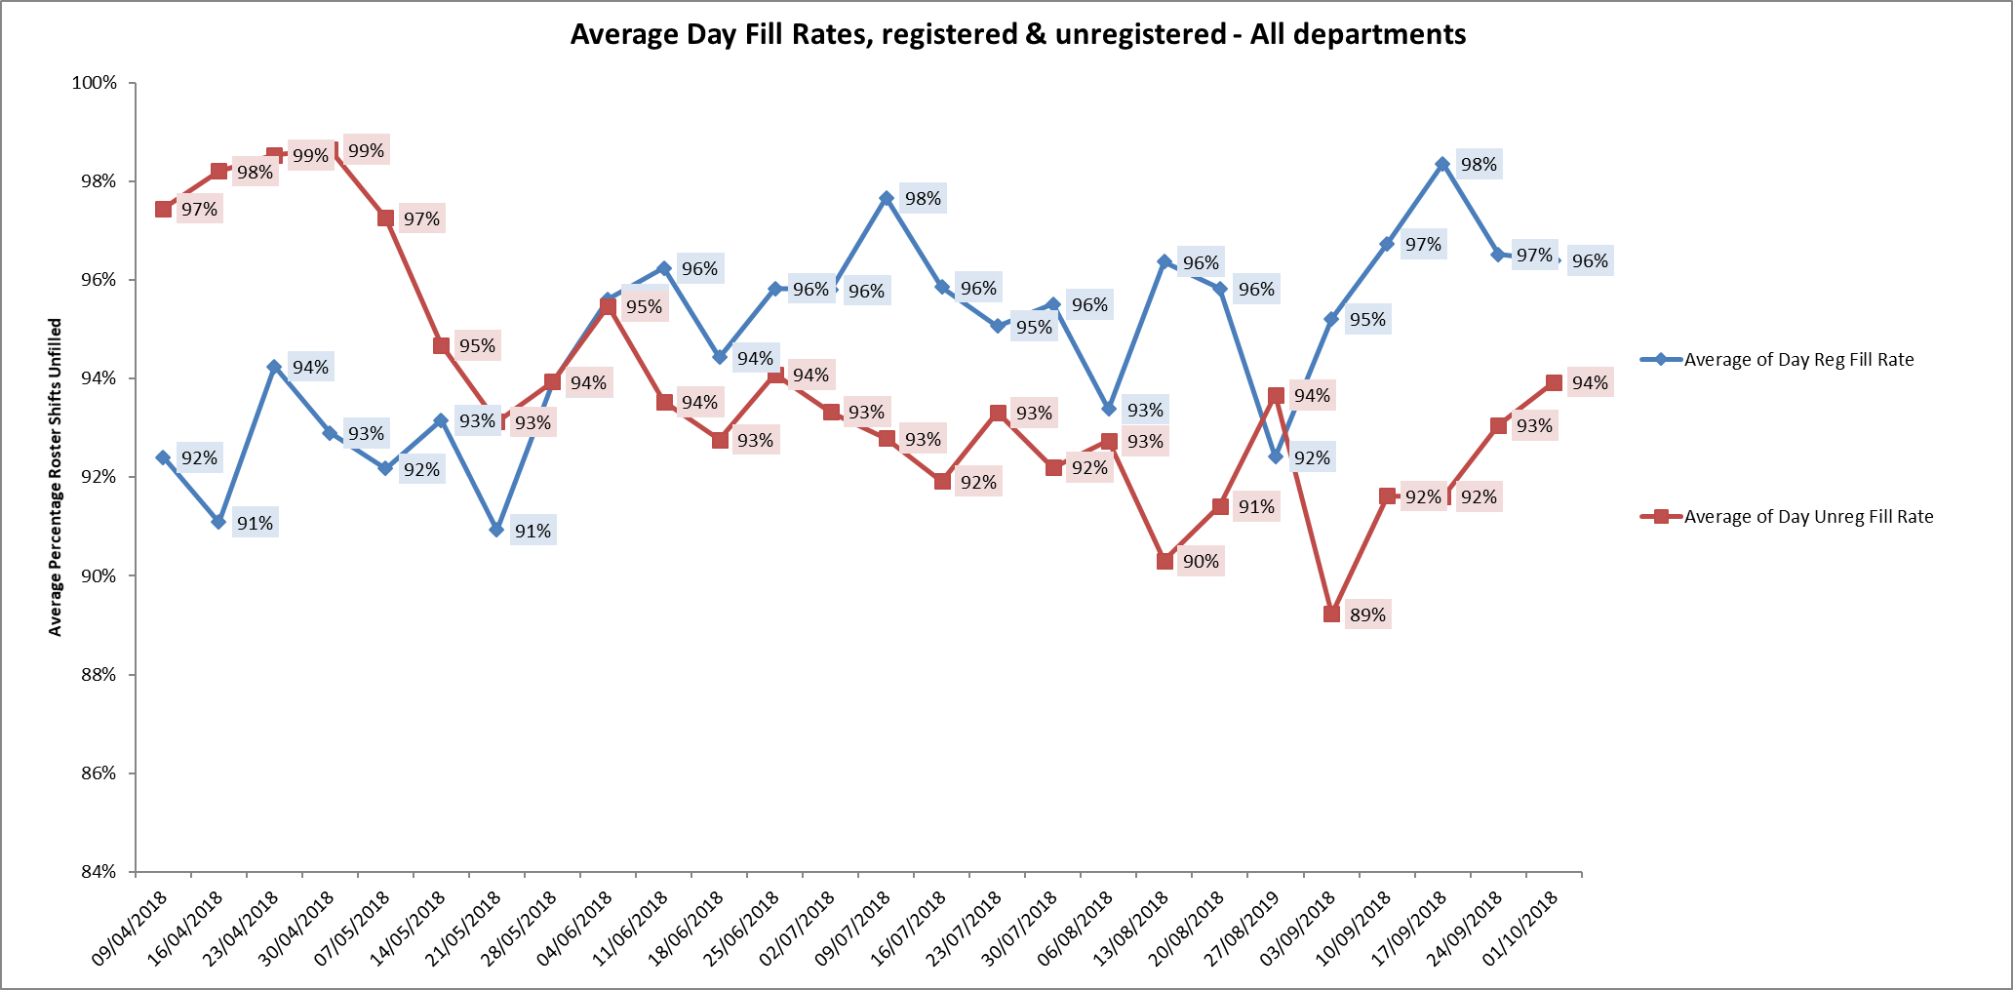

**Night shift fill rates**

Average weekly night shifts fill rates for registered nurse & unregistered staff were above the Trust target of 85% throughout this period. This included a mix of agency, flexible and substantive staff to make up staffing numbers. Three wards were below 85% for registered nurses. Ashurst, Glyme and Wenrisc. The unregistered fill rates for these wards were 88%, 128% and 88% respectively.

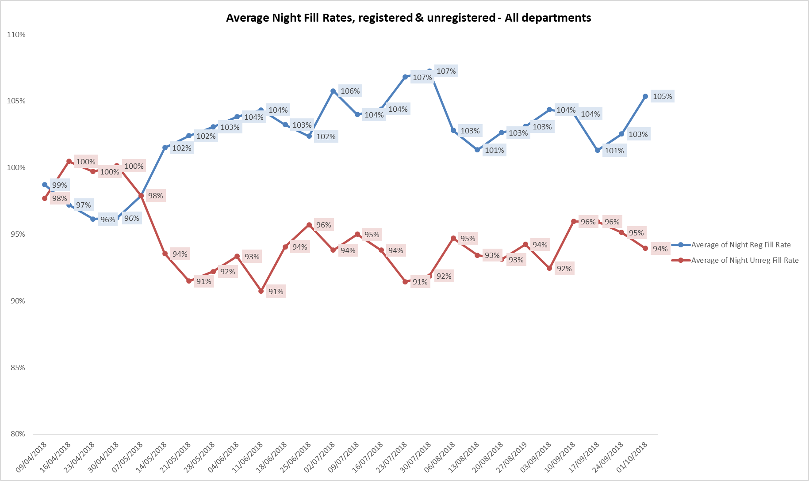

**Registered skill mix**

Fourteen wards had in place an average of 50% or above registered staff skill mix. The level of wards with below 50% registered skill mix is related to the continued registered nurse vacancies. Safe staffing is supported by the ward managers and matrons on the ward working clinically as part of the numbers where required to ensure registered nursing leadership is maintained.

Skill mix is achieved through use of our own staff and trust employed flexible registered workers and agency registered nurses.

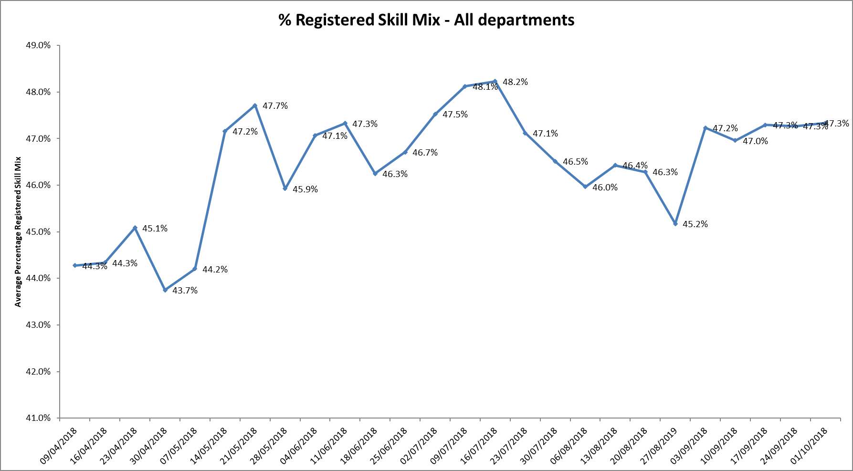

**Agency use**

The reduction in agency use continues from peak of 19.1% in February 2018.

The average weekly % agency use was 9.65% a decrease from 10.4% in the October report with a peak of 10.9% in the week 10.09.18 and decreased to 8.7% in the week of 01.10.18.

Further detail of agency use is provided in the Workforce report.

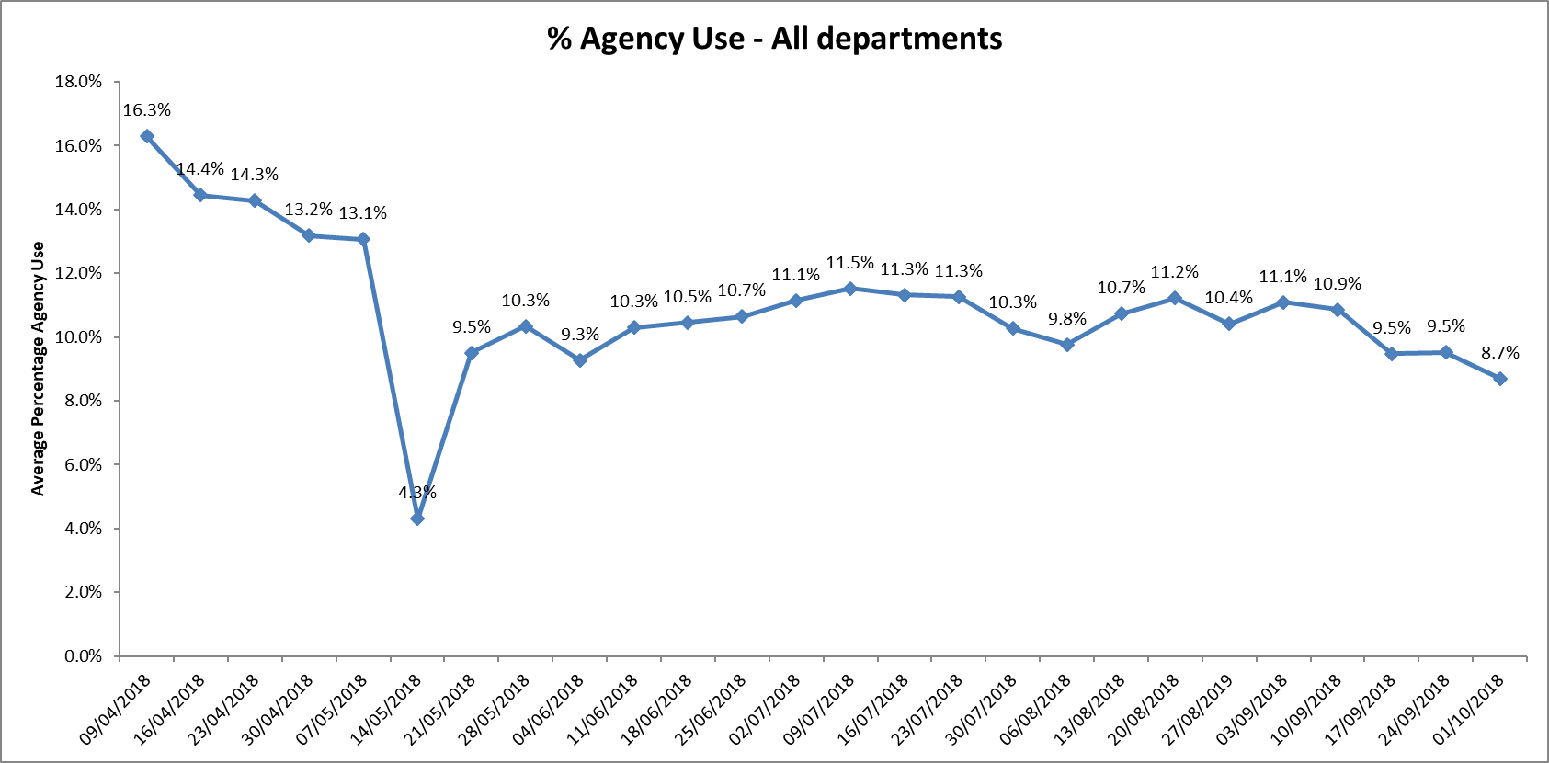

Thirteen wards were below trust target of 5% in this period an increase from ten wards in the last period.

Nineteen wards required between 5-25% agency staff.

Two wards Kestral and Allen ward required above 25% agency staff in the period, this was related to sickness, vacancies and patient acuity

**Maintaining Safer Staffing.**

**Community Hospitals.**

All eight wards: Abbey ward & Stroke Rehabilitation Unit (OSRU) at Abingdon, Bicester, City, Didcot, Linfoot, Wenrisc and Wallingford maintained above average 50% skill mix for this period.

Bed numbers have been at Bicester and OSRU reduced to manage safer staffing in the context of vacancies as outlined below:

There has been some improvement in recruitment at OSRU in November with two RGNs appointed.

City ward has experienced an improvement in fill rates for registered nurse day shifts in the last week of this period to 72% but remained below target of 85%. This is related to increased sickness rates and 6.31WTE registered nurse vacancies.

The ward is operating on reduced bed numbers to 12 from 20 to support safe staffing levels being maintained. There are additional unregistered staff in place and two Nursing Associates and 3rd Year students.

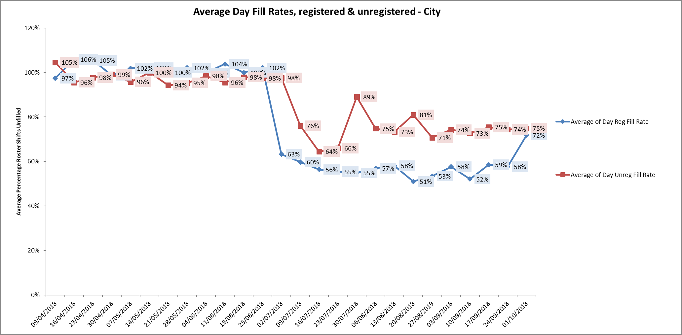

**Children and young peoples and adult eating disorders**

Cotswold House Oxford skill mix has improved from the last report, but registered nurse fill rates are below 85% target agency usage as the Matron is managing staffing with increased bank or substantive HCAs where possible to maintain staffing continuity for the patients.

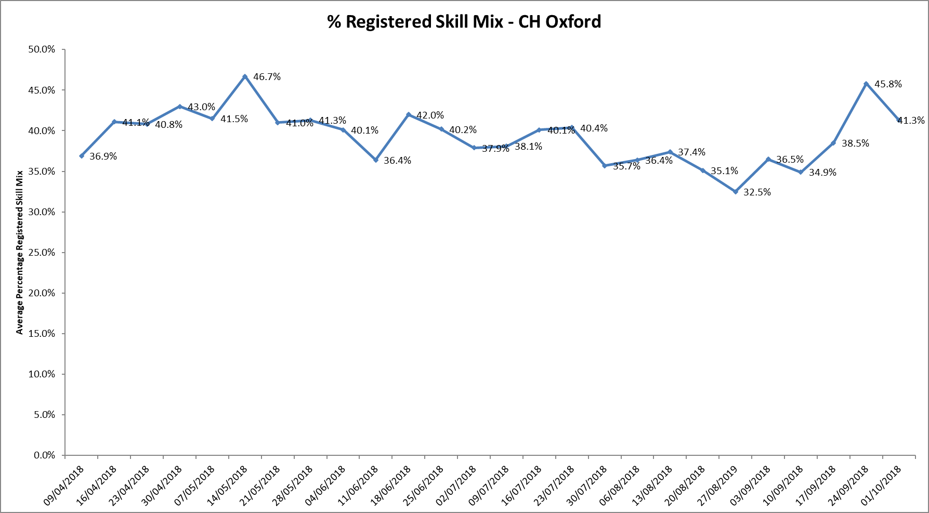

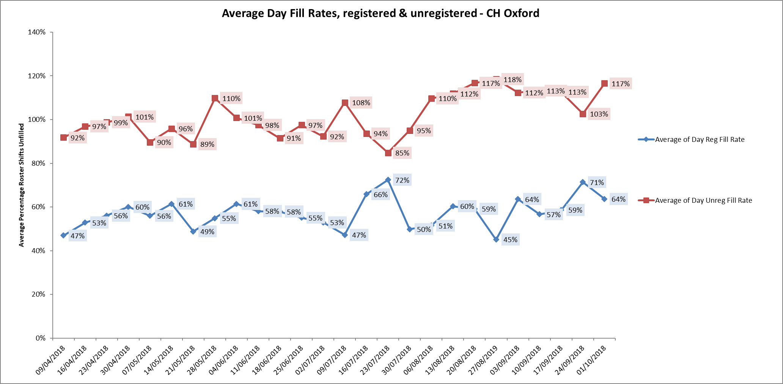

**Adult Wards**

Ashurst

The fill rates for registered nurses fluctuated during this four week period as demonstrated below. The ward has continued high nursing vacancies, to support safe staffing the ward is now operating as male only and longline agency staffing is in place.

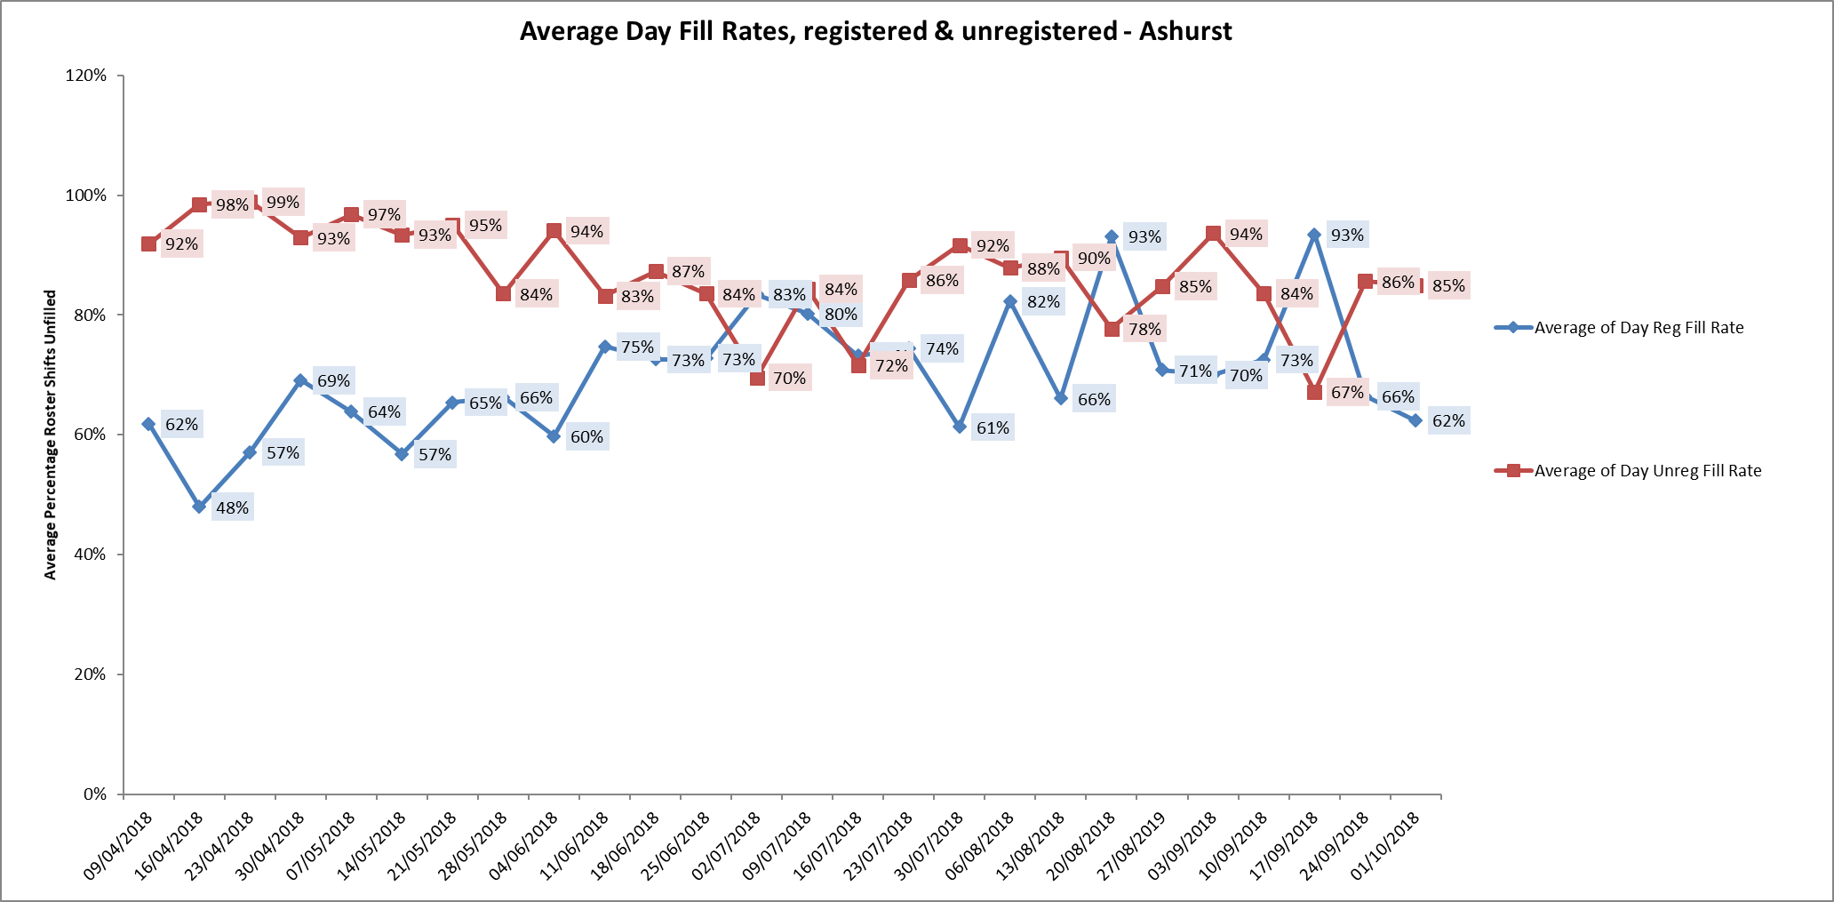

Phoenix ward.

Fill rates and sickness rates have improved during this period, there are four substantive Band 5s in post with two newly qualified staff joining in September, but there are continued vacancies on this ward. Several longline agency nurses are in post to provide consistency of staffing. The consultant vacancy has been recruited to and a locum is in place in the meantime.

Ashurst and Phoenix wards are co-located and staff work flexibly across to support patient needs on both wards. This is overseen by the Matron and ward managers for the wards. Twice daily conference calls for the adult wards are in place to support staffing across the wards when shifts cannot be filled with registered staff.

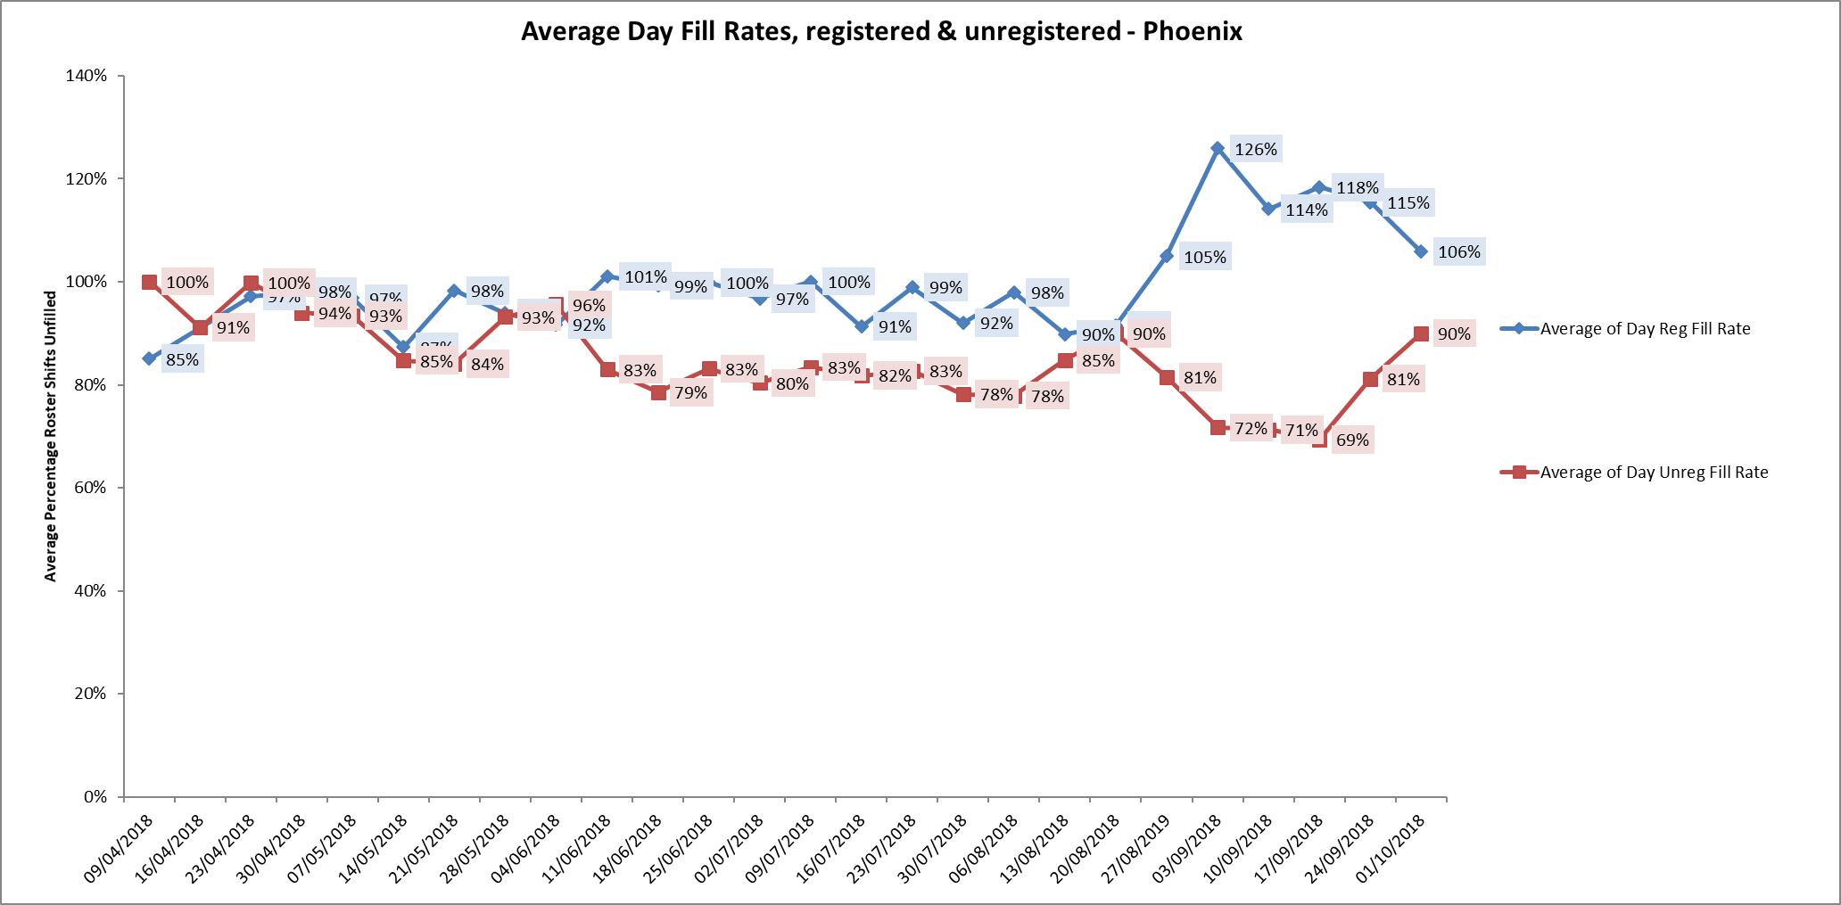

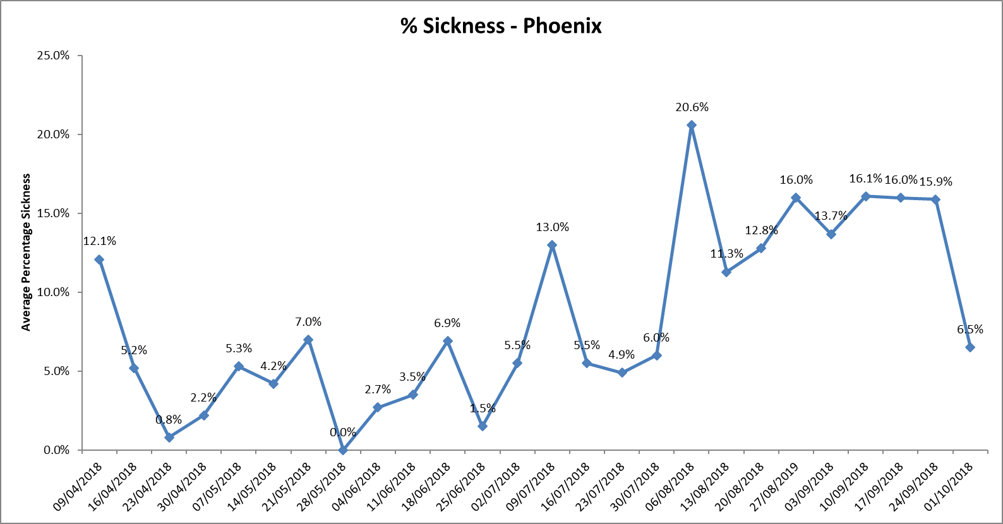

**Older Adult wards**

Cherwell and Sandford maintained above 50% skill mix for the whole period and with fill rates above 85%.

Amber Ward had increased levels of sickness and agency use during this period

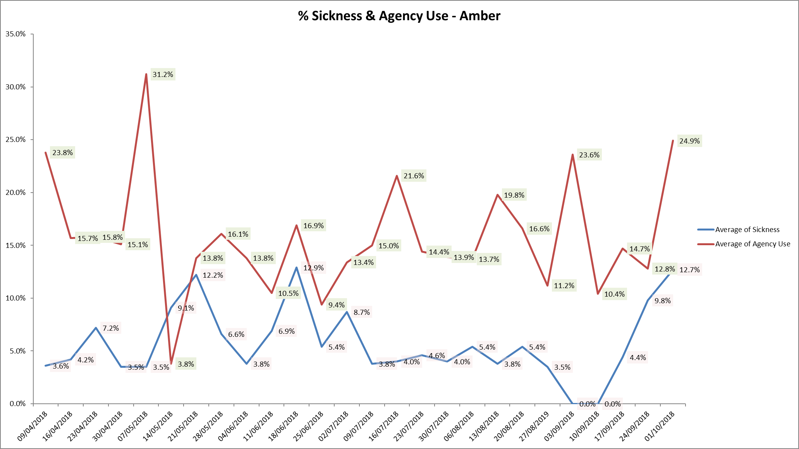

**Forensic wards**

All ten wards continued to be below average 50% skill mix registered nursing during this last period.

As reported last month vacancies continue to be high.

Kennet ward registered nurse skill mix data continues to have the lowest the average skill mix 32% of all wards across the Trust. There has been recruitment to two band five posts who are newly qualified who started in September this leaves 5.7 WTE Band 5 vacancies against establishment of 10.92 WTE

Fill rates were above 89% for both registered and unregistered staff.

A research approved Resilience programme has been running as a pilot within Forensic Services for Band 5 & 6 Nurses, which will help to inform the Trust with an ongoing strategy of support for our staff. Four cohorts are being currently delivered of a 6 Session Programme and during the 12 week programme, the Mentees are supported by Senior Nurse volunteers, Band 8 and above from outside of their Directorate

Cohorts 1 and 2 have been received well and are currently being evaluated the positive impact this has had upon attendees.

**Evenlode**

Agency use decreased during this period one patient required an alternative placement and this was esclated with NHSE. The patient was able to move to the alternative placement in the week of the 17/09/18. Sickness rates have decreased overall.

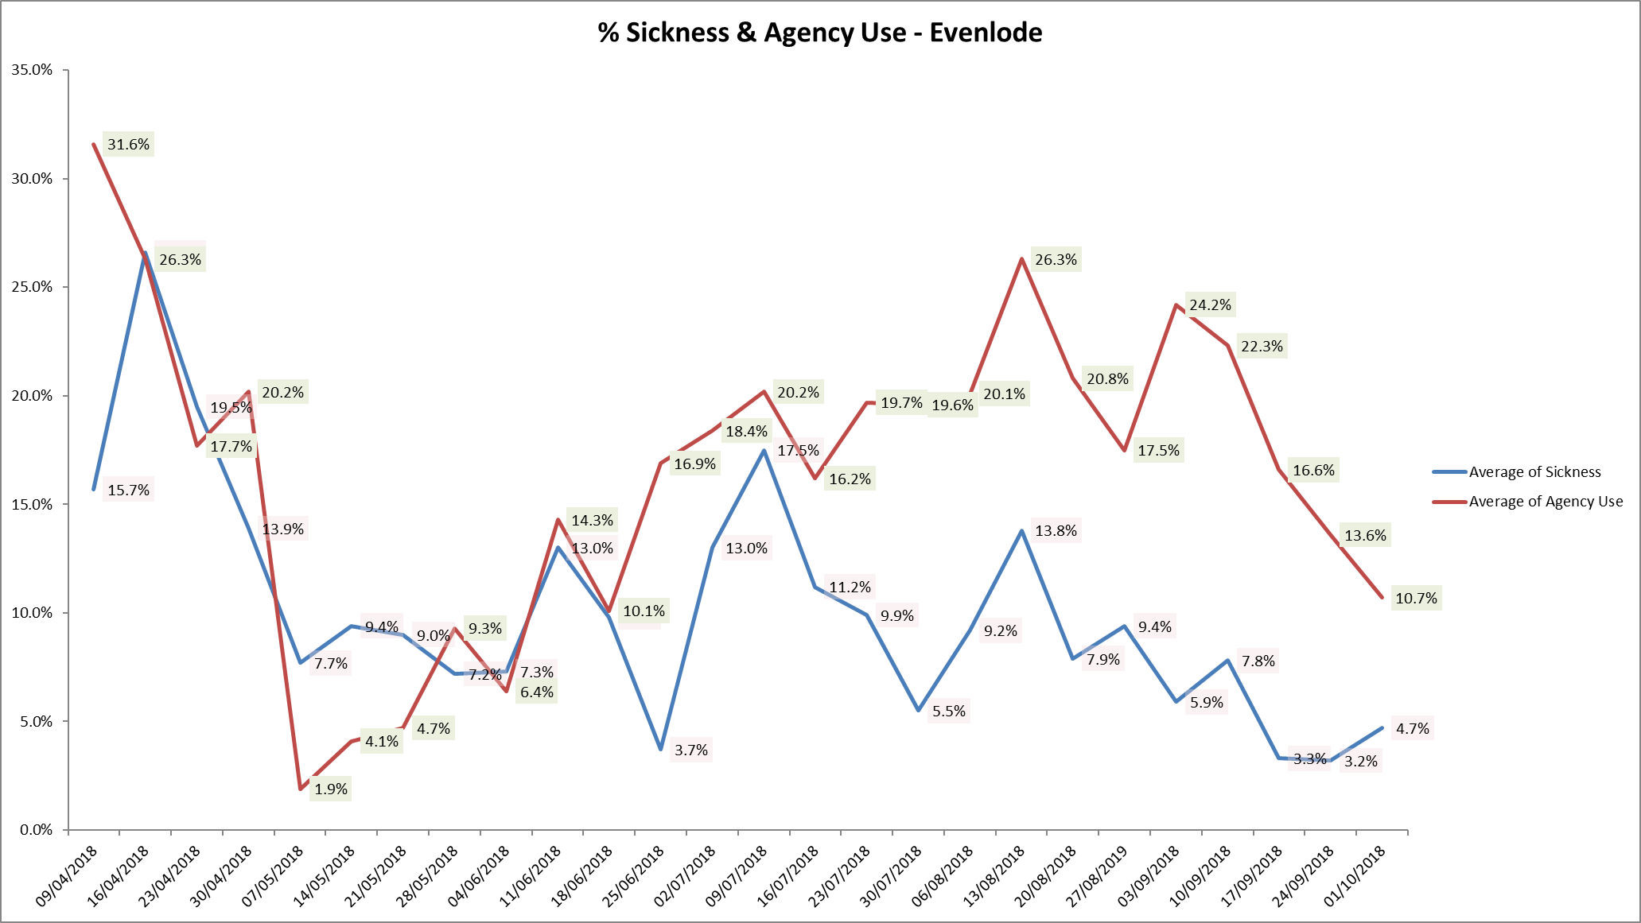

**Update on CHPPD**

The care hours per patient day (CHPPD) metric was developed to provide a consistent way of recording and reporting deployment of nursing staff providing care in inpatient ward settings.

From September 2018, for mental health and community trusts NHSI have extended the national CHPPD data collection to include all registered and non-registered AHPs**.** The monthly nursing CHPPD data will be published on My NHS and NHS Choices, the trust’s November 2018 CHPPD data for will be published on these platforms on 31 January 2019.

**Conclusion**

All ward staff and managers continue to make every effort to ensure wards continue to be staffed safely, fill rates remain high for most wards and that we continue to focus efforts on retaining our staff whilst recruiting new nurses to join Oxford Health FT. Skill mix review work as reported last month will be progressed to include Nurse associates and other roles.

**Appendix One All Metrics Period 10th September to 7th October 2018**

