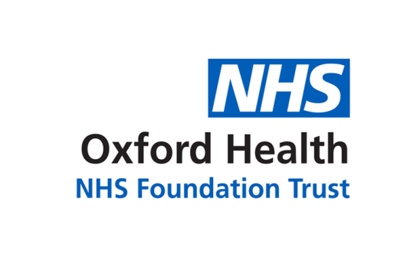

# Report to the Meeting of the

**BOD 75/2019**

(Agenda item: 7)

# Oxford Health NHS Foundation Trust

# Board of Directors

**24 July 2019**

**Human Resources Report**

**For: Information**

This report accompanies the slide pack showing the HR KPIs. It includes brief details of actions already in place to address some of the challenges as well as plans being developed.

**Recruitment**

Good feedback received from July’s Advert Writing course. Further sessions are scheduled.

Presentation on NHS careers delivered at the EMBS Community College in Oxford. Work continues with the Job Centre and Activate Learning in Oxford to promote NHS careers.

**Temporary Staffing**

NHSI Agency rule overrides decreased to 882. There were 431 grade swops. 145 Thornbury Shifts were used – the lowest in 6 months and the 3rd consecutive month-on-month decline.

**Sickness**

Virtually unchanged from last month but higher than the same period last year.

**Turnover**

Reduced marginally from last month and is lower than the same period last year.

**Vacancy Rate**

Unchanged from last month and is lower than the same period last year.

**Health & Wellbeing**

Employee Assistance Programme now out to tender. Expected launch by October 2019.

**Recommendation**

To note the report for information.

**Author and Title:**

Simon Denton (Head of HR Operations)

**Lead Executive Director:**

Tim Boylin