

# Report to the Meeting of the

# Oxford Health NHS Foundation Trust

**BOD 76/2019**  
(Agenda item: 8)

# Board of Directors

# 24th July 2019

# INPATIENT SAFER STAFFING Report Period 22nd April 2019 to 16th June 2019

**For: Information**

**Executive Summary**

**Ward Staffing**

The purpose of this paper is to provide the Trust Board with an interim exception report in line with the requirements of: “How to ensure the right people with the right skill are in the right place at the right time”, Chief Nursing Officer for England & National Quality Board November 2013. From June 2014 there has been a Department of Health requirement for trust boards to receive monthly updates on ward staffing levels. Ensuring sufficient staffing levels are in place is crucial to deliver safe, effective and high-quality care. This report will be published on our website with a link from NHS Choices website.

The data within the report will outline the staffing levels (for both registered and unregistered nursing staff) on each ward. These figures will be measured against the required figures on a shift by shift basis for the period 22nd April 2019 to 16th June 2019 (two months roster periods) in line with the requirements of the DH Unify reporting process and the data extract is attached (Appendix 1).

During this period:

Average weekly day shifts fill rates for registered staff & unregistered staff were above the Trust target of 85% with 92% or above for unregistered and 93% or above for registered staff.

Nine wards were below 85% target for average weekly fill rates for registered nurse day shifts during some of this period. The wards were Cherwell, Sandford, Vaughn Thomas, Ashurst, Highfield, Cotswold House Oxford, Watling and Wenrisc. City ward closed temporarily during this period on 31/5/19.

Average weekly night shifts fill rates for registered and unregistered for all wards apart from Ashurst 76% in the first period Watling 81% and Wenrisc 77% in the second period were above the Trust target of 85% with the average lowest fill rate at 91% for unregistered staff and remained above 100% for registered staff for each week.

The methods of filling these shifts includes substantive, flexible workers and agency registered staff and further detail in provided later in the report.

The average weekly % agency use was 9.8% a reduction from 11.3% in the last reporting period.

Average sickness rates for ward staff were 6.23% an increase from 5.575% last month.

This report also includes an update on the skill mix and staffing establishment reviews undertaken across all inpatients wards during 2018/19.

**Recommendations**

The Board is asked to note:

* There are processes in place to ensure safe staffing levels on all the wards in the organisation, those wards where there are concerns and the actions being taken to ensure safe staffing including project work and wider recruitment and retention work. There are no exceptions to report that directly link actual staffing levels to adverse outcomes for patients which have been identified through our Governance Structures.

**Author and Title:** Kate Riddle, Deputy Director of Nursing and Clinical Standards

**Lead Executive Director:** Marie Crofts Chief Nurse

*A risk assessment has been undertaken around the legal issues that this paper presents and there are no issues that need to be referred to the Trust Solicitors. This paper links to all the five CQC Domains.*

***Strategic Objectives*** *– this report relates to or provides assurance and evidence against the following Strategic Objective(s) of the Trust*

*Driving Quality Improvement (Goals: patients will be safe from harm; patients will achieve the clinical outcomes they want; and patients and carers will have an excellent experience)*

*Delivering Operational Excellence (Goals: our services will be effective and efficient; information will be translated into knowledge; and our planned surplus will be delivered)*

**Inpatient Safer Staffing**

Period 22nd April 2019 to 16th June 2019.

**Introduction**

This is the report to the Board of Directors outlining the staffing levels (registered and unregistered) on each ward against their required need on a shift by shift basis. These figures will be measured against the required figures on a shift by shift basis for the period 22nd April 2019 to 16th June 2019 (two months roster periods)

This report will focus on the percentage of day and night fill rates for registered and unregistered staff. This data is reported to NHSI and provides assurance of actual clinical staffing numbers being achieved. This report will be published on our website with a link from NHS Choices website.

**Management of Staffing Levels**

Anescalation process for the management of staff shortages is in place within each clinical area, to manage staffing safely on a shift by shift basis. As part of this process, senior clinical staff are providing appropriate support to ward teams as and when required. In addition, senior ward staff and immediate team managers review ward staffing levels on an on-going basis; shift by shift basis, and where there are changes in patient acuity. Ward Matrons review staffing daily as a minimum and more frequently where required.

In-patient staffing levels continue to be reported every week and discussed within the Weekly Review Meeting (WRM), which takes place each Monday morning with the Director of Nursing and/or Deputy present. To ensure that staffing levels are under continual review, every ward undertakes a range of immediate actions daily to ensure safe staffing levels are maintained appropriate to the needs of patients. These actions include booking flexible or agency staff via Staffing Solutions, revising rotas, moving staff between wards and utilising additional staff that are not included in the ward numbers as required for example modern matrons.

**Summary position of inpatients wards staffing levels.**

Appendix 1 shows the staffing levels for all wards by ward for the period 22nd April 2019 to 16th June 2019. The data presented includes details of staffing by shifts and details of skill mix, agency, ward staff sickness and ward vacancy figures. The thresholds presented in the table are measured against trust/ national targets and used for exception reporting.

During this period:

**Day shifts fill rates**

Average weekly day shifts fill rates for registered staff & unregistered staff were above the Trust target of 85% with 92% or above for unregistered and 93% or above for registered staff. This included a mix of agency, flexible and substantive staff including ward managers and matrons where required to make up staffing numbers and provide safe care.

Nine wards were below 85% target for average weekly fill rates for registered nurse day shifts during some of this period. The wards were Cherwell, Sandford, Vaughn Thomas, Ashurst, Highfield, Cotswold House Oxford, Watling and Wenrisc. City ward closed temporarily during this period on 31/5/19.

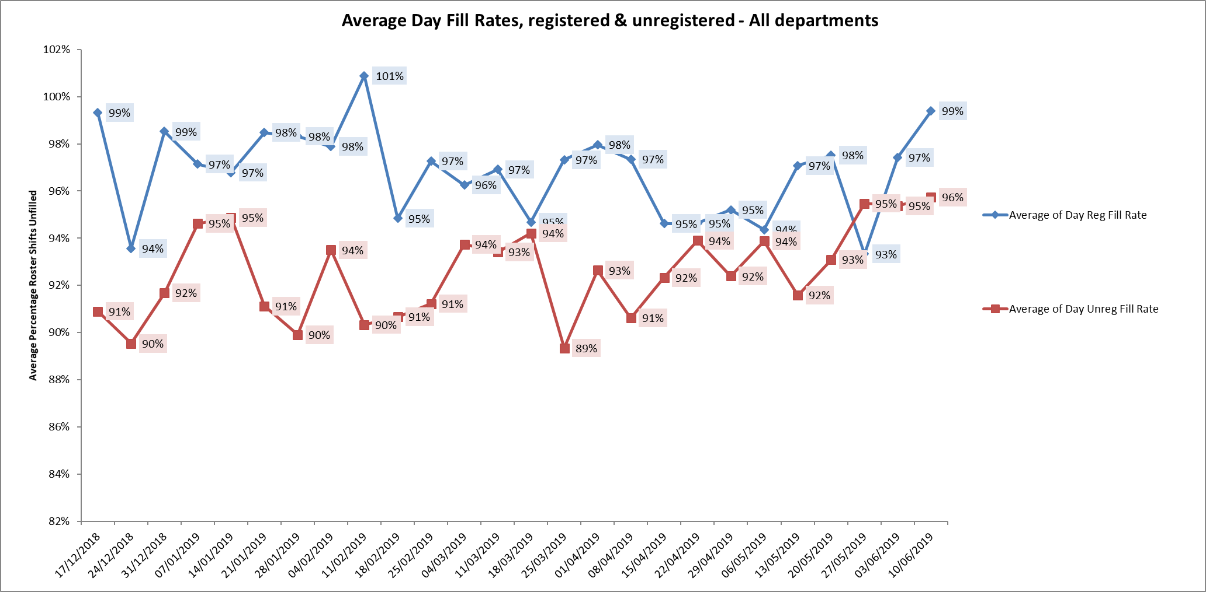

**Night shift fill rates**

Average weekly night shifts fill rates for registered and unregistered for thirty wards were above the Trust target of 85% with the average lowest fill rate at 91% for unregistered staff and remained above 100% for registered staff for each week. Three wards were below 85% Ashurst 76% in the first period, Watling 81% and Wenrisc 77% in the second period

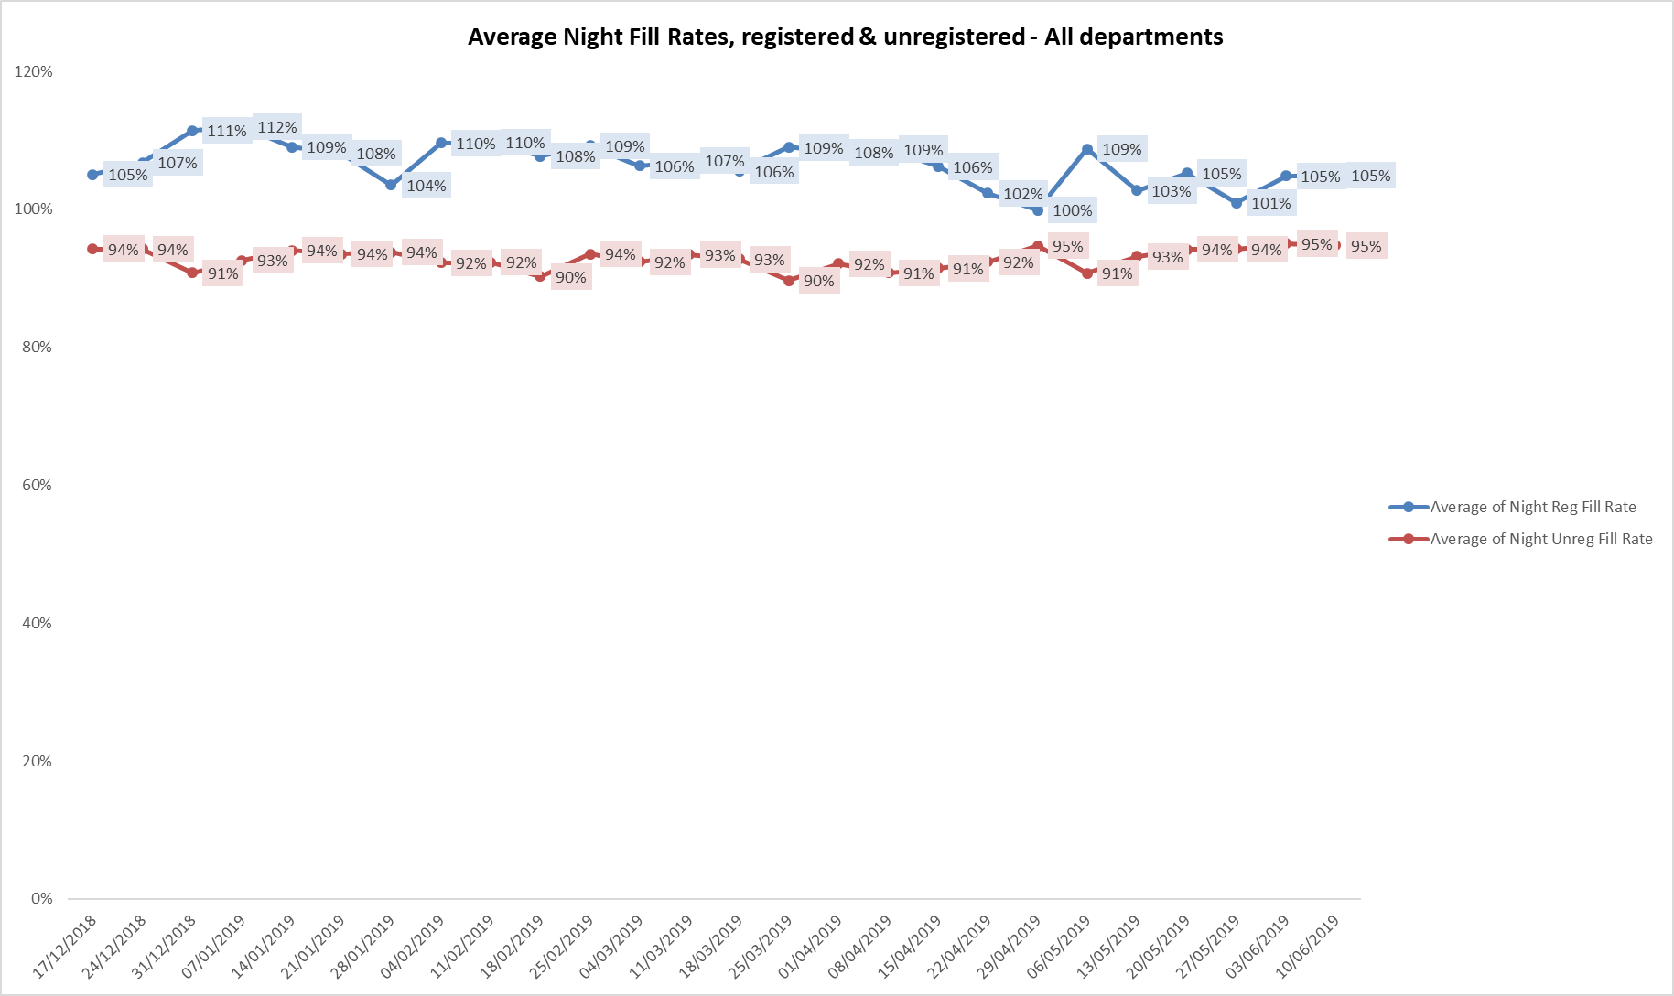

**Registered skill mix**

In the period 22nd April to May 19th

Eight wards had in place an average of 50% or above registered staff skill mix. Two wards had below 35% skill mix these were forensic wards Kennet and Kestrel.

In the period 20th May to 16th June:

Eleven wards had in place an average of 50% or above registered staff skill mix, no wards were below 35%.

For those wards with below 50% registered skill mix, this is related to the continued registered nurse vacancies. Safe staffing is supported by the ward managers and matrons on the ward working clinically as part of the numbers where required to ensure registered nursing leadership is maintained.

Skill mix is achieved through use of our own staff and trust employed flexible registered workers and agency registered nurses.

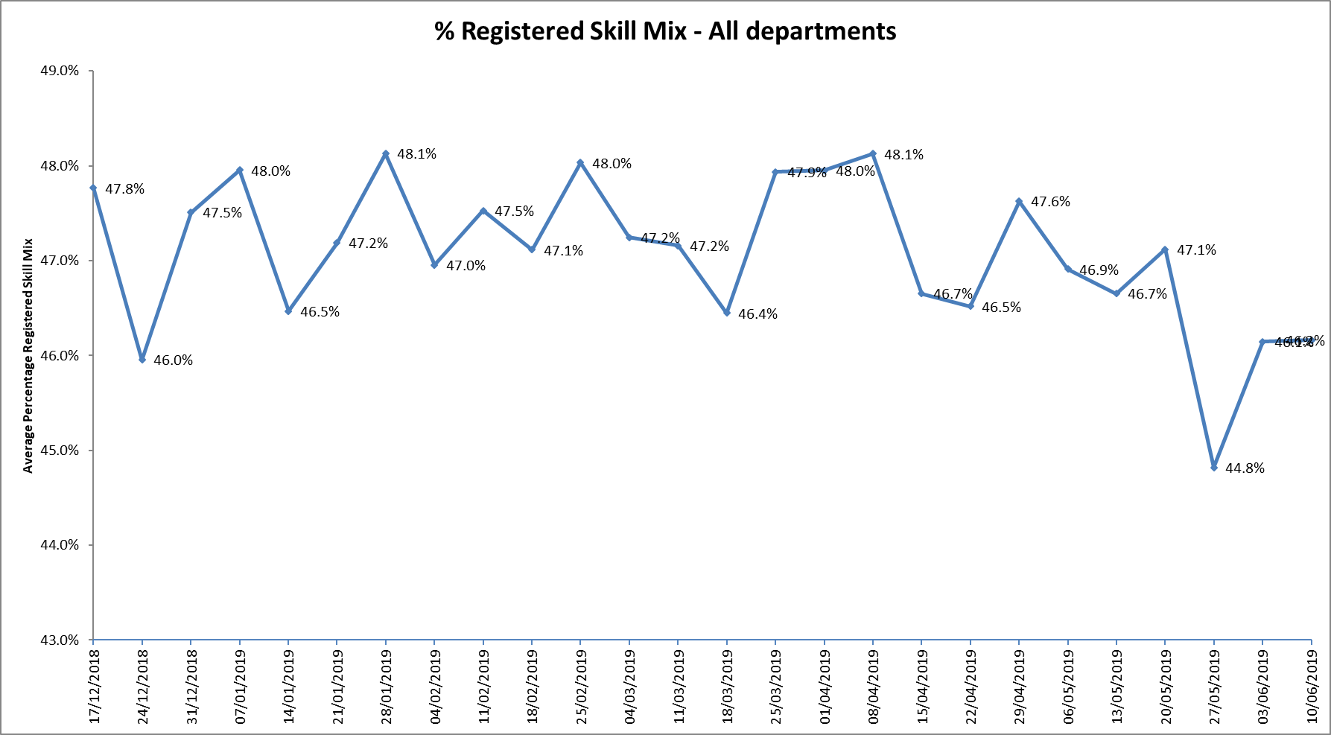

**Agency use**

The Trust moved to a new approach to reduce the use of unregistered agency staff in the week of 14.5.18. Further detail of this project is provided in the HR workforce report and commented on in relation to changes in skill mix ratios.

The average weekly % agency use was 9.8% a reduction from 11.3% in the last reporting period. This remains below the peak of 19.1% in February 2018.

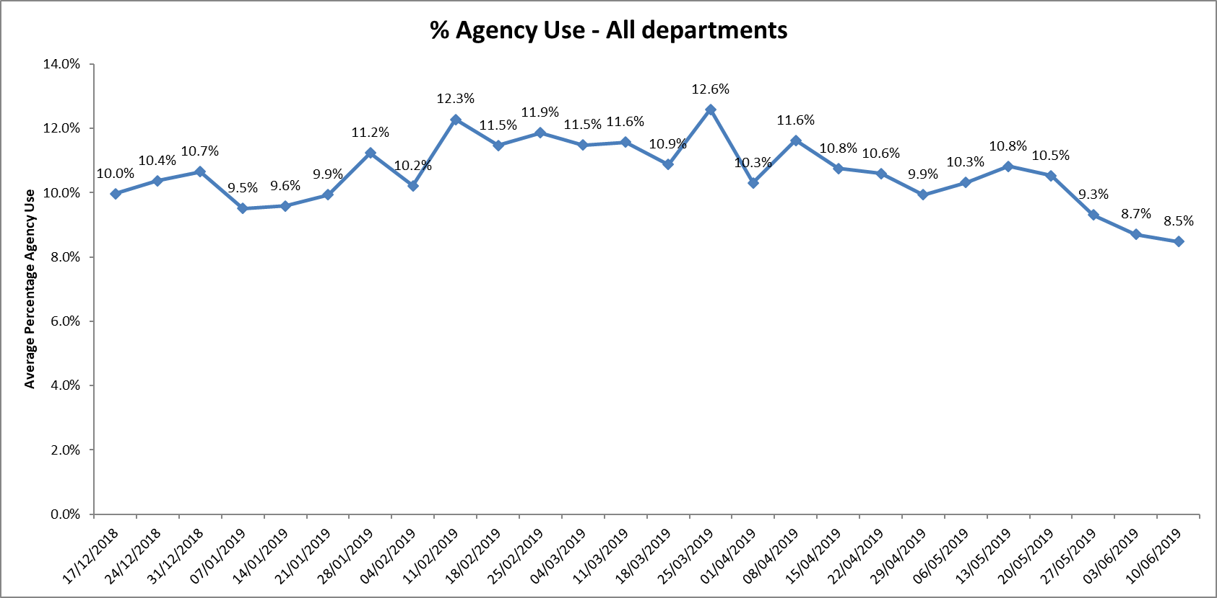

* Eight wards required less than 5% average agency use this increased to ten wards in the second period.
* Two wards did not use any agency in whole period Chaffron and Watling.
* Three wards Allen, forensic ward Kestrel and Kingfisher required above 20% average of agency staff throughout this period, this was related to a mixture of sickness, vacancies and patient acuity

Further detail of agency use and spend is provided in the Workforce report.

**Outcome of Establishment and Skill Mix Reviews**

**Nursing Numbers: See Appendix Two for details by ward.**

**Adult wards**

Shift numbers patterns are maintained across acute admission wards at **6,6,4,** with qualified staff making up **50%**

**Health Based Places of Safety: ( HBPoS)**

The decision has been made not to include extra staffing for the wards with Health based places of safety (HBPoS), as review of the data it was difficult to justify extra staff in a way that would have been meaningful as this work is unpredictable and must be seen in context overall ward activity. The creation of more HBPoS have lightened the load across wards, it therefore seemed reasonable that all wards go above numbers when acuity or use of HBPoS calls for it.

**CAMHS and Eating Disorders**

Shift numbers patterns will remain unchanged

**Forensic wards**

Summary of changes:

•           Evenlode set at the 6,6,5 working shift numbers with 3,3,2, qualified.

•           Ratio of qualified to unqualified on each shift has been increased from the safer staffing figures in many areas to work towards an equal split and provide a balanced establishment.

•           Kennet working numbers increased to 7,7,6 (one on each shift) to meet increased acuity.

•           Wenric has increased by 1 on a late shift to meet increased acuity.

•           Glyme night shift increased by 1 to bring it up to 4 to enable safer management of clinical situations and reduce the need to escalate patients back to the acute wards unless clinically appropriate.

**Skill Mix review**

**Forensics**

**Revised / New roles:**

* Ward Clerks Increase ward clerks from 0.5 WTE per ward to 1 WTE. This is to provide increased support to the ward enabling nursing staff to focus on clinical duties.
* Nursing Associate roles in each inpatient ward.
* Band 5 business roles to support ward managers and lead on non-clinical aspects of the ward manager role. Releasing ward managers to have more capacity to focus on clinical leadership. Career pathway for these roles needs to be established. 1WTE per ward.
* Security Lead Roles -to manage the security standards expected within Forensic wards. Releasing nursing staff to focus on their clinical roles. Also providing increased robustness to security including learning from incidents. 0.5WTE per secure ward.
* Activity Workers -There is currently variation across the forensic wards, with some having implemented activity workers successfully. Implement activity workers across all the wards. These roles have been implemented with a rotation of the nursing HCA teams supporting all HCA’s to develop skills in this area. These roles have had a positive impact of supporting increased structure on the ward.
* Apprenticeship & Senior HCA Recognise senior HCA roles for those that have completed the HCA apprenticeship.
* Foundation & Senior staff Nurse Role Recognise Senior Staff Nurse Roles following the two-year development programme.
* Educational Support Roles -Band 6 educational support roles embedded within teams to support the increased number of learners on the ward. To provide support for the learners and create an environment with rich learning opportunities. Support the nursing teams to have a leaning environment.
* Inpatient Social Workers
* Physical health nurse consultant 8a-To lead on implementing the physical health strategy. Two posts across the forensic service.
* RGN nursing roles available within the working numbers of qualified staff.
* Further band 6/7/8a roles working across the service will be explored. Potentially in the following areas:
  + Band 6 physical health leads to work alongside the 8a nurse consultant
  + Lead for implementing and supporting on reducing aggression towards staff, with a workstream to focus on racist abuse.
  + Patient & Carer involvement lead – following clarification of the current provision following service restructure.

Following review of the band 6 charge nurse roles, opportunities for more band 6 roles will be developed

**Adult Wards**

Over the last few years several new roles have been implemented across the wards, to ensure that they are in line with best practice, meet with AIMs accreditation guidance and are able to offer patients a variety of interventions. This has included 8a Physical Health lead nurse, ward based social workers, and ward based psychologists.

**Summary of recent skill mix changes made:**

* Creation of 4 band 4 Nurse Associates posts on each ward
* Increase of band 6 senior nurses (charge nurses) from 4 to 5 per ward.
* Creation of a band 8a Physical Health Nurse Lead in both counties working across wards.
* 0.5 wte 8a Psychologist per ward
* 0.5 wte band 6 ward based Social worker per ward
* 0.5 wte band 5 performance lead per ward.
* 1. Wte band 4 psychology assistant for OA wards

This proposal incorporates the new Occupational Therapy structure and includes all Clinical support staff involved in caring for the patient’s group.

**Older Adult Mental Health wards**

The wards have been operating on numbers of 6,6,4 in line with adult wards, this has now been reflected in the budgets through the skill mix review. In addition, the wards also had 1 x band 4 psychology assistant in place, to support psychological interventions on the ward and meet practice standards.

**CAMHs and Eating Disorder wards**

Highfield Unit

Additional Roles:

•             Physiotherapist Band 7:  0.2 WTE

•             NATS / Nursing associates post qualifying: Band 4 3 WTE

•             Psychology assistant Band 4: 1 WTE

•             Admin assistant / Ward Clerk Band 3: 1 WTE

Plan to reduce band 3 HCA WTE from 38.46 to 34 WTE to accommodate the above posts.

Cotswold House Oxford:

The unit is a specialist Eating Disorder Unit which has already been supporting Nursing associate trainees and are keen to continue this and employ Nursing Associates post qualification.

Shift skill mix Changes:

Aim of 2xBand 5 Staff Nurses on early/late shifts and towards some shifts with 1xBand 5 Staff Nurse

and 1xBand 4 NAT

Skill mix changes

Band 7 increase to 2.0WTE 7 as Modern Matron post moving to cover across ED service/cost share

Band 6 increase from 3 to 4 WTE

Band 5 reduction from 10.37 WTE to 8.37WTE to support cost of increase in Band 6 and Band 4

Band 4 Nursing Associate new role 1.0WTE

Band 3 HCA reduction from 16.48 WTE to 15.48 WTE

Development of new workforce role of dietetic assistant to support specialist ED needs and enhancement of MDT

Cotswold House Marlborough:

Discussions with the ward manager indicate that the staffing levels on this unit are at a suitable level and this is supported by the agency / flexible staffing figures. For the purpose of this review the current and required figures are based on what the inpatient clinical need is deemed to be. There may be a need to adjust the community budget to uplift the inpatient budget.

Stage 1 proposed new establishment did not give the ward a significant uplift in WTE / funding and therefore review opportunities are more limited.

The unit have been supporting 2 NATs and are seeking to support another.  The establishment skill mix review has focused on creating an opportunity for:

•             Nursing Associate Trainee / Nursing Associate band 4: 3 x WTE

It is proposed that the following adjustments are made from the stage 1 proposed budget:

•             Admin and clerical reduced from 0.9 WTE to 0.8 WTE

•             Reduce Band 7 psychologist from the proposed 2.4 to 2 WTE

•             Reduce the proposed HCA Band 3 WTE from 13.98 to 11.5 WTE

Marlborough House Swindon:

Proposed Changes:

•             Increase in band 6 wte by 1 wte

•             Reduction in band 5 by 1.66 wte

•             Decrease in HCA band 3 by 1.16 wte

•             2 WTE Band 4 Nursing associate post qualification posts on the unit

•             Increase in OT band 6 by 0.4 wte

•             Use of vacant Band 7 post Psychologist to employ band 4 psychology assistant to support Band 8A Psychologist

•             Increase in admin wte by 1.4 wte

Future considerations.

The arrangements for CYP inpatient units (2 Adolescent assessment units and 2 Eating Disorder) units) are funded differently to other Oxford health Inpatient Units. NHSE commission the CYP inpatient units. This exercise aims to reconfigure and review the staffing establishment, within the agreed budget essential point, however the different finding stream may give an opportunity for extra resource from outside of Oxford health budget.

Bespoke care packages. The above staffing in establishment review is in the context of general increase in acuity across all areas. There are occasions when the units will be seeking extra funding from NHSE to support bespoke packages of care for individuals with specific needs or delays in transfer to more suitable placements.

**COMMUNITY HOSPITAL WARDS**

The skill mix has been reviewed and the following establishment has been proposed this is inclusive of the 45 created Nurse Associate Posts that will be available from April 2019 in line with the graduation of the first cohort, this is being funding using previous Band 5 establishment budget and should support a reduction in agency spend. We will be increasing band 6 staffing to support the introduction of the new role

There has been a recognition that the Oxfordshire Stroke Rehabilitation Unit requires a specialist lead nurse for Stroke to drive quality and service developments. The development of this post is in process.

HEE funding has been agreed for the 2 Band 6 Nurses on the Stroke unit to undertake a 15-week Masters programme in Stroke specialist management. 2 Nurses have completed this course successfully the plan is to roll out to all registered nurses on the Stroke Unit

Bicester Community Hospital is commencing a pilot of Advance Nurse Practice for the Band 6/7 roles within the Unit. It is anticipated that this role will enhance the provision of medical cover going forward

Consultation for band 2 health care assistants to be re banded to Band 3 funded roles with the further role out of Rehabilitation and Health Care Competencies is now complete. The assumption is that all new recruits to the trust will undergo the Level 2 apprenticeship for 1 year and as such in completion will be Band 3.

**Conclusion**

All ward staff and managers continue to make every effort to ensure wards continue to be staffed safely, fill rates remain high for most wards and that we continue to focus efforts on retaining our staff whilst recruiting new nurses to join Oxford Health FT. Skill mix review work has been progressed to include Nursing associates and other roles this will support recruitment and retention of staff to inpatient areas.

**Author and Title:** Kate Riddle, Deputy Director of Nursing and Clinical Standards





Appendix Two: Shift Staffing Numbers July 2019

|  |  |  |  |  |  |  |  |  |  |  |  |  |
| --- | --- | --- | --- | --- | --- | --- | --- | --- | --- | --- | --- | --- |
|  | **2019** | | **Registered Nursing CHPPD Duties per day** | | | | | **Non Registered Nursing CHPPD Duties per day** | | | | |
| **Ward** | **No of Beds** | **Early** | **Late** | **Twilight** | **Night** | **Cross Shift** | **Early** | **Late** | **Twilight** | **Night** | **Cross Shift** |
| Forensics | Kestrel | 10 | 3 | 3 | 0 | 2 |  | 4 | 4 | 0 | 4 |  |
| Forensics | Kingfisher | 16 | 3 | 3 | 0 | 2 |  | 4 | 4 | 0 | 3 |  |
| Forensics | Lambourne House | 15 | 1 | 1 | 0 | 1 |  | 2 | 2 | 0 | 1 |  |
| Forensics | Wenric | 22 | 3 | 3 | 0 | 2 |  | 4 | 4 | 0 | 3 |  |
| Forensics | Woodlands | 20 | 3 | 2 | 0 | 2 |  | 2 | 3 | 0 | 2 | 1 |
| Forensics | Chaffron | 8 | 1 | 1 | 0 | 1 |  | 2 | 2 | 0 | 1 |  |
| Forensics | Watling | 20 | 4 | 4 | 0 | 3 |  | 4 | 4 | 0 | 4 |  |
| Forensics | Glyme | 17 | 3 | 2 | 0 | 2 |  | 2 | 3 | 0 | 2 |  |
| Forensics(LD) | Evenlode | 10 | 3 | 3 | 0 | 2 |  | 3 | 3 | 0 | 3 |  |
| Forensics | Kennet | 15 | 3 | 3 | 0 | 2 |  | 4 | 4 | 0 | 4 |  |
| Community Hospitals | Abbey | 18 | 4 | 3 | 0 | 3 |  | 3 | 3 | 0 | 2 |  |
| Community Hospitals | OSRU | 20 | 4 | 3 | 0 | 3 |  | 4 | 4 | 0 | 3 |  |
| Community Hospitals | Bicester | 12 | 2 | 2 | 0 | 2 |  | 2 | 2 | 0 | 2 |  |
| Community Hospitals | City | 16 | 4 | 3 | 0 | 2 |  | 3 | 3 | 0 | 2 |  |
| Community Hospitals | Didcot | 16 | 3 | 2 | 0 | 2 |  | 3 | 2 | 1 | 2 |  |
| Community Hospitals | Wallingford | 18 | 3 | 3 | 0 | 2 |  | 4 | 3 | 0 | 3 |  |
| Community Hospitals | Linfoot | 22 | 4 | 4 | 0 | 3 |  | 5 | 5 | 0 | 2 |  |
| Community Hospitals | Wenrisc | 24 | 4 | 4 | 0 | 3 |  | 5 | 5 | 0 | 2 |  |
| Adolescent  MH | CH Marlborough | 12 | 2 | 2 |  | 1 |  | 3 (2 Sat, Sun) | 3 (2 Fri, Sat) | 2 |  |  |
| Adult Eating Disorder | CH Oxford | 14 | 3 | 3 |  | 1 |  | 3 (2 Sat, Sun) | 3 (2 Fri, Sat) | 3 |  |  |
| Adult Eating Disorder | MH Swindon | 12 | 3 | 3 |  | 2 |  | 3 | 3 | 1 (Fri, Sun only) | 2 |  |
| Adolescent  MH | Highfield | 18 | 3 | 3 | 1 | 2 |  | 7 | 6 |  | 7 |  |
| Older adult Mh | Amber | 20 | 2 | 2 | 0 | 2 |  | 4 | 4 | 0 | 2 |  |
| Older adult Mh | Cherwell | 17 | 3 | 3 | 0 | 2 |  | 3 | 3 | 0 | 2 |  |
| Older adult Mh | Sandford | 14 | 3 | 3 | 0 | 2 |  | 3 | 3 | 0 | 3 |  |
| Adult Acute  MH | Sapphire | 20 | 3 | 3 | 0 | 2 |  | 3 | 3 | 0 | 2 |  |
| Adult acute | Ruby | 20 | 3 | 3 | 0 | 2 |  | 3 | 3 | 0 | 2 |  |
| Adult Rehab | Opal | 20 | 3 | 3 | 0 | 2 |  | 3 | 3 | 0 | 2 |  |
| Adult acute  MH | Allen | 15 | 3 | 3 | 0 | 2 |  | 3 | 3 | 0 | 2 |  |
| Adult Acute MH | Ashurst | 11 | 4 | 4 | 0 | 3 |  | 4 | 4 | 0 | 3 |  |
| Adult Acute MH | Phoenix | 18 | 3 | 3 | 0 | 2 |  | 3 | 3 | 0 | 2 |  |
| Adult Acute MH | Vaughan Thomas | 18 | 3 | 3 | 0 | 2 |  | 3 | 3 | 0 | 2 |  |
| Adult Acute MH | Wintle | 16 | 3 | 3 | 0 | 2 |  | 3 | 3 | 0 | 2 |  |