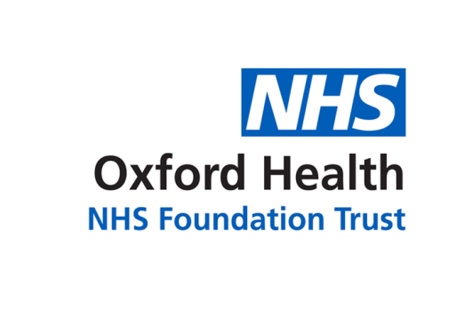

# Report to the Meeting of the

# Oxford Health NHS Foundation Trust

**BOD 80/2019**

(Agenda item: 12)

# Board of Directors

**July 2019**

**Communications and Engagement Report**

**For: [Information]**

**Executive Summary**

The Communications and Engagement report seeks to provide a clear outline of progress and developments within the following core elements of:

* Internal communications & engagement
* External and cross-cutting communications & engagement
* Communications & engagement systems development

**Governance Route/Escalation Process**

This is a new report and will be presented twice yearly, unless otherwise advised, as determined by the Director for Corporate Affairs and Company Secretary who has overall responsibility for these areas of work.

**Statutory or Regulatory responsibilities**

Updated strategy and policy information is provided in the body of the report.

**Recommendation**

The Board is asked to note the report.

**Author and Title: Lorcan O’Neill – Director of Communications & Engagement**

**Lead Executive Director: Kerry Rogers – Director for Corporate Affairs and Company Secretary**

1. *A risk assessment has been undertaken around the legal issues that this report presents and there are no issues that need to be referred to the Trust Solicitors*
2. ***Strategic Objectives*** *– this report relates to or provides assurance and evidence against the following Strategic Objective(s) of the Trust*

*1) Developing Our Business through Collaboration and Partnerships*

*(Goals: we will work in collaborative partnerships; we will maintain and grow our services where we add value; and we will have strong relationship with our stakeholders)*

*2) Developing Leadership, People and Culture*

*(Goals: staff satisfaction will be in the top 20% of Trusts nationally; our staff and teams will be high-performing; and we will recruit and retain an excellent workforce)*

*3) Delivering Operational Excellence*

*(Goals: our services will be effective and efficient; information will be translated into knowledge; and our planned surplus will be delivered)*

*4) Driving Quality Improvement*

*(Goals: patients will be safe from harm; patients will achieve the clinical outcomes they want; and patients and carers will have an excellent experience)*

**Communications and Engagement Report – July 2019**

**SITUATION**

This is a Communications and Engagement report for the Board, providing a broader summary of activity to support the work and strategic aims of the trust, beyond the monthly media reports. This report aims to demonstrate the breadth of team activity taking account of some of the following drivers:

* Business as usual: e.g. internal staff engagement; external public engagement, patient information, general enquiries.
* Change: service; system; strategic, e.g. City Community Hospital; Winter planning; BOB ICS; Warneford plan.
* External factors: e.g. funding; regulators; commissioners; independent reviews, key stakeholder and media interest.
* Internal factors: e.g. campaigns and drives generated by infrastructure and operational directorates.

**BACKGROUND**

The Communications and Engagement team has a broad portfolio, which has expanded over the past five years, for example, now including our NIHR BRC. To accommodate that, the skill mix and composition of the team has been strengthened to ensure that every member has a professional background and training appropriate to their role. Collectively the team has a century of professional communications experience and younger officers are digital natives, expert in growing and engaging online audiences.

All areas of the trust have contact with ‘comms’ at some point, whether to promote their work, run campaigns or manage media issues. We also produce the majority of printed material they give to their patients, families and carers.

We printed more than 10,000 patient leaflets in-house in 2018, reviewing, designing and distributing to services.

We organise around 18 major events each year (AGM, Linking Leaders, Health Matters for members, BRC Open Day) and support others like HealthFest and the Staff Awards.

We are also the first point of contact for all emailed general enquiries to Oxford Health, handling around 5,000 of these every year. They can be about anything – cancelled appointments, sales, health advice, complaints, contact from other organisations. We assess each one and respond or send to a team that can help. No email is left unanswered.

Our current priorities are: to ensure that communications are part of information flows so that the team is well briefed on all aspects of trust activity; to assess the effectiveness of channels and adjust accordingly; and to facilitate wider communication and engagement as part of everyone’s job.

**Internal communications**

Our internal channels promote a wide range of news and campaigns, including: strategically important areas like recruitment, research, wellbeing, staff survey, winter planning & flu, structural and service change and key announcements. We also promote staff morale building initiatives like awards, as well as preparedness and advice on things like the annual CQC inspection.

Internal communications are clearly important in an organisation with 6,000 staff dispersed across a wide geography. Given the diversity of roles, it is a challenge to ensure that messages are reaching enough people in the right ways.

**Intranet**

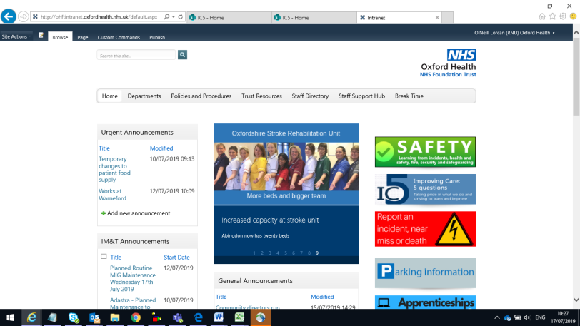The cornerstone of internal communication is the intranet offering key news stories, campaigns, announcements and briefings as well as core information about teams and services, policies and procedures, and interfaces to almost all of the key systems the trust operates – IT help, recruitment, patient safety, procurement, training etc. It is a meeting point and repository of information, with delegated editorial control given to teams for many sections. As well as ‘push’ messaging from management it carries user-generated announcements from anyone in the trust, from flat shares to urgent notifications, all moderated by the comms team.

Historically, it has not been easily possible to measure what is being visited and by how many people. We are working to improve on that as you will see in the ‘Assessment’ section.

**Weekly email bulletin, social media**

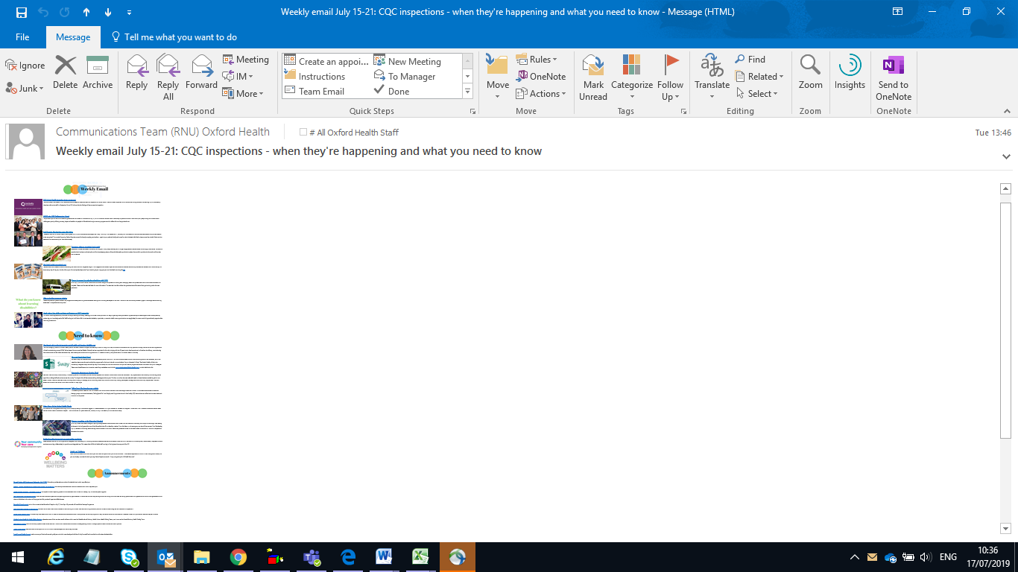The weekly e-bulletin and one-off target email briefings, supplemented by Facebook, Twitter are designed to alert staff to key issues and matters of interest and to signpost them towards more detailed information on the intranet, website or verified third party information provider.

We have dip-tested the weekly e-bulletin uptake using MailPoet software and prior to the current Office 365 environment roll-out around 50% of IT accounts were accessing the bulletin. Post roll-out this has become more difficult, for example, due to barriers to third-party software and the use of preview windows to scan email without opening.

Recognizing that significant numbers of staff in the course of their work do not routinely access online information we expect managers and team leaders to brief onward to their teams. We try wherever possible to funnel all-staff communications through the weekly bulletin to reduce email traffic and make it the go-to source for relevant information. We are looking at ways to improve measurement - discussed in the Assessment section.

**Video**

There is growing demand for video for all sorts of purposes –conferences, training, campaigns, considerably more than can be met in-house by the comms team. So, while we shoot, edit and produce many videos we also advise on the commissioning of them, and ensure that each is approved by comms and compliant with consent and GDPR considerations.

**Meetings and networks**

An under reported though resource intensive communications channel is face-to-face meeting to provide advice and support. At any one time comms is participating in many meetings and networks internally, including, but not exhaustively: Emergency Planning, Digital Strategy, Equality & Diversity, Community Involvement, Wellbeing/Stress, Charity, Membership Involvement Group, Council of Governors, Strategic Delivery Group, CQC inspection Gold Command, and Executive. In addition, we work closely with our university colleagues through our NIHR BRC, ARC, AHSN and AHSC.

**Linking Leaders**

Comms convenes the leadership of the trust at 12 events each year across three geographical areas – Oxon, Bucks and BSW. Each year a programme of four themes is developed in consultation with the chief executive and others, based on feedback gathered at events through the year. Venues, catering logistics and content support are delivered by the comms team, working with theme leads to shape and deliver the content, structure and agenda for each series. This is mirrored in membership matters events primarily aimed at external audiences to promote interest and involvement in trust membership.

**Exceptional People Awards**

Comms runs promotes and provides prizes monthly for staff nominated by their colleagues for these awards, and judged by a Governor-led panel. These are publicised through our channels – intranet, e-bulletin and Insight magazine and summarized in a roll of honour each year at the HR-led Annual Staff Awards.

**External and cross-cutting communications**

Public relations are a cost effective way of supporting the trust’s strategic agenda and promoting public confidence in our services, our values and our potential as an employer, as well as alerting people to significant developments in service delivery and research.

[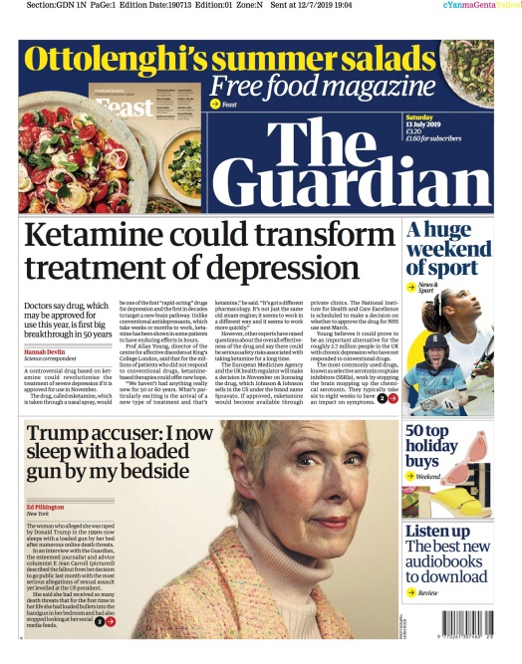](https://www.theguardian.com/science/2019/jul/12/ketamine-like-drug-for-depression-could-get-uk-licence-within-the-year)Board members will be aware of the volume and reach of this activity from the director of communications’ monthly media and social media reports but some recent examples include this Guardian front page story on ketamine treatment (courtesy of our collaboration with Science Media Centre), or below the BBC1 primetime documentary on Nadiya Hussein.

In addition to positively promoting stories, it is part of the comms team’s role to respond to press enquiries and issues aired in the public domain in order to ensure that the trust’s position is set out clearly, fairly and accurately. We look after our collective reputation as a trust, promoting good work, protecting patients and staff from inappropriate interest, correcting misconceptions and building confidence and support for services. Using media engagement and our own channels we have a broad and growing reach.

The trust has 24 official social media channels managed through comms using

Facebook, Twitter, Instagram, LinkedIn – in all 24 social media channels - managed through comms. This is pretty effective, our social media reached around 450,000 people in June which is excellent reach (though we think it was relatively speaking a bad month, compared to 700,000 in March).

Of all mental health trusts in the country, including those with community services, we are number two (after SLaM) in the national Twitter rankings with 13,500 followers – up 30% from last year. Our followers on Instagram have grown by 300% in the past 12 months.

**Media enquiries and promotion**

All media contact is managed and approved through comms as trust policy. Each year we manage over 300 direct local, national and trade media enquiries, ranging from people who have approached the media with complaints about service they, or a family member, have received, to documentary makers keen to explore our services – whether that’s our virtual reality treatments for psychosis, award-winning eating disorders unit or the ground-breaking ketamine clinic.

Some enquiries require sensitive exploration and careful management, especially around patient confidentiality. We also successfully seek media interest in new services and wider campaigns to promote mental and physical health.

[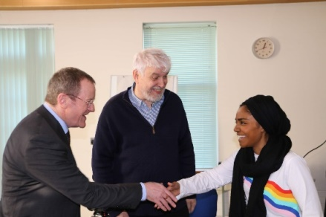](https://www.oxfordhealth.nhs.uk/news/bake-off-winner-nadiya-hussain-tackles-anxiety-and-panic-attacks-in-bbc-documentary-filmed-at-the-warneford/)One of the more high-profile successes this year was the BBC1 documentary with Bake Off winner Nadiya Hussain, as part of Mental Health Awareness Week. That required detailed work with the production company to agree terms, approve and arrange filming over a couple of days. That meant ensuring Nadiya’s consent and arranging suitable locations for filming, briefing staff, keeping areas clear while maintaining services, and ensuring patients knew when drone footage of the site was being taken, so that no alarm was caused. Once filming was complete, the other side of ‘comms’ got under way –publicising the documentary through external media and our own channels.

**Websites**

Comms has oversight and approval over all trust-related website creation working closely with ICT’s web and digital consultant. This includes related websites such as those for our NIHR Oxford Health BRC, which we manage directly and for Oxford Healthcare Improvement.

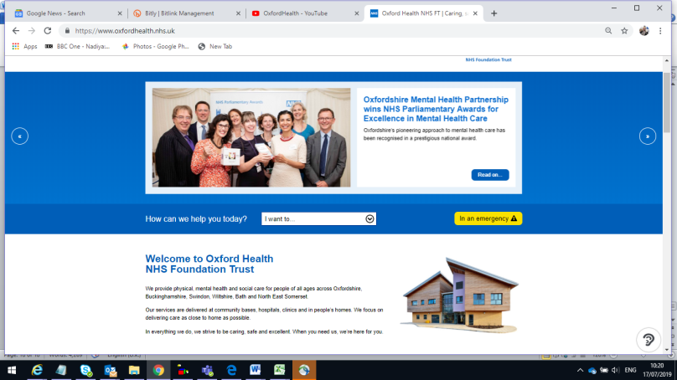The central Oxford Health website is our main window to the world and the first place many people will go to learn about us. It has many subsections and so challenging to maintain. The search engine, multi-story news carousel and general design have greatly improved the site in recent years. Content is co-produced with teams and subject matter experts. The biggest challenge is in maintaining this as we are reliant on being kept informed by services when there is change and by visitors to the site if they spot an error. We’ve made this easier to do by including a comment and reporting link on web-pages but aspire to move towards more automated change management.

Visitor numbers to the site are increasing, for example, year on year, from the six month period January to June 2018 to the same period in 2019, we’ve seen a 15.35% increase. In the last quarter (April to June 2019) we’ve averaged 35,000 unique visitors per month, with around 120,000 page views. Around 79% of unique users are returning visitors, while one in five visitors is new to the site.

Patterns of use are changing with perhaps predictably more people now using mobile devices to access the website, so that PC’s have dropped to 49% of traffic (down from 54%). Our strategy of using social media to drive traffic towards the website seems to be effective as 10% traffic is now coming to us from Facebook

The homepage (despite Google) remains the number one landing spot for visitors, with service pages and careers/job search high in the rankings for pages visited.

**Briefings**

We work with senior management to coordinate major announcements and briefings to a wide range of stakeholders and we ensure senior managers are briefed on any matters affecting the trust.

A good example of this in the past year has been the collaborative work with commissioners to highlight the significant mental health funding gap in relation to activity delivered, identified in the Shipman review. This resulted in the development and issue of joint stakeholder briefings, with subsequent highlighting through our other channels and external media engagement.

Others include the work with Oxfordshire Mental Health Partnership on highlighting the effects of proposed £1.6m cuts to local authority funding of services.

We closely monitor social, print and broadcast media as well as relying on early briefing from key staff to carry out this and other functions.

**Publications: Insight magazine, Annual Report**

The magazine for our public, members and staff aims to come out quarterly and is now much more widely available for download online, as well as the 1800 print [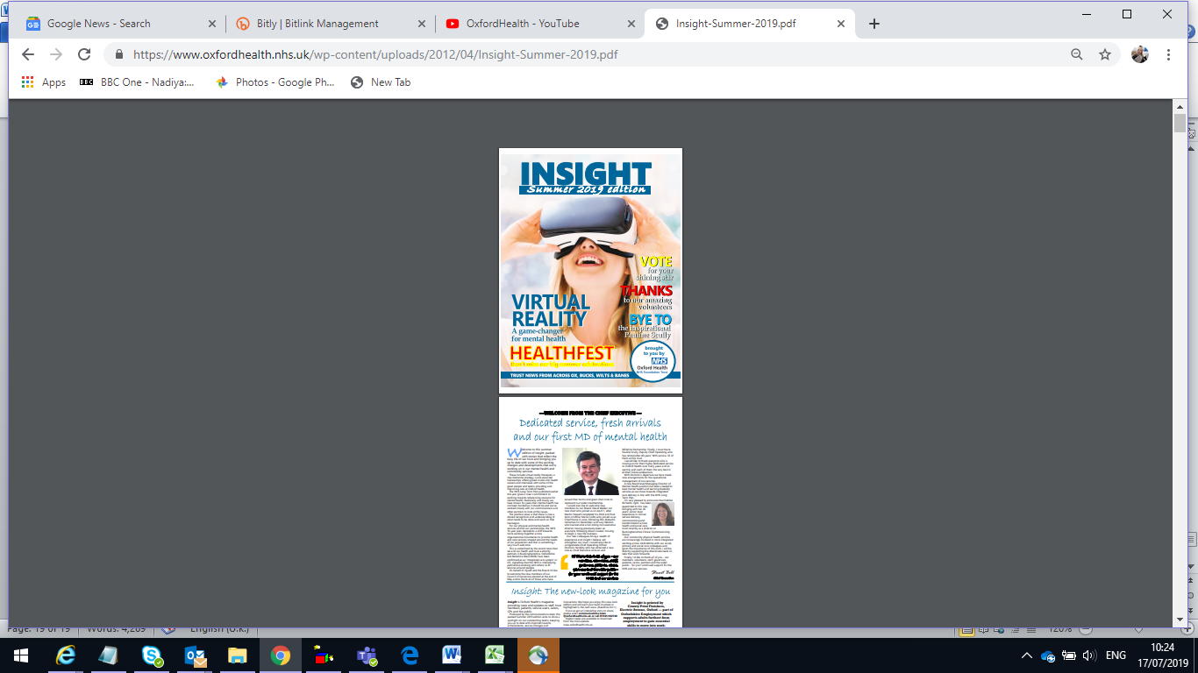](https://www.oxfordhealth.nhs.uk/wp-content/uploads/2012/04/Insight-Summer-2019.pdf)run. The story count and production values of the latest summer edition are high and written to have shelf-life as a promotional item for visitors and potential members. The Annual Report, including the Quality Account, as you will be aware is now before Parliament.

**System and partnership working**

We are involved in strategic communications planning with system partners across the trust area. This includes working closely with NHS and local authority partners’ communications leads in the counties we serve on a wide range of issues from service change and redesign, to planning and coordinating communications to support winter preparedness and service delivery. This is at county and BOB ICS level and stretches as far as BSW STP. We lead and participate in communications and engagement activity through local partnerships like the Oxfordshire Mental Health Partnership and cross-county initiatives like our New Care Models. We continue to work closely with commissioners to support preparation, engagement and consultation on service change, whether in community health services configuration, or in sharing understanding of funding, demand and capacity issues in mental health.

We also work closely with our academic partners, including University of Oxford and Oxford Brookes. With the former we host the NIHR BRC and ARC and with latter have close ties around the Oxford School of Nursing & Midwifery for example. Currently we are working closely with University of Oxford on the development and delivery of the vision for the future development of the Warneford site as a centre of excellence for treatment and research.

**Public events**

The comms team plans and delivers public Health Matters events to promote and reward Foundation Trust membership of the trust. The last round of these featured participative drama, chair dancing and art workshops.

We also provide dedicated input support and promotion for a wide range of other events, including Oxford Health Charity’s HealthFest at Warneford, Healthy Abingdon, LifeFest (OMHP service user led event), as well as the annual Staff Awards.

Finally, we promote, support and contribute to staff attendance at external events, most recently for example by supporting applications to the NHS Parliamentary Awards and publicising Positive Practice in Mental Health winners.

**Foundation Trust Membership and Governor elections**

A senior communications and engagement officer is now in post to dedicate time to membership involvement and recruitment, consult members and develop relationships, as well as supporting elections.

The Council of Governors election was held between March and May 2019. The process began with nominations running from 18 March to 16 April. Candidates statements were published from 17 April and polls were open 9 May to 30 May, with results posted on 31 May 2019.

There were 15 vacancies, which attracted 21 candidates, and 13 governors were elected. Seven seats were filled uncontested, and six in a contested poll. Two seats – in the public constituency in Buckinghamshire - remain vacant. The turnout was between 10 and 17 per cent in the classes with contested vote.

The trust currently has 36 governor seats and 35 governors appointed. All newly elected governors have now completed the induction process and taken up their post.

The election was run independently from the trust by Electoral Reform Services, and promoted by the trust comms team through media, web, social media, press, events and advertising. There were two governor information events, one in Oxford and one in Aylesbury, where members interested in the role were invited to find out more.

Membership was promoted in all election communications, to highlight that you need to be a member of our trust in order to vote or stand as a governor. People joining the trust peaked during the election period as a result, as shown in the graphs below:

Working with people with learning disabilities

We have been working with the Leading Together group to make membership more accessible and meaningful for people with learning disabilities. As part of this work we have co-produced an easy read membership application form and are working on other collateral. A member of the Leading Together group also attended the Council of Governors meeting 12 June to give us his observations how the meeting and governance can be made more accessible. The ultimate goal is to make governance more accessible and easier to understand for everyone.

Community involvement

The comms membership and engagement team has taken part in selected community events such as Oxford Pride and Wallingford patient participation group to promote the benefits of membership.

‘Getting Involved’ activities, particularly charity fundraising, have been well publicised this quarter to illustrate the benefits of involvement with the trust. Four fundraising projects were highlighted, each featuring members and with three raising money for Oxford Health Charity.

There is a network of membership officers developing in southern England, with the first meeting in Southampton in August. The aim of is to discuss ways NHS foundation trusts can work together more locally and to share ideas around improving communications and engagement with our members.

**ASSESSMENT**

Demand and capacity issues in comms mirror some of the issues faced by our clinical services. The more we do and the greater the awareness of that, the greater the demand – and our client base is the whole organisation and the wider systems in which we operate.

We aspire to provide the best advice we can. Many people who come to comms for support have a solution in mind, without necessarily knowing whether it is effective in delivering the outcome they want, or whether it is deliverable in terms of capacity and other workflows – both comms and their own.

We aim to manage this by aiming always to take an evidence based approach based on what we know works through measurement and is deliverable within the resources available. We have introduced forms that allow people to set out their requirements for things like website development and video and their ultimate purpose, so that we can make a fairer assessment of what to prioritise and offer reasonable proposals or alternative solutions.

More complex challenges – such as web and intranet quality control, or improving staff engagement, may ask for better solutions. We continue to refine and improve the design and usability of our websites and intranet channel. The next iteration of the intranet should for the first time allow detailed analytics, for example, and we have adopted a principle that the information architecture on our web and intranet should reflect audience needs rather than organizational form. However, we recognise that the greater challenge is around maintaining high quality content.

Under the Patient, Service User and Carer Information Policy (corp20), directorates are responsible for maintaining and notifying information in relation to what they do. This applies to web, intranet and patient leaflets, so that means service descriptions and notification of changes down to team and unit level. It also means summary information in relation to the structure and composition of teams, services and units. In practice while there is responsibility for this there is not a consistent approach to supplying information at regular intervals, nor is there capacity to chase it down given the volume of material (thousands of web and intranet pages, 700 leaflet types). This is not surprising, given the demands on teams and managers at all levels.

The director of communications’ view, which has been shared with ICT and HR colleagues, is that data currently held on a variety of systems could be harmonized to support even more accurate and timely communication. Work on aspects of this has begun.

For example, initial discussions have taken place with ICT and HR around synthesizing information from ESR and Active Service Directory to allow better stratification and targeting of internal communications towards specific staff groups and those with particular responsibilities. We have already made progress in terms of being able to generate distribution lists by geography.

Regarding service and directorate structured information, there is a larger piece of work to do around mapping systems that track change and how they might work more congruently to provide a unified view when it comes to describing the services we offer. So, acknowledging the great work taking place on developing business intelligence and other summary functions, and recognizing this might be some way off, we are meeting with colleagues to discuss how this might ultimately translate into something like an automated feed to support a real-time public facing website service directory.

We will continue to seek to improve our communications channels and to find ways to measure their effectiveness, mindful always of the following quote:

“The single biggest problem in communications is the illusion that it has taken place.” *George Bernard Shaw*.

We hope this has been a useful and informative report and as the first of its kind will seek the Board’s view whether it has passed the Shaw test.

**RECOMMENDATION**

This report is for information and to provide the Board with an update on how the Trust is progressing its communications and engagement activity and supporting the strategic intent of the Trust.

The continued support from the Board for these activities is welcomed.