

# Report to the Meeting of the

# Oxford Health NHS Foundation Trust

**BOD 62/2019**  
(Agenda item: 12)

# Board of Directors

# 25th May 2019

# INPATIENT SAFER STAFFING Report Period 25th March to 21st April 2019

**For: Information**

**Executive Summary**

**Ward Staffing**

The purpose of this paper is to provide the Trust Board with an interim exception report in line with the requirements of: “How to ensure the right people with the right skill are in the right place at the right time”, Chief Nursing Officer for England & National Quality Board November 2013. From June 2014 there has been a Department of Health requirement for trust boards to receive monthly updates on ward staffing levels. Ensuring sufficient staffing levels are in place is crucial to deliver safe, effective and high quality care. This report will be published on our website with a link from NHS Choices website.

The data within the report will outline the staffing levels (for both registered and unregistered nursing staff) on each ward. These figures will be measured against the required figures on a shift by shift basis for the period 25th March to 21st April 2019 in line with the requirements of the DH Unify reporting process and the data extract is attached (Appendix 1).

During this period:

Average weekly day shifts fill rates for registered staff & unregistered staff were above the Trust target of 85% with 89% or above for unregistered and 95% or above for registered staff.

Six wards were below 85% target for average weekly fill rates for registered nurse day shifts during some of this period. This is an increase from two wards in the last period. The wards were Cherwell, City Marlborough House Swindon, Sandford, Watling and Wenrisc. City had only 56% average fill rate for unregistered staff and Wenrisc had 67% average fill rate for unregistered staff .

Average weekly night shifts fill rates for registered and unregistered for all wards apart from Watling and Wenrisc were above the Trust target of 85% with the average lowest fill rate at 90% for unregistered staff and remained above 100% for registered staff for each week. The methods of filling these shifts includes substantive, flexible workers and agency registered staff and further detail in provided later in the report.

The average weekly % agency use was 11.3% slight decrease from 11.5% in the last reporting period.

Average sickness rates for ward staff were 5.575% a slight increase from 5.2 last month.

This report also includes an update on Older Adult Mental Health nursing vacancies.

**Recommendations**

The Board is asked to note:

* There are processes in place to ensure safe staffing levels on all the wards in the organisation, those wards where there are concerns and the actions being taken to ensure safe staffing including project work and wider recruitment and retention work. There are no exceptions to report that directly link actual staffing levels to adverse outcomes for patients which have been identified through our Governance Structures.

**Author and Title:** Kate Riddle, Acting Director of Nursing and Clinical Standards

**Lead Executive Director:** Kate Riddle, Acting Director of Nursing and Clinical Standards

*A risk assessment has been undertaken around the legal issues that this paper presents and there are no issues that need to be referred to the Trust Solicitors. This paper links to all the five CQC Domains.*

***Strategic Objectives*** *– this report relates to or provides assurance and evidence against the following Strategic Objective(s) of the Trust*

*Driving Quality Improvement (Goals: patients will be safe from harm; patients will achieve the clinical outcomes they want; and patients and carers will have an excellent experience)*

*Delivering Operational Excellence (Goals: our services will be effective and efficient; information will be translated into knowledge; and our planned surplus will be delivered)*

**Inpatient Safer Staffing**

Period 25th March to 21st April 2019.

**Introduction**

This is the report to the Board of Directors outlining the staffing levels (registered and unregistered) on each ward against their required need on a shift by shift basis. This report covers the period 25th March to 21st April 2019.

This report will focus on the percentage of day and night fill rates for registered and unregistered staff. This data is reported to NHSI and provides assurance of actual clinical staffing numbers being achieved. This report will be published on our website with a link from NHS Choices website.

**Management of Staffing Levels**

Anescalation process for the management of staff shortages is in place within each clinical area, to manage staffing safely on a shift by shift basis. As part of this process, senior clinical staff are providing appropriate support to ward teams as and when required. In addition, senior ward staff and immediate team managers review ward staffing levels on an on-going basis; shift by shift basis, and where there are changes in patient acuity. Ward Matrons review staffing daily as a minimum and more frequently where required.

In-patient staffing levels continue to be reported every week and discussed within the Weekly Review Meeting (WRM), which takes place each Monday morning with the Director of Nursing and/or Deputy present. To ensure that staffing levels are under continual review, every ward undertakes a range of immediate actions daily to ensure safe staffing levels are maintained appropriate to the needs of patients. These actions include booking flexible or agency staff via Staffing Solutions, revising rotas, moving staff between wards and utilising additional staff that are not included in the ward numbers as required for example modern matrons.

**Summary position of inpatients wards staffing levels.**

Appendix 1 shows the staffing levels for all wards by ward for the period 25th March to 21st April 2019.The data presented includes details of staffing by shifts and details of skill mix, agency, ward staff sickness and ward vacancy figures. The thresholds presented in the table are measured against trust/ national targets and used for exception reporting.

During this period:

**Day shifts fill rates**

Average weekly day shifts fill rates for registered staff & unregistered staff were above the Trust target of 85% with 89% or above for unregistered and 95% or above for registered staff. This included a mix of agency, flexible and substantive staff including ward managers and matrons where required to make up staffing numbers and provide safe care.

Six wards were below 85% target for average weekly fill rates for registered nurse day shifts during some of this period. This is an increase from two wards in the last period. The wards were Cherwell, City Marlborough House Swindon, Sandford, Watling and Wenrisc. City had only 56% average fill rate for unregistered staff and Wenrisc had 67% average fill rate for unregistered staff. There was addititional support from ward managers or matrons to support safe staffing.

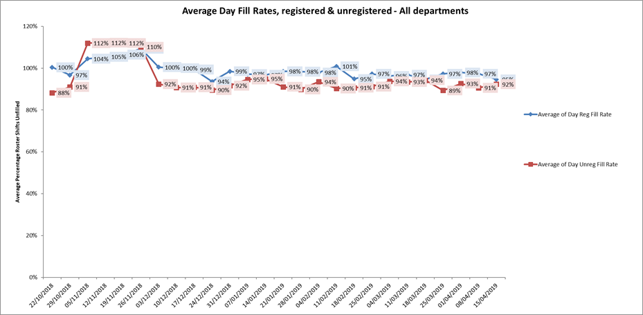

**Night shift fill rates**

Average weekly night shifts fill rates for registered nurse & unregistered staff were above the Trust target of 85% throughout this period for all wards. This included a mix of agency, flexible and substantive staff to make up staffing numbers.

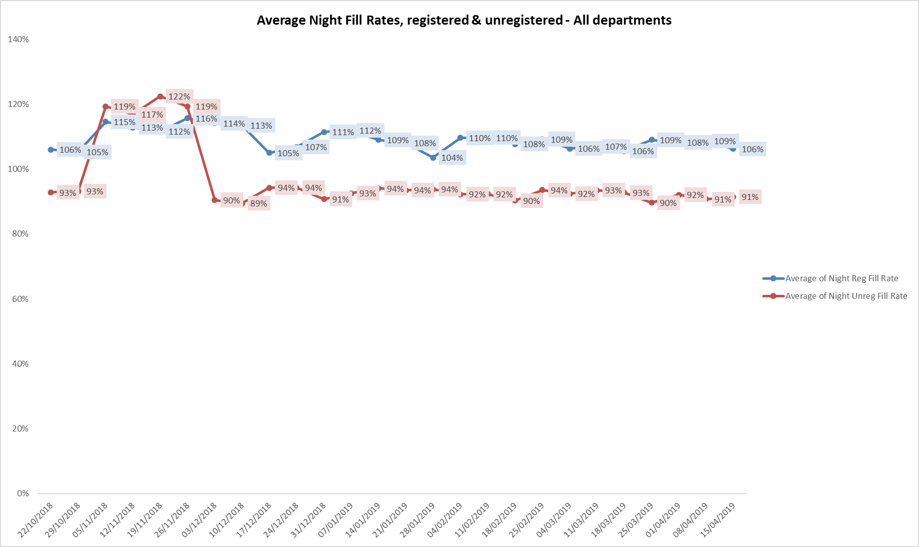

**Registered skill mix**

Fourteen wards had in place an average of 50% or above registered staff skill mix. Two wards had below 35% skill mix these were forensic wards Kestrel and Watling.

For those wards with below 50% registered skill mix, this is related to the continued registered nurse vacancies. Safe staffing is supported by the ward managers and matrons on the ward working clinically as part of the numbers where required to ensure registered nursing leadership is maintained.

Skill mix is achieved through use of our own staff and trust employed flexible registered workers and agency registered nurses.

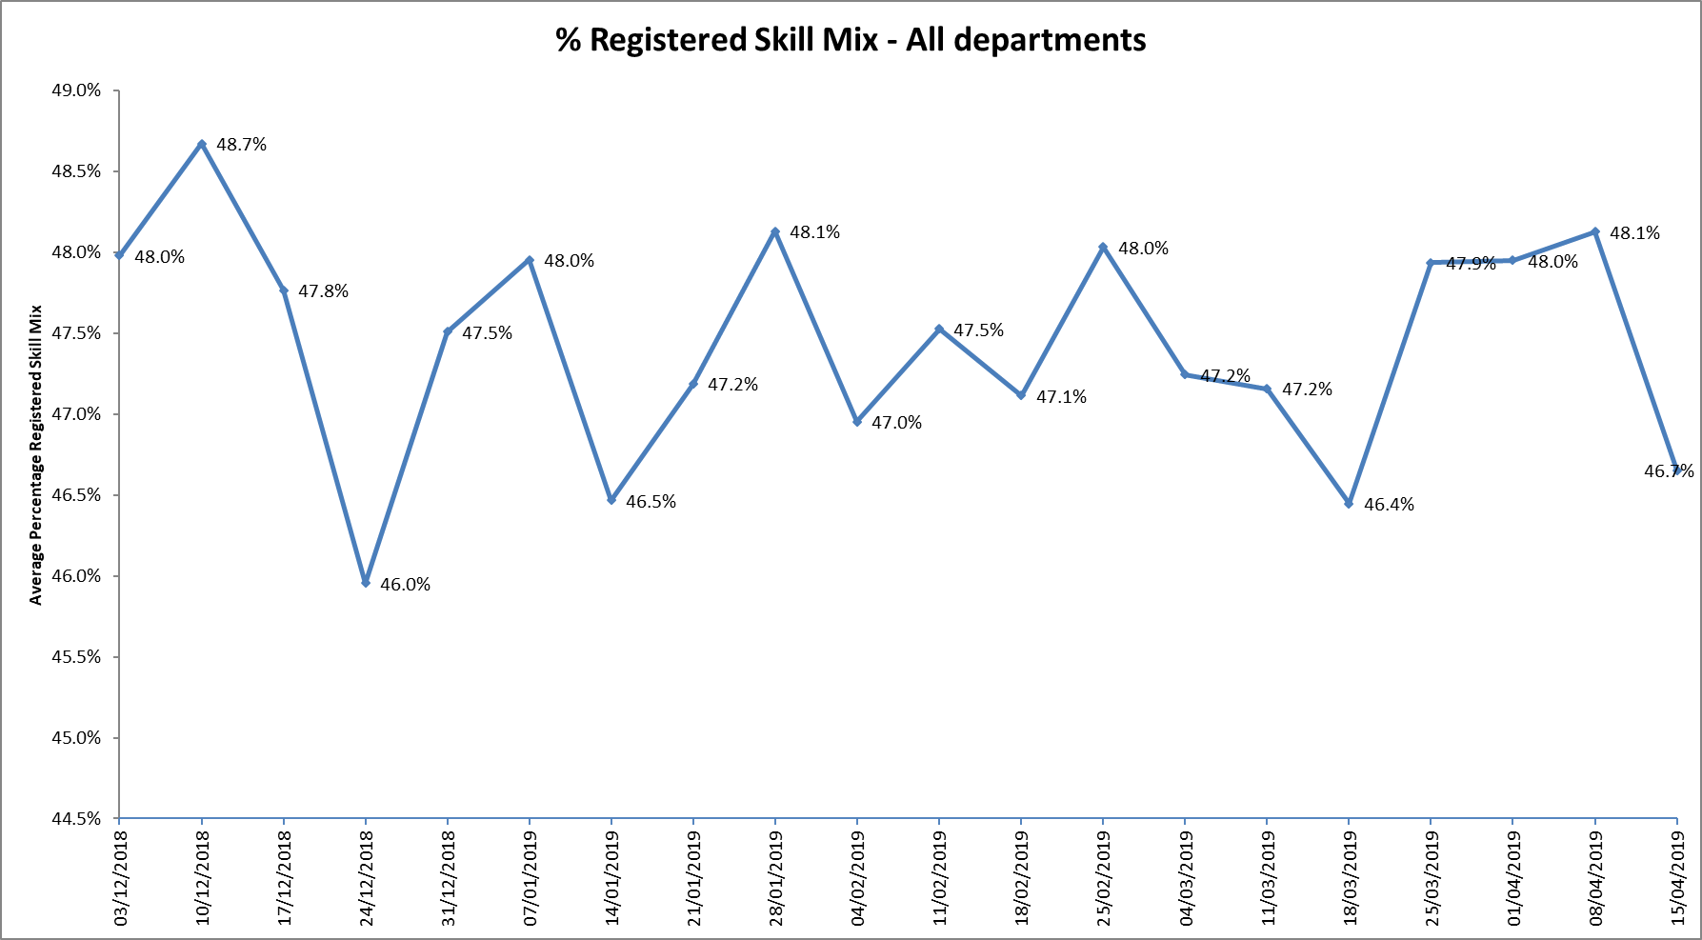

**Agency use**

The Trust moved to a new approach to reduce the use of unregistered agency staff in the week of 14.5.18. Further detail of this project is provided in the HR workforce report and commented on in relation to changes in skill mix ratios.

The average weekly % agency use was 11.3% a slight decrease from 11.5% in the last reporting period. This remains below the peak of 19.1% in February 2018.

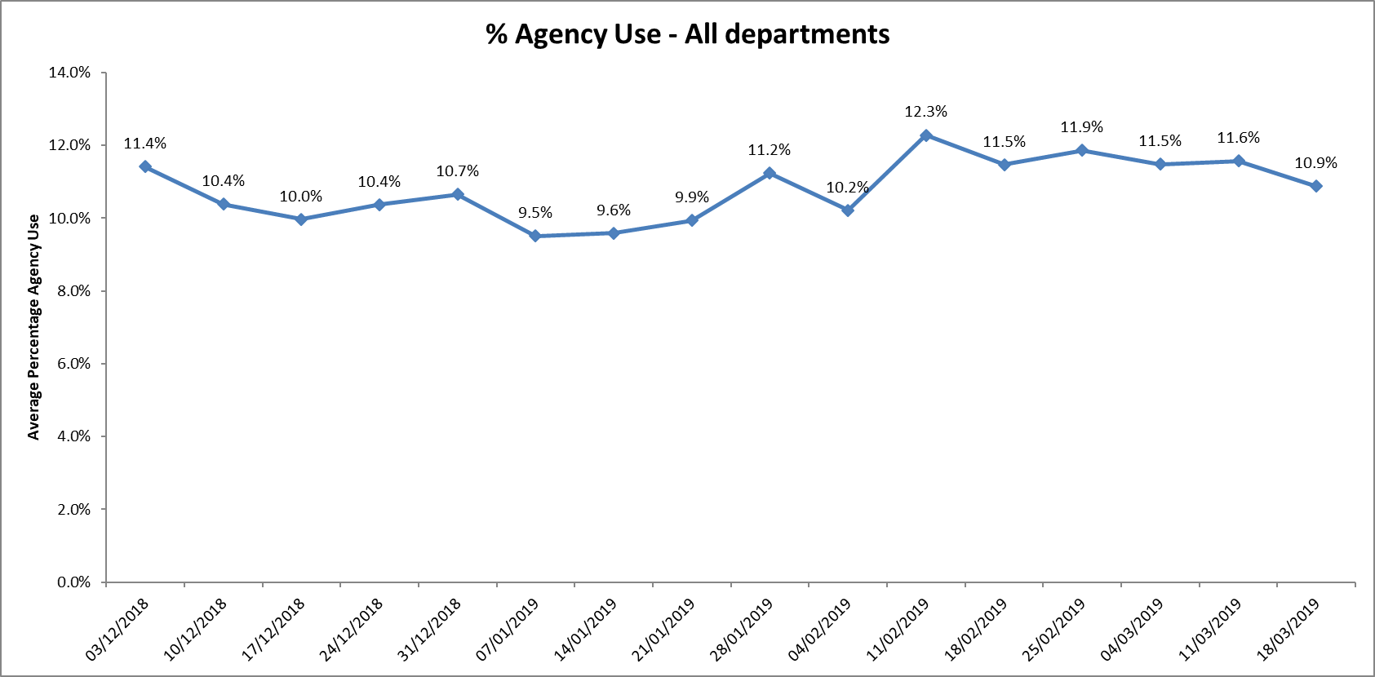

* Nine wards required less than 5% agency use (Trust target)
* Six wards between 5-10 % agency use
* Fifteen wards, up from thirteen wards last month, required between 10% -20% agency usage
* Three wards Allen, City, and forensic ward Kestrel required above 20% of agency staff in the period, this was related to a mixture of sickness, vacancies and patient acuity

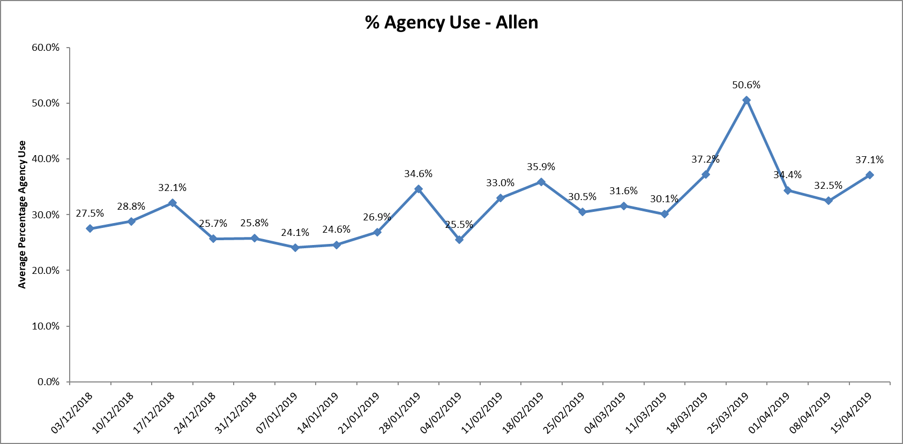

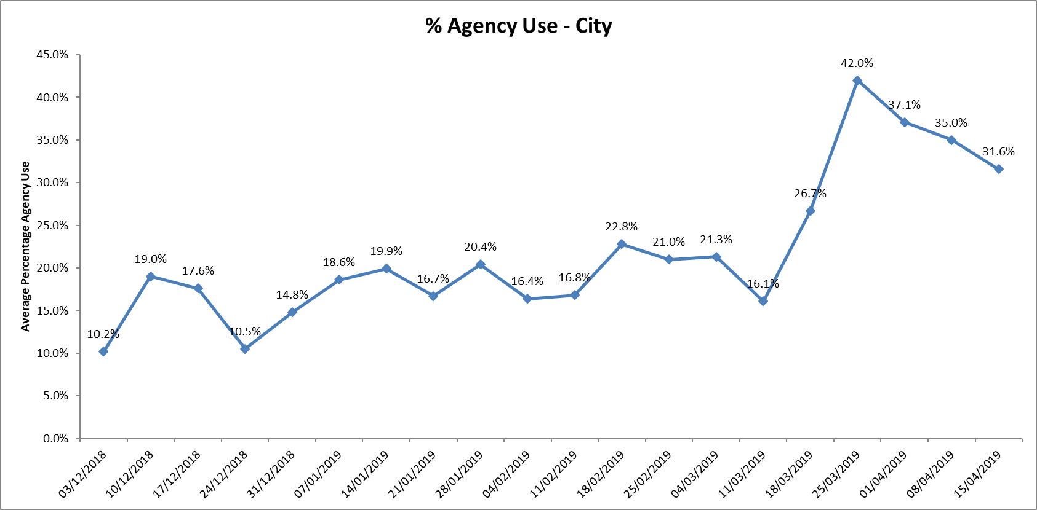

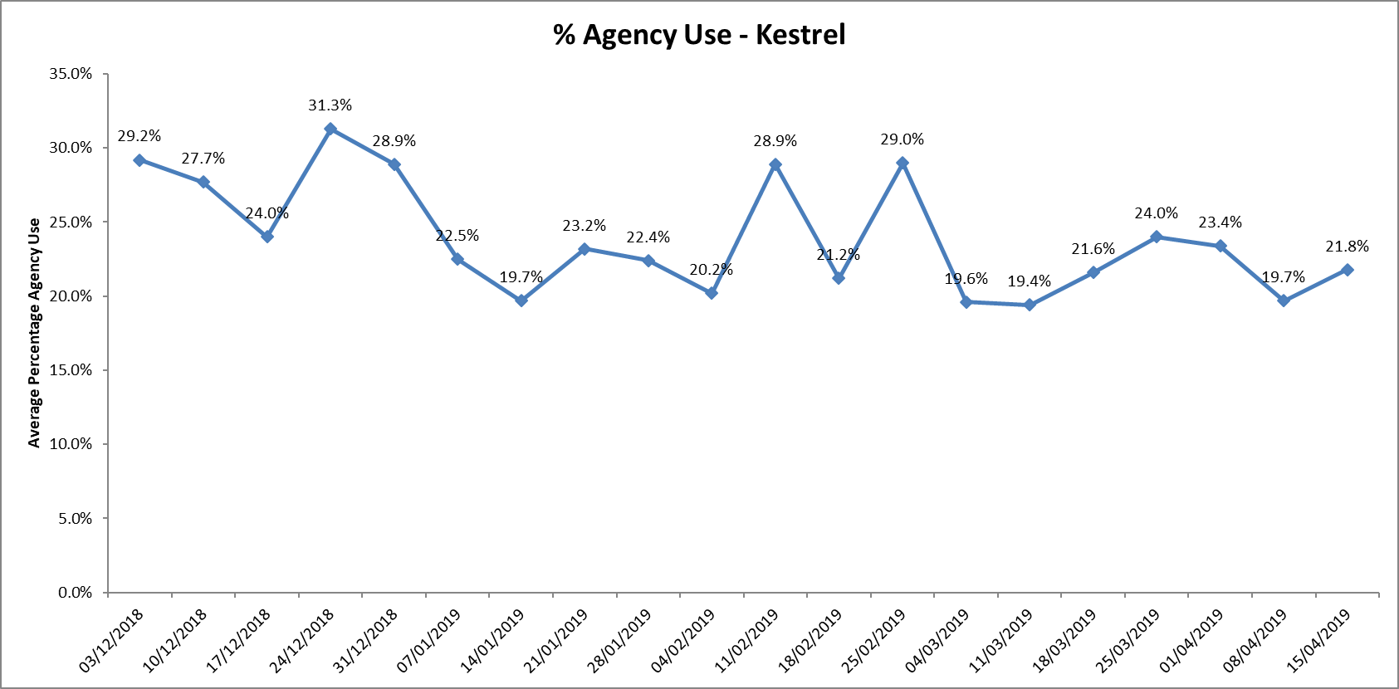

Further detail of agency use and spend is provided in the Workforce report.

**Maintaining Safer Staffing.**

**Older Adult Mental Health Wards.**

Fulbrook Centre Staffing position May 2019

Older adult mental health wards in consist of 3 inpatient units, 2 based at the Fulbrook centre, Churchill Hospital site Oxford.

Sandford ward is a 14 bedded Male ward

Cherwell is a 17 bedded Female ward

In Buckinghamshire there is one ward Amber mixed bedded ward.

All wards care for those over predominately over the age of 65 with both mental health illness and Dementia.

Staffing for both Oxford wards usually runs at 6, 6, 4. Frequently running to a 5th staff member at night time on Sandford ward which is shared with both wards. This is because of the frequency of disturbed and agitated behaviour at night time.

Both wards recruit jointly and allocate successful candidates to the ward where their strengths will best fit the team. HCAs are recruited on the basis that they will be likely be wanting to do further training. The wards where possible do try to add some flexibility to shift patterns but do not accept night only working. Both wards have worked hard to have competent, resilient staff at all grades who are encouraged to make improvement changes to care provided. Senior Matron reports staff are well managed by the ward managers and this has had an impact on the staff working on the wards feeling valued and an increase on those wanting to work with on the wards.

Across the wards In relation to registered staff there has been active engagement with 2nd year students to work with us post qualifying.

|  |  |  |  |  |
| --- | --- | --- | --- | --- |
| **Ward** | February 2018  Vacancies | | May 2019  Vacancies | Change |
| **Amber** | Band 3  Band 5 | 3.0 recruited and further3.0 planned  6.0 (one recruited not started)  Band 6 0 | 3.0 WTE  5.0 (four appointed to start in Sept 2019)  Band 6 0.2 | No change but one Band 4 in place and two Nurse associate trainees in place  -1.0 will decrease further in September    2.0WTE from Sept due to retirement vacancies from out to advert |
| **Cherwell** | Band 3  Band 5 | 1.0  3.0 | Establishment 15.76WTE  In post  12.53 WTE  3.23 vacancies  1 post covers the psychology assistant post  8.48 WTE  4.48 Actual in post  Vacancies 4.0 WTE | +2.23 WTE  1 on long term sick  1 of these is a NAT due to finish this summer.  One staff nurse is currently covering the band 6 role  2 new staff nurses have been appointed and due to start on completion of their training. |
| **Sandford** | Band 3  Band 5 | 4.0  5.0 | 15.76 WTE  13.96 Actual  Vacancies  1.8 WTE  8.48 WTE  6.23 actual  Vacancies 2.25 | 1 on maternity leave  2 of the HCA’s are going on to their NAT training starting in May.  2 new staff nurses have been appointed and due to start on completion of their training |

Amber ward is one of ten wards with high off Framework agency use where a review will be undertaken by Heads of Nursing working with ward staff and HR to review key areas of; incidents, complaints, concerns, admissions/ discharges, bed occupancy, training by course, appraisals, supervision, patient/ carer feedback, and detention rates. These will be reviewed alongside staffing levels, skill mix and patient acuity to provide an overall picture and action plan of support for the ward.

Nurse Associate Roles

23 trainees qualified in April 2019. They have all been recruited as Band 4 Nurse Associates, 21 in their home teams, 2 requested move to a new area.

A preceptorship programme has been developed to support these staff in their newly qualified roles.

Skill Mix and establishment work

Each area, Adults, Forensics, Children and Young people and Community Hospitals has completed a skill mix review. This skill mix review was undertaken to incorporate implementation and development of new roles, and is supportive to the recruitment, advancement and retention of staff.This is being finalised and will be subsequently included in the board report.

**Conclusion**

All ward staff and managers continue to make every effort to ensure wards continue to be staffed safely, fill rates remain high for most wards and that we continue to focus efforts on retaining our staff whilst recruiting new nurses to join Oxford Health FT. Skill mix review work will be progressed to include Nurse associates and other roles.

**Author and Title:** Kate Riddle, Acting Director of Nursing and Clinical Standards

