

**BOD 106/2019**

(Agenda item: 8)

# Report to the Meeting of the

# Oxford Health NHS Foundation Trust

# Board of Directors

**December 4th 2019**

**Monthly Performance Report – M7 October 2019**

**For: Information**

**Executive Summary**

This report summarises the Trust’s national and locally contracted key performance indicators (KPIs) for Month 7 (October) 2019. Overall, the Trust achieved 248 out of 333 targeted indicators (74%).

**Performance Trend:**

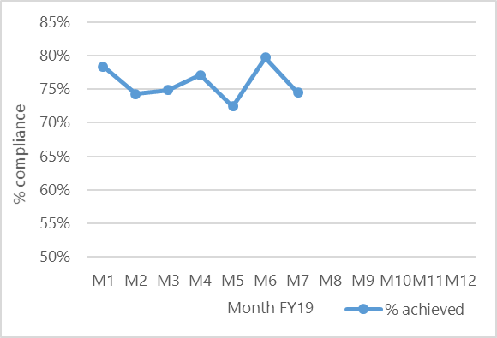

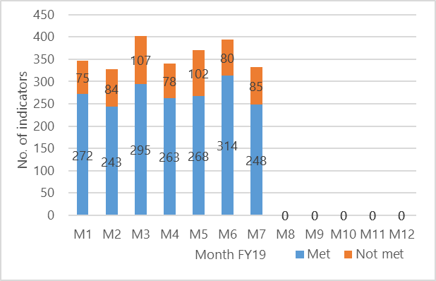

The number of locally **contracted** indicators (excluding Joint Management Group (JMG)) varies throughout the year as is illustrated in the graph above. This is due to some indicators only being reportable on a quarterly basis. Of the 85 indicators not met in October, 35 were more than 10% away from the commissioner defined targets (red category) and **demand exceeding workforce capacity** continues to have a major impact on service delivery.

**Areas to highlight to the Board from an overall Trust perspective**:

**National Position:**

The table below shows how the Trust is performing against the **operational performance** indicators within the NHSI Single Oversight Framework (SOF) (as at the latest available position).

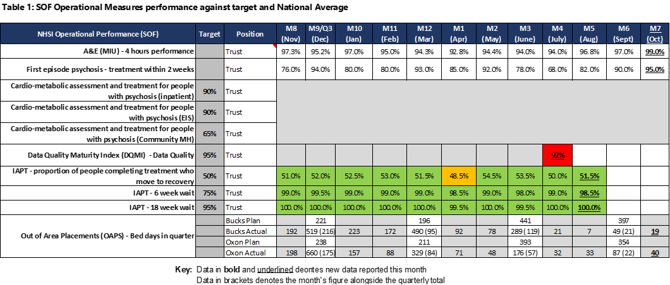

Highlights include;

* The Minor Injuries Unit performance was 99% in October. This is above the 95% national target.
* Out of Area Placements (OAPs) are monitored on a quarterly basis within the SOF and the Trust has substantially improved its performance over the past 6 months. There has been a significant reduction in the number of patients sent out of area due to a shortage of available beds. The Trust is on track to achieve the planned improvement and progress against plan is shown in the table below.

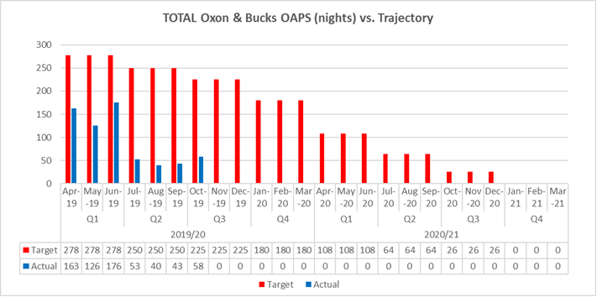

**Local Position:**

**Patient Access and Patient Flow**

The table in **Appendix 1** shows performance in relation to the Trust’s core mental health community services concerning demand, patient access and patient flow. Key headlines;

* **Demand**

Despite comparable population sizes, the number of Adult Mental Health referrals received in Oxfordshire continues to be higher than in Buckinghamshire (32% higher in October).

The number of referrals received by CAMH services has increased in October which is consistent with seasonal variation. Overall referrals to the Trust’s CAMH services across Oxon, Bucks, and BSW were 2624 in October which is 9% higher than this time last year. The average number of monthly referrals between November 2018 and October 2019 was 2198.

* **Access/Waits**

**Adult Mental Health** – A significant long-term underfunding of mental health in Oxfordshire has resulted in considerable pressure building up for mental health services.  Although the waiting time target was changed to 8 weeks, with the current levels of resources available, this position remains challenging. In October 54% of routine referrals were seen within 28 days compared to 84% in Buckinghamshire.

**Child & Adolescent Mental Health (CAMH)** During October, access to the Oxfordshire CAMH services continued to be challenging, with only 30% of patients referred to routine pathways seen within 12 weeks. this decrease in performance was expected as the longest waiters are now being prioritised as part of an improvement plan agreed with Commissioners.

Across Bath & North East Somerset, Swindon and Wiltshire, 49% CAMH referrals were seen within 4 weeks.

During October access to the Buckinghamshire CAMH services improved with 91% of patients seen within 4 weeks.

* **Delayed Transfers of Care (DTOC)**

In October, bed days lost to DTOC in mental health has reduced from 214 last month to 207 this month (equivalent to 7 beds), however, this is still above the rolling 12-month average of 183 (6 beds). Community DTOC increased by 235 days in October to 1317 bed days lost (equivalent to 43 beds), with a rolling 12-month average of 1304 days per month (42 beds).

* **Out of Area Placements (OAPs)**

11 new patients were placed out of area in October (6 in Oxon and 5 in Bucks). 13 patients in total were in out of area placements during the month utilising a total of 80 bed days in the month. The distance from patients’ home to placements ranged from 0.3 to 98.5 miles, with the average distance being 57 miles.

**Performance by Directorate in October 2019:**

**Oxfordshire, Swindon, Wiltshire & BaNES – All Ages Mental Health** achieved 90 of the 124 targeted indicators (73%)

**Highlights for the Board:**

1. **Emergency Department Psychiatric Service (EDPS).** Staffing pressures continue to affect performance at night and at weekends at both the John Radcliffe and Horton General Hospitals.  The pressures have been reported to Oxfordshire CCG so that any risks to patients can be understood and mitigated. The impact of resource shortages means that the Trust is not be able to achieve the commissioner defined targets - the Trust has been successful with its bid for funding to improve overnight and weekend cover with effect from April 2020.
2. **CAMHS (Swindon, Wiltshire, Bath and North East Somerset (BaNES)) –** A comprehensive waiting time improvement plan is now in progress and although commissioner targets have not yet been achieved, improvements have been seen in 4 week waiting times in BaNES & Wiltshire.
3. **Improving Access to Psychological Therapies (IAPT)** – Clinical accommodation pressures continue to affect performance of the IAPT Counselling & CBT Services. This has been reported to Oxfordshire CCG so that they are able to assist with finding affordable alternatives to GP surgeries.
4. **Oxfordshire Care Plans** – A new Carenotes dashboard was introduced in September and there has been a steady improvement in care plans being completed within the agreed timeframe.

**Buckinghamshire – All Ages Mental Health** achieved 28 of the 40 commissioner targeted indicators (70%).

**Highlights for the Board:**

1. **Bucks Care Reviews** – Ensuring that Care Reviews are carried out within the timeframes set out in the clusters continue to be an area of underperformance for the Directorate. As with Oxfordshire, the dashboard was rolled out to operational services in October. Performance will continue to be monitored and a review will be carried out in January 2020.

**Oxfordshire Community Services Directorate** achieved 32 of the 45 commissioner targeted indicators (71%)

**Highlights for the Board:**

1. **Buckinghamshire CHC** – Whilst the Trust is underperforming against the referrals completed within 28 days target, continuous improvement is being made and the Trust expects the service to achieve the target early next year, subject to resources being available.
2. **Oxfordshire CHC –** The Trust continues to underperform against the referrals completed within the 28 day target. The Trust is working closely with Oxfordshire CCG to address the underlying reasons, improve commissioning and procurement processes, ensure personalisation, and improve overall quality and sustainability.

**Specialised Services** achieved 98 out of 123 targeted indicators (80%)

**Highlights for the Board:**

1. **Eating Disorders (Bed Occupancy)** – There have been ongoing difficulties in providing beds due to high dependency patients and a shortage of workforce. The service has implemented a new Single Point of Access (SPA) as part of the New Care Models improvement work and the implementation of this is expected to improve patient flow and bed occupancy levels.

**Recommendation**

The Board of Directors is asked to review and note the Board Performance Report.

**Author and Title:** Martyn Ward – Director of Strategy & Chief Information Officer

**Appendix 1 – Patient Access and Flow**

