

# Report to the Meeting of the

# Oxford Health NHS Foundation Trust

**BOD 109/2019**

(Agenda item: 12)

# Board of Directors

# December 4th 2019

# INPATIENT SAFER STAFFING Report Period 12th August to 3rd November 2019

**For: Information**

**Executive Summary**

**Ward Staffing**

The purpose of this paper is to provide the Trust Board with an interim exception report in line with the requirements of: “How to ensure the right people with the right skill are in the right place at the right time”, Chief Nursing Officer for England & National Quality Board November 2013. From June 2014, there has been a Department of Health requirement for trust boards to receive monthly updates on ward staffing levels. Ensuring sufficient staffing levels are in place is crucial to deliver safe, effective and high-quality care. This report will be published on our website with a link from NHS Choices website.

The data within the report will outline the staffing levels (for both registered and unregistered nursing staff) on each ward. These figures will be measured against the required figures on a shift by shift basis for the period 12th August to 3rd November 2019 (three months’ roster period) in line with the requirements of the DH Unify reporting process and the data extract is attached (Appendix 1).

During this period:

Average weekly day shifts fill rates for registered staff & unregistered staff were above the Trust target of 85% with 86% or above for unregistered and 98% or above for registered staff.

Cherwell was below 85% target for average weekly fill rates for registered nurse day shifts during 9th Sept through to 3rd November (83% & 78%). Wintle ward was below during 12th August through to 6th October 2019 (81% & 78%). Three other wards were below 85% average for one of the three periods, Vaughn Thomas 73%, Allen 79%, Cotswold House Oxford 84%. All wards had increased levels of unregistered staff.

City ward remained closed temporarily during this period.

Average weekly night shifts fill rates for registered staff and unregistered staff across all wards was above the Trust target of 85% rates remained above 100% for registered staff for each week and above 89% for unregistered staff

The methods of filling these shifts includes substantive, flexible workers and agency registered staff and further detail in provided later in the report.

The average weekly % agency use was 10.2% an increase from 9.5% in the last reporting period.

Average sickness rates for ward staff were 5.98 a slight increase from 5.8% in the last reporting period.

This report also includes an update on the skill mix and staffing establishment reviews work, vacancy data by ward and recruitment work.

**Recommendations**

The Board is asked to note:

* There are processes in place to ensure safe staffing levels on all the wards in the organisation, those wards where there are concerns and the actions being taken to ensure safe staffing including project work and wider recruitment and retention work. There are no exceptions to report that directly link actual staffing levels to adverse outcomes for patients which have been identified through our Governance Structures.

**Author and Title:** Kate Riddle, Deputy Director of Nursing and Clinical Standards

**Lead Executive Director:** Marie Crofts Chief Nurse

*A risk assessment has been undertaken around the legal issues that this paper presents and there are no issues that need to be referred to the Trust Solicitors. This paper links to all the five CQC Domains.*

***Strategic Objectives*** *– this report relates to or provides assurance and evidence against the following Strategic Objective(s) of the Trust*

*Driving Quality Improvement (Goals: patients will be safe from harm; patients will achieve the clinical outcomes they want; and patients and carers will have an excellent experience)*

*Delivering Operational Excellence (Goals: our services will be effective and efficient; information will be translated into knowledge; and our planned surplus will be delivered)*

**Inpatient Safer Staffing**

Period 12th August to 3rd November 2019.

**Introduction**

This is the report to the Board of Directors outlining the staffing levels (registered and unregistered) on each ward against their required need on a shift by shift basis. These figures will be measured against the required figures on a shift by shift basis for the period 12th August to 3rd November 2019 ( three months roster period)

This report will focus on the percentage of day and night fill rates for registered and unregistered staff. This data is reported to NHSI and provides assurance of actual clinical staffing numbers being achieved. This report will be published on our website with a link from NHS Choices website.

**Management of Staffing Levels**

Anescalation process for the management of staff shortages is in place within each clinical area, to manage staffing safely on a shift by shift basis. As part of this process, senior clinical staff are providing appropriate support to ward teams as and when required. In addition, senior ward staff and immediate team managers review ward staffing levels on an on-going basis; shift by shift basis, and where there are changes in patient acuity. Ward Matrons review staffing daily as a minimum and more frequently where required.

In-patient staffing levels continue to be reported every week and discussed within the Weekly Review Meeting (WRM), which takes place each Monday morning with the Chief Nurse and/or Deputy present. To ensure that staffing levels are under continual review, every ward undertakes a range of immediate actions daily to ensure safe staffing levels are maintained appropriate to the needs of patients. These actions include booking flexible or agency staff via Staffing Solutions, revising rotas, moving staff between wards and utilising additional staff that are not included in the ward numbers as required for example modern matrons.

**Summary position of inpatients wards staffing levels.**

Appendix 1 shows the staffing levels for all wards by ward for the period 12th August to 3rd November 2019. The data presented includes details of staffing by shifts and details of registered nursing and unregistered staff skill mix, agency, total ward staff sickness and total ward vacancy figures. The thresholds presented in the table are measured against trust/ national targets and used for exception reporting.

During this period:

**Day shifts fill rates**

Average weekly day shifts fill rates for registered staff & unregistered staff were above the Trust target of 85% with 86% or above for unregistered and 98% or above for registered staff.

Cherwell was below 85% target for average weekly fill rates for registered nurse day shifts during 9th Sept through to 3rd November (83% & 78%). Wintle ward was below during 12th August through to 6th October 2019 (81% & 78%). Three other wards were below 85% average for one of the three periods, Vaughn Thomas 73%, Allen 79%, Cotswold House Oxford 84%. All wards had increased levels of unregistered staff.

City ward remained closed temporarily during this period.

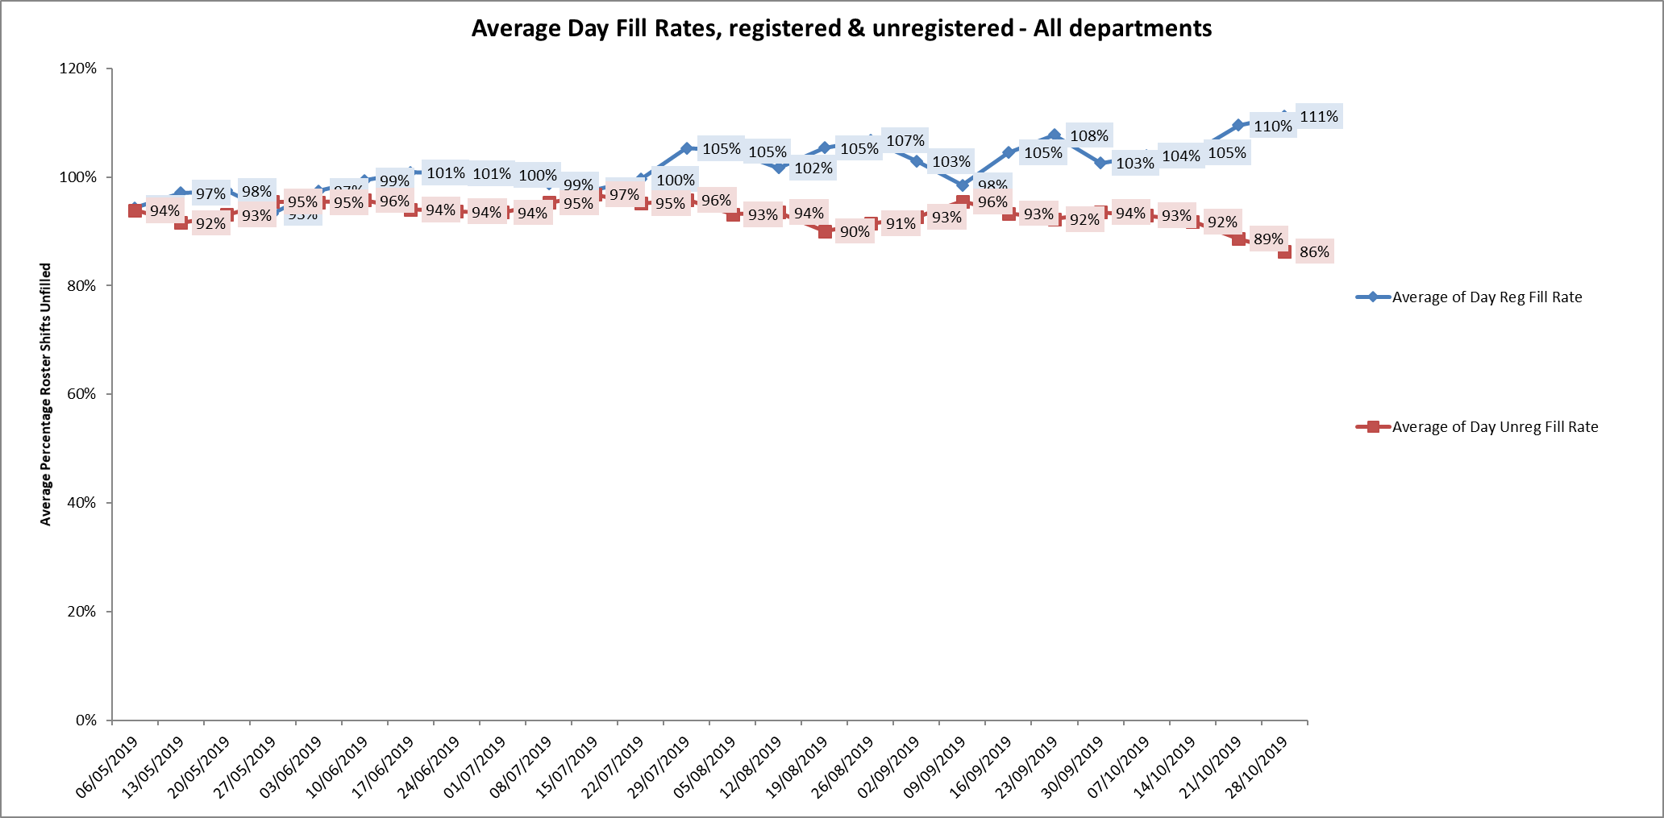

**Night shift fill rates**

Average weekly night shifts fill rates for registered staff and unregistered staff across all wards was above the Trust target of 85% rates remained above 100% for registered staff for each week and above 89% for unregistered staff

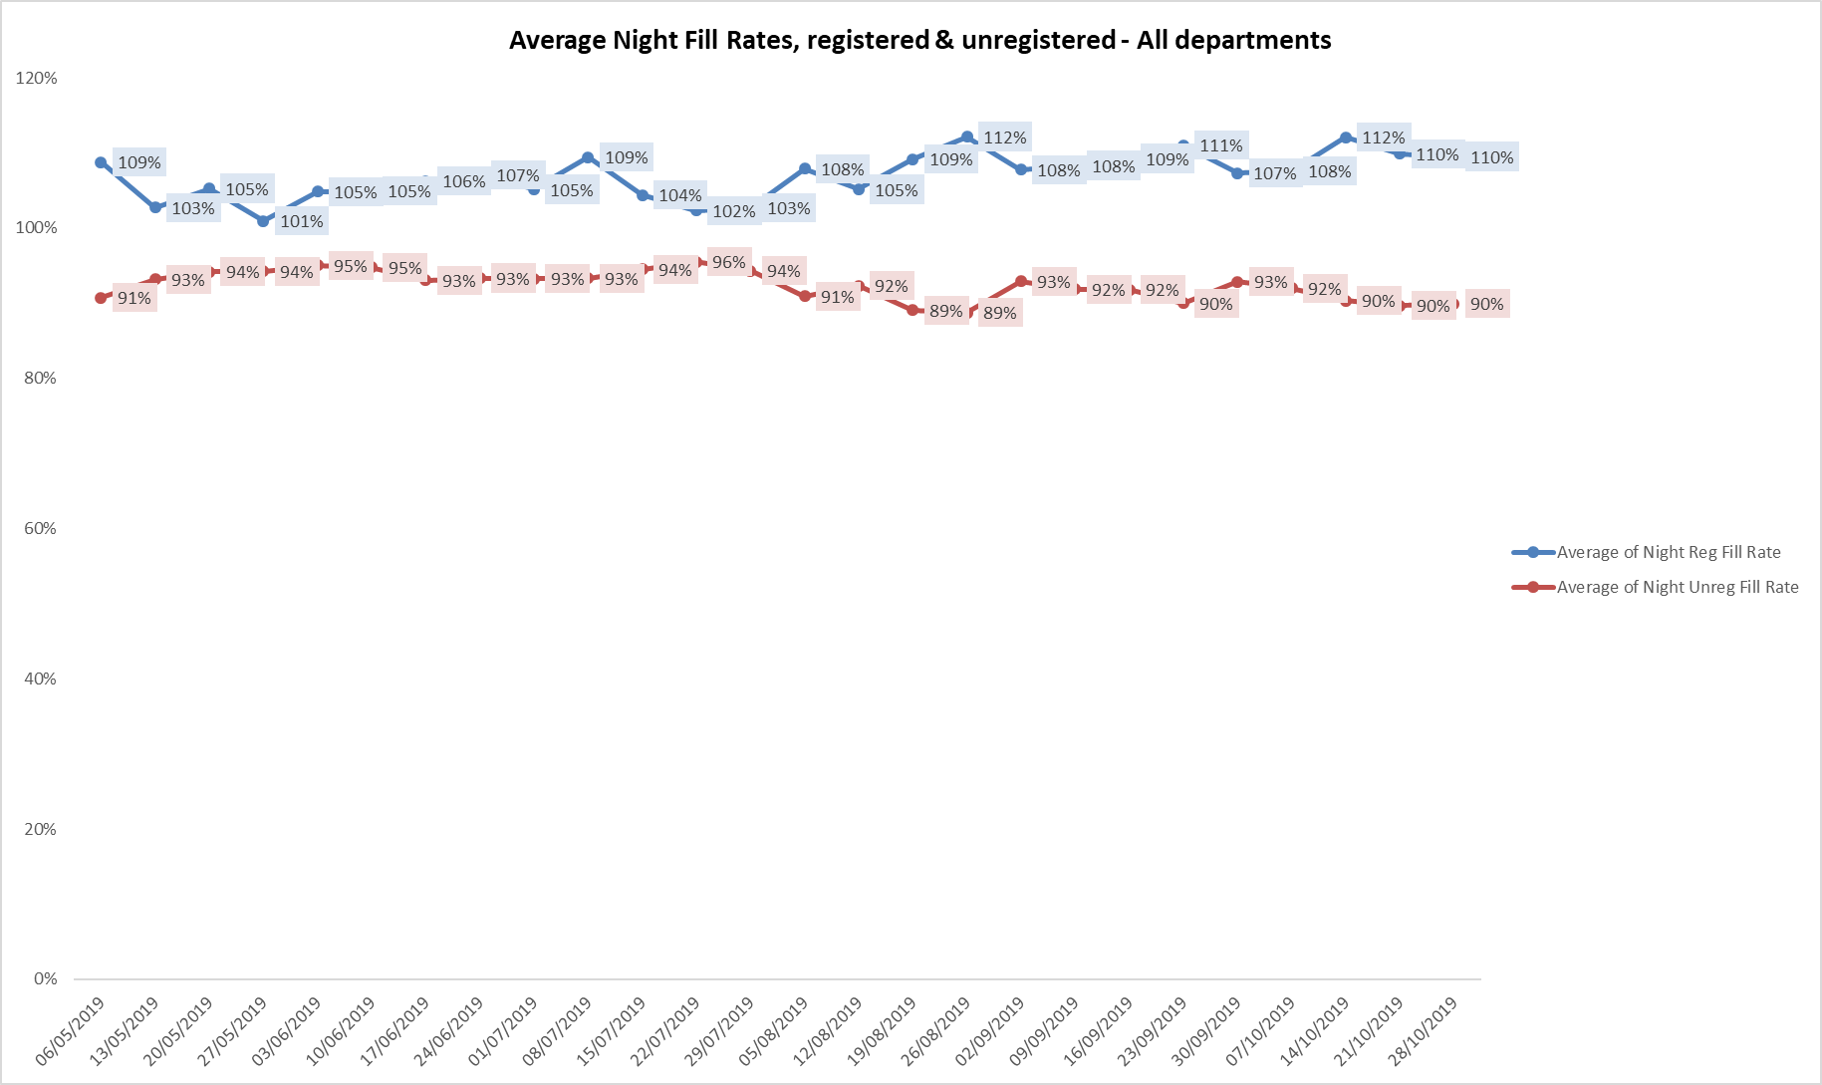

**Registered skill mix**

Ten wards had in place an average of 50% or above registered staff skill mix for the period 12th August to 6th October and this increased to thirteen wards in the last period

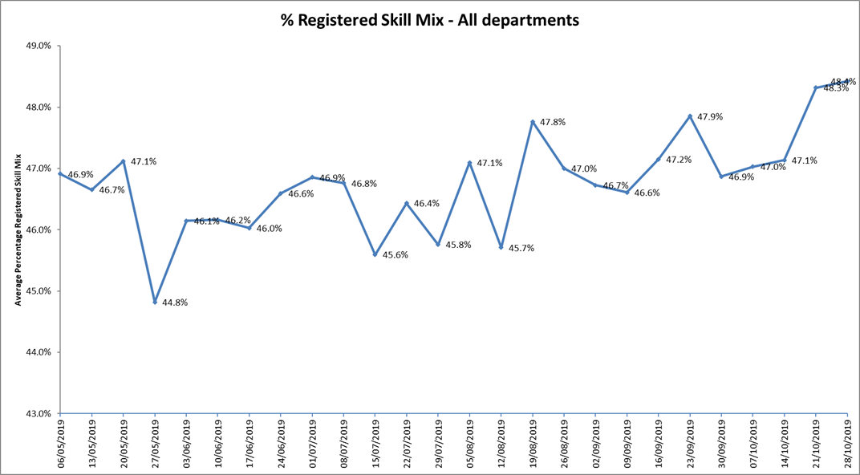

Three wards were below 35%, Kestrel for two of the three roster periods and Kennet and Watling in the first period.

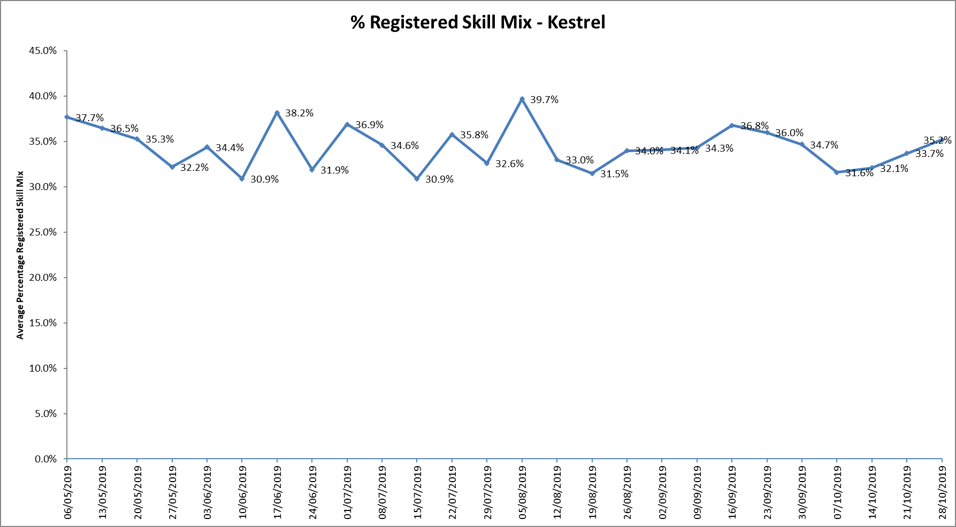

For those wards with below 50% registered skill mix, this is related to the continued registered nurse vacancies. Safe staffing is supported by the ward managers and matrons on the ward working clinically as part of the numbers where required to ensure registered nursing leadership is maintained.

Skill mix is achieved through use of our own staff and trust employed flexible registered workers and agency registered nurses.

**Agency use**

The Trust moved to a new approach to reduce the use of unregistered agency staff in the week of 14.5.18. Ongoing work to reduce use of Trust wide use of agency is in progress. A temporary Staffing programme board is being set up and will be chaired by the Chief Nurse with 4 work streams including recruitment and retention. The work streams will be either clinically chaired or have full engagement from clinical staff including matrons and senior matrons.

Further detail of this project is provided in the HR workforce report.

The average weekly % agency use was 10.2 % a slight reduction from 9.5% in the last reporting period. This remains below the peak of 19.1% in February 2018.

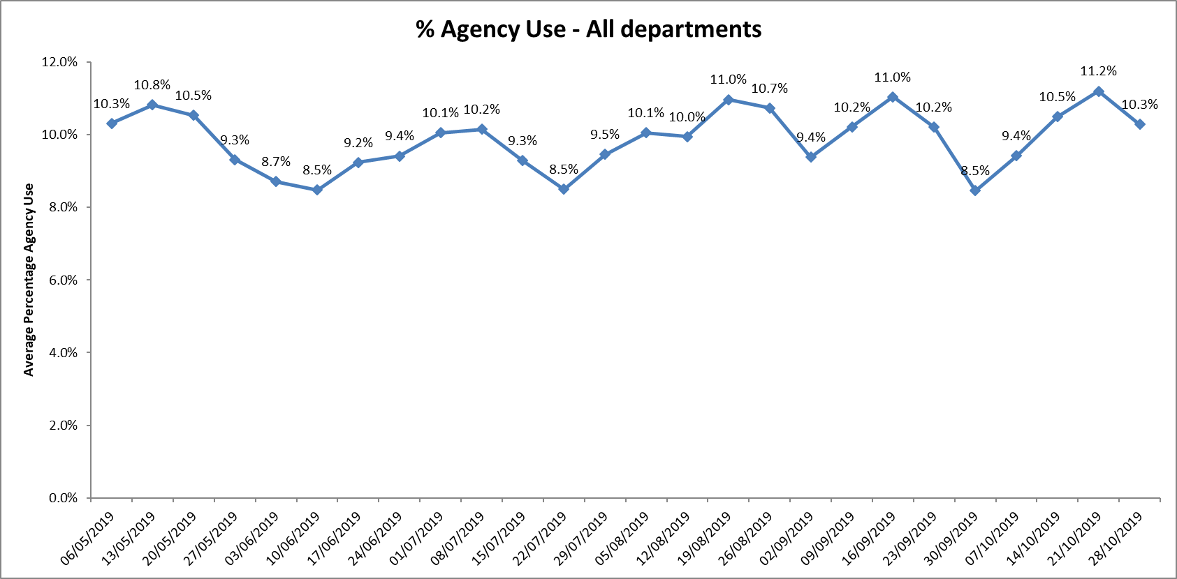

* Nine wards required less than 5% average agency use during first period and last period this dropped to eight wards in the period - 9th September 2019 to 6th October 2019
* Allen ward required above 20% agency staff throughout this 12-week period.
* Kestrel, Kingfisher, Oxfordshire Stroke Rehabilitation Unit, Wallingford, Didcot, Ashurst and Vaughn Thomas required above 20% average in one four week period.
* This was related to a mixture of sickness, vacancies and patient acuity

Further detail of agency use and spend is provided in the Workforce report.

**Update on Establishment and Skill Mix Reviews**

In July 2019, the detailed outcome of the inpatient work was reported to the Board. The next step is now in progress with regular inpatient staffing meetings in place.

The purpose of these meetings is to:

* Review inpatient establishments with a formal review every 6 months
* Understand true vacancy levels
* Discuss operational issues around working to agreed establishments
* Understand financial performance on inpatient units
* Understand the data from Safe Care
* Other issues relating to inpatient establishments

In addition, the finance team have worked with ward managers and matrons to discuss and explain new budgets with revised skill mix in place to ensure revised skill mix understood and to ensure ongoing recruitment to roles. As part of these meetings monthly vacancy date is provided from finance to enable wards managers and matrons to see this against budgeted establishment and support ongoing recruitment work to revised skill mix.

**Vacancy data M7 2019**

The detailed vacancy data is provided below, as part of the skill mix work there has been an increase in Band 6 roles, with most areas increasing by one per ward to support the nursing leadership on the ward and provide increased career opportunities. These roles are being recruited to, both internally and externally if this is needed. There has been proactive work to ensure nursing associate trainees are in place across the inpatient wards to develop future Band 4 Nursing Associates. There are 113 trainees from across the wards.

**Forensic wards**

Three of these wards continue to have high registered nurse vacancies, Kingfisher, Kestrel and Evenlode.

**Band 6 Vacancies** 

**Band 5 Nurse Vacancies**



**Oxfordshire Adult Wards**

Ashurst, Allen, Vaughn Thomas continue to have high vacancies at Band 5 & Band 6.

**Band 6 Nurse vacancies**



**Band 5 Nurse Vacancies**



**Buckinghamshire wards**

These wards have improved vacancy rates and work with the University of Bedfordshire continues to support securing newly qualified nurses into roles.

**Band 6 Nurse Vacancies**



**Band 5 Nurse Vacancies**



**Adolescent units**

These units have improved staffing following proactive recruitment work including an international recruitment at Highfield and seconded nurse students returning post graduating.

**Band 6 nurse vacancies**



**Band 5 nurse vacancies**



**Eating Disorder Units**

**Band 6 Nurse Vacancies**



**Band 5 Nurse Vacancies**



**Community Hospitals**

**Band 6 nurse vacancies** Recruitment for Band 6 vacancies will include external advertising to further develop the nursing leadership on the wards.



**Band 5 Nurse Vacancies**

Staff from City Community hospital have been working across other sites so this is affecting the Band 5 establishment overall.



**Recruitment and retention**

Nursing recruitment work with Oxford Brookes and Oxford University Hospital Trust continued this year working together as the Oxford School of Nursing & Midwifery.

It has been strengthened in academic year 2019/20, with timetabled career and employment events scheduled for year 2 and 3 students across all pathways. The first one was completed on November 7th 2019, over 60 students attended to meet clinical staff, discuss preceptorship and ongoing continuing professional development and post qualifying job opportunities. Students will continue to be able to have a streamlined recruitment process in year 3.

**Staffing Forward View – using Safe Care**

Background

Oxford Health NHS Foundation Trust has been using information the Safe Care System to help with staff planning for over two years. The staffing software matches staffing levels to patient acuity, providing control and assurance from bedside to board. It enables comparison of staff numbers and skill mix alongside actual patient demand in real time, allowing informed decisions about staffing and creates acuity driven staffing.

To work to date:

Data that is inputted into the system is reviewed at a senior level within the Trust on a weekly basis to identify themes and key areas for action. Main focus of the work has been undertaken to ensure that there is good compliance with data collection and it is now required that operational managers and clinical leads use this information in a more proactive way to identify key areas of risk around staffing in advance and put effective actions in place at an early stage to minimize risk and support staff

A process has been established across the Trust for doing this has been implemented in October 2019. This process has been incorporated into existing arrangements for bed and staffing capacity management i.e. teleconferences that already happen. The process is slightly different in each Directorate dependent on local arrangements. There are, however, key principles that are common to all Directorates:

• Twice weekly teleconference within each Directorate

• These are facilitated by the Heads of Nursing and attended by Matrons, a Head of Service and a member of the Staffing Solutions team.

• Prior to the teleconference a spreadsheet is circulated to those on the call

• This spreadsheet identifies any gaps in staffing for the following two weeks

• The Head of Nursing guide a structured discussion that identifies shifts that are of concerns and identifies any actions that need to be taken to mitigate or address concerns

• Confirmation that actions have been taken and outcomes will occur at the next meeting

**Conclusion**

All ward staff and managers continue to make every effort to ensure wards continue to be staffed safely, fill rates remain high for most wards and that we continue to focus efforts on retaining our staff whilst recruiting new nurses to join Oxford Health FT. Skill mix review work has been progressed to include Nursing associates and other roles this will support recruitment and retention of staff to inpatient areas.

**Author and Title:** Kate Riddle, Deputy Director of Nursing and Clinical Standards





