

**BOD 88/2019**

(Agenda item: 8)

# Report to the Meeting of the

# Oxford Health NHS Foundation Trust

# Board of Directors

**25th September 2019**

**Monthly Performance Report – M5 August 2019**

**For: Information**

**Executive Summary**

This report summarises the Trust’s national and locally contracted key performance indicators (KPIs) for Month 5 (August) 2019. Overall, the Trust achieved 275 out of 378 targeted indicators (73%)

**Performance Trend:**

The number of locally **contracted** indicators (excluding JMG) varies throughout the year as is illustrated in the graph above. This is due to some indicators only being reportable on a quarterly basis. Of the 103 indicators not met in August, 52 were more than 10% away from the commissioner defined targets (red category) and **demand exceeding workforce capacity** continues to have a major impact on service delivery.

**Areas to highlight to the Board from an overall Trust perspective**:

**National Position:**

The table overleaf shows how the Trust is performing against the **operational performance** indicators within the NHSI Single Oversight Framework (SOF) (as at the latest available position) and how performance also compares to the national average.

Highlights include;

* The Minor Injuries Unit performance was at 97% in August. This is above the 95% national target and an improvement over the last 6 months where performance was just below target.
* Out of Area Placements (OAPs) is monitored on a quarterly basis within the SOF and the Trust has substantially improved its performance over the past 6 months. There has been a significant reduction in the number of patients sent out of area due to a shortage of available beds. The Trust is on track to achieve the planned improvement and progress against plan is shown in the table below.

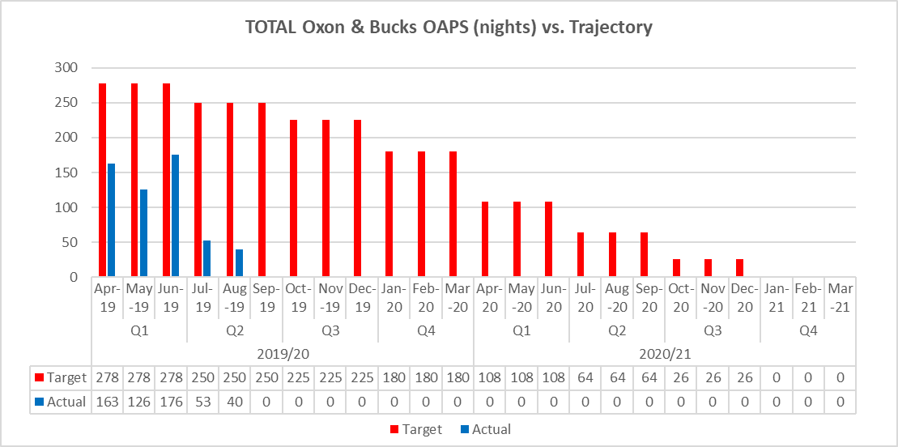



**Local Position:**

**Patient Access and Patient Flow**

The table in Appendix 1 shows performance in relation to the Trust’s core mental health community services concerning demand, patient access and patient flow. Key headlines;

* **Demand**

Despite comparable population sizes, the number of Adult Mental Health referrals received in Oxfordshire continues to be higher than in Buckinghamshire (35.5% higher in August).

The number of referrals received by CAMH services has decreased in August which is consistent with seasonal variation. Overall referrals to the Trust’s CAMH services across Oxon, Bucks, and BSW were 1276 in August which is 14% lower than this time last year. The average number of monthly referrals between September 2018 and August 2019 was 2164.

* **Access/Waits**

**Adult Mental Health** – A significant long-term underfunding of mental health in Oxfordshire has resulted in considerable pressure building up for mental health services.  Although the waiting time target was changed to 8 weeks, with the current levels of resources available, this position remains challenging. In August 52% of routine referrals were seen within 28 days.

**Child & Adolescent Mental Health (CAMH)** During August access to the Oxfordshire and Buckinghamshire CAMH services continued to be challenging, with only 29% of patients referred to routine pathways seen within 12 weeks in Oxon and 64% of patients seen within 4 weeks in Bucks. In Oxfordshire specifically, this decrease in performance was expected as the longest waiters are now being prioritised as part of an improvement plan agreed with Commissioners.

Emergency referrals continue to be prioritised within available resources and all patients since last October have been seen within the 4-hour target.

An action plan is in place with Buckinghamshire CCG in relation to Bucks CAMHS waits. A review of the waiting times report rules is in progress as part of this plan.

* **Delayed Transfers of Care (DTOC)**

In August, bed days lost to DTOC in mental health has reduced from last month at 170 (equivalent to 6 beds), compared with a rolling 12 month average of 192 (7 beds). Community DTOC increased by 129 days in August to 1406 bed days lost (equivalent to 48 beds), with a rolling 12 month average of 1301 days per month (42 beds).

* **Out of Area Placements (OAPs)**

2 new patients were placed out of area in August. 4 patients in total were in out of area placements during the month utilising a total of 40 bed days in the month. The distance from patients’ home to placements ranged from 71 to 244 miles, with the average distance being 150 miles.

**Performance by Directorate in August 2019:**

**Oxfordshire, Swindon, Wiltshire & BaNES – All Ages Mental Health** achieved 79 of the 126 targeted indicators (63%)

**Highlights for the Board:**

1. **Emergency Department Psychiatric Service (EDPS).** Although the EDPS service at the John Radcliffe Hospital saw all patients within the 90 min waiting time target in August, staffing pressures continue to affect performance at both the John Radcliffe and Horton General Hospitals.  The pressures have been reported to the Quality Review Meeting (Oxfordshire CCG) so that any identified risks to patients can be understood and mitigated. Until workforce shortages are resolved (through additional investment), the service will not be able to achieve the commissioner defined targets.
2. **CAMHS (Swindon, Wiltshire, Bath and North East Somerset) –** A comprehensive waiting time improvement plan has been put in place by the service and shared with the commissioners (from April 2019). Implementation is being overseen by a new Outcomes Performance and Improvement Group chaired by the Head of Service. Regular updates on performance are provided to commissioners at bi-monthly Contract Review Meetings. The plan is beginning to have a positive impact on waits with improvements seen throughout July and August.

**Buckinghamshire – All Ages Mental Health** achieved 29 of the 46 commissioner targeted indicators (63%).

**Highlights for the Board:**

1. **Bucks Care Reviews** – Ensuring that Care Reviews are carried out within the timeframes set out in the clusters continue to be an area of underperformance for the Directorate. This issue also affects performance in Oxfordshire. A new Carenotes dashboard has gone live in September that will give clinicians greater visibility of their caseload which will include early warning of when care reviews are required. As at August 60% had their review within time. Now that the new dashboard is operational, performance against this particular indicator is expected to improve.
2. **Bucks CAMHS** – The percentage of routine referrals assessed within 4 weeks continues to be below target at 65% for August. Performance is impacted by Patient choice. The service is requesting a change to the measure with commissioners, currently it is “The count of routine referrals seen within 4 weeks” the service is proposing that the measure should be “The count of routine referrals offered within 4 weeks” as patient choice is not within the Trust’s control. They will also be conducting a deep dive around all August breaches to ensure they have a robust process for reporting and recording for the new rules for this incentivised measure.

**Oxfordshire Community Services Directorate** achieved 60 of the 75 commissioner targeted indicators (80%)

**Highlights for the Board:**

1. **Community Hospitals** - The percentage of interim inpatient discharge letters (MDT letter for Community Hospitals) that are sent back to GPs within 24 hours of discharge has shown a period of continuous improvement: M1 73%, M2 62%, M3 83%, M4 89% M5 91% - no longer on the Board report. A better IT solution combined with local efforts by staff has delivered the improved performance.
2. **Buckinghamshire CHC** – The Trust continues to underperform against the referrals completed within 28 days target. However continuous improvement has been shown since May 2019.
3. **Oxfordshire CHC –** TheOxfordshire CCG has recognised the challenges of the 28 day target and is now organising a system-wide Task & Finish group that will have oversight of 4 different workstreams:
4. Reducing potentially unwarranted variation in CHC;
5. Improving commissioning and procurement;
6. Personalisation;
7. Sustaining and improving quality.

The latter workstream will be addressing performance against the contracted KPIs. The CCG has acknowledged that some of the contributing factors are external and that a collaborative approach is required to achieve a system wide improvement.

* **Specialised Services** achieved 100 out of 123 targeted indicators (81%)

**Highlights for the Board:**

1. **Eating Disorders (Bed Occupancy)** – The service has implemented a Single Point of Access (SPA) as part of the New Care Models improvement work and expect bed status to improve as patient flow becomes established across the network. There is a monitoring mechanism in place that is overseen by the Forensic Senior group.

**Recommendation**

The Board of Directors is asked to review and note the Board Performance Report.

**Author and Title:** Martyn Ward – Director of Strategy & Chief Information Officer

**Appendix 1 – Patient Access and Flow**

