

# Report to the Meeting of the

# Oxford Health NHS Foundation Trust

**BOD 90/2019**  
(Agenda item: 10)

# Board of Directors

# 25th September 2019

# INPATIENT SAFER STAFFING Report Period 17th June to 11th August 2019

**For: Information**

**Executive Summary**

**Ward Staffing**

The purpose of this paper is to provide the Trust Board with an interim exception report in line with the requirements of: “How to ensure the right people with the right skill are in the right place at the right time”, Chief Nursing Officer for England & National Quality Board November 2013. From June 2014, there has been a Department of Health requirement for trust boards to receive monthly updates on ward staffing levels. Ensuring sufficient staffing levels are in place is crucial to deliver safe, effective and high-quality care. This report will be published on our website with a link from NHS Choices website.

The data within the report will outline the staffing levels (for both registered and unregistered nursing staff) on each ward. These figures will be measured against the required figures on a shift by shift basis for the period 17th June to 14th July and 15th July to 11th August 2019 (two months’ roster period) in line with the requirements of the DH Unify reporting process and the data extract is attached (Appendix 1).

During this period:

Average weekly day shifts fill rates for registered staff & unregistered staff were above the Trust target of 85% with 93% or above for unregistered and 98% or above for registered staff.

Two wards were below 85% target for average weekly fill rates for registered nurse day shifts during this total period. This is decreased from nine wards as reported in July 2019. The wards were Sandford at 78% throughout and Vaughn Thomas (74% and 78%). Both wards had increased levels of unregistered staff.

City ward remained closed temporarily during this period.

Average weekly night shifts fill rates for registered staff and unregistered staff across all wards was above the Trust target of 85% rates remained above 100% for registered staff for each week and above 93% for unregistered staff

The methods of filling these shifts includes substantive, flexible workers and agency registered staff and further detail in provided later in the report.

The average weekly % agency use was 9.5% a slight reduction from 9.8% in the last reporting period.

Average sickness rates for ward staff were 5.8% a decrease from 6.23% in the last reporting period.

This report also includes an update on the skill mix and staffing establishment reviews work, recruitment and retention and Safe Care use.

**Recommendations**

The Board is asked to note:

* There are processes in place to ensure safe staffing levels on all the wards in the organisation, those wards where there are concerns and the actions being taken to ensure safe staffing including project work and wider recruitment and retention work. There are no exceptions to report that directly link actual staffing levels to adverse outcomes for patients which have been identified through our Governance Structures.

**Author and Title:** Kate Riddle, Deputy Director of Nursing and Clinical Standards

**Lead Executive Director:** Marie Crofts Chief Nurse

*A risk assessment has been undertaken around the legal issues that this paper presents and there are no issues that need to be referred to the Trust Solicitors. This paper links to all the five CQC Domains.*

***Strategic Objectives*** *– this report relates to or provides assurance and evidence against the following Strategic Objective(s) of the Trust*

*Driving Quality Improvement (Goals: patients will be safe from harm; patients will achieve the clinical outcomes they want; and patients and carers will have an excellent experience)*

*Delivering Operational Excellence (Goals: our services will be effective and efficient; information will be translated into knowledge; and our planned surplus will be delivered)*

**Inpatient Safer Staffing**

Period 17th June to 14th July and 15th July to 11th August 2019.

**Introduction**

This is the report to the Board of Directors outlining the staffing levels (registered and unregistered) on each ward against their required need on a shift by shift basis. These figures will be measured against the required figures on a shift by shift basis for the period 17th June to 14th July and 15th July to 11th August 2019 (two months’ roster period)

This report will focus on the percentage of day and night fill rates for registered and unregistered staff. This data is reported to NHSI and provides assurance of actual clinical staffing numbers being achieved. This report will be published on our website with a link from NHS Choices website.

**Management of Staffing Levels**

Anescalation process for the management of staff shortages is in place within each clinical area, to manage staffing safely on a shift by shift basis. As part of this process, senior clinical staff are providing appropriate support to ward teams as and when required. In addition, senior ward staff and immediate team managers review ward staffing levels on an on-going basis; shift by shift basis, and where there are changes in patient acuity. Ward Matrons review staffing daily as a minimum and more frequently where required.

In-patient staffing levels continue to be reported every week and discussed within the Weekly Review Meeting (WRM), which takes place each Monday morning with the Chief Nurse and/or Deputy present. To ensure that staffing levels are under continual review, every ward undertakes a range of immediate actions daily to ensure safe staffing levels are maintained appropriate to the needs of patients. These actions include booking flexible or agency staff via Staffing Solutions, revising rotas, moving staff between wards and utilising additional staff that are not included in the ward numbers as required for example modern matrons.

**Summary position of inpatients wards staffing levels.**

Appendix 1 shows the staffing levels for all wards by ward for the period 17th June to 14th July and 15th July to 11th August 2019. The data presented includes details of staffing by shifts and details of registered nursing and unregistered staff skill mix, agency, total ward staff sickness and total ward vacancy figures. The thresholds presented in the table are measured against trust/ national targets and used for exception reporting.

During this period:

**Day shifts fill rates**

Average weekly day shifts fill rates for registered staff & unregistered staff were above the Trust target of 85% with 93% or above for unregistered and 98% or above for registered staff.

Two wards were below 85% target for average weekly fill rates for registered nurse day shifts during this total period. This is decreased from nine wards as reported in July 2019. The wards were Sandford at 78% throughout and Vaughn Thomas (74% and 78%). Both wards had increased levels of unregistered staff.

City ward remained closed temporarily during this period.

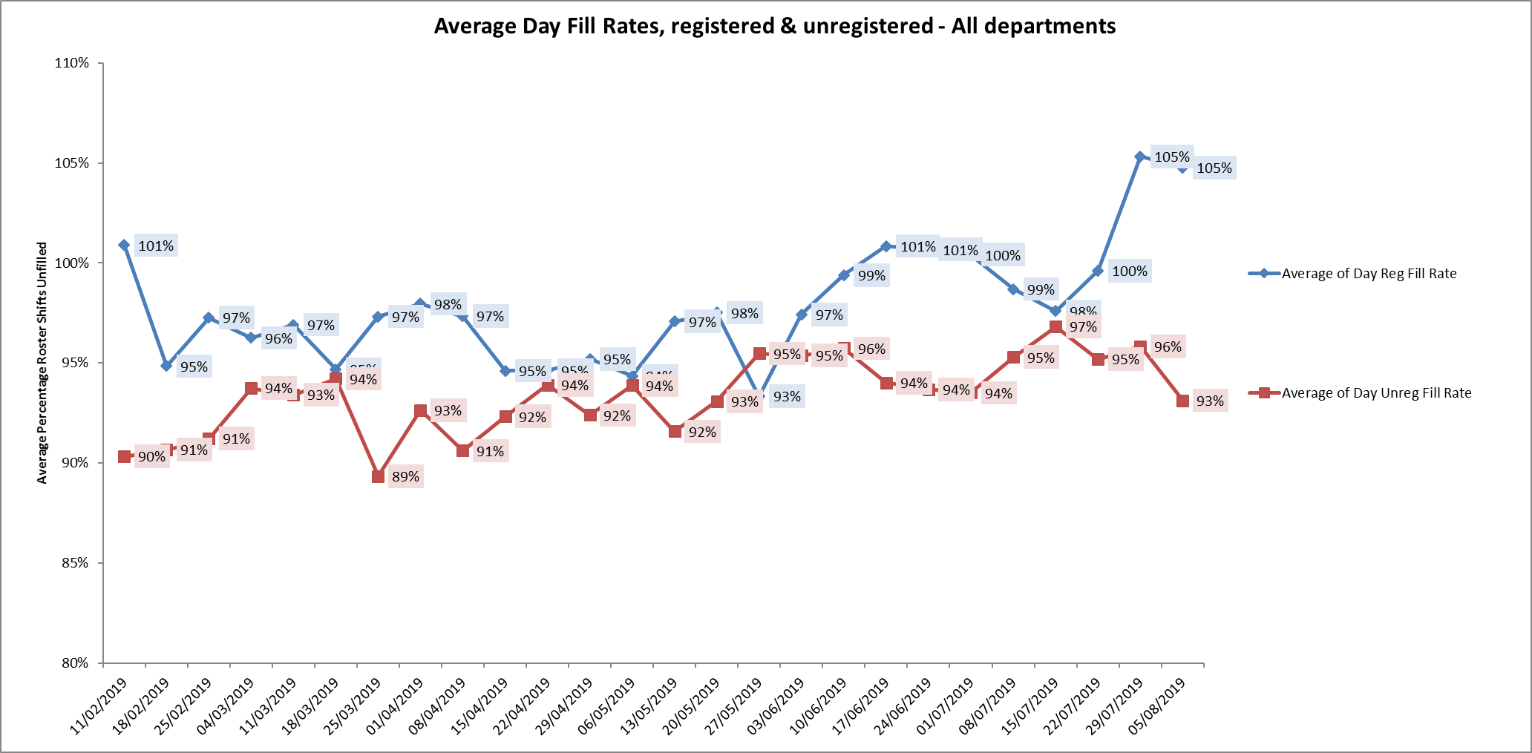

**Night shift fill rates**

Average weekly night shifts fill rates for registered staff and unregistered staff across all wards was above the Trust target of 85% rates remained above 100% for registered staff for each week and above 93% for unregistered staff

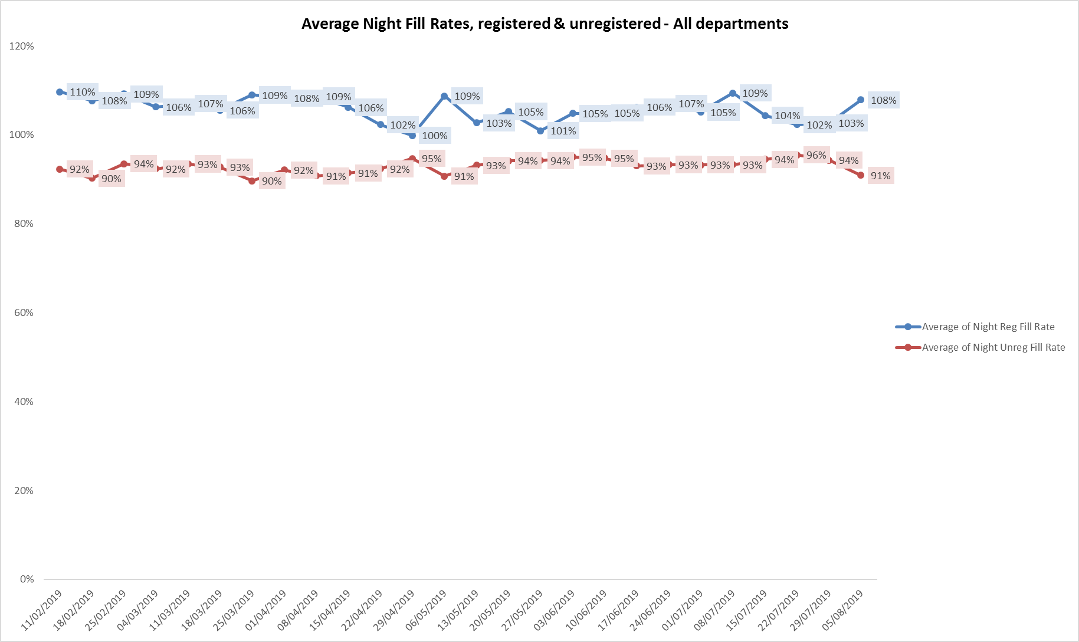

**Registered skill mix**

In the period 17th June to 14th July

Ten wards had in place an average of 50% or above registered staff skill mix, an increase of two from last period. One ward had below 35% skill mix this was forensic ward Kennet.

In the period 15th July to 11th August:

Twelve wards had in place an average of 50% or above registered staff skill mix, two wards Kennet and Kestrel were below 35%.

For those wards with below 50% registered skill mix, this is related to the continued registered nurse vacancies. Safe staffing is supported by the ward managers and matrons on the ward working clinically as part of the numbers where required to ensure registered nursing leadership is maintained.

Skill mix is achieved through use of our own staff and trust employed flexible registered workers and agency registered nurses.

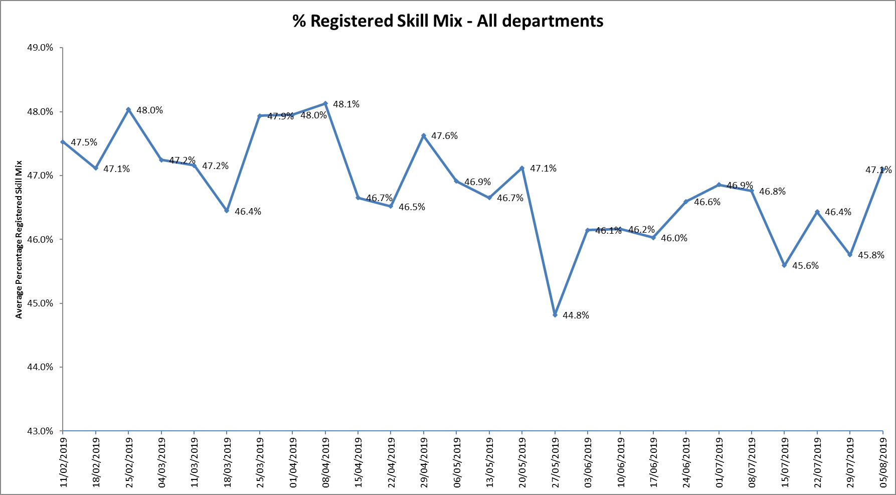

**Agency use**

The Trust moved to a new approach to reduce the use of unregistered agency staff in the week of 14.5.18. Ongoing work to reduce use of Trust wide use of agency is in progress. A temporary Staffing programme board is being set up and will be chaired by the Chief Nurse with 4 work streams including recruitment and retention. The work streams will be either clinically chaired or have full engagement from clinical staff including matrons and senior matrons.

Further detail of this project is provided in the HR workforce report.

The average weekly % agency use was 9.5% a slight reduction from 9.8% in the last reporting period. This remains below the peak of 19.1% in February 2018.

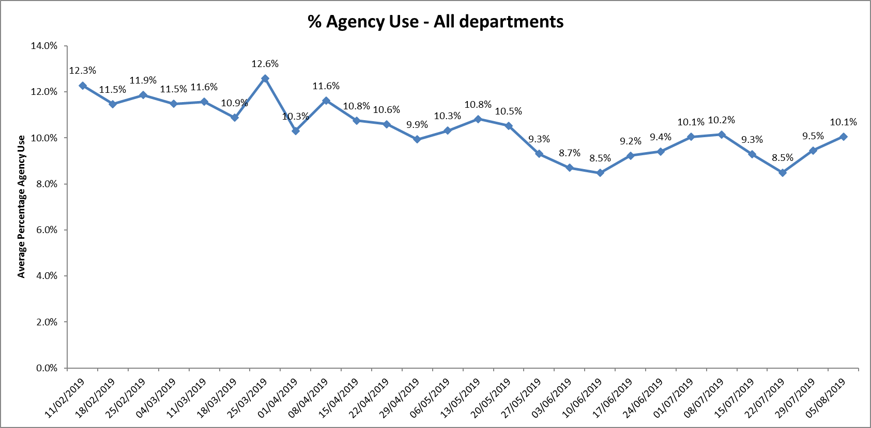

* Nine wards required less than 5% average agency use this increased to ten wards in the second period.
* Two wards continued not to use any agency in whole period Chaffron and Watling.
* Two wards Kestrel and Kingfisher required above 20% agency staff throughout this period,
* Oxfordshire Stroke Rehabilitation Unit required above 20% average in the second period
* This was related to a mixture of sickness, vacancies and patient acuity
* Highfield Unit have a high use of tier 5 agency; this has been due to packages of care agreed with NHSE and are therefore 'cost neutral' to the Trust. The implementation of a new coding system on FWMS will enable an oversight of clean data moving forward and a much clearer, accurate picture of when agency use is required.

Further detail of agency use and spend is provided in the Workforce report.

**Update on Establishment and Skill Mix Reviews**

In July 2019, the detailed outcome of the inpatient work was reported to the Board. The next step is now in progress with monthly inpatient staffing meetings in place. The first one commenced in August 2019 for mental health wards including CAMHs and Forensics.

The purpose of these meetings is to:

• Review inpatient establishments with a formal review every 6 months

• Understand true vacancy levels

• Discuss operational issues around working to agreed establishments

• Understand financial performance on inpatient units

• Understand the data from Safe Care

• Other issues relating to inpatient establishments

In addition the finance team have worked with ward managers and matrons to discuss and explain new budgets with revised skill mix in place to ensure revised skill mix understood and to ensure ongoing recruitment to roles.

**Recruitment and retention**

Nursing recruitment work with Oxford Brookes and Oxford University Hospital Trust continued this year

It is to be strengthened in academic year 2019/20, with timetabled career and employment events scheduled for year 2 and 3 students across all pathways. These will provide an opportunity for students to meet clinical staff, discuss post qualifying job and career opportunities. Students will continue to be able to have a streamlined recruitment process in year 3.

Preceptorship

Preceptorship has 3 elements within the Trust:

1. Preceptor Support (supported by Online Training Record).
2. Service/Profession skills/Competencies required for role (Technical Skills).
3. Learning & Development delivered sessions (Non-Technical Skills).

* (**Flyer Programme**) This element is for newly registered nurses and AHPs
* Newly registered, Registered Nursing Associates (RNA’s) (RNA Preceptorship Programme).

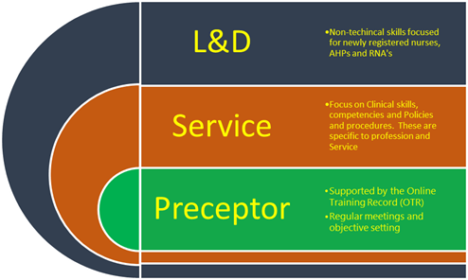

**FLYER PROGRAMME** update

The Flyer Programme content stands on its own as Health Education England (HEE) recognised preceptorship standards and Department of Health (DH) best practice. Oxford Brookes University (OBU) will be accrediting the module for Year 1 of the Flyer Programme with a 20 credit Masters module.

A celebration event for the inaugural intake of nurse and AHP preceptees onto the OHFT Flyer Programme. Of the 72 staff who started in October 2018, 66 staff have completed the Flyer Programme, the event is to celebrate their completion of Year 1 of the programme (and preceptorship period). The advances over this period are noteworthy but for the preceptees, the 19th Sep will be their 6th and final day of Year 1 and marks the end of their preceptorship period. In Year 2 they will have opportunity to gain additional Master modules;

Cohort two commenced in March 2019 lead by Steve Marcus Preceptorship Lead who is also a QI scholar whose project is to implement a system for preceptee identification and for extracting the retention data.

Nursing Associates- update on recruitment

Started April 2017, qualified summer 2019                                                                              22

Started June 2018, due to complete May 2020                                                                     28

Started October 2018, due to complete September 2020                                                55

Started start May 2019                                                                                                              55

Further recruitment planned for October 2019.

Preceptorship to support our 1st cohort of the 22 Registered Nursing Associates commenced in September 2019. The programme would then be reviewed, and the intention would be to run 2 courses a year (mirroring the flyer programme run) to capture all newly qualified Nurse Associates as they start in the Trust.

**Staffing Forward View – using Safe Care**

Background

Oxford Health NHS Foundation Trust has been using information the Safe Care System to help with staff planning for over two years. The staffing software matches staffing levels to patient acuity, providing control and assurance from bedside to board. It enables comparison of staff numbers and skill mix alongside actual patient demand in real time, allowing informed decisions about staffing and creates acuity driven staffing.

To work to date:

Data that is inputted into the system is reviewed at a senior level within the Trust on a weekly basis to identify themes and key areas for action. Main focus of the work has been undertaken to ensure that there is good compliance with data collection and it is now required that operational managers and clinical leads use this information in a more proactive way to identify key areas of risk around staffing in advance and put effective actions in place at an early stage to minimize risk and support staff

Next steps:

A process has been established across the Trust for doing this that will be implemented from the week commencing 23th September 2019. As far as possible this process will be incorporated into existing arrangements for bed and staffing capacity management i.e. teleconferences that already happen. The process will be slightly different in each Directorate dependent on local arrangements. There are, however, key principles that are common to all Directorates:

• There will be a twice weekly teleconference within each Directorate

• These will be facilitated by the Heads of Nursing and attended by Matrons, a Head of Service and a member of the Staffing Solutions team.

• Prior to the teleconference a spreadsheet will be circulated to those on the call

• This spreadsheet will identify any gaps in staffing for the following two weeks

• The Head of Nursing will guide a structured discussion that identifies shifts that are of concerns and identifies any actions that need to be taken to mitigate or address concerns

• Confirmation that actions have been taken and outcomes will occur at the next meeting

Further update to be provided in subsequent Board Reports

**Conclusion**

All ward staff and managers continue to make every effort to ensure wards continue to be staffed safely, fill rates remain high for most wards and that we continue to focus efforts on retaining our staff whilst recruiting new nurses to join Oxford Health FT. Skill mix review work has been progressed to include Nursing associates and other roles this will support recruitment and retention of staff to inpatient areas.

**Author and Title:** Kate Riddle, Deputy Director of Nursing and Clinical Standards



