Report to the Meeting of the

Oxford Health NHS Foundation Trust
BOD 92/2019
(Agenda item: 13)

Board of Directors

25th September 2019

Incident, Mortality and Patient Safety Quality Report

For: Information and Assurance

Executive Summary
This is a quarterly report which covers;
- Themes of incident reporting with detail by service, team and categories
- Themes being raised with the Freedom to Speak Up Guardian
- National developments covering the national patient safety strategy, world patient safety day and improvement collaboratives.
- Our response to national patient safety alerts
- Learning from deaths
- Serious incident and never events
- Reducing restrictive practice
- Themes from external reviews

Governance Route/Escalation Process
A more detailed version of this report was discussed at the last Safety Quality Sub-Committee in July 2019 and a highlight report presented to the Quality Committee in September 2019.

Recommendation
The Board is asked to note the report.

Author and Title: Jane Kershaw, Head of Quality Governance
Lead Executive Director: Marie Crofts, Chief Nurse

- A risk assessment has been undertaken around the legal issues that this report presents and there are no issues that need to be referred to the Trust Solicitors
- Strategic Objectives – this report relates to or provides assurance and evidence against the following Strategic Objective(s) of the Trust:
1) Driving Quality Improvement
(Goals: patients will be safe from harm; patients will achieve the clinical outcomes they want; and patients and carers will have an excellent experience)

Incident, Mortality and Patient Safety Quality Report

Introduction
This is a quarterly report which covers;
- Themes of incident reporting with detail by service, team and categories
- Themes being raised with the Freedom to Speak Up Guardian
- National developments covering the national patient safety strategy, world patient safety day and improvement collaboratives.
- Our response to national patient safety alerts
- Learning from deaths
- Serious incident and never events
- Reducing restrictive practice
- Themes from external reviews

A more detailed version of this report was discussed at the last Safety Quality Sub-Committee. The report is submitted to initiate discussion and to monitor improvements.

Overview of Reported Incidents

2.1 Number of incidents
Figure 1 shows reporting levels have increased from the point the Ulysses incident reporting system was introduced across all services from 2011. The increase in reporting in 2017 is largely a result of the transfer of the learning disabilities service from July, since then an average of 1255 incidents per month have been reported. High levels of incident reporting, particularly of those with no harm (60%) or minor harm (33%), is an indication of a positive learning environment.

No seasonality has been observed in numbers of incidents reported. Similar numbers of incidents are reported as occurring from Monday – Friday, while reduced numbers are reported on weekends. A review of the times incidents were reported as occurring (figure 2) showed that 29% of all incidents in the past year occurred between 10am and 1pm.

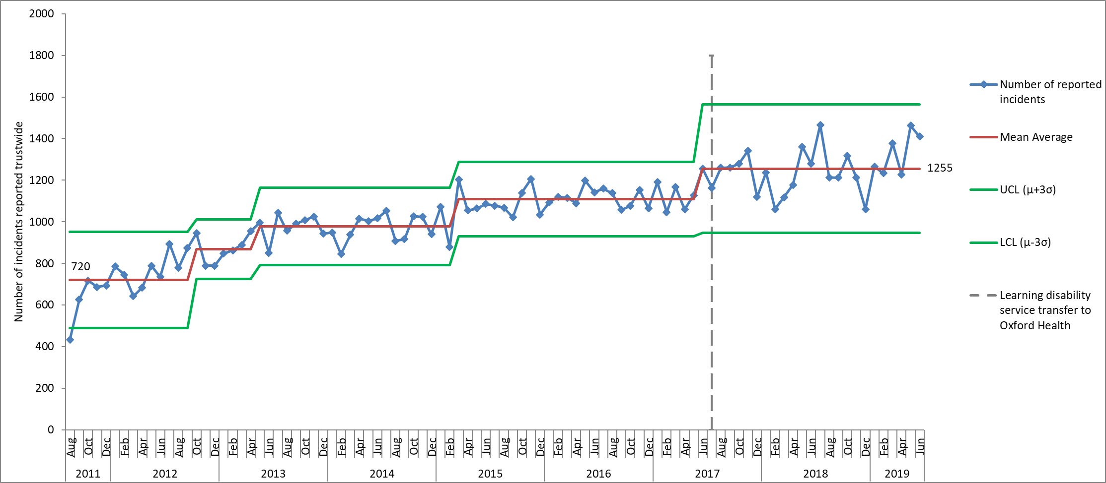
Figure 1. Control chart displaying monthly number of incidents reported on Ulysses incident reporting system from August 2011-June 2019
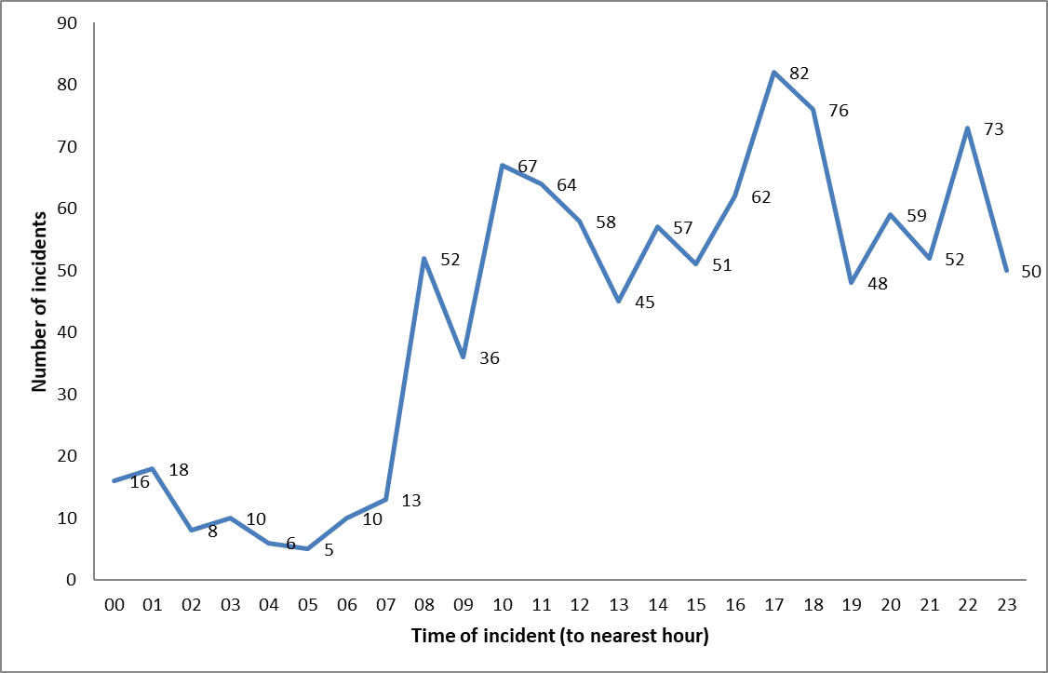
Figure 2. Number of incidents of Violence/Aggression on inpatient wards reported on Ulysses in past 6 months by time of incident (Jan – Jun 2019).

Actual Impact of Incidents
From April to June 2019, 4098 incidents were reported and 61% of these were reported as causing no harm. Of the 4098 incidents, 2240 (55%) were flagged as patient safety incidents and reported externally to the national reporting and learning system (NRLS). Of the patient safety incidents 60% resulted in no harm, 33% resulted in minor harm and 5% resulted in moderate harm. This is generally in line with the national picture according to the NRLS information up to September 2018, however, as discussed in previous reports, since Q4 16/17 a higher proportion of patient safety incidents have been reported by the trust in the category of severe harm/ property damage. This is as a result of the introduction of the category of SCALE in April 2017, and a decision within the directorate that grade 4 pressure ulcers and SCALE be graded a severe impact, even if there were no lapses in care. New national guidance was published to standardise pressure ulcers reporting and categorisation which should improve the accuracy of national comparison data in 2019.

In Q1 of FY 19/20 - 47 incidents were reported with major harm (excluding incidents of pressure ulcers that were present on admission also known as inherited), and of these 37 were flagged as patient safety incidents. Table 2 provides a breakdown of the major harm incidents. 23 were in the category of skin integrity, all of which were new grade 4 pressure ulcers. The skin integrity incidents occurred in 13 different departments; 11 District Nursing, one ILT and one Community Hospital. One of the District Nursing teams South East Oxford had four skin integrity incidents. Two out of the 23 skin integrity incidents are being investigated as serious incidents.

There were 7 incidents of self-harm that were graded as severe, all reported by different departments, and 4 of these were overdoses. The categories of patient safety incidents resulting in severe harm are provided in table 2 and details of all serious incidents are provided later in the report.

Table 2. Categories of patient safety incidents (PSI) reported with an actual impact of severe harm, April – June 2019
Cause 1 Category | Number of PSIs graded as severe | Number of serious Incidents
CM002 Delay In Providing Care/Treatment/Follow Up | 1
CN05 Transport Did Not Arrive | 1
Fi01 Fire - Wilful/Arson | 1
G02 Choking | 1
SH001 Self-Harm - Hanging | 1
SH003 Self-Harm - Cutting | 1
SH004 Self-Harm - Jumping | 1
SH005 Self-Harm - Overdose | 4
SI08 Category 4 New Pressure Ulcer (Developed In Service) | 23 | 2
SX13 Sexual Allegations Other | 1
VA012 Violence No Injury - Patient On Patient | 1
VA018 Violence With Injury - Public On Patient | 1
Total | 37 | 2

Incidents by Directorate
The clinical directorates went through a reconfiguration from 01.10.18, figure 4 shows the number of incidents reported based on where teams are managed within the new directorate structure.

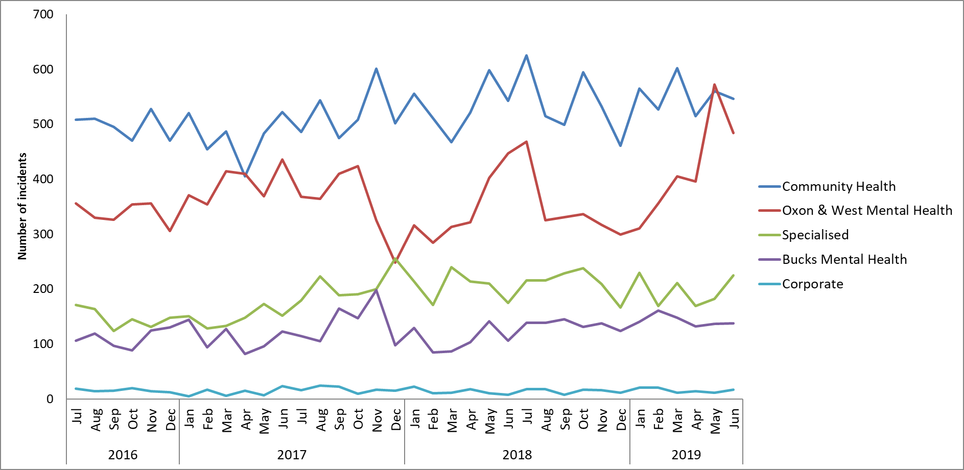
Figure 4. Reported incidents based on where teams are managed within the new directorate structure (following the changes in 01.10.18), April - June 2019

Community Health Directorate
Most incidents are reported by teams that now sit in the Community Health Directorate. Within this directorate numbers of incidents have increased within various services over the course of 2018, including Community Hospitals, GP OOHs, MIUs, Podiatry and Health Visiting.

Figure 5 shows the Community Health incidents by service line and shows that most incidents are reported by District Nursing with an average of 219 incidents per month, followed by Community Hospitals with an average of 135 incidents per month. Above average numbers of incidents have been reported by Community Hospitals in the past 6 months, a spike was seen in March 2019, but numbers have dropped since.

Within this directorate most incidents are reported in the cause group ‘Skin Integrity’ (33% in Q1, n= 529). In this reporting period this was followed by ‘communication/confidentiality’ with 13% (n=208), and then medication incidents and falls (with harm and not) with 10% each.

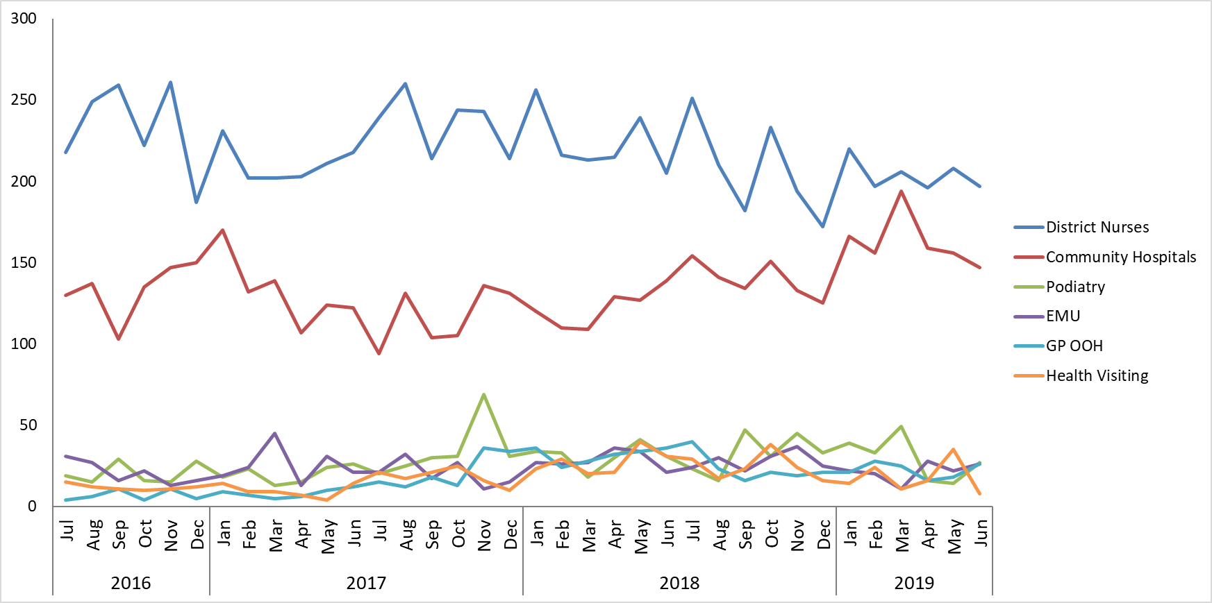
Figure 5. Incidents reported in the Community Health Directorate in services with most incidents, July 16 – June 2019.

Oxon & South West Mental Health Directorate
In this directorate most incidents are usually reported by adult acute mental health wards and CAMHS teams (figure 6), and numbers tend to fluctuate over time, often depending on the cohort of patients. In Q1 of 19/20 there was a particular spike in CAMHS incidents, this was a result of high numbers of incidents related to a few patients on the CAMHS Highfield and CAMHS Marlborough House wards.

In the Oxon & West Mental Health Directorate most incidents in the past 3 years have been reported in the category of Violence/Aggression (23%), followed by Self-Harm (22%) and Security i.e. AWOLs (11%). In Q1, however, 41% of incidents in the Directorate were attributed to self-harm (n=597), and 14% to Violence/Aggression (n=209). Of the incidents of self-harm, 80% occurred on CAMHS Highfield and CAMHS Marlborough House wards.

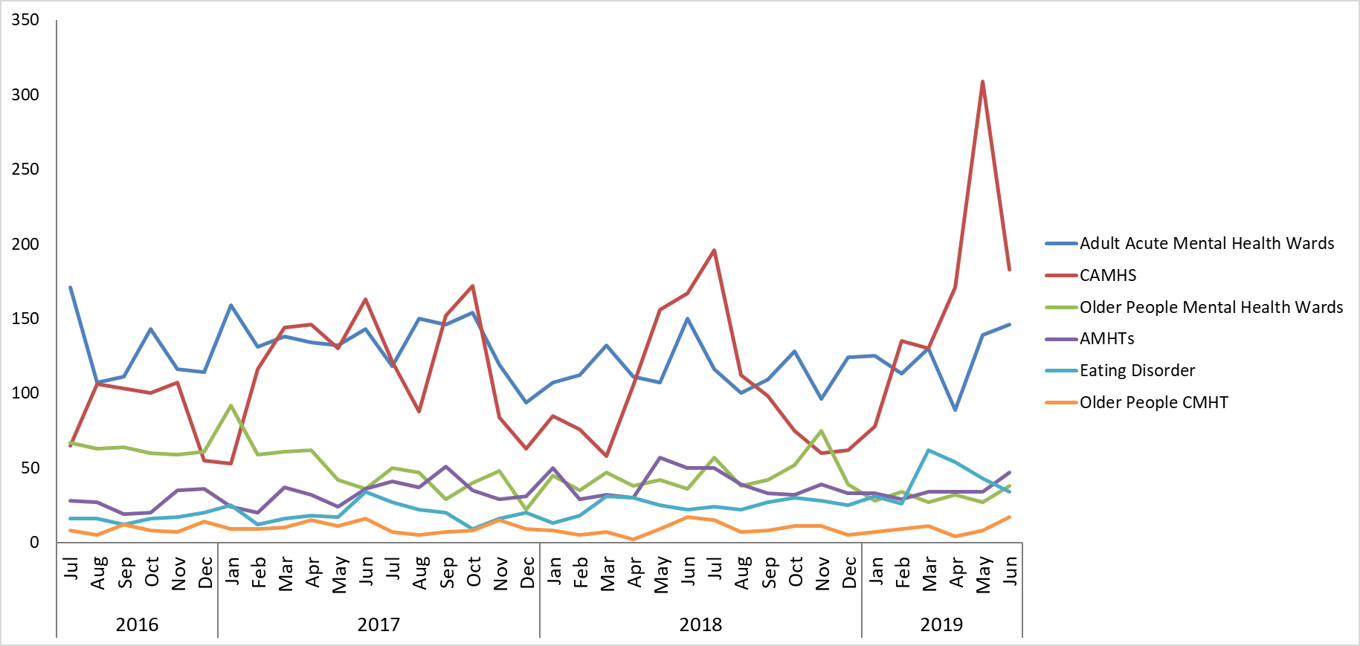Figure 6. Incidents reported in the Oxon & West Mental Health Directorate in services with most incidents, July 16 – June 2019.

Bucks Mental Health Directorate
In the Bucks Mental Health Directorate most incidents are reported by adult acute mental health wards (figure 7). As with the Oxon & West Mental Health Directorate most incidents in the past 3 years have been in the category of Violence/Aggression (25%). From April to June 2019, 407 incidents were reported in the Directorate and 110 of these were in the category of violence/aggression (27%), the next highest cause group was self-harm (13%, n=51), followed by Security with 11% (n=45), and medication incidents with 9% (n=37).

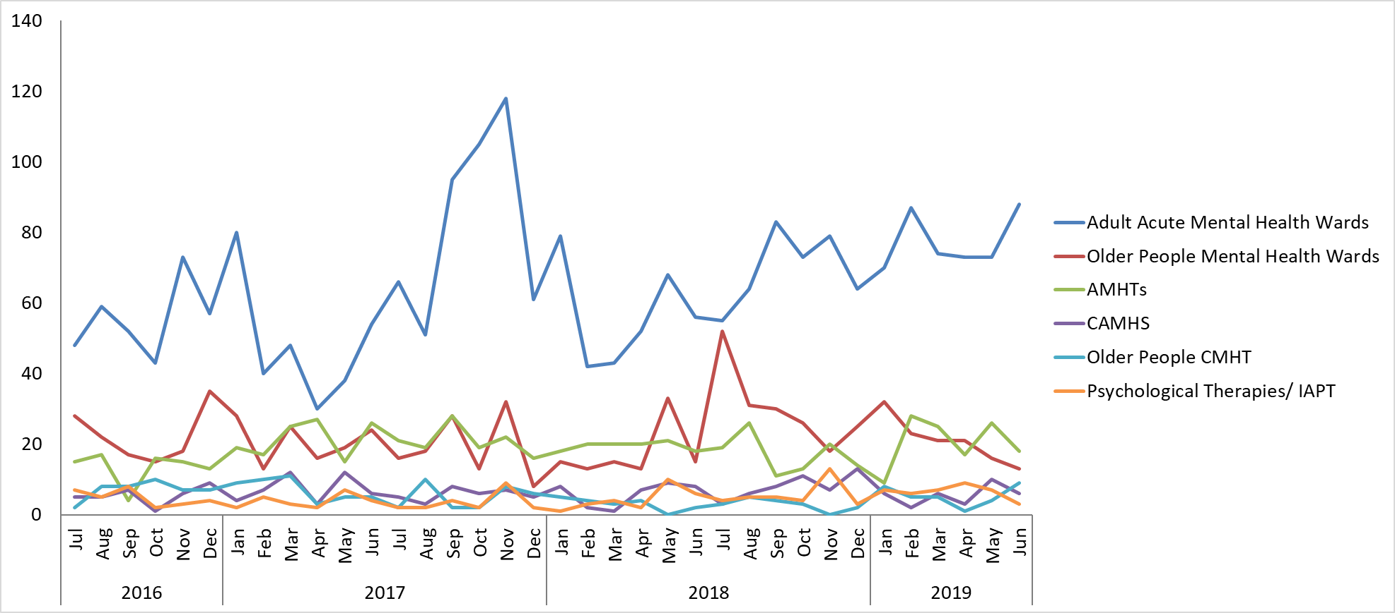
Figure 7. Incidents reported in the Bucks Mental Health Directorate in services with most incidents, July 16 – June 2019.

Specialised Service Directorate
Most incidents in this directorate are reported by forensic wards (figure 8). In July 2017 the learning disability service transferred to Oxford health, and the learning disability community teams now sit within the Specialised Service Directorate, along with the learning disability Forensic ward Evenlode. As a result of the service transfer the number of incidents has increased within forensic wards and in the Directorate as a whole.

Most incidents within this directorate are again reported in the categories of violence & aggression (36% since July 2017), security (14%) and self-harm (12%). In Q1 a total of 576 incidents were reported and 194 (34%) were as a result of violence & aggression and 98 (17%) were as a result of self-harm.

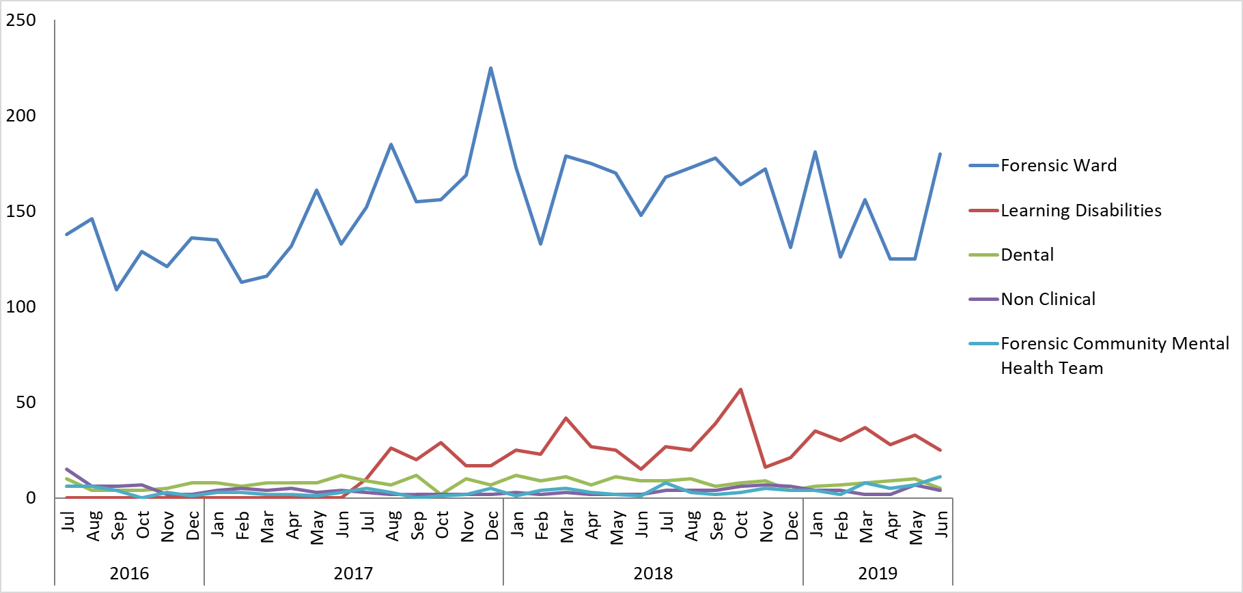
Figure 8. Incidents reported in the Specialised Service Directorate, July 16 – June 2019.

Service and Team level of analysis
Overall reporting has been reviewed for all departments over the past 3 years, July 2016 – June 2019.

Incidents per occupied bed days
For inpatient wards incident numbers have also been reviewed in the context of occupied bed days, trends remain the same as when looked at in terms of incident numbers alone. The rate of reporting on community hospital wards increased in 2018, with an average of 3.6 incidents per 100 bed days reported since June 2018, compared with 2.6 per month prior to that. Most community hospital incidents overall are reported by Linfoot ward with an average of 3.9 incidents/100 bed days since April 2015, however since the new dedicated Stroke Rehabilitation unit opened in July 2018, an average of 5 incidents per 100 bed days have been reported. The incidents in majority relate to falls, medication administration and insufficient staffing/ practice of agency staff. In April 2019 the clinical directorate carried out a deep dive into the quality of care in the unit and shared the outcome with the Quality Committee. There is currently a system review of the Oxfordshire stroke pathway with commissioners.

On mental health wards an average of 5 incidents/100 bed days have been reported per month over the same timeframe. Overall the ward that reports the highest number of incidents in relation to bed days is on CAMHS Highfield where an average of 15 incidents per 100 occupied bed days have been reported since April 15 (including bed days for the high dependency unit). Previously Kestrel ward had the highest proportion of incidents per occupied bed days, but incidents here have now reduced and from December to March an average of 7 incidents per 100 bed days were reported.

Adult Acute Mental Health Wards
Above average numbers of incidents have been reported on Sapphire ward in 9 of the past 10 months, with a peak in January 2019 when 38 incidents were reported, compared with a mean average of 21 per month since July 2016. Numbers have remained above average in Q1 and 92 incidents were reported in total. The increase on Sapphire has been as a result of an increase in incidents of violence & aggression, and 34 of the 92 Q1 incidents were in this category (37%). All of the incidents were graded as no harm or minor harm.

Overall most incidents on adult mental health wards continue to be reported by Ruby, where 97 incidents occurred in Q1, of these 39 (40%) were as a result of violence & aggression, 18 (19%) were due to self-harm, 12 to security and 11 to self-harm. Two incidents of self-harm on Ruby were graded as moderate and all other incidents were graded as no harm or minor harm.

Older People Mental Health Wards
In older adult mental health wards incidents declined on Sandford ward in the middle of 2017 and this has been maintained, meaning there has been an overall reduction in incidents in the service. However, Sandford ward was still the highest reporter in Q1 with 61 incidents in total. Of these 21 (34%) were as a result of violence & aggression, and 9 (15%) were fall related. On Amber most incidents were fall related (16 of 50 incidents, 32%), while on Cherwell most related to violence & aggression (10 of 36, 28%).

Forensic Wards
Evenlode ward was the highest reporter in Q1 with 71 incidents, and of these 62% were as a result of violence & aggression (n=44). Eight patients were involved in the incidents of violence/aggression, and one patient instigated 14 of them.

Following a decrease in incidents reported by Kingfisher ward in 2018 when an average of 7 incidents per month were reported, numbers have increased again and there was a spike in May when 31 incidents were reported. Overall in the quarter Kestrel was the second highest reporter with 67 incidents, of these 50% were attributed to self-harm (n=33) and 24% were attributed to violence & aggression (n=16). Three patients were involved in the self-harm incidents, with one patient harming on 15 occasions and another on 13 occasions.

Three incidents in the service were graded as severe, all were on Glyme Ward. One was as a result of arson by a patient, and 2 were incidents of violence with injury to staff, both instigated by the same patient. A serious incident investigation was carried out into the fire in April 2019 as well as a debrief with the fire service. No serious concerns in fire safety management or evacuation were identified.

AMHTs (Adult Mental Health Teams)
In increase in incidents was seen in the AMHTs in 2017, and an average of 57 incidents per month have been reported from March 2017 onwards. AMHT Oxon City & NE was the highest reported in Q1 with 49 incidents (28%), followed by AMHT Oxon South with 33 (19%) and AMHT Bucks Aylesbury with 28 (16%)

Of all the AMHT incidents in Q1, 18% (32 of 176) were in the category communication/confidentiality , 16% were in the category self-harm (n=28) and 19 unexpected deaths were reported. Four of the 19 deaths were reported as serious incidents, along with one incident of violence & aggression between a patient and their wife.

There were 5 serious incidents reported, relating to 3 in AMHT Bucks Chiltern AMHT, and 2 in AMHT Bucks Aylesbury. Seven further incidents in 4 different teams were graded as severe, 2 due to violence & aggression, 2 to physical illness, 1 to treatment delay, 1 to self-harm, and 1 to missing transport. One incident of manual handling by a staff member was reported as a RIDDOR in relation to carrying shopping for a patient from their car to the house.

CAMHS (Children and Adolescent Mental Health Services)
Numbers of incidents in CAMHS are generally very variable, and the peaks that are seen tend to be associated with high numbers of incidents for particular individuals. CAMHS Highfield is consistently the highest reporter, with 56% of incidents in the past 3 years. As discussed, numbers were high on both CAMHS Highfield and CAMHS Marlborough House wards in Q1, with a particular spike on Marlborough house in May when 144 incidents were reported compared with a mean average of 34 per month since July 2016.

Overall 385 incidents occurred on Highfield in Q1 (compared with 262 in the previous quarter and 89 in the one before that) of these 297 (77%) were as a result of self-harm. The self-harm incidents involved 18 different patients, with one patient harming on 107 occasions and another on 61. Of the 297 self-harm incidents, 97% were graded as no harm/minor harm. Five of the incidents were graded as moderate and 1 incident of cutting was graded as severe.

Of the 239 incidents reported by CAMHS Marlborough House in Q1, 74% (n=178) were as a result of self-harm. Eight patients were involved in the incidents with one patient harming themselves on 152 occasions. All of the self-harm incidents were graded as no harm or minor harm.

Two CAMHS community incidents were graded as severe, one was an overdose in CAMHS Bucks getting more help, and the other was as the result of a blood pressure machine not working. One CAMHS incident is being investigated as a serious incident because an under 18 was admitted to an Adult ward.

Community Hospitals
Following the spike in community hospital incidents in March 2019 when 186 incidents were reported, numbers dropped but were still above average in Q1 (average = 135 /month). This continues to be a result of incidents on the Stroke Rehabilitation Unit (OSRU), where 90 incidents were reported in Q1. Of these 19 were fall related (21%), 13 were medication incidents (14%) and 10 related to insufficient staffing/ practice of agency staff (11%).

Generally, in community hospitals most incidents are fall related (26% in Q1, 123 of 462), followed by skin integrity with 16% (n=72) and medication incidents with 12% (n=54). Five community hospital incidents were graded as severe and 2 incidents are being investigated as serious incidents, both on Witney Linfoot ward. One was a fall from a bed and one was a new category 4 Pressure Ulcer.

District Nursing
From January 2019 the departments on Ulysses have been amended for District Nursing and incidents are now reported based on the neighbourhood team structure, as a result it’s more difficult to look at trends from the past, but there has been no overall change in numbers in the past 3 years. In Q1 most incidents were reported by District nursing Abingdon with 80 (13%), followed by District nursing South East Oxford with 53 (9%).

Of all the District Nursing incidents reported in Q1, 410 of 601 (68%) were in the category of skin integrity. Three District Nursing incidents are being investigated as serious incidents and all are as a result of pressure ulcers.

Other Service and Departments
Incidents reported by the Oxon eating disorders inpatient unit increased in 2018 and an average of 20 incidents per month have been reported since June 2018, compared with 6 per month prior to that. A particular spike was seen in March 2018 when 47 incidents were reported, and numbers remained high in Q1 with 32 in both April and May, and 21 in June. Of the 85 Q1 incidents, 30 were in the category ‘health’, 28 of which related to patients resisting treatment. There were also 28 incidents of self-harm, 2 of which were graded as moderate. Of all the incidents in the department 42 involved one individual.

Incidents also increased in MIUs in 2017, partly as a result of an increase in medication incidents. Since June 2017 an average of 16 incidents per month have been reported compared with 6 per month previously,

As reported previously, incidents increased in the Health visiting service in 2017 as a result of the service not being notified of new births, this is reportedly due to a change in electronic system by the OUHFT which has been resolved between the safeguarding teams. From April to June 2019, 59 incidents were reported and 52 of these related to communication/confidentiality, 21 of these related to this same issue, and there were also 21 IT related incidents.

A spike in incidents occurred in CT-South East Team in May 2019 when 16 incidents were reported (mean average 2 per month since July 17). Of these 11 related to failed deliveries from the new community equipment provider NRS. The medical device group reviews the themes and learning from medical device incidents and national field safety alerts. The current issues with NRS affect a broad number of services which is being addressed through contract meetings with the provider. A new full-time Trust-wide medical devices safety officer has been recruited and due to start in the next few months.

The Paediatric Bladder and Bowel service reported 18 insufficient staffing incidents in Q1 (they reported zero incidents in the previous quarter and 2 in the one before that). All of the incidents related to challenges with not having enough staff to meet service demands.

Cause Groups
The trends across all cause groups are reviewed quarterly. Table 3 shows the three cause groups with most reported incidents in different services, and figure 10 provides the number of incidents by month for the seven cause groups with most reported incidents.

Unlike in previous quarters self-harm was the cause associated with most incidents in Q1 with 751 in total (18%). This was followed by violence & aggression with 14% of all incidents from December to March (n=586), and skin integrity with 13% (n=540). The increase in self-harm incidents relates to CAMHS Highfield and CAMHS Marlborough House wards, shown in figure 13 and explained in more detail below.

Table 3. Cause groups with most reported incidents, April to June 2019
Trust-wide services | Mental health services | Physical health services
Self-Harm (n=751) | Self-Harm (n=746) | Skin Integrity (n=529)
Violence and Aggression (n=586) | Violence and Aggression (n=513) | Communication/Confidentiality (n=210)
Skin Integrity (n=540) | Security (n=228) | Medication Incidents (n=168)

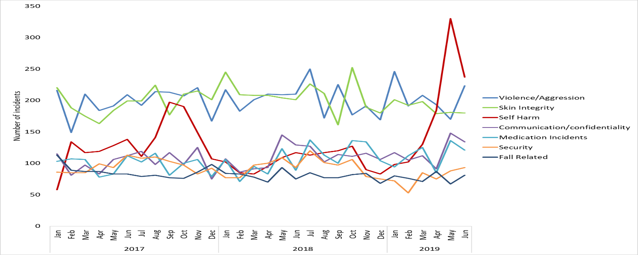Figure 10. Number of incidents reported in the 7 cause groups with most reported incidents on Ulysses from July 2017 to June 2019.

Details of the incidents under the cause groups self-harm and violence and aggression are looked at in more detail below.

Violence and Aggression
With the exception of Q1, violence and aggression, is generally the cause of most incidents in the Trust. An average of 202 incidents per month have been reported in the past 3 years, with some changes over time seen at ward level. The majority of incidents relate to violence and aggression from patients towards staff, most incidents cause no harm (72%) or minor injury (23%) however they have an impact on staff morale, sickness and retention.

Looking at incidents based on the new directorate structure (figure 12), incidents have increased in the specialist service directorate, as a result of the Evenlode incidents, but declined in Oxon + West mental health. The decline in Oxon + West is largely as a result of a decline in incidents on the older adult ward Sandford following the discharge of a complex patient. More recently incidents have increased in the Bucks Directorate, mainly as a result of increases on Ruby ward.

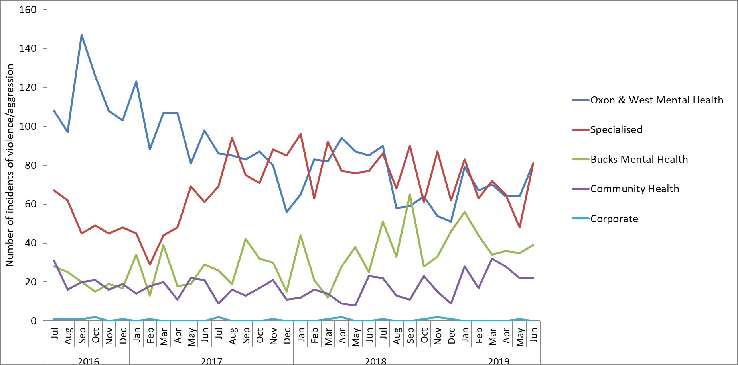
Figure 12 Breakdown of incidents of Violence & Aggression by Directorate, based on new Directorate structure, 01.07.17-30.06.19.

Overall 586 incidents were reported in Q1 of 19/20, with most incidents reported by Evenlode with 44, followed by Ruby with 39, Sapphire with 34 and Phoenix with 33. Eight patients were involved in the Evenlode incidents, with one individual instigating 14 incidents in total. On Ruby 14 patients were involved, and one patient instigated 16 of the 39 incidents. Two of the Evenlode incidents were graded as moderate and the remainder were graded as no harm or minor harm. All incidents on Ruby, Sapphire and Phoenix were graded as no harm or minor harm.

We recognise this as an area for improvement, therefore the Trust identified reducing the amount of violence and aggression on the adult acute wards as a quality account priority for 2019/20. Quality improvement work is underway which is using the learning from the national collaborative, the focus of the work is to improve relationships between staff and patients which should then reduce violence and aggression. From April 2019 new national reporting requirements have been introduced through the national MHSDS submission which will also enable the Trust to compare levels with other similar NHS trusts. A new zero tolerance framework has been developed and is going through being approved to better support staff who face abuse. There is also quality improvement work linked to a national collaborative which is focusing on reducing violence and aggression on wards.

Self-Harm
The number of incidents of self-harm continue to be variable across the trust. Prior to Q1 19/20, below average numbers have been reported in 14 of the previous 15 months. This was largely as a result of lower numbers of incidents being reported by the Bucks Mental health throughout 2018. In Q1, however, self-harm was the cause of most incidents in the Trust, as a result of increases on CAMHS Highfield and CAMHS Marlborough House wards.

On CAMHS Highfield, 297 incidents were reported in Q1, the incidents involved 18 patients, one individual harmed themselves on 107 occasions, and 95 of these related to them striking themselves/their surroundings (largely headbanging). One incident of cutting on Highfield was graded as severe, and 5 incidents were graded as moderate.

On CAMHS Marlborough House, 178 incidents were reported in Q1, all graded as minor harm or no harm. The incidents involved 8 patients and one individual harmed themselves on 152 occasions (including 86 incidents of striking themselves/their surroundings and 62 ligature incidents)

Skin Integrity
Since July 2016 60% of the reported pressure ulcers have been categorised as being present on admission (previously called inherited), rather than being new (previously known as acquired/developed in the service of Oxford Health). The trend in figure 11 shows the number of new ulcers has started to increase in the last 6 months, with the number of present on admission reducing. New national reporting requirements have been introduced from 1st April 2019 with first national reporting for Q1 in July 2019, this should improve the ability to compare our performance in a more accurate way nationally.

Of the 220-pressure ulcer that developed in service in the reporting period, four are being investigated as serious incidents, 3 in District Nursing teams and one on Witney community hospital Linfoot ward (two category 4 and two category 3 ulcers).

Alongside pressure ulcer incidents there were 23 skin tears (a new category from April 2019), 11 incidents of SCALE, 66 incidents of moisture associated skin damage, 10 incidents of moisture associated damage and 3 of medical device related damage.

In Q1 77% of skin integrity incidents were reported by District Nursing teams (n=410), followed by Community Hospitals with 14% (n=72).

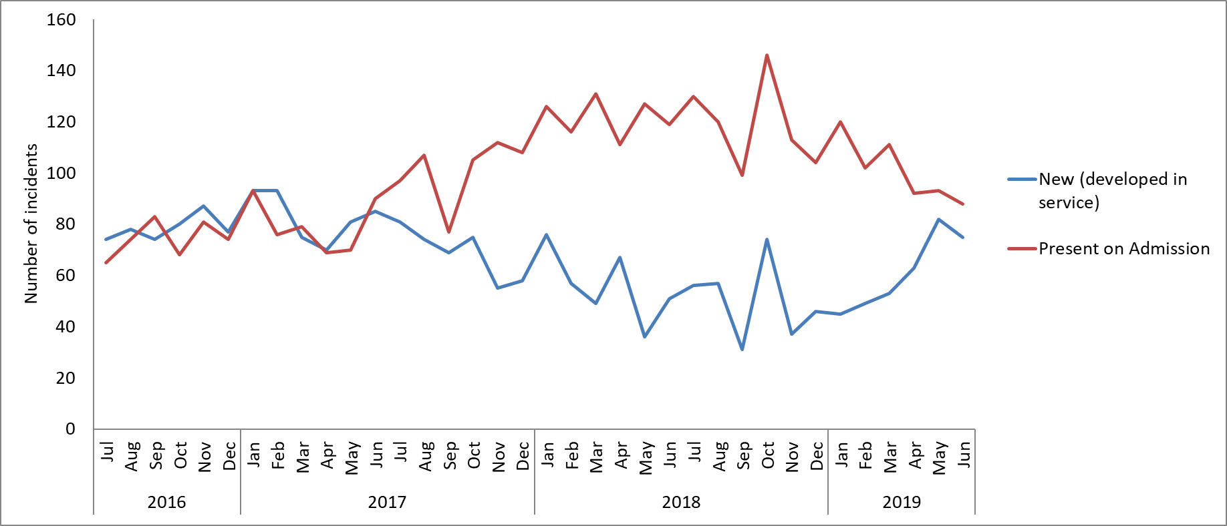Figure: 11. Incidents of pressure ulcers, July 2016 – June 2019

Sexual safety
In total 49 incidents were reported in Q1. The incidents were reported across 25 different departments, with most again being reported by Phoenix ward with 8 in total. Of the 49 incidents in Q1, 17 related to ‘inappropriate comments, and 12 to inappropriate touching. Three incidents were graded as moderate and one was graded as severe, one related to sexual assault of a patient by a stranger and the others related to sexual allegations. A sexual safety working group has been set up which carried out a self-assessment against the national standards to identify actions to take. One of the actions has been to develop an information leaflet for inpatients. The Trust has also joined a new national improvement collaborative to give this area attention and to share learning across all wards.

3.0 Freedom to Speak Up Guardian
The role of the Freedom to Speak Up Guardian is to provide independent and confidential support to staff that want to raise concerns by promoting a safe culture which is open, compassionate and continually looking to improve patient safety. The Trust’s Guardian presents an in-depth annual report to the Trust Board, last provided in November 2018. This summary is to bring together any themes from patient safety concerns raised with the Guardian and those reported through an incident route.

Staff have not reported any explicit patient safety concerns to the Guardian. However, a number of teams, mostly mental health teams, have raised concerns about capacity due to insufficient staff, increase in demand and complexity of patients. Although this does not have an immediate impact, staff are reporting that they are not able to do the best they can due to capacity.

Concerns most often brought to the Guardian are in relation to other staff behaviours for example staff feeling bullied. This impacts on the ability of the person to carry out their role and has an effect on staff experience which can impact on care being delivered.

The Guardian continues to work on developing a culture where all staff feel they can speak up for patient safety and that this is used to celebrate what works well, to address errors or failings and to make improvements.

- National Developments
NHS Improvement published a new patient safety strategy in July 2019 to cover the next five years focused on building a safer culture and safer systems to deliver safer patient care. The strategy is about continuously improving patient safety by maximising the things that go right and minimising the things that go wrong. The Trust is currently developing a local implementation plan.

The Trust celebrated the first World Patient Safety Day on 17th September 2019 an initiative by the World Health Organisation, with the slogan of speak up for patient safety! Some of the local improvements celebrated were:

- Legs Matter campaign which draws attention to the seriousness of leg and foot wounds and focuses on staff and patient health. This year we launched the first Legs Matter Week (June 3-7), and staff at the Trust took a stand for the campaign with a mobile information bus and conference. We have also joined the national collaborative on tissue viability.
- FallSafe is a care bundle approach to the risk assessment of patients and is designed to prevent patient falls in hospitals. All our community hospital wards have adapted FallSafe and have begun quality improvement projects to ensure these are embedded in common practice. There have already been tangible results, including an increase in falls awareness and a marked improvement in the taking of vital measurements such as lying and standing blood pressure.
- This month we are introducing Schwartz Rounds – multidisciplinary monthly forums designed for staff to discuss and reflect on the emotional and social challenges associated with working in healthcare. These forums have been known to boost morale and build stronger relationships and support networks within teams, which in turn enhances the level of care provided. The first Schwartz Round is set to be held on Thursday, September 26.
- We are using the model of ‘Safewards’ in some of our mental health wards. This model uses specific interventions within the environment to help reduce levels of conflict and to make the wards a safer place. This has included getting to ‘know each other’ whereby a folder is created on each ward in which staff and patients share their hobbies, likes and dislikes to develop stronger relationships. The work links with the national collaborative we joined on reducing restrictive practices.
- We are working on improvements to end of life care planning which has involved a series of workshops around personalisation of care and building staff confidence, as well as promoting the use of the specialist end of life care plan. A regular clinical audit is in place to review progress with embedding the care plan and the Trust takes part in the national audit of care at the end of life. In addition, the Trust has been part of a county-wide health needs analysis for the provision of end of life services which should improve the join up of service provision.
- A number of mental health teams have been part of a pilot using portable devices so that clients can have blood tests at home. This means that clients do not have to attend their GP surgery for blood tests and there is less delay in getting any treatment required. We are also able to complete physical health checks with clients, many of whom are at high risk of physical health problems due to mental health problems, their lifestyle choices and medication.
- Our suicide prevention lead has introduced an updated suicide prevention strategy and workplan to help staff recognise and address risks early on. This came into place at the end of 2018 and is being implemented across the trust. We were involved in the World Suicide Prevention Day on 10th September, where everyone was encouraged to talk about suicide as a conversation can save a life.
- We supported World Sepsis Day on 13th September to raise awareness of the risks and help people to recognise the signs and symptoms of sepsis to promote early and effective interventions and treatment. We launched the new national early warning sign tool this month, which builds upon previous versions and focusses on the early recognition of sepsis and immediate escalation when a patient is deteriorating.

Throughout the report we mention the national NHS Improvement collaboratives we have/ are involved in around patient safety, these include;
- Reducing time spent on enhanced observations in PICI and acute wards
- Reducing restrictive practices in acute, LD and forensic wards
- Closing the Gap in AMHTs
- Reducing length of stay for people with autism
- Improving Sexual Safety in mental health inpatient settings
- Tissue viability

5.0 National Alerts
There is a robust process of identifying, disseminating and monitoring the implementation of national patient safety alerts.

In 2018/19 the Trust received and managed 81 relevant national alerts, all alerts were actioned within the timescales required. From April to June 2019, 18 CAS alerts were issued, of these 12 were applicable to the Trust and were cascaded appropriately. These alerts concerned a range of topics from drug safety alerts, medical devices and estates. Of the 21 alerts deemed applicable to the trust 8 have been actioned and closed. In total 3 remain open (1 of which was issued in the previous quarter, March 19). The completion dates for these fall in July and September of 2019, the alerts are being actioned and remain under review.

A detailed separate report is provided to the Safety Quality Sub-Committee in relation to national alerts.

Three Risk notes were issued from April 2019 to June 2019:
- Risk Note 8 – Risks associated with combining packs of medication. Issued April 2019
- Risk Note 9 – Pregnancy Prevention Plan (Valproate). Issued April 2019
- Risk Note 10 – Risk of harm from the inappropriate placement of pulse oximeter probes. Issued June 2019

6.0 Learning from Deaths
6.1 Governance
The Trust has a stepped process for the screening, review and then investigation of deaths. Each clinical directorate manages their own mortality review process to identify learning from unexpected and inpatient deaths. We also have a trust-wide weekly forum to review unexpected/ unnatural deaths. If new complaints are received in relation to the care of a bereaved relative a mortality review is automatically triggered. The Trust-wide Mortality Review Group meets quarterly to oversee learning across the Trust reporting into the Safety Quality Sub-Committee. The group last met in July 2019 and has identified the following priorities for 2019/20; to test the current screening of deaths by local teams, to develop how beavered families are engaged in the process of initial review reports and to develop staff confidence and resources for supporting beavered families.

All deaths of a person with a learning disability or autism and all deaths of a person aged under 18 are reviewed externally by a multi-agency group as well.

6.2 Coroner reviews
In addition to our own local mortality reviews and SI investigations, the local coroner will independently review all deaths where the cause of death is unknown, violent, unnatural, or sudden and unexplained. As a result of the reviews a coroner has issued one Regulation 28 ruling/ Prevent Future Death (PFD) notice in 2019/20 (three were issued in 2018/19 relating to 2 deaths in 2017 and 1 death -where our patient was the perpetrator of a homicide in 2015).

The ruling in 2019/20 relates to the suicide of a female on Ruby ward in March 2017 who was on unescorted leave from the ward. An external investigation was commissioned by the Trust into the death which was shared with the coroner. The Trust received the preventing future death notice on 12th April 2019 and has responded to the concerns about; access to cutlery on the ward used for self-harm, access to means for self-harm outside the ward, timeliness of hourly observations, access to an immediate response from ward staff to telephone calls and planning for discharge.

6.3 Overview of trends and themes
In August 2019 we had a tragic death on Allen ward which is currently being investigated through the serious incident process. An initial review to identify immediate actions has been completed.

The pattern of deaths is analysed quarterly and the position up to June 2019 was reported in detail and discussed at the last Trust-wide Mortality Review Group in July 2019. The majority of deaths (for patients open to a service at the time of their death and those discharged within the last 6 months) relate to people aged over 75 who had received treatment from one of our physical health services (figures 15 and 16), such as the district nursing service. We saw an increase in deaths in January 2018 in line with the national picture, due to the winter weather and flu outbreak.

The key themes for learning from the review of deaths are: family engagement and communication, physical health for patients with a mental health illness, communication at points of transitions and changes in care between teams, services and organisations. There is an established workstream in the Trust focused on improving physical health care for patients with a mental health illness and/ or learning disability.

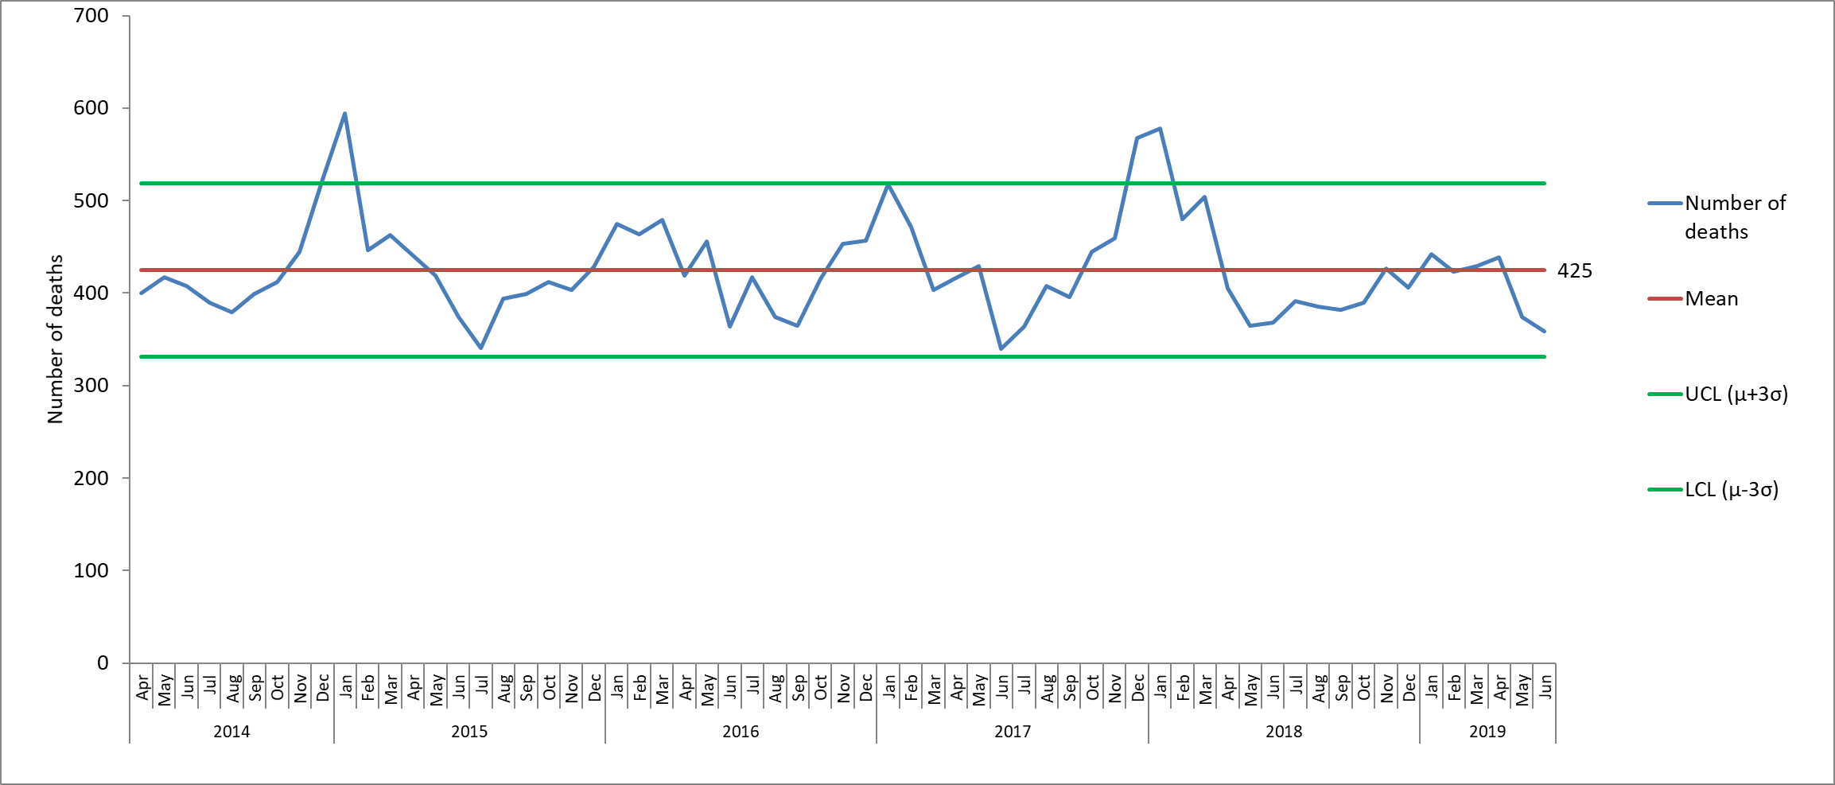
Figure 15. Deceased patients (for patients with open referrals and patients who were discharged but seen in the 6m prior to death), April 2014 – June 2019.

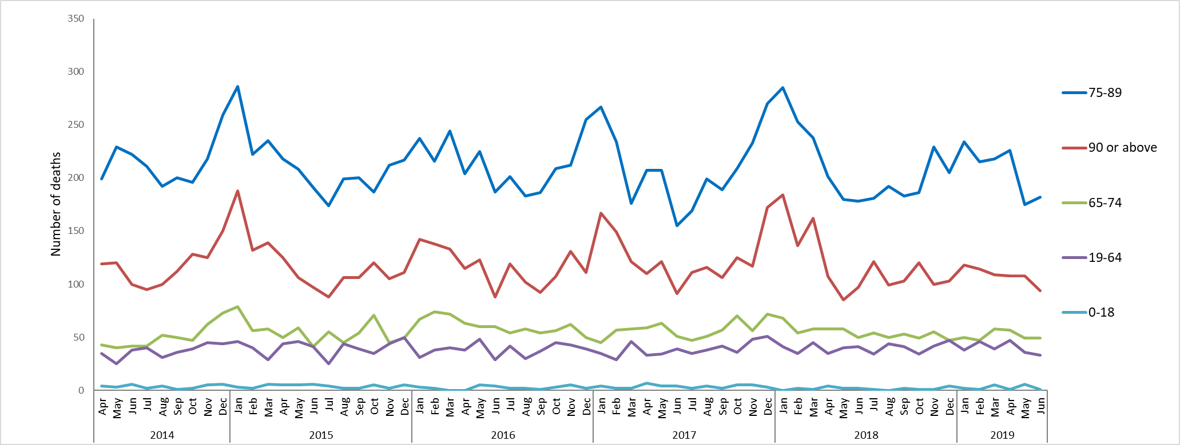
Figure 16. Deceased patients by age (for patients with open referrals and patients who were discharged but seen in the 6m prior to death), April 2014 – June 2019.

Serious Incident Reviews
All serious incidents are discussed weekly and escalated to the Executive Team meeting as required. The Safety Quality Sub-Committee keeps an oversight quarterly.

The national framework for managing serious incidents is due to be published shortly which is proposed to be very different to the current framework. NHS Trusts will be asked to start to introduce the new framework from autumn 2020 with full roll out by the summer 2021.

7.1 Number of serious incidents and themes
In 2018/19 the Trust reported 51 serious incidents all of which were investigated within an agreed timescale with the relevant commissioner. In Q1, from April to June 2019, 15 SIs were identified; 3 were in AMHT Bucks Chiltern and 2 were in CMHT South Bucks. 6 of the SIs relate to pressure ulcers and 8 involved a death, of which 5 are suspected suicides.

From April to June 2019, 9 SI investigations were completed, reviewed at panel and submitted to the relevant commissioner. One of these incidents (a suspected suicide in CAMHS) was downgraded over the course of the investigation.

Overall from November 2016 there has been a reduction in the number of confirmed serious incidents in the trust which has been maintained (from an average of 10 per month prior to November 2016 to an average of 4 per month subsequently). The decline in serious incidents from 2016 was largely in relation to a reduction in pressure ulcers. The majority of SIs in the last 12 months have related to self-harm and have occurred in five teams covering both AMHTs and older people CMHTs.

The main themes and learning from serious incidents have been:
- Challenges with meeting increased demand versus capacity impacting on consistency of care and lack of time to fully complete clinical documentation (particularly in adult and older people community mental health teams)
- Accessibility for staff of both historic and current risk assessments in Carenotes which can hinder staff when clinically assessing patients at a point of crisis.
- Staffing issues as a result of high vacancies creating more task focused nursing, lack of time to complete holistic assessments and lack of continuity of care (particularly in district nursing service)
- Transition points and communication between external organisations and services within the Trust

7.2 Never events
In 2019/20 the Trust has had one ‘never event’ which occurred in September 2019 in the community dental service related to the extraction of a wrong tooth of an adult with severe learning disabilities whilst under a general anaesthetic. Her mother was informed same day about the incident and the patient was discharged as planned from the ward the same day as treatment. A follow up appointment has been arranged. A serious incident investigation will be carried out led by a specialist dentist from another NHS trust. An initial review of the incident has been completed.

Timeliness of process
No serious incident investigations have been submitted past the stipulated time frame in 2018/19 or so far in 2019/20.

Developments to the SI process
We continue to develop the serious incident process to maximise learning from incidents, some of the developments include;
- The Root Cause Analysis training sessions continue to be delivered over 2 consecutive days with a focus on human factors recognition, duty of candour and involvement of families and carers in the investigation process. A total of seven 2-day sessions are being offered in 2019/2020. In Q1 - 24 authors led or supported 15 serious incident investigations.
- Additionally, a tailored Initial Review Report (IRR) training has been delivered across Oxon and with the aim of improving the quality of such reports to support appropriate decision making.
- An external audit was undertaken by Price Waterhouse Cooper in February 2019 which audited elements of the serious incident process including timeliness of completion and evidence of family/ carer involvement. The results were satisfactory with no actions for improvement recommended.
- The Serious Incident team continues to complete an internal audit to review the involvement of families in the conduct of investigations every 6 months. A random selection of 10 completed SI investigations were selected for review in June 2019 and the results were encouraging. In 9 out of 10 Duty of Candour was completed in line with our policy, 9 out of 10 RCA reports demonstrated family involvement and in the remaining case the patient stated they did not wish their family to be contacted. Seven out of the 10 cases reviewed were able to show that the final serious incident investigation report was shared with the patient and /or family member within 10 days of the report and action plan being finalised.

The future plans for improvement are: -
- To ensure that families are fully engaged and involved in investigations at all stages of the process.
- To seek out different ways to effectively share the learning from SI’s across the trust.
- To assess the impact of actions once completed
- Further work to gain assurance that completed reports are shared with patients, family members and or carers in a timely manner.

8.0 Reducing restrictive practice
The Safety Quality Sub-Committee receives a detailed report from the reducing restrictive practice steering group. In summary there are no new changes in the overall trends on the use of restrictive practices across the trust in the past 3 years. The previous reductions in older adult wards and a number of forensic wards have been maintained. On review where a ward has used restrictive practice this is related to a small number of particularly unwell patients presenting challenging behaviour. In the reporting period CAMHS Highfield was the highest reporter of physical restraints and administrations of rapid tranquilisation for NG feeding, and most seclusions occurred on Ashurst the intensive care unit, relating to a couple of patients. Safety Pods have been introduced at CAMHS Highfield and Cotswold House Oxford to support the administration of NG feeding and Kestrel are trialling the safety pod for use in seated de-escalation. Local clinical audits looking at documentation for seclusions, long term segregation and rapid tranquilisation have been completed and all identified improvements particularly around physical health monitoring.

A trust wide strategy for reducing harmful experiences related to the use of restrictive practice will be devised this year. Training will remain being a key feature and this training will be reviewed in line with new accreditation introduced by the restraint reduction network, which needs to be in place by April 2020.

The requirements of the Mental Health Units (Use of Force) Act 2018 have been evaluated against current practice. Patient information leaflets on the use of restraint have been developed and are currently out for consultation before rolling out. A young person and easy read versions are also being developed with the support of experts within these services. Information about our responsibilities under the Act are also included as part of mandatory PEACE Training.

NHS Improvement launched a collaborative on reducing restrictive practice looking at data, quality improvement and training standards. The aim is for the organisations involved to reduce the use of restrictive interventions by 25%. Kestrel Ward is participating in the collaborative and the process will be replicated concurrently with Kennet, Evenlode and Phoenix Ward supported by the Oxford Centre for Healthcare Improvement.

The CQC are also undertaking a national thematic review on restrictive practice. The Trust provided information on restrictive practice for all mental health wards, and two wards were visited as part of site visits; Evenlode and Kestrel. A national report will be published at the end of 2019.

9.0 External Reviews
The Trust participates in a range of multi-agency external reviews including mental health homicides, domestic homicide, safeguarding adult and child serious case reviews. The progress and outcome of mental health homicides are reported to Board. In addition, a detailed analysis of learning from the aforementioned external reviews is provided to the Quality Committee every 6 months.

The common themes summarised in the May 2019 analysis were;
- Communication across teams and between multi-agency teams.
- Ensuring there is someone coordinating the care for each individual person.
- Raising awareness of historic safeguarding and domestic abuse concerns
- Improving access to EHR and consistent use of alerts on patient /client records to support staff to view patient / client holistically.

The Trust is currently contributing to the investigations of seven independent domestic homicide review cases, at various stages of completion. The number of domestic homicide investigations has increased since the Home Office revised their guidance in December 2016 which sets out that all suspected or confirmed suicides where there was coercive controlling behaviour in a relationship will be subject to a domestic homicide review.

In 2018/2019 a Mental Health Homicide review was commissioned by NHS England into the care of a mother who killed her child in March 2017 who was under the care of an AMHT and GP. The review looked at the mental health care of the mother by three NHS trusts since 2011. The death of the child was also subject to a Serious Case Review. The final reports from both the MHHR and SCR for the child are to be published shortly. The Trusts action plan was shared with the CCG and grandparents in a meeting in July 2019 and will be monitored with the CCG.

10.0 Conclusions
The group is asked to note the report and to continue to encourage the reporting and learning from incidents and deaths.

Serious Incidents are nationally defined as incidents where there were acts or omissions identified in care that resulted in death, lead to abuse or serious harm requiring further treatment

