

**BOD 05/2020**

(Agenda item: 7)

# Report to the Meeting of the

# Oxford Health NHS Foundation Trust

# Board of Directors

**January 29th 2020**

**Monthly Performance Report – M09 December 2020**

**For: Information**

**Executive Summary**

This report summarises the Trust’s national and locally contracted key performance indicators (KPIs) for Month 9 (December) 2019. Overall, the Trust achieved 303 out of 390 targeted indicators (78%).

**Performance Trend:**

The number of locally **contracted** indicators (excluding Joint Management Group (JMG)) varies throughout the year as is illustrated in the graph above. This is due to some indicators only being reportable on a quarterly basis. Of the 87 indicators not met in December, 39 contractual indicators were more than 10% away from the commissioner defined targets (red category) and **demand exceeding workforce capacity** continues to have a major impact on service delivery.

**Areas to highlight to the Board from an overall Trust perspective**:

**National Position:**

The table below shows how the Trust is performing against the **operational performance** indicators within the NHSI Single Oversight Framework (SOF) (as at the latest available position).



Highlights include;

* The Data Quality Maturity Index (DQMI) remains below the 95% target with performance in September being 92%.
* Out of Area Placements (OAPs) are monitored on a quarterly basis within the SOF. There has been a further increase in the number of OAPs during December in Buckinghamshire however this remains below the Trust’s overall planned trajectory. The table below shows the progress against plan.

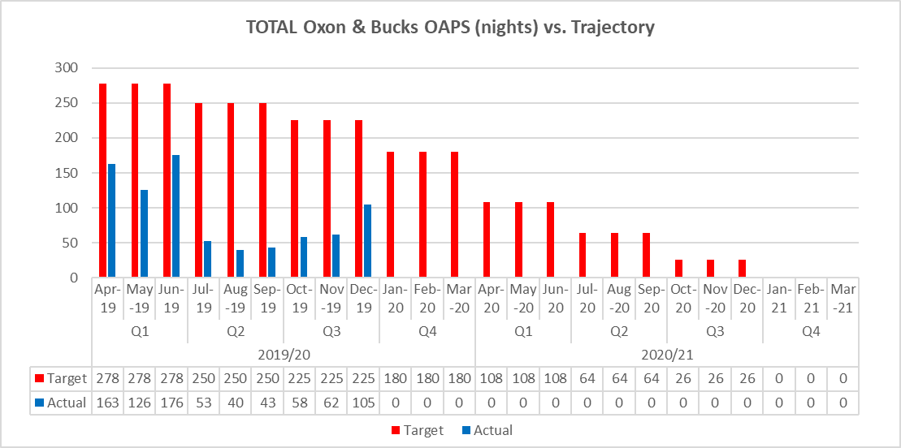

**Local Position:**

**Patient Access and Patient Flow**

The table in **Appendix 1** shows performance in relation to the Trust’s core mental health community services concerning demand, patient access and patient flow. Key headlines;

* **Demand**

Despite comparable population sizes, the number of Adult Mental Health referrals received in Oxfordshire continues to be higher than in Buckinghamshire (46% higher in December).

The number of referrals received by CAMH services has reduced in December which is consistent with seasonal variation. Overall referrals to the Trust’s CAMH services across Oxon, Bucks, and BSW were 2039 in December which is 9% higher than this time last year. The average number of monthly referrals between January 2019 and December 2019 was 2226.

* **Access/Waits**

**Adult Mental Health** – A significant long-term underfunding of mental health in Oxfordshire has resulted in considerable pressure building up for mental health services.  The target for seeing patients referred on a routine basis was changed from 4 weeks to 8 weeks in 2018. In December 50% of routine referrals were seen within 28 days compared to 86% in Buckinghamshire.

**Child & Adolescent Mental Health Services (CAMHS)** During December, only 51% of patients referred to routine pathways were seen within 12 weeks. This is primarily due to the focused effort to clear the backlog that has developed. Although performance remains below the 75% target at the present time, this position has and will continue to improve as the longest waiters are seen and treated.

Across Bath & North East Somerset, Swindon and Wiltshire, 46% CAMHS referrals were seen within 4 weeks. This is a 4% improvement from the previous month.

During December access to the Buckinghamshire CAMH services improved with 92% of patients seen within 4 weeks.

* **Delayed Transfers of Care (DTOC)**

In December, bed days lost to DTOC in mental health increased from 111 to 131 (equivalent to 5 beds), this is below the rolling 12-month average of 172 (6 beds). Community DTOC increased by 197 days in December to 1267 bed days lost (equivalent to 41 beds), with a rolling 12-month average of 1267 days per month (41 beds).

* **Out of Area Placements (OAPs)**

5 new patients were placed out of area in December (1 in Oxon and 4 in Bucks). 7 patients in total were in out of area placements during the month utilising a total of 105 bed days in the month. The distance from patients’ home to placements ranged from 28.9 to 88.6 miles, with the average distance being 57 miles.

**Performance by Directorate in December 2019:**

**Oxfordshire, Swindon, Wiltshire & BaNES – All Ages Mental Health** achieved 113 of the 143 targeted indicators (79%)

**Highlights for the Board:**

1. **CAMHS (Swindon, Wiltshire, Bath and North East Somerset (BaNES)) –** A comprehensive waiting time improvement plan is now in progress and although commissioner targets have not yet been achieved, continuous improvements have been seen in 4 week waiting times in BaNES & Wiltshire since April 2019 with a small exception in November 2019.
2. **Perinatal non-urgent assessments –** Significant improvements have been reported in December (28%) despite workforce shortages within the Service.
3. **Physical Health Checks –** There has been a sharp decline in performance as a result of changes in reporting methodology. Work is currently underway to understand the root cause of the issue and a further update will be provided at the next Board.

**Buckinghamshire – All Ages Mental Health** achieved 36 of the 49 commissioner targeted indicators (73%).

**Highlights for the Board:**

1. **Bucks Care Reviews –** Ensuring that Care Reviews are carried out within the timeframes set out in the clusters continue to be an area of underperformance for the Directorate. As with Oxfordshire, the dashboard was rolled out to operational services in October. No improvement has been noted so far, performance will continue to be monitored at Performance meetings and a review will be carried out in January 2020.
2. **Urgent referrals -** The service has been implementing the new Crisis model over past few months resulting in the urgent assessment team transitioning into the new crisis team at the end of January; the crisis team will be focusing on these urgent and emergency referrals. Significant improvement expected for end of March 2020.
3. **CAMHS** – Performance is consistently improving and local incentive scheme targets set by Commissioners are continuously met. 92% of routine referrals were seen within 4 weeks in Buckinghamshire.

**Oxfordshire Community Services Directorate** achieved 55 of the 77 commissioner targeted indicators (71%)

**Highlights for the Board:**

1. **Oxfordshire CHC –** The Trust continues to underperform against the referrals completed within the 28 day target and work to improve the position continues with Commissioners and partners. Improvements are being made and Oxfordshire CHC has cleared the backlog of 3 and 12 month reviews with both targets now being achieved.
2. **Falls Prevention Service –** The Trust has been underperforming against referrals offered an appointment within 8 weeks. This is due to a combination of issues that include reporting, staffing shortages and an increase in demand. The Trust is monitoring the performance through Service Review Meetings and will be initiating a root cause analysis to provide recommendations for improvement and inform the review of the Falls prevention pathway.

**Specialised Services** achieved 99 out of 121 targeted indicators (82%)

**Highlights for the Board:**

1. **Eating Disorders (Bed Occupancy)** – There have been ongoing difficulties in providing beds due to high dependency patients and a shortage of workforce. This has impacted negatively on the Cumulative bed occupancy target. The service has implemented a new Single Point of Access (SPA) as part of the New Care Models improvement work and the implementation of this is already seeing an improvement in patient flow and bed occupancy levels, with both M08 and M09 Ward occupancy being 100%.

**Recommendation**

The Board of Directors is asked to review and note the Board Performance Report.

**Author and Title:** Martyn Ward – Director of Strategy & Chief Information Officer

**Appendix 1 – Patient Access and Flow**

